CUSTOMER DATA |  |  |  |  |  |  |  |  |  |  |  |  |  |  | INTERTEK DATA
Name: |  |  | ADNOC Onshore  P.O. Box 270, Abu Dhabi, UAE |  |  |  |  |  |  |  |  |  |  |  | Intertek Project No. |  |  |  |  | 106792-25
Address: |  |  |  |  |  |  |  |  |  |  |  |  |  |  | Client P.O./I.O. to Intertek: |  |  |  |  | -
Attn: |  |  | Islam Khalifa |  |  |  |  | Phone: |  |  | +971 0567857160 |  |  |  | Requisition No: |  |  |  |  | P30339B-RFI-INST-008-ARC-INT-KSB-0109
E-Mail: |  |  | i.khalifa@adco.ae |  |  |  |  |  |  |  |  |  |  |  | Date of Order: |  |  |  |  | 15-Sept-26
Copies to: |  |  |  |  |  |  |  |  |  |  |  |  |  |  | Intertek Contract Coordinator: |  |  |  |  | Chethan Ramesh
SUPPLIER/SUB-SUPPLIER DATA |  |  |  |  |  |  |  |  |  |  |  |  |  |  | INSPECTION INFORMATION
Inspection  Performed: |  |  | With Customer Supplier With Sub-Supplier |  |  |  |  |  |  |  |  |  |  |  | Date(s) of Visit(s): |  |  |  |  | 15/09/2026
P.O. No:  04108-PM-INST-008 |  |  | Change No: N/A |  |  |  |  |  |  | Requisition No: N/A
 |  |  |  |  |  |  |  |  |  |  |  |  |  |  | Date of Previous Visit: |  |  |  |  |  | NA
Supplier: |  |  | KSB MIL CONTROLS LIMITED Meladoor, Annamanada - 680741, Kerala, India. |  |  |  |  |  |  |  |  |  |  |  | Date of Next Scheduled Visit: |  |  |  |  |  | 16/09/2026
 |  |  |  |  |  |  |  |  |  |  |  |  |  |  | P. O. Status: |  |  | Complete Incomplete
Supplier Job No: |  |  |  |  |  |  |  |  |  |  |  |  |  |  | Project Name:
Location: |  |  | Meladoor, Annamanada - 680741, Kerala, India |  |  |  |  |  |  |  |  |  |  |  | EPC for SE AiP5 Project (On plot) - ASAB/SAHIL (Package 1)
Primary Contact: |  |  | Mr. Alex Davis (KSB MIL Contract Management) |  |  |  |  |  |  |  |  |  |  |  | Materials/Items Inspected:  Control Valve
Phone: | +91 480 2695832 |  |  |  | E-mail: |  | Alex.Davis@ksb.com
Sub-supplier: |  |  | xxxxxxxxxxxxxxx
Sub-Supplier Job No: |  |  | xxxxxxxxxxxxxxx
Location: |  |  | xxxxxxxxxxxxxxx
Primary Contact: |  |  | xxxxxxxxxxxxxxxxx |  |  |  |  |  |  |  |  |  |  |  | Pre-Inspection Meeting Summary Attached: |  |  |  |  |  |  | Yes No
Phone: | xxxxxxxxxxxxxxxxxx |  |  |  | E-mail: |  |  | xxxxxxxxxxxxxxxxxx |  |  |  |  |  |  | Summary Report Attached: |  |  |  |  |  |  | Yes No
INSPECTION DISPOSITION: |  |  |  | Accept |  |  | Nonconformance(s) Identified |  |  |  |  |  |  |  |  | Placed on Hold |  |  |  | Other (Explain)
INSPECTION SUMMARY AND CONCLUSION:
The inspection was conducted in accordance with ITP No. P30339B-30-99-52-4607 Rev C , covering the inspection of Control Valves and its Components. All inspection activities were carried out as per ITP Clause Nos7.3, 7.4(a), 7.5(b), 7.6(c), 7.7(d), 7.8(e), 7.9(e), 7.10(f), 7.12,

Result: Acceptable
RECOMMENDED ACTION:
INSPECTION TIME: |  |  | DAYS  HOURS |  |  | 8 |  |  |  |  |  | TRAVEL HOURS: | 5 |  |  |  |  |  | DISTANCE:  MI KM |  |  |  | 160 KM
Technical Specialist: |  | XXXXXXX |  |  | Date: |  |  |  | XXXXXXXX |  |  |  |  | Project Coordinator:
This report is made solely on the basis of the Client’s instructions and/or information and materials supplied. It is not intended to be a recommendation for any particular course of action. Intertek does not accept a duty of care or any other responsibility to any person other than the Client in respect of this report and only accepts liability to the Client insofar as is expressly contained in the terms and conditions governing Intertek's provision of services. Intertek makes no warranties or representations either express or implied with respect to this report save as provided for in those terms and conditions.

- ATTENDEES

NAME | COMPANY REPRESENTED | TITLE
Adarsh MS | Intertek OBO ADNOC | Inspection Engineer
Shibu C | KTI OBO ARCHIRODON | Inspection Engineer
Sabari Giri | TUV SUD OBO Vendor | Inspection Engineer

- MATERIALS

  - GENERIC MATERIALS

TAG / EQPT NO. | DESCRIPTION
14-01-FCV-1601-01A | 24''-41611 ASME #600 RF Gr WCC CV=4500 58 24''
14-01-FCV-1601-01B | 24''-41611 ASME #600 RF Gr WCC CV=4500 58 24''

  - MATERIALS INSPECTED

PO ITEM NO. | TAG / SERIAL NO. | PRODUCT / MATERIAL / ITEM NAME | ORDERED QUANTITY | PRESENTED THIS VISIT | ACCEPTED  THIS VISIT | QUANTITY ACCEPTED TO DATE
`79 | 14-01-FCV-1601-01A | Control Valve |  | 1 | 1 | 1
`80 | 14-01-FCV-1601-01B | Control Valve |  | 1 | 1 | 1

- DOCUMENTS USED

DOCUMENT NO. | REVISION | TITLE | APPROVAL STATUS
RFI No: P30339B-RFI-INST-008-ARC-INT-KSB-0109 | 1 | RFI | -
P30339B-30-99-52-  4607 | C | ITP | 2
ASTM Standards | - | - | -
AGES-SP-04-002 | - | AGES | -
14-01-5046431 1/6 |  | GA | 1
ISO 4624 (pull-of test) ASTM D4541 |  | - | -
Metallic Comb Gauge, ISO 2808 | - | - | -
ASTM D4752

- SCOPE OF INSPECTION

ITP LINE NO. | ITP ACTIVITY DESCRIPTION | ITEMS | RESULTS | CLAUSE
7.3 (c) | Actuator Chamber - Strength & Leakage |  | Acceptable
7.4 (a) | Stroke Checking / Opening & Closing Time |  | Acceptable
7.5 (b) | Linearity |  | Acceptable
7.6 (c) | Hysteresis |  | Acceptable
7.7 (d) | Accessories |  | Acceptable
7.8 (e) | Failure action test / Dead band test |  | Acceptable
7.9 (e) | Dead band check |  | Acceptable
7.10 (f) | Functional test of position transmitters, limit switches, SOV as applicable. |  | Acceptable
7.12 | Fugitive Emission Production test - Leakage |  | Acceptable

- EQUIPMENT AND INSTRUMENTATION USED (TO BE SUPPLIED BY SUPPLIER)

EQUIPMENT / INSTRUMENT DESCRIPTION | SERIAL NO | CALIBRATION CERT. NO. | EXPIRY DATE
Stop Watch | MQC599 | SLT/26/02/415/008 | 27/02/2027
FE Testing machine | FC25004354 | 101209 | 11/02/2027
Measuring Tape | MIL-QC-1319 | SLT/26/04/480/021 | 16/10/2026
Vernier Caliper

- INSPECTION DETAILS

- NON-CONFORMANCES

NCR # | DESCRIPTION | DATE RAISED | DATE CLOSED
 | - | - | -

- QUALITY OBSERVATIONS

Item No. | Material Inspected: Control Valve
Observation Type: Positive Negative |  | Criticality: Critical Non-Critical
Category: Documentation |  | Sub-Category: Dimensional Inspection
Further Comments:

Item No. | Material Inspected: Choose an item.
Observation Type: Positive Negative |  | Criticality: Critical Non-Critical
Category: Documentation |  | Sub-Category: Incomplete Documentation
Further Comments:

- ATTACHMENTS TO THIS REPORT

- As Per Attached Annexure list
- Calibration Certificates Reviewed

- PHOTOGRAPHS
Inspection Photos.
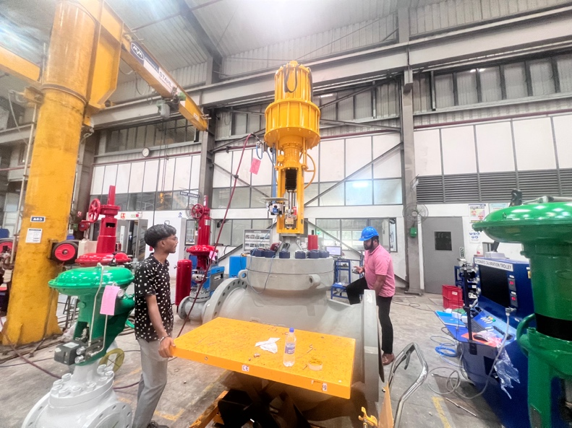 | 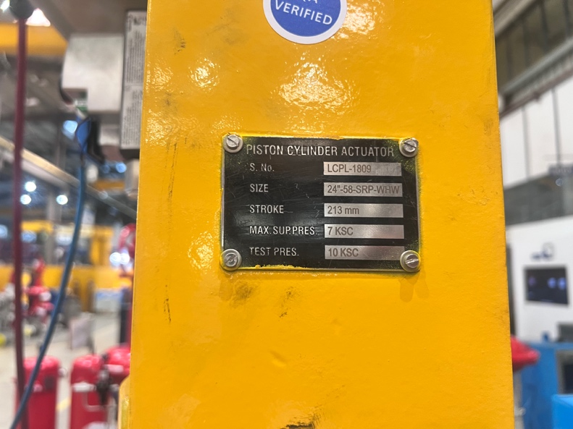
Control Valve | Name Plate verification
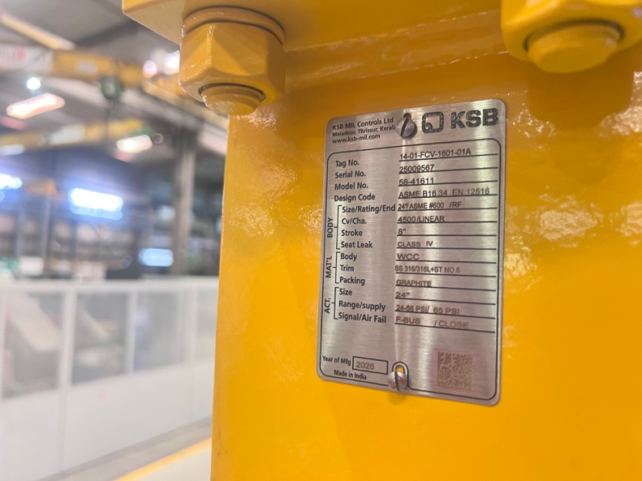 | 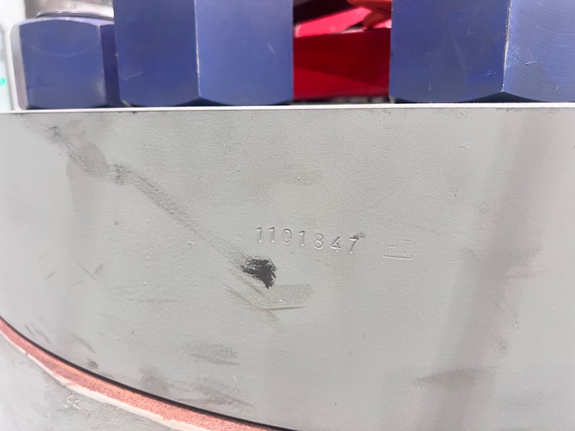
Name Plate verification | Bonnet No Verification
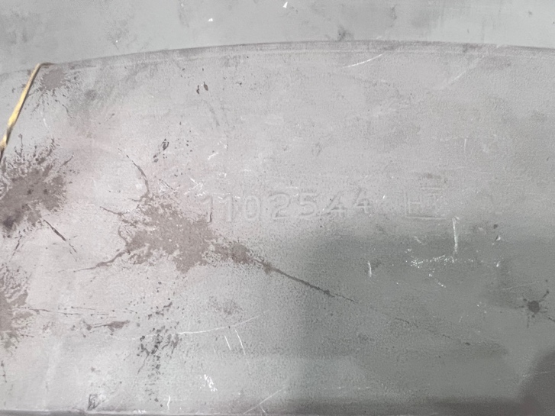 | 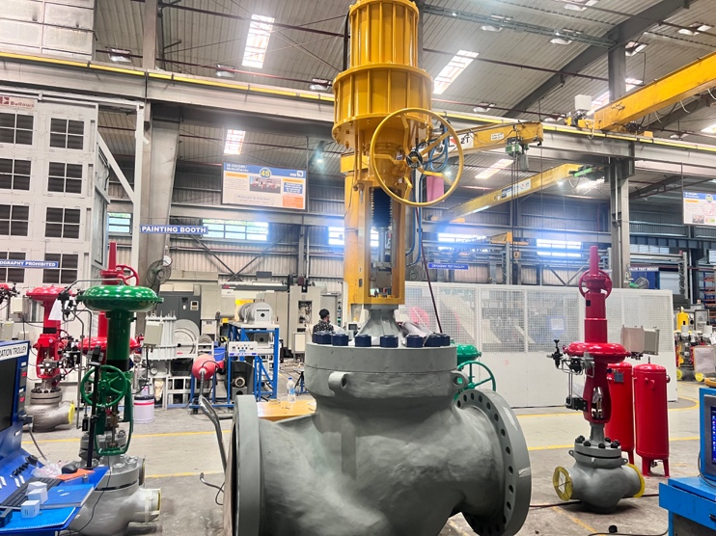
Body No Verification | Control Valve
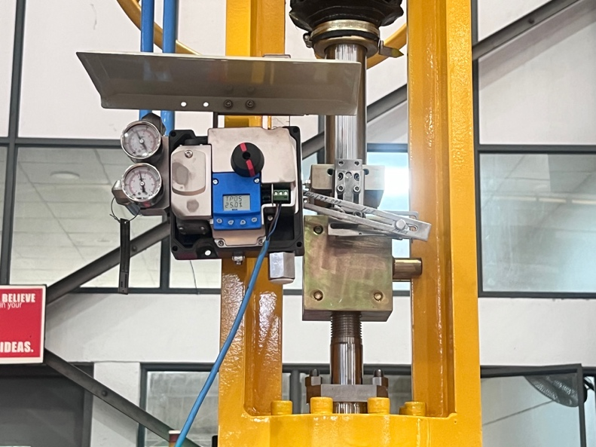 | 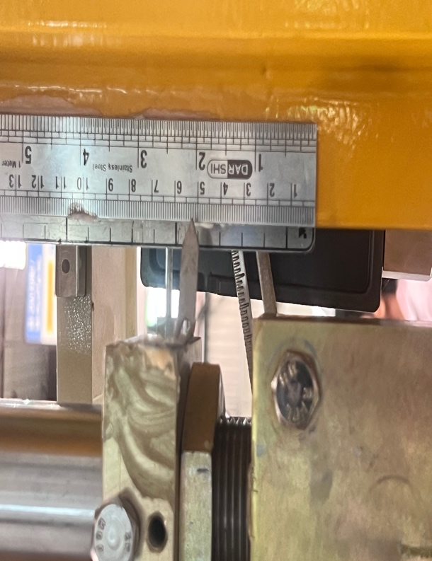
Calibration | Calibration
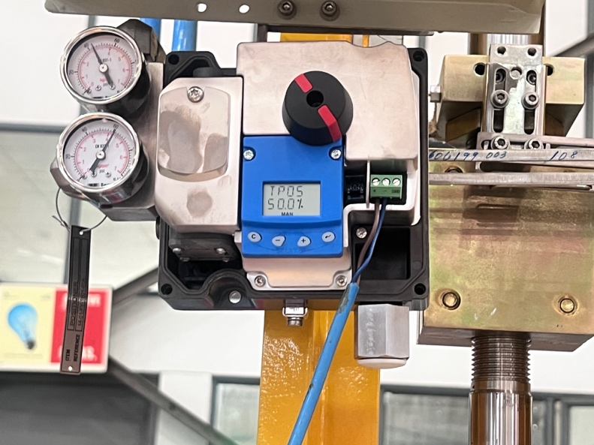 | 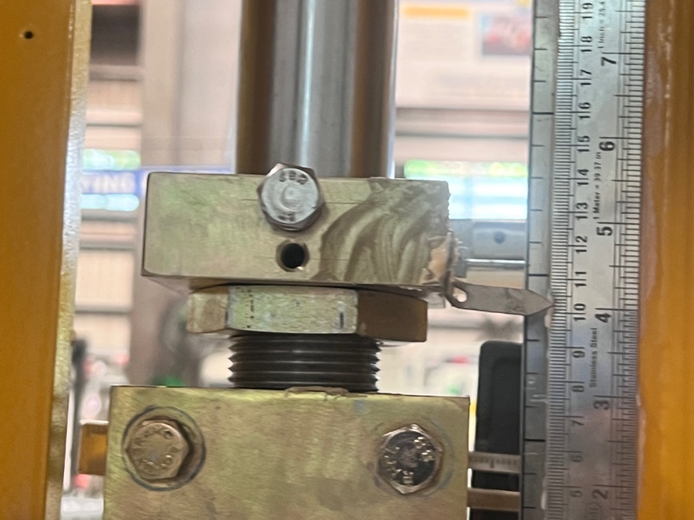
Calibration | Calibration
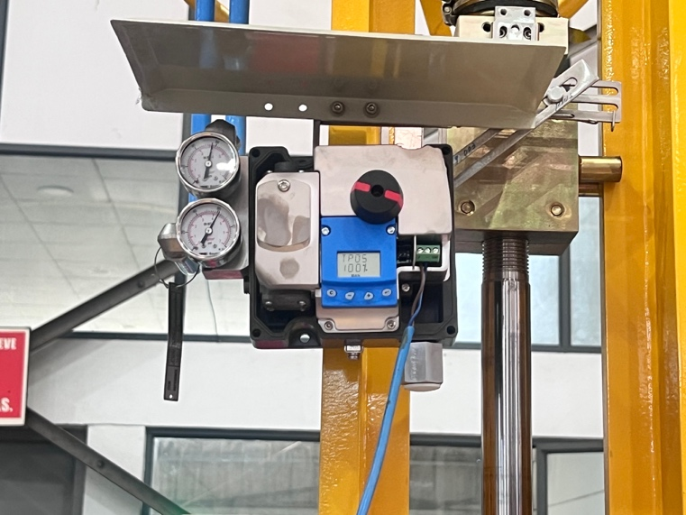 | 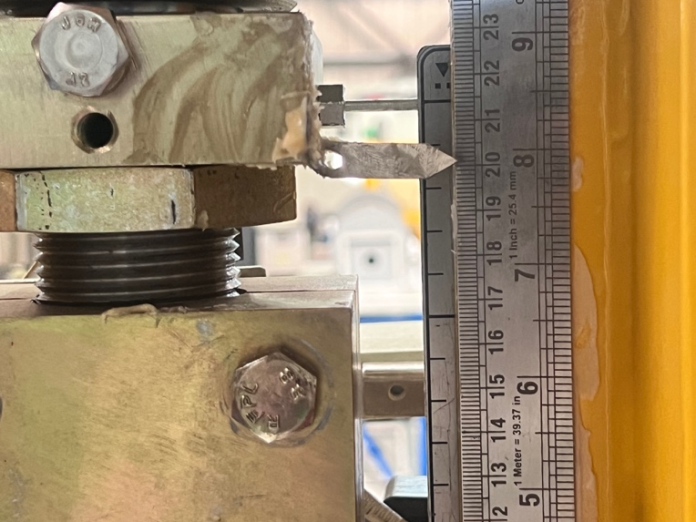
Calibration | Calibration
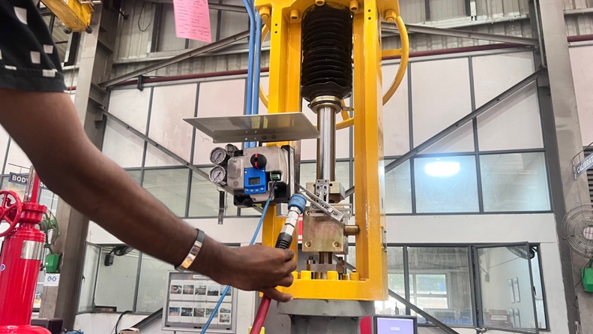 | 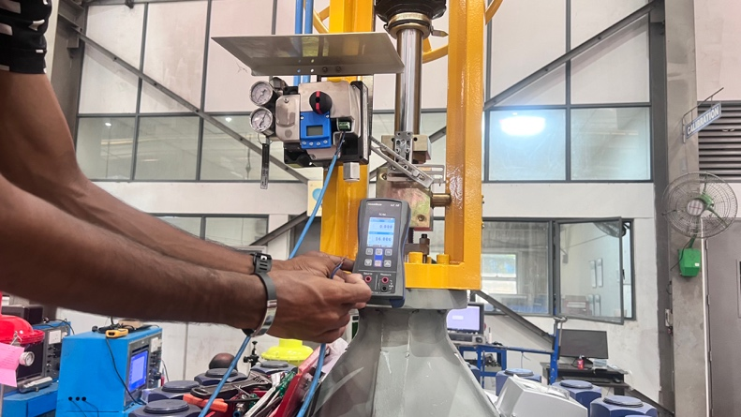
Air Cut off | Signal Cut off
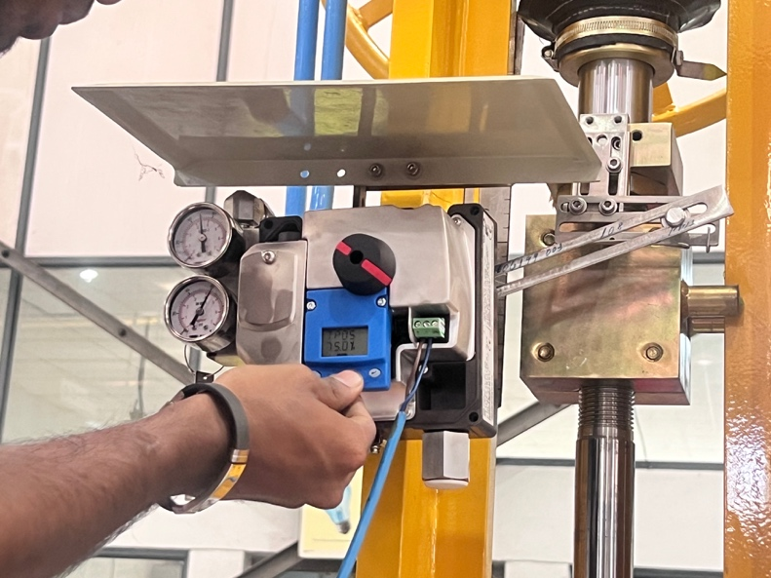 | 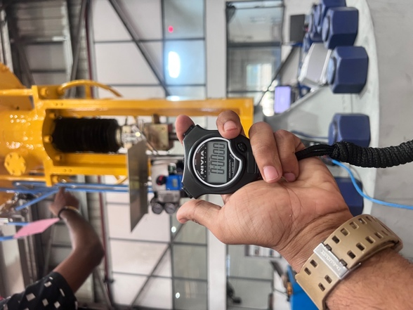
Signal Cut | Stop Watch Starting (Close)
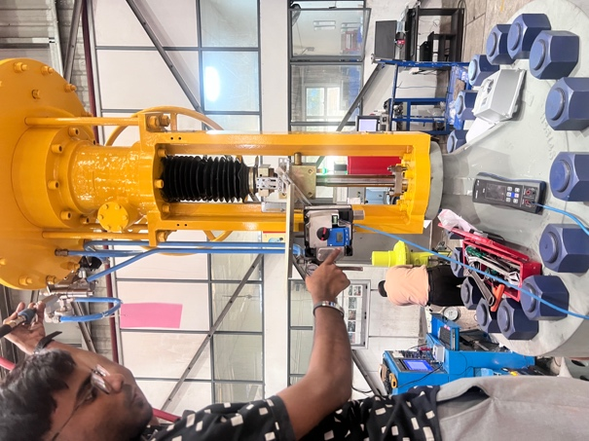 | 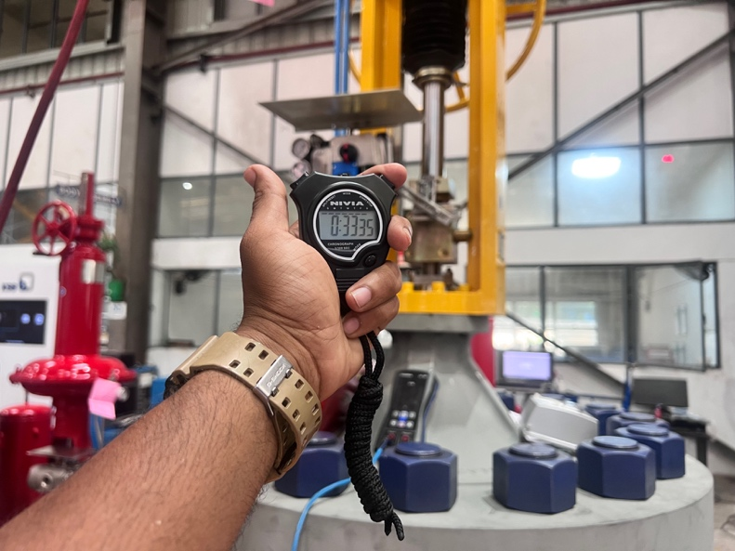
Close time Measurement | Stop Watch (close Time)
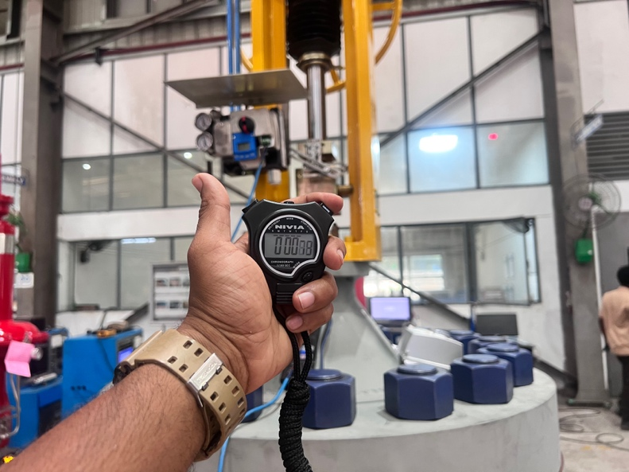 | 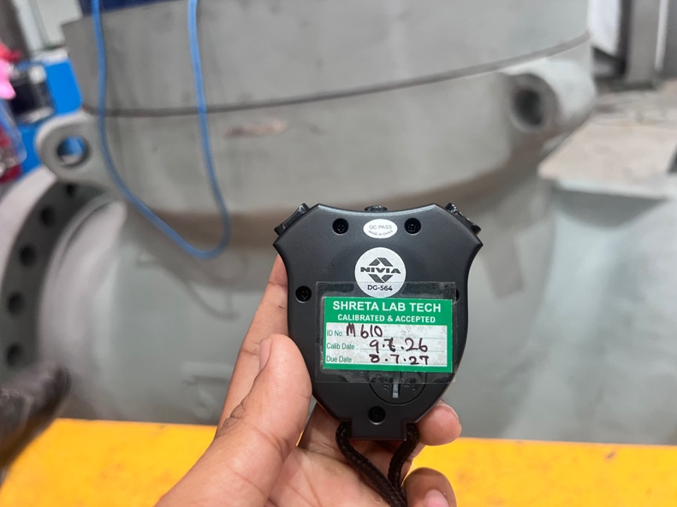
Start Time | Stop Watch
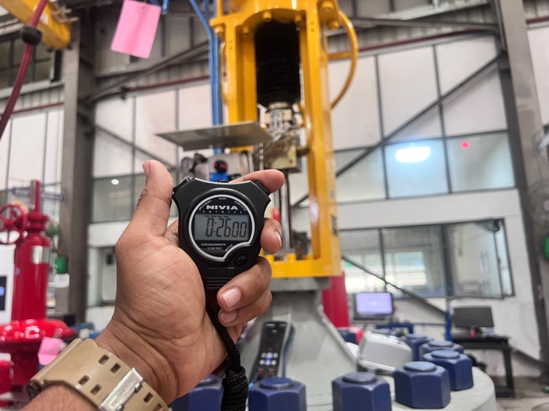 | 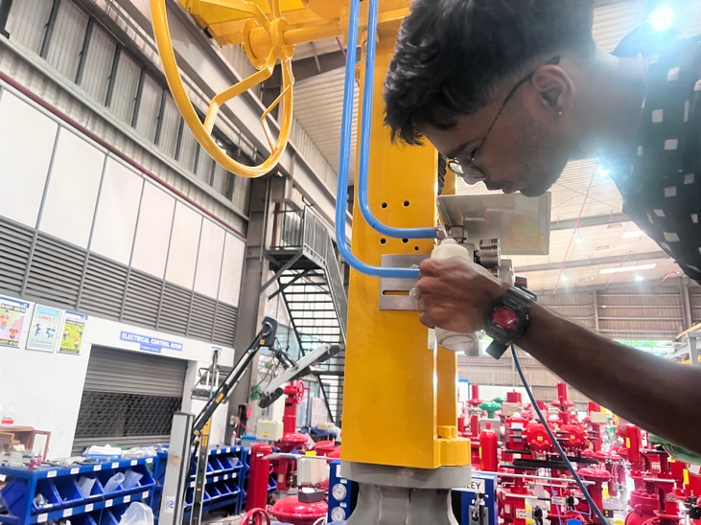
End Time | Leak Test
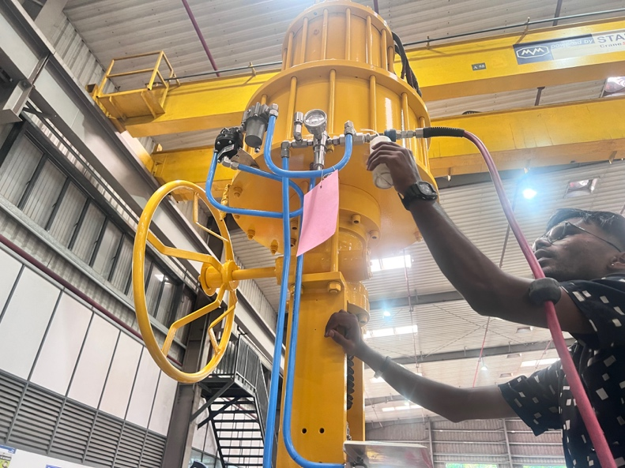 | 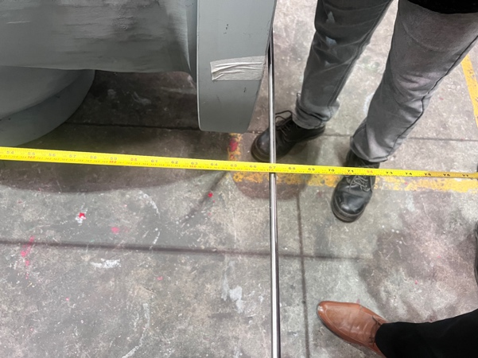
Leak test | Dimension
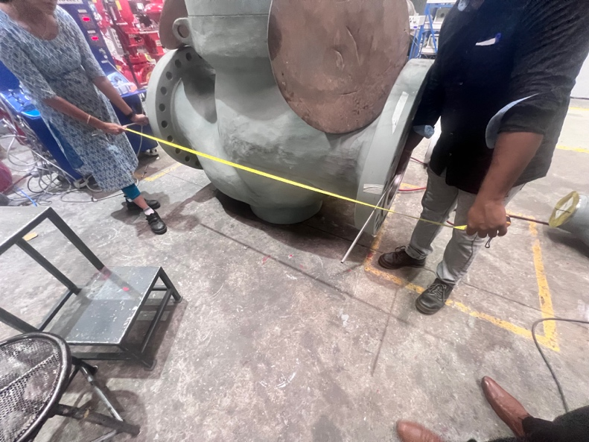
Dimension | Dimension
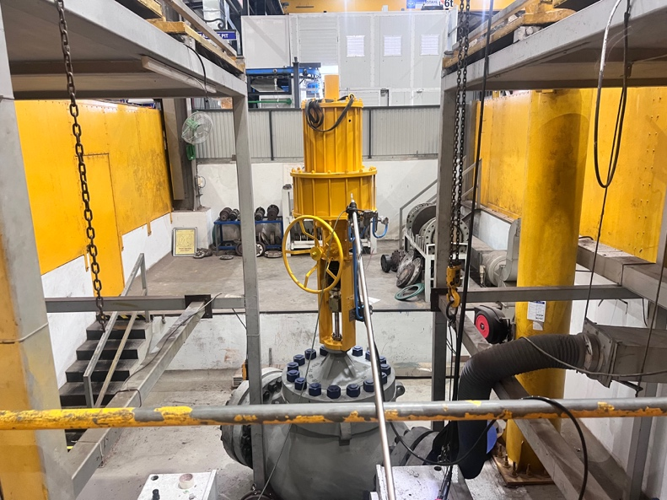 | 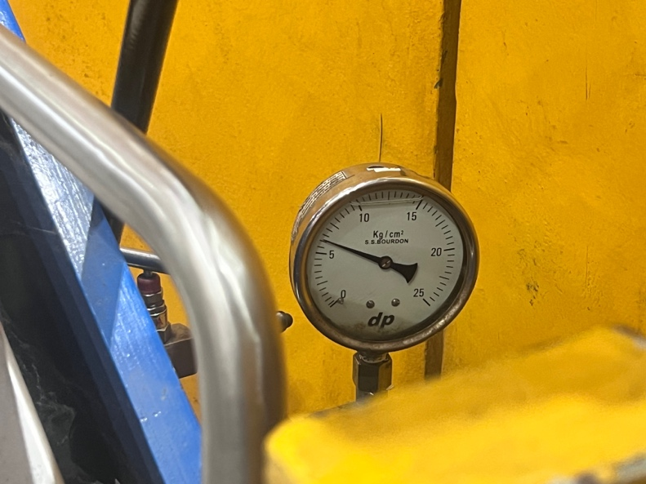
FE Test | FE Test
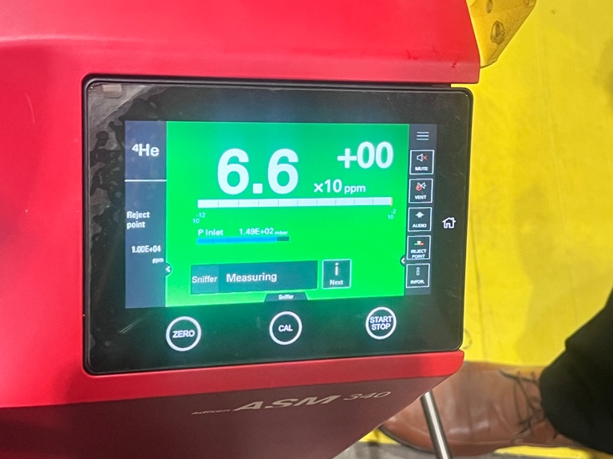 | 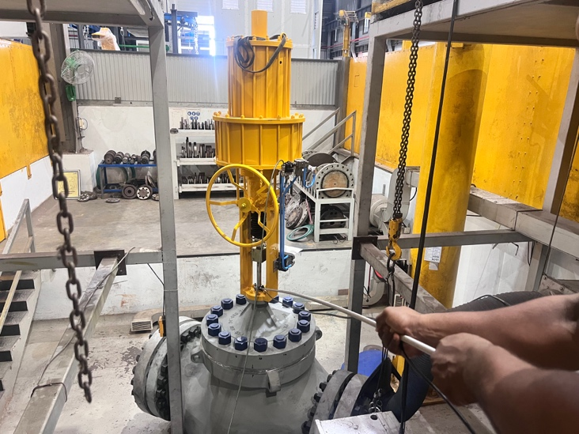
FE Test | FE Test
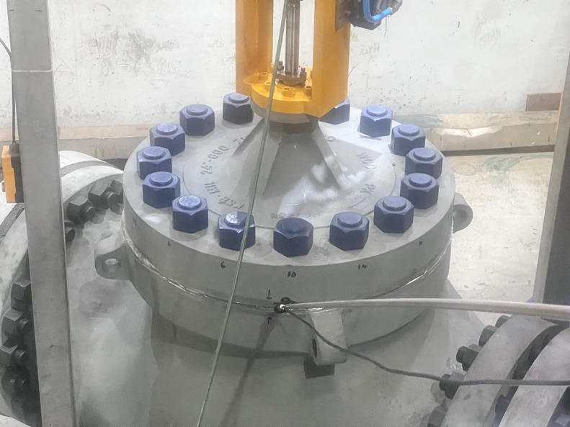 | 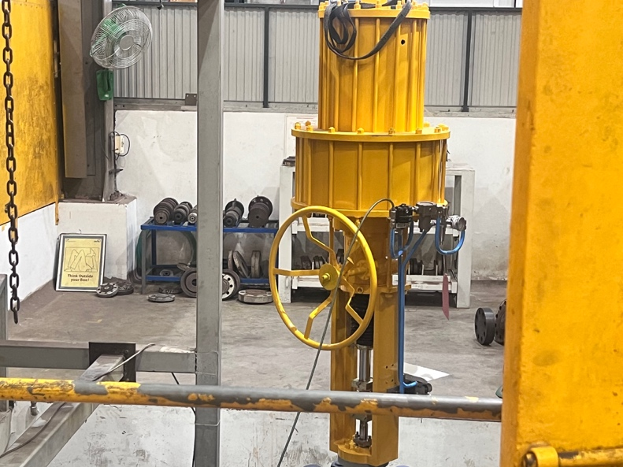
FE Test | FE Test
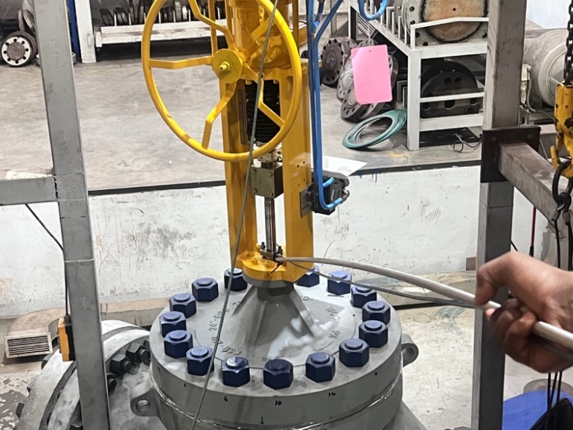 | 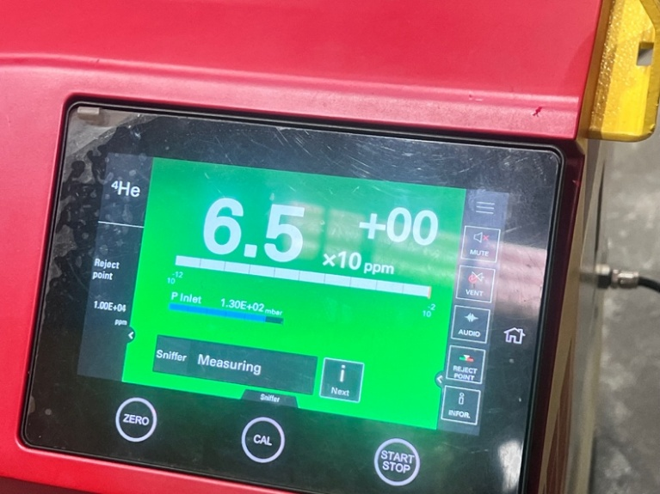
FE Test | FE Test

