**Web Technology**

**Lab Assignment 3**

**Name**-Adarsh Kumar **Rollno**-22CD3003

**T1. Add a CSS rule and appropriate html to style every other line of the unordered list with a light blue background color. Specify the background color using the rgb method.**

● Eswatini

● Ecuador

● Tanzania

● Spain

● Slovakia

● Iraq

**Ans**

**<!DOCTYPE html>**

**<html lang="en">**

**<head>**

**<meta charset="UTF-8">**

**<meta name="viewport" content="width=device-width, initial-scale=1.0">**

**<title>Lab3</title>\**

**<link rel="stylesheet" href="style.css">**

**</head>**

**<body>**

**<ul>**

**<li class="odd">Eswatini</li>**

**<li class="even">Ecuador</li>**

**<li class="odd">Tanzania</li>**

**<li class="even">Spain</li>**

**<li class="odd">Slovakia</li>**

**<li class="even">Iraq</li>**

**</ul>**

**</body>**

**</html>**

**//css code  
.odd{**

**background-color: rgb(89, 248, 248);**

**}**

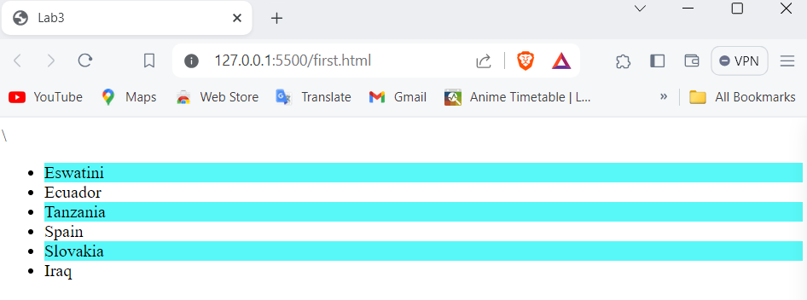

**T2. Given the table in the question style the table so that the odd rows have a light gray background. In addition add a header row to the table and style that row so it has white text and a black background color. Change the font so that they are all 14 point sans serif of some kind.**

**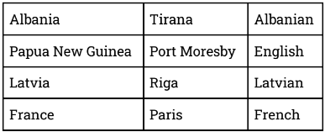  
  
Ans**

**<!DOCTYPE html>**

**<html lang="en">**

**<head>**

**<meta charset="UTF-8">**

**<meta name="viewport" content="width=device-width, initial-scale=1.0">**

**<title>Lab3</title>\**

**<link rel="stylesheet" href="style.css">**

**</head>**

**<body>**

**<table>**

**<thead>**

**<tr>**

**<th>Country</th>**

**<th>Capital</th>**

**<th>Launguage</th>**

**</tr>**

**</thead>**

**<tbody>**

**<tr class="odd">**

**<td>Albania</td>**

**<td>Tirana</td>**

**<td>Albanian</td>**

**</tr>**

**<tr class="even">**

**<td>Papua New Guinea</td>**

**<td>Port Moresby</td>**

**<td>Engilsh</td>**

**</tr>**

**<tr class="odd">**

**<td>Latvia</td>**

**<td>Riga</td>**

**<td>Latvian</td>**

**</tr>**

**<tr class="even">**

**<td>France</td>**

**<td>Paris</td>**

**<td>French</td>**

**</tr>**

**</tbody>**

**</table>**

**</body>**

**</html>**

**//Css code**

**table{**

**font-size: 14px;**

**font-family: sans-serif;**

**}**

**thead{**

**background-color: black;**

**color: white;**

**}**

**.odd{**

**background-color: lightgray;**

**}**

**td{**

**border: 2px solid black;**

**}**

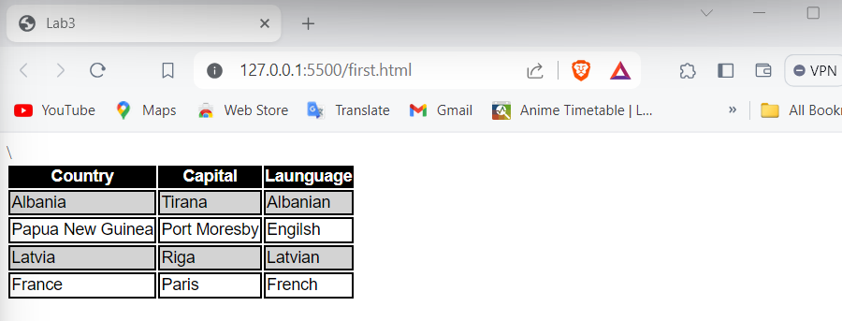

**T3. Suppose you are working on a recipe website. Recipes have a title, a list of ingredients, and an instructions section. Make a webpage that shows the recipe for grilled cheese sandwiches with bacon and tomato. The ingredients should be displayed as an unordered list, with no bullets. Meat ingredients should have a light red background color, vegetables should have a light green background, and dairy products should have a light yellow. The title should be in a sans serif font of your choice, and the instructions should**

**have a heading “Instructions” and the font for the instructions should be italic.**

**Ans**

**<!DOCTYPE html>**

**<html lang="en">**

**<head>**

**<meta charset="UTF-8">**

**<meta name="viewport" content="width=device-width, initial-scale=1.0">**

**<title>Lab3</title>**

**<link rel="stylesheet" href="style.css">**

**</head>**

**<body>**

**<h1 class="title">Recipe: Grilled Cheese Sandwich</h1>**

**<h3>List of Ingredients</h3>**

**<ul>**

**<li class="bread">Bread</li>**

**<li class="dairy">Cheese</li>**

**<li class="meat">Bacon</li>**

**<li class="veggie">Lettuce</li>**

**<li class="meat">Ham</li>**

**<li class="veggie">Onion</li>**

**</ul>**

**<h3>Instructions</h3>**

**<p><i>Lorem, ipsum dolor sit amet consectetur adipisicing elit. Molestiae exercitationem totam, voluptates quos deserunt laudantium optio enim architecto repudiandae, aliquid cupiditate consequatur laboriosam quaerat animi fugit aut recusandae voluptatum maxime.</i></p>**

**</body>**

**</html>**

**//Css code**

**li{**

**list-style: none;**

**}**

**.bread{**

**background-color: rgba(165, 42, 42, 0.6);**

**}**

**.meat{**

**background-color: rgba(255,0,0,0.6);**

**}**

**.veggie{**

**background-color: rgba(0,255,0,0.3);**

**}**

**.dairy{**

**background-color: rgba(255,255, 0, 0.5);**

**}**

**.title{**

**font-family: sans-serif;**

**}**

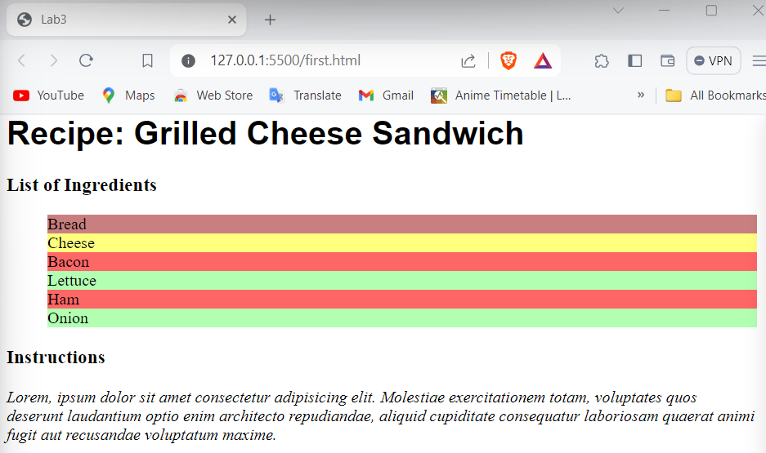

**T4. Using CSS and HTML Make a webpage that has two columns. Each column should use half of the width of the page. The left half should have a light gray background and the right half should have a light green background. The left half should have a list of the 5 best selling books in Amazon’s kindle store, and the right should have a list of your five favorite celebrities or athletes.**

**Ans**

**<!DOCTYPE html>**

**<html lang="en">**

**<head>**

**<meta charset="UTF-8">**

**<meta name="viewport" content="width=device-width, initial-scale=1.0">**

**<title>Lab3</title>**

**<link rel="stylesheet" href="style.css">**

**</head>**

**<body>**

**<div id="cont">**

**<div id="left">**

**<ol>**

**<li>The Teacher: A Psychological Thriller</li>**

**<li>The Women: A Novel</li>**

**<li>Ashes of You</li>**

**<li>The Reason I Married Him</li>**

**<li>The Exception to the Rule</li>**

**</ol>**

**</div>**

**<div id="right">**

**<ol>**

**<li>Sunil Chetri</li>**

**<li>Virat Kohli</li>**

**<li>MS Dhoni</li>**

**<li>Vikrant Messy</li>**

**<li>Ryan Reynold</li>**

**</ol>**

**</div>**

**</div>**

**</body>**

**</html>**

**//Css code**

**#cont{**

**display: flex;**

**margin: none;**

**height: 100vh;**

**}**

**#left{**

**width: 50%;**

**background-color: lightgray;**

**}**

**#right{**

**width: 50%;**

**background-color: lightgreen;**

**}**

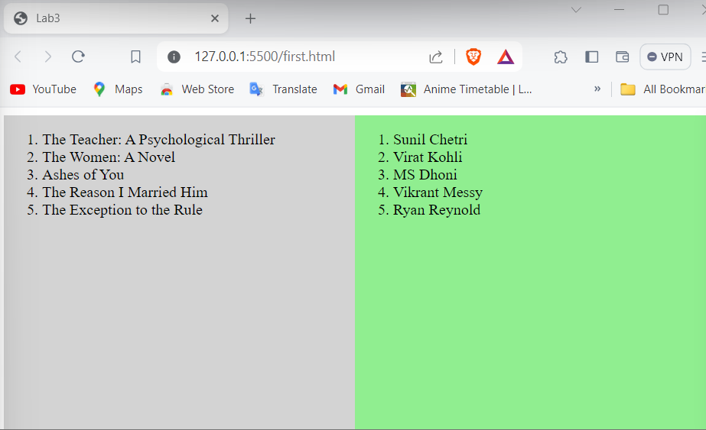

**T5. Using the nav element, make a navbar for at the top of a sample webpage. Add at least three links to the navbar using an unordered list that is displayed as inline rather than block. Make the navbar nava light blue background color, but change the background of the title to a darker blue when the mouse hovers over it.**

**Ans**

**<!DOCTYPE html>**

**<html lang="en">**

**<head>**

**<meta charset="UTF-8">**

**<meta name="viewport" content="width=device-width, initial-scale=1.0">**

**<title>Lab3</title>**

**<link rel="stylesheet" href="style.css">**

**</head>**

**<body>**

**<nav id="navbar">**

**<ul>**

**<li><a href="">Home</a></li>**

**<li><a href="">Contact</a></li>**

**<li><a href="">About Us</a></li>**

**</ul>**

**</nav>**

**</body>**

**</html>**

**//Css code**

**#navbar{**

**display: flex;**

**background-color: lightblue;**

**}**

**li{**

**list-style-type: none;**

**display: inline;**

**}**

**li a{**

**font-size: 20px;**

**text-decoration: none;**

**display: inline-block;**

**padding: 10px;**

**color: black;**

**}**

**li a:hover{**

**background-color: blue;**

**}**

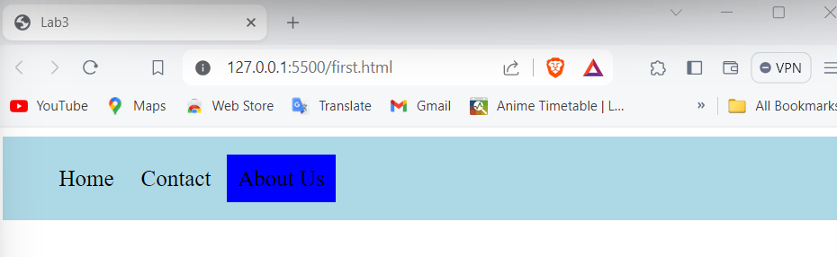

**T6. Using the image of the playing card, use transformations and animations to make the playing card spin around endlessly.**

**Ans**

**<!DOCTYPE html>**

**<html lang="en">**

**<head>**

**<meta charset="UTF-8">**

**<meta name="viewport" content="width=device-width, initial-scale=1.0">**

**<title>Lab3</title>**

**<link rel="stylesheet" href="style.css">**

**</head>**

**<body>**

**<div class="card">**

**</div>**

**</body>**

**</html>**

**//Css code**

**.card{**

**display:flex;**

**background-image: url(ace.png);**

**background-size: contain;**

**width:140px;**

**height:196px;**

**position: fixed;**

**border: 2px solid black;**

**border-radius: 10px;**

**top: 25%;**

**left: 30%;**

**animation-name: rotat;**

**animation-iteration-count: infinite;**

**animation-duration: 1s;**

**animation-timing-function: linear;**

**}**

**@keyframes rotat{**

**from{transform:rotate(0deg)}**

**to {transform:rotate(360deg);}**

**}**

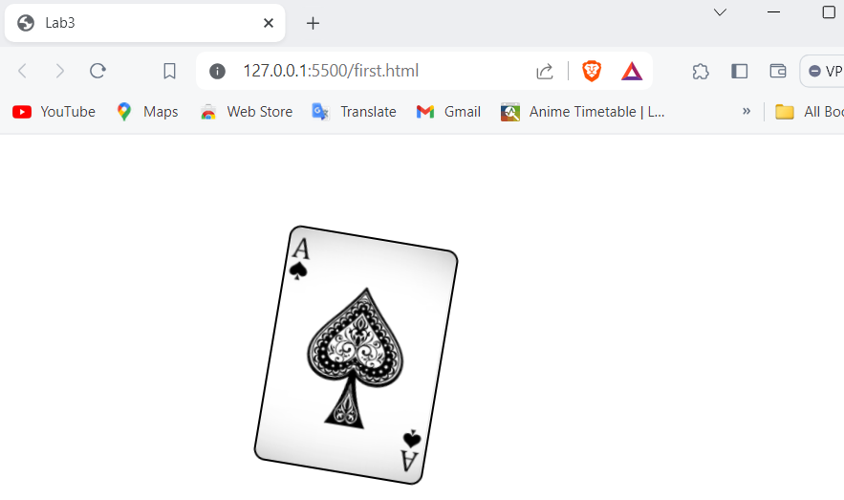

**T7. Develop a homepage for yourself, published on github pages, that employs a two column layout with a fixed navbar (always on screen), and a footer. The navbar should link to at least two additional pages used to describe your hobbies or favorite teams. The CSS for this website should be contained in its own CSS file, and all three pages should use this CSS file.**

**Ans**

**<!DOCTYPE html>**

**<html lang="en">**

**<head>**

**<meta charset="UTF-8">**

**<meta name="viewport" content="width=device-width, initial-scale=1.0">**

**<title>Lab3</title>**

**<link rel="stylesheet" href="style.css">**

**</head>**

**<body>**

**<nav class="navbar">**

**<ul>**

**<li><a href="first.html">Home</a></li>**

**<li><a href="second.html">Hobbies</a></li>**

**<li><a href="third.html">Favorite Teams</a></li>**

**</ul>**

**</nav>**

**<div class="content">**

**<div class="column left">**

**<h2>About Me</h2>**

**<p>Welcome to my homepage!</p>**

**</div>**

**<div class="column right">**

**<h2>Contact Us</h2>**

**<p>418415484184154152</p>**

**</div>**

**</div>**

**<footer>**

**<p>My Homepage.</p>**

**</footer>**

**</body>**

**</html>**

**//second html file  
<!DOCTYPE html>**

**<html lang="en">**

**<head>**

**<meta charset="UTF-8">**

**<meta name="viewport" content="width=device-width, initial-scale=1.0">**

**<title>Document</title>**

**<link rel="stylesheet" href="style.css">**

**</head>**

**<body>**

**<nav class="navbar">**

**<ul>**

**<li><a href="first.html">Home</a></li>**

**<li><a href="second.html">Hobbies</a></li>**

**<li><a href="third.html">Favorite Teams</a></li>**

**</ul>**

**</nav>**

**<div class="content">**

**<div class="column right">**

**<h1>My Hobbies</h1>**

**<p>Lorem ipsum dolor sit amet consectetur adipisicing elit. Ipsum, nisi doloremque? Asperiores labore autem expedita odit quidem aut necessitatibus ea qui nostrum rem, sit corrupti voluptate totam. Mollitia, provident adipisci.</p>**

**</div>**

**</div>**

**</body>**

**</html>**

**//third html file**

**<!DOCTYPE html>**

**<html lang="en">**

**<head>**

**<meta charset="UTF-8">**

**<meta name="viewport" content="width=device-width, initial-scale=1.0">**

**<title>Document</title>**

**<link rel="stylesheet" href="style.css">**

**</head>**

**<body>**

**<nav class="navbar">**

**<ul>**

**<li><a href="first.html">Home</a></li>**

**<li><a href="second.html">Hobbies</a></li>**

**<li><a href="third.html">Favorite Teams</a></li>**

**</ul>**

**</nav>**

**<div class="content">**

**<div class="column left"> <h1>Favourite teams</h1>**

**<ol>**

**<li>cascabscn</li>**

**<li>bcbjsdcjcd</li>**

**<li>bcshdbcj</li>**

**<li>bhcbscjnjcns</li>**

**</ol>**

**</div>**

**</div>**

**</body>**

**</html>**

**//Css code**

**body {**

**font-family: Arial, sans-serif;**

**margin: 0;**

**}**

**.navbar {**

**position: fixed;**

**top: 0;**

**left: 0;**

**width: 100%;**

**height: 10%;**

**background-color: lightblue;**

**}**

**.navbar ul {**

**list-style-type: none;**

**margin: 0;**

**padding: 10;**

**}**

**.navbar ul li {**

**display: inline;**

**margin-right: 20px;**

**font-size: 1.2em;**

**font-weight: 700;**

**}**

**.navbar ul li a {**

**text-decoration: none;**

**color: black;**

**}**

**.content {**

**margin-left:10px;**

**margin-top: 50px;**

**display: flex;**

**}**

**.column {**

**flex: 1;**

**padding: 20px;**

**height: 300px;**

**}**

**.left {**

**background-color: #f2f2f2;**

**}**

**.right {**

**background-color: #e0e0e0;**

**}**

**footer {**

**text-align: center;**

**padding: 10px;**

**background-color: lightgrey;**

**}**

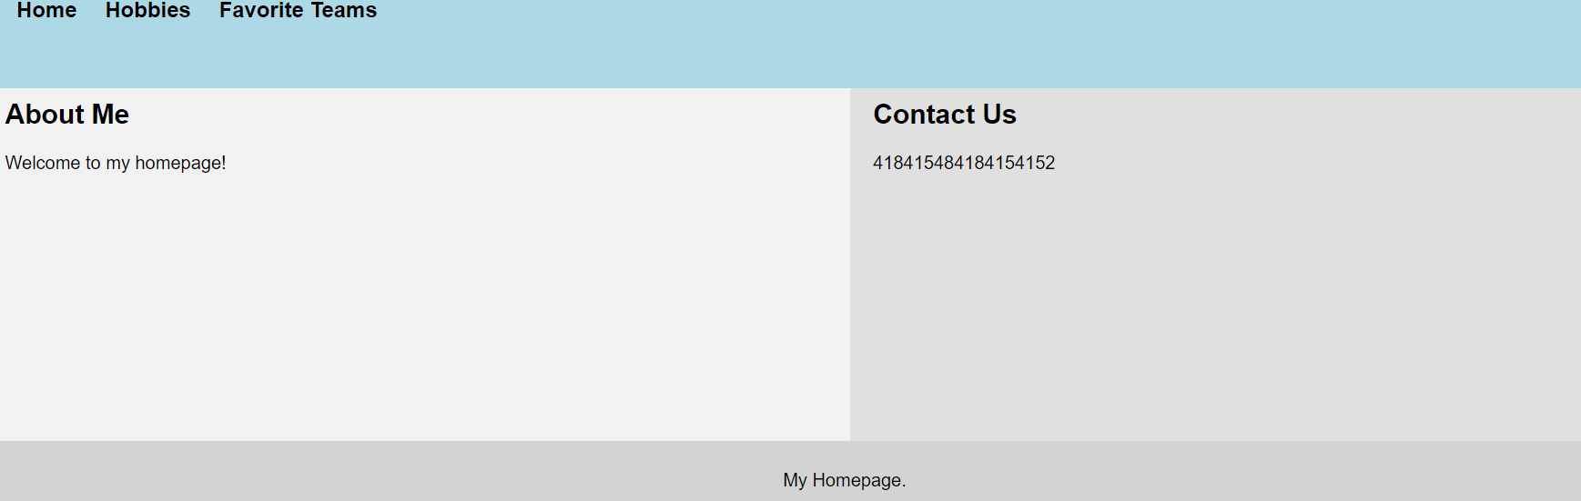

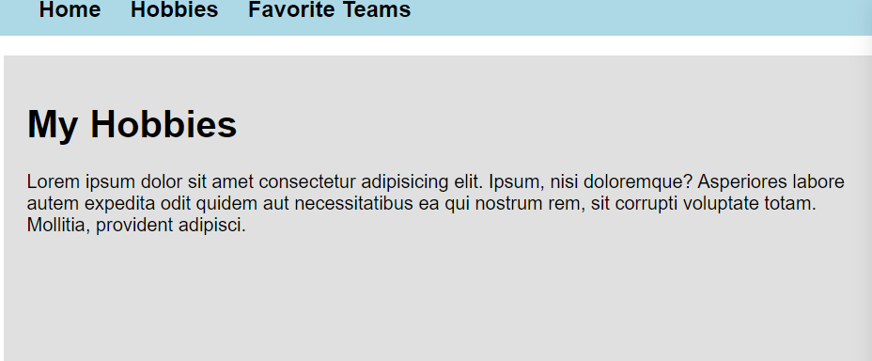

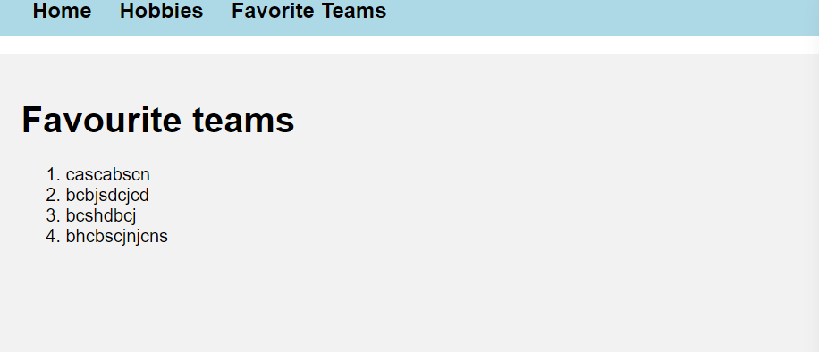

**T8. Modify the final version of the menu project so that the menu is a horizontal menu with the first level of submenus dropping down below the selected item.**

**Ans**

**<!DOCTYPE html>**

**<html lang="en">**

**<head>**

**<meta charset="UTF-8">**

**<meta name="viewport" content="width=device-width, initial-scale=1.0">**

**<title>Lab3</title>**

**<link rel="stylesheet" href="style.css">**

**</head>**

**<body>**

**<h1 class="title">Recipe: Grilled Cheese Sandwich</h1>**

**<div class="menu">**

**<ul>**

**<li><a href="#">Home</a></li>**

**<li>**

**<a href="#">Recipes</a>**

**<div class="submenu">**

**<ul>**

**<li><a href="#">Breakfast</a></li>**

**<li><a href="#">Lunch</a></li>**

**<li><a href="#">Dinner</a></li>**

**</ul>**

**</div>**

**</li>**

**<li><a href="#">About</a></li>**

**<li><a href="#">Contact</a></li>**

**</ul>**

**</div>**

**<h3>List of Ingredients</h3>**

**<ul>**

**<li class="bread">Bread</li>**

**<li class="dairy">Cheese</li>**

**<li class="meat">Bacon</li>**

**<li class="veggie">Lettuce</li>**

**<li class="meat">Ham</li>**

**<li class="veggie">Onion</li>**

**</ul>**

**<h3>Instructions</h3>**

**<p><i>Lorem, ipsum dolor sit amet consectetur adipisicing elit. Molestiae exercitationem totam, voluptates quos deserunt laudantium optio enim architecto repudiandae, aliquid cupiditate consequatur laboriosam quaerat animi fugit aut recusandae voluptatum maxime.</i></p>**

**</div>**

**</body>**

**</html>**

**//Css code**

**li{**

**list-style: none;**

**}**

**.bread{**

**background-color: rgba(165, 42, 42, 0.6);**

**}**

**.meat{**

**background-color: rgba(255,0,0,0.6);**

**}**

**.veggie{**

**background-color: rgba(0,255,0,0.3);**

**}**

**.dairy{**

**background-color: rgba(255,255, 0, 0.5);**

**}**

**.title{**

**font-family: sans-serif;**

**}**

**.recipe{**

**max-width: 600px;**

**margin: 20px auto;**

**padding: 0 20px;**

**}**

**.recipe h2{**

**margin-top: 20px;**

**}**

**.recipe ul{**

**list-style-type: none;**

**padding: 0;**

**}**

**.recipe ul li{**

**margin-bottom: 10px;**

**}**

**.menu{**

**list-style-type: none;**

**padding: 0;**

**margin: 0;**

**height: 40px;**

**background-color: lightgray;**

**}**

**.menu ul li{**

**display: inline-block;**

**position: relative;**

**margin-right: 20px;**

**}**

**.submenu{**

**display: none;**

**position: absolute;**

**background-color: grey;**

**padding: 10px;**

**min-width: 160px;**

**z-index: 1;**

**}**

**a{**

**color: black;**

**text-decoration: none;**

**}**

**.submenu ul li{**

**color: black;**

**display: block;**

**}**

**.menu ul li:hover {**

**background-color: grey;**

**}**

**.menu ul li:hover .submenu{display:flex;}**

