**LAB-7**

**Web Technology**

**T1. Develop prototype 3 continuing with the last lab. Confirm that the app now remembers your list even after a page refresh.**

<!DOCTYPE html>

<html lang="en">

<head>

<meta charset="UTF-8">

<meta name="viewport" content="width=device-width, initial-scale=1.0">

<title>Shopping List</title>

<style>

body {

font-family: Arial, sans-serif;

margin: 20px;

}

h1 {

color: #333;

}

form {

margin-bottom: 20px;

}

label {

display: block;

margin-bottom: 5px;

}

input, select {

margin-bottom: 10px;

padding: 8px;

width: 100%;

}

button {

padding: 10px;

background-color: #4CAF50;

color: white;

border: none;

cursor: pointer;

}

table {

width: 100%;

border-collapse: collapse;

margin-top: 20px;

}

th, td {

border: 1px solid #ddd;

padding: 12px;

text-align: left;

}

</style>

</head>

<body>

<h1>Shopping List</h1>

<form id="itemForm">

<label for="itemName">Item Name:</label>

<input type="text" id="itemName" placeholder="Enter item name">

<label for="itemQuantity">Quantity:</label>

<input type="number" id="itemQuantity" placeholder="1" value="1">

<label for="itemPriority">Priority:</label>

<select id="itemPriority">

<option value="low">Low</option>

<option value="medium">Medium</option>

<option value="high">High</option>

</select>

<label for="storeName">Store Name:</label>

<input type="text" id="storeName" placeholder="Enter store name">

<label for="storeSection">Store Section:</label>

<input type="text" id="storeSection" placeholder="Enter store section">

<label for="itemPrice">Price:</label>

<input type="number" id="itemPrice" placeholder="Enter price">

<button type="button" onclick="addItem()">Add Item</button>

</form>

<table id="itemList">

<thead>

<tr>

<th>Item</th>

<th>Quantity</th>

<th>Store</th>

<th>Section</th>

<th>Price</th>

</tr>

</thead>

<tbody>

<!-- Table content will go here -->

</tbody>

</table>

<script>

function addItem() {

var itemName = document.getElementById("itemName").value;

var itemQuantity = document.getElementById("itemQuantity").value;

var itemPriority = document.getElementById("itemPriority").value;

var storeName = document.getElementById("storeName").value;

var storeSection = document.getElementById("storeSection").value;

var itemPrice = document.getElementById("itemPrice").value;

saveItemToLocalStorage(itemName, itemQuantity, itemPriority, storeName, storeSection, itemPrice);

addRowToTable(itemName, itemQuantity, storeName, storeSection, itemPrice);

}

function saveItemToLocalStorage(name, quantity, priority, store, section, price) {

var items = JSON.parse(localStorage.getItem('shoppingList')) || [];

items.push({

name: name,

quantity: quantity,

priority: priority,

store: store,

section: section,

price: price

});

localStorage.setItem('shoppingList', JSON.stringify(items));

}

function addRowToTable(name, quantity, store, section, price) {

var table = document.getElementById("itemList").getElementsByTagName('tbody')[0];

var newRow = table.insertRow(table.rows.length);

var cell1 = newRow.insertCell(0);

var cell2 = newRow.insertCell(1);

var cell3 = newRow.insertCell(2);

var cell4 = newRow.insertCell(3);

var cell5 = newRow.insertCell(4);

cell1.innerHTML = name;

cell2.innerHTML = quantity;

cell3.innerHTML = store;

cell4.innerHTML = section;

cell5.innerHTML = price;

}

window.onload = function () {

var storedItems = JSON.parse(localStorage.getItem('shoppingList')) || [];

for (var i = 0; i < storedItems.length; i++) {

addRowToTable(storedItems[i].name, storedItems[i].quantity, storedItems[i].store, storedItems[i].section, storedItems[i].price);

}

};

</script>

</body>

</html>

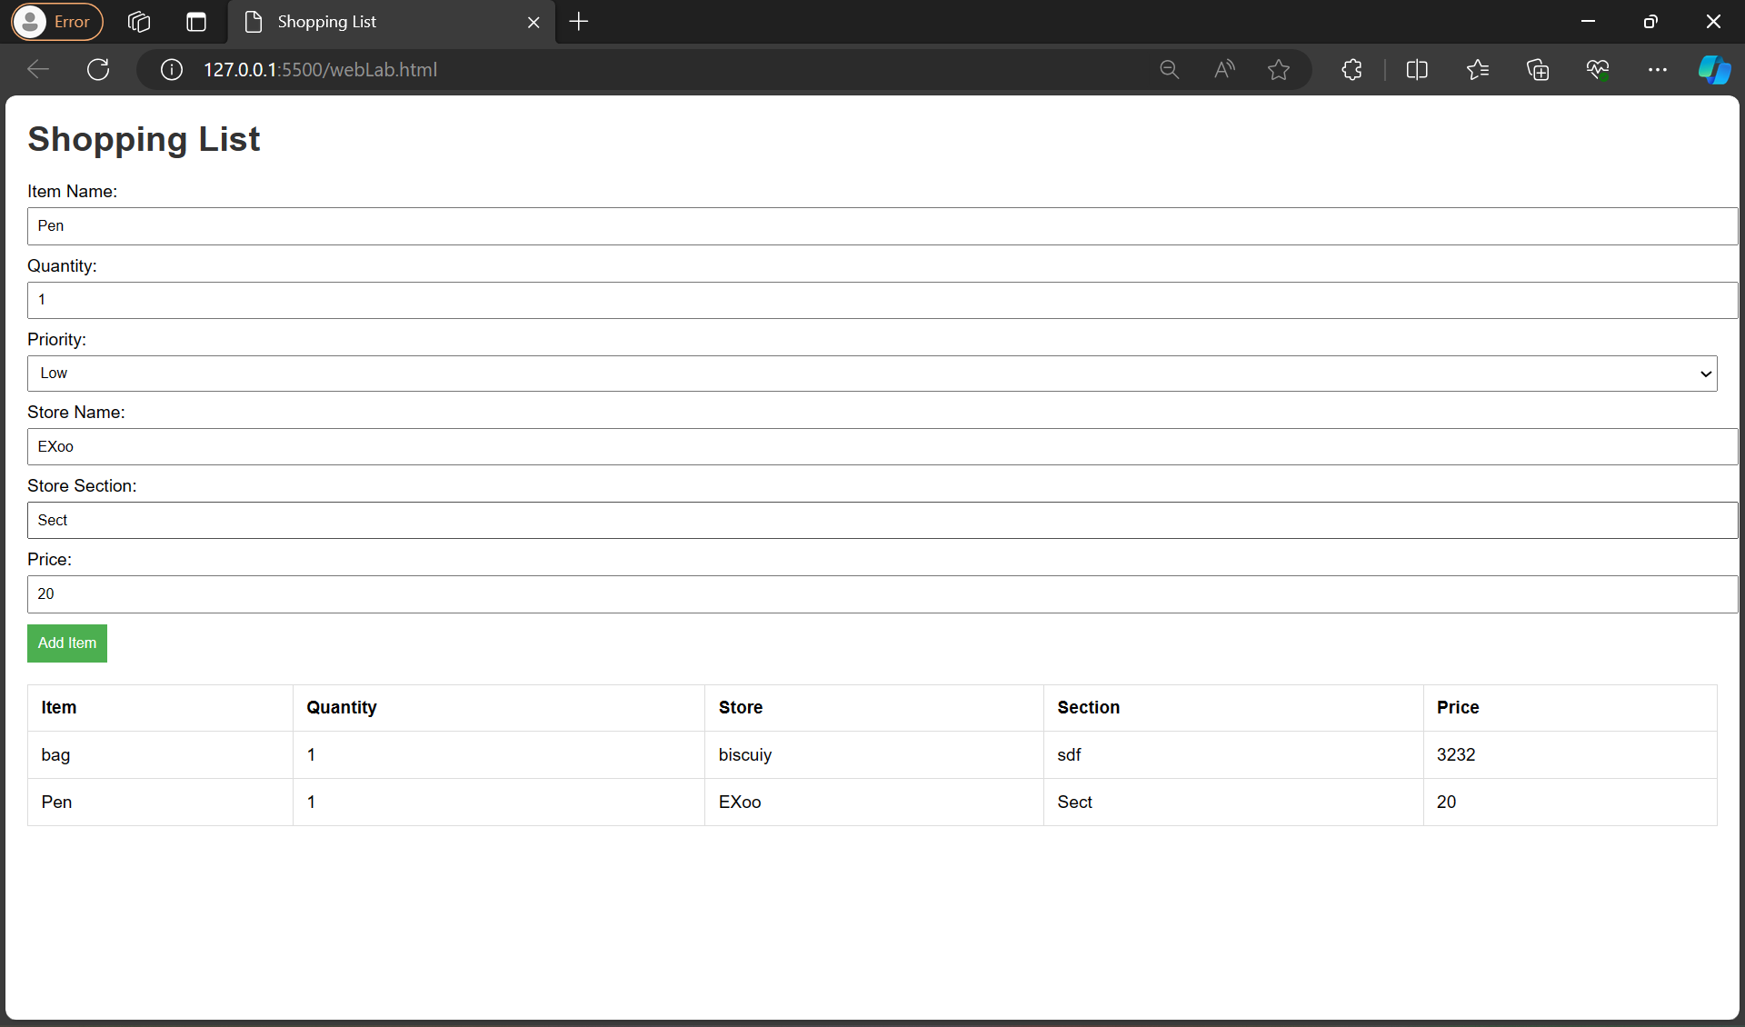

**T2. Create a local storage that saves the number of times you have accessed the page and displays it.**

<!DOCTYPE html>

<html lang="en">

<head>

<meta charset="UTF-8">

<meta name="viewport" content="width=device-width, initial-scale=1.0">

<title>Shopping List</title>

<style>

body {

font-family: Arial, sans-serif;

margin: 20px;

}

h1 {

color: #333;

}

form {

margin-bottom: 20px;

}

label {

display: block;

margin-bottom: 5px;

}

input, select {

margin-bottom: 10px;

padding: 8px;

width: 100%;

}

button {

padding: 10px;

background-color: #4CAF50;

color: white;

border: none;

cursor: pointer;

}

table {

width: 100%;

border-collapse: collapse;

margin-top: 20px;

}

th, td {

border: 1px solid #ddd;

padding: 12px;

text-align: left;

}

</style>

</head>

<body>

<h1>Shopping List</h1>

<form id="itemForm">

<label for="itemName">Item Name:</label>

<input type="text" id="itemName" placeholder="Enter item name">

<label for="itemQuantity">Quantity:</label>

<input type="number" id="itemQuantity" placeholder="1" value="1">

<label for="itemPriority">Priority:</label>

<select id="itemPriority">

<option value="low">Low</option>

<option value="medium">Medium</option>

<option value="high">High</option>

</select>

<label for="storeName">Store Name:</label>

<input type="text" id="storeName" placeholder="Enter store name">

<label for="storeSection">Store Section:</label>

<input type="text" id="storeSection" placeholder="Enter store section">

<label for="itemPrice">Price:</label>

<input type="number" id="itemPrice" placeholder="Enter price">

<button type="button" onclick="addItem()">Add Item</button>

</form>

<table id="itemList">

<thead>

<tr>

<th>Item</th>

<th>Quantity</th>

<th>Store</th>

<th>Section</th>

<th>Price</th>

</tr>

</thead>

<tbody>

<!-- Table content will go here -->

</tbody>

</table>

<p id="accessCounter">Number of times accessed: 0</p>

<script>

function addItem() {

var itemName = document.getElementById("itemName").value;

var itemQuantity = document.getElementById("itemQuantity").value;

var itemPriority = document.getElementById("itemPriority").value;

var storeName = document.getElementById("storeName").value;

var storeSection = document.getElementById("storeSection").value;

var itemPrice = document.getElementById("itemPrice").value;

saveItemToLocalStorage(itemName, itemQuantity, itemPriority, storeName, storeSection, itemPrice);

addRowToTable(itemName, itemQuantity, storeName, storeSection, itemPrice);

updateAccessCounter();

}

function saveItemToLocalStorage(name, quantity, priority, store, section, price) {

var items = JSON.parse(localStorage.getItem('shoppingList')) || [];

items.push({

name: name,

quantity: quantity,

priority: priority,

store: store,

section: section,

price: price

});

localStorage.setItem('shoppingList', JSON.stringify(items));

}

function addRowToTable(name, quantity, store, section, price) {

var table = document.getElementById("itemList").getElementsByTagName('tbody')[0];

var newRow = table.insertRow(table.rows.length);

var cell1 = newRow.insertCell(0);

var cell2 = newRow.insertCell(1);

var cell3 = newRow.insertCell(2);

var cell4 = newRow.insertCell(3);

var cell5 = newRow.insertCell(4);

cell1.innerHTML = name;

cell2.innerHTML = quantity;

cell3.innerHTML = store;

cell4.innerHTML = section;

cell5.innerHTML = price;

}

function updateAccessCounter() {

var accessCount = localStorage.getItem('accessCount') || 0;

accessCount++;

localStorage.setItem('accessCount', accessCount);

document.getElementById('accessCounter').innerText = 'Number of times accessed: ' + accessCount;

}

window.onload = function () {

var storedItems = JSON.parse(localStorage.getItem('shoppingList')) || [];

for (var i = 0; i < storedItems.length; i++) {

addRowToTable(storedItems[i].name, storedItems[i].quantity, storedItems[i].store, storedItems[i].section, storedItems[i].price);

}

updateAccessCounter();

};

</script>

</body>

</html>

