VISVESVARAYA TECHNOLOGICAL UNIVERSITY
“JnanaSangama”, Belgaum -590014, Karnataka.



LAB REPORT
on

OPERATING SYSTEMS

Submitted by
ADARSH A LADWA

in partial fulfillment for the award of the degree of
BACHELOR OF ENGINEERING
in
COMPUTER SCIENCE AND ENGINEERING


B.M.S. COLLEGE OF ENGINEERING
(Autonomous Institution under VTU)
BENGALURU-560019
Feb-2026 to June-2026

B. M. S. College of Engineering,
Bull Temple Road, Bangalore 560019
(Affiliated To Visvesvaraya Technological University, Belgaum)
Department of Computer Science and Engineering

CERTIFICATE

This is to certify that the Lab work entitled “OPERATING SYSTEMS – 23CS4PCOPS” carried out by ADARSH A LADWA (1BM24CS014), who is Bonafide student of B. M. S. College of Engineering. It is in partial fulfilment for the award of Bachelor of Engineering in Computer Science and Engineering of the Visvesvaraya Technological University, Belgaum during the year Feb-2026 to June-2026.
The Lab report has been approved as it satisfies the academic requirements in respect of a OPERATING SYSTEMS - (23CS4PCOPS) work prescribed for the said degree.

SEEMA PATIL Dr. Kavitha Sooda
Assistant Professor Professor and Head
Department of CSE Department of CSE
BMSCE, Bengaluru BMSCE, Bengaluru

Index Sheet
Sl.  No. | Experiment Title | Page No.
1a. | Write a C program to simulate the following non-pre-emptive CPU scheduling algorithm to find turnaround time and waiting time.  →FCFS  → SJF (pre-emptive & Non-preemptive)
1b. | Write a C program to simulate the following CPU scheduling algorithm to find turnaround time and waiting time.  → Priority (pre-emptive & Non-pre-emptive)  →Round Robin (Experiment with different quantum sizes for RR algorithm)
2. | Write a C program to simulate multi-level queue scheduling algorithm considering the following scenario. All the processes in the system are divided into two categories – system processes and user processes. System processes are to be given higher priority than user processes. Use FCFS scheduling for the processes in each queue.
3. | Write a C program to simulate Real-Time CPU Scheduling algorithms:  - Rate- Monotonic  - Earliest-deadline First  - Proportional scheduling
4. | Write a C program to simulate producer-consumer problem using semaphores  Write a C program to simulate the concept of Dining Philosophers problem
5. | Write a C program to simulate Bankers algorithm and deadlock avoidance.
6. | Write a C program to simulate Memory Allocation
7. | Write a C program to simulate Page Replacement

Course Outcomes
C01 | Apply the different concepts and functionalities of Operating System
C02 | Analyse various Operating system strategies and techniques
C03 | Demonstrate the different functionalities of Operating System.
C04 | Conduct practical experiments to implement the functionalities of Operating system.

Program1a
Question: Write a C program to simulate the following non-pre-emptive CPU scheduling algorithm to find turnaround time and waiting time.
- FCFS
- SJF (pre-emptive & Non-preemptive)

Soln: =>FCFS

#include <stdio.h>
#include <stdlib.h>

struct process {
int id, at, bt, ct, tat, wt, rt;
};

int main() {
int n;
printf("Enter the number of processes: ");
scanf("%d", &n);

struct process p[n];
for (int i = 0; i < n; i++) {
p[i].id = i + 1;
printf("Enter Arrival Time for P%d: ", p[i].id);
scanf("%d", &p[i].at);
printf("Enter Burst Time for P%d: ", p[i].id);
scanf("%d", &p[i].bt);
}
for (int i = 0; i < n; i++) {
for (int j = 0; j < n - i - 1; j++) {
if (p[j].at > p[j + 1].at) {
struct process temp = p[j];
p[j] = p[j + 1];
p[j + 1] = temp;
}
}
}
int timepassed = 0, sumtat = 0, sumwt = 0, sumrt = 0;
for (int i = 0; i < n; i++) {
if (timepassed < p[i].at) {
timepassed = p[i].at;
}
p[i].ct = timepassed + p[i].bt;
p[i].tat = p[i].ct - p[i].at;
p[i].wt = p[i].tat - p[i].bt;

timepassed += p[i].bt;

sumtat += p[i].tat;
sumwt += p[i].wt;

}
printf("\nID\tAT\tBT\tCT\tTAT\tWT\tRT\n");
for (int i = 0; i < n; i++) {
printf("%d\t%d\t%d\t%d\t%d\t%d\n",
p[i].id, p[i].at, p[i].bt, p[i].ct,
p[i].tat, p[i].wt);
}
printf("\nAverage TAT: %.2f\n", (float)sumtat / n);
printf("Average WT: %.2f\n", (float)sumwt / n);

return 0;
}

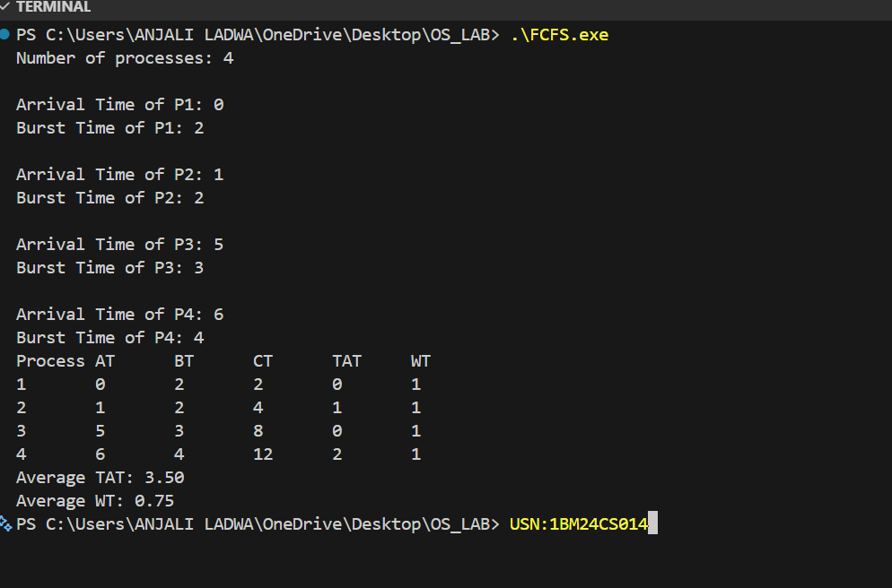

SOLN: =>SJF(Preemptive)
#include<stdio.h>

struct process {
int id, at, bt, ct, tat, wt, rt, rem;
};

int main() {
int n;
printf("Enter the number of processes: ");
scanf("%d", &n);

struct process p[n];
for (int i = 0; i < n; i++) {
p[i].id = i + 1;
printf("Enter Arrival Time for P%d: ", p[i].id);
scanf("%d", &p[i].at);
printf("Enter Burst Time for P%d: ", p[i].id);
scanf("%d", &p[i].bt);
p[i].rem = p[i].bt;
p[i].rt = -1;
}

int completed = 0, time = 0, sumtat = 0, sumwt = 0, sumrt = 0;
while (completed != n) {
int idx = -1, minrem = 1e9;
for (int i = 0; i < n; i++) {
if (p[i].at <= time && p[i].rem > 0) {
if (p[i].rem < minrem ||(p[i].rem==minrem&&p[i].at<p[idx].at)) {
minrem = p[i].rem;
idx = i;
}
}
}
if (idx == -1) {
time++;
continue;
}
if (p[idx].rt == -1) {
p[idx].rt = time - p[idx].at;
sumrt += p[idx].rt;
}
p[idx].rem--;
time++;
if (p[idx].rem == 0) {
completed++;
p[idx].ct = time;
p[idx].tat = p[idx].ct - p[idx].at;
p[idx].wt = p[idx].tat - p[idx].bt;
sumtat += p[idx].tat;
sumwt += p[idx].wt;
}
}

printf("\nID\tAT\tBT\tCT\tTAT\tWT\n");
for (int i = 0; i < n; i++) {
printf("%d\t%d\t%d\t%d\t%d\t%d\n",
p[i].id, p[i].at, p[i].bt, p[i].ct,
p[i].tat, p[i].wt);
}

printf("\nAverage TAT: %.2f\n", (float)sumtat / n);
printf("Average WT: %.2f\n", (float)sumwt / n);
return 0;
}

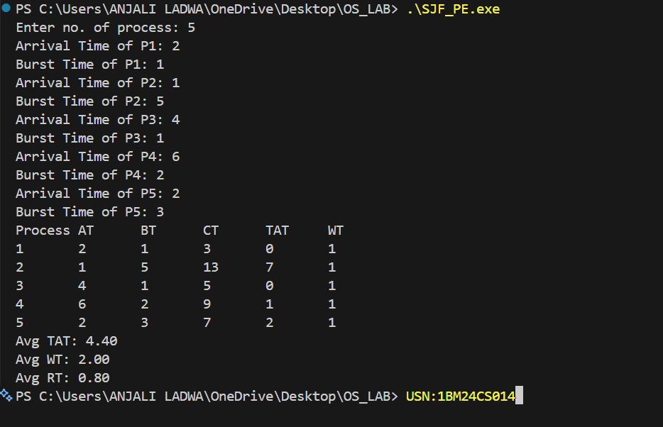

SOLN: => SJF Non preemptive

#include<stdio.h>
struct process{
int id,at,bt,ct,tat,wt,rt;
};

int main() {
int n;
printf("Enter the number of processes: ");
scanf("%d", &n);

struct process p[n];
for (int i = 0; i < n; i++){
p[i].id = i + 1;
printf("Enter Arrival Time for P%d: ", p[i].id);
scanf("%d", &p[i].at);
printf("Enter Burst Time for P%d: ", p[i].id);
scanf("%d", &p[i].bt);
}

int completed=0,time=0,sumtat=0,sumwt=0;
int iscompleted[n];
for(int i=0;i<n;i++) iscompleted[i]=0;

while(completed!=n){
int index=-1;
int minbt=1e9;
for(int i=0;i<n;i++){
if(p[i].at<=time && !iscompleted[i]){
if(p[i].bt<minbt){
minbt=p[i].bt;
index=i;
}
}
}
if(index!=-1){
p[index].ct=time+p[index].bt;
p[index].tat=p[index].ct-p[index].at;
p[index].wt=p[index].tat-p[index].bt;
p[index].rt=p[index].wt;
sumtat+=p[index].tat;
sumwt+=p[index].wt;
time=p[index].ct;
iscompleted[index]=1;
completed++;
} else {
time++;
}
}

printf("\nID\tAT\tBT\tCT\tTAT\tWT\n");
for(int i=0;i<n;i++){
printf("%d\t%d\t%d\t%d\t%d\t%d\n",p[i].id,p[i].at,p[i].bt,p[i].ct,p[i].tat,p[i].wt);
}

printf("\nAverage TAT: %.2f", (float)sumtat/n);
printf("\nAverage WT: %.2f", (float)sumwt/n);
}

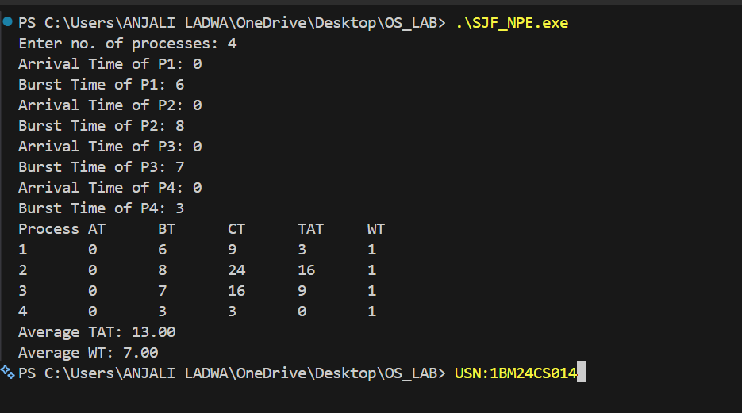

PROGRAM 1b

Question : Write a C program to simulate the following CPU scheduling algorithm to find turnaround time and waiting time.
→ Priority (pre-emptive & Non-pre-emptive)
→Round Robin (Experiment with different quantum sizes for RR algorithm)

SOLN: Priority Pre-emptive

#include <stdio.h>

struct process {
int pid, at, bt, p, rt, ct, wt, tat;
};

int main() {
int n, time = 0, completed = 0;
printf("Enter the number of processes: ");
scanf("%d", &n);
struct process p[n];

for (int i = 0; i < n; i++) {
p[i].pid = i + 1;
printf("Enter the arrival time, burst time, priority: ");
scanf("%d%d%d", &p[i].at, &p[i].bt, &p[i].p);
p[i].rt = p[i].bt;
}

while (completed < n) {
int idx = -1, highest = 9999;
for (int i = 0; i < n; i++) {
if (p[i].at <= time && p[i].rt > 0) {
if (p[i].p < highest) {
highest = p[i].p;
idx = i;
}
}
}
if (idx != -1) {
p[idx].rt--;
time++;
if (p[idx].rt == 0) {
completed++;
p[idx].ct = time;
p[idx].tat = p[idx].ct - p[idx].at;
p[idx].wt = p[idx].tat - p[idx].bt;
}
} else {
time++;
}
}

float totalwt = 0, totaltat = 0;
printf("\nPid\tAt\tBt\tP\tCt\tTat\tWt\n");
for (int i = 0; i < n; i++) {
totalwt += p[i].wt;
totaltat += p[i].tat;
printf("%d\t%d\t%d\t%d\t%d\t%d\t%d\n",
p[i].pid, p[i].at, p[i].bt, p[i].p,
p[i].ct, p[i].tat, p[i].wt);
}

printf("\nAverage waiting time : %.2f", totalwt / n);
printf("\nAverage turnaround time : %.2f\n", totaltat / n);

return 0;
}

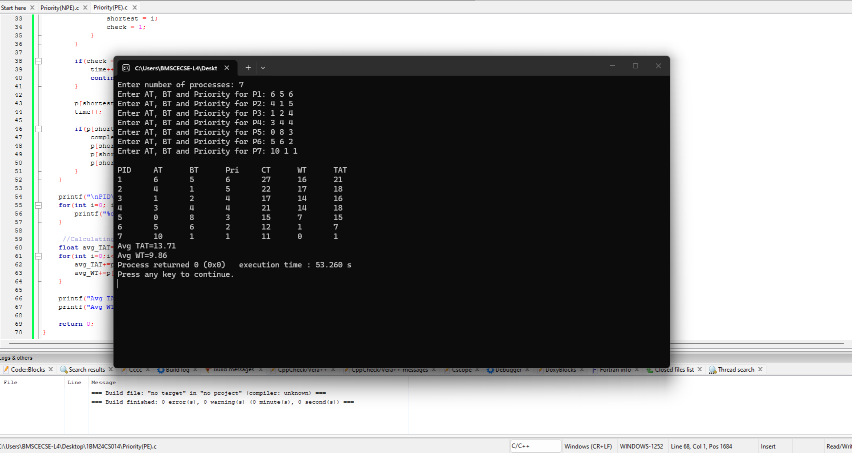

SOLN : Non premetive

#include <stdio.h>

struct process {
int id, at, bt, pr, ct, tat, wt, d;
};

int main() {
int n, t = 0, c = 0, h;
float tw = 0, tt = 0;

printf("Enter number of processes: ");
scanf("%d", &n);

struct process p[n];

for (int i = 0; i < n; i++) {
p[i].id = i + 1;
printf("Process %d\n", p[i].id);
printf("Arrival time: ");
scanf("%d", &p[i].at);
printf("Burst time: ");
scanf("%d", &p[i].bt);
printf("Priority: ");
scanf("%d", &p[i].pr);
p[i].d = 0;
}

while (c != n) {
h = -1;
for (int i = 0; i < n; i++) {
if (p[i].at <= t && p[i].d == 0) {
if (h == -1 || p[i].pr < p[h].pr) {
h = i;
}
}
}

if (h == -1) {
t++;
} else {
t += p[h].bt;
p[h].ct = t;
p[h].tat = p[h].ct - p[h].at;
p[h].wt = p[h].tat - p[h].bt;
tw += p[h].wt;
tt += p[h].tat;
p[h].d = 1;
c++;
}
}

printf("\nProcess\tAT\tBT\tPR\tCT\tTAT\tWT\n");
for (int i = 0; i < n; i++) {
printf("%d\t%d\t%d\t%d\t%d\t%d\t%d\n",
p[i].id, p[i].at, p[i].bt, p[i].pr,
p[i].ct, p[i].tat, p[i].wt);
}

printf("\nAverage Turnaround Time: %.2f", tt / n);
printf("\nAverage Waiting Time: %.2f\n", tw / n);

return 0;
}

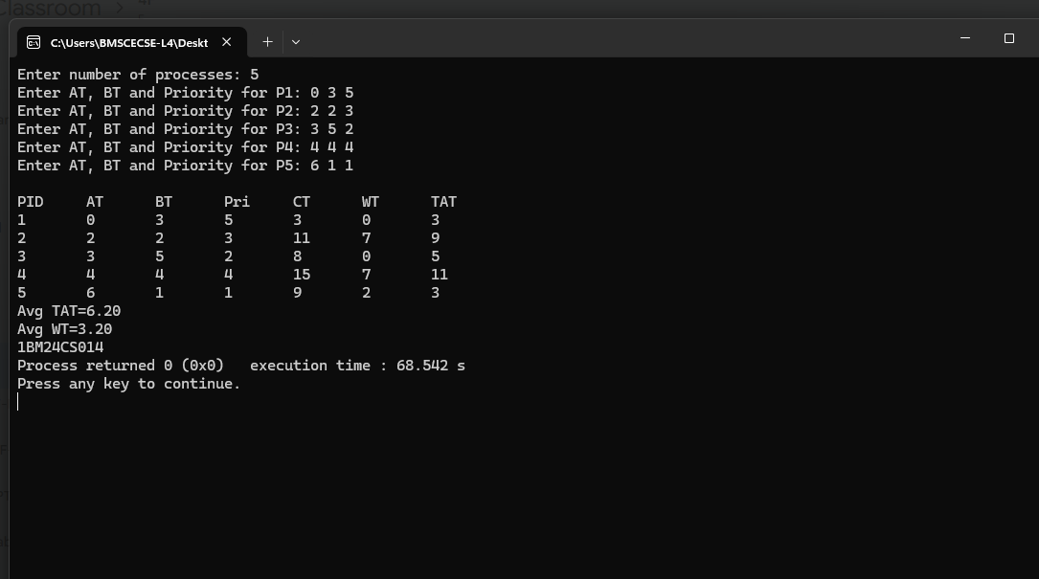

SOLN : Round Robin

#include <stdio.h>

struct Process {
int pid, at, bt, ct, tat, wt, rt;
};

int main() {
int n, tq;
printf("Enter number of processes: ");
scanf("%d", &n);

printf("Enter Time Quantum: ");
scanf("%d", &tq);

struct Process p[n];
int rem_bt[n];
int readyQ[100];
int front = 0, rear = 0;

printf("Enter arrival times:\n");
for(int i=0; i<n; i++) {
scanf("%d", &p[i].at);
p[i].pid = i+1;
}

printf("Enter burst times:\n");
for(int i=0; i<n; i++) {
scanf("%d", &p[i].bt);
rem_bt[i] = p[i].bt;
p[i].rt = p[i].bt;
p[i].ct = p[i].tat = p[i].wt = 0;
}

int time = 0, completed = 0;
int visited[n];
for(int i=0; i<n; i++) visited[i] = 0;

for(int i=0; i<n; i++) {
if(p[i].at == 0) {
readyQ[rear++] = i;
visited[i] = 1;
}
}

while(completed < n) {
if(front == rear) {
time++;
for(int i=0; i<n; i++) {
if(!visited[i] && p[i].at <= time) {
readyQ[rear++] = i;
visited[i] = 1;
}
}
continue;
}

int idx = readyQ[front++];
if(rem_bt[idx] > tq) {
time += tq;
rem_bt[idx] -= tq;
p[idx].rt = rem_bt[idx];
} else {
time += rem_bt[idx];
rem_bt[idx] = 0;
p[idx].ct = time;
p[idx].tat = p[idx].ct - p[idx].at;
p[idx].wt = p[idx].tat - p[idx].bt;
p[idx].rt = 0;
completed++;
}

for(int i=0; i<n; i++) {
if(!visited[i] && p[i].at <= time) {
readyQ[rear++] = i;
visited[i] = 1;
}
}

if(rem_bt[idx] > 0) {
readyQ[rear++] = idx;
}
}

printf("\nRRS scheduling:\n");
printf("PID\tAT\tBT\tCT\tTAT\tWT\n");
for(int i=0; i<n; i++) {
printf("%d\t%d\t%d\t%d\t%d\t%d\n",
p[i].pid, p[i].at, p[i].bt, p[i].ct,
p[i].tat, p[i].wt);
}

float avg_TAT = 0, avg_WT = 0;
for(int i=0; i<n; i++) {
avg_TAT += p[i].tat;
avg_WT += p[i].wt;
}

printf("\nAverage turnaround time: %.2f ms\n", avg_TAT/n);
printf("Average waiting time: %.2f ms\n", avg_WT/n);

return 0;
}

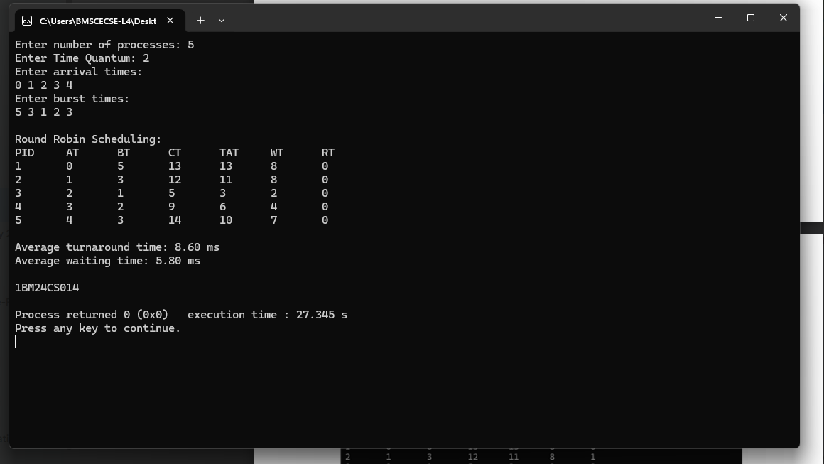

PROGRAM 2

Question : Write a C program to simulate multi-level queue scheduling algorithm considering the following scenario. All the processes in the system are divided into two categories – system processes and user processes. System processes are to be given higher priority than user processes. Use FCFS scheduling for the processes in each queue.

SOLN :

#include <stdio.h>

#define MAX 10

typedef struct {
int pid, at, bt, rt, ct, tat, wt, queue;
} Process;

int main() {
Process p[MAX];
int n, i, time = 0, completed = 0;
int tq = 2;

printf("Enter number of processes: ");
scanf("%d", &n);

for (i = 0; i < n; i++) {
printf("\nP%d\n", i + 1);
p[i].pid = i + 1;

printf("Arrival Time: ");
scanf("%d", &p[i].at);

printf("Burst Time: ");
scanf("%d", &p[i].bt);

printf("Queue (1-System, 2-User): ");
scanf("%d", &p[i].queue);

p[i].rt = p[i].bt;
}

printf("\nGantt Chart:\n");

while (completed < n) {

int executed = 0;

for (i = 0; i < n; i++) {
if (p[i].queue == 1 && p[i].rt > 0 && p[i].at <= time) {

executed = 1;

if (p[i].rt > tq) {
printf("P%d ", p[i].pid);
time += tq;
p[i].rt -= tq;
} else {
printf("P%d ", p[i].pid);
time += p[i].rt;
p[i].rt = 0;
p[i].ct = time;
completed++;
}
}
}

if (!executed) {
for (i = 0; i < n; i++) {
if (p[i].queue == 2 && p[i].rt > 0 && p[i].at <= time) {

executed = 1;

printf("P%d ", p[i].pid);
p[i].rt--;
time++;

if (p[i].rt == 0) {
p[i].ct = time;
completed++;
}

break;
}
}
}

if (!executed) {
time++;
}
}

float total_tat = 0, total_wt = 0;

printf("\n\nPID\tAT\tBT\tCT\tTAT\tWT\n");

for (i = 0; i < n; i++) {
p[i].tat = p[i].ct - p[i].at;
p[i].wt = p[i].tat - p[i].bt;

total_tat += p[i].tat;
total_wt += p[i].wt;

printf("P%d\t%d\t%d\t%d\t%d\t%d\n",
p[i].pid, p[i].at, p[i].bt,
p[i].ct, p[i].tat, p[i].wt);
}

printf("\nAverage TAT = %.2f", total_tat / n);
printf("\nAverage WT = %.2f\n", total_wt / n);

return 0;
}

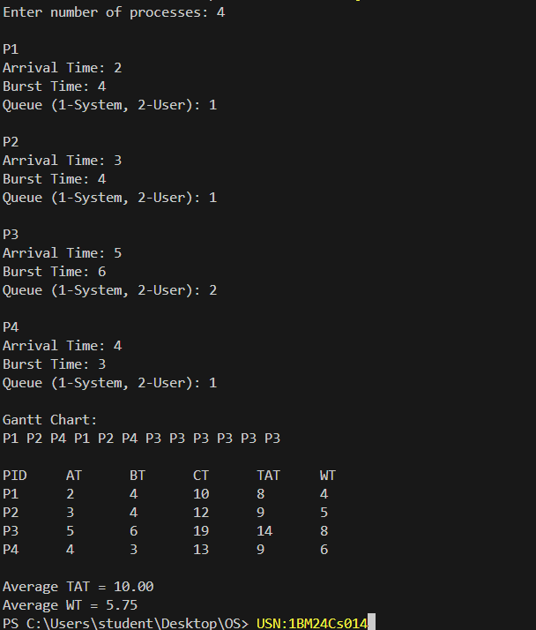

PROGRAM 3

QUESTION : Write a C program to simulate Real-Time CPU Scheduling algorithms:
Rate- Monotonic
Earliest-deadline First
Proportional scheduling

SOLN : Rate Monotonic Scheduling

#include <stdio.h>
#include <stdlib.h>
#include <math.h>
struct Process {
int pid;
int burst;
int period;
int remaining;
};

int gcd(int a, int b) {
if (b == 0) return a;
return gcd(b, a % b);
}
int lcm(int a, int b) {
return (a * b) / gcd(a, b);
}

int main() {
int n;
printf("Enter the number of processes: ");
scanf("%d", &n);

struct Process p[n];
printf("Enter the CPU burst times:\n");
for (int i = 0; i < n; i++) {
scanf("%d", &p[i].burst);
p[i].pid = i + 1;
}

printf("Enter the time periods:\n");
int hyperPeriod = 1;
for (int i = 0; i < n; i++) {
scanf("%d", &p[i].period);
hyperPeriod = lcm(hyperPeriod, p[i].period);
}

printf("\nLCM=%d\n", hyperPeriod);

printf("\nRate Monotone Scheduling:\n");
printf("PID\tBurst\tPeriod\n");
for (int i = 0; i < n; i++) {
printf("%d\t%d\t%d\n", p[i].pid, p[i].burst, p[i].period);
}

double U = 0.0;
for (int i = 0; i < n; i++) {
U += (double)p[i].burst / p[i].period;
}
double bound = n * (pow(2.0, 1.0/n) - 1);
printf("\n%.6f <= %.6f => %s\n", U, bound, (U <= bound ? "true" : "false"));
printf("Scheduling occurs for %d ms\n\n", hyperPeriod);

for (int t = 0; t < hyperPeriod; t++) {
int chosen = -1;

for (int i = 0; i < n; i++) {
if (t % p[i].period == 0) {
p[i].remaining = p[i].burst;
}
}

for (int i = 0; i < n; i++) {
if (p[i].remaining > 0) {
chosen = i;
break;
}
}
if (chosen != -1) {
printf("%dms onwards: Process %d running\n", t, p[chosen].pid);
p[chosen].remaining--;
} else {
printf("%dms onwards: CPU is idle\n", t);
}
}

return 0;
}

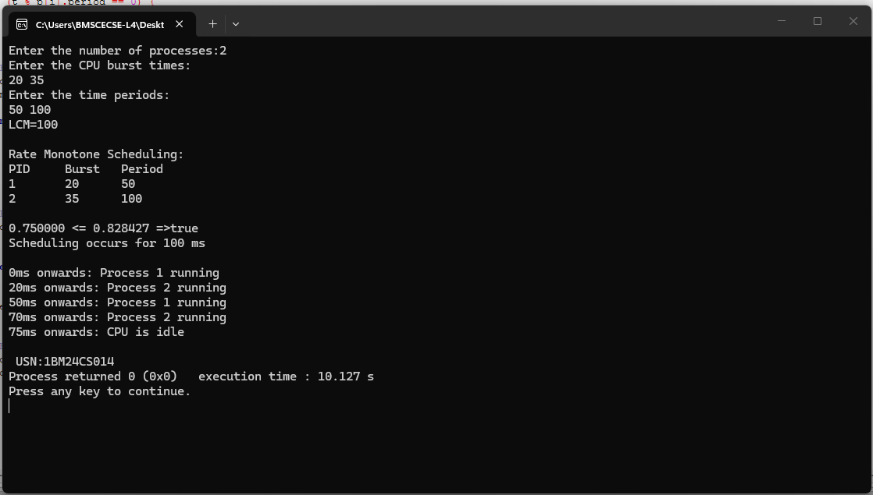

SOLN : Earliest Deadline First
#include <stdio.h>
#include <limits.h>

#define MAX_TASKS 10
typedef struct {
int pid;
int burst;
int deadline;
int period;
} Task;

int gcd(int a, int b) {
while (b != 0) {
int temp = b;
b = a % b;
a = temp;
}
return a;
}

int lcm(int a, int b) {
return (a * b) / gcd(a, b);
}

int main() {
int n;
Task tasks[MAX_TASKS];

printf("Enter number of tasks: ");
scanf("%d", &n);

for (int i = 0; i < n; i++) {
printf("\nTask %d:\n", i + 1);
tasks[i].pid = i + 1;

printf("Enter Burst Time: ");
scanf("%d", &tasks[i].burst);

printf("Enter Deadline: ");
scanf("%d", &tasks[i].deadline);

printf("Enter Period: ");
scanf("%d", &tasks[i].period);
}

int SIMULATION_TIME = tasks[0].period;
for (int i = 1; i < n; i++) {
SIMULATION_TIME = lcm(SIMULATION_TIME, tasks[i].period);
}

int remaining[MAX_TASKS] = {0};
int next_release[MAX_TASKS] = {0};
int abs_deadline[MAX_TASKS] = {0};
int active[MAX_TASKS] = {0};

printf("\nScheduling occurs for %d ms (LCM of periods)\n\n", SIMULATION_TIME);

for (int t = 0; t < SIMULATION_TIME; t++) {

// Release jobs
for (int i = 0; i < n; i++) {
if (t == next_release[i]) {
remaining[i] = tasks[i].burst;
abs_deadline[i] = t + tasks[i].deadline;
next_release[i] += tasks[i].period;
active[i] = 1;
}
}

int chosen = -1;
int earliest = INT_MAX;

for (int i = 0; i < n; i++) {
if (active[i] && remaining[i] > 0) {
if (abs_deadline[i] < earliest) {
earliest = abs_deadline[i];
chosen = i;
}
}
}

if (chosen != -1) {
printf("%dms : Task %d is running.\n", t, tasks[chosen].pid);
remaining[chosen]--;

if (remaining[chosen] == 0) {
active[chosen] = 0;
}
} else {
printf("%dms : CPU is idle.\n", t);
}
}

return 0;
}

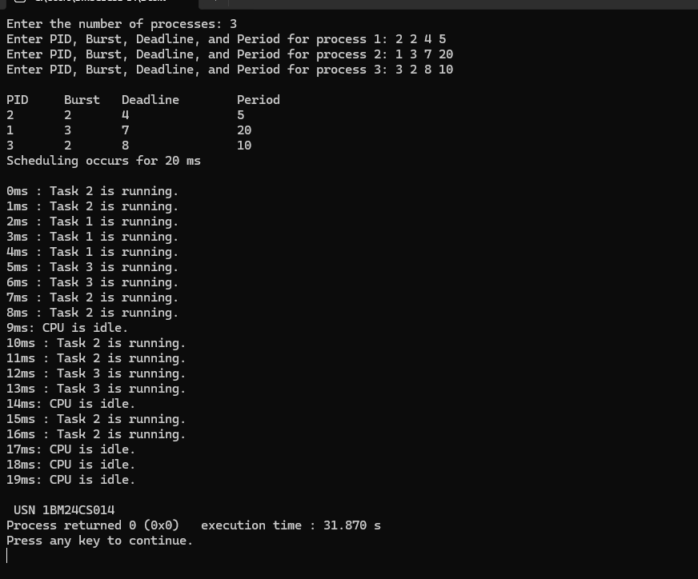

PROGRAM 4 :

QUESTION :
4a. Write a C program to simulate producer-consumer problem using semaphores
4b. Write a C program to simulate the concept of Dining Philosophers problem

SOLN : Bounded Buffer

#include <stdio.h>
#include <stdlib.h>
#define BUFFER_SIZE 5

int buffer[BUFFER_SIZE];
int in = 0;
int out = 0;

int empty = BUFFER_SIZE;
int full = 0;

void produce() {
if (empty == 0) {
printf("\nBuffer is full! Cannot produce.\n");
return;
}

int item;
printf("Enter item to produce: ");
scanf("%d", &item);

buffer[in] = item;
printf("Produced: %d\n", item, in);

in = (in + 1) % BUFFER_SIZE;
empty--;
full++;
}

void consume() {
if (full == 0) {
printf("Buffer is empty! Cannot consume.\n");
return;
}

int item = buffer[out];
printf("Consumed: %d\n", item, out);

out = (out + 1) % BUFFER_SIZE;
full--;
empty++;
}

int main() {
int choice;
printf("Buffer Size: %d\n", BUFFER_SIZE);

while (1) {
printf("\n1. Produce\n2. Consume\n3. Exit\n");
printf("Current State: [Full slots: %d | Empty slots: %d]\n", full, empty);
printf("Enter choice: ");

if (scanf("%d", &choice) != 1) break;

switch (choice) {
case 1:
produce();
break;
case 2:
consume();
break;
case 3:
printf("Exiting...\n");
exit(0);
default:
printf("Invalid choice!\n");
}
}

return 0;
}

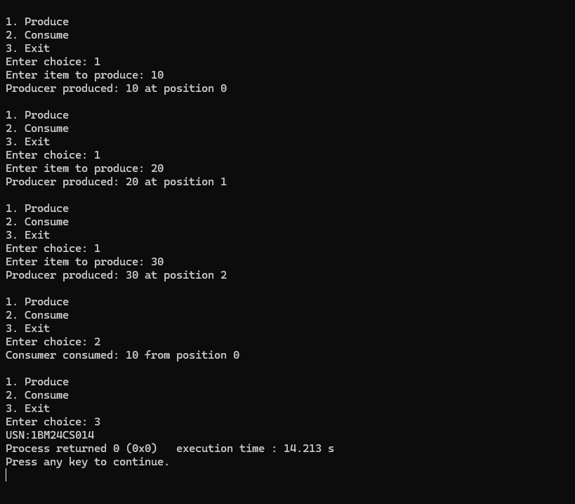

SOLN : Dining Philosopher
#include<stdio.h>
#include<pthread.h>
#include<unistd.h>
#define N 5
pthread_mutex_t forks[N];
pthread_t philosophers[N];

void* philosopher(void* num)
{
int id = *(int*)num;
int left = id; // left fork index
int right = (id + 1) % N; // right fork index
while (1)
{
printf("Philosopher %d is thinking.\n", id);
sleep(1); // Thinking
// To avoid deadlock, philosophers with even id pick left then right,
// odd id pick right then left.
if (id % 2 == 0)
{

pthread_mutex_lock(&forks[left]);
printf("Philosopher %d picked up left fork %d.\n", id, left);
pthread_mutex_lock(&forks[right]);
printf("Philosopher %d picked up right fork %d.\n", id, right); }
else
{
pthread_mutex_lock(&forks[right]);
printf("Philosopher %d picked up right fork %d.\n", id, right); // Pick up left
pthread_mutex_lock(&forks[left]);
printf("Philosopher %d picked up left fork %d.\n", id, left);
}
printf("Philosopher %d is eating.\n", id);
sleep(2); // Put down forks
pthread_mutex_unlock(&forks[left]);
pthread_mutex_unlock(&forks[right]);
printf("Philosopher %d put down forks %d and %d.\n", id, left, right);
}
return NULL;
}

int main() {
int i;
int ids[N]; // Initialize forks (mutexes)
for (i = 0; i < N; i++)
{ pthread_mutex_init(&forks[i], NULL);
ids[i] = i;
}
for (i = 0; i < N; i++){
pthread_create(&philosophers[i], NULL, philosopher, &ids[i]);
}

for (i = 0; i < N; i++){
pthread_join(philosophers[i], NULL); }
for (i = 0; i < N; i++){
pthread_mutex_destroy(&forks[i]);
}
return 0;
}

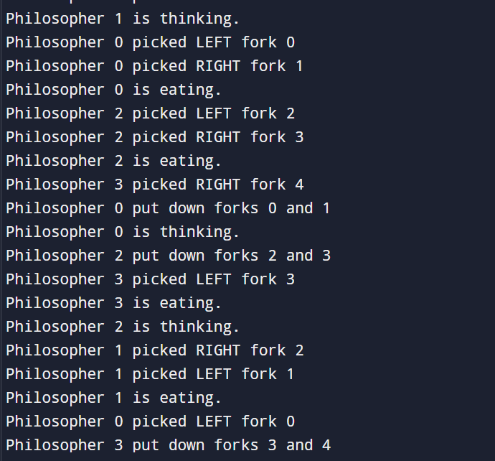

PROGRAM 5

QUESTION : Write a C program to simulate Bankers algorithm and deadlock avoidance

SOLN : Banker algorithm

#include <stdio.h>
#include <stdbool.h>

#define MAX_PROCESSES 10
#define MAX_RESOURCES 10

int main() {
int n, m;

printf("Enter number of processes: ");
scanf("%d", &n);

printf("Enter number of resource types: ");
scanf("%d", &m);

int allocation[MAX_PROCESSES][MAX_RESOURCES];
int max[MAX_PROCESSES][MAX_RESOURCES];
int need[MAX_PROCESSES][MAX_RESOURCES];
int available[MAX_RESOURCES];

printf("\nEnter Allocation Matrix:\n");
for (int i = 0; i < n; i++) {
for (int j = 0; j < m; j++) {
scanf("%d", &allocation[i][j]);
}
}

printf("\nEnter Max Matrix:\n");
for (int i = 0; i < n; i++) {
for (int j = 0; j < m; j++) {
scanf("%d", &max[i][j]);
}
}

printf("\nEnter Available Resources:\n");
for (int j = 0; j < m; j++) {
scanf("%d", &available[j]);
}

for (int i = 0; i < n; i++) {
for (int j = 0; j < m; j++) {
need[i][j] = max[i][j] - allocation[i][j];
}
}

bool finish[MAX_PROCESSES] = {false};
int safeSequence[MAX_PROCESSES];

int work[MAX_RESOURCES];

// Work = Available
for (int j = 0; j < m; j++) {
work[j] = available[j];
}

int count = 0;

while (count < n) {
bool found = false;

for (int i = 0; i < n; i++) {

if (finish[i] == false) {

bool canExecute = true;

for (int j = 0; j < m; j++) {
if (need[i][j] > work[j]) {
canExecute = false;
break;
}
}

if (canExecute) {

for (int j = 0; j < m; j++) {
work[j] += allocation[i][j];
}

safeSequence[count] = i;
count++;

finish[i] = true;
found = true;
}
}
}

if (!found) {
break;
}
}

if (count == n) {
printf("\nSystem is in SAFE state.\n");
printf("Safe Sequence: ");

for (int i = 0; i < n; i++) {
printf("P%d", safeSequence[i]);

if (i != n - 1) {
printf(" -> ");
}
}

printf("\n");
}
else {
printf("\nSystem is NOT in safe state.\n");
}

return 0;
}

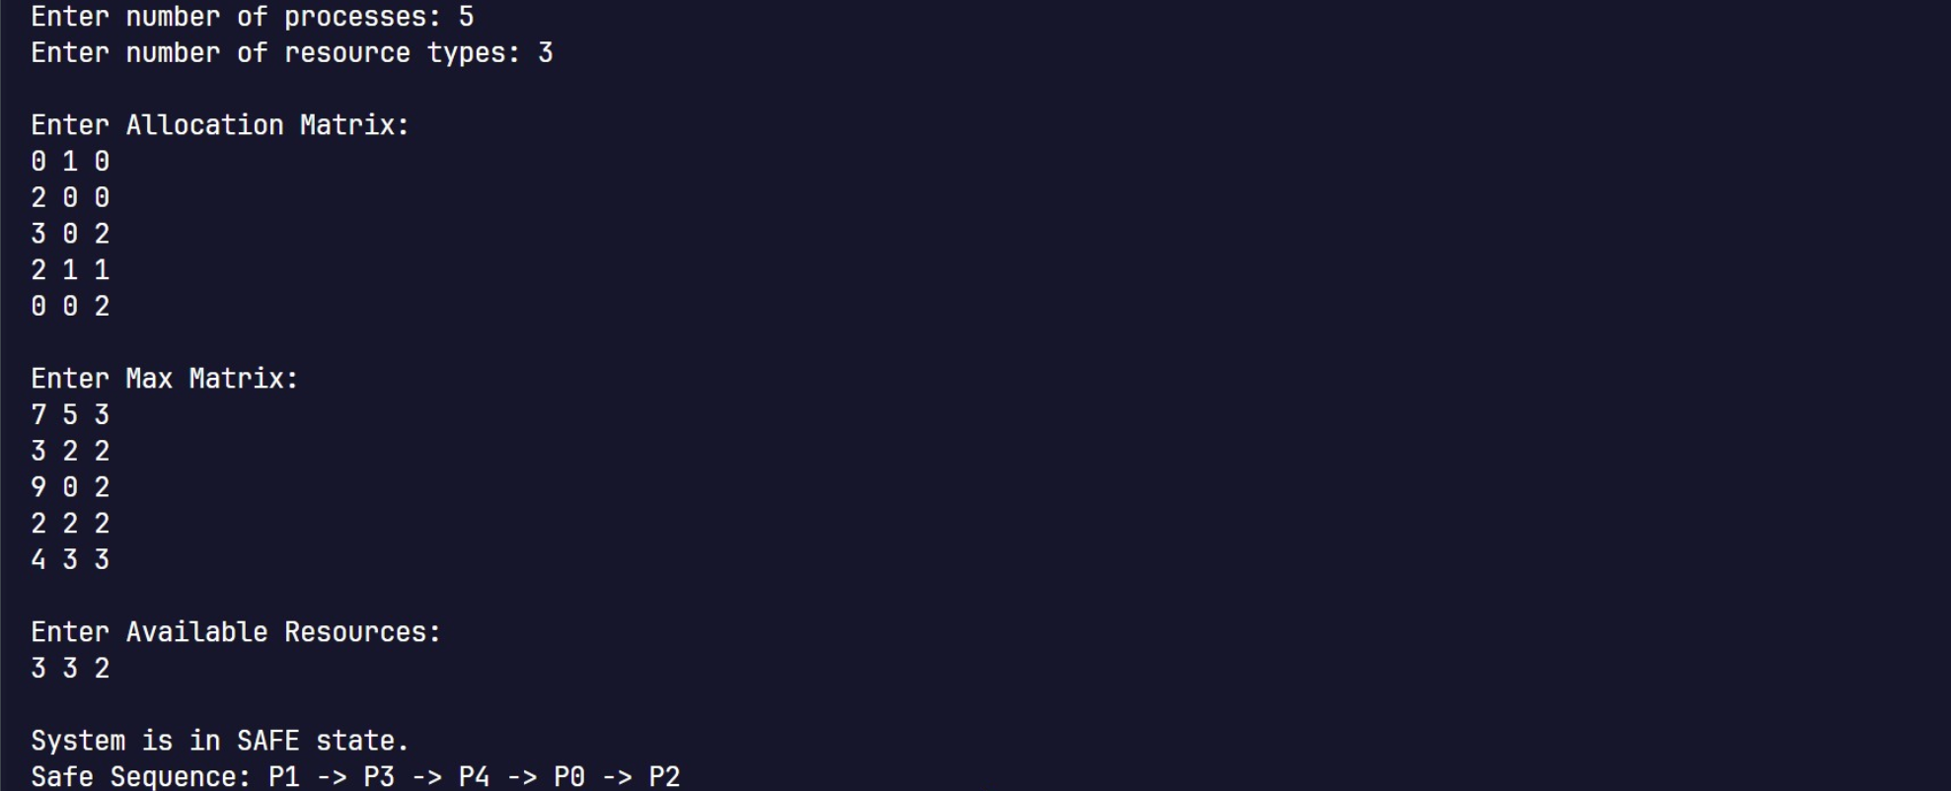

SOLN : Deadlock avoidance algorithm

#include <stdio.h>
#include <stdbool.h>

#define MAX_PROCESSES 10
#define MAX_RESOURCES 10

int main() {
int n, m;

printf("Enter number of processes: ");
scanf("%d", &n);

printf("Enter number of resource types: ");
scanf("%d", &m);

int allocation[MAX_PROCESSES][MAX_RESOURCES];
int request[MAX_PROCESSES][MAX_RESOURCES];
int available[MAX_RESOURCES];

printf("\nEnter Allocation Matrix:\n");
for (int i = 0; i < n; i++) {
for (int j = 0; j < m; j++) {
scanf("%d", &allocation[i][j]);
}
}

printf("\nEnter Request Matrix:\n");
for (int i = 0; i < n; i++) {
for (int j = 0; j < m; j++) {
scanf("%d", &request[i][j]);
}
}

printf("\nEnter Available Resources:\n");
for (int j = 0; j < m; j++) {
scanf("%d", &available[j]);
}

bool finish[MAX_PROCESSES];
int work[MAX_RESOURCES];
int safeSequence[MAX_PROCESSES];

for (int j = 0; j < m; j++) {
work[j] = available[j];
}

for (int i = 0; i < n; i++) {
bool zeroAllocation = true;

for (int j = 0; j < m; j++) {
if (allocation[i][j] != 0) {
zeroAllocation = false;
break;
}
}

finish[i] = zeroAllocation;
}

int count = 0;

while (1) {
bool found = false;

for (int i = 0; i < n; i++) {

if (finish[i] == false) {

bool canExecute = true;

for (int j = 0; j < m; j++) {
if (request[i][j] > work[j]) {
canExecute = false;
break;
}
}

if (canExecute) {

for (int j = 0; j < m; j++) {
work[j] += allocation[i][j];
}

finish[i] = true;
safeSequence[count] = i;
count++;

found = true;
}
}
}

if (!found) {
break;
}
}

bool deadlock = false;

for (int i = 0; i < n; i++) {
if (finish[i] == false) {
deadlock = true;
break;
}
}

if (!deadlock) {
printf("\nNo Deadlock detected.\n");

printf("Safe Sequence: ");
for (int i = 0; i < count; i++) {
printf("P%d", safeSequence[i]);

if (i != count - 1) {
printf(" -> ");
}
}

printf("\n");
}
else {
printf("\nDeadlock detected.\n");

printf("Processes involved in deadlock: ");

for (int i = 0; i < n; i++) {
if (finish[i] == false) {
printf("P%d ", i);
}
}

printf("\n");
}

return 0;
}
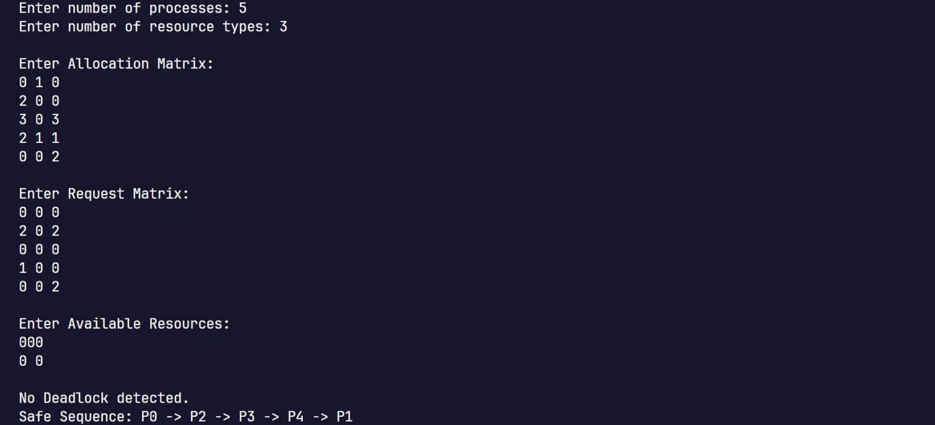

PROGRAM 6 :

QUESTION : Write a C program to simulate Memory Allocation (First Fit, Best Fit, Worst Fit)

SOLN : Memory Allocation

#include <stdio.h>

void firstFit(int blockSize[], int m, int processSize[], int n) {
int allocation[n];

for (int i = 0; i < n; i++)
allocation[i] = -1;

for (int i = 0; i < n; i++) {
for (int j = 0; j < m; j++) {
if (blockSize[j] >= processSize[i]) {
allocation[i] = j;
blockSize[j] = 0;
break;
}
}
}

printf("\nFirst Fit Allocation:\n");
printf("Process No.\tProcess Size\tBlock No.\n");

for (int i = 0; i < n; i++) {
printf("%d\t\t%d\t\t", i + 1, processSize[i]);

if (allocation[i] != -1)
printf("%d\n", allocation[i] + 1);
else
printf("Not Allocated\n");
}
}

void bestFit(int blockSize[], int m, int processSize[], int n) {
int allocation[n];

for (int i = 0; i < n; i++)
allocation[i] = -1;

for (int i = 0; i < n; i++) {
int bestIdx = -1;

for (int j = 0; j < m; j++) {
if (blockSize[j] >= processSize[i]) {
if (bestIdx == -1 || blockSize[j] < blockSize[bestIdx]) {
bestIdx = j;
}
}
}

if (bestIdx != -1) {
allocation[i] = bestIdx;
blockSize[bestIdx] = 0;
}
}

printf("\nBest Fit Allocation:\n");
printf("Process No.\tProcess Size\tBlock No.\n");

for (int i = 0; i < n; i++) {
printf("%d\t\t%d\t\t", i + 1, processSize[i]);

if (allocation[i] != -1)
printf("%d\n", allocation[i] + 1);
else
printf("Not Allocated\n");
}
}

void worstFit(int blockSize[], int m, int processSize[], int n) {
int allocation[n];

for (int i = 0; i < n; i++)
allocation[i] = -1;

for (int i = 0; i < n; i++) {
int worstIdx = -1;

for (int j = 0; j < m; j++) {
if (blockSize[j] >= processSize[i]) {
if (worstIdx == -1 || blockSize[j] > blockSize[worstIdx]) {
worstIdx = j;
}
}
}

if (worstIdx != -1) {
allocation[i] = worstIdx;
blockSize[worstIdx] = 0;
}
}

printf("\nWorst Fit Allocation:\n");
printf("Process No.\tProcess Size\tBlock No.\n");

for (int i = 0; i < n; i++) {
printf("%d\t\t%d\t\t", i + 1, processSize[i]);

if (allocation[i] != -1)
printf("%d\n", allocation[i] + 1);
else
printf("Not Allocated\n");
}
}

int main() {
int m, n;

printf("Enter number of memory blocks: ");
scanf("%d", &m);

int blocks[m], firstBlocks[m], bestBlocks[m], worstBlocks[m];

printf("Enter sizes of memory blocks:\n");
for (int i = 0; i < m; i++) {
scanf("%d", &blocks[i]);
firstBlocks[i] = blocks[i];
bestBlocks[i] = blocks[i];
worstBlocks[i] = blocks[i];
}

printf("Enter number of processes: ");
scanf("%d", &n);

int processSize[n];

printf("Enter sizes of processes:\n");
for (int i = 0; i < n; i++) {
scanf("%d", &processSize[i]);
}

firstFit(firstBlocks, m, processSize, n);
bestFit(bestBlocks, m, processSize, n);
worstFit(worstBlocks, m, processSize, n);

return 0;
}

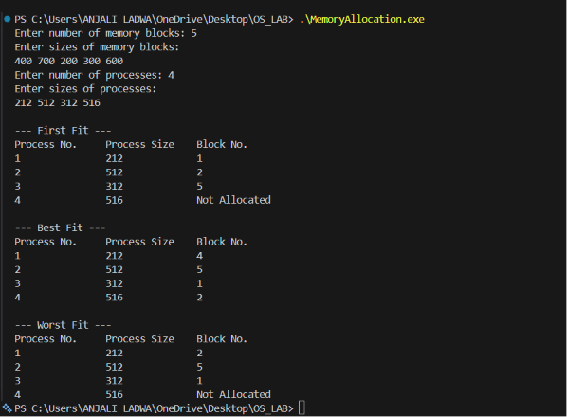

PROGRAM 7 :

QUESTION : Write a C program to simulate Page Replacement

#include <stdio.h>
#include <stdbool.h>

#define MAX_PAGES 100

void printFrames(int frames[], int num_frames) {
printf("[");
int count = 0;
for (int i = 0; i < num_frames; i++) {
if (frames[i] != -1) {
printf("%d", frames[i]);
count++;
}
}
printf("]\n");
}

void fifoPageReplacement(int pages[], int num_pages, int num_frames) {
printf("\n--- FIFO Page Replacement ---\n");

int frames[num_frames];
for (int i = 0; i < num_frames; i++) frames[i] = -1;

int page_faults = 0;
int next = 0;

for (int i = 0; i < num_pages; i++) {
int page = pages[i];
bool is_present = false;

for (int j = 0; j < num_frames; j++) {
if (frames[j] == page) {
is_present = true;
break;
}
}

printf("Page %d -> ", page);

if (!is_present) {

frames[next] = page;
next = (next + 1) % num_frames;
page_faults++;
}

printFrames(frames, num_frames);
}
printf("Total Page Faults (FIFO): %d\n", page_faults);
}

void lruPageReplacement(int pages[], int num_pages, int num_frames) {
printf("\n--- LRU Page Replacement ---\n");

int frames[num_frames];
int last_used[num_frames];
for (int i = 0; i < num_frames; i++) {
frames[i] = -1;
last_used[i] = -1;
}

int page_faults = 0;

for (int i = 0; i < num_pages; i++) {
int page = pages[i];
bool is_present = false;
int present_index = -1;

for (int j = 0; j < num_frames; j++) {
if (frames[j] == page) {
is_present = true;
present_index = j;
break;
}
}

printf("Page %d -> ", page);

if (is_present) {

last_used[present_index] = i;
} else {

page_faults++;

int empty_index = -1;
for (int j = 0; j < num_frames; j++) {
if (frames[j] == -1) {
empty_index = j;
break;
}
}

if (empty_index != -1) {

frames[empty_index] = page;
last_used[empty_index] = i;
} else {

int lru_index = 0;
int min_time = last_used[0];
for (int j = 1; j < num_frames; j++) {
if (last_used[j] < min_time) {
min_time = last_used[j];
lru_index = j;
}
}
frames[lru_index] = page;
last_used[lru_index] = i;
}
}

printFrames(frames, num_frames);
}
printf("Total Page Faults (LRU): %d\n", page_faults);
}

void optimalPageReplacement(int pages[], int num_pages, int num_frames) {
printf("\n--- Optimal Page Replacement ---\n");

int frames[num_frames];
for (int i = 0; i < num_frames; i++) frames[i] = -1;

int page_faults = 0;

for (int i = 0; i < num_pages; i++) {
int page = pages[i];
bool is_present = false;

for (int j = 0; j < num_frames; j++) {
if (frames[j] == page) {
is_present = true;
break;
}
}

printf("Page %d -> ", page);

if (!is_present) {
page_faults++;

int empty_index = -1;
for (int j = 0; j < num_frames; j++) {
if (frames[j] == -1) {
empty_index = j;
break;
}
}

if (empty_index != -1) {
frames[empty_index] = page;
} else {

int replace_index = -1;
int farthest_use = -1;

for (int j = 0; j < num_frames; j++) {
int next_use = -1;

for (int k = i + 1; k < num_pages; k++) {
if (pages[k] == frames[j]) {
next_use = k;
break;
}
}

if (next_use == -1) {
replace_index = j;
break;
}

if (next_use > farthest_use) {
farthest_use = next_use;
replace_index = j;
}
}

frames[replace_index] = page;
}
}

printFrames(frames, num_frames);
}
printf("Total Page Faults (Optimal): %d\n", page_faults);
}

int main() {
int num_pages, num_frames;
int pages[MAX_PAGES];

printf("Enter number of pages: ");
if (scanf("%d", &num_pages) != 1 || num_pages <= 0 || num_pages > MAX_PAGES) {
printf("Invalid number of pages.\n");
return 1;
}

printf("Enter page reference string:\n");
for (int i = 0; i < num_pages; i++) {
scanf("%d", &pages[i]);
}

printf("Enter number of frames: ");
if (scanf("%d", &num_frames) != 1 || num_frames <= 0) {
printf("Invalid number of frames.\n");
return 1;
}

fifoPageReplacement(pages, num_pages, num_frames);
lruPageReplacement(pages, num_pages, num_frames);
optimalPageReplacement(pages, num_pages, num_frames);

return 0;
}

