DJANGO

TOPICS

a) introduction to django 5
b) Django Prerequisities
c) install django
d) create django project
e) Django Directory Structure g
f) Views
g) URL ROUTING
h) DTL
I) MODEL
j) admin panel
k) Authentication and authorization
l) Cookie and Session
m) Cache
n) Signals
o) Testing
p) Security
q) Deployment

Q) What is Django5 ?

Django is a high level web framework written in python that encourages rapid devlopment and clean pragmatic design

a) IT FOLLOWS DRY
b) It follows MVT(MODEL VIEW TEMPLATE ) architectural pattern
c) created in 2003

FEATURES

a) Built-in Admin interface
b) ORM -->
c) Authentication System
d) Rapid Development
e) Versatility
f) Security

DJANGO 5 PREREQUISITE

a) HTML
b) CSS
c) JS
d) SQL
e) Python
f) MVT
g) PIP pip –version (to check version of pip)
pip freeze ----> return the list of all installed packages

Q) HOW TO INSTALL DJANGO ?

a) django-admin –version ==> to check django is there in system or not

steps to install django

a) install virtual evn
-->pip install virtualenv == to create virtual environment
---> pip uninstall virtualenv --> to remove virtual environment

b) create and activate virtual env
--> virtualenv venv --> create
---> source venv/bin/activate --> activate
c) install django
---> pip install django

DJANGO PROJECT

->A group of application and files is called as Django project
->An application is a part of Django Project

CREATE DJANGO PROJECT

A) If No Project Folder exists

syntax--> django-admin startproject projectname
ex--> django-admin startproject sms

note--> isse problem ye hai ki venv project ke bahar banta hai to hme manually usko usme dalna parta hai
so alway use B approach
B) If Project Folder exists

syntax--> django-admin startproject projectname.(outer project folder create na ho that’s why i gave dot there

ex--> django-admin startproject sms .
Dot means sms mai hi isko start kro

C) To start project

python3 manage.py runserver

HOW TO CREATE DJANGO PROJECT ?

a) create Virtual ENV
b) Activate Virtual ENV
c) Install Django
d) Create Django Project

UNDERSTAND FOLDER STRUCTURE

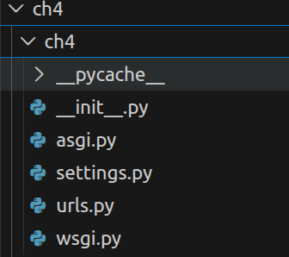

YE CH4 FOLDER(OUTER FOLDER) KE ANDAR JO FOLDER BANA HAI ISKO BOLTE HAI INNERPROJECTFOLDER STRUCTURE

iska theory aapko notes mai miljayega

DAY2

a) RUN DJANGO ON SPECIFIC PORT

python3 manage.py runserver 4000 ---> to run on specific port you just have to add that port when you run and here that is
4000

b) SETUP VS CODE FOR DJANGO DEVLOPMENT

download these 3 extension
python
autopep8
django

ctrl+shift+p
python select interpretor

these two we can use to selecto which interpretor we want to use

c) Create Django Application like pro

a) syntax-- python manage.py startapp name_of_App

ex-- python manage.py startapp app1

after this there is one folder app1 created
when you open it you found this
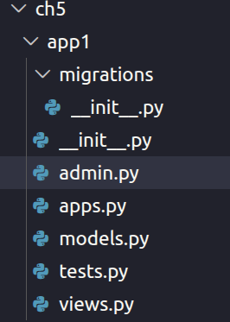

so start your application normally and write in url /admin you get admin panel

http://127.0.0.1:8000/admin

admin.py -> in this file jab bhi aapko admin application pai datbase kai kisi table ko registar krna ho to uska code idhar hi lkheng

apps.py --> all theory you get in document
views.py ---> business logic related code we write here
all remaing info you get in pdf
b) now application app1 is created but still django project not recogine it so make it recognizable

go to inner project folder

a) setting.py
b) then in INSTALLED_APPS
c) write app1

INSTALLED_APPS = [
'django.contrib.admin',
'django.contrib.auth',
'django.contrib.contenttypes',
'django.contrib.sessions',
'django.contrib.messages',
'django.contrib.staticfiles',
'app1',
]

so this is how we install django application in django project

FUNCTIONS BASED VIEW IN DJANGO (ch6)

django follow mvt architecute so here we see about views

a) function based views -> it is a python function that take web request
and send webresponse

app1/views.py

def myfunction(request):
return HttpResponse('Hello Django')

understand this syntax :-->

a) first parameter of function is always --> webrequest
b) then it return webresponse that is --> HttpResponse

ye jo HttpResponse hai ye ek class hai

and all the logic of our project we wrote just above this return

now if you want to check it in webpage so you have to attach this function with any url

steps :
a) go to innerproject folder
b) urls.py
c) import that file here (before it read comment you understand the process of it

after this http://127.0.0.1:8000/myfun you get you page

THIS IS ALL ABOUT FUNCTION BASED VIEW CHECK TWO FILES IN CH6 views.py and in inner folder urls.py

CREATE MULTIPLE APPLICATION IN DJANGO (ch7)

when we create one application no issue but when you create more than one you get this error

File "/home/developer/DJANGO/django5/ch7/ch7/urls.py", line 23, in <module>
path('',views.home,name="home"),
AttributeError: module 'app2.views' has no attribute 'home'

this error comes because in url.py

from app1 import views
from app2 import views

and python consider second views not first , and home is not there in app2 views
so to handle this we have to do aliasing

from app1 import views as ap1
from app2 import views as ap2

this is one way to do this

there is one more way to do this that is

from app1.views import home,myapp1
from app2.views import myapp2,myapp2_me

app1 is package app1.views means from package we import subpackage views then from views we impot all of this

NOTE---> as i told earlier after creating application we also have to install it but here we saw , only by creating it’s work why ?

So the reason is when we work with model, template,staticfiles, in that case it required not here

URL PATTERNS IN DJANGO (url dispatcher)ch8

here we go in depth about url.py file in inner directory

path('route',view,kwargs,name)

name argument is for url url reversing
here root and view you must have to write

path('py/',learn_django,{'status':'OK'})

when you pass this keyword argument status:ok then you can access it in the view learn_django function

there is a concept here that you have to understand
a) in dj route we have not status so when we called it learn_django it gives none that’s why i wrote
here status = kwargs.get('status','not allowed')
because if it become none in status not allowed will set

view.py

def learn_django(req,**kwargs):
status = kwargs.get('status','not allowed')
print(status)
return HttpResponse(f'<h1>Hello django</h1> {status}')

url.py

urlpatterns = [
path('admin/', admin.site.urls),
path('dj/',learn_django,name="learn_django"),
path('py/',learn_django,{'status':'OK'})
]

now if you go and check url.py in ch8 you find for app1 and app2(i also created it) we wrote path individually for all functions so this is not a good practise try seperate the code

means let’s if app1 having two path so write that two path in app1 itself then import it here in url

so question is how to seperate it ?(ch9)

steps

a) make urls.py in app1 or app2
b) include that views here
c) then in inner directory ch9 in urls.py
d) use include in path to add it

ex---

urls.py in app2

from django.urls import path
from app2.views import myapp2

urlpatterns = [
path('app2/',myapp2)
]

urls.py in inner diretory

from django.contrib import admin
from django.urls import path,include

urlpatterns = [
path('admin/', admin.site.urls),
path('',include('app2.urls'))
]
path('xy/',include('app2.urls'))

rls it’s means here xy/app2 when hit it will execute

TEMPLATE (CH10)

IN DJANGO TEMPLATE IS A TEXT FILE ,THAT CAN GENERATE , TEXT BASED FORMAT(HTML,XML,CSV ETC)

MEANS ACTUALLY TO SEPERATE HTML OR TEXT FILE FROM VIEWS
WE USE TEMPLATE

Always try to create template inside application

structure to make template

inside application

a) make folder --->template
b) inside it make folder same name as application ex course
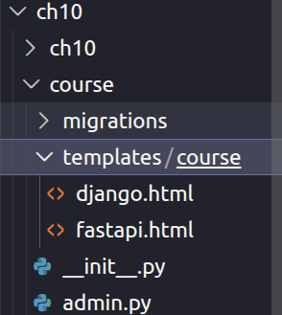

now we are using template so it’s must be important to install application in setting

now as we also render our template by using views so how to do it ?

a)one thing more when we use template , there is no need of HttpResponse inside view

instead of these we use render that we import from shortcuts

from django.shortcuts import render

syntax of render

def learn_django(req):
return render(req,template_name,context=dict_name,content_type=MIME_TYPE,status=None ,using=None)

render method combine krta hai aapke template ko then dictionary or variables ko and jo bhi result milta hai usse usko as a http response object return krta hai

req ---> it is your request name

template_name--> name of template , here you can write one or more template
yah pai jo path hoga wo hoga, template folder ke andar jo
folder and file bnaya hai

context--> in context we send dictionary , that data pass to template
by defualt it is an empty dictionary

content_type--> type of your content by default ye text/html hota hai

status ---> it define your status code
using --> here we can write which templating engine we are using for render template ex--> ninja2 etc

HOW TO RENDER DYNAMICALLY (ch11)

a) define you variable in business logic part of views.py
b) in render inside context pass it ,ex context=di
c) now inside template use {{di}}

ex--- views.py

def learn_django(req):
# businees logic
coursename = {'cname':'Django'} # or you can pass this dictionary directly in context or you can also pass this coursename directly without using context
return render(req,'course/django.html',context=coursename)

b and c khud se kr lena

DJANGO TEMPLATE LANGUAGE (ch12)

please go through views.py

a) view in views.py or django.html
b) “ ”
c)filter --> so we use pipe symbol to apply python inside template language

1) way 1 of apply filter --> |
<h2> example 2 filters </h2>
<h3>{{name |upper}} </h3>

2)<h3>Desc:{{desc|truncatewords:4}}</h3>
{% comment %} *chainging of filters {% endcomment %}

<h3>Desc:{{desc|upper|truncatewords:4}}</h3>

some more filters

<h3>Desc:{{desc|upper|truncatewords:4}}</h3>
<h3>{{name |lower}} </h3>
<h3>{{name |capfirst}} </h3>
<h3>{{name |default:'nothing'}} </h3>
<h3>{{name |length}} </h3>
<h3>{{name |slice:'2'}} </h3>
<h3>{{name |truncatechars:3}} </h3>

note ---> truncate words works on words not letter
you can also chain the filters

d) date and time

<h2>dateTime:{{dt}} </h2>
<h2>dateTime:{{dt|date}} </h2>
<h2>dateTime:{{dt|date:'D d M Y'}} </h2>
<h2>dateTime:{{dt|time}} </h2>
<h2>dateTime:{{dt|time:'H:i'}} </h2>
<h2>dateTime:{{dt|date:'SHORT_DATE_FORMAT'}} </h2>
<h2>dateTime:{{dt|time:'TIME_FORMAT'}} </h2>

e)
<h2>Float Format</h2>

<h3>p1 : {{ p1 }}</h3>
<h3>p2 : {{ p2 }}</h3>
<h3>p3 : {{ p3 }}</h3>

<h3>p1 : {{ p1|floatformat }}</h3>
<h3>p2 : {{ p2|floatformat }}</h3>
<h3>p3 : {{ p3|floatformat }}</h3>

<h3>p1 : {{ p1|floatformat:3 }}</h3>
<h3>p2 : {{ p2|floatformat:3 }}</h3>
<h3>p3 : {{ p3|floatformat:3 }}</h3>

<h3>p1 : {{ p1|floatformat:0 }}</h3>
<h3>p2 : {{ p2|floatformat:0 }}</h3>
<h3>p3 : {{ p3|floatformat:0 }}</h3>

<h3>p1 : {{ p1|floatformat:-3 }}</h3>
<h3>p2 : {{ p2|floatformat:-3 }}</h3>
<h3>p3 : {{ p3|floatformat:-3 }}</h3>

f) if tag

{% if nm%}
<h3> Hello If Tag </h3>
{% endif %}

g) if else
{% comment %} * if else {% endcomment %}

{% if nm == 'Django1' %}

<h3> Hello {{nm|upper}}If Tag {{nm}}</h3>

{% else %}
<h3> Name :{{nm}} </h3>

{% endif %}

h) elif
{% comment %} * if else {% endcomment %}

{% if nm == 'Django1' %}

<h3> Hello {{nm|upper}}If Tag {{nm}}</h3>

{% elif st1 %}
<h3> Name :{{nm}} </h3>

{% else %}
<h1> nothing is there </h1>
{% endif %}

g) for loops

{% comment %} * for loops {% endcomment %}

<ul>

{% for name in names %}
<li> {{name}} </li>
{% endfor %}
</ul>

HOW TO USE STATIC FILES IN DJANGO (CH13)

a) how to use css

---> make folder inside your applicatoin static
-----> then make folder inside static that is your app_name
----> then make css folder inside your app_name

static/course/css/style.css

now ho to use this static file inside our templates

a) load it inside you template

<!DOCTYPE html>
{%load static%}
<html lang="en">
<head>
<meta charset="UTF-8">
<meta name="viewport" content="width=device-width, initial-scale=1.0">
<title>Document</title>
<link rel="stylesheet" href="style.css">
</head>
<body>
<h1>{{nm}} with static files </h1>

</body>
</html>

b) add static url in link href

<link rel="stylesheet" href="{% static 'course/css/style.css'%}">

b) Now we understand how to use JS

static/course
--->css
-----> style.css
---> js
--->index.js

after this inside your templates add this in last inside body

<script src="{% static 'course/js/script.js%}"></script>

c) now we understand how to put image here

---> for this create images folder inside your course , and then add that image file
--> after this add images in your templates

<img src="{% static 'course/images/apple.avif%}">

we can also add like this
<img src="{% get_static_prefix %}course/images/apple.avif" alt="apple">

d) template inheritance in django(ch14)

let’s say maine two application banaya course,core dome mai templates bnaye
now ye dekho .

<!DOCTYPE html>
<html lang="en">
<head>
<meta charset="UTF-8">
<meta name="viewport" content="width=device-width, initial-scale=1.0">
<title>Document</title>
</head>
<body>
<ul>

<li> Home </li>
<li> Django </li>
<li> Python </li>

<ul>
<h1> python page </h1>
</body>
</html>

lnow agar aap dekho is code mai itna portion har jagah use hoga so, we need to do something , so that’s why inheritance cam in it
<!DOCTYPE html>
<html lang="en">
<head>
<meta charset="UTF-8">
<meta name="viewport" content="width=device-width, initial-scale=1.0">
<title>Document</title>
</head>
<body>
<ul>

<li> Home </li>
<li> Django </li>
<li> Python </li>

<ul>

so for inheritance we have to make base class first :
make base.html in your templates

base . html

<!DOCTYPE html>

<html lang="en">
<head>
<meta charset="UTF-8">
<meta name="viewport" content="width=device-width, initial-scale=1.0">
<title>{%block title%} {% endblock title %}</title>

</head>
<body>
<ul>
<li> Home one </li>
<li> Django </li>
<li> Python </li>

</ul>
{%block hero%} {%endblock hero%}
<h1> {% block content %} {% endblock content %} </h1>
</body>
</html>

django.html

{% extends 'course/base.html'%}

{%block title%} python{% endblock title %}

{%block content%} Home Page {%endblock content%}

note ye jo block content likh hai or block title likha hai usko aap kuch bhi name de skte ho aapne according

Django template inheritance with static files

FORM IN DJANGO (ch27)

There are two ways to create form :

a) by using plain html

b) by form model

forms.py

from django import forms

class Registration(forms.Form):
first_name = forms.CharField()
last_name = forms.CharField()
email = forms.EmailField()
city = forms.CharField()

now if you want to use this form so what is the process :

a) import it in views.py then

def registration(req):
fm = Registration() // make object
return render(req,'student/registration.html',{'form':fm}) // pass in template

b) now in registration.html

<!DOCTYPE html>
<html lang="en">
<head>
<meta charset="UTF-8">
<meta name="viewport" content="width=device-width, initial-scale=1.0">
<title>Document</title>
</head>
<body>
<h1> student registration</h1>
{{form}}
</body>
</html>

Note --->

now this form will visible on url , but there is one more problem here that is this not contain form tag so we have to explicitly include form

there are various way of rendering
a) {{form.as_p}}
b) {{form.as_tr}}
c) {{form.as_table}}
d) <table>
{{form.as_table}}
</table>
aisa kia because kewal table lagnae se st nhi hota check kr lena pagesource mai
e) {{form.as_ul}}---> isko bhi ul tag ken andar dalna
f){{form.first_name}} ---> it’s give onely first name field of form

example view this html form that is generated by form class

<!DOCTYPE html>
<html lang="en">
<head>
<meta charset="UTF-8">
<meta name="viewport" content="width=device-width, initial-scale=1.0">
<title>Document</title>
</head>
<body>
<h1> student registration</h1>
<form >
<table>
<div>
<label for="id_email">Email:</label>
<input type="email" name="email" maxlength="320" required id="id_email">
</div>
<div>
<label for="id_password">Password:</label>
<input type="text" name="password" required id="id_password">
</div>
</table>
<button>submit</button>
</form>
</body>
</html>

a) how to modify id

Yaha jo id dikh reha hai na we can also customize that id
views.py
def login(req):
fm = Login(auto_id = 'sonam_%s')
return render(req,'student/login.html',{'form':fm})

now id change by sonam_remaing part and if you make auto_id = True then field name is goes to id

b) how to modify label

fm = Login(label_suffix='A')

c) give initial value

fm = Login(initial ={'email':'sonam@gmail.com','password':'Adarsh@568'})

d) we can also ordered our field

fm = Registration(field_order =['email','city'])

Render Form Fields Manually (CH28)

By default, Django ModelForms render fields automatically using:
{{ form.as_p }}
{{ form.as_table }}
{{ form.as_ul }}
But one limitation is:
👉 You cannot fully control styling (Bootstrap / Tailwind / custom CSS) easily.
So, Django allows us to render form fields manually.

✅ 1. Basic Manual Rendering
Instead of rendering the whole form:
<form method="post">
{% csrf_token %}
First Name : {{ form.first_name }}
<br>
Last Name : {{ form.last_name }}
<br>
<button type="submit">Submit</button>
</form>
Now each field can be styled individually.

✅ 2. Rendering Label Manually

Method 1 — Using Django label_tag
{{ form.first_name.label_tag }} {{ form.first_name }}
<br>
{{ form.last_name.label_tag }} {{ form.last_name }}
✔ Automatically connects label with input field.

Method 2 — Using HTML Label
You can also write labels manually:
<label for="{{ form.first_name.id_for_label }}">
First Name
</label>
{{ form.first_name }}
<br>
<label for="{{ form.last_name.id_for_label }}">
Last Name
</label>
{{ form.last_name }}
👉 id_for_label links label with the correct input field.

✅ 3. Rendering Input Field Manually (Full Customization)
You can copy input structure from View Page Source and customize it.

Example
<label for="{{ form.first_name.id_for_label }}">
First Name
</label>
<input
type="text"
name="{{ form.first_name.name }}"
id="id_first_name"
required
>

✅ Benefit
- Full CSS control
- Bootstrap / Tailwind classes can be added
- Dynamic field binding with Django form
Example with Tailwind:
<input
type="text"
name="{{ form.first_name.name }}"
id="{{ form.first_name.id_for_label }}"
class="border p-2 rounded w-full"
>

✅ 4. Dynamic Name and Value

Dynamic Name
name="{{ form.first_name.name }}"
This ensures:
✔ If form field name changes → template updates automatically.

Dynamic Value
value="{{ form.first_name.value }}"
Problem:
👉 Initially it may show None

Solution 1 — Using default filter
value="{{ form.first_name.value|default:'' }}"

Solution 2 — Using Initial Value (Recommended)
In forms.py:
initial = {
"email": ""
}
This prevents None from appearing.

✅ 5. Useful Form Field Attributes
Django provides many useful properties while rendering manually.

🔹 Label Name
{{ form.first_name.label }}
Returns:
First Name

🔹 Field Value
{{ form.first_name.value }}
Returns entered or initial value.

🔹 HTML Name
{{ form.first_name.html_name }}
Used as input name attribute.

🔹 Required Check
{{ form.first_name.field.required }}
Returns:
True / False
Useful for showing * required mark.
Example:
{% if form.first_name.field.required %}
*
{% endif %}

🔹 Help Text
{{ form.first_name.help_text }}
Displays help text defined in form or model.
Example:
first_name = forms.CharField(
help_text="Enter your first name"
)
Output:
Enter your first name

✅ 6. Why Manual Rendering is Important
Manual rendering allows:
✅ Bootstrap styling
✅ Tailwind integration
✅ Custom layouts
✅ Floating labels
✅ Error placement control
✅ Better UI design

we can also do lopping to handle all this inside template instead of write that much code

form.py

class Address(forms.Form):
name = forms.CharField()
city = forms.CharField()
state = forms.CharField()
pin_code = forms.IntegerField()

now i show you isko for loop se kasie print karenge in template
addrress.html
a) how to print all labels tag

<form action="/">

{% for field in form %}
{{field.label_tag}}
{% endfor %}
</form>

b) now i print all label with input

Looping Through Form Fields (Manual Rendering – Advanced)
Instead of writing every field manually, Django allows looping through form fields.

✅ 1. Rendering Fields Using Loop
<form method="post">
{% csrf_token %}
{% for field in form %}
{{ field.label_tag }}
{{ field }}
<br>
{% endfor %}
</form>

⚠️ Problem
Although this reduces repetition, complete customization is still not possible because:
- Input HTML is still generated by Django
- Limited CSS control
- Hard to apply Bootstrap / Tailwind classes individually
- Layout flexibility is restricted
👉 Therefore, manual field rendering (previous method) is still the best approach when full UI control is required.

✅ 2. Customizing Fields Inside Loop (Recommended Way)
We can still achieve better control by manually defining label and input inside the loop.

✅ Customized Loop Rendering
<form method="post">
{% csrf_token %}
{% for field in form %}
<label for="{{ field.id_for_label }}">
{{ field.label }}
</label>
<input
type="text"
name="{{ field.name }}"
id="{{ field.id_for_label }}"
value="{{ field.value|default:'' }}"
class="border p-2 rounded w-full"
>
<br><br>
{% endfor %}
</form>
✅ Now you can:
- Add CSS classes
- Apply Tailwind / Bootstrap
- Control structure completely

✅ 3. Hidden Fields vs Visible Fields (Important Concept)
Django forms internally contain two types of fields:

🔹 Hidden Fields
Fields not visible to users.
Examples:
- CSRF token
- ID fields
- Management form data

Rendering Hidden Fields
{% for hidden in form.hidden_fields %}
{{ hidden }}
{% endfor %}
⚠️ Normally label is not required for hidden fields.

🔹 Visible Fields
Fields shown to the user.
{% for visible in form.visible_fields %}
{{ visible.label_tag }}
{{ visible }}
{% endfor %}

✅ 4. Best Practice (Industry Style)
Combine both hidden and visible fields.
<form method="post">
{% csrf_token %}
<!-- Hidden Fields -->
{% for hidden in form.hidden_fields %}
{{ hidden }}
{% endfor %}
<!-- Visible Fields -->
{% for field in form.visible_fields %}
<div class="mb-3">
<label for="{{ field.id_for_label }}">
{{ field.label }}
</label>
<input
type="text"
name="{{ field.name }}"
id="{{ field.id_for_label }}"
value="{{ field.value|default:'' }}"
class="form-control"
>
</div>
{% endfor %}
<button type="submit">Submit</button>
</form>

✅ 5. Why Separate Hidden & Visible Fields?
Field Type | Purpose
hidden_fields | Backend data handling
visible_fields | User interaction
separation | Cleaner customization

Form field type argument and widgets

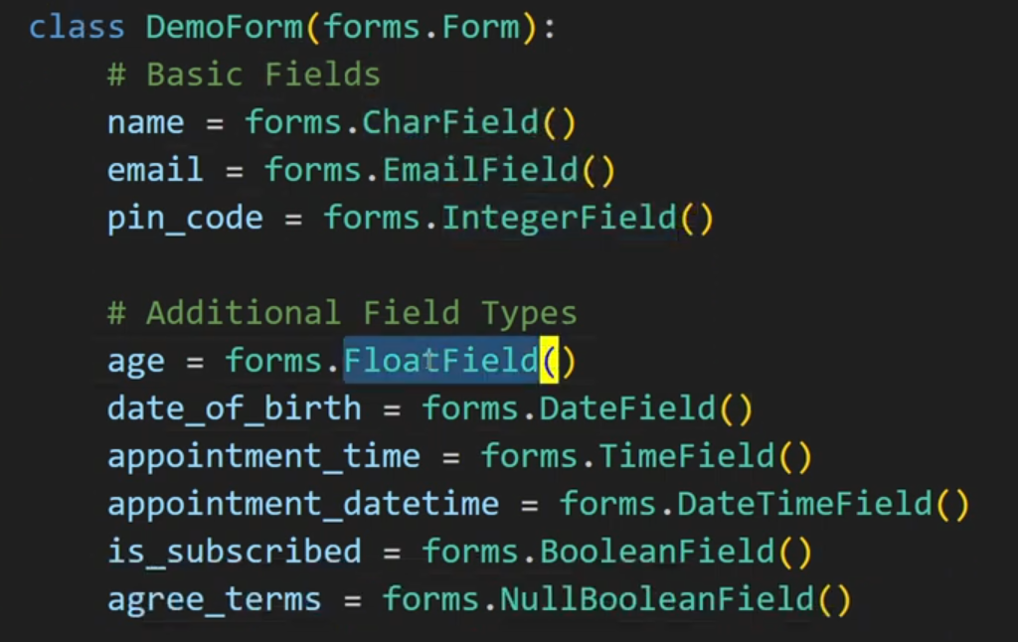

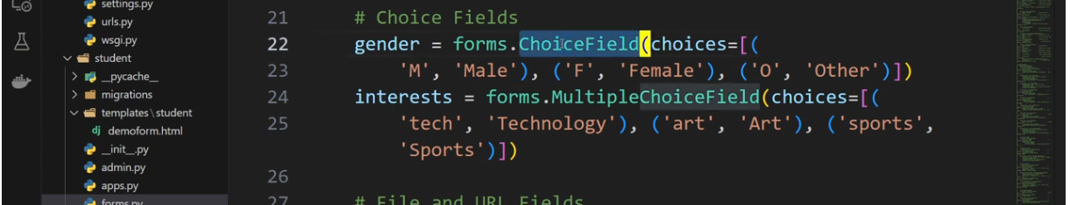

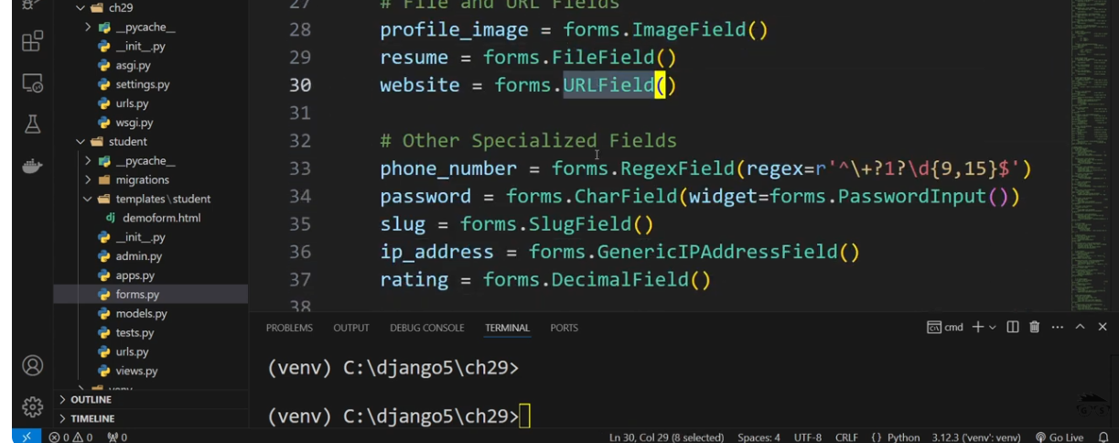
see this are some field

diffrence between choice and multiple choice is in choice you can select only one field , but in multiple choice you can select more than one

now we see some field options in form

a)
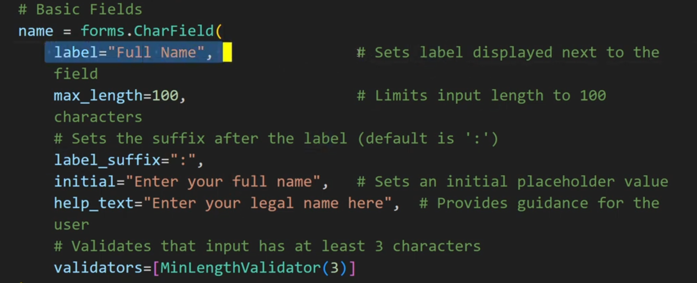
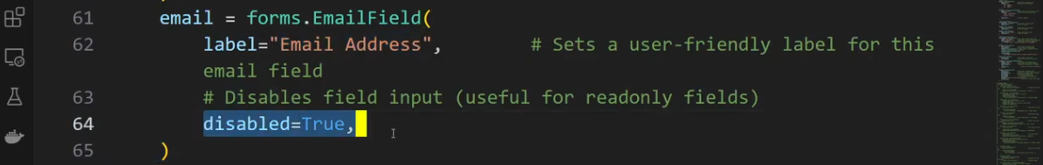
b)
c)
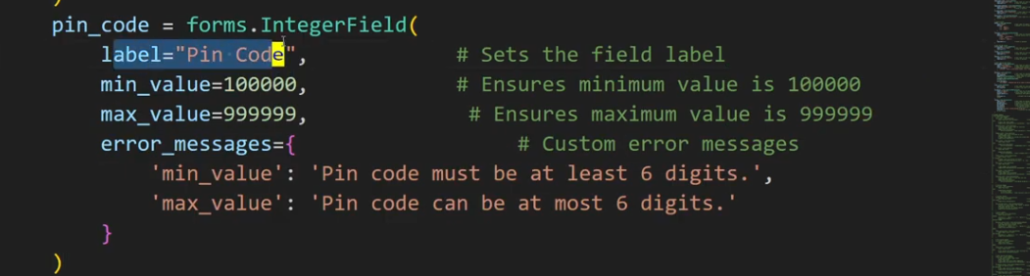
d)

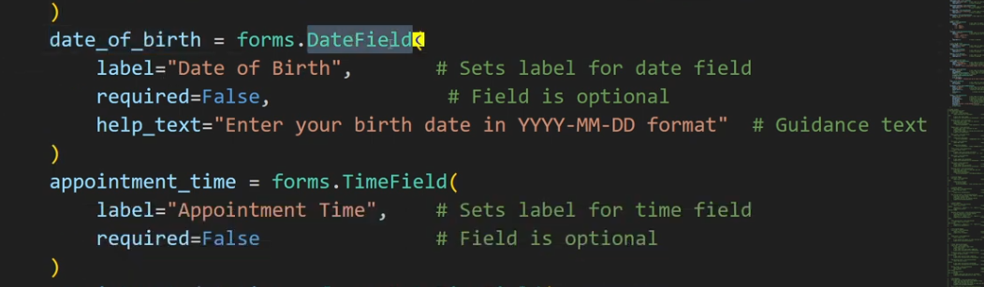
e)
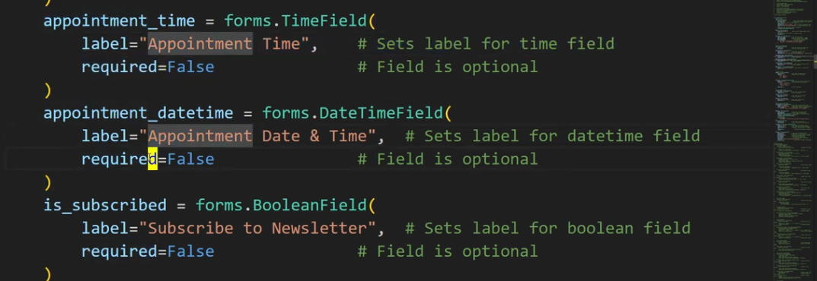
f)
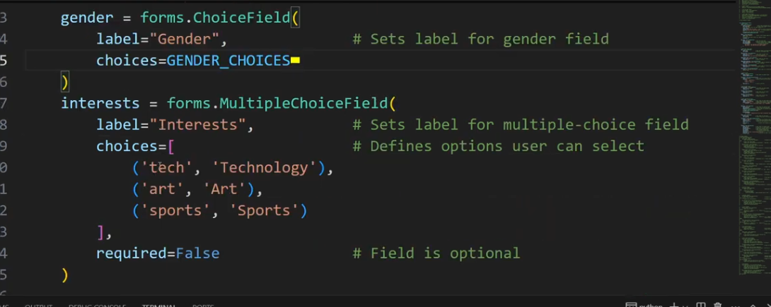
g)
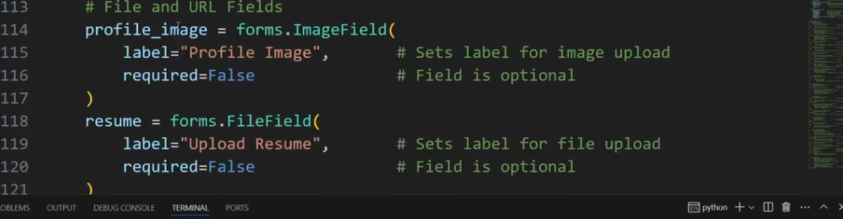
h)
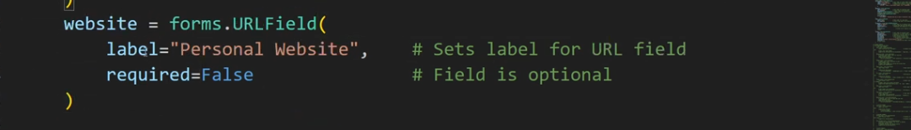
i)
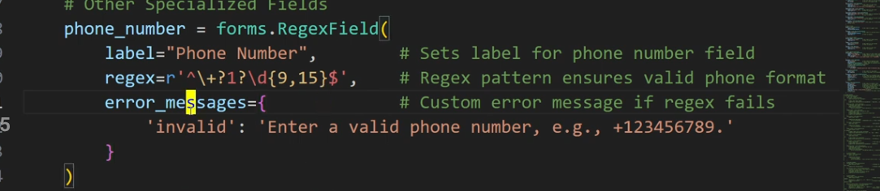
j)
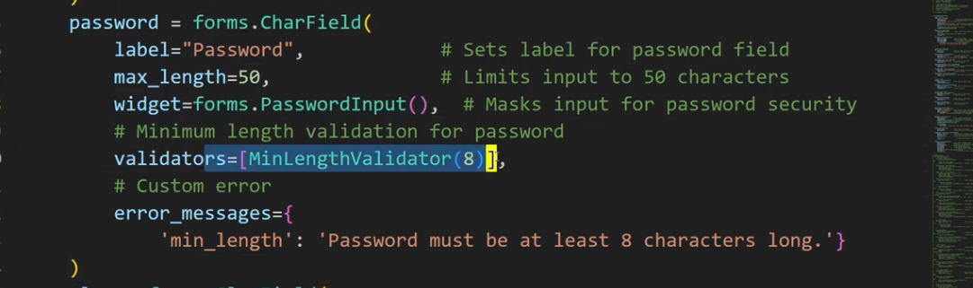
k)

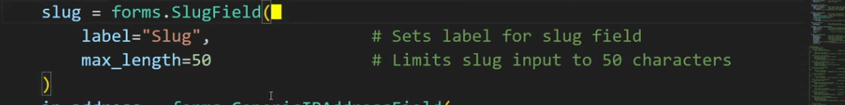
i)
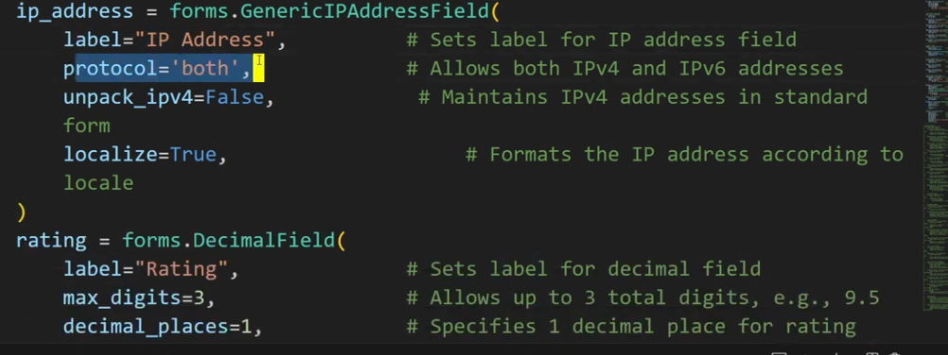
j)
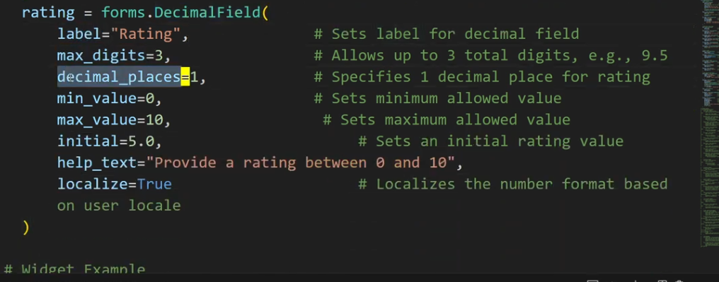
j
now we see some widgets in form

A widget is Django’s representation of an HTML input element. The widget handles the rendering of the HTML, and the extraction of data from a GET/POST dictionary that corresponds to the widget.
Widget = Form field ka HTML appearance (dikhne ka tarika)
👉 Matlab user ko input kaise dikhai dega, ye widget decide karta hai.

1️⃣ TextInput

✅ Used For
Normal text input.
name = forms.CharField(widget=forms.TextInput)

HTML Output
<input type="text">
📌 Used in:
- username
- title
- city
- product name

2️⃣ NumberInput

✅ Used For
Numeric values.
age = forms.IntegerField(widget=forms.NumberInput)
HTML:
<input type="number">
📌 Used in:
- age
- price
- quantity

3️⃣ EmailInput

✅ Used For
Email validation + browser validation.
email = forms.EmailField(widget=forms.EmailInput)
HTML:
<input type="email">
✅ Browser automatically checks email format.

4️⃣ PasswordInput ⭐

✅ Used For
Hidden password typing.
password = forms.CharField(widget=forms.PasswordInput)
HTML:
<input type="password">
✔ Characters hidden
✔ Login/Register forms

5️⃣ Textarea ⭐ (Very Important)

✅ Used For
Large text input.
description = forms.CharField(widget=forms.Textarea)
HTML:
<textarea></textarea>
📌 Used in:
- comments
- blog content
- feedback
- message box

6️⃣ CheckboxInput

✅ Used For
True / False values.
agree = forms.BooleanField(widget=forms.CheckboxInput)
HTML:
<input type="checkbox">
📌 Example:
✔ Accept terms & conditions

7️⃣ Select (Dropdown)

✅ Used For
Single choice dropdown.
CHOICES = [
("M","Male"),
("F","Female")
]
gender = forms.ChoiceField(
choices=CHOICES,
widget=forms.Select
)
HTML:
<select></select>

8️⃣ RadioSelect

✅ Used For
Multiple options shown as radio buttons.
gender = forms.ChoiceField(
choices=CHOICES,
widget=forms.RadioSelect
)
📌 User selects only one option.

9️⃣ SelectMultiple

✅ Used For
Multiple selection dropdown.
skills = forms.MultipleChoiceField(
choices=[("py","Python"),("js","JS")],
widget=forms.SelectMultiple
)
User can select many values.

🔟 CheckboxSelectMultiple ⭐

✅ Used For
Multiple checkbox selection.
skills = forms.MultipleChoiceField(
choices=[("py","Python"),("js","JS")],
widget=forms.CheckboxSelectMultiple
)
📌 Very common in:
- skills
- interests
- tags

1️⃣1️⃣ FileInput

✅ Used For
Uploading files.
file = forms.FileField(widget=forms.FileInput)
HTML:
<input type="file">
⚠️ Requires:
<form enctype="multipart/form-data">

1️⃣2️⃣ HiddenInput

✅ Used For
Hidden backend data.
token = forms.CharField(widget=forms.HiddenInput)
Not visible to user.

⭐ MOST IMPORTANT (Interview + Project)
If interviewer asks top widgets, say:
✅ TextInput
✅ Textarea
✅ PasswordInput
✅ Select
✅ RadioSelect
✅ CheckboxInput
✅ FileInput

🔥 Industry Tip (Very Important)
Instead of:
widget=forms.TextInput
Real projects use:
widget=forms.TextInput(attrs={
"class":"form-control",
"placeholder":"Enter name"
})
👉 Styling + Bootstrap control.

HANDLE GET AND POST REQUEST IN FORM

A) HANDLE GET POST REQUEST ---> khud se kr lena

B) DON’T DIRECT SAVE DATA OF FORM IN DATABASE FIRST VALIDATE IT .

c) cleaned data

b)
Views.py (see how i validate it )

def registration(req):
if req.method == 'POST':
# validate form
form = Student()
print(form)
return HttpResponseRedirect(reverse("student:registration"))
else :
fm = Student()
return render(req,"student/registration.html",{'form':fm})

see the highlighted field it’s give you form when you submit

a) form.is_valid() --> it will tell this form is valid or not
form = Student()
yaha pai Student empty hai it means abhi agar aap form.is_valid() doge to false aayeaga

def registration(req):
if req.method == 'POST':
# validate form
form = Student(req.POST)
if form.is_valid()://True
return HttpResponse("all set")
else :
fm = Student()
return render(req,"student/registration.html",{'form':fm})

there is one more problem of resubmission , this you can solve by redirecting , this onto another page or same page .
def registration(req):
if req.method == 'POST':
# validate form
form = Student(req.POST)
if form.is_valid():
return HttpResponseRedirect(reverse('student:registration'))// or you can user redirect
else :
fm = Student()
return render(req,"student/registration.html",{'form':fm})

c) cleaned_data

print(form.cleaned_data)

{'name': 'Ankit', 'email': 'adarshduveyv@gmail.com', 'password': 'Adarsh@123'}

a perfect form for you

def registration(req):

if req.method == 'POST':
form = Student(req.POST)

print(form.is_valid()) # run validation
print(form.errors) # DEBUG

if form.is_valid():
print(form.cleaned_data['name'])
print(form.cleaned_data['password'])
return HttpResponseRedirect(
reverse('student:registration')
)

else:
print("all this ")
form = Student()
return render(
req,
"student/registration.html",
{'form': form}
)

DJANGO FORM CUSTOM VALIDATORS

forms.py

from django import forms

class Student(forms.Form):
name = forms.CharField()
email = forms.EmailField()
password = forms.CharField(widget=forms.PasswordInput)

there is no validation here so to apply it see what can i do ?

a) from django.core import validators

b)from django import forms
from django.core import validators

class Student(forms.Form):
name = forms.CharField(validators=[validators.MaxLengthValidator(10)])
email = forms.EmailField()
password = forms.CharField(widget=forms.PasswordInput)

like this you can apply validators

CUSTOMIZE DJANGO FORM ERROR FIELD

forms.py

class Student(forms.Form):
name = forms.CharField(error_messages={'required':'Name is required'})
email = forms.EmailField(error_messages={'required':'Email is required'})
password = forms.CharField(widget=forms.PasswordInput,error_messages={'required':'password is required'})

by using this error_message in form model you can implement custom error message

b) now you can customize it in your form after adding this(error_message)

<form action="{% url 'student:registration'%}" method="post" novalidate>
{% csrf_token %}
{%for field in form%}
{{field.label_tag}} {{field}} {{field.errors}}
{%endfor%}
<button>submit</button>
</form>

now when error occred it will come in field.erros and it will display

now see this code abhi jo error aa rahi hai wo li mai aa rahi hai , mai cahta hu ki wo list mai na aaya normal aaya so what can i do ?

<!DOCTYPE html>
<html lang="en">
<head>
<meta charset="UTF-8">
<meta name="viewport" content="width=device-width, initial-scale=1.0">
<title>Registration</title>
</head>
<body>
<h1> Registration Form </h1>
<form action="/registration/" method="post" novalidate>
<input type="hidden" name="csrfmiddlewaretoken" value="aU1kk8Lx2ZNBUJ1Uv8fprEUYBEXINa3FUxUgiAUov9h1OsFCJPpHxqQogvhKxoeq">
<label for="id_name">Name:</label> <input type="text" name="name" required aria-invalid="true" aria-describedby="id_name_error" id="id_name"> <ul class="errorlist" id="id_name_error"><li>Name is required</li></ul>
<label for="id_email">Email:</label> <input type="email" name="email" maxlength="320" required aria-invalid="true" aria-describedby="id_email_error" id="id_email"> <ul class="errorlist" id="id_email_error"><li>Email is required</li></ul>
<label for="id_password">Password:</label> <input type="password" name="password" required aria-invalid="true" aria-describedby="id_password_error" id="id_password"> <ul class="errorlist" id="id_password_error"><li>password is required</li></ul>
<button>submit</button>
</form>
</body>
</html>

{{field.errors|striptags}} // by this li will not coe

---> field.errors contain multiple error
-->so you can also loop it

{for error in field.errors}
{{error}}

there are some error that is not field based ---> means it come on whole form

so django bolta hai ki aap top pai isko mention kr do ki agar aisa kuch aaya to handle ho jaye

{{form.non_field_erros}} --> isko csrf token kai just niche likhna

we can also apply colors in error list

.errorlist{
color:red
}
</style>
<body>
<h1> Registration Form </h1>
<form action="{% url 'student:registration'%}" method="post" novalidate>
{% csrf_token %}
{%for field in form%}
{{field.label_tag}} {{field}} {{field.errors}}
<br>
{%endfor%}
<button>submit</button>
</form>
</body>
</html>

JSON IN FORM

