INTERVIEW QUESTIONS

Q1) what is GIL ? What is the cons of gil .

----> it stands for global interpreter lock , it is a mechanism that allow , at a time one thread will execute .

1. Thread-Safe Memory Management
Reason:
GIL prevents multiple threads from corrupting Python objects.
Counter:
Other languages solve this with:
- atomic operations
- fine-grained locks ----> Database Row-Level Locking----> Instead of locking a whole table to update one row, the DBMS locks only the specific row being modified

Instead of one global lock, every object or structure has its own lock.
Example idea:
list_lock
dict_lock
object_lock

- lock-free data structures ----> Lock-Free Stack:
Examples:
- Java
- Go
They provide thread safety without blocking the whole interpreter.

2. Protects Reference Counting
Reason:
Reference counting updates must be thread-safe.
Ex counter += 1
Counter:
Reference counts can be updated using atomic increment/decrement instructions (the CPU updates a value in one indivisible step, so no other thread can interrupt it.)supported by modern CPUs.
Many systems already do this.

3. Simpler Interpreter Design
Reason:
GIL makes the interpreter easier to implement.
Counter:
Ease for interpreter developers should not limit performance for millions of users.
Many interpreters manage complexity without a global lock.

4. Faster Single-Thread Performance
Reason:
Without locks everywhere, single-thread programs run faster.
Counter:
Modern CPUs have:
- cheap atomic operations---> LOCKINC , LOCKDEC
NOTE ---> The GIL may be removed in the future so Python programs can use multiple CPU cores and achieve true parallel execution. SAID BY SAM GROSS
Performance difference today is much smaller than in the 1990s.

5. Safe C Extension Integration
Reason:
Extensions rely on GIL to safely access Python objects.
Counter:
Extensions could instead use:
- explicit locks
- atomic APIs
- thread-safe interfaces
This is how most other ecosystems work.
Simple memory trick
Concept | Python Example
Explicit lock | threading.Lock()
Atomic-like operation | itertools.count()
Thread-safe structure | queue.Queue()

6. Prevents Race Conditions
Reason:
Multiple threads modifying objects could break them.
Counter:
Languages solve this using:
- synchronized blocks----> threading.lock , and ther is a code A it is executing so b will execute after it is free
- immutable data----> it doesnot change after creation
Race conditions are handled without global locking.

7. Reduces Deadlocks
Reason:
Fewer locks means fewer deadlocks.
Counter:
The GIL itself causes performance bottlenecks.
Deadlocks can still happen in user code anyway.

8. Compatibility With Existing Code
Reason:
Removing GIL could break existing libraries.
Counter:
Backward compatibility can be maintained with:
- compatibility layers
- transition APIs
- gradual migration
Many languages evolve this way.

9. Easier Debugging
Reason:
Less concurrency makes debugging easier.
Counter:
Debugging tools for concurrency have improved dramatically:
- thread analyzers
- race detectors
- profilers
So this is less of a concern today.

10. Interpreter Stability
Reason:
Without GIL the interpreter might crash more.
Counter:
a) fine graded lock
b) atomic operations ---> list.append()
c) lock free data structures

5 solids point that no one coutner it ?

1️) It Prevents True Multi-Core Parallelism for CPU Work
The biggest limitation of the GIL is that only one thread can execute Python bytecode at a time.
So even if a machine has:
- 4 cores
- 8 cores
- 32 cores
a CPU-bound Python program will effectively use only one core.
Example tasks affected:
- image processing
- scientific computing
- machine learning preprocessing
- data analytics
Other runtimes like Java and Go can use all CPU cores with threads, but Python threads cannot.
This is a fundamental scalability limitation.

2️) It Forces Developers to Use Multiprocessing Instead of Threads
Because of the GIL, Python developers often have to use multiprocessing to achieve parallelism.
Problems with multiprocessing:
- higher memory usage
- expensive process creation
- slow inter-process communication
- complex architecture
Threads would normally solve this more efficiently, but the GIL prevents that.

3️) It Makes CPU-Bound Python Code Much Slower Than Other Languages
For workloads like:
- numerical simulations
- heavy computations
- real-time systems
Python performs worse because threads cannot run simultaneously.
That’s why many Python libraries move heavy work to C libraries like:
- NumPy
- TensorFlow
- PyTorch
This shows that Python itself cannot scale CPU workloads efficiently without external help.

4) It Limits Python’s Use in High-Performance Systems
Because of the GIL, Python is rarely used directly for:
- high-frequency trading engines
- game engines
- real-time simulation systems
- high-performance distributed systems
Instead, developers rely on languages designed for concurrency like:
- Rust
- Go
- Java
Python is often used as a wrapper around faster systems.

MONLITHIC ARCHITECTURE

mono --> single
lithic---> block

The basic explanation of monolith architecture is that a single, centralized code base manages all application functions.

The main reason of using relational database is it’s include acid properties
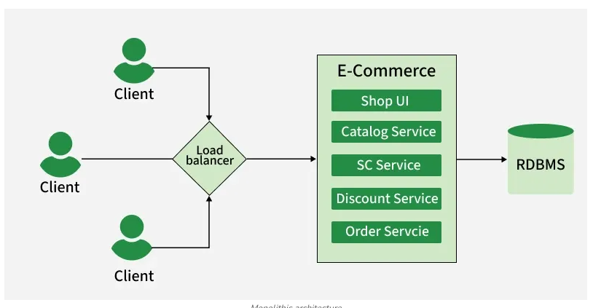
charcteristic

Single Codebase: All components are developed and maintained in one codebase, simplifying management.
- Tight Coupling: Components are closely linked and often depend on each other.
- Shared Memory: Components communicate efficiently using the same memory space without network overhead.
- Centralized Database: A single database instance handles all data storage.
- Layered Structure: Separate layers (data, business logic, presentation) exist but may create inter-layer dependencies.
- Limited Scalability: Scaling requires the whole application, often causing inefficiencies and higher resource use.

Design Principles of Monolithic Systems
Monolithic system design focuses on preserving manageability, consistency, and simplicity within a single codebase. Some of the key design principles are:
- Modularity: Structure the code in separate modules even within a single codebase.
- Separation of Concerns: Keep different responsibilities (UI, business logic, data access) separate for clarity and easier debugging.
- Scalability: Design for horizontal scaling using caching, asynchronous processing, and optimized components.
- Encapsulation: Expose only necessary interfaces while hiding internal implementation to reduce dependencies.
- Consistency: Maintain consistent coding styles, design patterns, and principles across the codebase.
To scale monolithic we can do , vertical scaling then caching .

Cookie Parameters(third)

It is a sister of query ,path and body means it is user inside :
i said it sister because it also pass inside annotate .
from typing import Annotated
from fastapi import Cookie, FastAPI
app = FastAPI()
@app.get("/items/")
async def read_items(ads_id: Annotated[str | None, Cookie()] = None):
return {"ads_id": ads_id}

how to pass cookies :
a) open hopscoth
b) go to header
c) in key select cookie
d) in value put ---> ads_id=1234

note ---> at a time we can only give on meta option eitehr query,path or Cookie etc

HEADER

It is a sister , of query , path ,body and cookie,

@app.get("/header/")

async def check_header(header:Annotated[str|None ,Header()]):
return {"header":header}

how to send header

a) just go on hopsocth
b) then go into header
c) key write header
d) in value write the value

WHY RAW SQL IS BETTER THAN ORM ?

-----> ANSWER

1) Better Performance

Raw SQL can be faster because it directly interacts with the database without the abstraction layer that ORMs add.

Abstraction layer means , in orm first query inteact with classes ,then orm translate it into query

2) 2. Full Control Over Queries

With raw SQL, developers have complete control over the query structure, joins, indexes, and execution.
ORM, the framework automatically generates SQL queries from your code

3. Optimized Complex Queries
Very complex joins, window functions, and aggregations are easier and more efficient in SQL than in ORM.
ORM must first translate high-level code into SQL, which can make complex operations harder and sometimes inefficient.

4. Smaller Memory Usage
ORM often loads objects into memory, while SQL can fetch only the required data.

5. Better Control Over Transactions

SQL allows precise control over:
- transactions
- locking
- isolation levels
ORMs abstract these details to make development easier, but that reduces low-level control.
Low-level control = direct control over database commands and behavior.

6) Better Control Over Joins
In SQL you can precisely control:
- INNER JOIN
- LEFT JOIN
- RIGHT JOIN
- FULL JOIN
ORM sometimes generates inefficient joins automatically.
We know N+1 query problem

N+1 Query Problem (Common ORM Issue)
Example ORM code:
orders = Order.objects.all()
for order in orders:
print(order.user.name)
Generated queries:
SELECT * FROM orders; -- 1 query
SELECT * FROM users WHERE id=1;
SELECT * FROM users WHERE id=2;
SELECT * FROM users WHERE id=3;
SELECT * FROM users WHERE id=4;
If there are 100 orders, ORM might execute 101 queries.

7) Easier Database Migration Between Tools
SQL is a universal language supported by almost every database.
ORM code is often framework-specific (Django ORM, SQLAlchemy, etc.), making migration harder.

8). More Control Over Data Retrieval
With SQL you can select exactly what you want:
SELECT name, email FROM users;
ORM may sometimes fetch extra fields unnecessarily.

9) Better Learning and Understanding of Databases
When developers write raw SQL, they directly work with concepts like:
- joins
- indexes
- query optimization
- normalization
This helps them understand how databases actually work.
ORM hides many of these internal operations, so developers may not fully understand what is happening inside the database.

WHY FASTAPI IS POPULAR IN NOW A DAYS IN AIML FIELD

a) Buitl on starleete and powered by asgi it can handle ten thousand of request per second

🚀 1. Super Fast (Performance)
- iAPI fast hona must hai
2) Automatic validation via pydantic --> error ,type , reliablity etc
3) auto generate swagger docs that include all your apiendpoints , so we don’t have to generate it manually

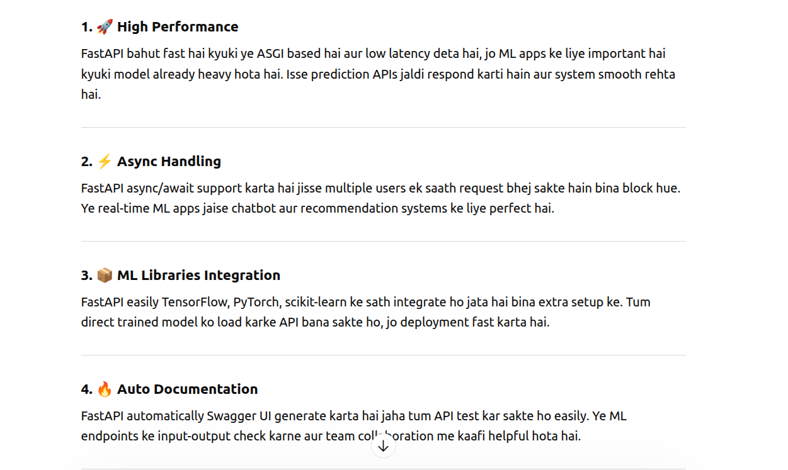
a
