STREAMLIT

for my project first we understand how to make this chat interface in streamlit
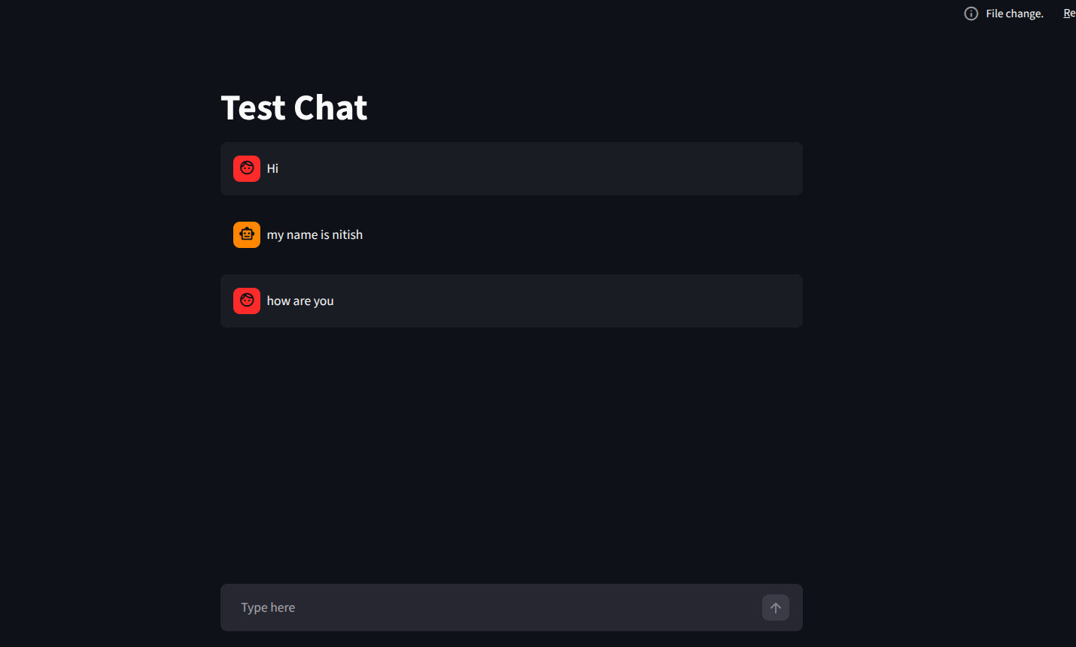

import streamlit as st
# from langgraph_backend import chatbot
from langchain_core.messages import HumanMessage

if 'message_history' not in st.session_state:
st.session_state['message_history'] = []

# loading the conversation history
for message in st.session_state['message_history']:
with st.chat_message(message['role']):
st.text(message['content'])

#{'role': 'user', 'content': 'Hi'}
#{'role': 'assistant', 'content': 'Hi=ello'}

user_input = st.chat_input('Type here')

if user_input:

# first add the message to message_history
st.session_state['message_history'].append({'role': 'user', 'content': user_input})
with st.chat_message('user'):
st.text(user_input)

st.session_state['message_history'].append({'role': 'assistant', 'content': user_input})
with st.chat_message('assistant'):
st.text(user_input)

