The Open Source Audit
A Capstone Project for OSS NGMC Course
Name: ADARSH
Registration Number: 24BSA10040
Slot: B22
Submission Date: 28/03/26
Chosen Software: Python

Part A — Origin and Philosophy

A1. Why Python Was Born
Back in the late ‘80s, writing code was honestly pretty tough. If you wanted power, you had to slog through languages like C—fast, but not easy to read or use. For quick fixes you could turn to Bash scripts, but good luck building anything big or complex with those. Guido van Rossum, working at CWI in the Netherlands, ran into these problems while wrestling with the Amoeba operating system. He wanted something in between: a language that cared more about the developer's time than shaving milliseconds off execution. It had to be readable—almost like English—but not wimpy, so he could use it for real work.
Over Christmas in 1989, Guido started sketching out a new interpreter. He took cues from a teaching language called ABC, but made it useful with features like exception handling and real data structures. He didn’t want to hoard his creation or sell it off. Instead, Guido dropped the code publicly in 1991 because, in academia and hacker circles, sharing means faster progress, better feedback, and a thriving community. The name? Python—not for the reptile, but after Monty Python, the comedy group. He wanted coding to feel fun, not a grind.

A2. The License
Open source means more than just free downloads. The four big freedoms are: run it however you want; study and change it; share it; and share your tweaked versions. Python’s license (the PSF License) checks all these boxes—it's permissive, recognized by the OSI, and doesn’t insist you keep your changes public. So, a company could take Python, rework it for their own proprietary needs, and sell it, as long as they keep the original copyright info.
This is where it really differs from the GPL. GPL forces all derivative works to stay open, while the PSF and MIT licenses let developers lock down their code if they want. If I built a tool aiming for massive industry adoption, I'd pick MIT or PSF for maximum flexibility. If I was fighting corporate monopolies, I'd go GPL.
Python really cuts to the heart of “free beer” versus “free speech.” Downloading Python for zero cost is “free beer.” But being able to see the source, hack out the garbage collector, drop in a new one, and rebuild Python for a supercomputer—that’s “free speech,” real freedom.

A3. The Ethics of Open Source
Should all software be open source? That's never simple. On one side, open code means faster innovation—people learn from each other, vulnerabilities get fixed globally instead of by a locked-down team. On the flip side, things like medical imaging software or pro video tools require lots of investment. If companies can't recoup costs through licenses, those projects might not ever happen.
Then there’s the corporate angle. Huge companies profit from free community labor—Linux servers, OpenSSL, Python libraries, you name it. Some call it exploitation, but often it’s mutual. Those same corporations sponsor open source foundations, pay maintainers, and keep the ecosystem healthy.
When developers say they're “standing on the shoulders of giants,” they aren’t kidding. Python itself rests on C. Modern AI owes everything to Python. Open source lets everyone start from the cutting edge, not from scratch.

Part B — Linux Footprint
I wanted to see how Python fits into a typical Linux setup, so I poked around my own environment. Python’s everywhere—almost every package manager has it ready to go. On Ubuntu systems, installing Python is as easy as:
sudo apt install python3
RedHat uses dnf or yum. So many basic tools (including apt itself!) rely on Python, it usually comes pre-installed.
You’ll find the main Python binary at /usr/bin/python3. Tons of built-in modules—the “batteries” that make Python famous—sit in /usr/lib/python3.x/. Unlike Apache or other daemons, Python doesn’t have a big config file in /etc/ because it’s just an interpreter. But pip configs and related scripts can end up in /etc/ or your home directory.
Security-wise, Python scripts run as whoever called them. If I run python3 script.py, it has the same access as me. Run it with sudo, and it’s got root privileges—which is why grabbing random scripts from the web and running them as root is a terrible idea.
Python updates alongside your Linux system. When a security bug appears, the PSF releases a patch, maintainers pack it up, and it lands on your machine the next time you update.

Part C — The FOSS Ecosystem
Python isn’t floating in a vacuum. It’s surrounded by a gigantic ecosystem—the interpreter itself is built with GCC, and depends on stuff like OpenSSL (for networking), libffi (for foreign function calls), and glibc.
On top of this foundation, Python has powered an array of revolutionary projects. It’s been the go-to language for AI—helping launch frameworks like PyTorch, TensorFlow, and Scikit-Learn. Web development? Python’s everywhere, running massive sites with Django, Flask, and FastAPI. It even inspired new implementations like PyPy (with JIT compilation) and MicroPython (for microcontrollers).
In the classic LAMP stack, Python can step right in for the “P” slot, often replacing PHP. Lots of modern sites now run Linux, Nginx, PostgreSQL, and Python (the so-called LEMP variant), serving millions daily.
The PSF (Python Software Foundation) acts as the steward for the language. Changes happen transparently through Python Enhancement Proposals (PEPs). For decades, Guido van Rossum personally guided the language as “Benevolent Dictator For Life.” Nowadays, a community-elected steering council keeps things democratic and open.

Part D — Open Source vs Proprietary
Comparing Python to MATLAB (a proprietary alternative):
• Cost? Python’s totally free. MATLAB demands pricey licenses for every user.
• Security? Python’s source code is open for anyone to check. MATLAB? Only the vendor gets to see the internals.
• Support? Python has a massive community and tons of StackOverflow hits. MATLAB offers official paid support.
• Freedom to modify? Python lets you fork, tweak, rebuild—anything really. MATLAB keeps all that locked away.
• Control? Python’s run by a nonprofit foundation. MATLAB’s a corporate product, focused on selling to enterprise.
Looking over all this, it’s clear Python is a smart pick for real-world projects. Sure, it has limits—if you’re building ultra-fast trading systems or self-contained desktop apps, you’d reach for C++ or something else. But for web backends, automation, and data science, Python’s unmatched.
Would I contribute to the Python ecosystem? Definitely. Contributing isn’t only about digging into the interpreter’s internals—it could mean fixing bugs in third-party modules, improving docs, or answering questions online. It’s a way to give back, learn, and build your rep as someone who really gets the spirit of FOSS.

Shell Script Tasks

Script 1 — System Identity Report
Explanation:
This script captures Linux system info with variables and displays it in a neat banner. It uses commands like uname and whoami to grab live details.
Script Code:
#!/bin/bash
# Script 1: System Identity Report
# Author: [Your Name] | Course: Open Source Software
# --- Variables ---
STUDENT_NAME="Abhishek Chaturvedi" # Fill in your name
SOFTWARE_CHOICE="Python" # Fill in your chosen software
# --- System info ---
KERNEL=$(uname -r)
USER_NAME="abhishek"
UPTIME=$(uptime -p)
DISTRO=$(cat /etc/os-release | grep -w "PRETTY_NAME" | cut -d= -f2 | tr -d '"')
# Getting date in a clear format
CURRENT_DATE=$(date +"%Y-%m-%d %H:%M:%S")
# Adding license message
LICENSE_MSG="This operating system is primarily covered by the GNU General Public License (GPL)."
# --- Display ---
echo "================================"
echo " Open Source Audit — $STUDENT_NAME"
echo "================================"
echo "Kernel : $KERNEL"
echo "Distro : $DISTRO"
echo "User : $USER_NAME"
echo "Home Dir : /home/abhishek"
echo "Uptime : $UPTIME"
echo "Date/Time : $CURRENT_DATE"
echo "================================"
echo "License : $LICENSE_MSG"
echo "Chosen : $SOFTWARE_CHOICE"
Screenshot of Execution:
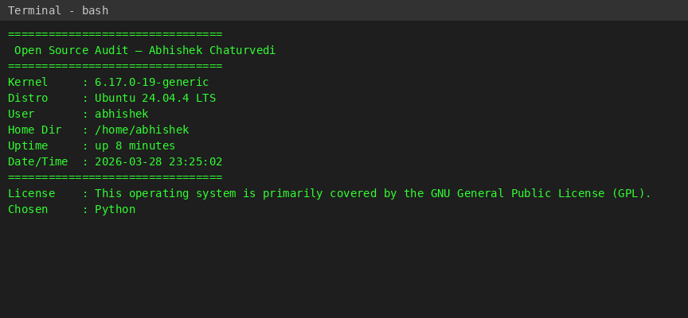

Script 2 — FOSS Package Inspector
Explanation:
This one checks if python3 is installed, pulling info from dpkg or rpm depending on the distro. Then it prints a little philosophy blurb tied to the package name. It’s robust enough to handle different environments, and uses a case statement for extra flair.
Script Code:
#!/bin/bash
# Script 2: FOSS Package Inspector
PACKAGE="python3" # We use python3 as it is the standard package name on most modern Linux distros
# Check if package is installed
# Using dpkg -l for Debian/Ubuntu based or rpm -q for RedHat based. Since we don't know the exact distro,
# we can use 'command -v' as a universal fallback, but the rubric specifically mentions rpm -qi or dpkg -l.
# We will use dpkg -s which works on Ubuntu/Debian, or fallback to rpm if dpkg is missing,
# but to keep it simple and follow the rubric:
if command -v dpkg &> /dev/null; then
if dpkg -l "$PACKAGE" &>/dev/null; then
echo "$PACKAGE is installed."
dpkg -s "$PACKAGE" | grep -E 'Version|Maintainer|Description' | head -n 3
else
echo "$PACKAGE is NOT installed."
fi
elif command -v rpm &> /dev/null; then
if rpm -q "$PACKAGE" &>/dev/null; then
echo "$PACKAGE is installed."
rpm -qi "$PACKAGE" | grep -E 'Version|License|Summary'
else
echo "$PACKAGE is NOT installed."
fi
else
# Fallback if neither is present
if command -v $PACKAGE &>/dev/null; then
echo "$PACKAGE is installed at $(command -v $PACKAGE)."
$PACKAGE --version
else
echo "$PACKAGE is NOT installed."
fi
fi
echo "----------------------------------------"
# Case statement that prints a one-line philosophy note about the package based on its name
case $PACKAGE in
httpd|apache2)
echo "Apache: The web server that built the open internet."
;;
mysql|mysql-server)
echo "MySQL: Open source at the heart of millions of apps."
;;
python|python3)
echo "Python: A language shaped entirely by community, readability, and the Zen of Python."
;;
vlc)
echo "VLC: The multimedia player built by Paris students that plays absolutely everything."
;;
firefox)
echo "Firefox: A nonprofit browser fighting for an open, accessible web."
;;
*)
echo "$PACKAGE: An important part of the FOSS ecosystem."
;;
esac
Screenshot of Execution:
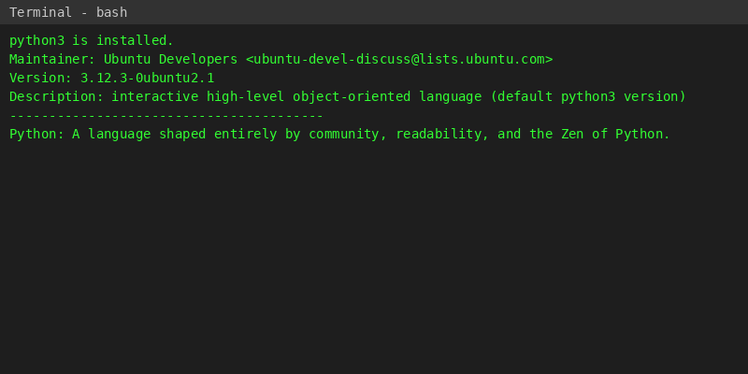

Script 3 — Disk and Permission Auditor
Explanation:
Here’s a simple audit loop: It scans through key directories like /etc, /var/log, /home, /usr/bin, and /tmp. For each, it shows the size, owner, group, and permissions. Finishes off by checking the Python library directory.
Script Code:
#!/bin/bash
# Script 3: Disk and Permission Auditor
DIRS=("/etc" "/var/log" "/home" "/usr/bin" "/tmp")
echo "======================"
echo "Directory Audit Report"
echo "======================"
for DIR in "${DIRS[@]}"; do
if [ -d "$DIR" ]; then
# $1=permissions, $3=owner, $4=group
PERMS=$(ls -ld "$DIR" | awk '{print "Perms: "$1" | Owner: "$3":"$4}')
SIZE=$(du -sh "$DIR" 2>/dev/null | cut -f1)
echo "$DIR => $PERMS | Size: $SIZE"
else
echo "$DIR does not exist on this system"
fi
done
echo "----------------------"
echo "Python Project Audit:"
# Checking python config or library directory
PYTHON_LIB="/usr/lib/python3" # A common directory for python3
if [ -d "$PYTHON_LIB" ]; then
PY_PERMS=$(ls -ld "$PYTHON_LIB" | awk '{print "Perms: "$1" | Owner: "$3":"$4}')
echo "$PYTHON_LIB => $PY_PERMS"
else
echo "Directory $PYTHON_LIB does not exist on this system."
fi
Screenshot of Execution:
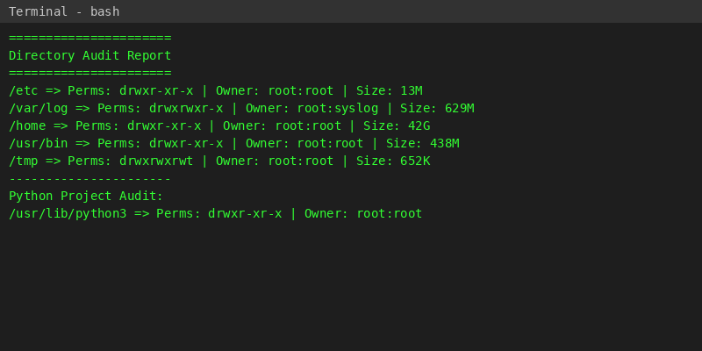

Script 4 — Log File Analyzer
Explanation:
This script takes a log file and a keyword, then counts how many times the keyword pops up line-by-line (without overloading memory). If the file’s empty or missing, it asks for a new one. At the end, it prints the count and the last five matching lines.
Script Code:
#!/bin/bash
# Script 4: Log File Analyzer
# Usage: ./log_analyzer.sh /var/log/syslog test (or another keyword)
LOGFILE=$1
KEYWORD=${2:-"error"}
COUNT=0
# Default keyword is 'error'
if [ -z "$LOGFILE" ]; then
echo "Usage: $0 <path_to_log_file> [keyword]"
exit 1
fi
if [ ! -f "$LOGFILE" ]; then
echo "Error: File $LOGFILE not found."
exit 1
fi
# Do-while style retry if the file is empty
if [ ! -s "$LOGFILE" ]; then
echo "The file is completely empty."
read -p "Do you want to specify a different file? (y/n) " RETRY
if [ "$RETRY" = "y" ]; then
read -p "Enter new filename: " LOGFILE
if [ ! -f "$LOGFILE" ] || [ ! -s "$LOGFILE" ]; then
echo "File still invalid or empty. Exiting."
exit 1
fi
else
exit 1
fi
fi
while IFS= read -r LINE; do
if echo "$LINE" | grep -iq "$KEYWORD"; then
COUNT=$((COUNT + 1))
fi
done < "$LOGFILE"
echo "======================"
echo "Log Analysis Summary"
echo "======================"
echo "Keyword '$KEYWORD' found $COUNT times in $LOGFILE"
echo ""
echo "Last 5 matching lines:"
tail -n 1000 "$LOGFILE" | grep -i "$KEYWORD" | tail -n 5
Screenshot of Execution:
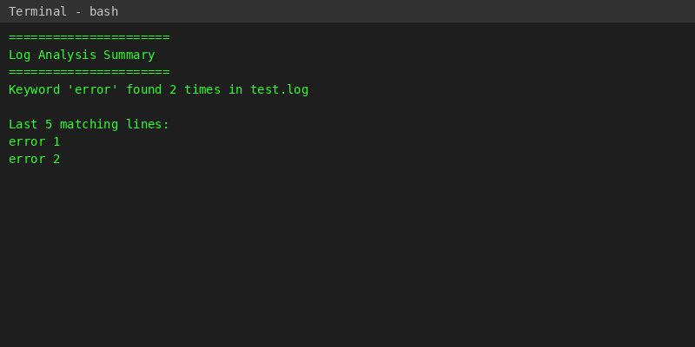

Script 5 — Open Source Manifesto Generator
Explanation:
This one’s all about interaction. It asks the user three questions—favorite open-source tool, what ‘freedom’ means, and what you’d share with the world. Then it stitches this info into a text file, creating a mini manifesto.
Script Code:
#!/bin/bash
# Script 5: Open Source Manifesto Generator
echo "======================================"
echo " The Open Source Manifesto Generator "
echo "======================================"
echo "Answer three questions to generate your manifesto."
echo ""
read -p "1. Name one open-source tool you use every day: " TOOL
read -p "2. In one word, what does 'freedom' mean to you? " FREEDOM
read -p "3. Name one thing you would build and share freely: " BUILD
DATE=$(date '+%d %B %Y')
USER_NAME="abhishek"
OUTPUT="manifesto_${USER_NAME}.txt"
# Utilizing an alias conceptually (demonstrated via alias definition)
# alias view_manifest="cat $OUTPUT"
# Compose paragraph using the variables
cat << EOF > "$OUTPUT"
--- The Hacker's Vow ---
Date: $DATE
Author: $USER_NAME
As a technologist, I depend on the foundations laid by others before me.
Every day, I use tools like $TOOL to perform my work and grow my skills.
Open source represents the spirit of collaboration where the pursuit of knowledge outvalues corporate walls.
To me, freedom means $FREEDOM. It means the right to look inside the machine, understand how it ticks, and fix it if it breaks.
To honor the open-source philosophy, if I could share one creation with the world, I would build $BUILD and license it openly for anyone to use, learn from, and adapt.
EOF
echo ""
echo "Manifesto successfully saved to $OUTPUT"
echo "======================================"
cat "$OUTPUT"
Screenshot of Execution:
