

**“AUBERGE”**

### Project Report for

**Internet and Web Technology Lab**

**DEEPJYOTI NAYAK (A1, 2)**

**ADARSH KUMAR DALAI (A1, 15)**

**SHIBASHISH CHAULIA (A1, 19)**

**SABYASACHI NANDA (A2, 22)**



**DEPARTMENT OF COMPUTER SCIENCE AND ENGINEERING**

**SILICON INSTITUTE OF TECHNOLOGY**

**SILICON HILLS, BHUBANESWAR – 751024, ODISHA, INDIA**

**December, 2023**

**Table of Content**

1. Abstract
2. Introduction
3. System Analysis

3.1 Objective

3.2 Scope

3.3 Functionalities of the System

3.4 Tools & Environment

1. Technical Specification

4.1 HTML

4.2 CSS

4.3 JavaScript

4.4 JSP

4.5 Oracle/ MySQL

4.6 Apache Tomcat

1. System Design

5.1 Use Case Diagram

5.2 Flow Diagram

5.3 ERD

5.4 Table Structure/Relational Model

1. Implementation Screen Shot
2. Conclusion and Future Work
3. Bibliography

**ABSTRACT**

The "Auberg" website emerges as a fundamental digital solution catering to the needs of students seeking suitable hostel and mess accommodations near their educational institutions. Developed with an acute focus on user convenience, this platform endeavors to simplify the intricate process of identifying and selecting appropriate lodging. This report serves as a comprehensive documentation of the meticulous development journey, highlighting the methodologies, technical tools utilized, and the integration of software engineering principles that culminated in the creation of the "Auberg" website. Embodying a user-centric approach, the platform is meticulously designed to provide a seamless and tailored experience, offering students a centralized hub to explore, select, and customize accommodations based on their preferences and specific requirements. By facilitating a more efficient and user-friendly process, the "Auberg" website strives to significantly enhance the overall educational journey for students, ensuring a comfortable and conducive living environment away from home.

**INTRODUCTION**

The "**Auberge**" website aims to address a pressing need encountered by students when relocating for education: finding suitable accommodations. Crafted with a user-centric approach, the platform endeavors to simplify the often challenging task of securing comfortable lodging. By offering an intuitive and efficient solution, the website endeavors to enhance the overall educational experience for students studying away from their homes.

**Key Components:**

**Technological Stack**: The system is built using HTML and CSS for a user-friendly interface, JSP for dynamic content generation, and an Oracle Database for robust data storage and management. The development environment is Eclipse IDE, ensuring a cohesive and efficient workflow.

**Dynamic Interactions**: JSP plays a pivotal role in enabling dynamic content generation, allowing seamless interactions between the user interface and the Oracle Database. This ensures a responsive and interactive platform for input, retrieval, and updating of student academic records.

**Reliable Backend**: The Oracle Database serves as the backend powerhouse, ensuring data integrity, security, and efficient management. It acts as a centralized repository for storing and retrieving student records, emphasizing scalability and performance.

**Deployment on Tomcat**: The system is deployed on the Tomcat server, prioritizing scalability, security, and performance. This ensures that the platform is accessible across various browsers and devices, accommodating the diverse needs of educational institutions.

**OBJECTIVE**

The core objective of the "Auberg" website is to revolutionize the process of seeking accommodations for students studying away from their homes. Through a user-centric and comprehensive digital platform, "Auberg" aims to simplify the daunting task of finding suitable hostel and mess accommodations near educational institutions. By offering an intuitive and centralized hub, the website facilitates hassle-free user registration, empowering students to explore a diverse range of accommodations that align with their preferences, budget, and proximity to their educational centers. Moreover, the platform enables users to personalize meal plans, borrow books from a virtual library, and conveniently select transportation options, all tailored to their specific needs and schedules. "Auberg" endeavors to enhance the overall educational experience by providing students with a seamless and efficient solution, ensuring a comfortable and conducive living environment away from home.

**SCOPE**

The scope of the “Auberge” is defined by the range of functionalities and features it offers to users. Here are some aspects of the scope based on the information provided:

**Accommodation Management:** The "Auberg" website offers a comprehensive system for students seeking hostel and mess accommodations in areas near educational institutions. It allows users to explore, select, and personalize their accommodation preferences based on location, amenities, pricing, and proximity to educational facilities.

**User Registration and Customization:** Students can register and create personalized profiles on the platform. Registration involves capturing essential information for identification and preference customization, enabling tailored recommendations and personalized experiences.

**Facility-specific Features:** The website facilitates specific functionalities, such as meal preference customization, book borrowing from a virtual library, and convenient transport selection to educational institutions, aiming to cater to students' diverse needs.

**Dynamic Interface and Personalized Content:** Utilizing responsive design and dynamic content generation techniques, the platform ensures an interactive and user-friendly interface. Content is personalized based on user interactions and preferences, enhancing the overall user experience.

**Database Management and Security:** Efficient data management utilizing robust database technologies (Oracle/MySQL) ensures the secure storage and management of user profiles, accommodation details, preferences, and transaction records. The system implements stringent security measures, including access controls and encrypted data transmission, to safeguard user information.

**Scalability and Compatibility:** Designed for scalability, the website can accommodate an expanding user base and increased data volume without compromising performance. Compatibility across various web browsers ensures accessibility for a wide range of users.

**User Experience Enhancement:** Aiming for a positive user experience, the platform incorporates an intuitive interface, easy navigation, and quick access to essential functionalities, prioritizing user satisfaction.

**Documentation and Reporting:** Comprehensive documentation, including flow charts, diagrams, and user guides, aids in understanding the platform's functionality. Additionally, the system may include reporting features providing insights into user preferences, accommodation trends, and user engagement metrics.

Understanding the scope of the "Auberg" website delineates the functionalities and features vital for delivering a user-centric platform, meeting the diverse accommodation needs of students studying away from their homes.

**FUNCTIONALITIES OF THE SYSTEM**

* **User Sign-up:** Enables new users to register by providing essential details like name, email, and password, establishing personalized profiles for accommodation preferences and service usage.
* **User Authentication:** Validates registered users through email and password verification, granting access to explore accommodations, schedule appointments, and manage preferences.
* **Provider Sign-up:** Allows hostel/mess providers to register by entering details like establishment name, contact information, and services offered, creating dedicated profiles for listing accommodations.
* **Provider Authentication:** Validates providers' credentials to access and manage their hostel/mess listings, availability, and service details.
* **Accommodation Search and Booking:** Provides users with a search feature to explore available hostel/mess accommodations based on location, amenities, pricing, and proximity to educational institutions. Allows users to book preferred accommodations.
* **User Preferences Management:** Enables users to set and manage accommodation preferences such as room type, meal plans, amenities, and proximity to educational facilities.
* **System Monitoring:** Enables monitoring of user activity, accommodation availability, and service utilization for effective system management and performance evaluation.

**TOOLS AND ENVIRONMENT**

The “Auberge” involves the use of various tools and environments for both front-end and back-end development, as well as for database management. Here's a breakdown of the tools and environment based on the information provided:

1. Oracle 11g

2. Tomcat Server (version 9.0)

3. Eclipse IDE

4. Web Browser

**TECHNICAL SPECIFICATIONS**

4.1 HTML (Hyper Text Markup Language):

HTML is the standard markup language used to create and design documents on the World Wide Web. It is essential for building the structure of web pages and applications. HTML provides a set of elements or tags that define the different parts of a document, such as headings, paragraphs, lists, links, images, forms and more.

4.2 CSS (Cascading Style Sheets):

is a style sheet language used for describing the presentation of a document written in HTML or XML (including XML dialects such as SVG or XHTML). CSS defines how elements should be displayed on a screen, in print, or in other media. It allows web developers to control the layout, style, and appearance of multiple web pages at once.

4.3 JavaScript:

JavaScript is a high-level, interpreted programming language primarily known for its use in web development. It allows developers to add interactivity, manipulate the Document Object Model (DOM), and create dynamic content within web browsers. JavaScript is a key technology for building modern web applications.

4.4 JSP (Java Server Pages):

JSP is a technology used for dynamic web content creation by embedding Java code within HTML. It enables developers to generate web pages dynamically, separating presentation and logic. JSP files are translated into servlets, executed on the server, and produce HTML responses for clients. They integrate seamlessly with Java EE technologies and databases, simplifying complex tasks like form processing or database interactions. With reusable components and tag libraries, JSP streamlines web development, enhancing code maintainability and scalability.

4.4 Oracle 11g:

Oracle 11g is a robust and sophisticated relational database management system (RDBMS) known for its scalability, security, and comprehensive feature set. As an integral component of modern enterprise solutions, Oracle 11g offers a versatile platform for managing and organizing vast amounts of data efficiently. Its advanced capabilities include high availability, data encryption, partitioning, and robust backup and recovery mechanisms, ensuring data integrity and reliability. Oracle 11g's rich set of tools and features cater to complex data management needs, providing SQL and PL/SQL support for powerful query execution and procedural language extensions. Furthermore, its support for various data types, indexing techniques, and data compression aids in optimizing storage and performance. Overall, Oracle 11g stands as a cornerstone in database technology, empowering organizations with a secure and scalable foundation to manage their data effectively.

4.5 Apache Tomcat:

Tomcat often referred to simply as Tomcat, is an open-source web server and servlet container developed by the Apache Software Foundation. It implements several Java EE (Enterprise Edition) specifications and provides a "pure Java" HTTP web server environment for running Java Servlets and Java Server Pages (JSP).

**5. SYSTEM DESIGN**

5.1 **USER CASE DIAGRAM**

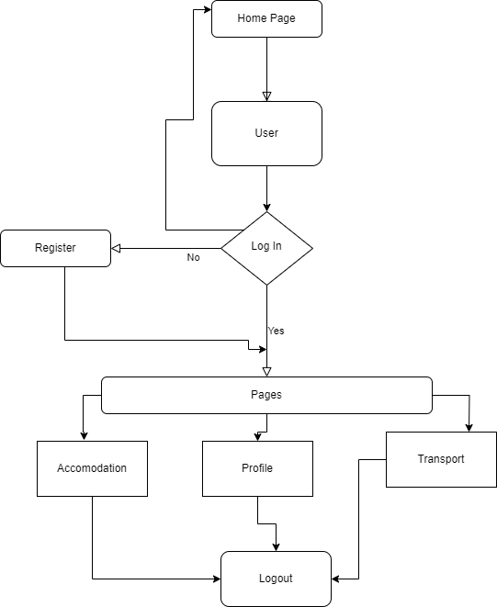

5.2 **FLOW CHART**

* 1. **RELATIONAL MODE**LA paper with text on it

     Description automatically generated

**IMPLEMENTATION OF SCREEN SHOT**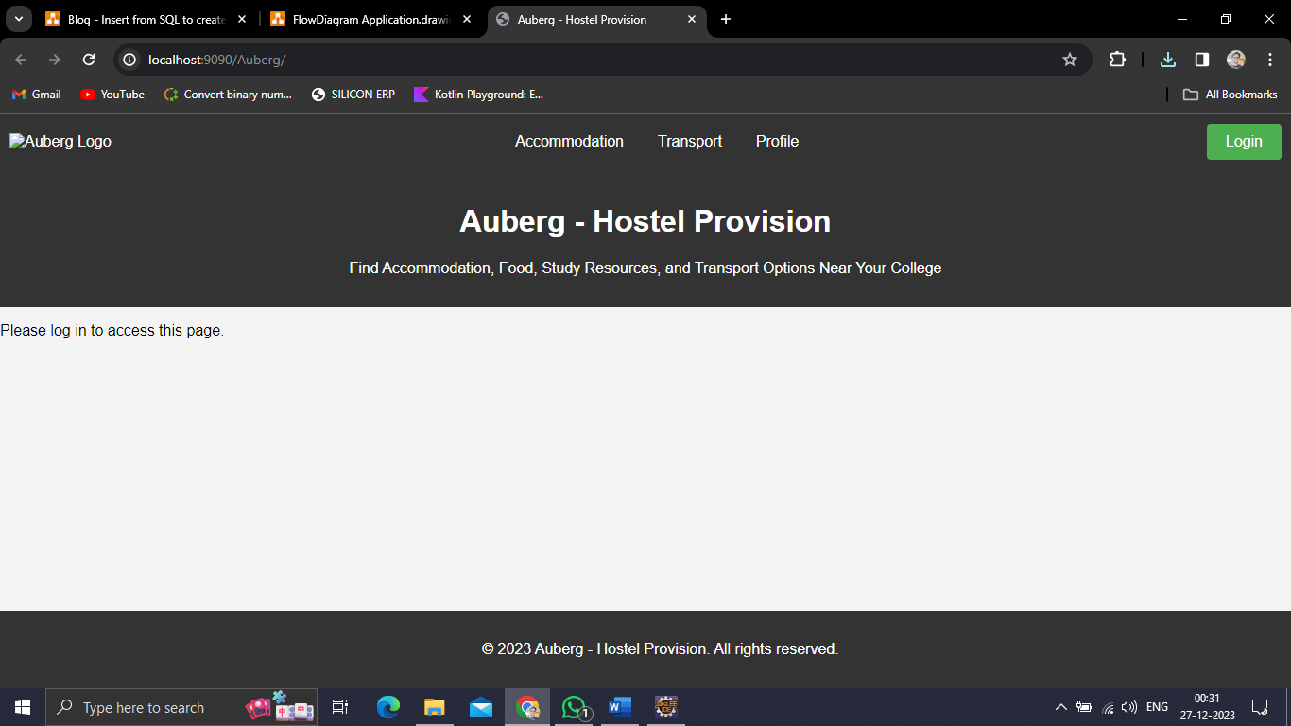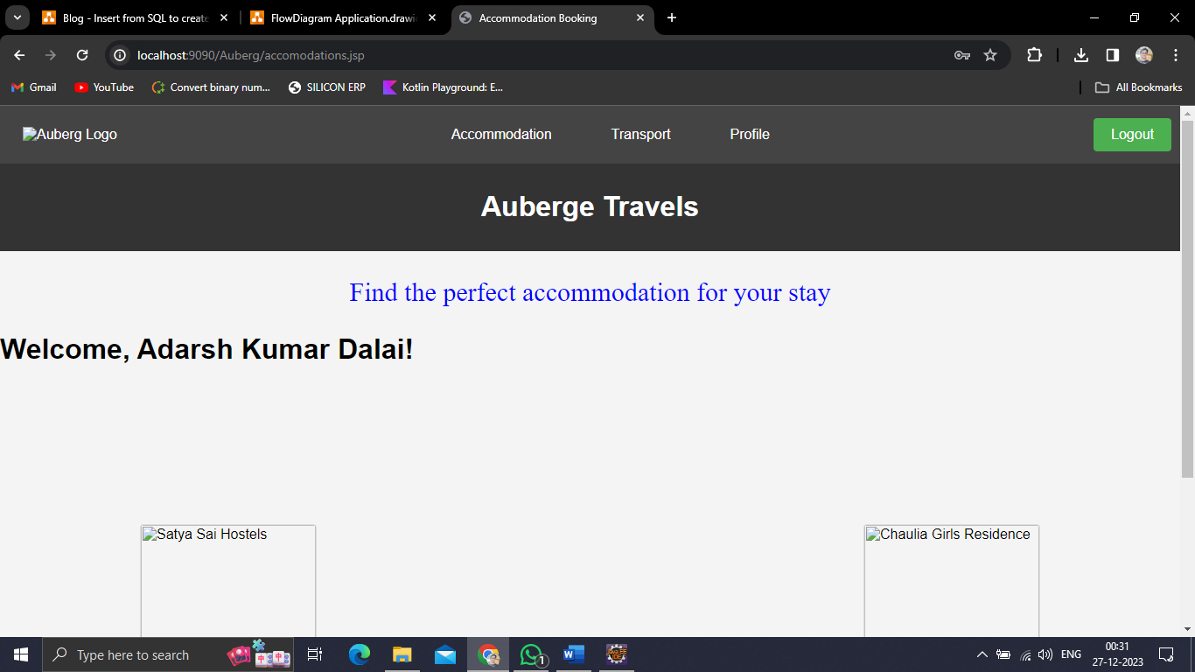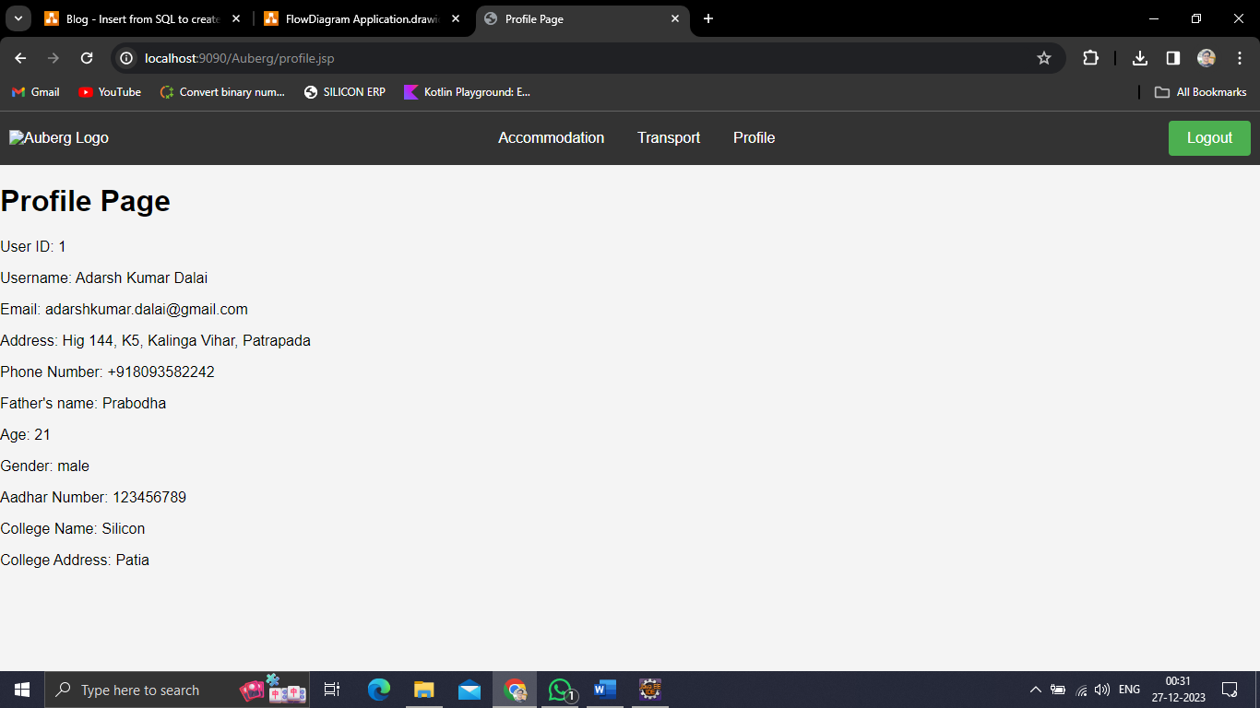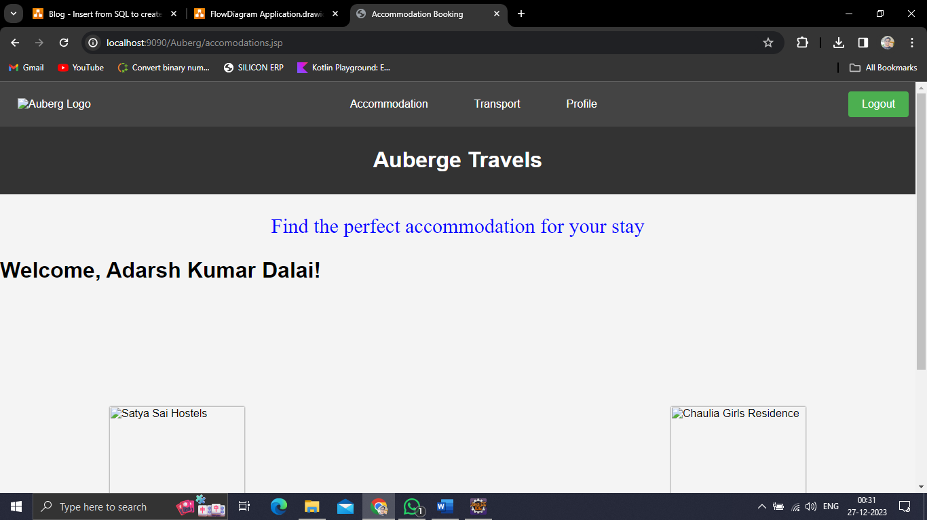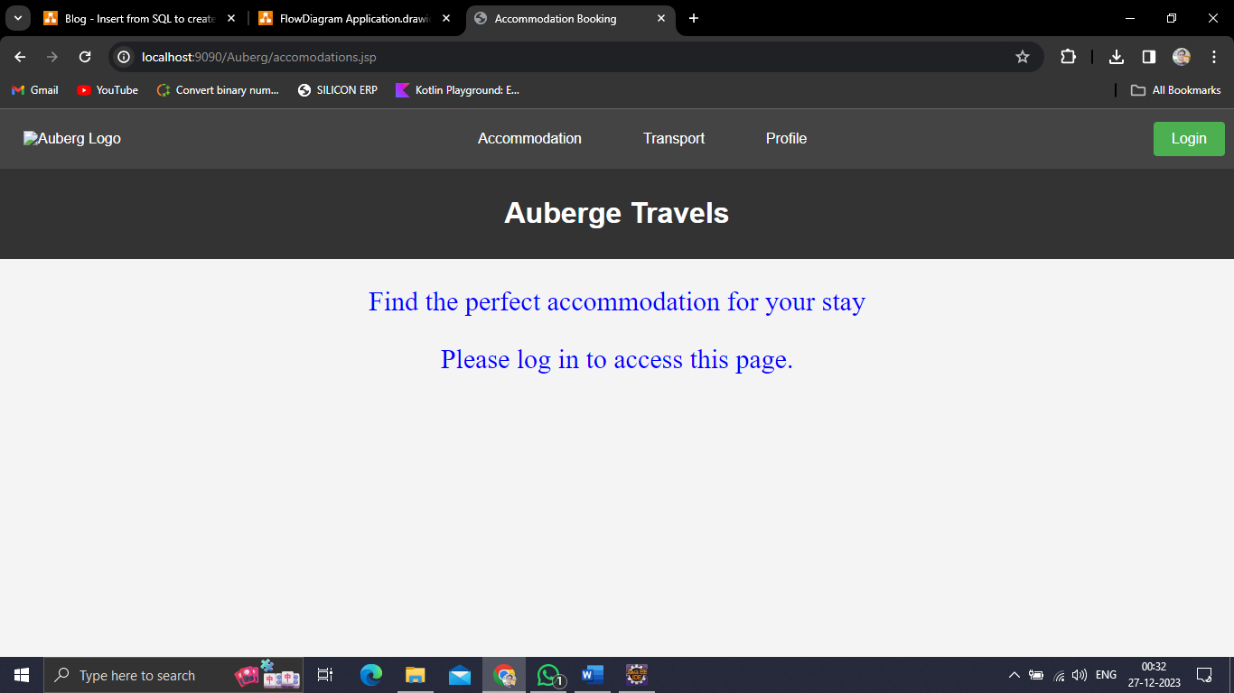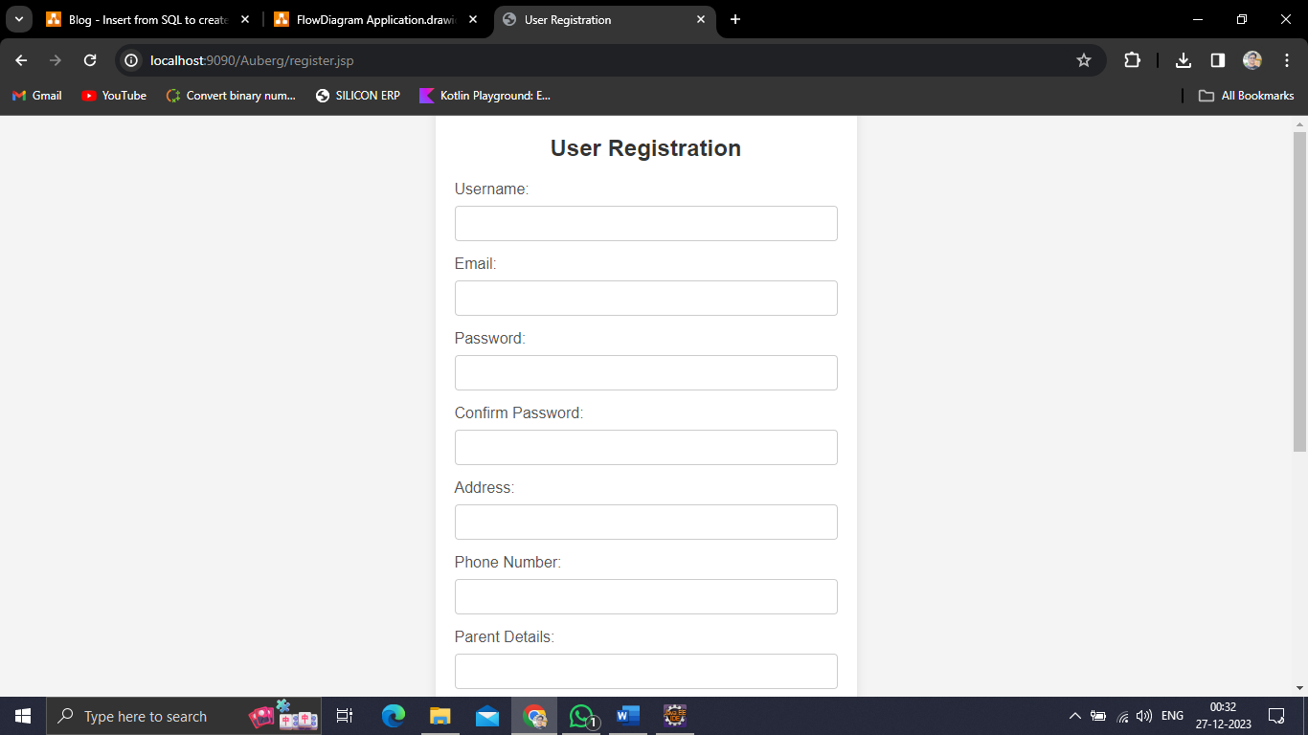

**Conclusion and Future Work**

The development and implementation of the "Auberge" website mark a significant milestone in addressing the accommodation needs of students studying away from their homes. The platform successfully achieves its primary objectives by providing a user-centric and streamlined process for exploring, selecting, and customizing hostel and mess accommodations near educational institutions. The intuitive user interface, coupled with personalized accommodation search options, appointment scheduling, and user-friendly functionalities, has significantly enhanced the overall user experience. Through robust user registration, accommodation management, and appointment scheduling systems, "Auberge" has successfully simplified the otherwise intricate process of finding suitable accommodations, thereby contributing to a more comfortable and conducive living environment for students.

While the "Auberg" website has achieved notable success in its initial implementation, several avenues for future enhancements and expansions remain open:

**Enhanced User Interactivity:** Implementing additional interactive features, such as real-time messaging for user-doctor interactions, user reviews and feedback mechanisms, and community-driven forums, would foster greater engagement and enrich the overall user experience.

**Advanced Recommendation Systems:** Developing more sophisticated algorithms for accommodation recommendations based on user preferences, past bookings, and personalized user behavior analysis would offer more tailored and accurate suggestions to users.

**Mobile Application Development:** Creating a dedicated mobile application for "Auberg" would extend accessibility, allowing users to explore accommodations, manage appointments, and access services conveniently via their mobile devices.

**Integration of Additional Services:** Expanding the platform to incorporate additional services such as educational resources, local area information, and emergency services could further support students in adjusting to new environments and accessing essential resources.

**Enhanced Security Measures:** Continuously updating and fortifying security protocols, including data encryption, secure data transmission, and stringent access controls, to safeguard user information and ensure data privacy.

**Analytics and Reporting Features:** Implementing comprehensive analytics tools and reporting mechanisms to analyze user engagement patterns, accommodation preferences, and service utilization, providing insights for continual platform improvement.

**BIBLOGRAPHY**

**Books:**

**Rajib Mall (2014). Fundamentals of Software Engineering. PHI Learning Private Limited.**

**Websites:**

**World Wide Web Consortium. (2022). HTML Basics. W3C Schools. https://www.w3schools.com/html/**

**Documentation:**

**Apache Software Foundation. (2022). Apache Tomcat 9 Documentation.**

**Apache Tomcat**

**Project. https://tomcat.apache.org/tomcat-9.0-doc/**