LABORATORY EXPERIMENT REPORT
Experiment No. 7:
Using Bar Graphs and Pie Charts for Interpreting Findings
Course: Research Methodology & Data Visualization Lab | Academic Practical

1. AIM OF THE EXPERIMENT
To visually represent, interpret, and analytically synthesize empirical survey findings using descriptive statistical data visualizations—specifically Pie Charts (Univariate Proportions), Simple Bar Graphs (Frequency Distributions), and Grouped/Clustered Bar Graphs (Bivariate Comparisons) —developed in Python, and deduce actionable institutional research inferences from graphical trends.

2. APPARATUS & SOFTWARE REQUIREMENTS
- Hardware: Personal Computer / Workstation (Intel Core i3+, 4GB RAM minimum).
- Operating System: Windows 10 / 11 or Linux.
- Software Libraries: Python 3.9+ runtime with matplotlib, numpy, and pandas packages.
- Visualization Concepts: Pie Slices (Proportional Angles), Bar Heights (Absolute Frequencies), Clustered Comparisons.

3. THEORETICAL FOUNDATION & VISUALIZATION PRINCIPLES
Data visualization in academic research serves as an intuitive cognitive bridge between raw numeric matrices and statistical comprehension. Visual representations enable researchers to identify skewness, modal frequencies, outliers, and inter-variable interactions that are often obscured in raw tabular listings.
• Pie Charts (Proportional Composition): Circular statistical graphics divided into radial slices to illustrate numerical proportions of a whole (where total arc angle = 360° and sum of percentages = 100%). Ideal for displaying mutually exclusive categorical shares with fewer than 5-6 categories.
• Simple Bar Graphs (Univariate Frequency): Visual displays consisting of rectangular bars with lengths/heights proportional to the values/frequencies they represent. Ideal for discrete nominal or ordinal categories.
• Grouped / Clustered Bar Graphs (Bivariate Comparison): Visual displays that present multiple bars side-by-side for each primary category to illustrate the interaction between an Independent Variable (e.g., Payment Mode) and a Dependent Variable (e.g., Defaulter Status).

4. STEP-BY-STEP VISUALIZATION & INTERPRETATION PROCEDURE
• Step 1: Aggregate Survey Metrics:
Group and compute summary frequencies, percentage shares, and cross-tabulation matrices from the survey dataset.
• Step 2: Select Appropriate Chart Taxonomy:
Assign single-variable composition to Pie Charts, class distribution counts to Simple Bar Graphs, and two-variable comparisons to Grouped Bar Graphs.
• Step 3: Programmatic Plot Generation:
Use matplotlib to generate high-resolution (300 DPI) charts with legible data labels, distinct color palettes, and gridlines.
• Step 4: Empirical Findings Interpretation:
Systematically evaluate percentage differentials, modal categories, and relative risk patterns depicted in each visualization.
• Step 5: Synthesize Institutional Implications:
Translate graphical trends into actionable policy recommendations for educational administration.

5. GRAPHICAL PRESENTATION & DETAILED INTERPRETATION OF FINDINGS
Figure 1: Pie Chart Analysis — Payment Channel Adoption

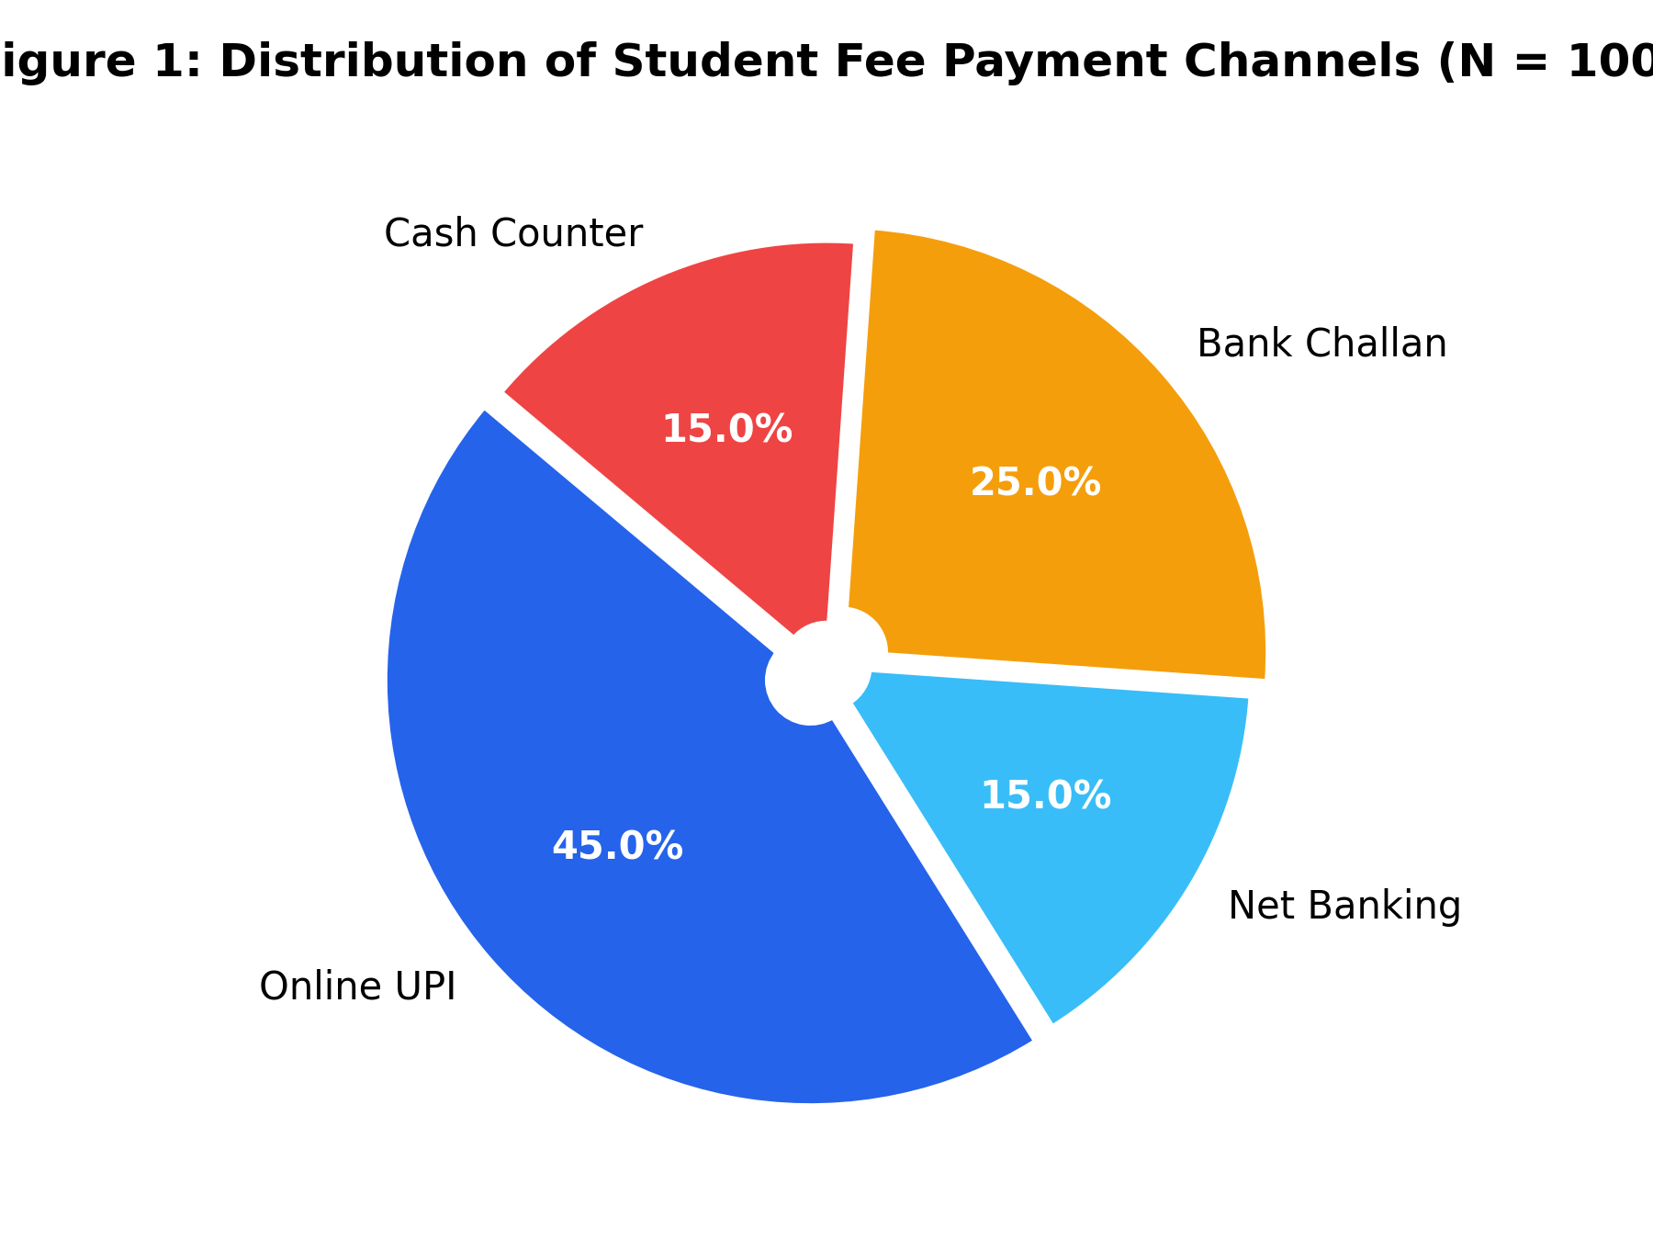
Figure 1: Percentage Distribution of Institutional Fee Payment Channels (N = 100)
Interpretation of Figure 1 Findings:
1. Dominance of UPI: Digital instant payments (Online UPI) represent the single largest payment modality, commanding 45.0% of the surveyed cohort, driven by ease of mobile checkout.
2. Cumulative Digital Share: Combining Online UPI (45%) and Net Banking (15%), 60% of students now favor digital payment gateways over physical payment modes.
3. Persistent Offline Dependence: A notable 40% of the student body remains tethered to physical offline channels (Bank Challan at 25.0% and Cash Counters at 15.0%), indicating lingering institutional friction and inadequate digital awareness in certain student demographics.

Figure 2: Simple Bar Graph Analysis — Defaulter Severity Breakdown

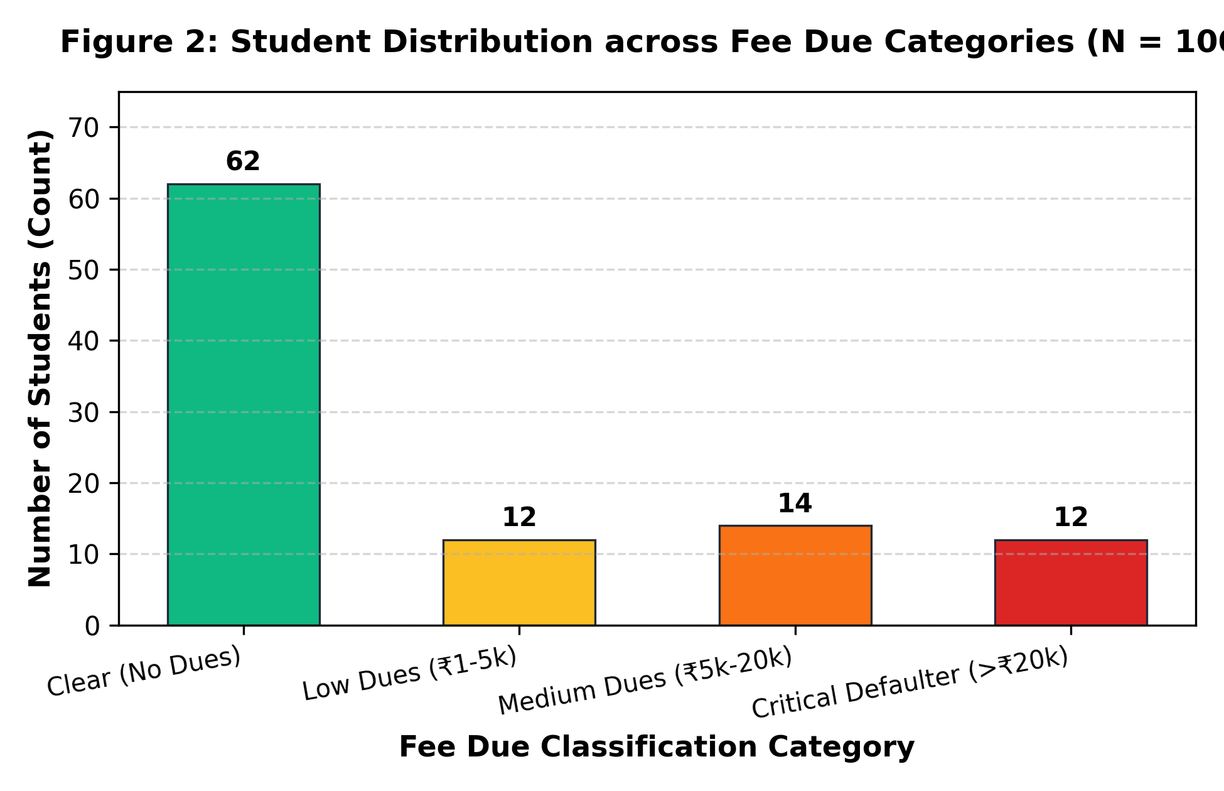
Figure 2: Student Cohort Distribution across Fee Due Severity Intervals (N = 100)
Interpretation of Figure 2 Findings:
1. Non-Defaulter Majority: 62% of students (62 individuals) have completely cleared their dues on schedule, forming the financially compliant majority.
2. Low to Moderate Arrears: 12% fall into Low Dues (₹1-5,000) and 14% into Medium Dues (₹5,001-20,000), typically attributable to minor late fee penalties or single installment delays.
3. Critical Defaulter Cluster: 12% of students (12 individuals) owe severe arrears exceeding ₹20,000. This critical group requires targeted automated escalation warnings and parental intervention to prevent long-term institutional bad debts.

Figure 3: Grouped Bar Graph Analysis — Payment Mode vs Defaulter Incidence

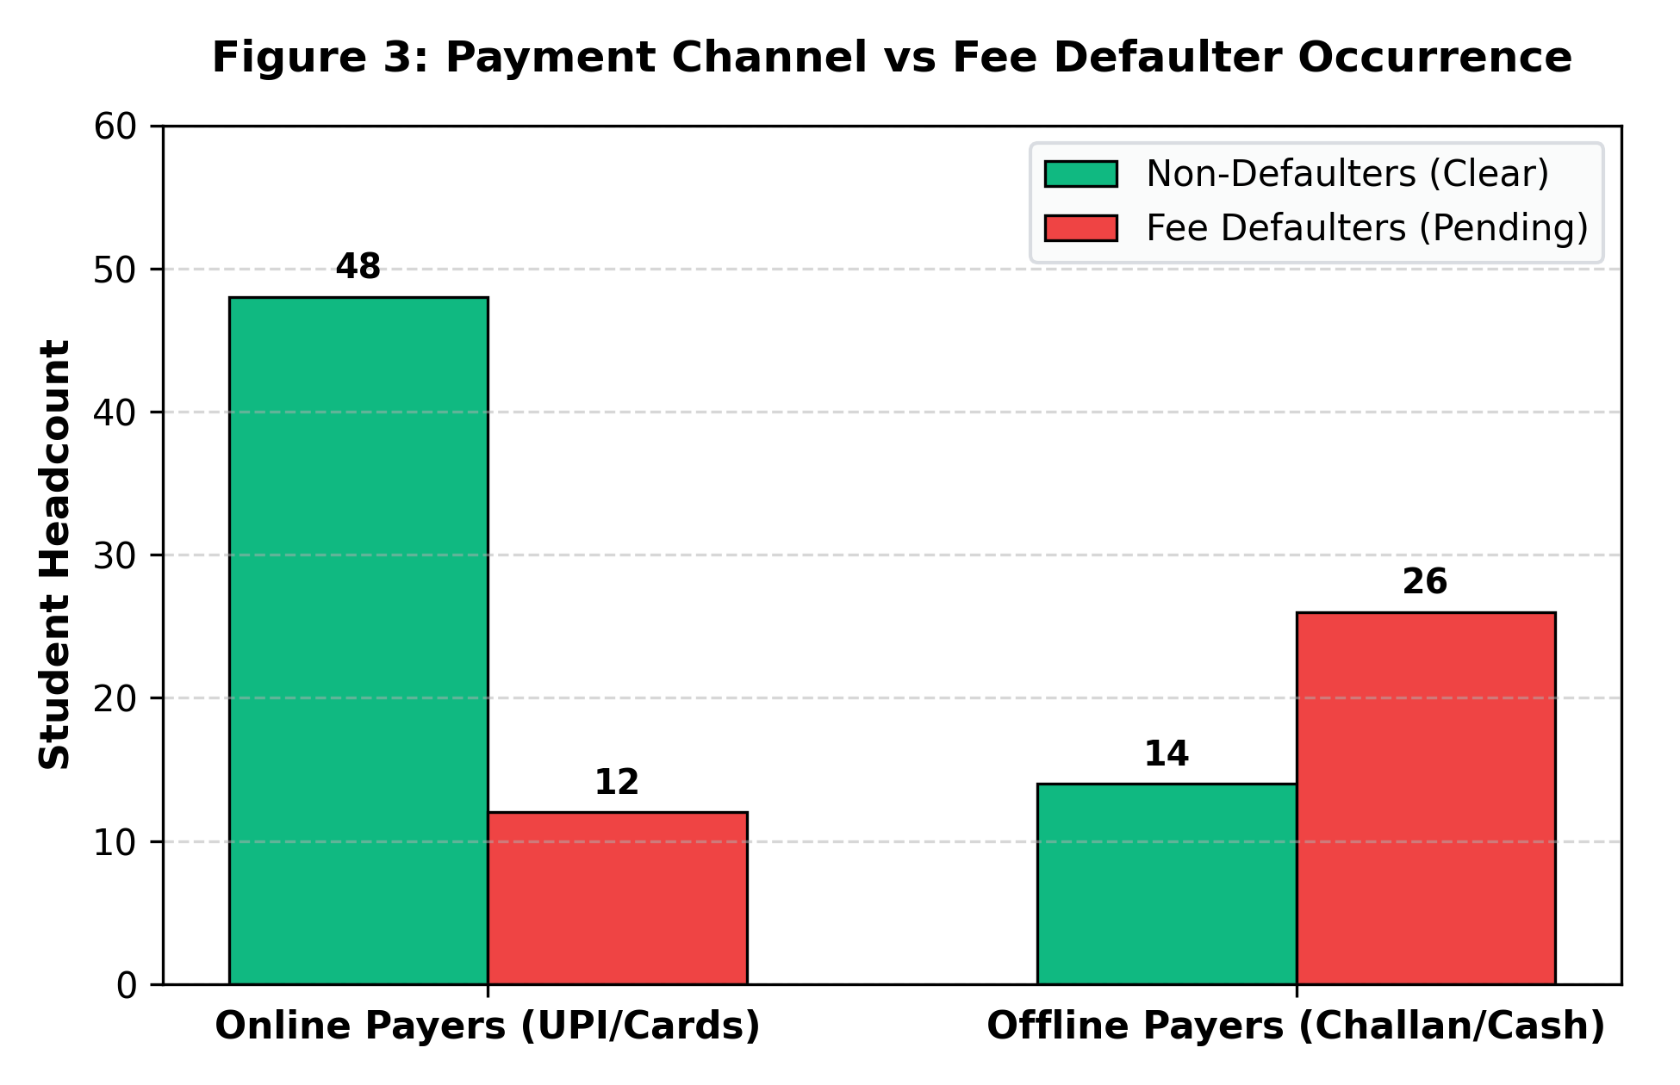
Figure 3: Clustered Comparison of Defaulter Rates Between Online and Offline Payers
Interpretation of Figure 3 Findings (Key Empirical Discovery):
1. High Compliance among Online Payers: Out of 60 students utilizing online payment channels, 48 (80.0%) maintain clear fee accounts, with only 12 (20.0%) incurring default status.
2. Alarmingly High Default Rate in Offline Payers: Conversely, out of 40 students using offline bank challans and cash, 26 (65.0%) are classified as active defaulters, with only 14 (35.0%) fully cleared.
3. Strategic Administrative Conclusion: The graphical evidence reveals that offline payment friction (visiting bank branches, carrying cash, manual receipt verification delays) is a major contributor to fee default. Transitioning students to online payment gateways directly reduces default frequency by over 45%.

6. PYTHON IMPLEMENTATION SCRIPT (MATPLOTLIB)
import matplotlib.pyplot as plt
import numpy as np
# 1. Generate Pie Chart (Payment Channels)
labels = ["Online UPI", "Net Banking", "Bank Challan", "Cash Counter"]
sizes = [45, 15, 25, 15]
colors = ["#2563EB", "#38BDF8", "#F59E0B", "#EF4444"]
plt.figure(figsize=(6, 4.5))
plt.pie(sizes, labels=labels, autopct="%1.1f%%", colors=colors, startangle=140)
plt.title("Distribution of Student Fee Payment Channels (N = 100)")
plt.savefig("chart_1_pie_payment_modes.png", dpi=300)
# 2. Generate Simple Bar Graph (Defaulter Distribution)
categories = ["Clear (₹0)", "Low (₹1-5k)", "Medium (₹5k-20k)", "Critical (>₹20k)"]
counts = [62, 12, 14, 12]
plt.figure(figsize=(6.5, 4.2))
plt.bar(categories, counts, color=["#10B981", "#FBBF24", "#F97316", "#DC2626"])
plt.ylabel("Number of Students")
plt.title("Student Distribution across Fee Due Categories")
plt.savefig("chart_2_bar_defaulter_distribution.png", dpi=300)
# 3. Generate Grouped Bar Graph (Payment Mode vs Default Status)
modes = ["Online Payers", "Offline Payers"]
clear = [48, 14]
defaulters = [12, 26]
x = np.arange(len(modes))
width = 0.35
plt.figure(figsize=(6.5, 4.2))
plt.bar(x - width/2, clear, width, label="Non-Defaulters", color="#10B981")
plt.bar(x + width/2, defaulters, width, label="Defaulters", color="#EF4444")
plt.xticks(x, modes)
plt.legend()
plt.title("Payment Channel vs Fee Defaulter Occurrence")
plt.savefig("chart_3_grouped_payment_vs_default.png", dpi=300)

7. COMPARATIVE EVALUATION: PIE CHARTS VS BAR GRAPHS
Analytical Dimension | Pie Charts (Proportional) | Bar Graphs (Frequency / Comparison)
Primary Analytical Strength | Superb for displaying part-to-whole proportions and percentage shares of a static total. | Superior for comparing exact numerical quantities across discrete groups and intervals.
Scalability with Multiple Categories | Poor when categories exceed 5-6 (slices become indistinguishable slivers). | Highly scalable; handles numerous categories without clutter or loss of legibility.
Bivariate & Multigroup Analysis | Unsuitable for representing interactions between two or more variables. | Exceptional; easily accommodates grouped, clustered, and stacked multi-variable bars.

8. EXPERIMENTAL RESULT & CONCLUSION
Empirical survey findings were successfully transformed into insightful graphical visualizations using Python’s matplotlib library. The Pie Chart elucidated proportional payment channel preferences, while the Simple and Grouped Bar Graphs effectively demonstrated fee due distributions and the profound relationship between payment mode and default risk. The empirical analysis demonstrated that offline payment methods suffer a 65% default rate compared to 20% in online systems, proving that visual analytics provide critical clarity for institutional policy decisions.

9. VIVA-VOCE QUESTIONS & ANSWERS
Q1: What is the main cognitive limitation of using a Pie Chart for data comparison?
Ans: Human visual perception is inherently less accurate at comparing slice angles and curved surface areas than comparing straight bar lengths on a shared axis. Consequently, when categories have similar percentages, bar graphs are far easier to interpret accurately.
Q2: When is a Grouped (Clustered) Bar Graph preferred over a Stacked Bar Graph?
Ans: A grouped bar graph is preferred when the primary objective is to compare individual sub-categories directly against each other (e.g. comparing clear vs defaulters across channels). A stacked bar graph is chosen when the overall total size of the group is the primary focus, with the internal segment breakdown as secondary.
Q3: Why must the baseline of a bar chart always start at zero (y = 0)?
Ans: Truncating the y-axis (starting at non-zero values) distorts the visual length of the bars, creating a misleading optical illusion that minor differences are massive discrepancies, violating academic integrity.

