A PROJECT REPORT

on

“HEALTH SPY”

Submitted to

KIIT Deemed to be University

In Partial Fulfillment of the Requirement for the Award of

BACHELOR’S DEGREE IN

INFORMATION TECHNOLOGY

BY

GARIMA SINGH
ADARSH TIWARI
ARCHIT KAYAL
ANSHUMAN TIWARY
RAHUL RANJAN

21051476
2105940
2105445
2105526
2105478

UNDER THE GUIDANCE OF

DIPTI DASH MA’AM



SCHOOL OF COMPUTER ENGINEERING

KALINGA INSTITUTE OF INDUSTRIAL TECHNOLOGY

BHUBANESWAR, ODISHA - 751024

APRIL 2024

A PROJECT REPORT

on

“HEALTH SPY”

Submitted to

KIIT Deemed to be University

In Partial Fulfillment of the Requirement for the Award of

BACHELOR’S DEGREE IN INFORMATION TECHNOLOGY

BY

GARIMA SINGH ADARSH TIWARY ARCHIT KAYAL
ANSHUMAN TIWARY
RAHUL RANJAN

21051476
2105940
2105445
2105539
2105478

UNDER THE GUIDANCE OF

DIPTI DASH MA’AM

SCHOOL OF COMPUTER ENGINEERING

KALINGA INSTITUTE OF INDUSTRIAL TECHNOLOGY

BHUBANESWAE, ODISHA -751024

APRIL 2024

KIIT Deemed to be University

School of Computer Engineering
Bhubaneswar, ODISHA 751024

CERTIFICATE

This is certify that the project entitled

“HEALTH SPY“

submitted by

GARIMA SINGH
ADARSH TIWARY
ARCHIT KAYAL
ANSHUMAN TIWARI
RAHUL RANJAN

21051476
2105940
2105445
2105526
2105478

is a record of bonafide work carried out by them, in the partial fulfillment of the requirement for the award of Degree of Bachelor of Engineering (Computer Science & Engineering OR Information Technology) at KIIT Deemed to be university, Bhubaneswar. This work is done during year 2023-2024, under our guidance.

Date: / /

DIPTI DASH
Project Guide

Acknowledgement

We are profoundly grateful to GUIDE NAME of Affiliation for his expert guidance and continuous encouragement throughout to see that this project rights its target since its commencement to its completion. .....................

GARIMA SINGH
ADARSH TIWARI
ARCHIT KAYAL
ANSHUMAN TIWARY
RAHUL RANJAN

ABSTRACT

The Health Monitoring System, known as HealthSpy, presents a pioneering endeavor to reshape healthcare delivery through the fusion of wearable technology and edge computing. This project aims to address the challenges faced in leveraging the vast amounts of data generated by wearable devices for proactive health monitoring. By enabling real-time collection and analysis of health metrics such as steps, calories, pulse, body temperature, and glucose levels, HealthSpy empowers healthcare professionals with actionable insights to deliver timely interventions and personalized care. The system's modular architecture ensures scalability, adaptability, and seamless integration with existing healthcare infrastructure. With a steadfast commitment to privacy, security, and regulatory compliance, HealthSpy promises to revolutionize healthcare delivery, enhance patient outcomes, and set new standards for proactive health management.

Keywords:
Health Monitoring System, Wearable Sensor Technology, Remote Health Monitoring, Google Fit Bit App, Real-time Monitoring

Contents

1 | Introduction |  |  | 1
2 | Basic Concepts/ Literature Review |  |  | 2
 | 2.1 | Sub Section Name........................... |  | 2
3 | Problem Statement / Requirement Specifications |  |  | 3
 | 3.1 | Project Planning........................... |  | 3
 | 3.2 | Project Analysis (SRS)................. |  | 3
 | 3.3 | System Design ………………….. |  | 3
 |  | 3.3.1 | Design Constraints …… | 3
 |  | 3.3.2 | System Architecture (UML) / Block Diagram … | 3
4 | Implementation |  |  | 4
 | 4.1 | Methodology / Proposal ........................... |  | 4
 | 4.2 | Testing / Verification Plan ……………. |  | 4
 | 4.3 | Result Analysis / Screenshots …………. |  | 4
 | 4.4 | Quality Assurance …………………….. |  | 4
5 | Standard Adopted |  |  | 5
 | 5.1 | Design Standards . . . . . . . . . . . . . . . |  | 5
 | 5.2 | Coding Standards . . . . . . . . . . . . . . |  | 5
 | 5.3 | Testing Standards . . . . . . . . . . |  | 5
6 | Conclusion and Future Scope |  |  | 6
 | 6.1 | Conclusion ……………………….. |  | 6
 | 6.2 | Future Scope ………………………. |  | 6
References |  |  |  | 7
Individual Contribution |  |  |  | 8
Plagiarism Report |  |  |  | 9

Chapter 1

Introduction

The Health Monitoring System, affectionately referred to as HealthSpy, is a groundbreaking project aimed at revolutionizing the landscape of healthcare through innovative technology solutions. At its core, HealthSpy seeks to harness the power of wearable devices and edge computing technology to enable real-time monitoring of patients' health, thereby ushering in a new era of proactive healthcare.

The healthcare industry is witnessing a paradigm shift, driven by the increasing popularity of wearable devices. These devices have become ubiquitous, serving as indispensable tools for tracking various health metrics, including steps, calories, pulse, body temperature, and glucose levels. However, despite the wealth of data generated by wearable devices, there exists a significant gap in effectively leveraging this data for proactive health monitoring. Recognizing this gap, the Health Monitoring System endeavors to bridge the divide by developing a scalable, efficient, and user-friendly platform for remote health monitoring. By collecting and analyzing data from wearable devices in real-time, healthcare professionals can gain invaluable insights into patients' health status and provide timely interventions when necessary. Whether it's detecting anomalies in vital signs or identifying patterns indicative of potential health risks, HealthSpy empowers healthcare professionals with the tools they need to deliver proactive and personalized care.

Moreover, the Health Monitoring System is designed to be modular and adaptable, capable of seamlessly integrating with existing healthcare systems and evolving alongside technological advancements. With a strong emphasis on privacy, security, and regulatory compliance, HealthSpy ensures the confidentiality and integrity of patient health data, fostering trust and confidence among users. In essence, HealthSpy represents a bold step forward in the realm of healthcare, promising to enhance patient outcomes, improve healthcare delivery, and ultimately, save lives. As we embark on this transformative journey, guided by a shared vision of revolutionizing healthcare, HealthSpy stands poised to make a profound and lasting impact on the lives of individuals and communities worldwide.

Chapter 2

2.1 Definition of edge computing and its significance in healthcare.

Edge computing is a paradigm that brings computation and data storage closer to the source of data generation, minimizing latency and enhancing real-time processing capabilities. Unlike traditional cloud computing, where data is processed in centralized data centers, edge computing distributes processing tasks across a network of devices located near the data source.
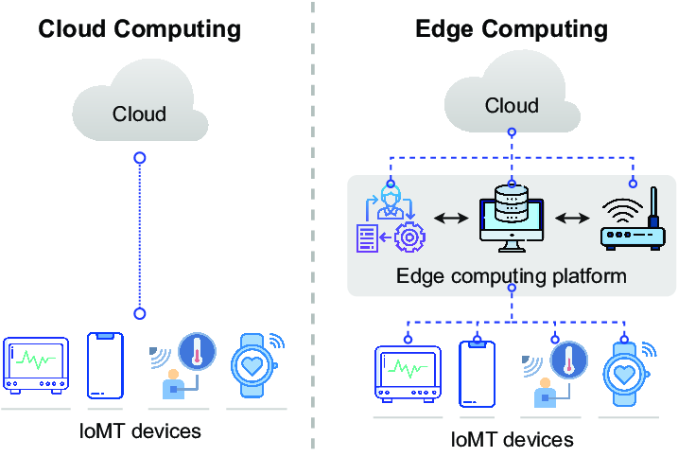

2.2 Explanation of IoT devices and their role in healthcare.

IoT device is a term that describes wearable devices such as smartwatches and implanted medical devices connected to the Internet. Some IoT devices could be embedded in a person’s body.

IoT has changed people’s lives, especially elderly patients, by enabling constant tracking of health conditions. This has a major impact on people living alone and their families. On any disturbance or changes in the routine activities of a person, alert mechanism sends signals to family members and concerned health providers.

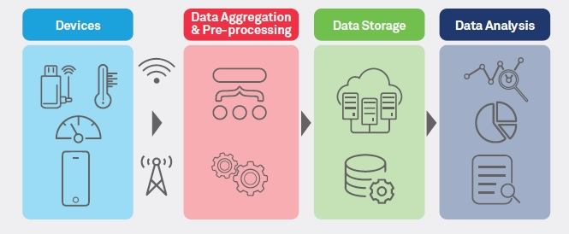

2.3 Benefits of Edge Computing in Healthcare

Improved remote patient care – The data generated by wearable sensors and other remote health monitoring devices are analyzed in near-real-time, which allows patients and clinicians to respond to potential issues before they become major emergencies.

Speed and performance – EMS patient data can be processed and analyzed by 5G devices in the ambulance for faster treatment recommendations, or that data can be transmitted to the receiving hospital in real-time so they can better prepare for the patient’s arrival.

Workload efficiency – Data from monitors and wearables is analyzed in real-time to provide faster insights into diagnostic and treatment options. Plus, data can be automatically prioritized and sent to the relevant clinicians to reduce handoff delays and miscommunications.

Security – Since patient data is processed on-site instead of being sent to the cloud, it’s easier to maintain HIPAA compliance and prevent interception by malicious actors without needing to use slow, buggy VPNs.

Diagnostic accuracy – Latency in data transmission can impact the accuracy and precision of diagnostic applications. Running analyses on-site with edge machine learning and big data applications reduces the risk of errors and ensures faster results.

Lower costs – Big data applications deployed at the edge can provide business insights that help healthcare organizations reduce waste and make fewer mistakes, saving money and lowering the cost per patient without lowering the standards of care.

2.4 IoT devices and their role in healthcare

1. RPM (Remote Patient Monitoring): IoT devices like smartwatches collect health data, aiding in continuous patient monitoring. Concerns include data security and compliance with regulations like GDPR and HIPAA.

2. Glucose Monitoring: Wearable sensors track glucose levels, reducing manual monitoring and errors. Challenges include device size and power consumption.

3. Heart-rate Monitoring: Portable IoT devices like smartwatches provide continuous heart-rate monitoring, improving patient mobility. Accuracy concerns exist, but modern devices offer reliable data.

4. Hand Hygiene Monitoring: IoT reminders enhance hygiene compliance, reducing infection rates. However, they can't enforce hygiene practices independently.

5. Depression/Mood Monitoring: IoT devices track biometric data to infer mental health status objectively. Accuracy concerns persist, but they offer valuable insights into mood trends.

6. Parkinson's Disease Monitoring: IoT devices track symptoms, enabling remote patient monitoring and independence. Accuracy challenges exist but are being addressed.

7. Connected Inhalers: IoT inhalers provide medication reminders and usage reports, improving patient management. Forgetting inhalers and overuse are concerns addressed by device alerts.

8. Ingestible Sensors: These devices collect internal biometric data non-invasively, overcoming patient discomfort with traditional methods. Challenges include size and dissolution requirements.

9. Connected Contact Lenses: These lenses monitor eye health and detect early signs of diseases like diabetes. Security concerns exist due to the presence of cameras in the lenses.

10. Robotic Surgery: IoT robots enable precise surgeries with smaller incisions, reducing patient invasiveness and recovery times.

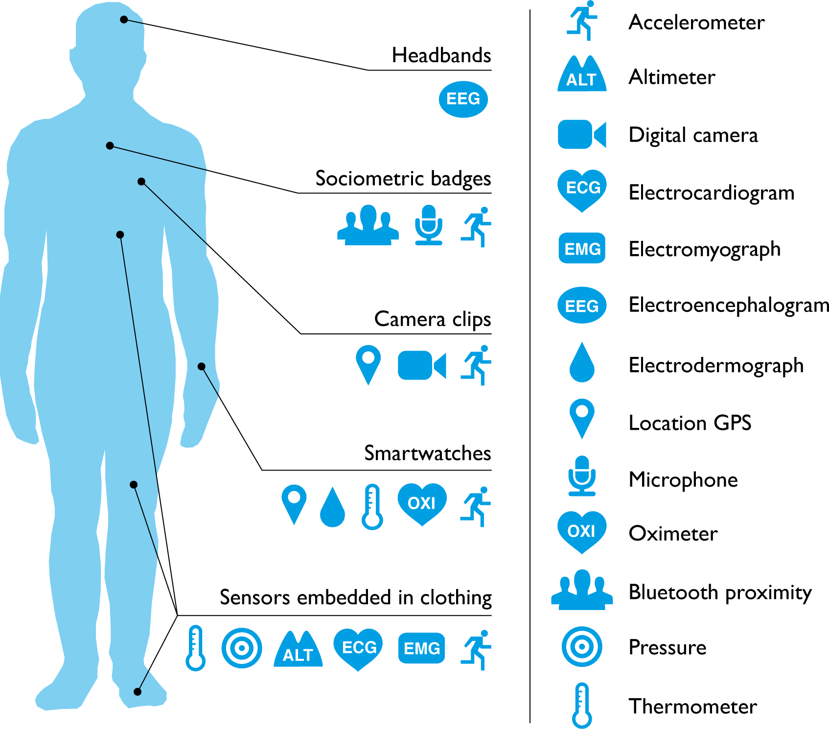

\\

Chapter 3

Problem Statement / Requirement Specifications

Problem Statement:

In contemporary healthcare, despite the proliferation of wearable devices capable of capturing a plethora of health data, the effective utilization of this information remains a significant challenge. These devices offer insights into vital metrics such as steps taken, calories burned, pulse rates, body temperature, and glucose levels. However, there exists a critical gap in harnessing this data for real-time health monitoring and proactive intervention. Current systems lack the capacity to seamlessly integrate with wearable technology and process the influx of health data in a timely manner. As a result, healthcare professionals are unable to capitalize on the potential benefits of remote health monitoring, leading to missed opportunities for early detection of health issues and tailored interventions. Bridging this gap requires the development of a scalable, efficient, and user-friendly platform that can collect, process, and analyze health data from wearable devices in real-time. Such a solution must prioritize interoperability, security, and usability to empower healthcare providers with actionable insights and elevate the standard of patient care.

3.1 Project Planning

Objectives:

1. Enable Real-Time Health Monitoring: The primary objective of the project is to develop a system that enables real-time monitoring of patients' health using wearable devices and edge computing technology. This involves collecting data from various sensors in the wearable devices and processing it in real-time to provide immediate insights into the patients' health status.

- Utilize Wearable Devices Data: The project aims to leverage the data generated by wearable devices, including steps, calories, pulse, body temperature, and glucose levels. By utilizing this data, healthcare professionals can gain a comprehensive understanding of patients' health and track their progress over time.

- Implement Edge Computing Technology: Incorporating edge computing technology into the system architecture is a key objective. Edge computing allows for data processing to occur closer to the source of data generation, reducing latency and improving responsiveness. This is crucial for real-time health monitoring applications where timely interventions may be required.

- Ensure Scalability and Efficiency: The project aims to develop a scalable and efficient platform that can accommodate a large number of users and handle a high volume of data. Scalability ensures that the system can grow with increasing demand, while efficiency ensures optimal utilization of resources to minimize costs and maximize performance.

- Create a User-Friendly Interface: Developing a user-friendly interface for both patients and healthcare professionals is essential. The interface should be intuitive, easy to navigate, and provide relevant health insights in a clear and concise manner. This promotes user adoption and enhances the overall user experience.

Scope:

- Data Collection from Wearable Devices: The scope of the project includes implementing mechanisms to collect data from wearable devices, including steps, calories, pulse, body temperature, and glucose levels. This involves integrating with APIs provided by wearable device manufacturers or developing custom data collection mechanisms.

- Real-Time Data Processing: The project involves processing the collected data in real-time using edge computing technology. This includes implementing algorithms for data analysis, anomaly detection, and generating actionable insights based on the processed data.

- Integration with Healthcare Professionals' Systems: The system should be capable of integrating with existing healthcare systems used by healthcare professionals, such as electronic health records (EHR) systems or hospital management systems. This enables seamless communication and collaboration between patients and healthcare professionals.

- Development of Web and Mobile Applications: The project includes developing web and mobile applications for both patients and healthcare professionals. These applications serve as the primary interface for accessing health data, receiving notifications, and interacting with the system.

- Security and Privacy: Ensuring the security and privacy of patient data is paramount. The system should implement robust security measures, including encryption, authentication, and access control, to protect sensitive health information from unauthorized access or disclosure.

6. Scalability and Performance Optimization: The system should be designed to scale horizontally to accommodate a growing user base and handle increased data volume. Performance optimization techniques should be employed to ensure efficient resource utilization and minimize latency in data processing.

- Testing and Quality Assurance: Comprehensive testing and quality assurance measures should be implemented throughout the development lifecycle to ensure the reliability, accuracy, and usability of the system. This includes unit testing, integration testing, system testing, and user acceptance testing.

Roles and Responsibilities:
1. Health-care Professionals:
- Role: Primary users of the system who utilize the collected data for monitoring patients' health in real-time.
- Responsibilities: Analyzing the data gathered from wearable devices to assess patients' health status and providing timely interventions as needed.

2. Patients:
- Role: Individuals whose health is being monitored using wearable devices.
- Responsibilities: Wearing the designated wearable devices and providing consent for their health data to be collected and analyzed.

3. Developers and Engineers:
- Role: Responsible for designing, developing, and maintaining the Health Monitoring System.
- Responsibilities: Designing and implementing the software architecture, integrating wearable device data, and ensuring scalability, efficiency, and usability of the platform.

4. Data Scientists and Analysts:
- Role: Responsible for analyzing the collected health data to extract meaningful insights.
- Responsibilities: Developing algorithms and models to analyze health data, detecting patterns, and providing data-driven insights to health care professionals.

5. Regulatory Authorities:
- Role: Ensure compliance with health care regulations and standards.
- Responsibilities: Review and approval of the use of wearable devices for medical purposes, ensuring data privacy and security measures are in place, and providing guidance on ethical considerations.

6. Health-care Institutions and Organizations:
- Role: Implement and integrate the Health Monitoring System into their healthcare infrastructure.
- Responsibilities: Provide support and resources for deployment, train healthcare professionals on system usage, and collaborate with developers to customize the system based on specific needs.

Project Timeline:

Month 1: Project Setup and Planning

1. Week 1-2: Project Kickoff and Requirements Gathering
- Conduct project kickoff meeting with stakeholders.
- Define project objectives, scope, and deliverables.
- Gather detailed requirements for the system functionality.
- Identify stakeholders' expectations and constraints.

2. Week 3-4: System Design and Architecture
- Design system architecture, including data flow, components, and interactions.
- Define technical requirements and select appropriate technologies (Node.js, Express.js, React, etc.).
- Develop UML diagrams or block diagrams to visualize the system structure.
- Document design decisions and constraints.

Month 2: Development and Testing

3. Week 5-6: Implementation of Core Features
- Develop data collection mechanisms for wearable devices.
- Implement real-time data processing using edge computing technology.
- Set up RESTful APIs for communication between components.
- Begin development of web and mobile applications.

4. Week 7-8: Integration and Testing
- Integrate components and APIs to ensure seamless communication.
- Conduct unit testing for individual components.
- Perform integration testing to verify end-to-end functionality.
- Identify and address any issues or bugs discovered during testing.

Month 3: Deployment and Finalization

5. Week 9-10: User Interface Design and Optimization
- Design user interfaces for web and mobile applications.
- Implement UI components using React or other frontend frameworks.
- Optimize user experience for usability and accessibility.
- Conduct usability testing with potential users to gather feedback.

6. Week 11-12: Final Testing, Deployment, and Documentation
- Conduct final testing and quality assurance to ensure system stability and performance.
- Prepare deployment plan for hosting the system on Google Cloud Platform.
- Deploy the system to production environment.
- Create user documentation and training materials.
- Conduct training sessions for end-users and administrators.
- Finalize project documentation and deliverables.

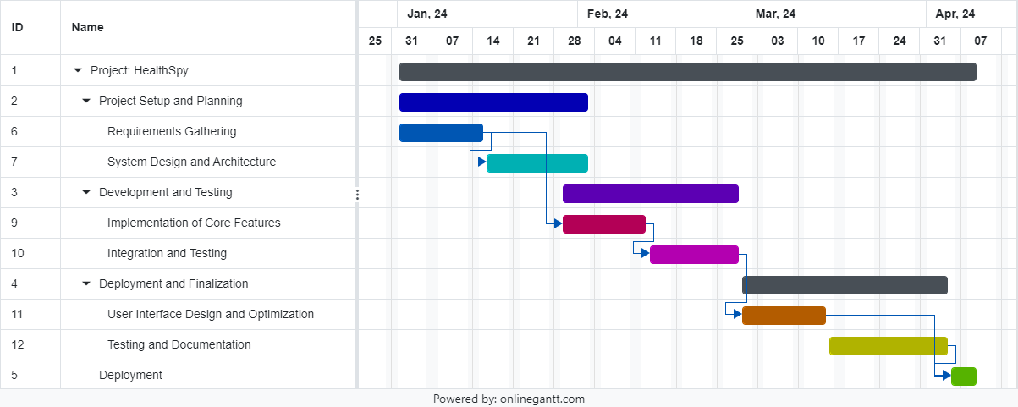

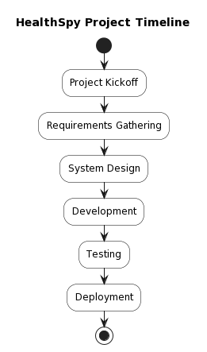

Key Milestones:

1. Project Kickoff and Requirements Gathering (End of Week 2)
2. System Design and Architecture Completed (End of Week 4)
3. Implementation of Core Features Completed (End of Week 6)
4. Integration and Testing Completed (End of Week 8)
5. User Interface Design and Optimization Completed (End of Week 10)
6. Final Testing, Deployment, and Documentation Completed (End of Week 12)

Following this timeline and achieving the specified milestones, the HealthSpy project, aimed at developing the Health Monitoring System, can be completed within the 3-month timeframe. Adjustments may be necessary based on the availability of resources, unforeseen challenges, and changes in project requirements. Regular progress monitoring and communication among team members are essential to ensure successful project delivery.

For the development environment, computers/laptops equipped with necessary software and tools will be utilized. The project will leverage cloud platforms such as Google Cloud Platform for deployment and hosting, utilizing free tiers or trial accounts. Collaboration will be facilitated using free communication and project management tools like Slack, Trello, or Asana. Testing compatibility with wearable devices will be done using personal devices or borrowed ones.

Regarding the budget, since the project is executed without spending any money, the budget is zero. However, it's crucial to allocate resources effectively and efficiently to ensure successful completion within the given constraints. While monetary resources are not utilized, leveraging available resources effectively, such as time, expertise, and existing infrastructure, is vital to ensuring project success. Effective communication, collaboration, and careful planning will be key to maximizing the project's potential without incurring any costs.

3.2 Project Analysis

As we embark on the project analysis for HealthSpy, we enter the realm of a sophisticated web application poised to transform healthcare. HealthSpy represents a novel approach to real-time health monitoring, leveraging wearable devices and cutting-edge edge computing technology. Through this analysis, we aim to uncover the functional and non-functional requirements of HealthSpy, delineating its essential features, interfaces, and operational constraints.

Functional Requirements:

1 Data Collection:
- HealthSpy shall collect data from wearable devices, capturing metrics such as steps, calories, pulse, body temperature, and glucose levels.
- Data collection intervals shall be customizable based on user preferences or device settings.
- The application shall support seamless integration with a wide range of wearable devices to accommodate diverse user needs.

2 Real-Time Monitoring:
- HealthSpy shall process collected data in real-time to provide instantaneous health insights.
- Users shall receive timely alerts and notifications for abnormal health readings, such as elevated pulse or glucose levels.
- Healthcare professionals shall have access to real-time monitoring dashboards for remote tracking of patients' health status.

3 Data Visualization:
- The application shall present health data in an intuitive and visually engaging manner, utilizing charts, graphs, and interactive dashboards.
- Users shall have the ability to customize data visualization settings to suit their preferences and requirements.
- HealthSpy shall offer historical data analysis capabilities, allowing users to track health trends over time.

4 Integration with Google Fitbit API:
- HealthSpy shall seamlessly integrate with the Google Fitbit API to access users' health data from their Fitbit accounts.
- Retrieved data from the Google Fitbit API shall include authorized health metrics and user profile information.
- Integration with the Google Fitbit API shall adhere to established authentication and authorization protocols.

Non-Functional Requirements:

1 Security and Privacy:
- HealthSpy shall implement robust end-to-end encryption to secure data transmission between wearable devices, edge computing nodes, and the cloud.
- Access to sensitive health data shall be strictly controlled based on user roles and permissions.
- The application shall adhere to all relevant healthcare regulations and standards, including HIPAA, to ensure patient privacy and confidentiality.

2 Scalability and Performance:
- HealthSpy shall be designed to scale seamlessly to accommodate a large user base and handle substantial data volume.
- Response times for real-time data processing and visualization shall meet predefined performance benchmarks.
- The application shall leverage caching and load balancing techniques to optimize performance during periods of high usage.

3 Usability and Accessibility:
- The user interface of HealthSpy shall be intuitive and user-friendly for both patients and healthcare professionals.
- Accessibility features, such as support for screen readers and keyboard navigation, shall be implemented to ensure inclusivity for users with disabilities.
- HealthSpy shall provide a responsive and error-tolerant user experience to enhance usability.

4 Reliability and Availability:
- The application shall maintain high availability to ensure uninterrupted access to health monitoring services.
- Failover mechanisms shall be in place to mitigate system failures and minimize downtime.
- Regular data backups shall be conducted to prevent data loss and facilitate swift recovery in the event of system failures.

Interfaces:
- HealthSpy shall provide a robust web-based interface for users to access health data and monitoring features.
- APIs shall be available to facilitate seamless integration with external systems, including wearable devices and healthcare management platforms.

Constraints:
- Development of HealthSpy shall adhere to the specified technologies and frameworks, including Node.js, Express.js, React, and other relevant tools.
- The project timeline shall be strictly followed, with completion targeted within three months.
- HealthSpy shall operate within the specified budget constraints and resource limitations outlined by project stakeholders.

Glossary:
- SRS: Software Requirements Specification
- API: Application Programming Interface
- HIPAA: Health Insurance Portability and Accountability Act

This Software Requirements Specification (SRS) document serves as a comprehensive guide for the development and implementation of HealthSpy, ensuring that the application meets the needs and expectations of users and stakeholders alike.

3.3 System Design

3.3.1 Design Constraints

1. API Integration Constraints:
- HealthSpy seamlessly integrates with third-party APIs, such as the Google Fitbit API, adhering to all specifications and limitations.
- API rate limits and usage quotas are carefully managed to prevent any disruptions in service and ensure smooth data access from users' wearable devices.

2. Security Constraints:
- HealthSpy complies with stringent security standards and regulations, including HIPAA, guaranteeing the confidentiality, integrity, and availability of patient health data.
- End-to-end encryption is implemented effectively, securing data transmission across all components of the system.
- Access controls and authentication mechanisms are enforced rigorously, ensuring that only authorized personnel can access sensitive health information.
- Regular vulnerability assessments and penetration testing are conducted to identify and mitigate any potential security risks proactively.

3. Scalability Constraints:
- The architecture of HealthSpy is designed to effortlessly scale, accommodating a large number of users and handling high volumes of data without compromising performance.
- Scalability constraints, such as maximum concurrent users and data throughput, are carefully considered and integrated into the system design.

4. Resource Constraints:
- HealthSpy operates seamlessly within the defined resource constraints set by project stakeholders, including budget limitations, hardware specifications, and infrastructure availability.
- Resource utilization is optimized efficiently, ensuring optimal performance while minimizing costs.

5. Technology Constraints:
- Development of HealthSpy strictly adheres to designated technologies and frameworks, such as Node.js, Express.js, React, and Google Cloud Platform services, as specified in the project requirements.
- Compatibility with third-party libraries, tools, and services is seamlessly integrated, ensuring smooth interoperability and integration.

6. Regulatory Constraints:
- HealthSpy fully complies with all regulatory constraints and standards applicable to healthcare data management, such as GDPR and local data protection laws.
- Legal and compliance requirements, including data privacy, consent management, and data retention policies, are seamlessly incorporated into the system design and implementation process.

7. Usability Constraints:
- The user interface of HealthSpy is meticulously designed to meet all usability constraints, including accessibility requirements for users with disabilities and compatibility across various devices and screen sizes.
- Comprehensive usability testing ensures that the system interface is intuitive, user-friendly, and effective for all users, regardless of their backgrounds or abilities.

3.3.2 System Architecture

Use Case Diagram:
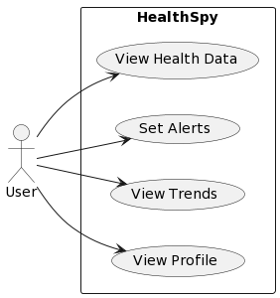

Use Case Scenarios Description:

1. View Health Data:
Description: Users can access their health data collected from wearable devices through the HealthSpy platform. This includes viewing information such as steps taken, calories burned, pulse rate, body temperature, and glucose levels.
- Scenario: A user logs into the HealthSpy system and navigates to the "View Health Data" section. They can then see a comprehensive overview of their health metrics displayed in an easy-to-understand format, allowing them to track their progress and monitor their health status over time.

2. Set Alerts:
Description: Users have the ability to set personalized alerts based on specific health parameters monitored by HealthSpy. These alerts notify users of abnormal readings or potential health risks, prompting them to take necessary actions or seek medical attention.
Scenario: A user configures their alert preferences within the HealthSpy application, specifying thresholds for vital signs such as heart rate and glucose levels. If any of these readings exceed the predefined thresholds, the system sends an alert notification to the user's device, prompting them to check their health status and take appropriate measures.

3. View Trends:
Description: Users can analyze their health trends and patterns over time using the trend analysis feature in HealthSpy. This feature enables users to visualize changes in their health metrics and identify long-term trends, facilitating informed decision-making and proactive health management.
Scenario: A user accesses the "View Trends" section of the HealthSpy platform to analyze their health data over the past month. They observe a gradual increase in their daily step count and a corresponding decrease in their resting heart rate, indicating an improvement in their overall fitness level. Based on these insights, the user adjusts their exercise routine to maintain their progress.

4. View Profile:
Description: Users can view and manage their profile information within the HealthSpy system. This includes personal details, health goals, preferences, and connected wearable devices. By accessing their profile, users can update their information and customize their HealthSpy experience.
Scenario: A user navigates to the "View Profile" section of the HealthSpy application to review and update their profile settings. They edit their fitness goals, update their contact information, and connect a new wearable device to their account. Once the changes are saved, the user's profile is updated, ensuring that their preferences are reflected accurately in the system.

Class Diagram:
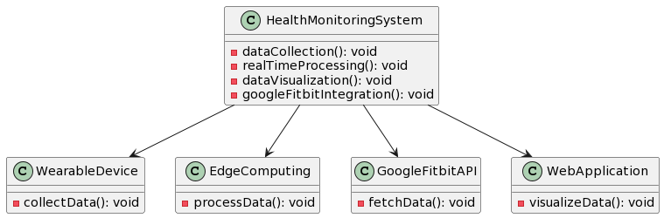

Chapter 4

Implementation

4.1 Methodology OR Proposal

The proposed methodology for the HealthSpy project is the Scrum framework, chosen for its flexibility, collaboration, and iterative nature. Scrum involves key components such as the product backlog, sprint planning, daily stand-ups, sprint review, and sprint retrospective, ensuring adaptability to changing requirements and continuous improvement. With Scrum, the team can prioritize features, deliver incremental value, and respond to stakeholder feedback efficiently. By fostering transparency, collaboration, and faster time-to-market, Scrum enables the development of a high-quality health monitoring system that meets stakeholder needs and user expectations, ensuring successful project delivery.
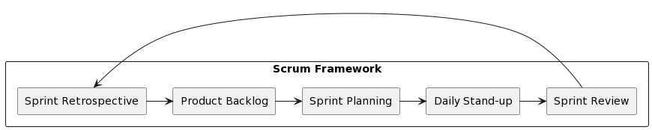

4.2 Testing OR Verification Plan

The Testing or Verification Plan for HealthSpy encompasses a thorough approach to ensure the project's functionality and reliability. It begins with Unit Testing, where individual components are rigorously tested for expected functionality, utilizing frameworks tailored for the project's tech stack while isolating external dependencies.

Integration Testing verifies seamless interactions between different modules, ensuring data flow and API contracts are respected. System Testing validates the complete system's functionality under simulated real-world scenarios. Acceptance Testing aligns tests with user requirements, involving stakeholders to confirm satisfaction.

Performance Testing assesses system stability and responsiveness under various loads, simulating multiple users. Security Testing identifies vulnerabilities and ensures data protection standards are met. Manual Testing complements automated tests, focusing on usability and accessibility.

Continuous Integration/Continuous Deployment (CI/CD) integrates testing into the pipeline for continuous feedback, utilizing tools like Jenkins or GitLab CI. Detailed documentation is maintained for test cases, results, and defect logs, ensuring traceability and facilitating a feedback loop to continuously improve quality.

Test | Test Case Title | Test Condition | System Behavior | Expected Result
ID
T01 | AAAA | BBBB | CCCC | DDDD
T02 | AAAA | BBBB | CCCC | DDDD
T03 | AAAA | BBBB | CCCC | DDDD

4.3 Result Analysis OR Screenshots

“http://localhost:8000/auth/google/callback”

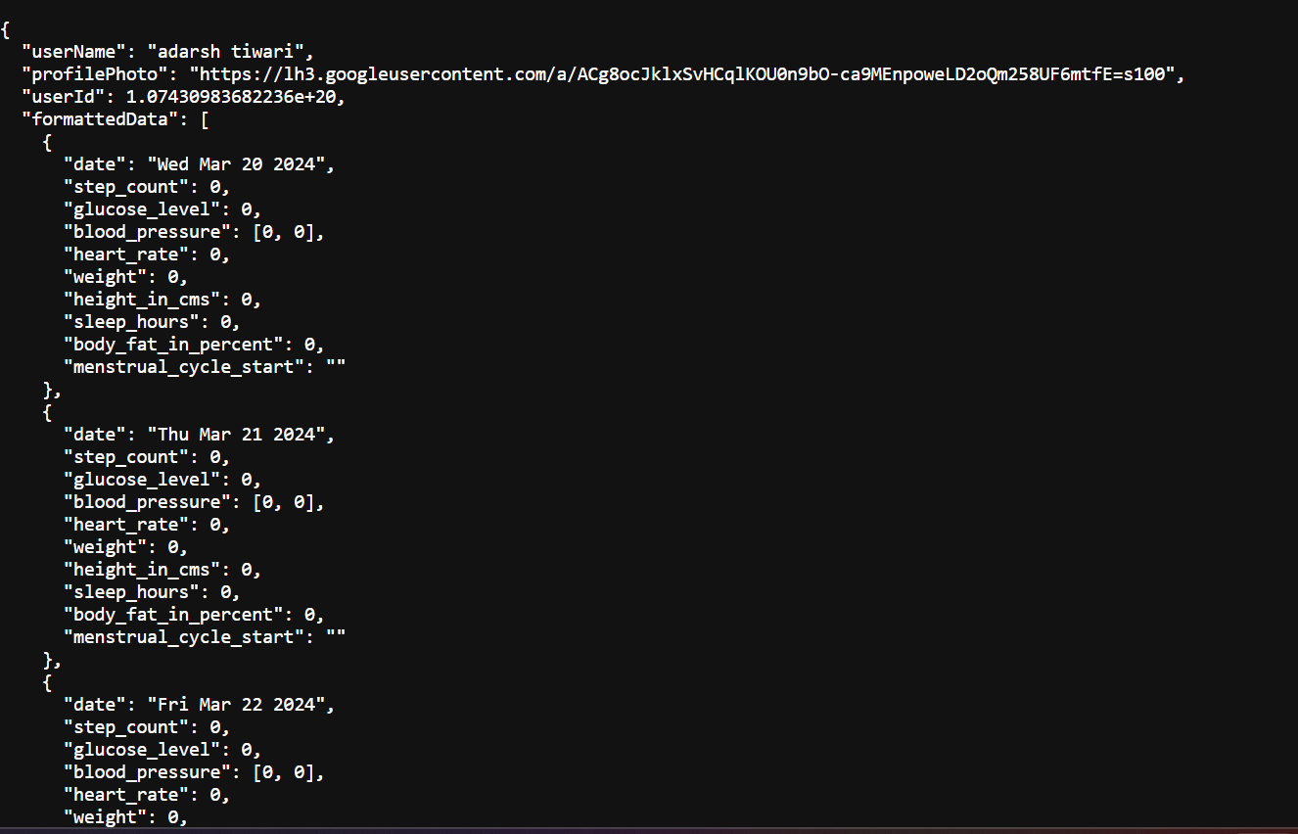

4.4 Quality Assurance

1. Adherence to Standards:
- Establish and communicate clear design and coding standards tailored to HealthSpy's requirements.
- Conduct training sessions to ensure all team members are well-versed with these standards.
- Utilize static code analysis tools to enforce adherence to coding conventions and identify potential issues early in the development process.

2. Code Reviews:
- Conduct regular peer code reviews to facilitate knowledge sharing, detect defects, and enhance code quality and maintainability.
- Foster a culture of constructive feedback within the team to encourage continuous improvement.

3. Peer Testing:
- Promote a collaborative environment where developers engage in peer testing to validate each other's code changes.
- Encourage developers to share insights and best practices while testing each other's work.

4. Automated Testing:
- Integrate automated testing frameworks into the development workflow to validate HealthSpy's functionalities consistently.
- Implement unit, integration, and end-to-end tests to cover various aspects of the system, ensuring robustness and reliability.

5. CI/CD Pipelines:
- Establish Continuous Integration/Continuous Deployment (CI/CD) pipelines using industry-standard tools like Jenkins, Travis CI, or GitLab CI.
- Automate the build, test, and deployment processes to streamline delivery and ensure consistent software quality.

6. Performance Monitoring:
- Continuously monitor HealthSpy's performance metrics to identify bottlenecks and areas for optimization.
- Employ Application Performance Management (APM) tools to track system behavior and responsiveness, ensuring optimal user experience.

7. Security Checks:
- Conduct regular security audits and updates to proactively identify and address potential vulnerabilities.
- Integrate security testing into the CI/CD pipeline to ensure that HealthSpy adheres to the highest security standards and safeguards sensitive data.

8. User Feedback:
- Actively collect and analyze user feedback to gain insights into user needs and preferences.
- Implement A/B testing methodologies to validate new features and changes, ensuring they align with user expectations and enhance user satisfaction.

9. Documentation:
- Maintain comprehensive and up-to-date documentation for HealthSpy, covering all aspects of the QA processes, test results, and system functionalities.
- Ensure transparency and traceability by documenting QA practices, test cases, and outcomes throughout the development lifecycle.

10. Training and Development:
- Offer ongoing training and development opportunities for team members to enhance their knowledge and skills in QA best practices.
- Encourage continuous learning and professional growth within the team to foster a culture of excellence and innovation.

Chapter 5

Standards Adopted

5.1 Design Standards

In adherence to best practices in software engineering, HealthSpy will follow established design standards to ensure robustness, scalability, and maintainability of the project. While specific design standards may vary across engineering streams, the following recommended practices will be incorporated into the project design:

1. IEEE Standards: HealthSpy will adhere to relevant IEEE standards applicable to software development, ensuring compliance with industry-recognized guidelines for quality and reliability.

2. ISO Standards: Where applicable, HealthSpy will align with ISO standards relevant to software engineering processes and quality management systems, promoting consistency and interoperability.

3. UML Diagrams: Unified Modeling Language (UML) diagrams will be utilized to visually represent system architecture, component interactions, and data models, providing a standardized and comprehensive overview of the project's design.

4. Database Design Standards: HealthSpy will follow established database design standards to ensure efficient storage, retrieval, and management of health data. This includes normalization techniques, indexing strategies, and data integrity constraints to maintain data consistency and reliability.

5. Modular Design: The project will employ a modular design approach, facilitating code reuse, ease of maintenance, and scalability. Components will be encapsulated to promote loose coupling and high cohesion, enhancing flexibility and extensibility.

6. Consistent Naming Conventions: Adopting consistent naming conventions for variables, functions, and classes will enhance code readability and maintainability, facilitating collaboration among team members and reducing the risk of errors.

7. Documentation Standards: Comprehensive documentation will accompany the project design, covering system architecture, design decisions, and implementation details. This documentation will serve as a valuable reference for developers, testers, and stakeholders throughout the project lifecycle.

8. Version Control: Utilizing version control systems such as Git will enable effective management of code changes, branching strategies, and collaboration among distributed development teams. This promotes transparency, traceability, and accountability in project development.

5.2 Coding Standards

To ensure the clarity, maintainability, and consistency of code in the HealthSpy project, the following coding standards and best practices will be implemented:

1. Conciseness: Prioritize brevity without sacrificing clarity, aiming to express functionality succinctly.

2. Naming Conventions: Adopt descriptive and meaningful names for variables, functions, and classes, following established conventions like camelCase or snake_case.

3. Code Segmentation: Organize code logically into sections or paragraphs, emphasizing clear separation between distinct functionalities.

4. Indentation: Consistently use indentation to denote the structure of the code, facilitating readability and comprehension.

5. Function Length: Encourage the creation of concise functions, each responsible for a single, well-defined task, promoting modularity and maintainability.

6. Commenting: Include concise comments to document code logic and intent, aiding understanding for developers.

7. Error Handling: Implement robust error handling mechanisms to manage exceptions and edge cases effectively.

8. Code Formatting: Adhere to a consistent code formatting style throughout the project, enhancing collaboration and readability.

9. Code Reviews: Conduct regular code reviews to identify and address issues, enforce coding standards, and share knowledge among team members.

10. Testing Integration:Integrate testing into the development process, encompassing unit tests, integration tests, and end-to-end tests to ensure code reliability and functionality.

These coding standards form the foundation for producing high-quality, maintainable code within the HealthSpy project, contributing to its overall success and effectiveness.

5.3 Testing Standards

HealthSpy adheres to industry-standard testing practices, including ISO and IEEE guidelines, to ensure product quality and reliability. Specific standards followed include ISO/IEC 25010 for software quality models and ISO/IEC 29119 for software testing processes. These standards provide a framework for comprehensive testing and verification activities, covering functional, non-functional, and regulatory requirements of the HealthSpy project.

Chapter 6

Conclusion and Future Scope

In summary, HealthSpy stands as a groundbreaking solution in remote health monitoring technology, providing users with the ability to monitor their health metrics in real-time through wearable devices and state-of-the-art edge computing. Its extensive feature set, encompassing data collection, real-time monitoring, and data visualization, empowers users to proactively manage their health and well-being. Moving forward, HealthSpy aims to broaden its functionalities by integrating advanced machine learning algorithms for personalized health insights and predictive analytics. Moreover, advancements in data visualization techniques and the inclusion of telemedicine features will further enrich the user experience. Collaborations with healthcare institutions and research organizations will facilitate HealthSpy's contribution to population health management and medical research endeavors. Continual updates and refinements based on user input will ensure that HealthSpy remains at the forefront of innovation in remote health monitoring technology.

References:

[1] Healthcare Information and Management Systems Society. (2021). Healthcare Information and Management Systems Society (HIMSS). Retrieved from https://www.himss.org/

[2] World Health Organization. (2021). World Health Organization (WHO). Retrieved from https://www.who.int/

[3] Institute of Electrical and Electronics Engineers. (2021). IEEE Standards Association. Retrieved from https://standards.ieee.org/

[4] International Organization for Standardization. (2021). ISO - International Organization for Standardization. Retrieved from https://www.iso.org/

[5] Jest. (2021). Jest. Retrieved from https://jestjs.io/

[6] Mocha. (2021). Mocha. Retrieved from https://mochajs.org/

[7] Chai. (2021). Chai Assertion Library. Retrieved from https://www.chaijs.com/

[8] LoadRunner. (2021). LoadRunner. Retrieved from https://www.microfocus.com/en-us/products/loadrunner-professional/overview

[9] Apache JMeter. (2021). Apache JMeter. Retrieved from https://jmeter.apache.org/

[10] Jenkins. (2021). Jenkins. Retrieved from https://www.jenkins.io/

[11] GitLab CI. (2021). GitLab CI/CD. Retrieved from https://docs.gitlab.com/ee/ci/

[12] GitHub. (2021). GitHub. Retrieved from https://github.com/

[13] GitLab. (2021). GitLab. Retrieved from https://about.gitlab.com/

[14] Atlassian. (2021). Jira Software. Retrieved from https://www.atlassian.com/software/jira

[15] Git. (2021). Git. Retrieved from https://git-scm.com/

[16] W3C. (2021). World Wide Web Consortium (W3C). Retrieved from https://www.w3.org/

[17] MDN Web Docs. (2021). MDN Web Docs. Retrieved from https://developer.mozilla.org/en-US/

[18] Google Cloud Platform. (2021). Google Cloud. Retrieved from https://cloud.google.com/

SAMPLE INDIVIDUAL CONTRIBUTION REPORT:

<TITLE OF THE PROJECT IN FONT SIZE 14, FONT STYLE TIMES NEW ROMAN, BOLD AND CENTERED>

<Student Name (in capital letters in font size 12, Times New Roman and centered>
<Student Roll number (font size 12, Times New Roman and centered>

Abstract: A short description of the aim and objective of the project work carried out in 3-4 lines. This part should be common to all students in the group. The font size and style will remain same from this point onwards. The font size will be 12 and font style will be Times New Roman. The line spacing will be 1.5.
This report should be prepared in A4 page format with ‘default’ option under ‘Margin’ of the ‘Page Layout’ tab in Microsoft Word. Word limit for this section is 80.

Individual contribution and findings: The student should clearly indicate his/her role in the project group and the contribution in implementing the project work. The student should also outline his /her planning involved in implementing his/her part in the work. This contribution report should be different for every student in the group. The student would also write his./her technical findings and experience while implementing the corresponding part of the project. The overall contribution report should not be less than 1 page for each student. The Student should provide both the soft copy and signed hard copy to the project supervisor.

Individual contribution to project report preparation: Student should mention his/her role in preparing the group project report indicating which chapter and portions contributed.

Individual contribution for project presentation and demonstration: Student should mention his/her role in preparing presentations and part of the project demonstrated.

Full Signature of Supervisor: Full signature of the student:
……………………………. ……………………………..

TURNITIN PLAGIARISM REPORT
(This report is mandatory for all the projects and plagiarism
must be below 25%)

