1. Create a node application and initialize it

Create a folder databasedemo in D drive and open this folder in VS Code

Open terminal and type

**npm init**

To install mysql module type

**npm install mysql.**

Open MySQL and Create a database **MCA**

In MCA database create one table named as emp

Create database MCA;

Use MCA;

Create table  **emp (id int, ename varchar(20), age int);**

**Insert into emp values(1,’ABC’,45);**

**Insert into emp values(2,’XYZ’,34);**

**Insert into emp values (3, ‘PQR’, 32);**

**Select * from emp;**

1. **Write node.js program to connect with MySQL Database**

**index.js**

**var mysql = require('mysql');**

**var conn = mysql.createConnection({**

**host: 'localhost',**

**user:'root',**

**password: 'root',**

**database:'MCA'**

**});**

**conn.connect( function(error){**

**if(error) throw error;**

**console.log("Connected");**

**}**

**);**

**Run index.js**

**If you get an error like below error**

*code: 'ER_ACCESS_DENIED_ERROR',*

*errno: 1045,*

*sqlMessage: "Access denied for user 'root'@'localhost' (using password: YES)",*

*sqlState: '28000',*

*fatal: true*

the type below query in mysql database.

*show variables like 'default_authentication_plugin';*

*select user, plugin*

*FROM mysql.user*

*where user='root';*

*------Change password-------*

*alter user 'root'@'localhost' identified with*

*mysql_native_password by 'root123';*

*flush privileges;*

Now make changes in index.js code as below

**host: 'localhost',**

**user:'root',**

**password: 'root123', //new password**

**database:'MCA'**

save the changes and rerun the code

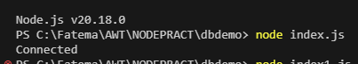

1. **Write node.js program to select table data from MySQL database;**

**Index1.js**

**var mysql = require('mysql');**

**var conn = mysql.createConnection({**

**host: 'localhost',**

**user:'root',**

**password: 'root123',**

**database:'MCA'**

**});**

**conn.connect( function(error){**

**if(error) throw error;**

**conn.query("select * from emp",function(error,result){**

**if(error) throw error;**

**console.log(result);**

**});**

**}**

**);**

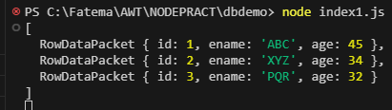

1. **Write node.js program to select only one record from MySQL database;**

**Index2.js**

var mysql = require('mysql');

var conn = mysql.createConnection({

host: 'localhost',

user:'root',

password: 'root123',

database:'MCA'

});

conn.connect( function(error){

if(error) throw error;

conn.query("select * from emp",function(error,result){

if(error) throw error;

console.log(result[0]);

});

}

);

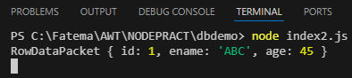

1. **Write node.js program to select name of employee having id=1from MySQL database;**

**Index3.js**

var mysql = require('mysql');

var conn = mysql.createConnection({

host: 'localhost',

user:'root',

password: 'root123',

database:'MCA'

});

conn.connect( function(error){

if(error) throw error;

conn.query("select * from emp",function(error,result){

if(error) throw error;

console.log(result[0].ename);

});

}

);



1. **Write node.js program to create a table ‘emp1’;**

**Index4.js**

**var mysql = require('mysql');**

**var conn = mysql.createConnection({**

**host: 'localhost',**

**user:'root',**

**password: 'root123',**

**database:'MCA'**

**});**

**conn.connect( function(error){**

**if(error) throw error;**

**conn.query("create table emp1(id int, ename varchar(10))",function(error){**

**if(error) throw error;**

**console.log("Table created");**

**});**

**}**

**);**

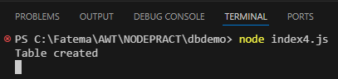

1. **Write node.js program to insert a record in emp1 table ;**

**Index5.js**

var mysql = require('mysql');

var conn = mysql.createConnection({

host: 'localhost',

user:'root',

password: 'root123',

database:'MCA'

});

conn.connect( function(error){

if(error) throw error;

conn.query("insert into emp1 values(1,'KF')",function(error){

if(error) throw error;

console.log("Record inserted");

});

}

);



