Create a complete CI-CD pipeline using bash, python and crontabs. The list of tasks is specified below:

**Task 1: Set Up a Simple HTML Project**

Create a simple HTML project and push it to a GitHub repository.

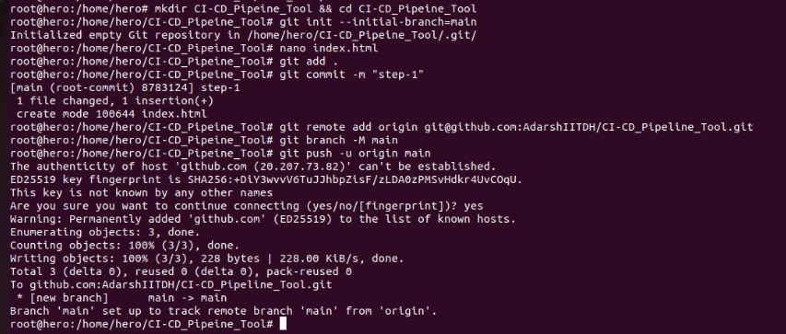

**Task 2: Set Up an AWS EC2/Local Linux Instance with Nginx**

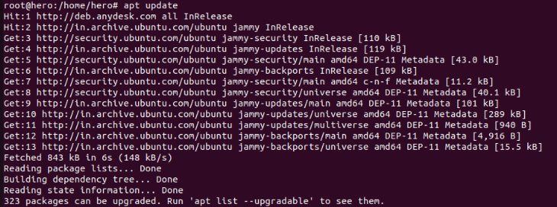

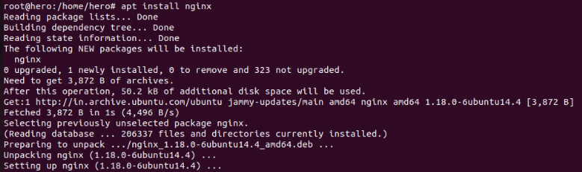

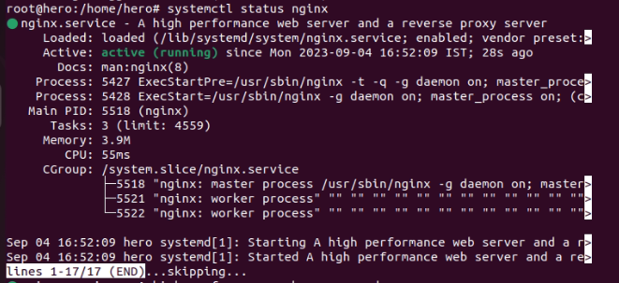

**Task 3: Write a Python Script to Check for New Commits**

Create a Python script to check for new commits using the GitHub API.

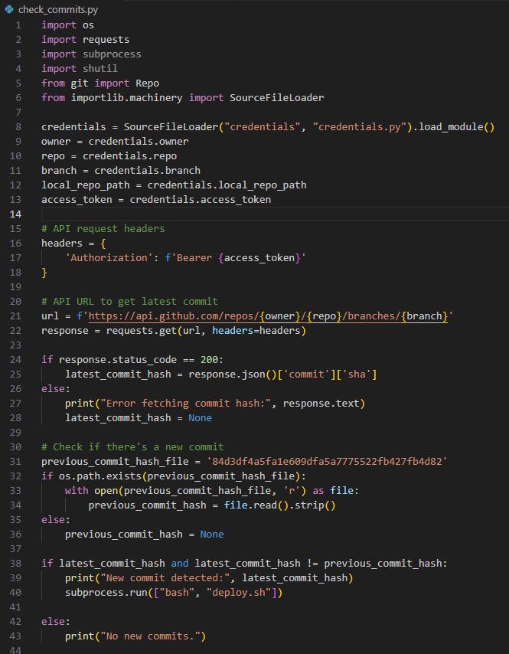

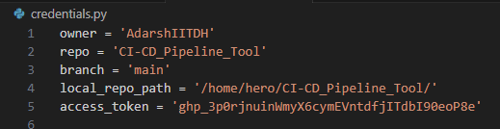

**Task 4: Write a Bash Script to Deploy the Code**

Create a bash script to clone the latest code and restart Nginx.

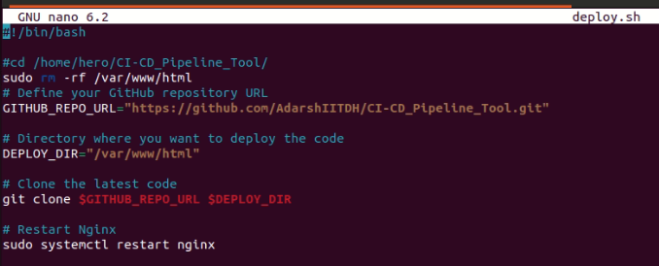



**Task 5: Set Up a Cron Job to Run the Python Script**

Create a cron job to run the Python script at regular intervals.

Created a cron job which will run the python script after every min.

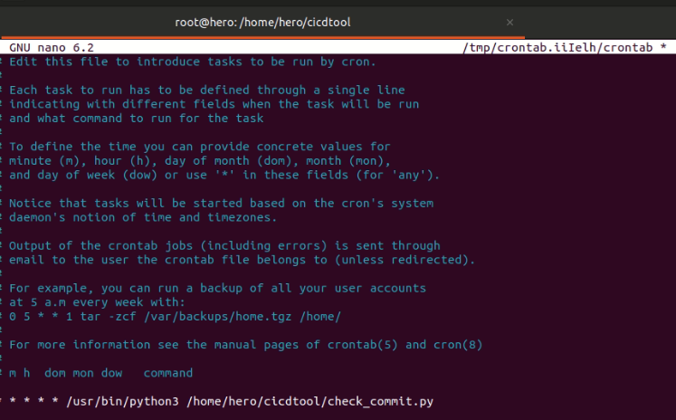

Then changes the timing to 15 min, after every 15 min the python script will get executed automatically.

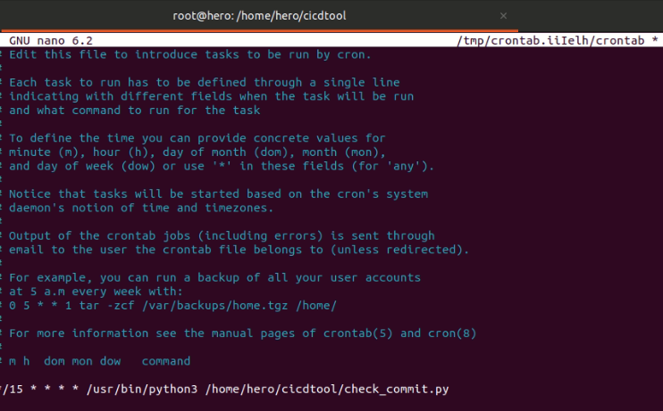

**Task 6: Test the Setup**

Make a new commit to the GitHub repository and check that the changes are automatically deployed.

Before doing any change in backend nginx page

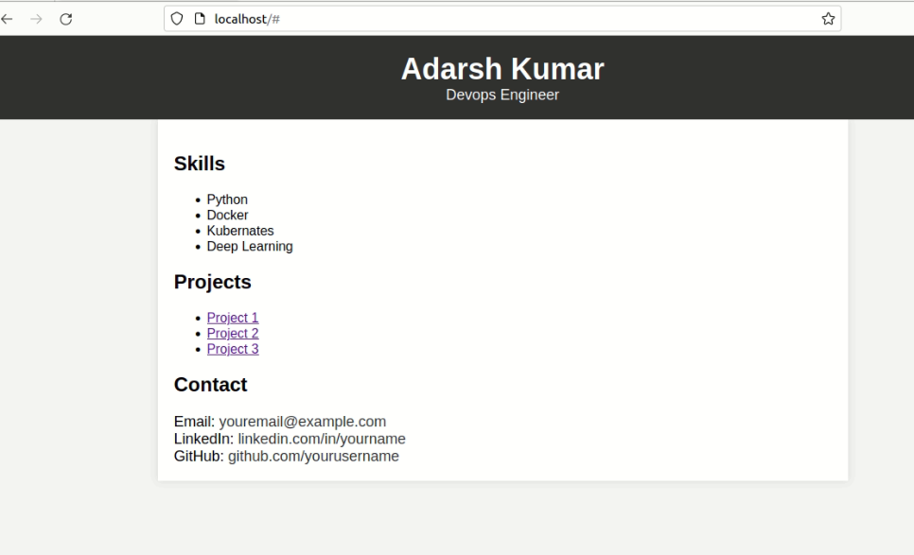

Made some changes like added a new project4 edited the email, LinkedIn and GitHub URLs.

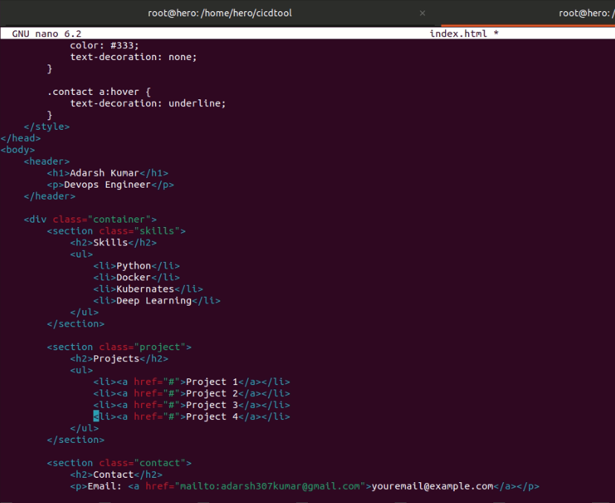

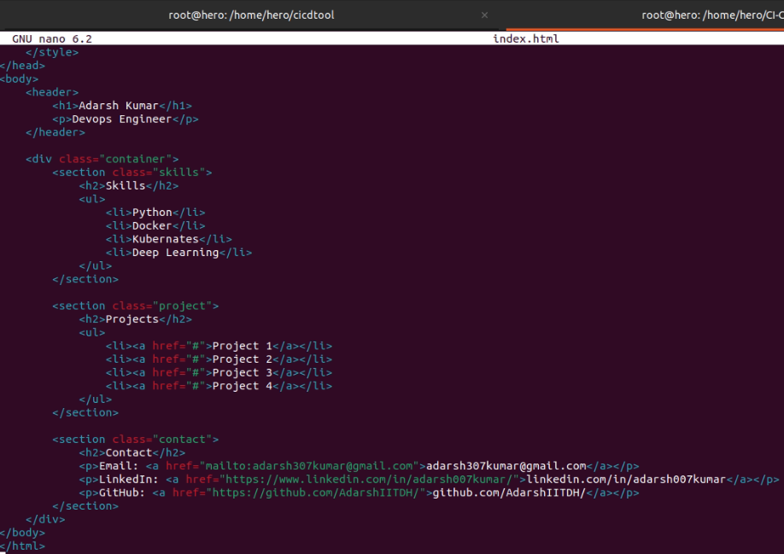

After making the changes in the file added the file committed it and pushed it to GITHUB repository.

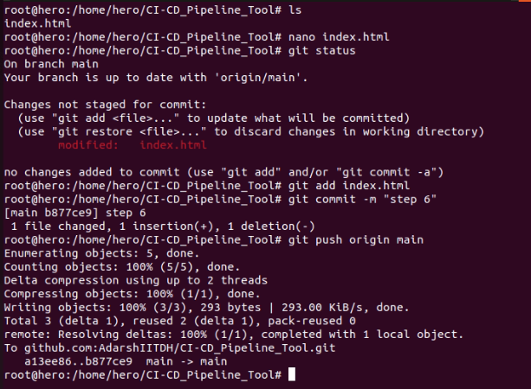

After 15 min the nginx page automatically changed.

