**CS825-001, Spring/Summer 2020**

**Assignment 1**

**Submitted to Dr. Xue Dong Yang**

**By**

**Adarsh Koppa Manjunath**

**200397257**

**Q.1** (30 marks) *Programming*

Write a program that reads a grayscale image in raw format from a file; resize the image to a specified resolution using the single point resampling method; and save the new image into a new file in raw format. Test your program with the following data:

a) Input image filename: “rose.raw”

Format: grayscale

Original resolution: 256x256

**Method: single point resampling**

**New resolution: 500x500**

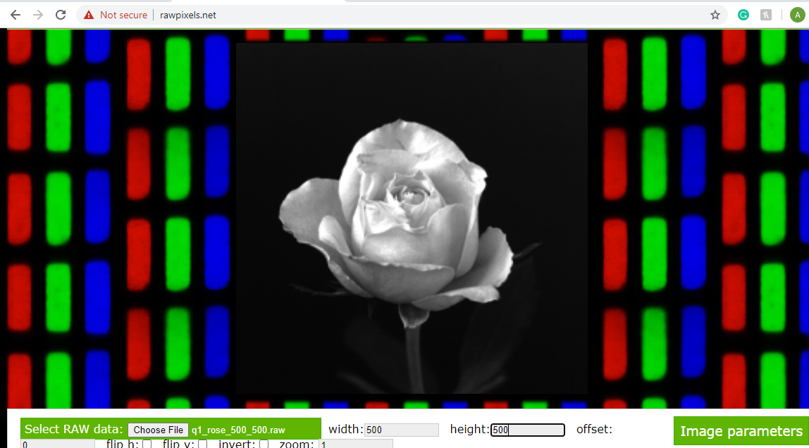Fig 1-rose image ( resolution 500*500)

b) Input image filename: “winter-landscape-1600x1000-grayscale.raw”

Format: grayscale

Original resolution: 1600x1000

**Method: single point resampling**

**New resolution: 1000x625**

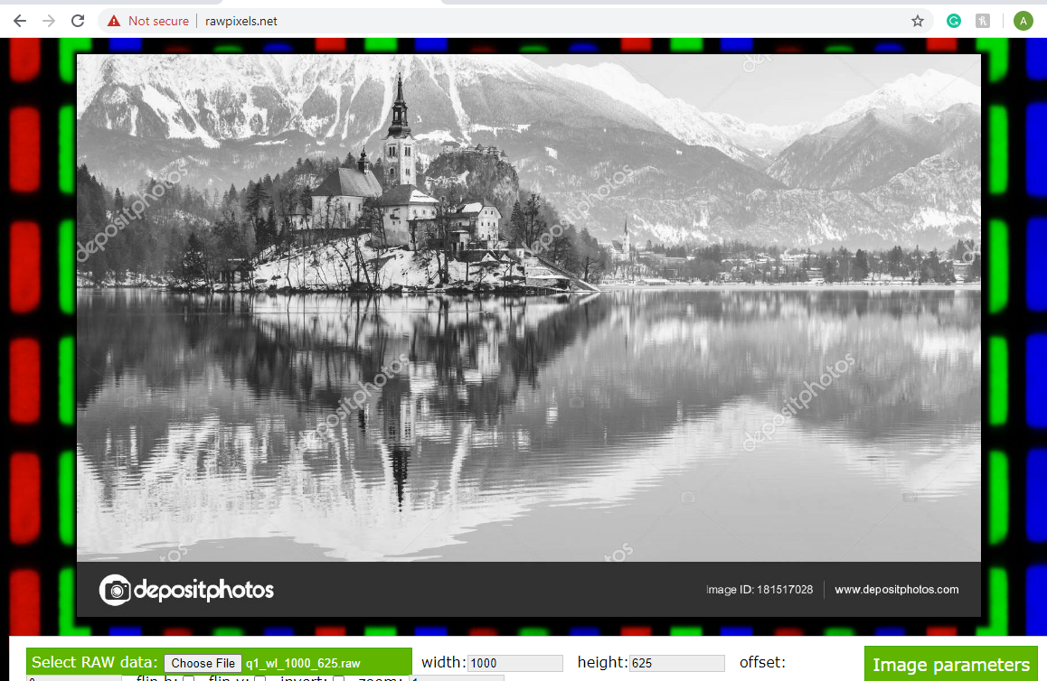

Fig 2-winter landscape image( resolution 1000*625)

c) Input image filename: “winter-landscape-1600x1000-grayscale.raw”

Format: grayscale

Original resolution: 1600x1000

**Method: single point resampling**

New resolution: 640x400

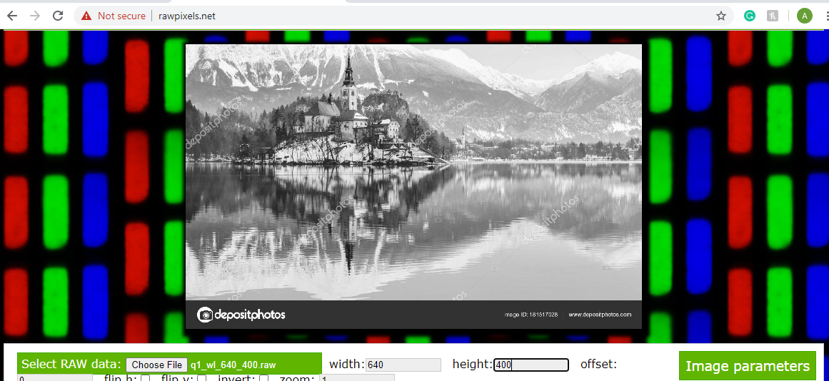

Fig 3- winter landscape image ( resolution 640*400)

**Q.2** (30 marks) *Programming*

Repeat Q.1, but using the weighted average resampling method

a) Input image filename: “rose.raw”

Format: grayscale

Original resolution: 256x256

**Method: weighted average resampling**

**New resolution: 500x500**

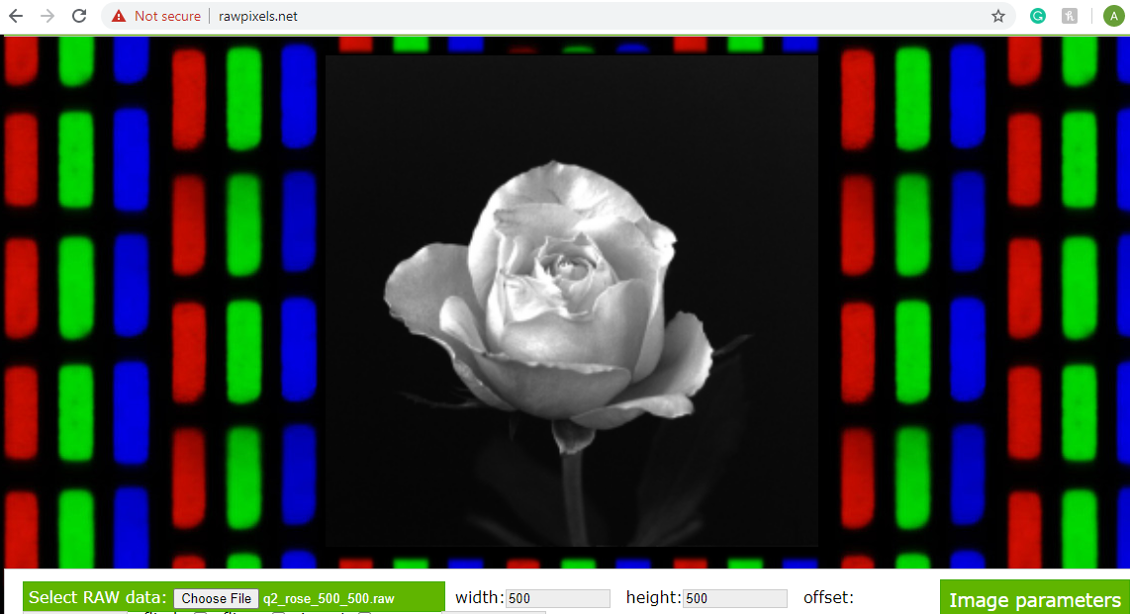

Fig 4-rose image ( resolution 500*500)

b) Input image filename: “winter-landscape-1600x1000-grayscale.raw”

Format: grayscale

Original resolution: 1600x1000

**Method: weighted average resampling**

**New resolution: 1000x625**

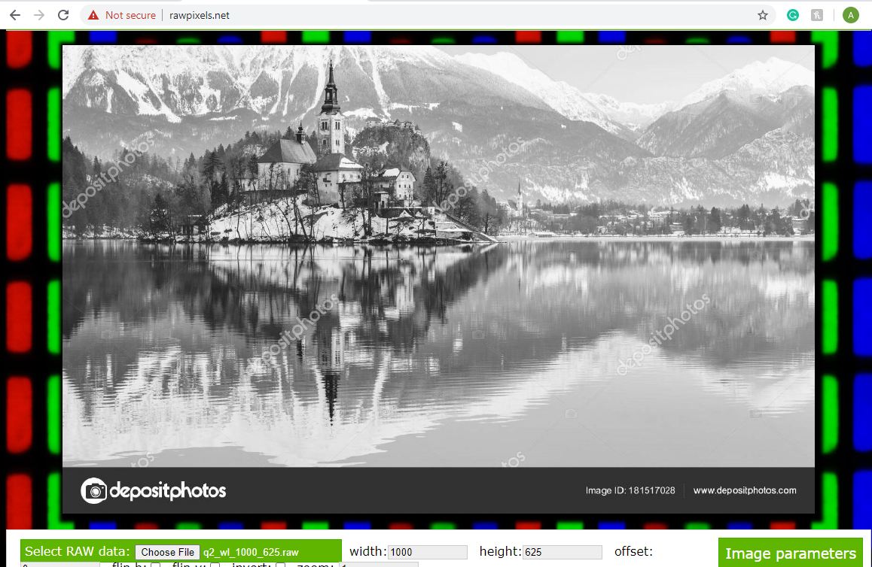

Fig 5-winter landscape image( resolution 1000*625)

c) Input image filename: “winter-landscape-1600x1000-grayscale.raw”

Format: grayscale

Original resolution: 1600x1000

**Method: Weighted average resampling**

New resolution: 640x400

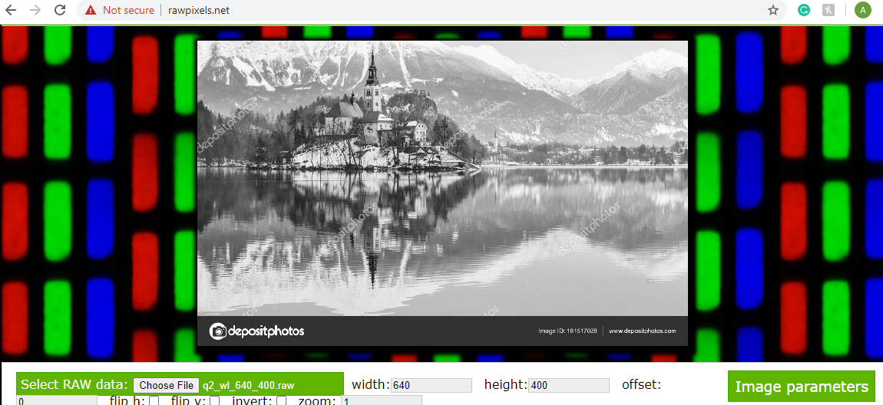

Fig 6- winter landscape image ( resolution 640*400)

**Q.3** (30 marks) *Programming*

Write a program that reads “rose.raw” as the input image; change the intensity quantization level; and save the new image into a new file in raw format. The original image uses 8 bits per pixel, thus having 256 intensity levels. Test your program by converting intensity level to the following 4 new levels respectivfely:

a) 128 levels (by setting the least significant bit of each pixel to 0)

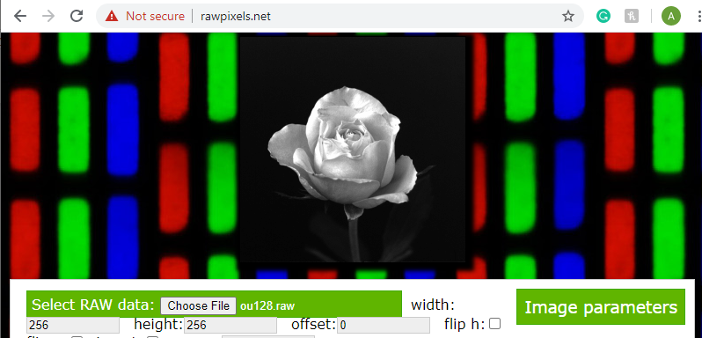

Fig 7: 128 levels

b) 64 levels (by setting the two least significant bits of each pixel to 0’s)

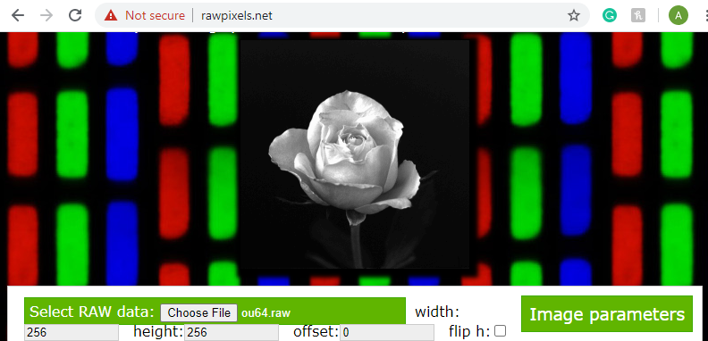

Fig 8: 64 levels

c)32 levels (by setting the three least significant bits of each pixel to 0’s)

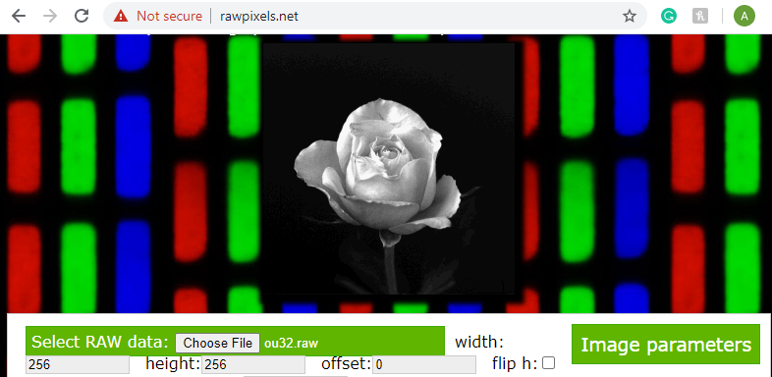

Fig 9: 32 levels

d)16 levels (by setting the four least significant bits of each pixel to 0’s)

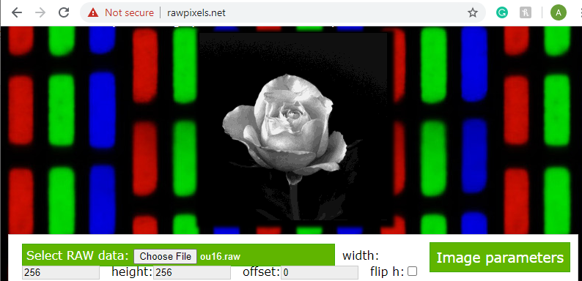 Fig 10: 16 levels

**Q.4** (10 marks) *Non-Programming*

Refer to the four new images generated in Q.3.

**a) Describe what “false contour” is.**

We can see decrease in smoothness as intensity decreases. At one point, boundaries merge between different intensities and these boundaries are called false contours.

As we can see in the 3rd question, at 128 level image smoothness is fine and we don’t see any major difference, but at 62 level, we can see very minute decrease in smoothness around left leaf and at 32 level, we can see decrease in smoothness around stem and leaf area. Major changes can be seen at 16 level, around petals, stem, and leaf area.

Below two images are enlarged images from fig 9 and fig 10 for intensity levels 32 and 16 respectively to show how smoothness been decreased.

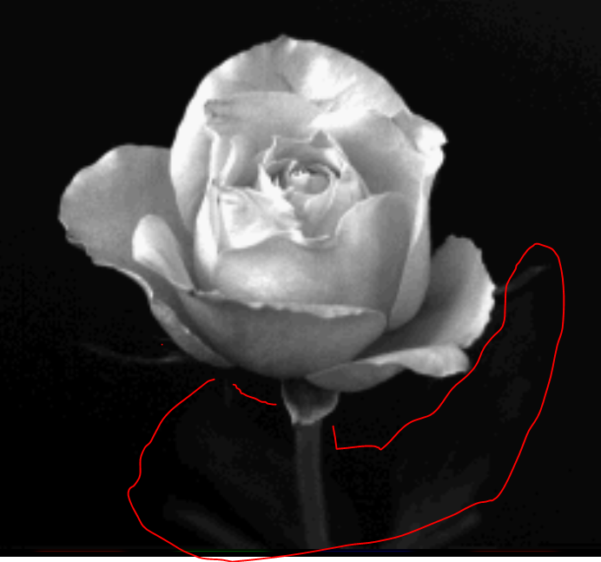

Fig 11: enlarged image of 32 levels

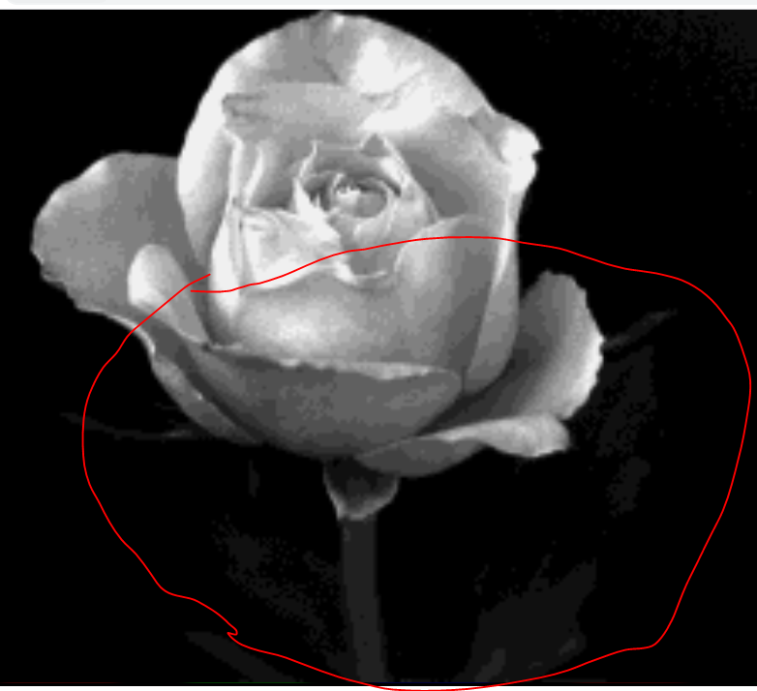

Fig 12: enlarged image of 16 levels

b) At which level do false contours become visible?

**At 32 levels, leaf edge is hardly visible** .

c) Is 8 bits per pixel (or 256 levels of intensity) sufficient for human visual system?

**Yes 8 bits is sufficient.**