**CS825-001, Spring/Summer 2020**

**Assignment 3**

**Submitted to Dr. Xue Dong Yang**

**By**

**Adarsh Koppa Manjunath**

**200397257**

**Q1)**

Below image is the screenshot of template matched output from q1. Black Squares are the template matched results.



Fig-1: Template matching output

Below image is the screenshot of all the computation of q1.

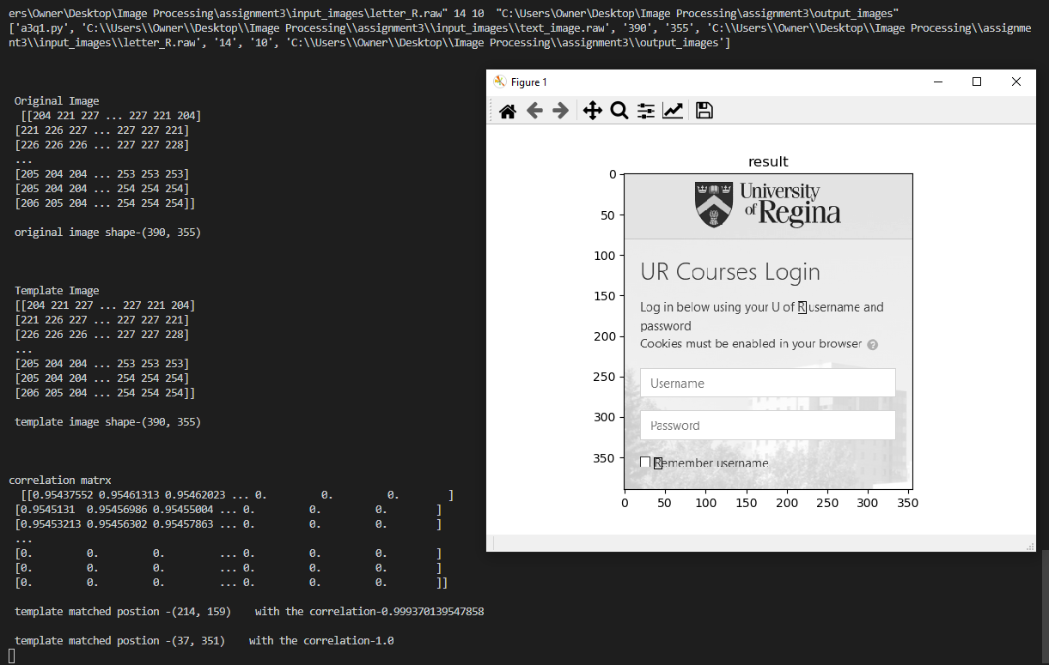

Fig-2: Q1 computations

**Q2) Gx image**

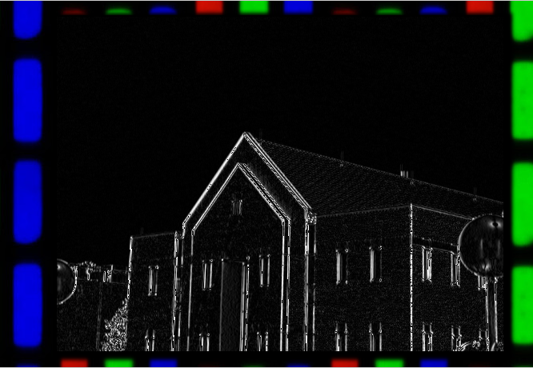

Fig -3 : Gx image

Computation involved in Gx

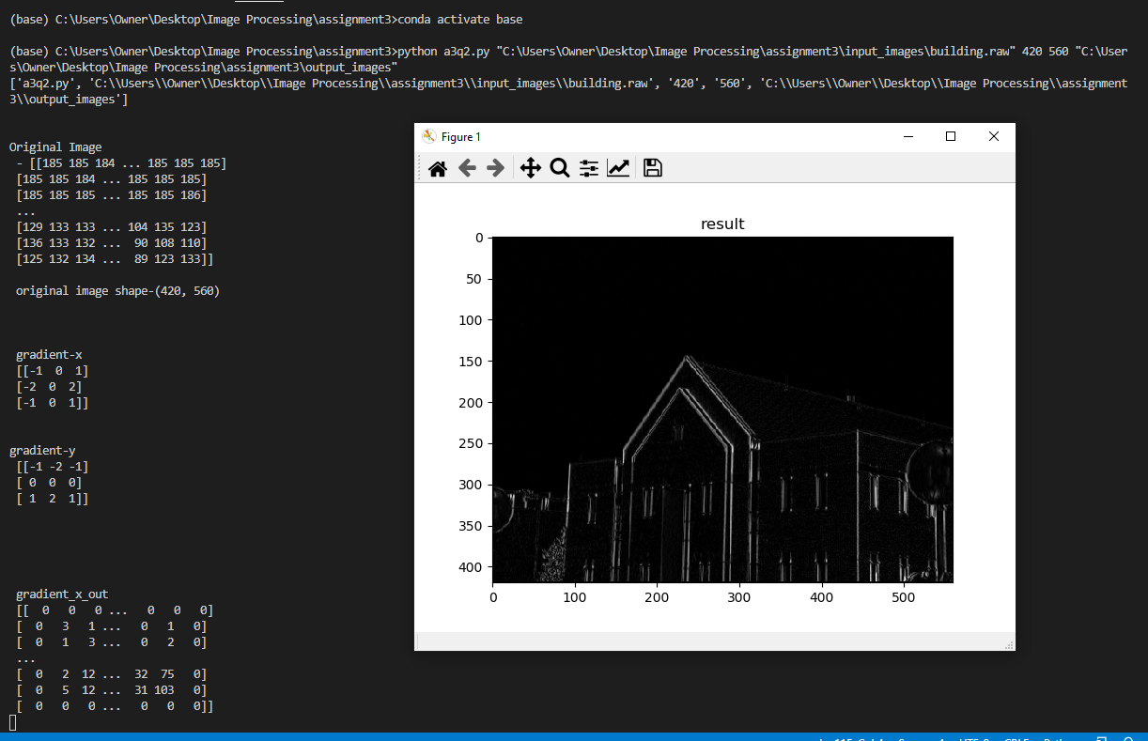

Fig-4 Computation Involved in Gx

**Q2) Gy Image**

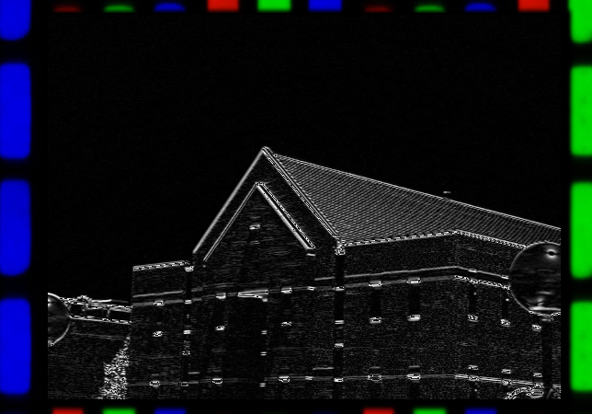

Fig 5- Gy image

Computation involved in calculating Gy

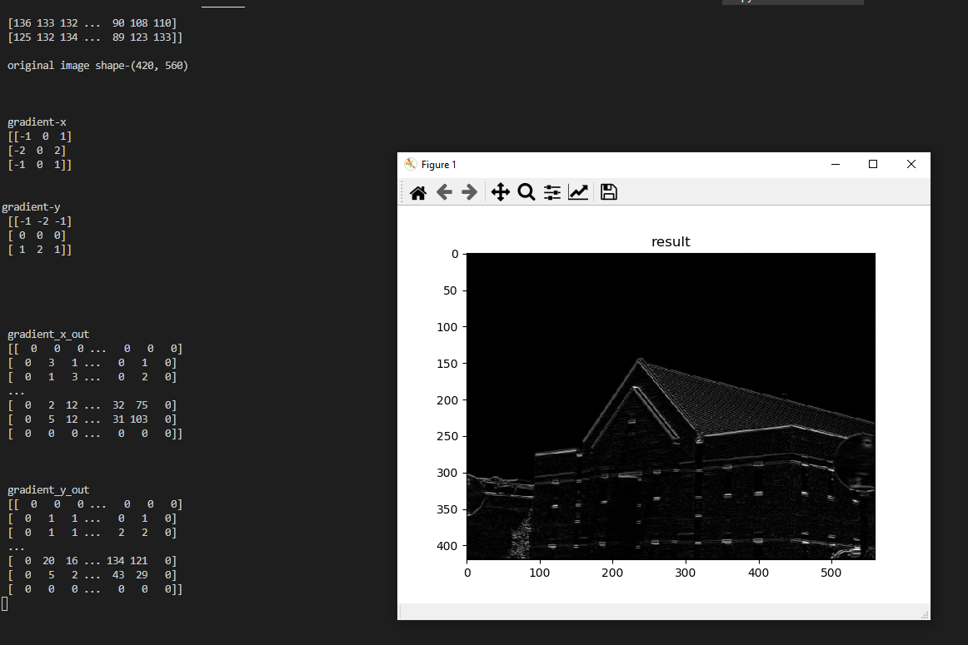

Fig 5- Gy computation

**Q2) Gradient Image**

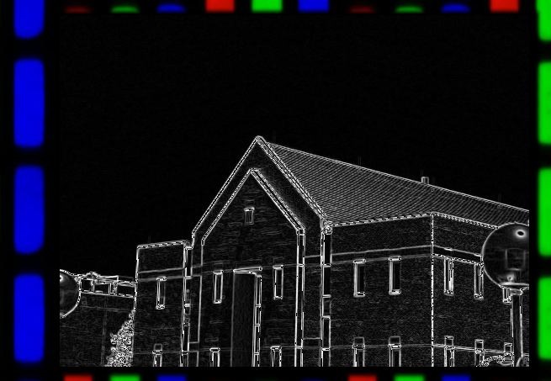

Fig-6 : Gradient Image

Gradient output and image

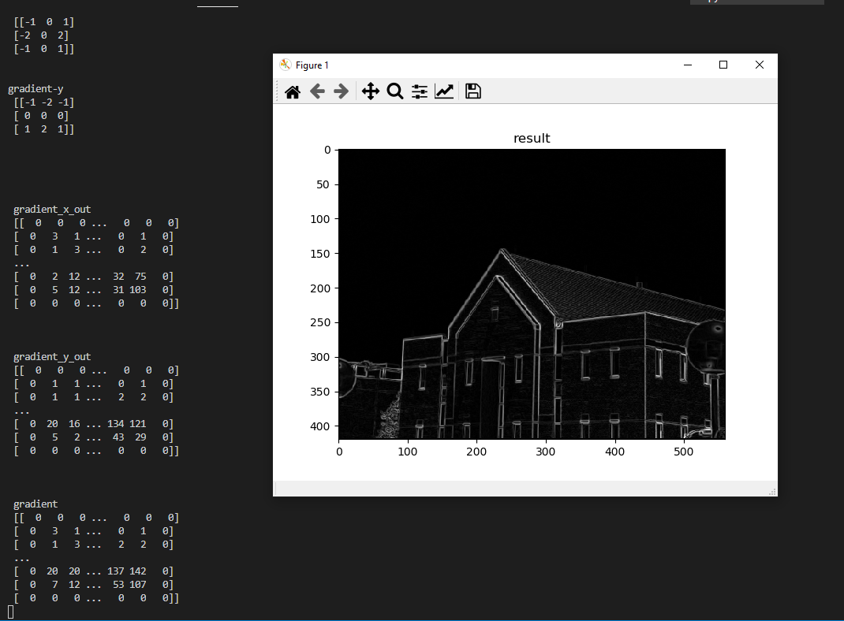

Fig-7: Gradient result

Q2) the edge map with threshold TE = 128

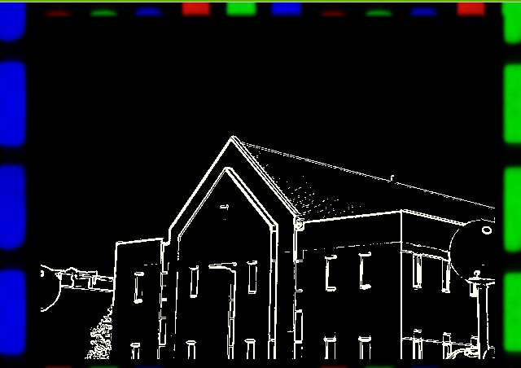

Fig-8: the edge map with threshold TE = 128

the edge map with threshold =128 result and image

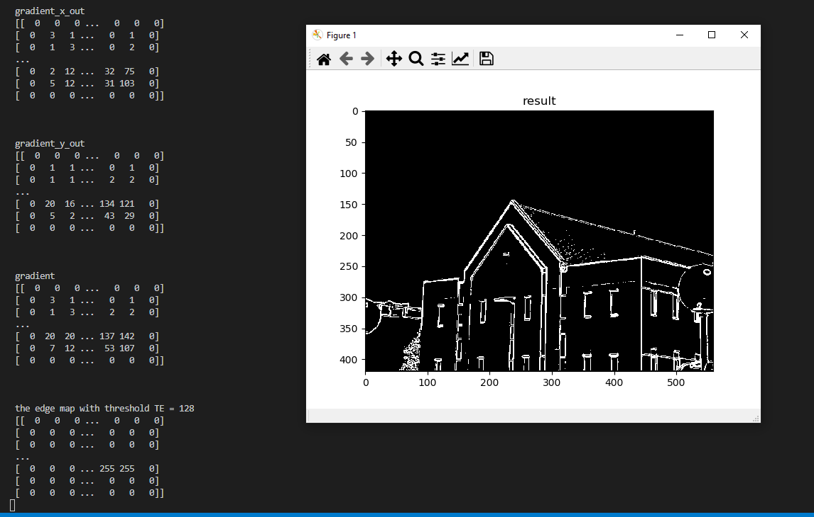

Fig-9: the edge map with threshold TE = 128 and results

Q3) zero-crossing points map.

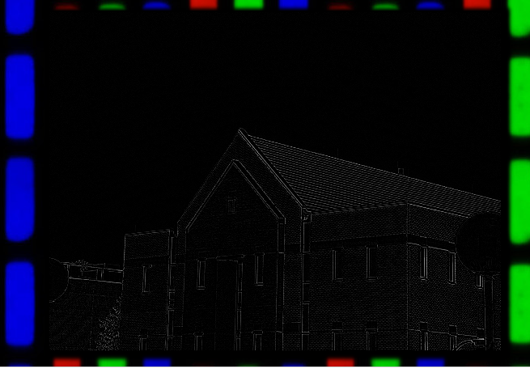

**Fig-10:** zero-crossing points map.

Computation involved in zero-crossing points map.

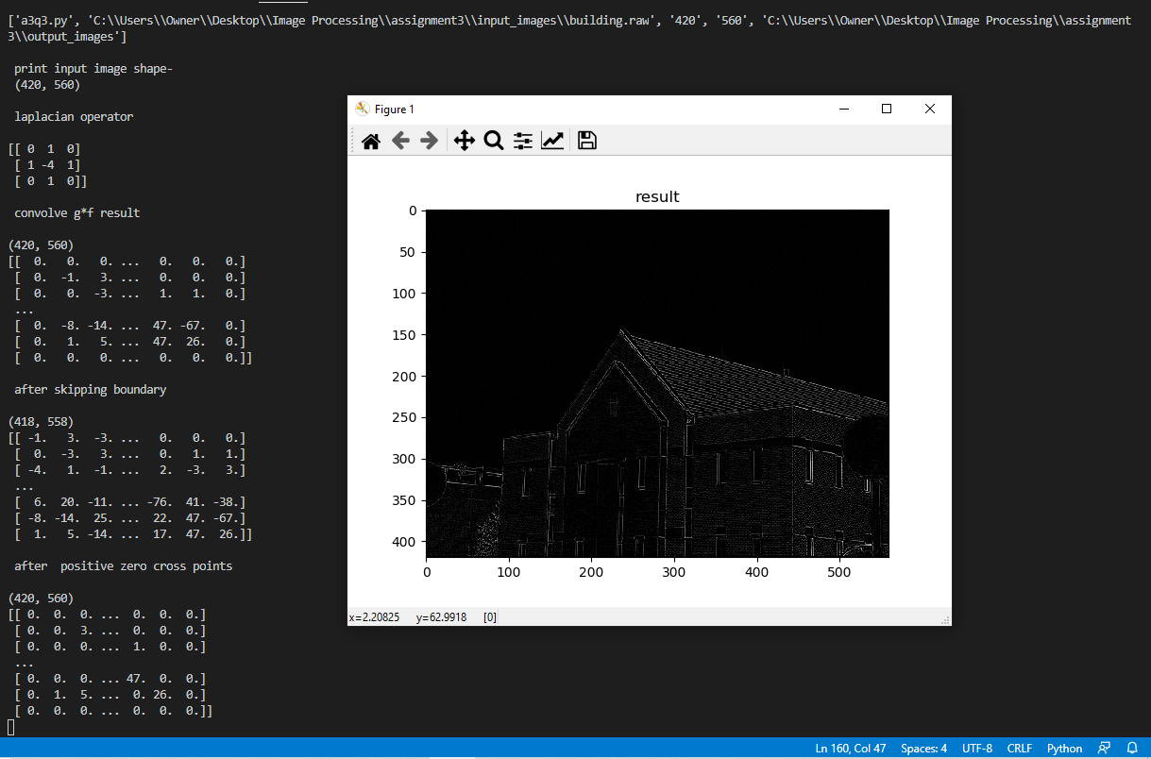

Fig 11: zero-crossing points results and image

**Q 4) W=1**

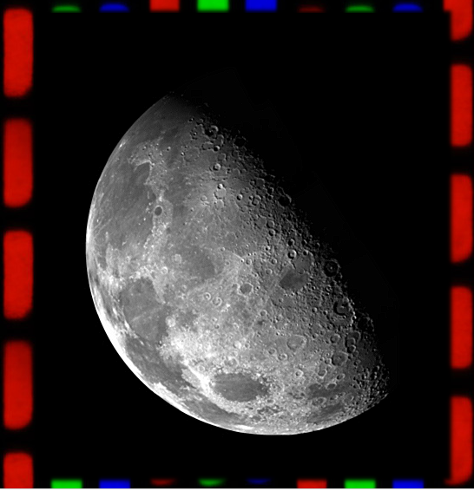

Fig 11: Image Sharpening with w=1

Image sharpening with w=1 results and image

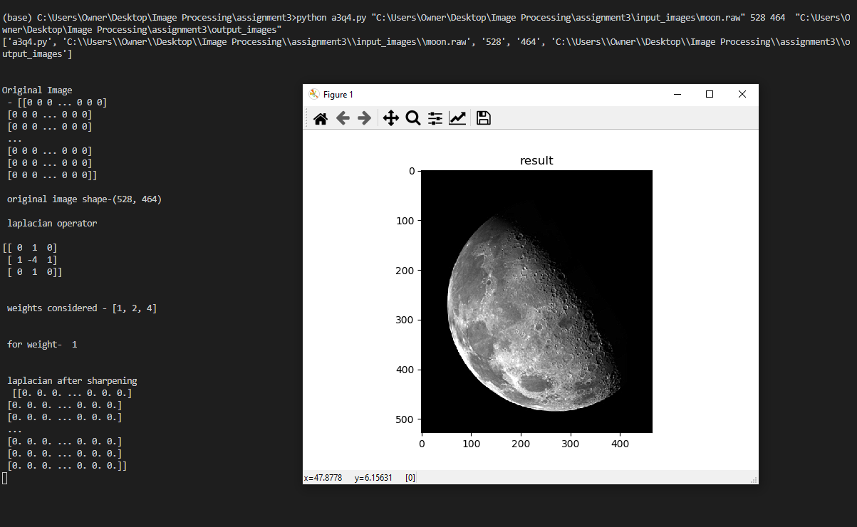

Fig-12: Image sharpening with w=1 results and image

**Q 4) W=2**

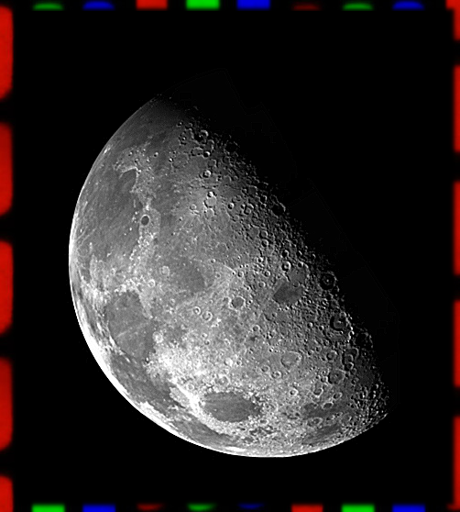

Fig-13: Image sharpening with w=2

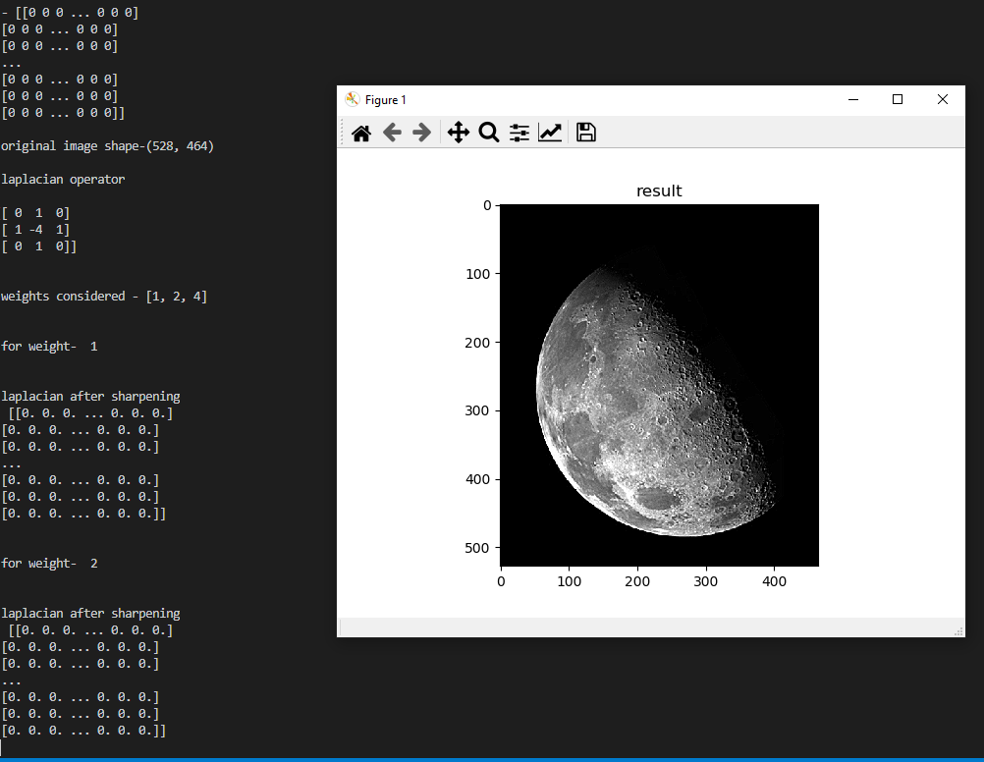

Fig-14: Image sharpening with w=2 results and image

**Q 4) W=4**

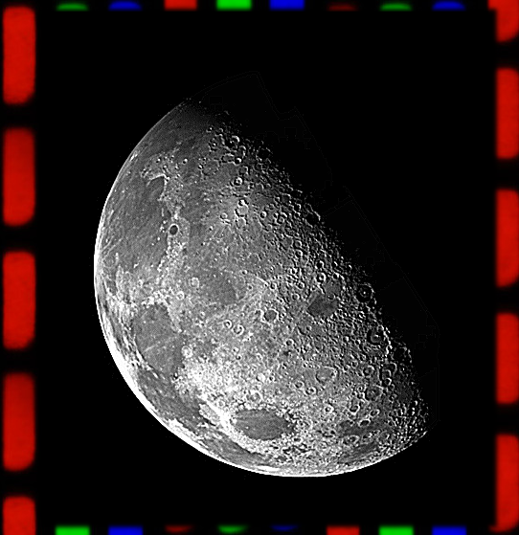

Fig-15: Image sharpening with w=4

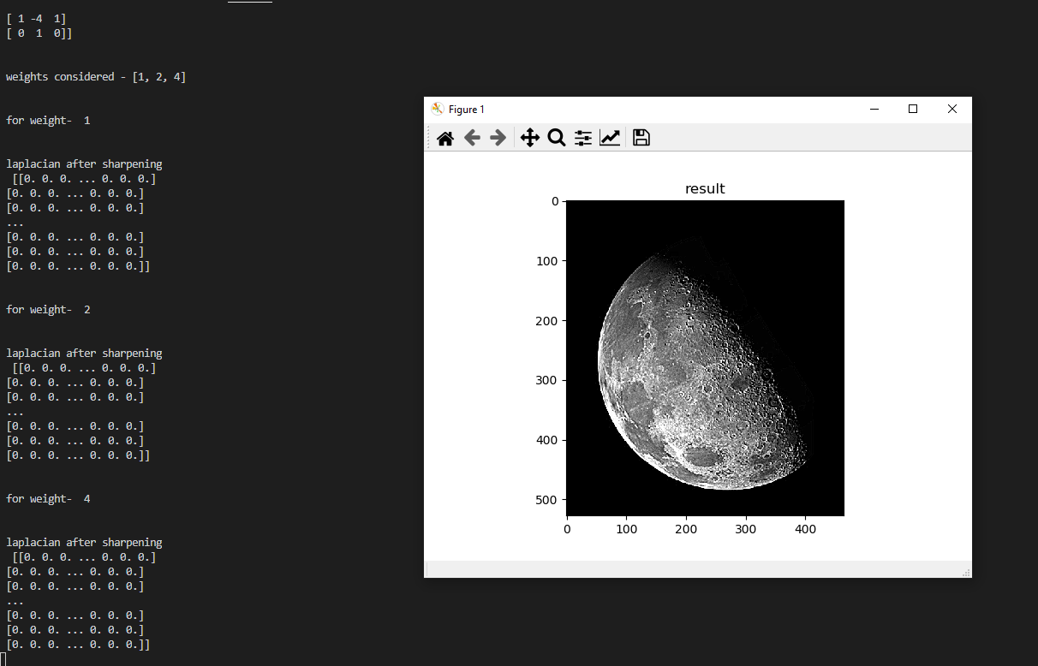

Fig-16: Image sharpening with w=4 results and image