Insight: 1

By comparing the years 2023, 2024 for My way, we can able to see there is a difference in the total tickets sold through myway platform , from the box plot we can see that people using myway tickets comparatively higher than 2023

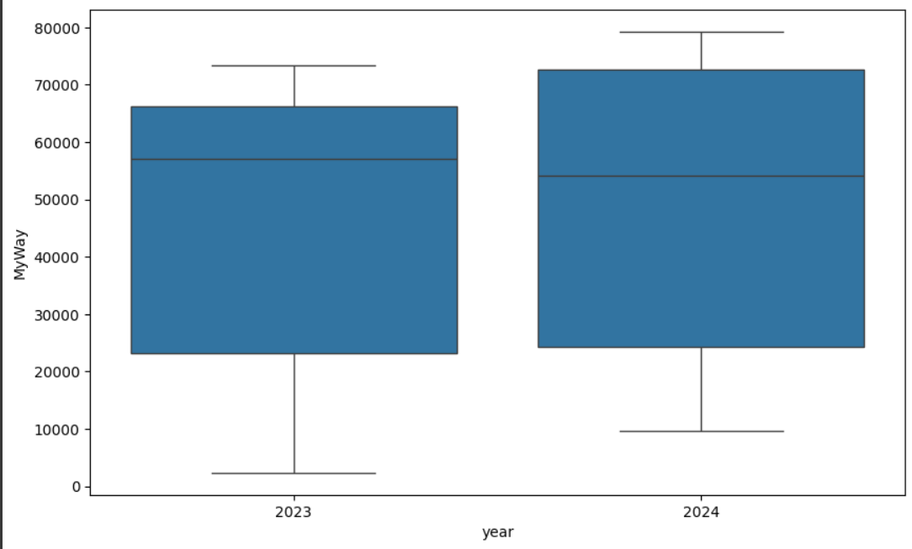

Insight: 2

From both the seasonal plots we can conclude there is more usage of public transport in the month of February and august holds the second most in the useage of public transport.

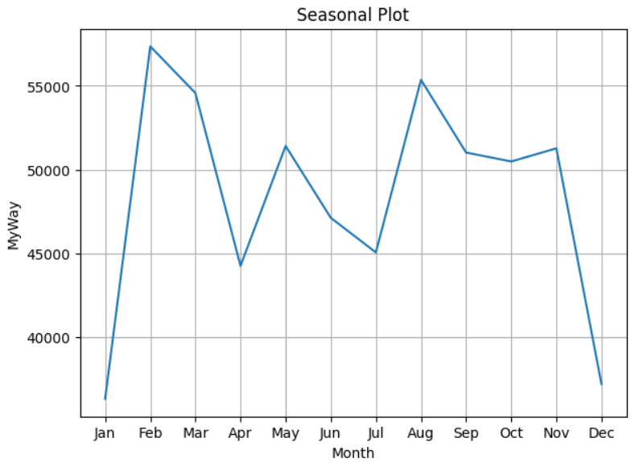 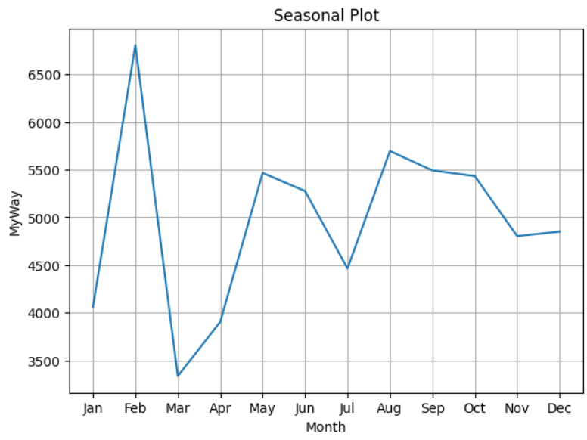

Insight: 3

By comparing the years 2023, 2024 for Paper tickets, we can able to see there is a difference in the total tickets sold through papertickets, from the box plot we can see that people using paper tickets comparatively lower than 2023

From comparing the 75% of tickets sold in 3034 is approximately equal to 50% of tickets sold via papers

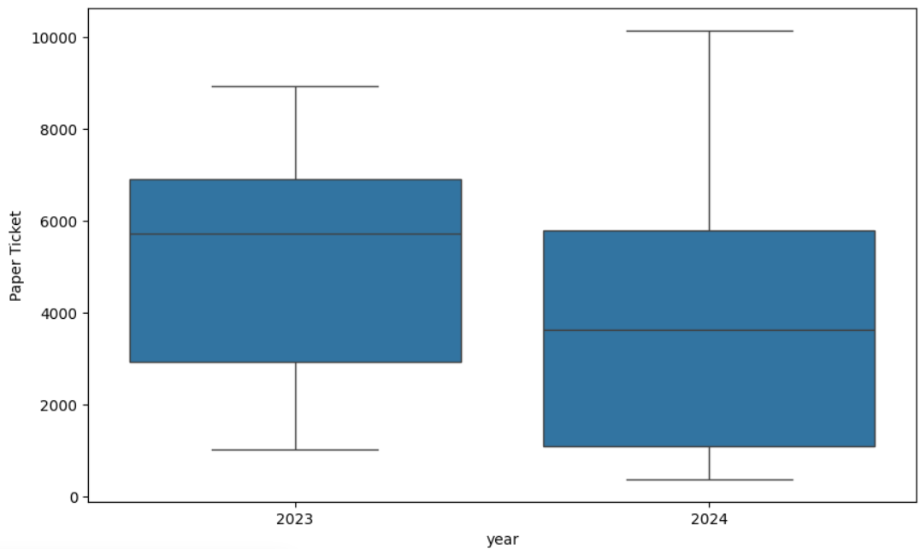

Insight: 4

From the visualization below , we can able to see the total number of tickets sold by MyWay and by Paper Ticket and MyWay tickets leads the total count overall.

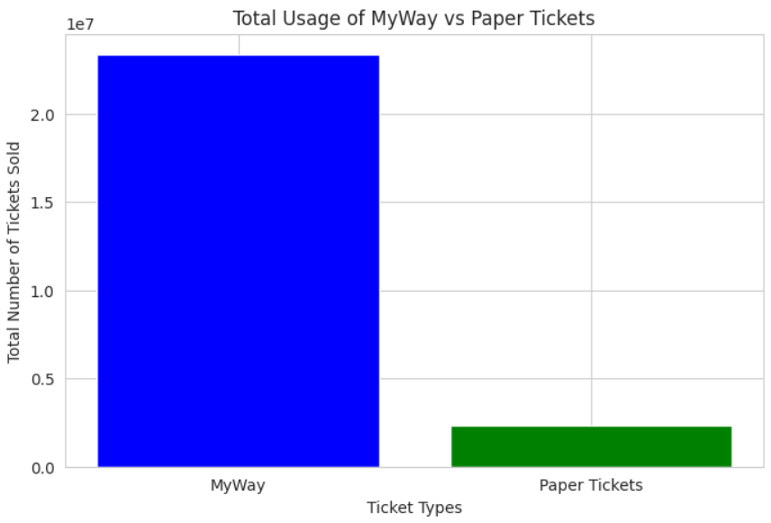

Insight: 5

From the visualization below, we can able to see the average ticket sales by day of the week, there is a slight lower sales of ticket in the weekends.

