ISER **Registration Form**e-mail : info@iser.org.in  
web: <http://iser.org.in>



*Payment of a registration fee covers the cost to attend all conference activities, coffee breaks, conference reception and banquet, and all lunches during the conference. In addition, each registrant will receive a copy of the conference proceedings with ISBN. Notice that this registration fee does not cover transportation fee, accommodation fee, and after conference tour fee.*

|  |  |
| --- | --- |
| *All questions and inquiries concerning registration*  *and payment should be addressed to*:  **info@iser.org.in** | *Please complete this form and email a scanned copy to:*  **info@iser.org.in** |

|  |  |
| --- | --- |
| Event Name | *International Conference on Nanotechnology and Smart Materials, Design Artificial Intelligence, Manufacturing and Engineering (ICNSMDAIME-21)* |
| Venue/Place of Event | *Vadodara India* |
| Date of Event | *25th April 2021* |

|  |  |  |  |  |  |  |  |
| --- | --- | --- | --- | --- | --- | --- | --- |
| PLEASE KINDLY FILL IN A SEPARATE REGISTRATION FORM FOR EACH CONFERENCE PARTICIPANT | | | | | | | |
| Full Name | Adarsh Pathak | | Highest Qualification | | B-Tech | | |
| Affiliation/Designation | **Medi-Caps University** | | | | | | |
| Mailing Address | **50, Ambikapuri (Main), Airport Road, Indore** | | | | | | |
| City, Zip, Country | **Indore, 452005, India** | | | Passport Number: U3499536 | | | |
| Mobile(With Country code) | **+91 9893068404** | | | Email | | **adarsh24699@gmail.com** | |
| ACCEPTED PAPER INFORMATION | **Paper ID: ISER_31625**    Title of the paper: Comparison of CNN and Contour Algorithm for Number Identification Using Hand Gesture Recognition.  Author’s Name: Adarsh Pathak | | | | | | |
| Co-Author’s Name & Designation | 1. Faraz Ahmed Khan, B-Tech | 2. | | 3. | | | Guided by: Mr. Chandrashekhar Kothari  Mail ID: shekhar.kothari@medicaps.ac.in  Contact No:9407120202  Affiliation: Medi-Caps University |

**PAYMENT INFORMATION**

|  |  |  |  |  |
| --- | --- | --- | --- | --- |
| Total Amount | Bank Name | Remitter | Date | Ref. No |
| **4100** | **Paytm Payments Bank**   |  |  | | --- | --- | | |  | | --- | | Paytm Payments Bank | | | **Adarsh Pathak** | 20/04/2021 | 110140262045 |
| **For online transfer (Debt card/Credit card/Online Banking)** | **Order ID/Traction ID:** 607ea1b502468 | | |

***Note: It is mandatory to provide a scan copy of ID Proof /Passport along with this Registration form***

**ADDITIONAL INFORMATION**

* Will you present physically at the event__________N__________________(Y/N).

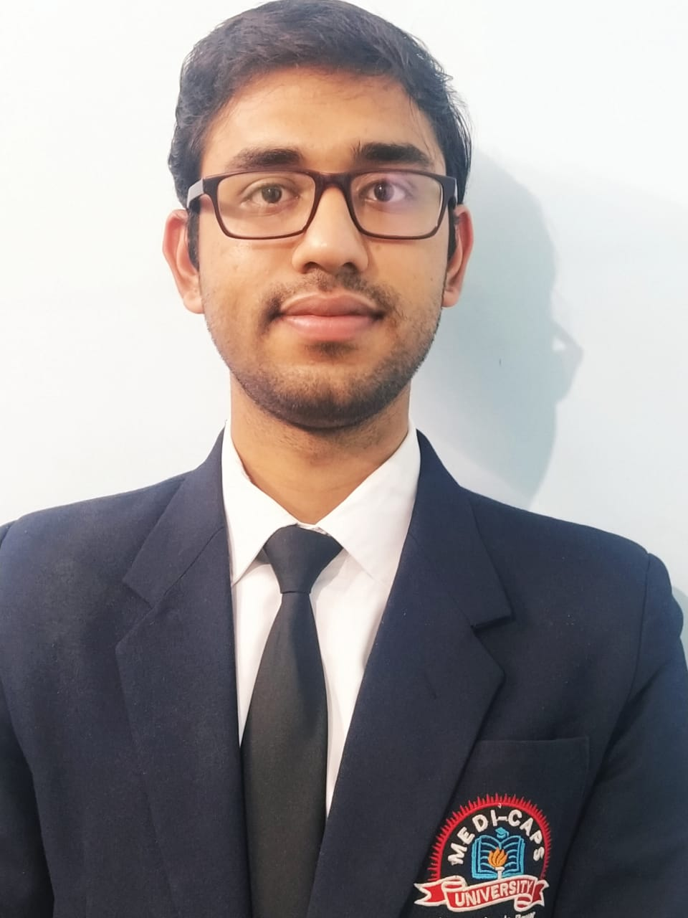

Photo Here   
(the photo should match your Passport)

* No. of Persons attending the event with you?(Including your Co-authors)____2__.
* Will your Guide/HOD/Principal attending will attend the Event?____N_____(Y/N).

**Declaration & Undertaking**

*1. I have not published this paper anywhere before and I am transferring the Copyright of my paper to ISER*

*2. I will not cause or involve in any sort of violence or disturbance within and Outside of the Conference/Event Venue or during the travel to the venue at any Country during my Visa Period.*

*3. ISER has all rights reserved to shift the venue, rescheduling the date of the Event.*

*4. I do here by declare that all the information given by me is true and if at any moment it is found to be wrong my registration for event will be cancelled by ISER and take necessary action against me.*

*5. ISER is not responsible for any violation of Rules and Regulations by me or by my Co-authors of this paper at any country during the Event.*

Signature (Author): _____________________Adarsh Pathak_______________________ Date: 20-04-2021

Remarks: _________________________________________________________________________________________________