AIP (Agentic Investment Pod): Building a Multi-Agent AI Stock Analyst
Oct 26, 2026 · @Adarsh

1. Overview
AIP, short for Agentic Investment Pod, is a Python web app in which four AI agents, each powered by Google Gemini, research a stock and agree on a final BUY, HOLD or SELL. You type a company name or ticker; the agents gather real data, reason about it, and explain their decisions in plain English.
What makes it agentic: no buy/sell rules are hard-coded. Each agent receives a role, a goal and a toolbox of Python functions. The agent decides which tools to call, reads the results, and makes its own judgement.
Agent | Job | Data source
SEC Filings Agent | Judges the company's financial health from its official annual report (10-K) | SEC EDGAR
Price Trend Agent | Reads the price chart, momentum and valuation | Yahoo Finance (yfinance)
News Sentiment Agent | Reads recent headlines and judges what they mean for the stock | Yahoo Finance news, Google News
Risk Agent | Measures risk, weighs the other three reports, makes the final call | All of the above
The first three agents work at the same time, each on its own free Gemini model. The Risk Agent acts as the manager: it waits for their reports, checks the risks itself, and decides.
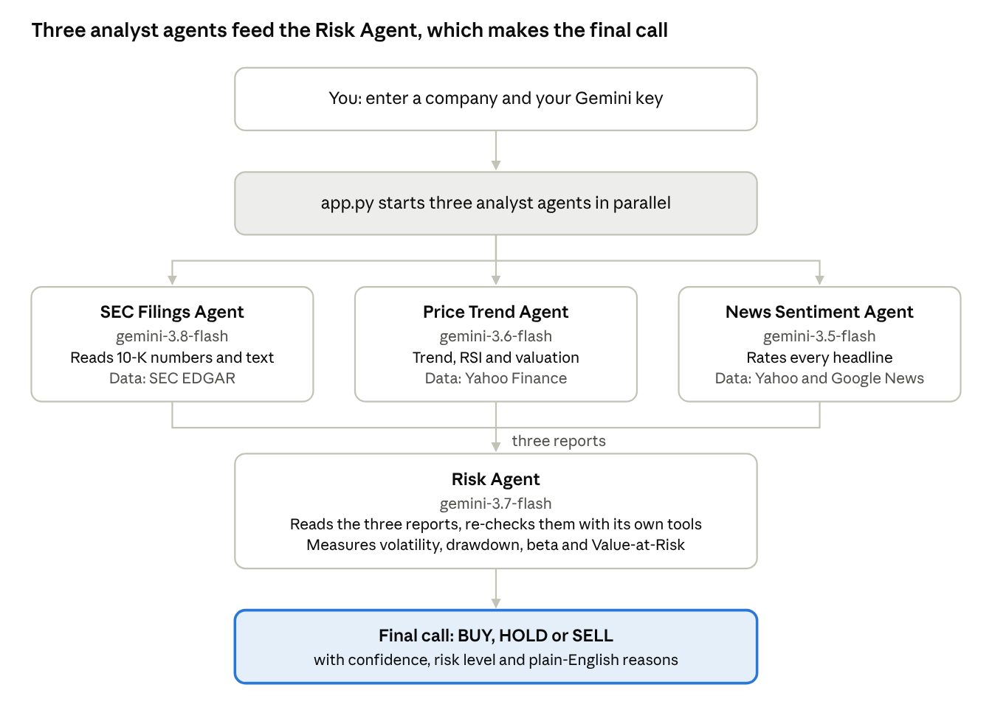
AIP architecture · 4 Gemini agents
Read it top to bottom: the three analysts work side by side on their own data, and only the Risk Agent sees all three reports.

2. Key concepts
Five ideas explain the whole project. Teach these first and the code reads easily.
Concept | Plain-English meaning | Where it lives in AIP
Large language model (LLM) | An AI that reads text and writes text. It can reason, summarise and follow instructions. | Google Gemini, called through the google-genai Python library
Agent | An LLM given a role, a goal and tools, that decides its own next steps until the goal is met | sec_agent.py, price_agent.py, sentiment_agent.py, risk_agent.py
Tool | A normal Python function the LLM is allowed to call, such as "get the last 4 years of financials" | agents/tools.py
Agent loop | Ask the model → run the tools it requests → send back results → repeat until it answers | run_agent() in agents/llm.py
Structured output | The agent's final answer is JSON (signal, score, confidence, reasons), so the app can display it | BASE_FORMAT in agents/common.py
Tools fetch, the model judges. The Python tools only download and tidy data. Every opinion (is this margin good, is this headline bad news, how risky is this stock) comes from Gemini.
The data sources are free and public:
- SEC EDGAR: the US Securities and Exchange Commission's database of company filings. A 10-K is the audited annual report; an 8-K announces a major event. No key needed, only a name and email in the request header.
- Yahoo Finance via yfinance: daily OHLC prices (Open, High, Low, Close) and volume, plus valuation figures such as the P/E ratio and analyst price targets.
- Google News RSS and Yahoo Finance news: recent headlines about the company.

3. Step-by-step setup
Setup takes about 10 minutes and costs nothing. You need Python 3.10 or newer, the project folder, and a free Gemini API key.
- Check Python. Open a terminal (Terminal on macOS, PowerShell on Windows) and run python3 --version. If it prints 3.10 or higher you are ready; otherwise install Python from python.org.
- Get the project folder. Copy the AlphaAgent folder to your computer and move into it:
cd ~/Carey_TA_Fall/AlphaAgent
- Create a virtual environment (recommended). This keeps the project's packages separate from the rest of your computer:
python3 -m venv .venv
source .venv/bin/activate # Windows: .venv\Scripts\activate
- Install the packages. One command installs everything listed in requirements.txt (Gemini, Streamlit, yfinance, Plotly, pandas):
pip install -r requirements.txt
- Get a free Gemini API key. Go to Google AI Studio, sign in with a Google account, and click Create API key. Copy the key that starts with AIza.
- Keep the key private. Never paste it into code or share it in class slides. The app asks for it in a password box. Optionally, set it once per terminal session so it is pre-filled:
export GEMINI_API_KEY="AIza...your key..."
No SEC account is needed. SEC only asks that programs identify themselves; the app sends a name and email in each request header.

4. Step-by-step: running an analysis
One command starts the app, and the whole analysis is driven from the left sidebar. Screenshots in this guide use sample data for Apple (AAPL); your numbers will differ.
- Start the app. In the AlphaAgent folder run:
streamlit run app.py
Your browser opens at http://localhost:8501 and shows the welcome screen.
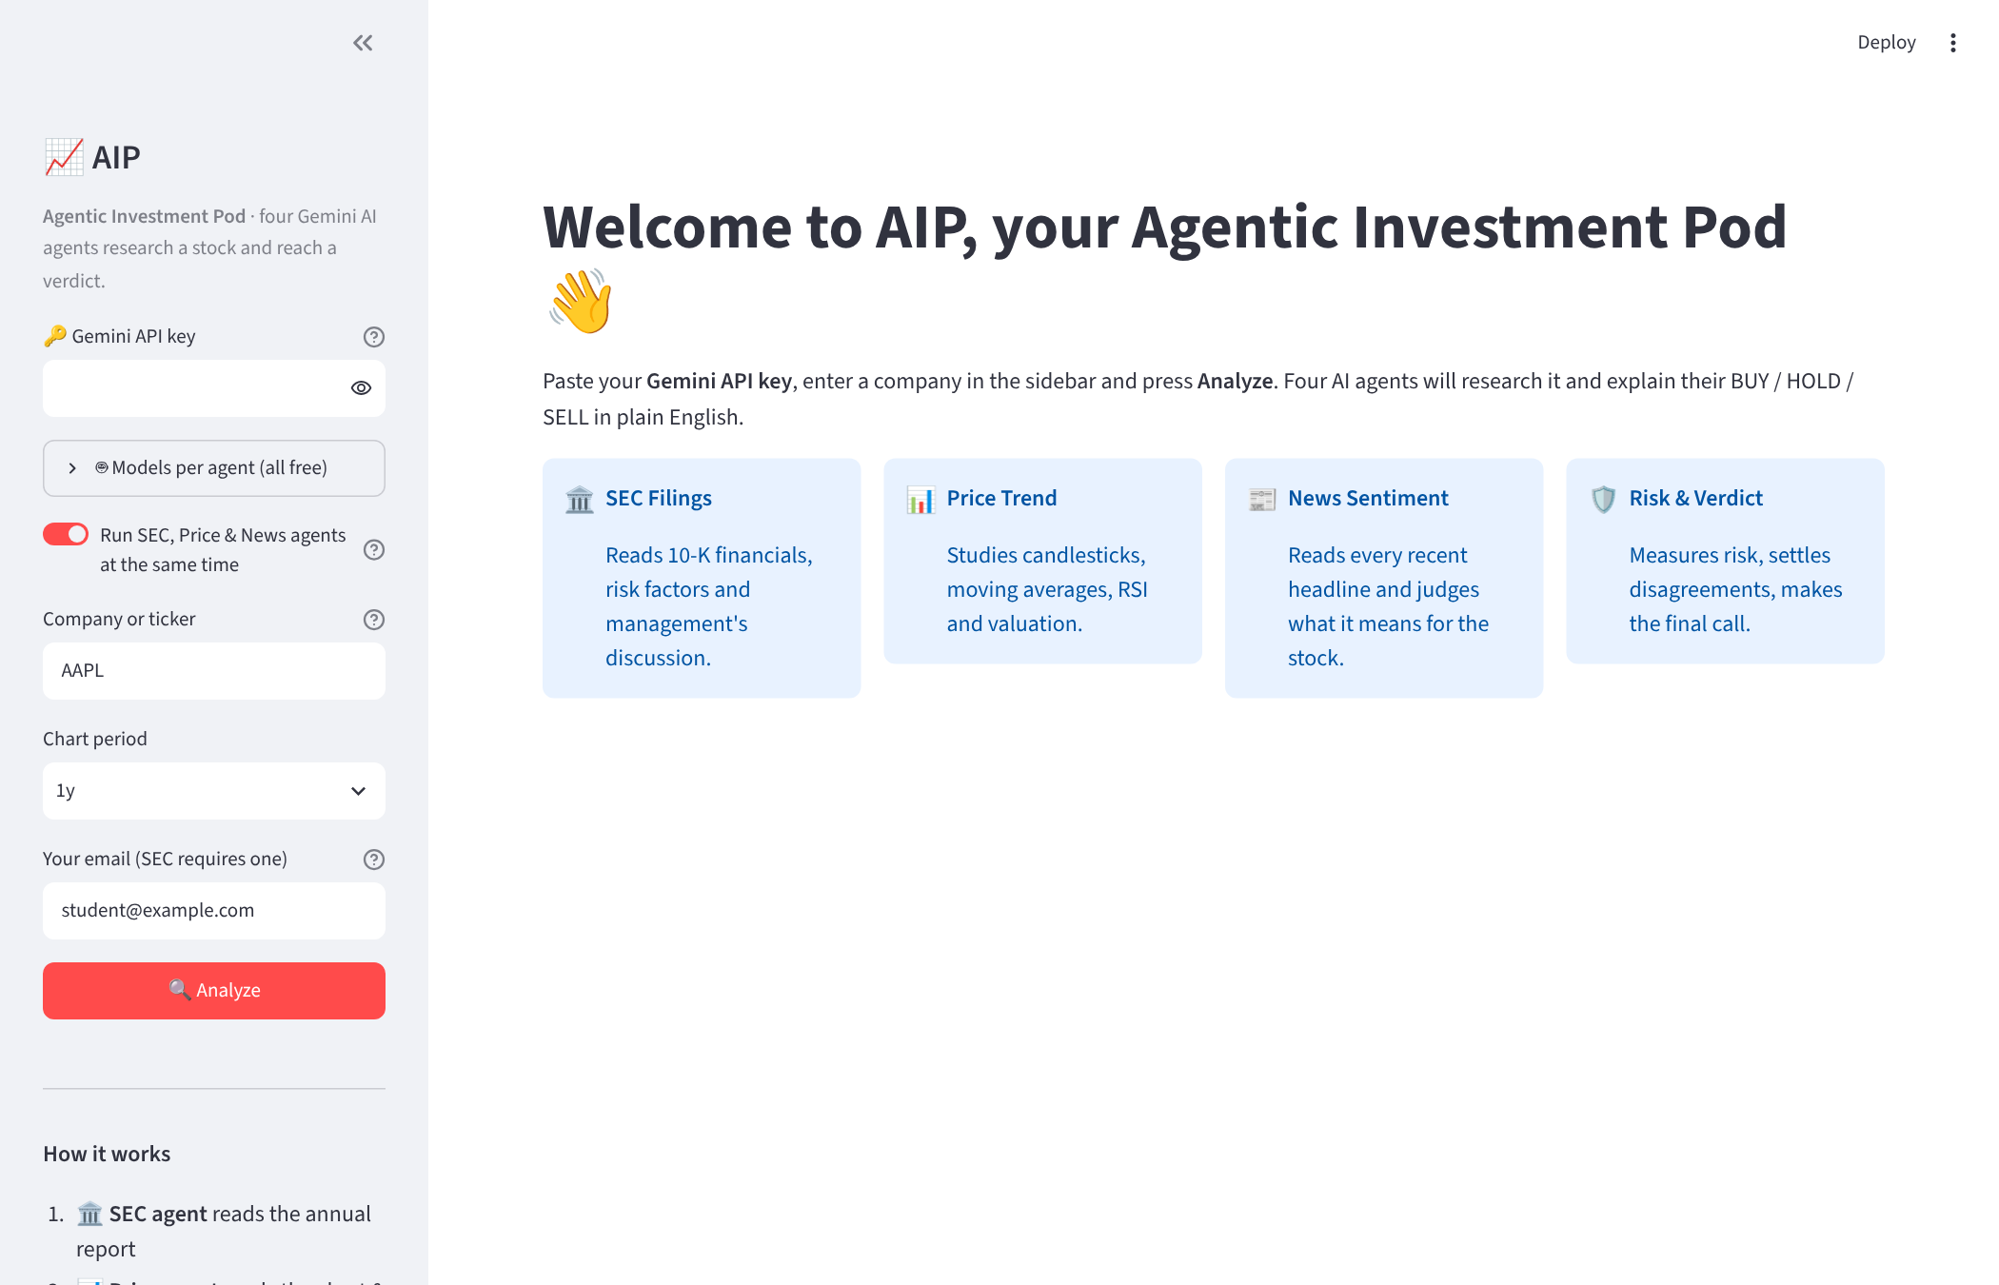
- Paste your Gemini API key into the Gemini API key box. It is hidden like a password and is never saved to a file.
- Open "Models per agent" and click "Check which models my key can use". The app asks Google which free models your key can call, then limits the dropdowns to those. Each agent gets a different model by default, because each model has its own free quota.
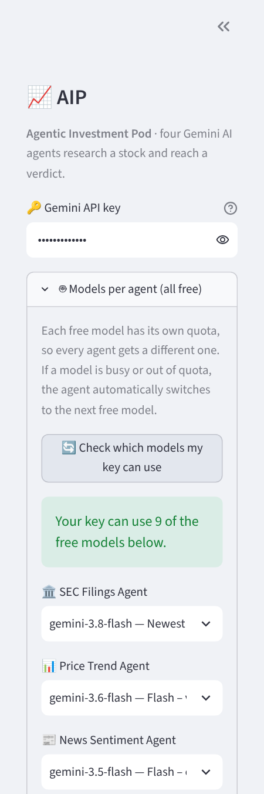
- Choose the options.
  - Run SEC, Price & News agents at the same time: on by default, for speed.
  - Company or ticker: a ticker such as MSFT or a name such as nvidia.
  - Chart period: how much price history to draw (3 months to 2 years).
  - Email: optional; sent only to SEC as identification.
- Click Analyze. A status box lists each agent as it finishes: its decision, how many tools it called, how long it took, and which model answered. A typical run takes 30 to 90 seconds.
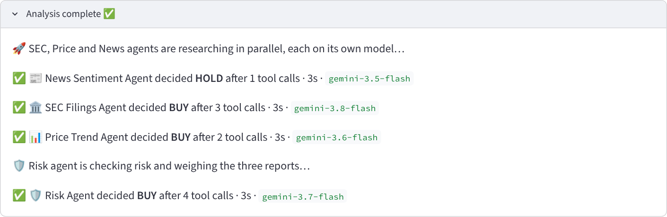

5. Reading the results
The page reads top-down: the final verdict first, then one card per agent, then four tabs with each agent's full reasoning.
The verdict and agent cards. The coloured box is the Risk Agent's final call (green BUY, amber HOLD, red SELL) with its confidence, risk level and who it suits. Below it, each card shows one agent's own decision, its score from −100 (strong sell) to +100 (strong buy), its confidence, and the model that answered. Agents can disagree; here the News agent says HOLD while the others say BUY.
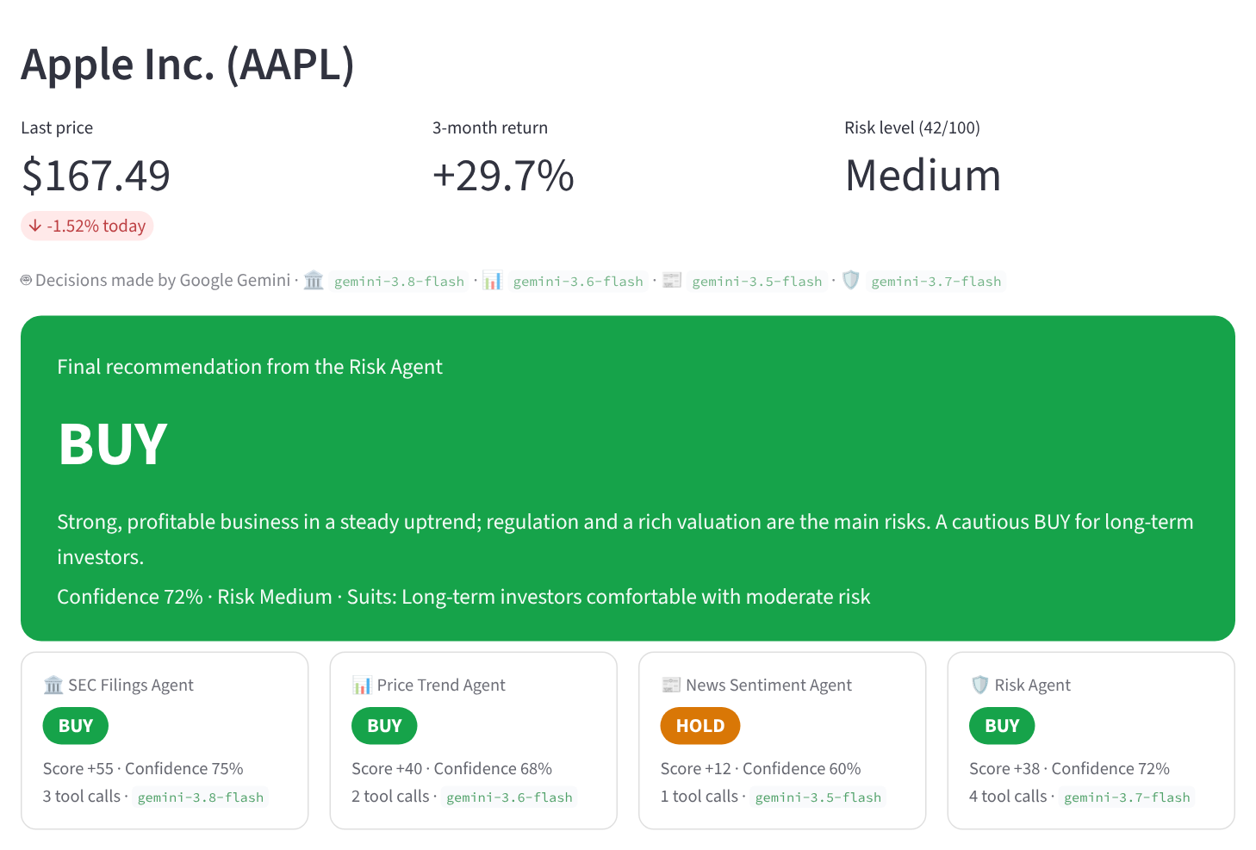
Price Chart tab. A candlestick chart of daily OHLC prices with the 50-day (blue) and 200-day (orange) moving averages, volume bars and the RSI indicator. The dashed green and red lines are the support and resistance levels the Price agent chose itself.
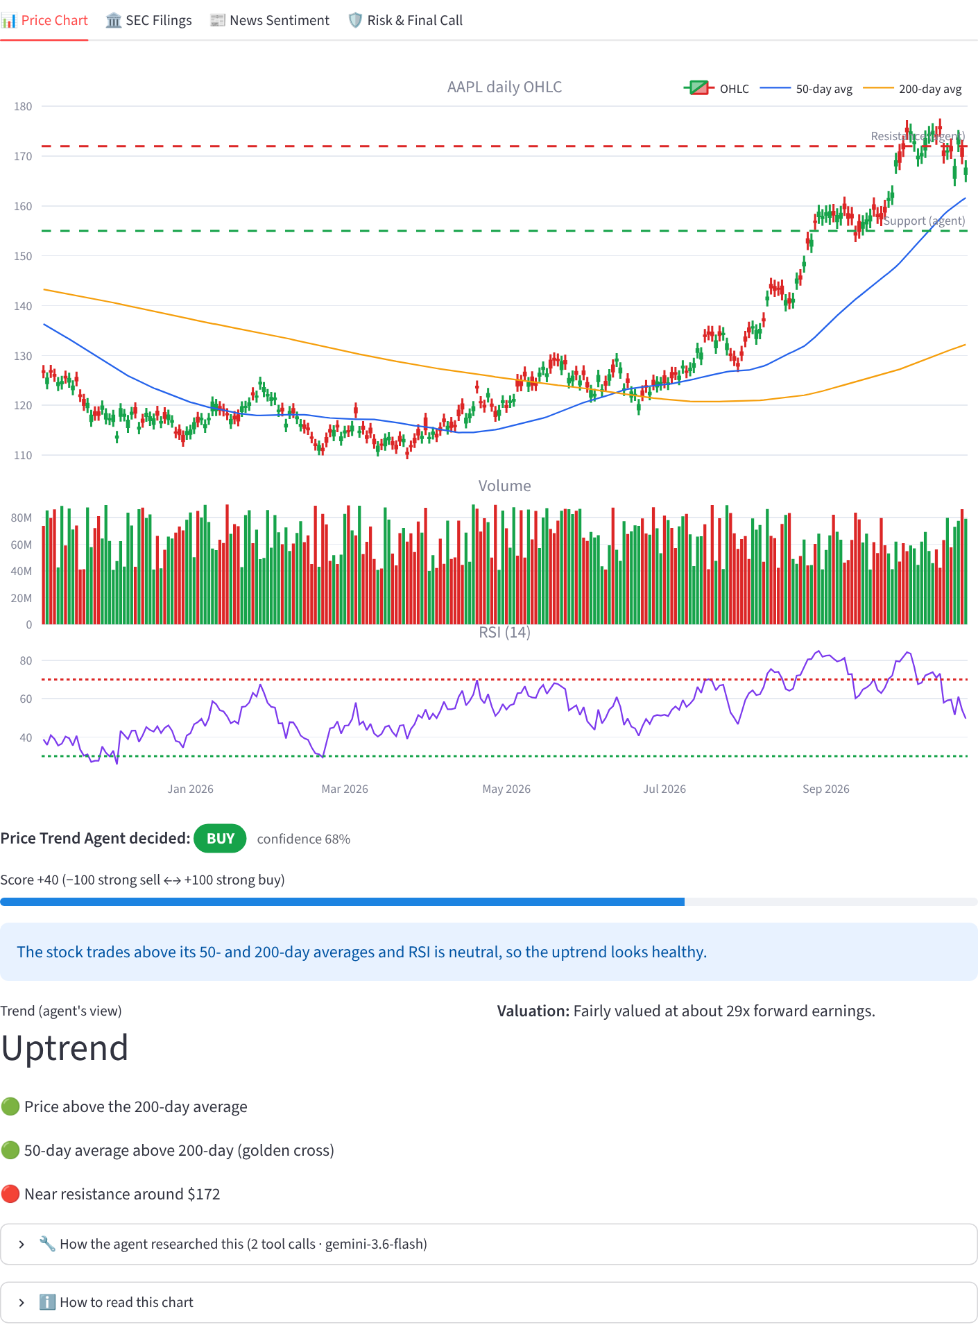
SEC Filings tab. The agent's summary, its plus and minus points, the metrics it decided were most important, highlights it found in the 10-K text, and links to the latest filings on SEC.gov.
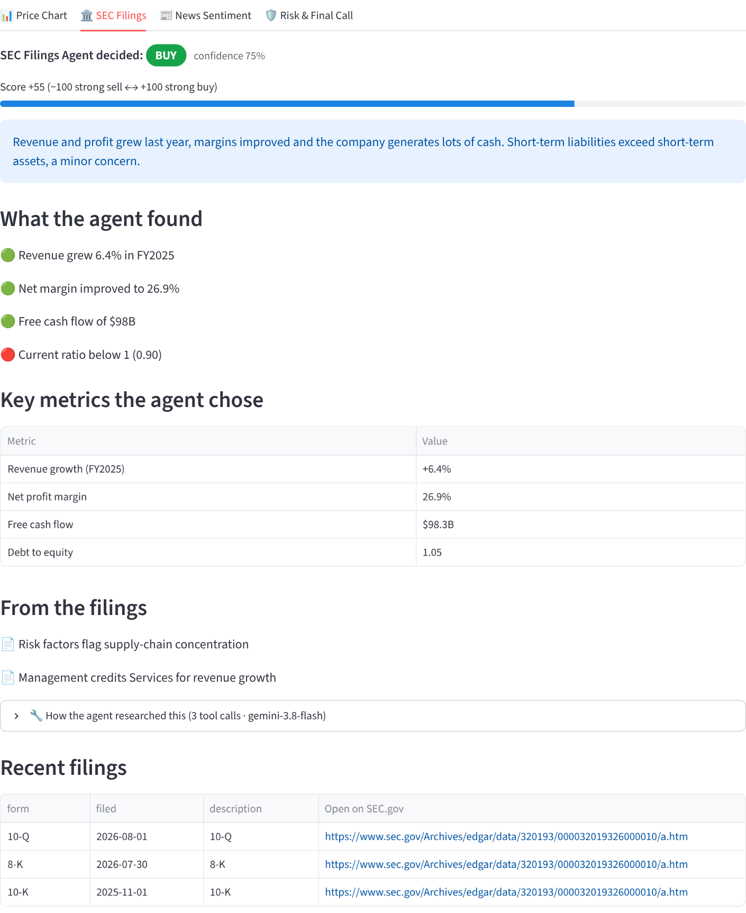
News Sentiment tab. The overall mood, main themes, and every headline rated Positive, Neutral or Negative with its importance and a one-line reason. Each headline links to the article.
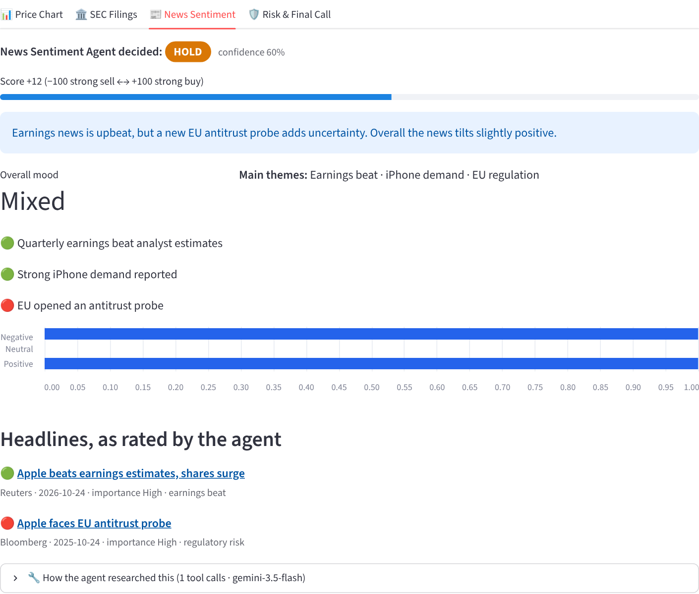
Risk & Final Call tab. The risk level and score, key risks, how much weight the Risk Agent gave each analyst, how it settled disagreements, and what would change its mind.
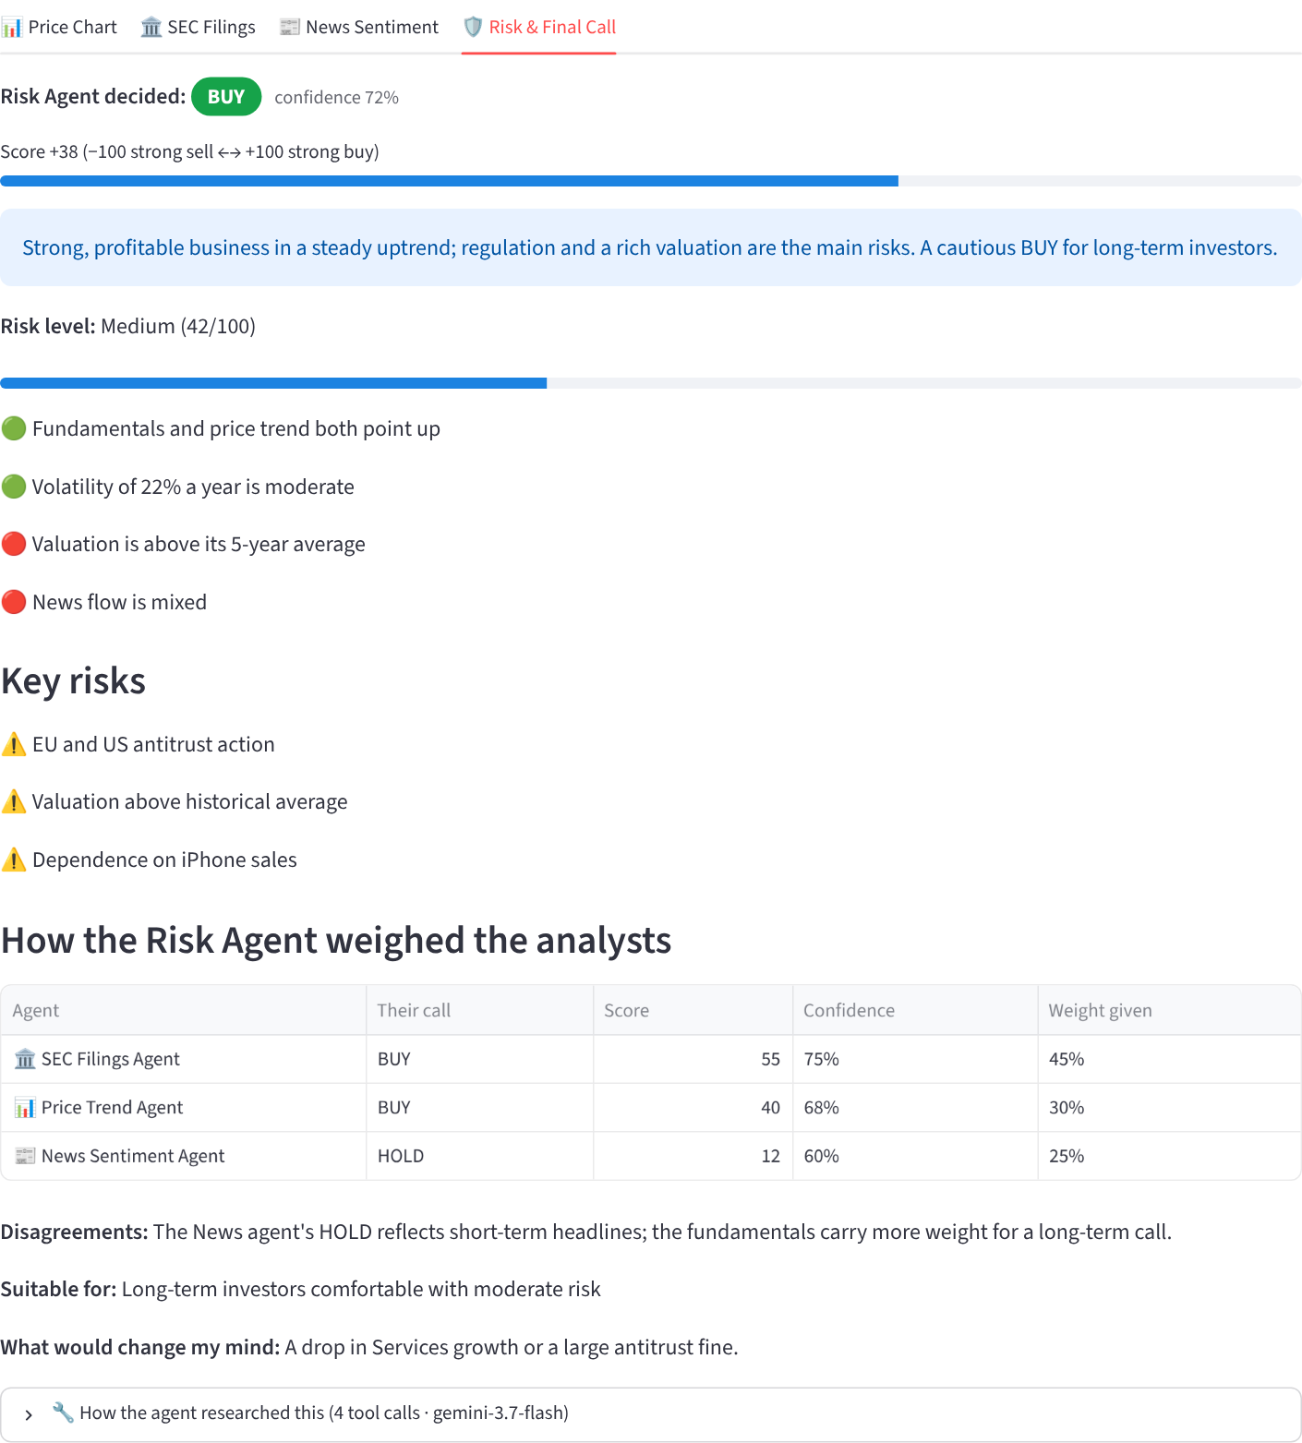
"How the agent researched this". Every tab ends with this expandable list: each tool the agent chose to call, with its inputs, a preview of the data returned, and the time taken. It is the best way to show a class that the agent really did its own research.
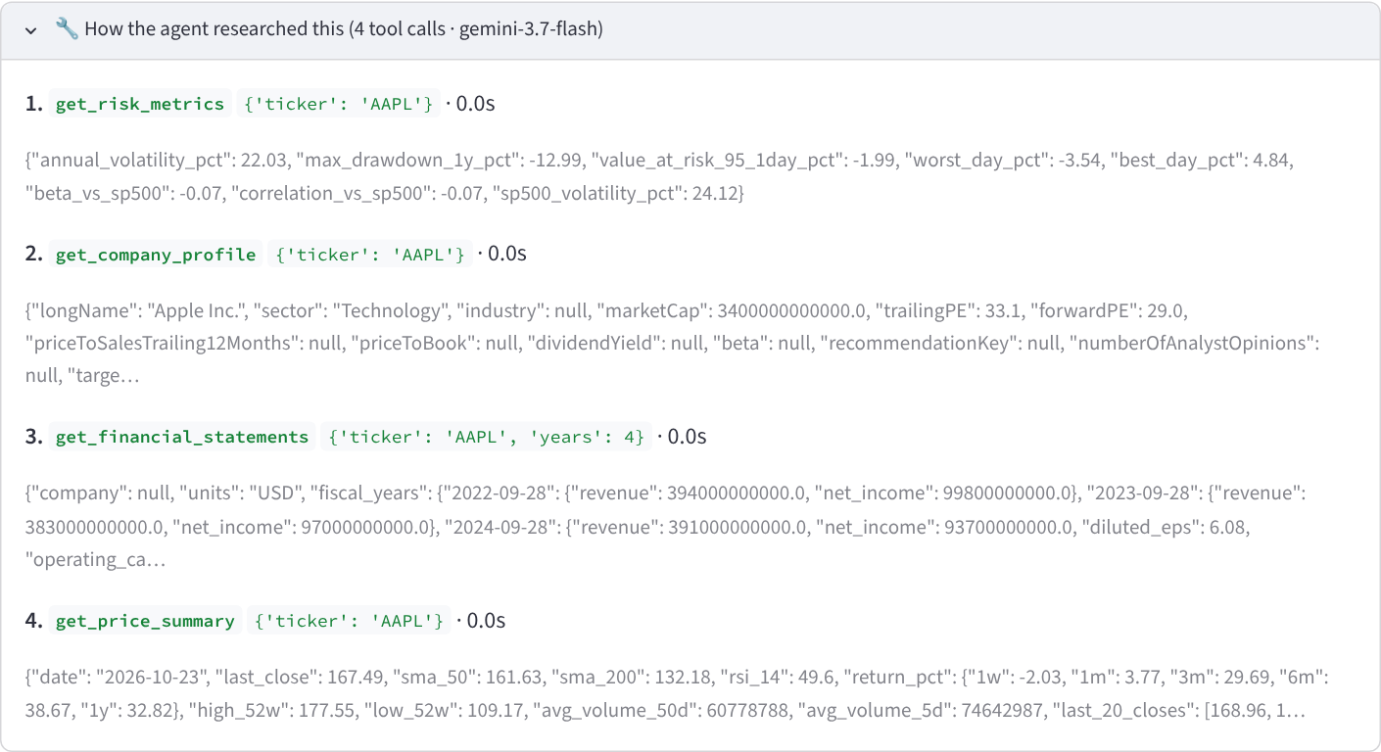

6. How each agent works
Every agent file has the same three parts: a role (the system prompt that tells Gemini who it is), a toolbox (the Python functions it may call), and an output format (the JSON it must return). Change any of the three and the agent behaves differently, with no other code changes.
Agent | Role given to Gemini | Tools it can call | Extra fields it returns
SEC Filings | Senior fundamental analyst who judges a company only from its SEC filings | get_financial_statements, read_10k_section, get_recent_filings | key_metrics, filing_highlights
Price Trend | Market and technical analyst | get_price_summary, get_company_profile | trend, support_level, resistance_level, valuation_view
News Sentiment | Financial news analyst who reads each headline in context | get_news_headlines | overall_mood, themes, a rating per headline
Risk | Chief risk officer and portfolio manager who makes the final call | get_risk_metrics, get_company_profile, get_financial_statements, get_price_summary | risk_level, risk_score, key_risks, agent_weights, what_would_change_my_mind
All four agents also return the same core fields: signal (BUY/HOLD/SELL), score, confidence, summary and reasons.
What each tool returns:
- get_financial_statements: up to 6 years of revenue, profit, cash flow, debt, assets and equity from the company's 10-K data.
- read_10k_section: the actual text of the 10-K's Business, Risk Factors or Management's Discussion and Analysis section.
- get_recent_filings: the latest 10-K, 10-Q and 8-K filings with links.
- get_price_summary: last price, 50/200-day averages, RSI, returns over 1 week to 1 year, 52-week high and low, volume trend.
- get_company_profile: sector, market cap, P/E ratios, dividend yield and analyst price targets.
- get_news_headlines: recent headlines with source, date and summary.
- get_risk_metrics: yearly volatility, worst drop in the past year, beta versus the S&P 500, and 1-day Value-at-Risk.
The Risk Agent is different in one way: its task includes the other three agents' reports. It can re-check their claims with its own tools, decides how much to trust each one, and explains how it settled any disagreement.
Example: the role given to the News Sentiment Agent (from sentiment_agent.py):
You are a financial news analyst. Fetch the latest news about the stock and read every
headline in context. Judge each story's sentiment for the STOCK (not just the wording: e.g.
"avoids lawsuit" is good news), and how important it is ...

7. Inside the agent loop
The agent loop in agents/llm.py is about 30 lines, and it is what turns a chatbot into an agent. Gemini never runs code itself: it only asks for a tool, and our Python loop runs it and hands back the result.
- Send the request. The system prompt (role + JSON format), the task ("Analyse Apple…") and the list of tools go to Gemini.
- Gemini replies with either tool requests or a final answer. A tool request looks like get_financial_statements(ticker="AAPL", years=4).
- Run the tools. The loop calls the matching Python functions, records each call for the research trace, and turns the results into JSON.
- Send the results back. The model's turn and the tool results are appended to the conversation, and Gemini is asked again.
- Repeat until Gemini stops asking for tools (at most 8 rounds), then read its JSON decision.
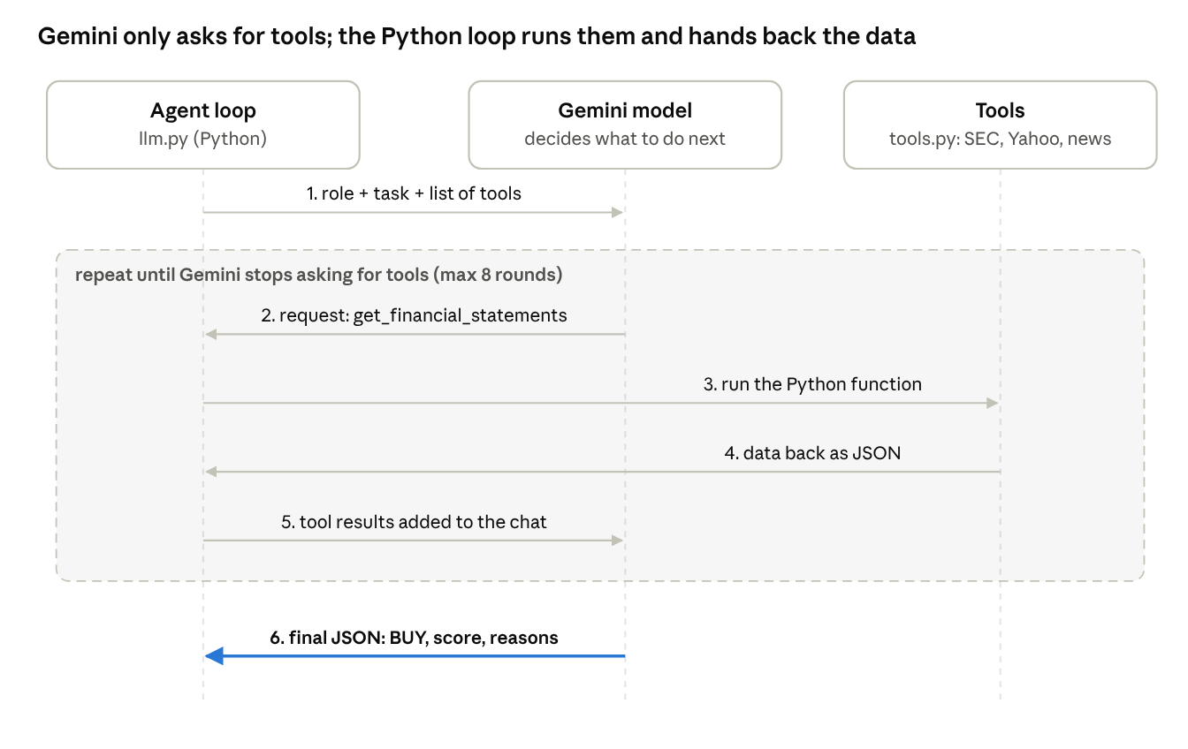
The agent loop · one research round
Steps 2 to 5 repeat as many times as Gemini wants more data; step 6 ends the loop.
The heart of the loop, slightly simplified:
for step in range(MAX_STEPS):
response = generate(model, contents, config) # ask Gemini
calls = response.function_calls or []
if not calls:
break # no tool requests = finished
contents.append(response.candidates[0].content) # keep Gemini's turn
results = [
Part.from_function_response(
name=c.name,
response={"result": run_tool(tools[c.name], c.args)})
for c in calls
]
contents.append(Content(role="user", parts=results)) # hand back the data
decision = extract_json(text_of(response)) # the final BUY/HOLD/SELL
How Gemini knows what a tool does: the google-genai library reads each function's name, type hints and docstring, and sends them to Gemini as a tool description. A clear docstring therefore matters as much as the code:
def get_risk_metrics(ticker: str) -> dict:
"""Compute objective risk statistics from the past year of daily prices:
annualised volatility, maximum drawdown, beta and correlation versus the
S&P 500 (SPY), 95% one-day Value-at-Risk and the worst single day."""
Why the final answer is JSON: the app needs fields it can display (a colour for the signal, a bar for the score). If Gemini answers in prose instead, the loop sends one more request asking it to restate its answer as JSON.
Running the agents together (in app.py): the SEC, Price and News agents start at the same time using a ThreadPoolExecutor. When all three finish, their reports are passed into the Risk Agent's task.

8. Free models, quotas and speed
AIP runs entirely on Gemini's free tier by giving each agent its own model and switching automatically when one runs out. A free key allows only a few requests per minute and per day, and Google counts that quota separately for each model.
Agent | Default free model | Why
SEC Filings | gemini-3.8-flash | Reads the most text, so it gets the strongest model
Risk | gemini-3.7-flash | Makes the final decision
Price Trend | gemini-3.6-flash | Smaller, numeric inputs
News Sentiment | gemini-3.5-flash | Short headlines
Other free backups: gemini-flash-latest, gemini-3.5-flash-lite, gemini-3.1-flash-lite, and the open Gemma 4 models gemma-4-31b-it and gemma-4-26b-a4b-it. This list was checked in October 2026; Google changes it often, so use the Check which models my key can use button.
What happens when Google says no (an HTTP 429 "quota exceeded" error):
- Short "slow down" (20 seconds or less): the agent waits and retries that one step.
- Longer wait, daily quota used up, or model not available: the agent switches to its next backup model. Each agent's backup list starts at a different model so they do not all pile onto the same quota.
- A model that is out for the day is skipped by every agent for the rest of that analysis.
- Every model rate-limited: the agent waits 60 seconds once and tries the list again.
Speed features:
- Shared data cache: downloaded data is kept for 10 to 60 minutes, so when the Risk Agent re-checks prices the Price Agent already fetched, the answer is instant.
- Fresh models for the Risk Agent: models the analysts just used go to the end of its list, because their per-minute quota is already spent.

9. Project files
The project is 10 Python files, each with one job; reading them in the order below follows the path of one analysis.
File | What it does | Read it to learn
app.py | Streamlit web page: sidebar, running the agents, showing results | How a Python web front end is built
agents/sec_agent.py | SEC agent's role, tools and output format | How to define an agent
agents/price_agent.py | Price agent | Same pattern, different tools
agents/sentiment_agent.py | News agent; links ratings back to articles | Using an agent's output in the UI
agents/risk_agent.py | Risk agent; receives the other reports | Agents that build on other agents
agents/llm.py | The agent loop, retries and model fallback | How tool calling actually works
agents/tools.py | Data tools for SEC EDGAR, Yahoo Finance and news; the cache | Calling public data APIs
agents/models.py | Free model list, default per agent, fallback order | Working within API quotas
agents/common.py | AgentReport and the shared JSON format | Structured output
agents/charts.py | Plotly candlestick chart (display only) | Financial charting
requirements.txt lists the packages, and README.md repeats the setup steps.

10. Troubleshooting
Most problems come from the API key's free quota or from typing the company name differently than SEC lists it.
What you see | Why | Fix
429 RESOURCE_EXHAUSTED or "No free model worked" | Free quota used up for this minute or day | Wait a minute; run the model check; daily limits reset at midnight US Pacific; or enable billing in Google AI Studio
"No free-tier quota for model X" | That model needs a paid key | Pick another model under Models per agent
"Couldn't find 'XYZ'" | Name not in SEC's list | Use the ticker symbol, e.g. AAPL
SEC request fails with 403 | SEC blocks requests without identification | Keep a name and email in the email box
No price chart | Yahoo Finance did not respond or the ticker is not US-listed | Try again or use a US ticker
Risk Agent is slow | It reasons over three reports | Choose a flash-lite model
ModuleNotFoundError | Packages not installed in this environment | Activate the virtual environment and rerun pip install -r requirements.txt

11. Disclaimer
AIP is an educational project. AI models can be wrong or inconsistent, and the data may be delayed or incomplete. Nothing it produces is financial advice.

