SARKARI SAHAYAK
Multilingual Document-Aware Agentic Welfare RAG System
Technical Architecture, Design Documentation, and Security Manual
Prepared for: Prototype Screening Committee
Version: 1.1.0
Status: Showcase Ready

1. Executive Summary & Vision Statement
Accessing government benefits in developing nations remains plagued by structural barriers. Language barriers prevent rural citizens from finding schemes, complex eligibility criteria require reading fine-print regulations, and document illiteracy keeps millions from completing complex registration forms.
Sarkari Sahayak resolves this by serving as an intelligent, conversational agent running on top of WhatsApp - the interface users are already familiar with. By allowing users to talk in their local dialect, upload identity certificates for parsing, and receive pre-filled application forms, the system acts as an agentic counselor, democratizing welfare accessibility.
2. High-Level Human Analogy
Think of the system as walking into a local Welfare Helpdesk office manned by six specialized staff members working in perfect coordination:
• The Receptionist (FastAPI Webhook): Greets you, translates your voice notes, and directs files to the desk.
• The Document Reader (Llama 4 Vision OCR): Glances at your Aadhaar or Income papers, writes key parameters onto a temporary scratchpad, and locks them in a drawer.
• The Librarian (RAG Vector Store): Runs into the records library to find scheme manuals matching your general query.
• The Legal Evaluator (Rules Engine): Cross-checks the details on your scratchpad against the scheme eligibility criteria.
• The Senior Counsel (Llama 3.3 Graph): Suggests complementary schemes and writes a friendly, spoken response in your preferred language.
• The Clerk (FormFiller Service): Fills out the application form with your scratchpad details and hands it back to you.
3. System Architecture & Request Pipeline
Sarkari Sahayak employs an asynchronous, high-throughput pipeline driven by FastAPI and LangGraph. The request-response execution pipeline operates as follows:
When a voice note, text message, or image upload hits the FastAPI webhook, it retrieves or creates the user session. Voice audio is transcribed using Whisper Large-v3, while document uploads are parsed using Llama 4 Scout Vision OCR. The extracted parameters are stored in the session cache.
Next, the LangGraph engine runs a 5-node reasoning cycle to search schemes, filter by rules, suggest complementary packages, and compose the voice/text response. The synthesized speech is returned along with a link to the filled PDF form.
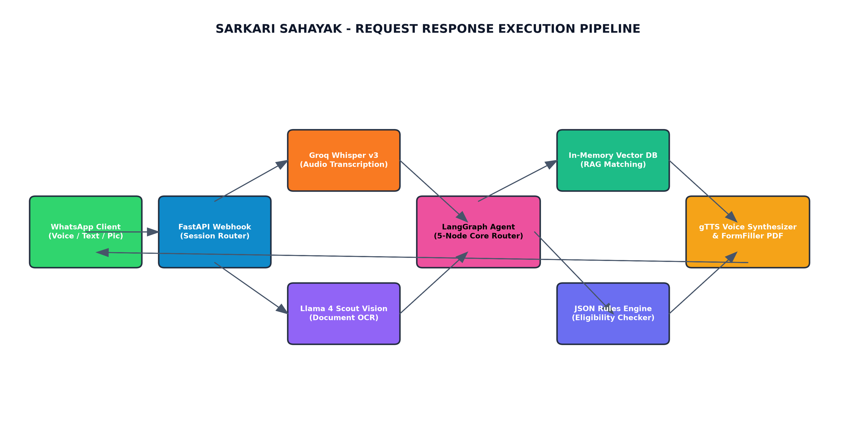
Figure: Diagrammatic representation of System Architecture & Request Pipeline
4. The LangGraph Reasoning Engine Deep-Dive
The core reasoning engine is built as a stateful graph where each node updates a shared state schema:
• Node 1: Extract (Demographics Node): Uses Llama 3.3 to structure demographic details from incoming messages or OCR strings.
• Node 2: Retrieve (RAG Search Node): Queries the database using semantic search and ranks schemes based on cosine similarity of text embeddings.
• Node 3: Evaluate (Rules Node): Iterates over the candidate schemes, comparing rules (age, income caps, land size, gender) against the parsed user profile.
• Node 4: Chain (Forward Chaining Node): Infers supplementary opportunities. If primary schemes are eligible, it automatically appends related welfare options.
• Node 5: Compose (Response Node): Directs Llama 3.3 to write a friendly, conversational synthesis of the eligible programs and next steps.
5. Option A Privacy-First Data Compliance
Handling personal identification records (Aadhaar cards, bank details, income files) demands strict security compliance. Sarkari Sahayak adopts an Option A Privacy architecture:
• Ephemeral State Caching: Extracted details are held temporarily inside memory/Redis caches during the turn. No PII is written to persistent SQL logs.
• Zero Residual Traces: Session caches are destroyed when the user clicks 'Clear Session' or terminates the chat flow.
• Persistent Session Auditing: Only non-PII diagnostic logs (anonymous counts, transaction latency, and model tokens) are permanently saved.
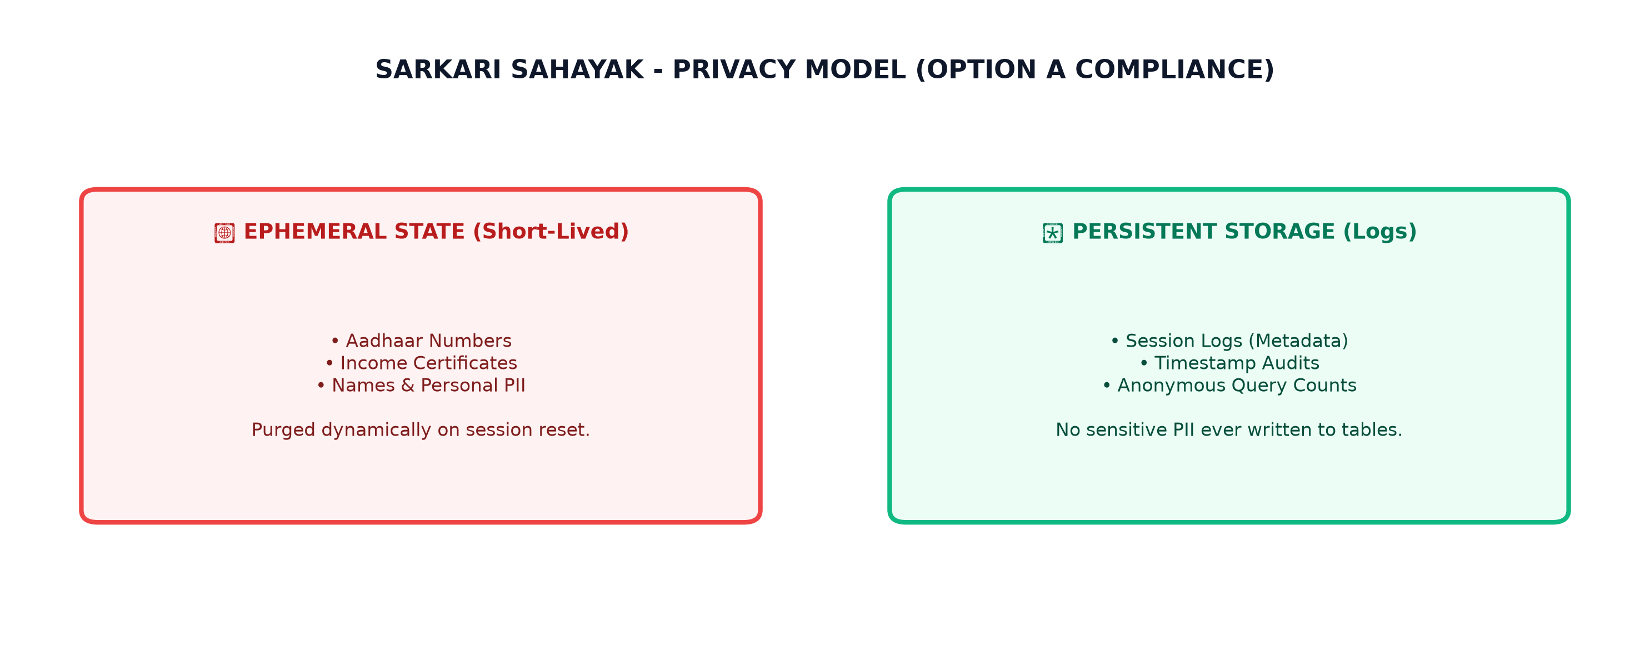
Figure: Diagrammatic representation of Option A Privacy-First Data Compliance
Appendix: Seeded RAG Schemes Registry (50 Schemes)
The database contains 50 active-user schemes loaded from 'schemes_seed.json' for the RAG engine:
Scheme Name | Category | State | Key Description
PM-Kisan Samman Nidhi | Agriculture | Uttar Pradesh | Financial support of ₹6,000 per year for landowning farmers across India.
UP Senior Pension Scheme | Pension | Uttar Pradesh | Old age pension monthly assistance of ₹1,000 for senior citizens in UP.
UP Kanya Sumangala Yojana | Women & Child | Uttar Pradesh | Financial assistance of ₹15,000 for girls' education, health, and welfare in Uttar Pradesh.
UP Free Tablet Smartphone Yojana | Education | Uttar Pradesh | Free tablets and smartphones for college students and youth pursuing higher education in Uttar Pradesh.
Ayushman Bharat Yojana | Health | All India | Universal health insurance coverage providing up to ₹5 Lakhs per family per year for secondary and tertiary hospitalization.
Pradhan Mantri Awas Yojana - Gramin | Housing | All India | Provides financial assistance of ₹1.2 Lakhs to rural families for constructing pucca houses with basic amenities.
UP Widow Pension Scheme | Women & Child | Uttar Pradesh | Pension assistance of ₹1,000 per month for widows residing in Uttar Pradesh.
Pradhan Mantri Ujjwala Yojana | Energy & Power | All India | Free LPG connections and cylinder support to women from below poverty line (BPL) households.
UP Divyangjan Pension Yojana | Pension | Uttar Pradesh | Financial monthly assistance of ₹1,000 for disabled persons (40% or more disability) in Uttar Pradesh.
Pradhan Mantri Shram Yogi Maan-dhan | Pension | All India | Voluntary and contributory pension scheme for unorganized sector workers providing ₹3,000/month after age 60.
UP Shadi Bimari Yojana | Women & Child | Uttar Pradesh | Financial marriage grant of ₹20,000 for daughters of poor families in Uttar Pradesh.
National Social Assistance Programme - IGNDPS | Pension | All India | Disability pension for BPL citizens aged between 18 and 79 with severe or multiple disabilities.
UP Free Cycle Scheme | Labour Support | Uttar Pradesh | Provides free cycles to registered construction laborers in Uttar Pradesh to commute to work.
Pradhan Mantri Mudra Yojana - Shishu | Business Loan | All India | Collateral-free loans up to ₹50,000 for starting small businesses or shops.
Pradhan Mantri Mudra Yojana - Kishor | Business Loan | All India | Collateral-free business loans between ₹50,000 and ₹5 Lakhs for expanding micro enterprises.
Pradhan Mantri Mudra Yojana - Tarun | Business Loan | All India | Collateral-free business expansion loans between ₹5 Lakhs and ₹10 Lakhs for established businesses.
Atal Pension Yojana | Pension | All India | Government-backed pension scheme providing monthly pension of ₹1,000 to ₹5,000 after age 60.
Pradhan Mantri Suraksha Bima Yojana | Insurance | All India | Accidental death and disability insurance cover of ₹2 Lakhs at a premium of just ₹20 per year.
Pradhan Mantri Jeevan Jyoti Bima Yojana | Insurance | All India | Life insurance cover of ₹2 Lakhs in case of death due to any reason, at a premium of ₹436 per year.
PM Street Vendor AtmaNirbhar Nidhi | Business Loan | All India | Special micro-credit facility providing working capital loans up to ₹10,000 for street vendors.
PM Vishwakarma Scheme | Labour Support | All India | Skill training, toolkit incentive of ₹15,000, and low-interest collateral-free loans for traditional artisans and craftsmen.
UP Post-Matric Scholarship Scheme | Education | Uttar Pradesh | Tuition fee reimbursement and maintenance stipend for UP students studying in Class 11, 12, or higher courses.
UP Pre-Matric Scholarship Scheme | Education | Uttar Pradesh | Financial scholarship for students studying in Class 9 and 10 in Uttar Pradesh schools.
Mahatma Gandhi National Rural Employment Guarantee Act | Employment | All India | Provides at least 100 days of guaranteed wage employment in a financial year to every rural household whose adult members volunteer to do unskilled manual work.
Deen Dayal Upadhyaya Grameen Kaushalya Yojana | Employment | All India | Placement-linked skill training program for rural poor youth to enhance employability and income.
Prime Minister Employment Generation Programme | Business Loan | All India | Credit-linked subsidy program for setting up new micro-enterprises in manufacturing or service sectors, offering subsidies up to 35%.
National Means-cum-Merit Scholarship | Education | All India | Scholarship of ₹12,000 per year awarded to meritorious students from economically weaker sections to prevent drop-outs after Class 8.
Pradhan Mantri Fasal Bima Yojana | Agriculture | All India | Crop insurance scheme offering financial support to farmers suffering crop loss or damage due to natural calamities.
Kisan Credit Card Scheme | Agriculture | All India | Provides farmers with timely credit cards to meet their cultivation and crop production needs at a very low interest rate.
UP Mukhyamantri Abhyuday Yojana | Education | Uttar Pradesh | Free coaching classes (physical and virtual) for competitive exams like UPSC, JEE, NEET, and NDA for students in UP.
UP Bhagirathi River Fishery Scheme | Agriculture | Uttar Pradesh | Financial assistance and subsidies to fishermen and fish breeders for river farming and boat purchasing.
Pradhan Mantri Matsya Sampada Yojana | Agriculture | All India | Flagship scheme for sustainable development of the fisheries sector, supporting aquaculture, deep sea fishing, and cold chain infrastructure.
UP Gopalak Yojana | Agriculture | Uttar Pradesh | Loans up to ₹9 Lakhs for unemployed youth in Uttar Pradesh to establish dairy farms with 10 to 20 cattle.
UP Kamdhenu Dairy Scheme | Agriculture | Uttar Pradesh | Capital subsidy and commercial bank loans for starting high-yield milk-producing dairy centers in rural UP.
UP Solar Pump Yojana | Agriculture | Uttar Pradesh | Provides up to 60% subsidy to farmers for installing solar water pumps for agricultural irrigation.
UP Atal Residential School Admission Scheme | Education | Uttar Pradesh | Free high-quality residential boarding school education (class 6 to 12) for the children of registered laborers.
UP Matritva Shishu Evam Balika Madad Yojana | Labour Support | Uttar Pradesh | Financial assistance of ₹25,000 for maternity costs and newborn child care to registered construction workers.
UP Shramik Awas Sahayata Yojana | Housing | Uttar Pradesh | Financial aid of ₹1 Lakh for house construction or repairs to registered building construction laborers.
UP Mukhyamantri Bal Seva Yojana | Social Welfare | Uttar Pradesh | Financial assistance of ₹4,000 per month for orphans or children who lost breadwinners to pandemics.
Sovereign Gold Bond Scheme | Investment | All India | Government securities denominated in grams of gold, offering a secure gold investment with 2.5% annual interest.
Stand-Up India Scheme | Business Loan | All India | Bank loans between ₹10 Lakhs and ₹1 Crore to at least one SC/ST borrower and one woman borrower per bank branch for setting up a greenfield enterprise.
Sukanya Samriddhi Yojana | Investment | All India | A high-interest savings scheme targeted at parents of girl children to build a fund for their higher education and marriage.
UP Sant Ravidas Shiksha Sahayata Yojana | Education | Uttar Pradesh | Monthly education stipend from ₹150 to ₹2,000 for children of registered laborers studying in class 1 to higher degrees.
UP Kaushal Vikas Mission Training Scheme | Employment | Uttar Pradesh | Free skill training and certification in high-demand industrial sectors for unemployed youth in UP.
UP ODOP Toolkit Training Scheme | Labour Support | Uttar Pradesh | Skill upgrade training and free modern toolkits distributed to local artisans under the One District One Product scheme.
PM Programme for Restoration Awareness Generation Nourishment of Mother Earth | Agriculture | All India | Promotes balanced use of chemical fertilizers along with organic and bio-fertilizers, offering subsidies on soil health testing.
UP Free Boring Scheme | Agriculture | Uttar Pradesh | Provides financial grant and boring facilities to small and marginal farmers in UP for irrigation tube wells.
UP Mukhyamantri Audyogik Kushta Pension | Pension | Uttar Pradesh | Monthly pension assistance of ₹3,000 for leprosy-affected individuals residing in UP.
National Career Service Portal Registration | Employment | All India | A single-point platform offering job matching, career counseling, and vocational guidance to job seekers across India.
Central Sector Scheme of Scholarship for College and University Students | Education | All India | Scholarship awarded to top 80th percentile board students pursuing graduate or post-graduate courses, providing ₹12,000 per year.

