Internet and Web Technology Lab Dept. of CSE, Silicon University Assignment2

- Create a table to display student information with the following fields and insert atleast two student details: Roll Number, Name, Email, Mobile Number, Profile Photo
- Design the following time table using HTML table tags and attributes only:
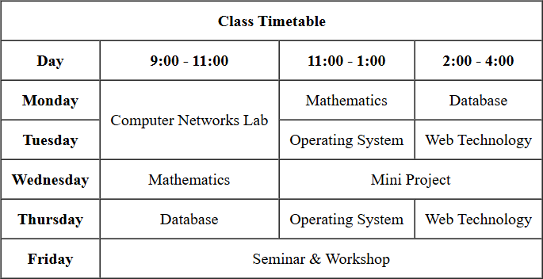

- Create a registration form for an online course with the following fields:
  - Full Name(text)
  - Email(text)
  - Password and Confirm Password(password)
  - Gender(radio buttons :Male, Female, Other)
  - Date of Birth(date picker)
  - Course(drop down: B.Tech, M.Tech, MCA ,MBA)
  - Skills(checkboxes: HTML, CSS, JavaScript, Python, Java)
  - Address(text area)
  - Upload Resume(file input)
  - Submit and Reset buttons
- Create a webpage that demonstrates multimedia integration:
- Embed an audio file with controls(play/pause).
- Embed a video file with controls.
- Create a webpage named My Profile using HTML5 semantic elements. Your page must use appropriate semantic tags (forexample: <header>, <nav>, <main>, <section>, <footer>) and must satisfy all of the following requirements:

- Use a<nav>with anchor links (bookmarks) to the sections on the same page: About, Education, and Hobbies.
- Use a <header> element that contains your name as the main heading (<h1>), your phone number and your email.
- Use a<main> element to wrap the primary page content.
- Create three <section> elements with id attributes about, education, and hobbies. Each section must have a heading (<h2>) and atleast one paragraph describing the topic.
- In the about section, Include your profile image and a paragraph about yourself. Use a list to showcase your skills.
- In the education section, use a table to showcase your academic records.
- In the hobbies section, add a list of hobbies.
- The footer section must contain hyperlinks to your social media handles.

