**Assignment No:5 Date: 07/11/2024**

**Topic : Inheritance, Abstract Class**

1. Write a program that creates a class Account that have members customer name, account number. Account has constructor to initialize its members and method display() to show the result. Create a child class Savings_Account that is derived from Account class. Savings_Account have members min_bal and saving_bal. Use show() to display its details. Then create another child class Account_details from Savings_Account class have members deposit, withdrawl and a method show1() to show its details. Child classes have constructors of their own. Create a driver class that creates a record of customer and display all its details.
2. Create a class Figure with instance members dim1 and dim2. Use constructor and area() that returns the area of figure. Create a derived class Rectangle derived from Figure and area() that returns the area of rectangle. Create another derived class Triangle and Square that has area() which returns area of Triangle and Square respectively. Derived class have appropriate constructor. Using method overriding concept test the functionalities of derived class by creating objects and super class memory references in Driver class.
3. Write a program to create a class named Shape.  It should contain two methods, draw() and erase() that prints “Drawing Shape” and “Erasing Shape” respectively. For this class, create three sub classes, Circle, Triangle and Squareand each class should override the parent class functions - draw () and erase ().  The draw() method should print “Drawing Circle”, “Drawing Triangle” and “Drawing Square” respectively.  The erase() method should print “Erasing Circle”, “Erasing Triangle” and “Erasing Square” respectively. Create objects of Circle, Triangle and Square, assign each to Shape variable(reference) and call draw() and erase() method using each object.
4. Define an abstract class named “Figure”, having data members dim1 and dim2. Extend this class to create two concrete classes named Rectangle and Triangle. Override the getArea() method in the sub classes. Invoke the getArea() method in the main method of another Driver class through the abstract class reference variable.
5. Create a class Point2D with the data member x and y coordinate. Use default and parameterised constructor to set the coordinate values and display() to show the coordinates. Create a subclass called Point3D which is derived from the superclass Point2D with data members z coordinate and has constructor to initialize the input and show() method to display the coordinates. Test the methods of both the classes by creating objects in the main method of driver class.
6. Create the classes as given in the below figure. Display the interest rate in the following format:

SBI Rate of Interest : 8

ICICI Rate of Interest : 7

AXIS Rate of Interest : 9

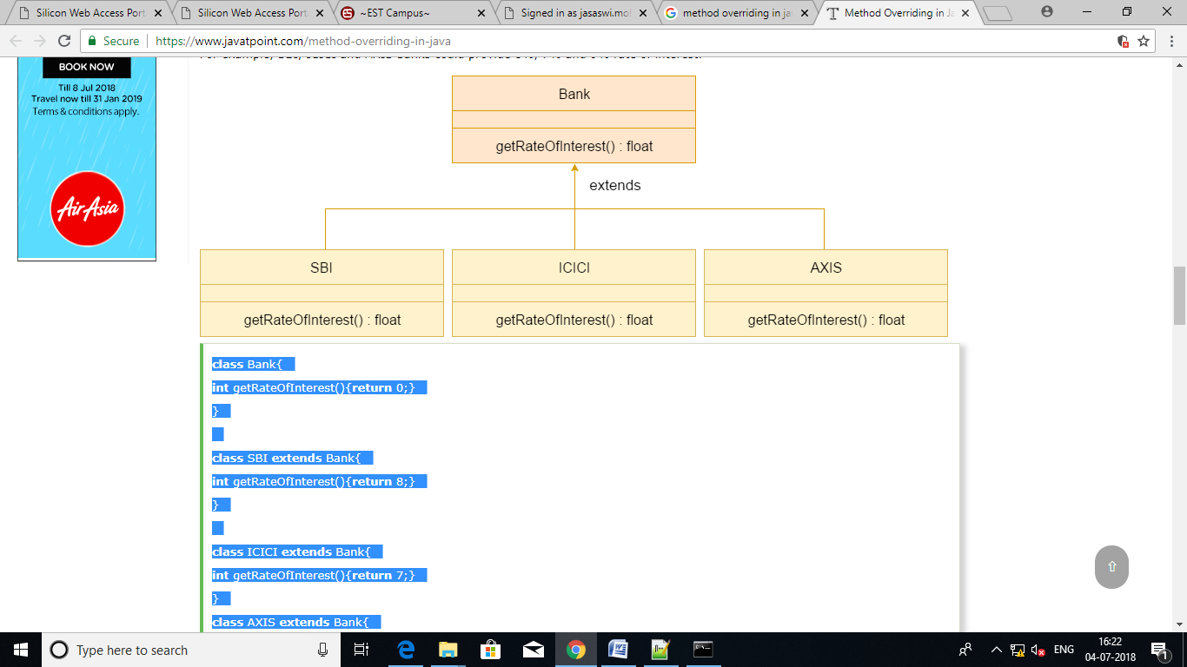

1. Create a class Person that has data member name. Use constructor to initialize name and display() to display name. Create a derived class Employee from Person class having private members empid. Using constructor initialize empid and have method display() to display empid. Create another derivedclass HourlyEmployee from Employee with private members hourlyRate and hoursWorked. Use constructor to initialize input and methods getGrossPay() that computes and returns the gross pay of the employee and display() to display the hourlyRate, hoursWorked and gross pay. Create a driver class to test the functionalities of the above classes and display output in the following format

Name : John Smith

EmpID : 7569

Hourly Rate : 100

Hours worked : 2000

Gross pay : 200000