Impact of Social Media in Shaping a Major Outbreak(COVID-19)

Anas Shah  Faculty of Computer Science  University of Windsor  Ontario, Canada  shah1ag@uwindsor.ca | Adarsh Sai Gupta  Faculty of Computer Science  University of Windsor  Ontario, Canada  murugana@uwindsor.ca | Sadman Hasan  Faculty of Computer Science  University of Windsor  Ontario, Canada  hasan124@uwindsor.ca | Samir Shahriar  Faculty of Computer Science  University of Windsor  Ontario, Canada  shahria1@uwindsor.ca

Abstract—The optimistic view is that social media could prove useful at a time when many of us are otherwise isolated from one another. Conversations around the coronavirus, especially those at the community level, can help us navigate this crisis. But several users on these platforms are spreading rumors and misrepresentation at a time when people are emotionally charged and looking for valid information. In this study, we are trying to prove this hypothesis with Data processing and Analytics and showcasing some level of impact of social media on world level catastrophe.
Keywords—Social media, impact, twitter, Big data, cleaning, Natural language processing, heat maps, coronavirus

Introduction

This report accounts for showcasing the impact of social media on the present world crisis of novel coronavirus (COVID-19). Study was done using the data collected from the Twitter across the world and mapped those data in a heat map to show an impact of it. This data contain the tweets about this outbreak and related topics around it.

General Overview
In this study we collected the data from Twitter application. This platform captures the text called as tweets from their user on its platform. Other users can read those texts or comments and can response to it. This process excavates more where another person can post the comments from other users on their accounts. This process is called retweets. Any information started from a single person tweets can reach to multiple users with the help of these process.
We tried to captures these information from the Twitter users all around the globe, particular about the novel coronavirus. By doing so, we get the idea of the people who are interested in getting information and how many people are giving positive or negative data about it. This way, we can collect all the data from a single country and later compare the results of the outbreak on these countries. If the country is tweeting more about this epidemic and misinformation is spread on social platform, we want to see, if the number of confirmed cases due to this outbreak increases or decreases?

Motivation
As we all are in amid of a pandemic, team wanted to make general population aware about the misleading information provided on the popular social platforms. Authors want to spread awareness that not all the information should be blindly trusted and only the official or approved information with validity should be taken in to action. Some users on these sets of platforms want to spread panic for unknown reasons. Therefore, we as a team focused to put some concrete results in front of masses. This study results are not scientific in nay means and only a hypothesis on which authors strongly believe on.

Importance
Social media in the time of a pandemic should ideally prove useful when the users are looking for official information like instruction, precautions, etc. This information should only be considered from the authentic sources, but sometime people start to believe in the fake information and take them in to consideration. This is very important to address at the time of world level crisis as people should be aware of the correct information and should not really on all the information that are on social platform.
There are around 300 million users on Twitter all around the world and on average there are around 500 million tweets posted daily. This gives the huge opportunity for analytics to better understand the mindset of general population related to any topics. This huge amount of data gives an importance to channel the thoughts of the masses if analyzed and compared with other useful information. This study will try to prove the importance using the data and the maps to showcase the impact of the social media in shaping this pandemic.[1]

Contribution
The contribution of the team members towards different parts of the research are given underneath:
- Data retrieval from Twitter - Anas Shah and Adarsh Sai Gupta
- Data cleaning and processing – Adarsh Sai Gupta
- Database design and storage – Sadman Hasan, Samir Shahriar
- Data retrieval and queries from the database – Sadman Hasan, Samir Shahriar
- Designing Heat Map, prediction and analysis – Anas Shah

Literature review
In research conducted by Doo-Hun et.al titled “The impact of social media on risk perceptions during the MERS outbreak in South Korea”[2] which talks about the survey of online data during the MERS outbreak in South Korea and examine the role of social media in shaping public’s risk perceptions of MERS. The findings of this study showed that social media is not positively related to create risk perceptions among masses during the time of an outbreak. Our study is closely related to this and taking inspiration from the work and put the similar findings for COVID-19.
The other works like “Social media in Ebola outbreak” L. Hossain et.al [3] was a similar study during another major outbreak. The study was done for almost 31 weeks from 19th March 2014- 15th October 2014 to pick any keyword with Ebola from the social media platform. This paper concludes with the finding of showing dissatisfactory results of social media used in effective surveillance response mechanism in such an outbreak of global concerns.

Project details and methodology

Definitions
Below are some basic definitions that are needed for the proper understanding of this study.

- Data Processing: Data processing is a technique where the unstructured data is cleaned from its source for further processing, this include but not limited to, Noise removal, redundant data removal, multi-language removal etc.
- Data Collection: Data is collected from the source where it fulfills the properties of Big data. This data contains variety, volume, and velocity.
- Natural Language processing (NLP): NLP involves processing of speech recognition, natural language understanding and generation.[4]
- Application Program Interface (API): An API is a set of routines, protocols, and tools for building software applications. An API specifies how software components should interact.[5]

Specification
Anaconda software is required to be installed on the operating system for running the code in python. Also, we need 4 GB RAM minimum, but 8 GB RAM is recommended along with 1 GB for installation of Python workstations like Spyder or Jupyter.[6]

Architecture
Twitter developer account credentials is required in order to get access to the tweets to form a big data. The first step is to create developer account by answering questions such as intent of purpose, reason to create developer account, etc. After two days the account creation got confirmed and with the normal credentials of twitter when used for logged in showed the developer dashboard.[7]
Below is a figure that shows the precise flow of how the architecture was designed along with integration with other modules:
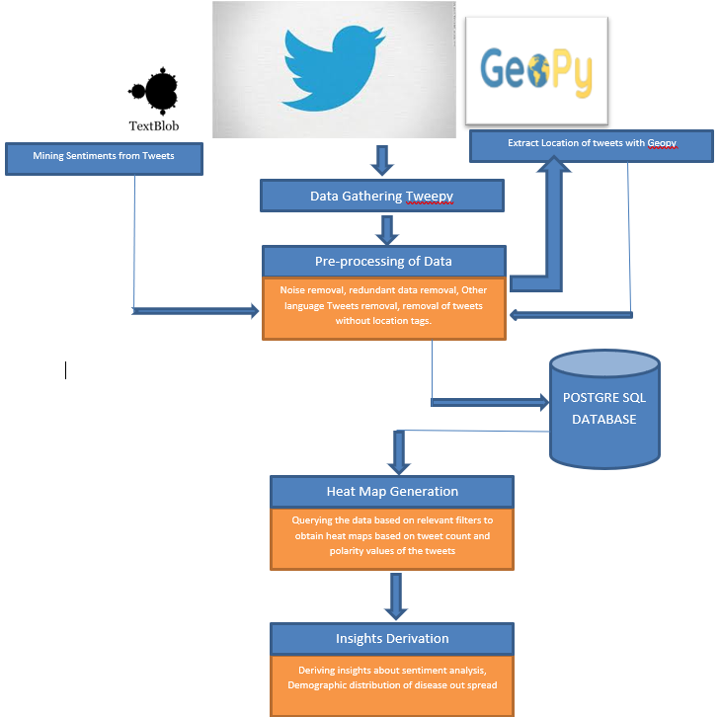
Figure 1: System Architecture
In this study we have gather data from Twitter using Tweepy API, which is send to Geopy for processing and cleaning. Once polished, we store it in our designated database, designed in PostgreSQL. With the help of queries retrieval technique, a heat map is generated, and is compared with other insights and conclusion is drawn.

Database
Data is stored in PostgreSQL. It is free and open source and code is available under license which allows anyone to modify and distribute this database in any form as per their necessity. It's an Object-relational database management system. The reason behind calling it an ORDBMS because it supports features like table inheritance and function overloading. One of the situations where the object-oriented approach is visible is the fact that for each table there is a corresponding data type created. So, a table is essentially a set of "instances" of a specific type.[8]
The outstanding features of PostgreSQL is that it meets all the requirements to be fully ACID-compliant. That means it can store data in an “all-or-nothing” approach. It gives a consistent picture of data and guarantees that all transactions will occur in isolation. And once the data is written it will not be lost. Multi-version concurrency controls which means it enables different users to read and write information to a database at the same time. PostgreSQL supports users-defined datatypes. Users can customize functions to define individual data types. It supports all major programming languages such as Python, C, and Java.
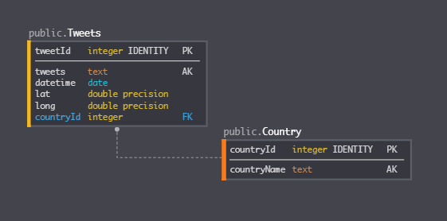
Figure 2: Database Architecture

Design

Python offers an exclusively API named Tweepy with which we can extract the twitter data. In our project we used the OAuth and Customer credential keys that were obtained by the developer dashboard. Tweepy API was given a call with appropriate parameters. Filters such as date and keyword search like ‘COVID19’ or ‘Corona Virus’ and geo-location filter (the tweets that has tagged with locations) were implemented during extraction of tweets. We initially imported the structure data which had row number, date, Tweets and Location were stored in a python data frames. As the data for each month was increasing, we appended the data in the same format to the same.[7]

We observed that despite filters certain data had tweets that had other languages except English. It also had some noisy data such as emoticons, symbols, etc. So, all these data were pre-processed with the help of python library functions such as dropna, language filter etc. After pre-processing we observed that the information stored in the location had different cities, towns, provinces names. In order to follow a standard country names, have to be used which later will also be useful for creating heatmaps.

Geopy API offered by Twitter has variety of geolocation extraction adavantage. Geopy is useful in extracting the location based on cities. The latitude, longitude and corresponding citiy’s country location were extracted with the help of Geopy API. After generating the data unwanted columns in the dataset were dropped. At the end the dataset only contains the columns of S.no, Date, Tweets and Country. Thus, a consistent dataset was generated. Thusthe whole dataframe data was exported at the end to a csv file.[9][10]

From this data we must mine sentiment analysis. Python offers NLP with the help of TextBlob API which needs a string as input to produce the polarity and subjectivity values. Polarity values range from -1 to 1 where -1 being negative, 0 being neutral and +1 being positive. Subjectivity values is from 0 to 1 where it describes the facts, stories or public opinions. All these values were averaged for a single country based on the count and summation of polarity values in order to have an insight from specific Country’s people tweets. So, a dataset is created for facilitating the demographic sentiment analysis. [11]

Experimental setup

Implementation
Result generated from 50,000 data stored in Database. Tags includes #corona, #virus, #coronavirus #outbreak #panic #shortage #pandemic #toilet papers. This database includes columns like category(#tags), tweets, date, location, latitude, and, longitude. Once data is stored, we are using SQL queries to fetch and pour it in Microsoft tool called Geographical heat map. This heat map is used for making inference and future prediction on our Big Data, i.e. converting information into wisdom.
The data was taken to compare between the gap of 15 days to show the significant differences along with the reason that this virus takes 14 days to start showing symptoms. Next we took twitter data on 1st March and plotted them on the heat map and waited 15 days for the confirmed number of cases and plotted the same on the world map again to see any pattern. This process was repeated for 15th March and checked for pattern on 30th march again. Once we learned some pattern, we try to predict the future with our findings from 30th March 2020 data i.e. second week of April 2020. These findings will be discussed in more details in next few sections of this report.
Below is a representation of the tweets from all around the world on Coronavirus or anything related to this pandemic and following figure shows the actual number of cases of active patient for COVID-19:

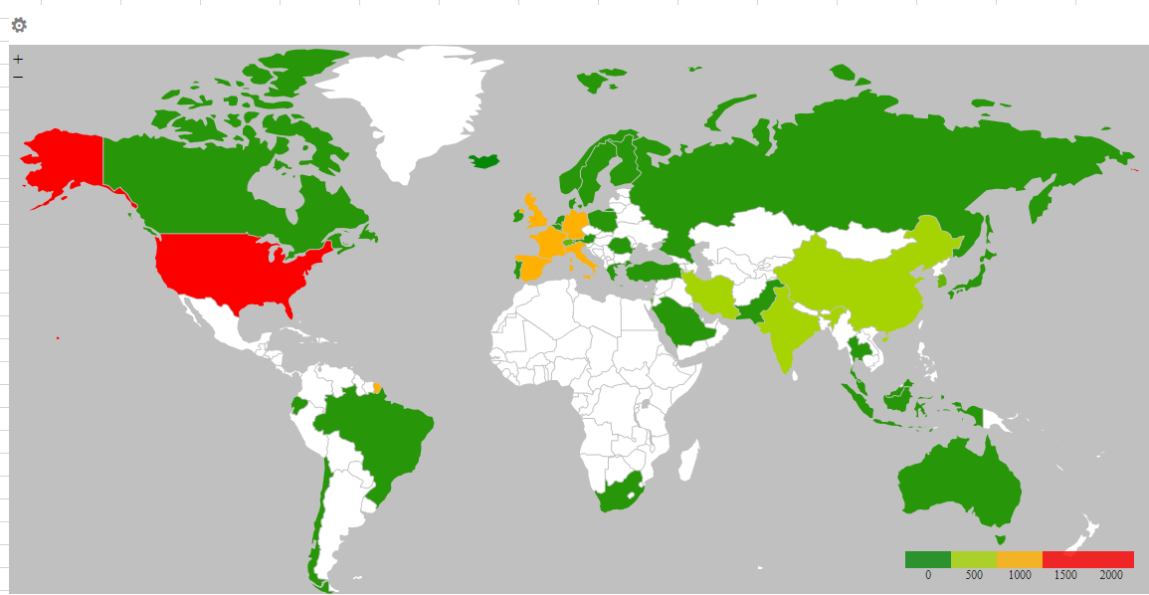
Figure 3: Spread of the Tweets for COVID-19 on 1st March 2020

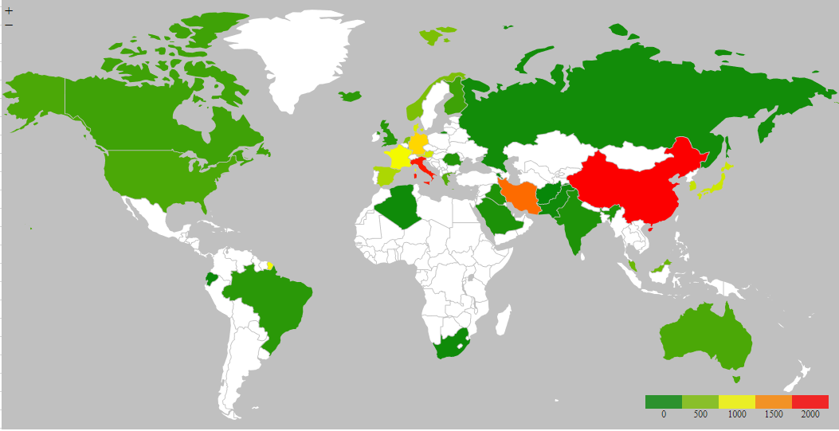
Figure 4: Confirmed cases for COVID-19 on 15th March 2020

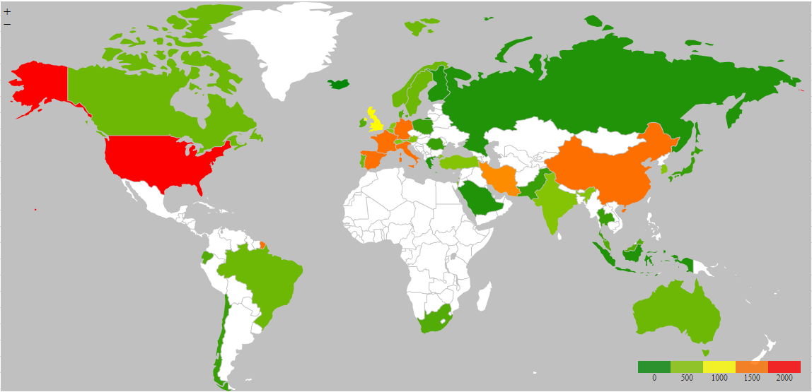
Figure 5: Spread of the Tweets for COVID-19 on 15th March 2020

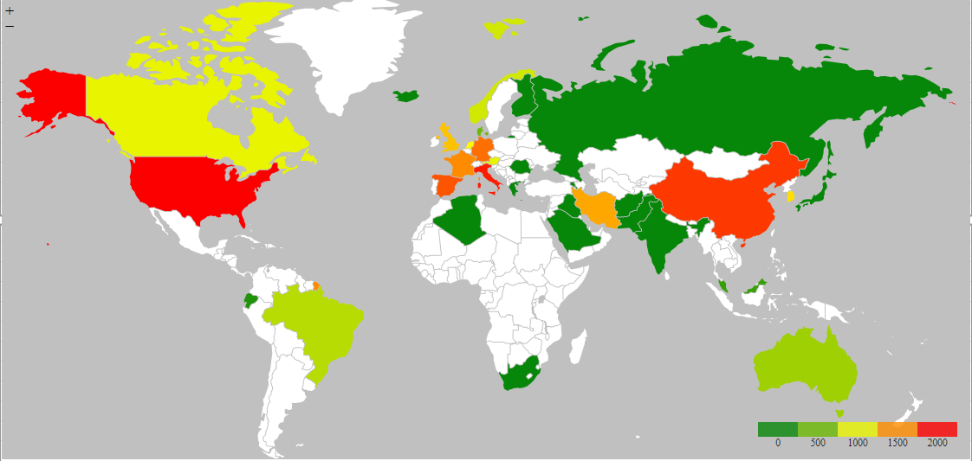
Figure 6: Confirmed case for COVID-19 on 30th March 2020

Findings
As per our findings, this study sees a lot of tweet coming from countries that are in orange, and the reported cases in these countries are still less compared to others. Based on our assumption, in next 15 days, we are going to see an increase in the no. of cases in Canada, France, Germany, India, and, United Kingdom. The confirmed case shown here is the total number of cases from Jan-March time period. This is not a scientific result and the outcome might change as more countries are taking drastic measures to mitigate the situation like social distancing or lockdown.
Right now, the world is battling a coronavirus epidemic. However, this study indicates that the issue is larger than just the spread of the virus. Our Data shows whenever a country start to tweet more about this virus outbreak, there is a spike in the number of cases in that country
Surely virus is not spreading through social media, which indicates that these tweets are creating some sort of fearmongering among the masses. This study believes misinformation spread through these platforms create panic among general population, leading them to take drastic measures instead of what is recommended.

Challenges
- team faced challenges in downloading the location of the tweets as Twitter doesn’t allow the user’s actual location while tweeting. Hence we took the location of the user’ account instead of his location while tweeting. This gives us a close idea of where the data will be coming from in terms of their location around the world
- Next challenge was to decipher the location into a latitude and longitude matrix, as data contain special characters and foreign language which need to be removed and converted to English text for NLP algorithm to understand.

conclusion
The study was concluded to showcase the negative impact of the social media on the shaping of an outbreak. We study the impact on recent world crisis of COVID-19, but as shown earlier in this report other authors also confirmed such scenario in previous major outbreak. Hence, it safe to say as per our study there is a huge impact of social media on times when people are most emotionally charged. The positive view is that social media should help at a time when many of us are otherwise isolated from one another. But conversation around the crisis is usually lead to misinformation and fake news. This led people to make erroneous decision of stepping out of their isolation and hence spreading the disease or becoming defenseless to the disease at the same time.

Future work
One of the most critical aspects of this study is shortage of data and we want to extend the comparison made in this research to other previous world crisis to solidify our claims. This might include, outbreaks like MERS, EBOLA and SARS which happened in the recent times. Due to the shortage of the social media at these times of the crisis, data collection is one of the challenges, but team is working on finding ways where we can use other platforms like Facebook or general blogs as well like to include in this study. This way we can overcome the shortage of data and will be able to confirm our findings with more proofs and examples.

Acknowledgement
We want to offer our thanks towards our professor and mentor, Dr. Pooya Moradian Zadeh, Assistant Professor at the University of Windsor, Canada, who has given us enormous guidance, support, suggestions and recommendations. Without his assistance, we could not have built up this project up to the present standard.

References
- "Twitter overcounted active users since 2014, shares surge on profit hopes". USA Today.
- Doo-Hun Choi Woohyun Yooc Ghee-YoungNoh Keeho Parke, “The impact of social media on risk perceptions during the MERS outbreak in South Korea”, vol. 5, no. 2, pp. 1788–1791, 2019.
- L. Hossain D. Kam F. Kong R. T. Wigand T. Bossomaier, “Social media in Ebola outbreak”, Epidemiology and Infection, 144(10), 2136-2143. doi:10.1017/S095026881600039X
- Steven Bird, Ewan Klein, and Edward Loper (2009). Natural Language Processing with Python. O'Reilly Media. ISBN 978-0-596-51649-9..
- Clarke, Steven (2004). "Measuring API Usability". Dr. Dobb's. Retrieved 29 July 2016..
- “Anaconda repository". anaconda.org..
- https://towardsdatascience.com/how-to-access-twitters-api-using-tweepy-5a13a206683b.
- "PostgreSQL". Retrieved September 21, 2019. "PostgreSQL: The World's Most Advanced Open Source Relational Database".
- https://towardsdatascience.com/mapping-geograph-data-in-python-610a963d2d7f.
- https://geopy.readthedocs.io/en/1.10.0/.
- https://textblob.readthedocs.io/en/dev/.

