Introduction
Data:
Any factual information in raw and disorganized form is called data.
Database:
A database is a collection of related data organized in a way so that data can be easily accessed, managed and updated.
Database Management System:
- A general-purpose Database Management System(DBMS) is a software system designed to allow the definition, creation, querying, updating and administration of databases.
- Well-known Database Management System's( DBMS's )include MySql,Oracle,Microsoft SQL server,Foxpro, SQLite, FileMaker Pro etc.
- The primary goal of a Database Management System(DBMS) is to provide a way to store and retrieve database information in a convenient and efficient manner.
Architecture of a DBMS
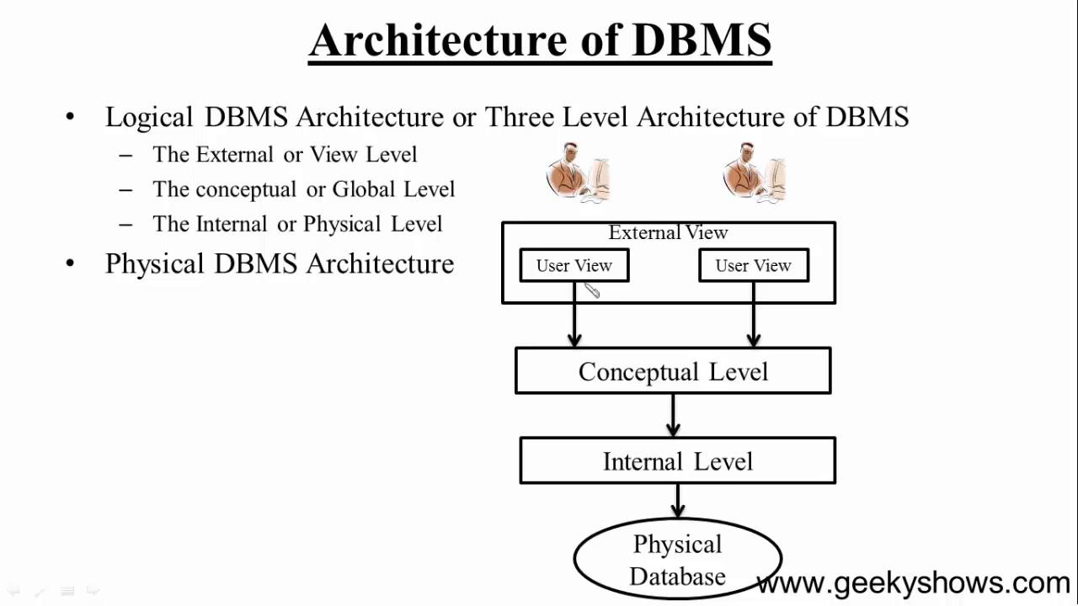

DBMS Architecture and Data Abstraction :
Application developers use abstraction to make the system efficient in terms of retrieval of data, and reduce complexity in terms of usability of users.
Abstraction simplifies database design and separates the applications from physical data storage.
The three layers in DBMS architecture represents three levels of abstractions :
Physical Level: This is the third level ,the physical schema of the DBMS architecture depicted in the diagram above.This is the lowest level of data abstraction.
Logical Level: This is the middle layer of database architecture. This is the second level, the conceptual schema of the DBMS architecture depicted in the diagram above. This level comprises of what information is actually to be stored in the database in the form of tables. It also describes the relationship among the data entities in relatively simple structures.
View Level: This is the top most layer of the database architecture. This is the first level, the external level of the DBMS architecture depicted in the diagram above.This is the highest level of abstraction. Each user uses only a part of the actual database. This level exists to ease the accessibility of the database by an individual user. As per requirement of each individual user, multiple views of the same database may exist. Users can just view the data and interact with the database, independent of storage and implementation details of it.
The main purpose of data abstraction is achieving data independence in order to save time and cost required when the database is modified or altered.
There are two levels of data independence achieved from these levels of abstraction :
Physical level data independence : The characteristic of being able to modify the physical schema without any alterations to the conceptual or logical schema, done for optimization purposes, e.g., we can easily make any change in the storage size of the database system, without affecting the conceptual structure of the database .
Logical level data independence: The characteristic of being able to modify the logical schema without affecting the external schema or application programs. The user view of the data would not be affected by any changes to the conceptual view of the data like insertion or deletion of attributes, altering table structures entities or relationships to the logical schema etc.
Data Modeling
Data model is the logical design and structure of a database. Data model defines how data will be stored, accessed and updated in a database management system. It defines data elements and relationships among various data elements for a specified system and the constraints to maintain data integrity.
Data modeling is the process of documenting the logical design in the form of an easily understood diagram, using text and symbols to represent the way data needs to flow. This diagram can be used as a blueprint for the construction of the database for applications to be developed.
For example , Entity Relationship Modelling or ER Modelling,

Traditional File Processing System
A file system is a method of storing and organizing computer files and the data they contain and to make it easy to find and access them.
Limitations of File processing System:
- Separated and Isolated Data
- Data Redundancy
- Data Dependence
- Difficulty in representing data from the user's view
- Inflexibility in retrieving the Data
- Data Security
- Transactional Problems
- Concurrency problems
Need of a Database Management System
To overcome the limitations of the traditional file processing system , the modern DBMS was created.
Advantages of DBMS :
- Minimal Data Redundancy
- Data Consistency
- Data Integration
- Data Sharing
- Application Development Ease
- Better Controls
- Data Independence
- Reduced Maintenance
Types of DBMS
Commonly used databases are:
- Hierarchical Database
- Network database
- Object relational database
- Relational database
Hierarchical DBMS:
- In hierarchical DBMS , the relationships among data in the database are established in such a way that one data item is present as the subordinate of another one .
- The data structure "tree" is followed by the DBMS to structure the database.
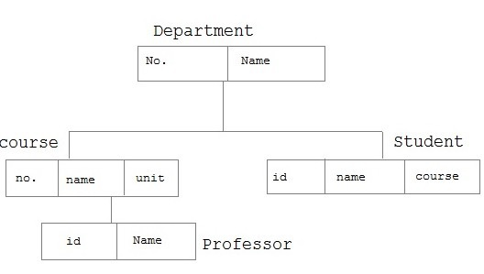
Network DBMS:
- In a Network DBMS the relationships among data in the database are of type many-to-many and appears in the form of a network.
- The structure of a network database is extremely complicated because of these many-to-many relationships in which one record can be used as a key of the entire database.

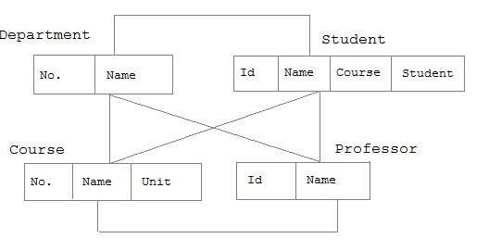
Object Relational Database :
- Object Oriented DBMS add database functionality to object oriented programming languages.
- They bring much more than persistent storage of programming language objects.
- As a result, applications require less code, use more natural datamodelling, and code bases are easier to maintain.
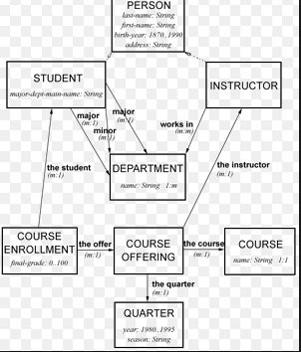
Relational Database Management System:
- Relational Database Management System is based on a relational model .
- Relational model is the most successfully used Data Base Management System (DBMS) model.
- Relational model represents data in the form of tables or relations.
- Some popular examples are Oracle, Microsoft SQL Server and Microsoft Access.
Schema:
The overall design or description of the database is the database schema. It represents the logical view of the entire database and defines how the data is organized and how the relations among them are associated along with formulation of all the constraints that are to be applied on the data to retain data consistency and integrity.
For example the design of the tables for an entire application or project.
Schema is of two types:
- Physical schema: It is the design of a database at its physical level. In this level, it is expressed how data is stored in blocks of storage.
- Logical schema: It is the design of the database at its logical level. At this level, data is described as certain types of data records that can be stored in the form of data structures without having the implementation details of it.
Instance:
It is the data stored in database at a particular moment of time. It is the information collected in a database at some specific moment.
RDBMS terminologies
Relation:
A relation is a collection of related data entries consists of columns and rows.
Tuple:
A tuple, also called a row of data, is each individual entry that exists in a table.
Fields:
- Every table is broken up into smaller entities called fields.
- A field is a column in a table that is designed to maintain specific information about every record in the table.

Keys in DBMS
Keys are used to establish and identify relation between tables.
Super Key:
A Super key is any combination of fields within a table that uniquely identifies each record within that table.
Candidate Key:
- A candidate key is a subset of a super key.
- A candidate key may be a single field or the least combination of fields that uniquely identifies each record in the table.
- The least combination of fields distinguishes a candidate key from a super key.
Primary key:
- A primary key is a candidate key that is most appropriate to be the main reference key for the table.
- It is a key that uniquely identifies a record in a table.
Foreign key:
- A foreign key is the field in a table that generally references values from primary key field of other table

Oracle Connectivity
Connecting to Oracle from Unix/Linux :
If we are going to connect to Oracle from Unix , after successful login to unix, one can connect to oracle schema from any directory. For example, in the below screen shot the user has connected to oracle schema from his “home” directory.
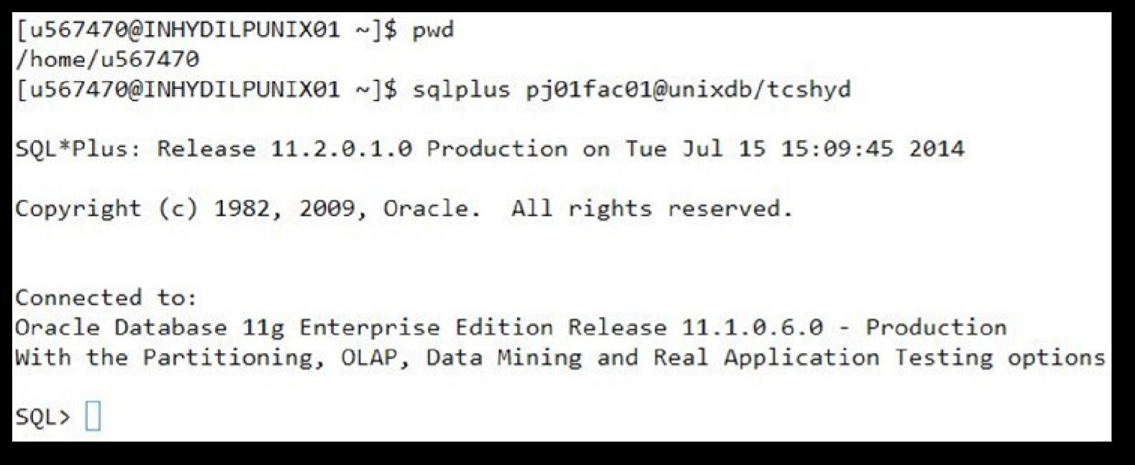
-Use the command sqlplus followed by username@dbname/password.
For example, if user name is “pj01fac01” , db name is “unixdb” and “tschyd” is the password, command will be as below:
$sqlplus pj01fac01@unixdb/tschyd
For clearing the screen, we can use “cl scr” command at SQL prompt
SQL> cl scr
(Note: “cl” and “scr” are two words separated by space) Or clear Screen can be used.
To switch from one user to another user, use “connect” command
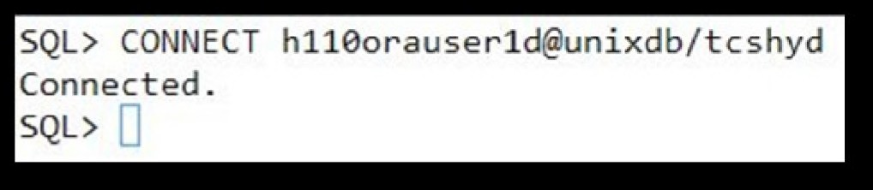
If you want to execute UNIX commands from SQL prompt, use “!” before the command as shown below
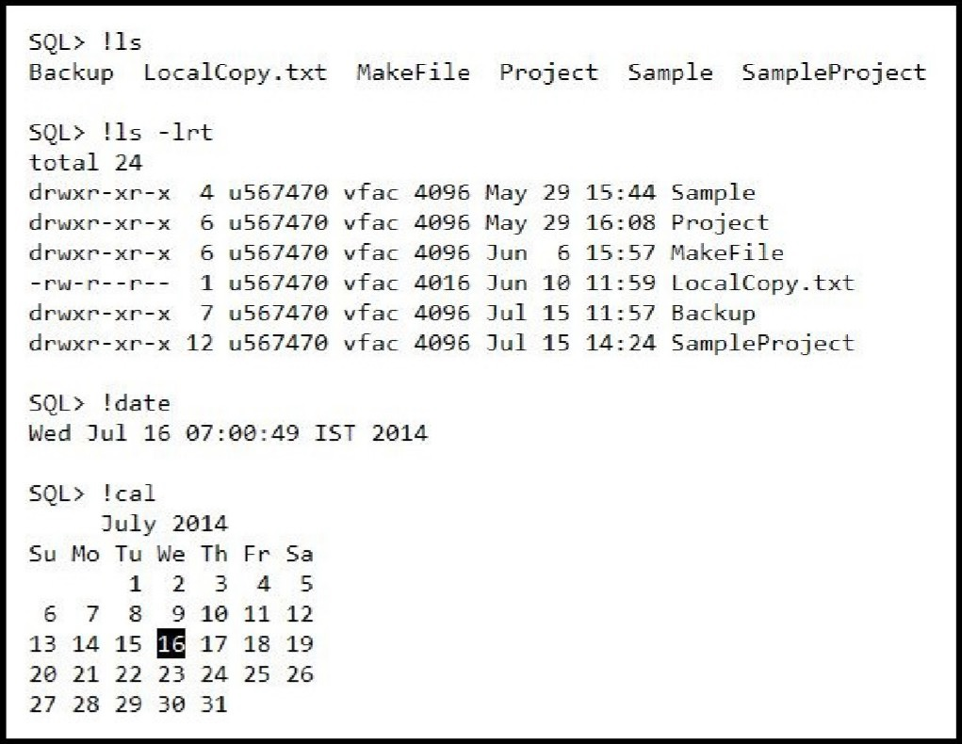
Note : By using only !, you can go to unix shell prompt. To be back to oracle, exit is the command.
We can also use “vi” editor for preparing the “.sql” files and editing SQL queries. To view the buffer content use “L[IST]” Command at SQL prompt.
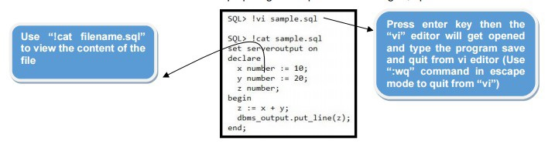
The last SQL query which is executed at SQL prompt will get stored in buffer.
To view the buffer content use “L[IST]” Command at SQL prompt.
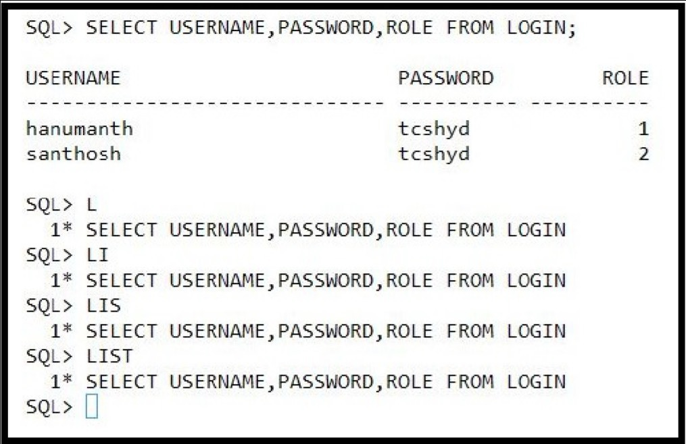
To edit the buffer content, use “E[DIT]” command at SQL prompt. Edit the content in insert mode then save and quit from the editor by using “:wq” command in escape mode.
To execute the buffer content use “/” or “R[UN]” command at SQL prompt.
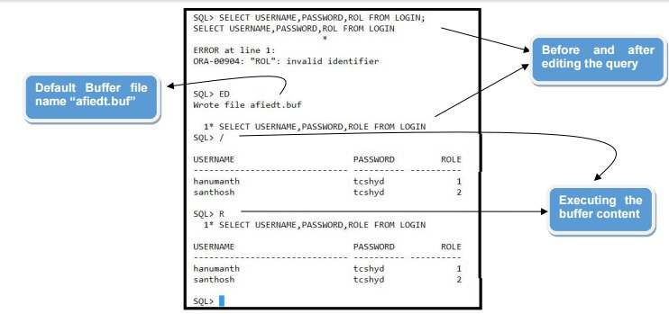
To disconnect from SQL, use “exit” command as shown below
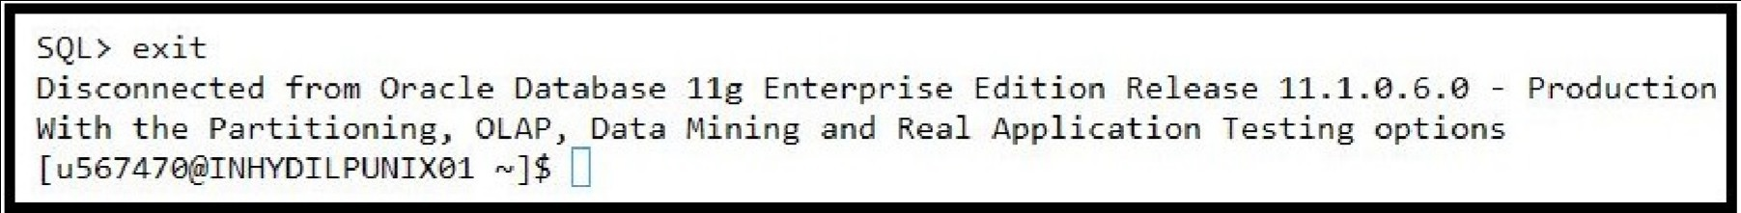

Introduction
Entity Relationship (ER) model proposed by Peter Chen in 1976 is a conceptual representation of data. It is capable of describing the data requirements for a new information system in a direct and easy to understand graphical notation. ER data model represents the overall logical structure of the
DB. ER diagram is a graphical representation of the logical structure of a database.
Basic ER constructs
The ER model is designed with the help of the below basic constructs:
- Entity
- Attribute
- Relationship
Entity and entity types
An entity is an instance of a physical object in the real world.Represents the real world objects (eg., facts , things , people.,,,etc) that have properties in common.
It is an object that exists and is distinguishable from other objects.
An entity may be
- concrete (eg., person,book, employee etc...)
- abstract (eg., leave,transaction etc...)
Entities have attributes.
Graphically an entity is represented by a rectangle.

Weak Entity
- Weak entity is an entity whose existence depends on existence of another entity.
- A weak entity cannot be uniquely identified by its attributes alone, hence it must use a foreign key along with its attributes which is a primary key of the entity on which the weak entity depends upon.
- Graphically weak entity is represented by double rectangle.
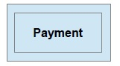
Relationship and relationship types
A relationship is a logical link between entities.
A relationship can be graphically represented by a diamond.
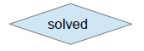
A relationship can be
a) recursive
b) binary
c) n array
d) have attributes
Recursive relationship
A recursive relationship is the one which involves only one single entity. The above representation specifies , a person marries another person.
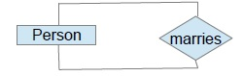
Binary relationship
A relationship which involves two entities. The above representation specifies that 'books' are available in the 'library'. 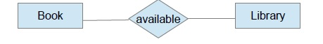
The above representation specifies that 'books' are available in the 'library'.
Ternary Relationship
A relationship which involves three entities.
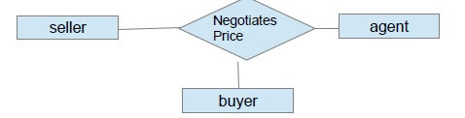
The above ERD represents a ternary relationship.
Relationship with attributes
A relationship can also contain an attributes.
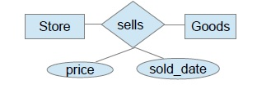
The above ERD represents 'Store sells Items and maintains the quantity sold and the date Item was sold for all the Items sold'.
ER ATTRIBUTE & CARDINALITIES:
Attribute and attribute types
- An attribute is a property / feature of an entity.
- Attributes are nothing but properties of entities and relationships that describe their characteristics.
- The value of an attribute is an element of a data type like number, date etc..
- An attribute is graphically represented by an ellipse.
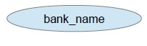
Simple attribute
An attribute which can have atomic values, which cannot be divided further.
For example, a employee's phone number is an atomic value of 10 digits.
Key attribute
An attribute or a collection of attributes of an entity that uniquely identifies an entity among entity set
- Key attribute is used to represent the primary key.
- Key attribute uniquely identifies the entity.
- Key attribute is graphically represented by ellipse with an attribute name underlined.

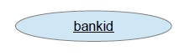
Composite attribute
An attribute which consists of several simple attributes.
For example : Address consists of 3 attribute Street,city,postal code. ​
Derived attribute
An attribute that do not exist in the physical database, but their values are derived from other attributes present in the database. For example, age of an employee. Age of an employee need not have to store and can be derived from data_of_birth.
Derived attribute is graphically represented as dashed ellipse.
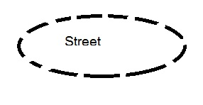
Multivalued attribute
An attribute with a set of possible values for the same entity. (Eg. Phone no - can have mobile no , land number).A multivalued attribute is graphically represented by double ellipse.

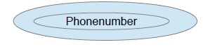
Cardinalities
In case of a relationship between two entity sets , cardinality defines the number of entities in one entity set, which can be associated with the number of entities of other set via relationship set..
4 types of cardinalities can be maintained:
a) 1 : 1 ( ONE to ONE )
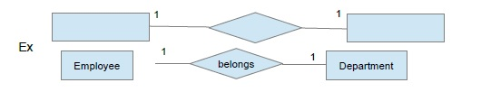
The above representation indicates “one employee belongs to only one department”.
b) 1 : * ( ONE to MANY )
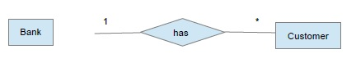
The above representation indicates “One bank deals with many customers”.
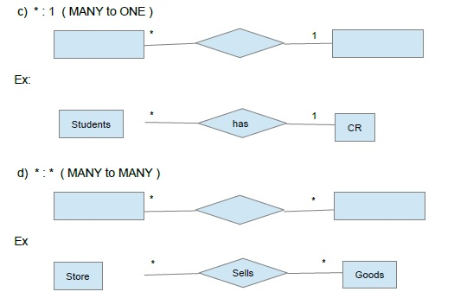
The above representation indicates 'many stores sells many goods'. Note :( * ) specifies many

Normalization
Normalization is a series of steps followed to obtain a Database design that allows efficient access and storage of data.
With Normalization we can –
- Eliminate data redundancy(storing the same data in more than one table)
- Ensure Data Dependencies(only storing related data in a table)
- Ensure Data Consistency
- Reduces the amount of space a database consumes
- Ensure that data is logically stored.
Normal Forms
The database community has developed a series of guidelines for ensuring that databases are normalized. The below are the normal forms we can apply to normalize the tables
- First Normal Form
- Second Normal Form
- Third Normal Form
- Boyce Codd Normal Form
- Fourth Normal Form
- Fifth Normal Form
Demonstration of Normalization with an Example
Consider student table containing student details along with his/her semester subjects as shown below.
StudentId | StudentName | Year | Semester | UnitCode | UnitName
0023765 | John Doe | 2009 | 2 | UG45783 | Advanced Database
0023765 | John Doe | 2009 | 2 | UG45832 | Network System
0023765 | John Doe | 2009 | 2 | UG45734 | Multi-User Operating System
0035643 | Ann Smith | 2009 | 2 | UG45832 | Network System
0035643 | Ann Smith | 2009 | 2 | UG45951 | Project
0061234 | Peter Wolf | 2009 | 2 | UG45783 | Advanced Database
First Normal Form
To say a table to be in First normal form , the below two rules needs to be satisfied
1. The table should be atomic - Each Column for a respective row should be atomic in the table"
2. Repeating groups of data representing a single entity should be minimized
Let us consider the above table - Which is having "Repeating groups of data" for the records of students named Ann Smith and John Doe.
As shown in the highlighted boxes, the data in some columns is repeating because of values to be accommodated in other columns.
Any way the table maintains atomicity as each column / attribute consists of single value .
To convert the above table into First normal form, We need to avoid the repeating groups. By splitting this table into two tables as Shown below, that has been achieved.
Following are the two tables Student and Student_Unit respectively.
Student Table:
StudentId | StudentName | Year | Semester
0023765 | John Doe | 2009 | 2
0035643 | AnnSmith | 2009 | 2
0061234 | Peter Wofl | 2009 | 2
Student_Unit Table:
StudentId | UnitCode | UnitName
0023765 | UG45783 | Advanced Database
0023765 | UG45832 | Network System
0023765 | UG45734 | Multi-User Operating System
0035643 | UG45832 | Network System
0035643 | UG45951 | Project
0061234 | UG45783 | Advanced Database
To identify each row uniquely , there is a primary key for each table as below
StudentId for Student table
StudentId,UnitCode (composit primary key) for Student_Unit table.
In the first table student id is primary key where as in second table the combination of student id and unit code is defined as primary key.
Second Normal Form
Let us consider the table , which is in first normal form . Let us consider the following Student_Unit table .
The table is in 1NF but still we can see redundant data in the second and third columns for the first and the last rows of the table. This redundancy has taken place because of the partial dependency that exists in the table.
The primary key of this table is a composite primary key ,consisting of columns StudentId and UnitCode. (Combination of these two attributes). But we can see that , the non key attribute UnitName can be determined by the UnitCode itself. That means, a part of the primary key can determine a non-key attribute.
Since, the table has partial dependency, table is not in 2NF.
What does second normal form says?
" Every non key attribute of a table should fully depend on Primary key, but not on part of the Primary Key"
To make the table to be in Second Normal Form, we have to remove the partial dependency. Hence we have to divide the table into two tables, in such a way that , each non key attribute depends fully on primary key, but not on part of Primary key

If we notice the above tables, all Non Key attributes (UnitCode in first table and Unit Name in Second table) are fully depends on Primary key
Third Normal Form
Let us consider the below table

UnitCode | UnitName | CourseCode | CourseName
UC1 | Advance DB | C2009 | Computing
UC2 | Networking Sys | C2009 | Computing
UC3 | Project | B2009 | Business and Computing
A table is said to be in third normal form if it satisfies the following conditions:
- It is in second normal form
- There is no transitive functional dependency
But the above table is not in Second Normal form and as well as there is a transitive dependency between Course Name ->CourseCode->UnitCode.
Which leads data inconsistency while performing DML operations on the above table, So let us divide the above table into the below tables in such a way that the resultant tables are in second normal form and as well as in third Normal Form
UnitCode | UnitName | CourseCode
UC1 | Advance DB | C2009
UC2 | Networking Sys | C2009
UC3 | Project | B2009

CourseCode | CourseName
C2009 | Computing
C2009 | Computing
B2009 | Business and Computing
Boyce Codd Normal Form
A relational schema S is considered to be in Boyce–Codd normal form (BCNF) if, for every dependencies X → Y, one of the following conditions holds true:
- X → Y is a trivial functional dependency (i.e., Y is a subset of X)
- X is a super key for schema S
So the Boyce-Codd normal form is described as “Each attribute must represent a fact about the key, the whole key, and nothing but the key ITSELF.”

How to Decompose
To convert a table to BCNF, you must split the table using these two steps.
- Find a nontrivial functional dependency X → Y, which violates the BCNF condition (where the X is not a super key)
- Then Split your table in two tables:
-one with attributes XY , ie Key Set and
One with attributes of X together with the remaining attributes from the original relation
Keep repeating the above decomposition process until all of your tables are in BCNF.
Example
Let’s take a look at this table, which is not in BCNF.
Writer | Location | Book Title | Total Page Count
W1 | Hyderabad | TITLE1 | 200
W2 | Banglore | TITLE2 | 100
W3 | Chennai | TITLE3 | 300
The nontrivial functional dependencies in the table , which are violating BCNF are
Writer -> Location
BookTitle ->Total Page Count
Writer and book title together acts as a key here
Let us split into multiple tables to maintain trivial dependencies
Writer | Location
W1 | Hyderabad
W2 | Banglore
W3 | Chennai

Book title | Total Page Count
TITLE1 | 200
TITLE2 | 100
TITLE3 | 300

Writer | Book title
W1 | TITLE1
W2 | TITLE2
W3 | TITLE3

None of the above functional dependencies are not violating the BCNF Rules,
The key for the first table is Writer ,The key for the second table is Book title. The key for the third table is Writer and Book title, together.
So the table is in BCNF form.

Structured Query Language:
Structure Query Language(SQL) is a database query language used for storing and managing data in Relational DBMS.SQL was the first commercial language introduced for E.F Codd's Relational model of database. Today almost all RDBMS(MySql, Oracle, Infomix, Sybase, MS Access) use SQL as the standard database query language. SQL is used to perform all types of data operations in RDBMS.
The different categories of SQL used in RDBMS to store and manipulate data are:
- Data Definition Language(DDL)
- Data Manipulation Language(DDL)
- Transaction Control Language(TCL)
- Data Query Language(DQL)

Data Definition Language (DDL)
DDL statements define the data structure such as tables, views etc.. that make up the database. All DDL statements are auto committed means the changes will become permanent and database objects created are available to all users.
Commonly used DDL statements are:
- CREATE
- ALTER
- DROP
- RENAME
- TRUNCATE
Data types
A data type identifies or classifies a particular type of information or data. Some commonly used data types are:
- CHAR (size) - Used to store character strings values of fixed length.
- VARCHAR2 (size) – Used to store variable length string data.
- NUMBER (size, precision) – Used to store numbers(fixed or floating point)
- DATE – Used to represent date and time.
- LONG – Used to store large variable length strings(upto 2GB).
DDL statement : CREATE
The CREATE keyword is used for creating database objects like tables, views,triggers, and indexes
Syntax:
CREATE TABLE table_name
(
column_name1 DATATYPE(Size) ,
column_name2 DATATYPE(Size),
column_name3 DATATYPE(Size)
);
Ex: Create Table Employee
(
Emp_id number(4) NOT NULL,
Name varchar2(20) NOT NULL,
Salary number(8),
E_Mail varchar2(30),
Country varchar2(20),
);
The above statement creates a table named Employee with columns Emp_id, ame,Salary,E_Mail and Country.
DDL statement : ALTER
Alter statement is used to modify the structure of database or database objects like tables, views etc..
Alter table statement - to add column to a table:
Ex: ALTER TABLE Employee ADD age number(10,2) NOT NULL;
The above statement adds a new column 'age' of number data type with
constraint not null.
Modifying the column
Ex: ALTER TABLE Employee MODIFY salary number(10,2);
Table Altered.
Rename and Drop a Column
Using the alter statement we can rename a column and also the drop any column.
Ex: ALTER TABLE Employee RENAME COLUMN salary TO em_sal;
Ex: ALTER TABLE Employee DROP COLUMN age;
The above statements renames the column name salary to em_sal and drops column age
DDL statements : TRUNCATE , DROP , RENAME
Truncate Table:
Remove all the rows and resets schema of the table.
TRUNCATE TABLE Employee;
Drop table :
Deletes table entirely from the database.
DROP TABLE Employee;
Renaming a Table:
Changing the name of a table.
RENAME Employee to Emp_table;

Data Query Language (DQL) :
The Data Query Language (DQL) is used to retrieve the data from one or more tables.
- The SELECT statement is the only DQL statement.
- Using SELECT statement the following operation can be performed
- Projection : This operation results subset of columns
- Selection : This operation results subset of rows
Projection means selecting set of columns from a table. In the Below table, 3 columns marked with yellow colour suggesting That those columns are selected.
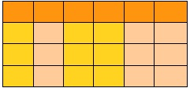
Selection means selecting set of rows from a table. In the Below table, 3 rows marked with yellow colour suggesting That those rows are selected.
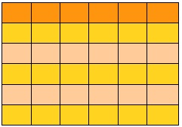
A Typical SELECT statement may consists of six clauses.
Syntax:
SELECT column_name [, column_list]
FROM table_name
[WHERE search_condition]
[GROUP BY grouping_column_name]
[HAVING aggregated_search_condition]
[ORDER BY sorting_column]
The SELECT and FROM clauses of the statement are mandatory.The remaining four clauses are optional.
Consider the following table
Table 1.1 customer_details
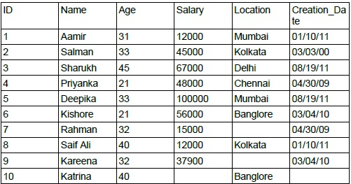

SELECT Statement (selection)
The where clause can be used to refine selection results by adding search criteria.
Restricting Selection using comparison operators:
SELECT name, age FROM customer_details WHERE salary>50000;
The above query displays name and age of customers whose salary more than 50000 From customer_details table
Restricting Selection using IN keyword:
SELECT name,location FROM customer_details WHERE location IN ('Kolkata','Delhi');
The above query displays name and location of customers who are from Kolkata and Delhi
Restrict based on pattern matching:
SELECT name,location FROM customer_details WHERE name LIKE '_a%';
The above query displays name and location of customers whose name's second
character is a.
Restricting Selection using BETWEEN …
SELECT name,location FROM customer_details WHERE age BETWEEN 20AND 40;
The above query displays name and location of customers whose age ranging from 20 to 40
Restricting based on NULL value:
Condition on NULL value can be given using the keyword IS.
SELECT name, age FROM customer_details WHERE location IS NULL;
The above query displays name and age of customers whose location not specified
SELECT name, age FROM customer_details WHERE age IS NOT NULL;
The above query displays name and age of customers whose age available
DQL statement : OrderBy Clause
ORDER BY clause in the SELECT statement is used to sort the results
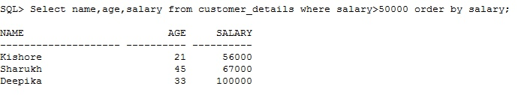
- Name, age and salary of the customers displayed as per the ascending order of their salary.
- DESC keyword can be used to display the list in descending order.
DQL statement : GroupBy
The GROUP BY statement is used to group the result-set by one or more columns.
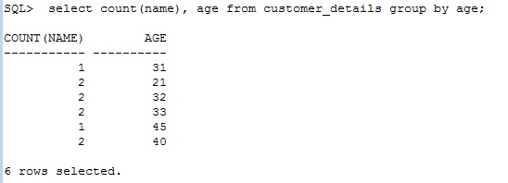
The above query displays number of customers present in Particular age group.

Data Manipulation Language
- Data Manipulation Language(DML) is a structured query language which is used for inserting, updating and deleting data in the database objects like table or view.
- DML comprises the SQL change statements which modifies the stored data but not the database object.
- DML consist of three SQL statements namely
  - Insert
  - Update
  - Delete
INSERT statement
- Insert statement is used for inserting data into table.
- Insertion of data can be done in multiple ways.
Syntax:
INSERT INTO table_name[(column1, column2,...)]
VALUES(value1, value2,....);
If values in all the columns inserted in proper order, column names are not mandatory.
Syntax-:
INSERT INTO table_name VALUES(value1, value2,....);
Insertion can also be done in interactive way. The records can be inserted in interactive manner also
Syntax:
INSERT INTO table_name VALUES(&value1, &value2, …..);

Syntax:
INSERT ALL
INTO table_name VALUES(value1, value2, …..)
INTO table_name VALUES(value1, value2, …..)
INTO table_name VALUES(value1, value2, …..);
Multiple Insertions using ALL command.

UPDATE statement
- Update command is used to change or modify data of one or more records in a table.
Syntax:
UPDATE Table_name SET Column_name1=value1
[,Column_name2=value2,...]
[WHERE Condition];
- All rows will be updated if no condition is specified in where clause.
DELETE statement
- Delete statement is used to remove one or more records from a table.
- A subset may be defined for deletion using a condition, otherwise all records are removed.
Syntax:
DELETE FROM Table_Name [WHERE Condition];
Delete statement using WHERE condition.

Note: Delete statement without where condition deletes all the rows from table.

Introduction to Transaction Control
Oracle server ensures data consistency based upon transactions. Transactions consist of DML statements that make up one consistent change tothe data.
Transaction Start and End Scenarios:
A Transaction begins when the first executable sql statement is encountered. The Transaction terminates when the following specifications occur.
- A COMMIT or ROLL BACK issued.
- A DDL statement issued
- A DCL statement issued
- Failure of machine or system crashes
- A DDL or DCL statement is automatically committed and hence implicitly ends a Transaction.
Explicit Transaction Control Statements
- COMMIT
- SAVEPOINT
- ROLLBACK
- COMMIT
It ends the current Transaction by making all pending data changes permanent.
Syntax:COMMIT;
Once commit is issued, data changes will become permanent.
The previous state of the data is permanently lost.
All users can view the results of the recent transactional changes.
Ex: UPDATE employee SET salary =1000 WHERE emp_id = 10;
COMMIT;
SAVEPOINT:
It marks a savepoint with in the current Transaction. We can create multiple savepoints in single Transaction.Savepoints can be used to control the reverting of changes.
Syntax:SAVEPOINT ;
Ex: SAVEPOINT S1;
ROLLBACK:
- It ends the current Transaction by discarding all pending data changes.
- The data changes are undone.
- The previous state of data is restored.
- The locks on the affected rows are automatically released.
Syntax: ROLLBACK or ROLLBACK to ;
Ex: UPDATE employee SET salary =1000 WHERE emp_id = 10;
ROLLBACK;
Using savepoint the Transaction can be discarded up to the marker by using rollback statement.
Ex: INSERT INTO employee VALUES(10,'JHON',3000);
INSERT INTO employee VALUES(10,'KELLY',2000);
SAVEPOINT S1;
INSERT INTO employee VALUES(10,'WILSON',4000);
ROLLBACK TO S1;

Introduction
- SQL Constraints are used to specify rules for the data in the table, to ensure that the data in the table conforms to the requirements defined.
- Constraints are very important to maintain the data integrity.
- Constraints can be defined when the table is created (with the CREATE statement) or can be added after the table is created (with the ALTER statement).
- Every constraint is provided with a name (CONSTRAINT_NAME) in the database and name can be given when it is defined. In case we do not give a name to the constraint when we declare the constraint, Oracle associates the constraint with a name.
- Within the same scope, no two objects can have same name. Hence one user, can not use a name as constraint name if it is already used for some other object.
Constraint Types
There are six types of constraints available to provide rules to the tables.
- PRIMARY KEY
- UNIQUE
- FOREIGN KEY
- CHECK
- NOT NULL
- DEFAULT
Declaration Style
We can define constraints for a column in 2 different ways
1. Column Level (OR) In-line style : Constraint is defined as part of the definition of an individual column or attribute. Constraints can be defined at column level using both the CREATE and ALTER statements. They are usually specified when the constraint is specific to the column only.
Syntax:
CREATE TABLE sample (col1 DATATYPE(size) CONSTRAINT_NAME,col2 DATATYPE(size)
CONSTRAINT_NAME,…......);
2. Table Level (OR) Out-of-lilne style : Constraint is defined as part of the table definition. Constraints can be defined at table level using CREATE statement. They are usually specified when the constraint need to be applied on the combination of columns together.
Syntax:
CREATE TABLE sample
(col1 DATATYPE(size), col2 DATATYPE(size),col3DATATYPE(size),CONSTRAINT_NAME(col1), CONSTRAINT_NAME(col2),…......);
Primary Key
- A PRIMARY KEY constraint uniquely identifies each record in the table.
- A PRIMARY KEY column cannot have duplicate values.
- A PRIMARY KEY column cannot have null values.
- A PRIMARY KEY can consist of one or more columns.
- If a single column does not qualify for a PRIMARY KEY, we can define a primary key by combining more than one columns.This is called COMPOSITE PRIMARY KEY.
Restrictions
- A table can have only one PRIMARY KEY.
- PRIMARY KEY cannot be defined on the columns having LOB,LONG,LONG RAW,BFILE etc... data types.
- A Composite PRIMARY KEY can be defined only as a table level key.
- A composite PRIMARY KEY cannot have more than 32 columns.
Primary key creation with Create table (Column Level) statement:
Syntax :
CREATE TABLE table1 (col1 DATATYPE(size) CONSTRAINT cons_name PRIMARY KEY, col2 DATATYPE(size), col3 DATATYPE(size),........);
Ex: CREATE TABLE Location( loc_id NUMBER(4) CONSTRAINT loc_pk PRIMARY KEY, street_address VARCHAR2(20), city VARCHAR2(15), state VARCHAR2(15), pincode NUMBER(6));
The above example specifies that every location must have a unique location_id value to identify the location and that should not be left blank.
Primary key with Create statement (Table Level)
A PRIMARY KEY can be defined at the table level once the attributes of the table are declared .
Syntax :
CREATE TABLE table1 (col1 DATATYPE(size), col2 DATATYPE(size), col3 DATATYPE(size), ........, CONSTRAINT cons_name PRIMARY KEY(col1));
Ex: CREATE TABLE location ( loc_id NUMBER(4), street_address VARCHAR2(20), city VARCHAR2(15), state VARCHAR2(15), pincode NUMBER(6) CONSTRAINT loc_pk PRIMARY KEY(loc_id));
The above example specifies that every location must have a unique value for location_id and that should not be left blank.
Composite Primary key
A PRIMARY KEY can be defined on multiple columns if required. This type of defining on multiple columns is called as composite PRIMARY KEY.
Syntax :
CREATE TABLE table1 (col1 DATATYPE(size), col2 DATATYPE(size), ........,
CONSTRAINT cons_name PRIMARY KEY(col1,col2));
Example:
CREATE TABLE sales (sales_id NUMBER(6), cust_id NUMBER(4), prod_id NUMBER(5), qnty NUMBER(6), sold_date DATE, CONSTRAINT sales_pk PRIMARY KEY(sales_id,cust_id,prod_id));
The above example specifies that, for each record in this table , the combination of the following three fields sales_id , cust_id and prod_id will only give a unique value but not the value of only one of these fields can be unique .This is an example of a composite PRIMARY KEY .
Primary key with Alter statement
Using ALTER statement we can create a Primary Key for a table already created.
Syntax:
ALTER TABLE table_name ADD CONSRAINT cons_name PRIMARY KEY(colname);
Ex:
CREATE TABLE person ( aadhar_id VARCHAR2(10), name VARCHAR2(30), dob DATE, phone_number NUMBER(12), address VARCHAR2(30));
ALTER TABLE person ADD CONSTRAINT aadhar_pk PRIMARY KEY (aadhar_id);
Removing Primary Key:
We can remove the primary key constraint from a table.
In order to remove a PRIMARY KEY constraint which is defined on a table , we
need to use DROP CONSTRAINT with ALTER Table
Syntax:
ALTER TABLE table1 DROP CONSTRAINT cons_name;
Ex: ALTER TABLE location DROP CONSTRAINT loc_pk;
Foreign Key
- A FOREIGN KEY means establishing the relationship between parent and child tables. (parent – PRIMARY / UNIQUE defined table , child – FOREIGN KEY defined table)
- A FOREIGN KEY in one table points to a PRIMARY KEY in another table.
- The PRIMARY KEY and FOREIGN KEY can exist in the same table.
- A composite FOREIGN KEY should be defined at table level. A composite FOREIGN KEY must refer to the composite PRIMARY KEYcolumn.
Restrictions
- The child and parent tables must be in the same database.
- The column to be declared as FOREIGN KEY in child table must be of same data type as the data type of the PRIMARY KEY column of the parent table.
Foreign key constraint is called the Referential Integrity Constraint.
- It preserves the defined relationship between the tables when the records are inserted or deleted.
- It ensures that key values are consistent across the table
When referential integrity (Foreign Key ) is enforced , it prevents from
1. Adding records to a child table if there is no associated record available in the parent table.
2. Changing values in the parent table is associated records available in the child table.
3. Deleting records from the parent table if there are matching records available in the child table.
Foreign key with Create statement -Column Level
A FOREIGN KEY constraint can be defined on a table with the help of a CREATE statement immediately after the column definition with the help of REFERENCES keyword to refer the parent table.
Syntax :
CREATE TABLE table_name (col_name1 DATATYPE(size) CONSTRAINT cons_name REFERENCES parent_table_name(col1), col5 DATATYPE(size), col6 DATATYPE(size) , ........);
Example :
CREATE TABLE person(name VARCHAR2(30),dob DATE,gender CHAR(1),address NUMBER(4) REFERENCES location(loc_id),gender CHAR(1));
The above example specifies that the address column values in the person table are linked/references with the column: loc_id values of the location table.
Foreign key with Create statement -Table Level
A FOREIGN KEY constraint can be defined as a table level definition once finishing all the column definitions.
Syntax :
CREATE TABLE table2 (col4 DATATYPE(size), col5 DATATYPE(size), col6 DATATYPE(size), ........, CONSTRAINT cons_name FOREIGN KEY(col4) REFERENCES table1(col1));
Ex: CREATE TABLE person(name VARCHAR2(30),dob DATE,gender CHAR(1),address NUMBER(4),gender CHAR(1),FOREIGN KEY(address) REFERENCES location(loc_id));
The above example specifies that in order to maintain the address for each person, the addresses available in the location table must be linked to the address field of the person table.
Composite Foreign key
We can define a FOREIGN KEY constraint multiple columns. This type of defining on multiple columns is called as composite FOREIGN KEY.
Syntax :
CREATE TABLE table2 (col4 DATATYPE(size), col5 DATATYPE(size), col6 DATATYPE(size), ........, CONSTRAINT cons_name FOREIGN KEY (col4,col5) REFERENCES table1(col1,col2));
Ex: CREATE TABLE production(suppl_id NUMBER(4),warehouse_id NUMBER(6), warehouse_name VARCHAR2(20),product_name VARCHAR2(20),qnty NUMBER(4),unit_price NUMBER(6,2),CONSTRAINT suppl_fk FOREIGN KEY(suppl_id) REFERENCES
supplied(supp_id),CONSTRAINT warehouse_fk
(warehouse_id,warehouse_name) REFERENCES (id,name));
Foreign key with Alter statement
We can use ALTER statement to add a Foreign Key to an already created table.
Syntax:
ALTER TABLE table2 ADD CONSRAINT cons_name FOREIGN KEY (col4)
REFERENCES table1(col1);
Ex: CREATE TABLE person(name VARCHAR2(30),dob DATE,gender CHAR(1),address NUMBER(4) ,gender CHAR(1));
ALTER TABLE person ADD CONSTRAINT location_fk FOREIGN KEY(address)
REFERENCES location(loc_id);
Removing Foreign Key:
We can remove the foreign key of a table by using the ALTER table and Drop Constraint command.
Syntax:
ALTER TABLE table_name DROP CONSTRAINT cons_name;
Ex:
ALTER TABLE person DROP CONSTRAINT location_fk;
Use Of ON DELETE SET NULL and ON DELETE CASCADE:
When we use the column value of a parent table as foreign key in a child table, if the record in the parent table is deleted and the value still remains in the child table will lead to data inconsistency. Hence, database does not allow it . While creating a foreign key, we can specify what to do if we try to delete a value from a parent table which we have used as foreign key in a child table by using clauses like ON DELETE SET NULL and ON DELETE CASCADE .
ON DELETE SET NULL:
A foreign key with ON DELETE SET NULL means , if a record in the parent table is deleted then the corresponding records in the child table will be automatically set to NULL.
Syntax:
CREATE TABLE table_name (colname1 DATATYPE(size), colname2 DATATYPE(size), ........,
CONSTRAINT cons_name FOREIGN KEY (colname1,colname2) REFERENCES table1(col1,col2) ON DELETE SET NULL);
Ex:
CREATE TABLE production(suppl_id NUMBER(4),warehouse_id NUMBER(6), warehouse_name VARCHAR2(20),product_name VARCHAR2(20),qnty NUMBER(4),unit_price NUMBER(6,2),CONSTRAINT suppl_fk FOREIGN KEY(suppl_id) REFERENCES supplied(supp_id), CONSTRAINT warehouse_fk (warehouse_id,warehouse_name) REFERENCES warehouse (id,name) ON DELETE SET NULL);
The above example specifies that if at all the records available in the warehouse table are deleted, then automatically the respective records in the production table (warehouse_id , warehouse_name) ( which are referring the values of the composite key warehouse(id,name) of the deleted record from warehouse ) will be set to null.
Syntax:
ALTER TABLE table2 ADD CONSRAINT cons_name FOREIGN KEY (col4)
REFERENCES table1(col1) ON DELETE SET NULL;
Ex: CREATE TABLE person(name VARCHAR2(30),dob DATE,gender CHAR(1), address NUMBER(4) ,gender CHAR(1));
ALTER TABLE person ADD CONSTRAINT location_fk FOREIGN KEY(address)
REFERENCES location(loc_id) ON DELETE SET NULL;
The above example specifies that if any record in the location table (loc_id) is / are deleted , then automatically the respective records from the person table ( which are REFERENCING the values of respective loc_id of the deleted record from Location table) will be set to NULL
ON DELETE CASCADE
A FOREIGN KEY with ON DELETE CASCADE means that if a record in the parent table is deleted , then the corresponding records in the child table will be deleted automatically .
Syntax :
CREATE TABLE tablename (col1 DATATYPE(size) CONSTRAINT cons_name REFERENCES table1(col1) ON DELETE CASCADE,col2 DATATYPE(size), col3 DATATYPE(size) , ........);
Ex: CREATE TABLE person(name VARCHAR2(30),dob DATE,gender
CHAR(1),address NUMBER(4) REFERENCES location(loc_id) ON DELETE
CASCADE, gender CHAR(1));
The above example specifies that, If the any record is deleted from the location table, then the corresponding records from the person table ( which are depending on the values of loc_id of deleted record from location table) will be deleted automatically
Syntax:
CREATE TABLE table2 (col4 DATATYPE(size), col5 DATATYPE(size), col6
DATATYPE(size), ........, CONSTRAINT cons_name FOREIGN KEY
(col4,col5) REFERENCES table1(col1,col2) ON DELETE CASCADE);
Ex: CREATE TABLE production(suppl_id NUMBER(4),warehouse_id NUMBER(6), warehouse_name VARCHAR2(20),product_name VARCHAR2(20),qnty NUMBER(4),unit_price NUMBER(6,2),CONSTRAINT suppl_fk FOREIGN KEY(suppl_id) REFERENCES supplied(supp_id),CONSTRAINT warehouse_fk (warehouse_id,warehouse_name) REFERENCES warehouse (id,name) ON DELETE CASCADE);
The above example specifies that, If any record is deleted from the warehouse table , then automatically the records from production table( which are referring the values of the composite key(id ,name) of the deleted record from the warehouse table ) will be deleted automatically.
Syntax:
ALTER TABLE table2 ADD CONSRAINT cons_name FOREIGN KEY (col4)
REFERENCES table1(col1) ON DELETE CASCADE;
Ex: CREATE TABLE person(name VARCHAR2(30),dob DATE,gender CHAR(1),
address NUMBER(4) ,gender CHAR(1));
ALTER TABLE person ADD CONSTRAINT location_fk FOREIGN KEY(address)
REFERENCES location(loc_id) ON DELETE CASCADE;
The above example specifies that , If the data is deleted from the location table location id , automatically they will be removed from person table address field.

Not Null:
- NOT NULL is an in-line constraint, which specify that a column cannot contain null values.
- It should be defined at column level.
Syntax :
CREATE TABLE table1 (col1 DATATYPE(size) CONSTRAINT cons_name NOT NULL,col2 DATATYPE(size) CONSTRAINT cons_name NOT NULL, col3 DATATYPE(size) , ........);
Example:
CREATE TABLE student (sid NUMBER(4) CONSTRAINT sid_pk PRIMARYKEY, sname VARCHAR2(30) CONSTRAINT name_nn NOT NULL,dob DATE CONSTRAINT dob_nn NOT NULL,gender CHAR(1) CONSTRAINT gndr-chk CHECK (gender ='M' OR gender='F'));
The above example specifies that Student id should not contain any duplicate and null values , student name and date of birth should not contain null values but they can have duplicate values and gender field is restricted with the specified values.
Not Null constraint with Alter statement
Suppose a table has been created without a CHECK constraint and later it was identified to maintain a CHECK constraint in the table , this can be achieved with the help of ALTER statement.
Syntax:
ALTER TABLE table2 MODIFY (col1 DATATYPE(size) NOT NULL);
Example:
CREATE TABLE student (sid NUMBER(4) CONSTRAINT sid_pk PRIMARYKEY, sname VARCHAR2(30) ,dob DATE,gender CHAR(1) CONSTRAINT gndrchk
CHECK (gender ='M' OR gender='F'));
ALTER TABLE student MODIFY(sname VARCHAR2(30) NOT NULL,dob DATE
NOT NULL);
The above statement modifies the existing table schema by adding NOT NULL constraint on table2 using column modify option. The above example specifies that student id should not contain any duplicate and null values, student name and date of birth should always have a value but need not have to be unique and gender field is restricted with the specified values.
Remove Constraint:
In order to remove a NOT NULL constraint which is defined on a table , we need to drop the constraint defined.
Syntax:
ALTER TABLE table1 DROP CONSTRAINT cons_name;
Example:
ALTER TABLE person DROP CONSTRAIN dob_nn;
From the above example we can observe that if at all the government does not want to maintain a NOT NULL constraint for the dob field, that can be removed.
Unique Key:
- A UNIQUE KEY constraint allows to maintain uniqueness of a table column values, depending on the column the constraint is applied.
- A column can have null values though it is defined as a UNIQUE.
- A UNIQUE KEY constraint can consist of one or more columns.
- When required to define multiple columns as UNIQUE KEY , a COMPOSITE UNIQUE constraint can be defined.
Restrictions
- Only one UNIQUE KEY constraint can be defined on a table.
- UNIQUE KEY constraint cannot be defined on the columns having LOB,LONG,LONG RAW,BFILE etc... data types.
- Composite UNIQUE KEY constraint can be defined only as a table level definition.
- A composite UNIQUE KEY constraint cannot have more than 32columns.
Unique with Create statement (Column Level)
A UNIQUE KEY constraint can be defined on a table with the help of a CREATE statement. UNIQUE KEY can be defined immediately after the column definition.
Syntax :
CREATE TABLE table1 (col1 DATATYPE(size) CONSTRAINT cons_name
UNIQUE, col2 DATATYPE(size), col3 DATATYPE(size),........);
Example:
CREATE TABLE supplier ( supp_id NUMBER(4) CONSTRAINT supid_unq
UNIQUE, name VARCHAR2(20), contact_number NUMBER(15));
The above example specifies that every supplier must have a unique value to
identify the supplier.
Unique with Create statement (Table Level)
A UNIQUE KEY constraint can be defined as a table level definition once
finishing all the column definitions.
Syntax :
CREATE TABLE table1 (col1 DATATYPE(size), col2 DATATYPE(size), col3 DATATYPE(size), ........, CONSTRAINT cons_name UNIQUE(col1));
Example:
CREATE TABLE supplier( supp_id NUMBER(4), name VARCHAR2(20), contact_number NUMBER(15), CONSTRAINT supid_unq UNIQUE(supp_id));
The above example specifies that every supplier must have a unique value to
identify the supplier.
Composite Unique constraint
A UNIQUE KEY constraint can be defined on multiple columns if required. This type of defining on multiple columns is called as composite UNIQUE constraint.
Syntax :
CREATE TABLE table1 (col1 DATATYPE(size), col2 DATATYPE(size), col3 DATATYPE(size), ........, CONSTRAINT cons_name UNIQUE(col1,col2));
Example:
CREATE TABLE warehouse(id NUMBER(6), name VARCHAR2(20),address VARCHAR2(20), contact_number NUMBER(12), CONSTRAINT warehouse_unq UNIQUE(id,name));
The above example specifies that every warehouse need to have a specific id and specific name, which is possible with composite UNIQUE constraint.
Unique with Alter statement
Suppose a table has been created without a UNIQUE KEY constraint and later it was identified to maintain a UNIQUE constraint in the table, this can be achieved with the help of ALTER statement.
Syntax:
ALTER TABLE table2 ADD CONSRAINT cons_name UNIQUE(col1);
Example:
CREATE TABLE new_sim_registration(name VARCHAR2(20), gender CHAR(1), dob DATE, existing_contact_no NUMBER(12), new_sim_no NUMBER(12), address_proof VARCHAR2(10));
ALTER TABLE new_sim_registration ADD CONSTRAINT newsim_unq UNIQUE(new_sim_no);
The above example specifies that, whenever a customer wants to take a new simcard , the telephone service provider will collect all the details of the customer and makes the new_sim_no as UNIQUE so that the new_sim_no can be filled later once the address_proof submitted is verified.
Remove Constraint:
In order to remove a UNIQUE KEY constraint that is defined on a table, we need to drop the constraint defined.
Syntax:
ALTER TABLE table1 DROP CONSTRAINT cons_name;
Example:
ALTER TABLE location DROP CONSTRAINT newsim_unq;
From the above example, we can observe that if at all the government does not want to maintain a UNIQUE constraint, which can be removed.

Check Constraints
- CHECK constraint allows to apply conditions on a column(s), to specifies the data/values to be allowed in the column
- CHECK constraint validates the values in a given column to meet the specified criteria.
- CHECK constraint is used to limit the value range that can be placed in a column.
Restrictions
- The CHECK constraint can refer any column of the current table , but cannot refer any column of another table.
- CHECK constraint condition cannot include any view or sub query.
Check constraint with Create statement (Column Level)
A CHECK constraint can be defined on a table with the help of a CREATE statement.
Syntax :
CREATE TABLE table1 (col1 DATATYPE(size) CONSTRAINT cons_name
CHECK (condition), col2 DATATYPE(size) , ........);
Example:
CREATE TABLE person(name VARCHAR2(10), dob DATE, gender CHAR(1)
CONSTRAINT gndr_chk CHECK(gender IN ('M','F'));
The above example specified in the gender fields only the values 'M' or 'F' only need to be entered.
Check constraint with Create statement (Table Level)
A CHECK constraint can be defined as a table level definition once finishing all the column definitions.
Syntax :
CREATE TABLE table1 (col1 DATATYPE(size),col2 DATATYPE(size), ........,
CONSTRAINT cons_name CHECK (condition),CONSTRAINT cons_name CHECK (condition));
Example:
CREATE TABLE person(name VARCHAR2(10), gender CHAR(1),dob DATE,
CONSTRAINT gndr_chk CHECK(gender IN ('M','F'));
The above example specifies that gender fields only the values 'M' or 'F' only need to be entered.
Check constraint with Alter statement
Suppose a table has been created without a CHECK constraint and later it was identified to maintain a CHECK constraint in the table , this can be achieved with the help of ALTER statement.
Syntax:
ALTER TABLE table2 ADD CONSRAINT cons_name CHECK (condition);
Example:
CREATE TABLE person(name VARCHAR2(10), gender CHAR(1),dob DATE);
ALTER TABLE person ADD CONSTRAINT gndr_chk CHECK(gender IN ('M','F'));
The above example specifies that gender fields only the values 'M' or 'F' only need to be entered.
In order to remove a CHECK constraint which is defined on a table , we need to drop the constraint defined.
Syntax:
ALTER TABLE table1 DROP CONSTRAINT cons_name;
Example:
ALTER TABLE person DROP CONSTRAIN gndr_chk;
From the above example we can observe that if at all the government does not want to maintain a CHECK constraint for the gender field, that can be removed.

Introduction to Oracle Built-in Functions
Oracle Built-in Functions are the functions supplied by Oracle that can be used to manipulate data items and return a result.There are two types of Built-in functions available in Oracle.
Single Row Functions: Single row or Scalar functions return a value for every row that is processed.
Group Functions: These functions group the rows of data based on the values returned by the query, performs the aggregate function(sum,avg etc.) on each group and return one value per group of rows.
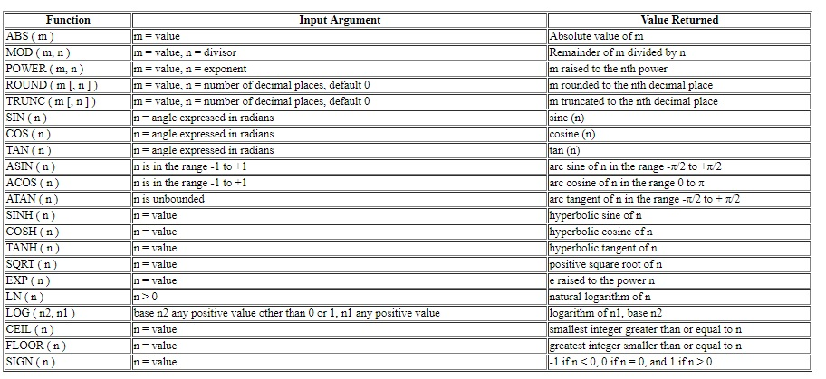
Single Row Functions:
Single row or Scalar functions return a value for every row that is processed .
There are four different types of single row functions-
1) Conversion Functions: These are functions that help us to convert a value in one form to another form. For Example: a null value into an actual value, or a value from one data type to another data type like NVL,TO_CHAR, TO_NUMBER, TO_DATE etc...
2) Character or Text Functions: These are functions that accept character input and can return both character and number values.
3) Numeric Functions: These are functions that accept numeric input and return numeric values.
4) Date Functions: These are functions that take values that are of data type DATE as input and return values of data type DATE, except for the MONTHS_BETWEEN function, which returns a number.
Numeric Functions
- Numeric functions are used to perform operations on numbers.
- They accept numeric values as input and return numeric values as output.
- Following are the few examples of Numeric functions available in Oracle.
Dual table
- This is a single row and single column dummy table provided by oracle.
- This is used to perform mathematical calculations without using a table.
- Oracle presents the output of every operations in a tabular format so that it seems to the user that the output comes from a table
Content of Dual Table Sample output using dual table
Selects * from DUAL; Selects 20*23 from DUAL;
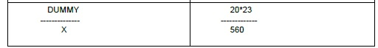
ABS and MOD Function
The ABS function returns the absolute value of the parameter passed.
Syntax : ABS(number)
Ex: SELECT ABS(-10) FROM dual;
Output : 10
The above query returns the absolute value of the given 'number'.
The MOD function returns the remainder value of the parameter passed.
Syntax : MOD(number1,number2)
Ex: SELECT MOD(10,4) FROM dual;
Output : 2
The above query returns the remainder when 10 is divided by 4.
POWER and SQRT Function:
POWER function returns the argument raised to the specified power.
Syntax : POWER(number1,number2)
Ex:
SELECT POWER(4,3) As Cube FROM dual;
Output :
Cube
64
The above query returns the output when 4 is raised to the power of 3. SQRT function returns the square root of a number passed as parameter.
Syntax: SQRT(number)
Ex:
SELECT SQRT(64) As “Square Root” FROM dual;
Output:
Square Root
8
The above query returns the square root value of 64.
FLOOR and CEIL Function
The FLOOR function returns the largest integer less than or equal to the value passed in parameter.
Syntax: FLOOR(decimal number)
Ex: SELECT FLOOR(7.14), FLOOR(7.84) FROM dual;
Output : 7 7
The above query returns the largest integer nearest to 7.14 & 7.84.
Ex: SELECT FLOOR(-7.14) FROM dual;
Output : -8
The above query returns the largest integer nearest to -7.14.
The CEIL function returns the smallest integer greater than or equal to the value mentioned in parameter.
Syntax: CEIL(decimal number)
Ex: SELECT CEIL(7.14), CEIL(7.84) FROM dual;
Output : 8 8
The above query returns the smallest integer nearest to 7.14 & 7.84.
Ex: SELECT CEIL(-7.14) FROM dual;
Output : -7
The above query returns the smallest integer nearest to -7.14.
TRUNC and ROUND Function
1) The TRUNC function truncates the value present in the column, expression up to decimal places mentioned in first parameter.
2) If the second argument is 0 or is missing, the value is truncated to zero decimal places.
Syntax: TRUNC(decimal number,number of places)
Ex:
SELECT TRUNC(137.5738,3) As Rounded FROM dual;
137.573
The above query returns the decimal number with three digits after the decimal point.
Ex:
SELECT TRUNC(137.5738,0) As Rounded FROM dual;
Output :
Rounded
137
The above query returns the integer value.
1) The ROUND function round off the value present in the column,expression up to decimal places mentioned in first parameter.
2) If the second argument is 0 or is missing, the value is rounded to zero decimal places.
Syntax: ROUND(decimal number,number of places)
Ex: SELECT ROUND(137.5738,3) As Rounded FROM dual;
Output :
Rounded
137.574
The above query returns the decimal number with three digits after the decimal point where 4th digit is rounded.
SQL> SELECT ROUND(137.5738,0) As Rounded FROM dual;
Output :
Rounded
138
The above query returns the integer value rounded to the next highest value. If the second argument is negative number, the value is rounded up specified decimal places to the left (rounded to the nearest unit of 10).
Ex: SELECT ROUND(137.5748,-1) As Rounded FROM dual;
Output :
Rounded
140
The above query returns the integer value which is the nearest tens value.
Ex: SELECT ROUND(137.5748,-2) As Rounded FROM DUAL;
100
The above query returns the integer value which is the nearest hundreds value.
Character Functions:
There are two types of character functions.Character to character functions accept string as input and will give string as output.
- INITCAP
- LOWER
- UPPER
- CONCAT
- LPAD,RPAD
- TRIM
- SUBSTR
- REPLACE
Character to number functions accept string as input and will give number as output.
- LENGTH
- INSTR
INITCAP: This function sets the first character in each word to upper case and the rest to lower case.
Syntax : INITCAP(expr1)
Ex: SELECT INITCAP(emp_name) FROM Employee:
Amit
Ajay
Sima
Dipa
Anuj
The above query returns all the employee names with the first letter in upper case and rest other characters in lower case.
LOWER: This function converts all letters in the specified string to lower case. If there are characters in the string that are not letters, they are unaffected by this function.
Syntax : LOWER(expr1)
Ex: SELECT LOWER (emp_name) FROM employee:
amit
ajay
sima
dipa
anuj
The above query returns all the characters of the employee name in lower case.UPPER:This function converts all letters in the specified string to uppercase. If there are characters in the string that are not letters, they are unaffected by this function.
Syntax : UPPER(expr1)
Ex: SELECT UPPER (emp_name) FROM Employee:
AMIT
AJAY
SIMA
DIPA
ANUJ
The above query returns all the characters of the employee name in upper case.
CONCAT: This function allows you to concatenate two strings together.
Syntax : CONCAT(expr1,expr2)
Ex: SELECT CONCAT(emp_name,dep_name) full_name FROM Employee;
The above query returns the emp_name & dep_name concatenated into a single string.
SUBSTR: Returns specified characters from a string, starting from specific position to required characters length.
Syntax : SUBSTR(col/expr,m,n)
If 'm' is positive,oracle counts from beginning of string, If it is negative Oracle counts from the end of string.
If 'n' is omitted, Oracle returns all characters to end of the string starting from m.
Ex: SELECT SUBSTR(emp_name,3,2) FROM Employee.
The above query starts searching from the third position of the employee name from the starting of the string and displays two characters from there.
Ex: SELECT SUBSTR('abcdefg'-4,2) FROM dual;
dc
The above query starts searching from the fourth position of the given string from the end of the string and display two characters from there.
REPLACE: It returns the every occurrence of search_string replaced by thereplacement_string.
If the replacement string is omitted or null all occurrences of search string will be removed.
Syntax : REPLACE(string,search_string,replace_string)
Ex: SELECT REPLACE(branch_name,'Mumbai','Kolkata') FROM Employee
WHERE dep_name = 'HR';
The above query replaces branch name to 'Kolkata' wherever 'Mumbai' is available for the HR department .
LPAD,RPAD:
LPAD pads the character value right justified to a total width of n character positions.
Syntax : LPAD(expr1,padded_length,padded_string)
RPAD pads the character value left justified to a total width of n character positions.
Syntax : RPAD(expr1,padded_length,padded_string)
The default padding character is space.
Ex: SELECT LPAD('jhon',8) FROM dual;
jhon
Since the third parameter is not specified in the result of the above query will be by default space padded for the previous four positions.
Ex2: SELECT LPAD('jhon',8 ,'x') FROM dual;
xxxxjhon
The above query fills the four blank spaces with 'x' left of the given string.
Ex3: SELECT RPAD('jhon',8 ,'x') FROM dual;
jhonxxxx
The above query fills the four blank spaces with 'x' right of the given string.
TRIM: It enables to trim leading or trailing characters or both from a string.
If we don’t specify anything, it will trim spaces.
Syntax : TRIM( [LEADING | TRAILING | BOTH] character FROM string)
LTRIM : Removes the leading characters
RTRIM : Removes the trailing characters
TRIM : Removes both
Ex: SELECT RTRIM('s' from 'ssmithss') FROM dual;
ssmith
The above query removes 'trailing' 's' from the given string.
Ex: SELECT LTRIM('s' from 'ssmithss') FROM dual;
mithss
The above query removes 'leading' 's' from the given string.
Ex: SELECT TRIM('s' from 'ssmiths') FROM dual;
mith
The above query removes 'trailing' & 'leading' 's' from the given string.
Ex: SELECT TRIM(' smith ') FROM dual;
smith
The above query removes 'trailing' & 'leading' spaces from the given string.
INSTR: This function returns the location of a sub string in a given string.
Syntax : INSTR( string, sub_string [, start_position [, nth_appearance ] ] ).
start_position and nth_appearance are optional. If not specified, always INSTR starts with first position and will give first appearance.
Ex: SELECT INSTR('internet','e') FROM dual;
4
The above query returns the first position of 'e' searched from the start of the given string.
Ex: SELECT INSTR('internet','e',1,2) FROM dual;
7
The above query returns the second position of 'e' searched from the start of the given string.
Ex: SELECT INSTR('internet','e',5,1) FROM dual;
3
The above query returns the first position of 'e' searched from the fifth position of the given string.
LENGTH: Returns number of characters in a value.
Syntax : LENGTH(column)
Ex: SELECT LENGTH(branch_name) FROM Employee;
The above query returns number characters in the branch_name field for each and every record.
Ex: SELECT LENGTH('jhon') FROM dual;
4
The above query returns the number of characters from the given string.
Date Functions: These are functions that take values that are of data type DATE as input and return values of data type DATE, except for the MONTHS_BETWEEN function, which returns a number.
The Oracle date function SYSDATE() returns the current date and time in the default Oracle date format.
The default format for the date returned is MM-DD-YY
It’s very common to use the Oracle date function SYSDATE() in conjunction with to_char().
For example,
to_char (SYSDATE, 'MM-DD-YYYY HH:MI:SS');
This Oracle date function returns a string containing not only the current date, but also the current time down to the second. The most common uses of SYSDATE()don’t use a date format model:
dStartDate := SYSDATE;
Other Oracle Date Functions:
1.months_between()
2.add_months()
3.last_day()
4.next_day()
Conversion Functions:
- NVL
- NVL2
- NULLIF
NVL: lets you replace null with a string in the results of a query .
Syntax : NVL( string1, replace_with).
If string1 is null, then NVL returns replace_with .
If string1 is not null, then NVL returns string1.
Ex: SELECT NVL(emp_name,'NA') FROM Employee;
The above query will display 'NA' wherever emp_name is null.
We can also replace with another column.
Ex: SELECT NVL(emp_name,dep_name) FROM Employee;
The emp_name and dep_name should belongs to same data type family.
The above query will display dep_name wherever emp_name is NULL.
Ex: SELECT NVL(salary,0) FROM Employee;
The above query returns 0 only if the salary is defined as NUMBER and is NULL.
NVL2: NVL2 function extends the functionality found in the NVL Function.
It lets you substitutes a value when a null value is encountered as well as when a non-null value is encountered.
Syntax : NVL2(string1,value_if_not_null,value_if_null)
if string1 is not null then NVL2 returns value_if_not_null.
if string1 is null then NVL2 returns value_if_null.
Ex: SELECT NVL2(emp_name,dep_name,'NOT AVAILABLE') FROM Employee;
NULLIF: NULLIF compares expr1 and expr2. If they are equal, then the function returns null. If they are not equal, then the function returns expr1 .
Syntax : NULLIF(expr1,expr2)
Ex: SELECT NULLIF( dep_name,'HR') FROM Employee;
The above query returns NULL if dep_name field consists of 'HR', otherwise it
returns job.You cannot specify the literal NULL for expr1.

Aggregate / Group Functions:
- Group Functions, as the name suggests, are functions that operate on groups(sets) of values and returns one result per group.
- Group function returns a single result row for every group of queried rows.
- Based on the query statement it may return single or multiple rows.
- The functions that are used as Aggregate Functions are:
- SUM
- AVG
- MAX
- MIN
- COUNT
Consider the following table: Employee
AVG: Returns an average value, ignoring null values.
Syntax:
AVG([DISTINCT] column_name)
Ex: SELECT AVG(salary) as “Average Salary” FROM Employee;
Output :
Average Salary
21500
The above query displays the average salary of all the employees in the table
Employee
MAX: Returns the maximum value, ignoring null values.
Syntax: MAX([DISTINCT] column_name)
Ex: SELECT MAX(salary) as “Maximum Salary” FROM Employee where
Dep_Name='HR';
Output :
Maximum Salary
16000
The above query displays the maximum salary of all the employees in HR
Department in the table Employee.
MIN: Returns the minimum value, ignoring null values.
Syntax:
MIN([DISTINCT] column_name)
Ex: SELECT MIN(salary) as “Minimum Salary” FROM Employee where
Dep_Name='HR';
Output :
Minimum Salary
10000
The above query displays the minimum salary of all the employees in HR
Department in the table Employee.
COUNT: Returns the count of not null values ignoring null values.
Syntax:
COUNT([DISTINCT] column_name)
Ex: SELECT COUNT(DISTINCT Dep_name) Departments FROM Employee;
3
The above query displays the count of different departments in the table Employee.
COUNT:(*) Count function with asterisk returns the count of total number of rows
including null values
Syntax:
COUNT(*)
Ex: SELECT COUNT(*) FROM Employee;
5
The above query displays the total number of rows in table Employee.
GROUP BY clause
Creates a data set, containing several sets of records grouped together based on
a condition.
Syntax:
SELECT [,], AGGREGATE FUNCTION() FROM Table_Name GROUP BY [,] ;
Ex: SELECT dep_name,COUNT(emp_id) "No of Employee" FROM Employee GROUP BY dep_name;
Output :
No of Employee
HR 2
Marketing 2
Admin 1
The above query displays the number of employee in each department.
WHERE clause
Used to apply a filter condition before the Grouping the rows.
Syntax:
SELECT [,], AGGREGATE FUNCTION() FROM Table_Name WHERE GROUP BY [,] ;
Ex: SELECT Dep_Name,COUNT(Salary) FROM Employee WHERE
Salary>15000 GROUP BY Dep_Name;
Output :
HR 1
Marketing 1
Admin 1
The above query displays department wise count of salary more than 15000.
HAVING clause
Used to apply a filter condition on Aggregated values.
Syntax:
SELECT [,], AGGREGATE FUNCTION() FROM Table_Name WHERE GROUP BY [,] HAVING ;
Ex: SELECT Dep_Name, SUM(Salary) FROM Employee WHERE Salary>12000
GROUP BY Dep_Name HAVING SUM(Salary)<30000;
Output :
HR 16000
Marketing 20000
The above query displays the departments for which total salary is less 30000
excluding the Admin department, total salary for which is 40000.

Introduction to Joins:
- A join is a query that combines rows from two or more tables based on a condition based on common column
- Join achieves the goal of creating a single SQL query that can fetch data from two or more tables.
- The SELECT statement can select any of the columns from any of the tables referred in from clause in Join query

Different types of SQL joins :
There are different types of joins:
- CROSS JOIN
- INNER JOIN
- EQUI JOIN
- NON EQUI JOIN
- OUTER JOIN
  - LEFT OUTER JOIN
  - RIGHT OUTER JOIN
  - FULL OUTER JOIN
- SELF JOIN
Guidelines:
When writing a SELECT statement that joins tables, if the same column name appears in more than one table, the column name must be prefixed with the table name/Alias name of the table. To join 'N' tables , a minimum of 'N-1' join conditions are required. Consider the below tables:
Consider the below three Tables to understand the joins working mechanism:

1.Cross Join:
The Cross join / Cartesian product is a join query , that does not contain a join condition. Oracle combines each row of one table with each and every row of the other.
Syntax:
SELECT * FROM tableA , tableB;
Ex:
SELECT * FROM Employee, Department;
The above query returns 35 records. Each row of of Employee table is linked with each and every row of Department table . So the 101 (Emp Id) record from Employee table appears 5 times ie once for each record of the Department table. So 101 is appearing in 5 rows in the resultant record set, as below – Some records from result set
2.Inner Join:
An inner is used when the join fields are guaranteed not to be NULL.
2.a) Equi Join : Comes under Inner join category
It is a join condition containing an equality operator ( = ) .
This join condition combines/fetch the data from the matched records of two tables (Tow copies of same table in case of self-join ) based on the common columns from the two tables ,on which the join condition is applied .
Syntax :
SELECT tableA.col1, tableA.col2, tableB.col1,..... FROM
tableA, tableB WHERE tableA.col1 = tableB.col1;
Ex: To get Department name for each Employee along with the Employee details
Select EMP_ID,EMP_NAME,EMP_SAL,EMP_LOC,EMP_MGR_ID,EMP_JOB, EMP_DEPT_ID,DEPT_NAME from Employee,Department where Employee.EMP_DEPT_ID=Department.DEPT_ID;
The above query return multiple records where each record contains the data from the matched records of Employee and Department tables , based on the join condition formed on common column between the two tables
i.e .. For each record of employee table, if there is a matched record in department table with reference to the department Id , then the Query will fetch some data from Employee and some data from department table
Output for the above Query:
In the above output EMP_ID,EMP_NAME,EMP_SAL,EMP_LOC, EMP_MGR_ID, EMP_JOB, EMP_DEPT_ID are fetched from employee table and DEPT_NAME from Department table i.e., the rows from both the tables where Department Id is matching.
Note:
Table Name is not mandatory to prefix before the Column in the Select Statement column list , if the column name is not same across two tables , from which the data is being fetched.
2.b) Non Equi Join:
It is a join condition that is executed when no column in one table is directly linked with a column in another table. The data in the tables are logically related through appropriate values.
Syntax :
SELECT tableA.col1, tableA.col2, tableB.col1,..... FROM
tableA, tableB WHERE tableA.col1 BETWEEN tableB.col2 AND tableB.col3;
Example:
select * from Employee ,Grade where Employee.Emp_sal between grade.LowSal and grade.HighSal;
The above query retrieves the employee details along with his salary grade
based on the join condition.
3.Outer Join:
Outer join extends the result of Equi join. Outer join returns all the rows from both the tables that satisfy the join condition and also the rows from one table which do not satisfy the join condition. The Outer join operator is ( + ) , which is used on one side of the join condition.
3.a) Left Outer Join:
It is a join which returns all the rows from the left hand side of the table specified at the join condition and only those rows from the other table which are matching with the join condition.
Syntax : SELECT tableA.col1,tableA.col2,tableB.col1,..... FROM tableA,tableB WHERE tableA.col1 = tableB.col1(+);
Example:
Retrieve all the employee details along with their department details.
If employees are already tagged then get the tagged department details along with the employee details , If not tagged to any department then get atleast the employee details
Query:
select EMP_ID,EMP_NAME,EMP_SAL,EMP_LOC,EMP_MGR_ID,EMP_JOB, EMP_DEPT_ID,DEPT_Name from Employee,Department where Employee.EMP_DEPT_ID=Department.DEPT_ID(+);
The above query displays all the records which are matching with the join condition from both the tables along with the rows from employee table which are not matched with department table.
Output from the above Query:
If we notice the above output, for the first 5 records, there is a match of Department Id between two tables. Therefore, the Query retrieves the data from the matched records from both the tables. However, in case of last two records from Employee table, there are no records in the department table having the same department id, so there is no match found in department table. Hence, only the data from Employee table is displayed.

3.b) Right Outer Join:
It is a join which returns all the rows from the right hand side of the table specified at the join condition and only those rows from the other table which are matching with the join condition.
Syntax : SELECT tableA.col1,tableA.col2,tableB.col1,..... FROM tableA,tableB WHERE tableA.col1(+) = tableB.col1;
Example: Fetch the department details for all the departments with the details of Employee, for all employees tagged to a department. If for any department, there is no employee, fetch the department details only.
Query:
select EMP_ID,EMP_NAME,EMP_SAL,EMP_LOC,EMP_MGR_ID,EMP_JOB, EMP_DEPT_ID, DEPT_Name from Employee,Department where Employee.EMP_DEPT_ID(+)=Department.DEPT_ID;
Output from the above Query:
If we notice the above output, for the first 5 records, there is a match of Department Id between two tables. Hence, the Query retrieves the data from the matched records from both the tables. However, for the last two records of Department table, there are no record in the Employee table having that department Id. Hence, only the data from Department table is displayed .
3.c) Full Outer Join:
It is a join which returns all the rows from both the tables which are placed on either side of the join condition.
Syntax : SELECT tableA.col1,tableA.col2,tableB.col1,..... FROM
tableA,tableB WHERE tableA.col1 = tableB.col1(+)
UNION
Syntax : SELECT tableA.col1,tableA.col2,tableB.col1,..... FROM
tableA,tableB WHERE tableA.col1(+) = tableB.col1;
Example:
Retrieve all the records from Employee and Department table in such a way that, if there is a match between the tables with reference to Department Id, then get the resulted record from two tables else fetch the employee data though they have not tagged and Department data though there is no single employee tagged for the department
Query for the above requirement:
The above query displays all the records, which fulfill the join
condition along with the rows from both employee and department tables which do not fulfill the join condition.
Output:
4.Self Join:
It is a join used to join a table to itself. Single table is logically considered as two tables and joined .
Syntax : SELECT A.* FROM tableA A,tableA B WHERE A.col1 = B.col1 AND condition;
Example:
GET the names of the Managers for each Employee from Employee table.
In the Employee table, Manager name is not available as a column in the table. However, every Manager is an Employee. For each row , the value for the attribute Emp_Mgr_Id is the value of the emp_Id of attribute the employee who is the manager for that employee.
To solve the query, we have to join the Employee table to itself and compare the Manager Id of each Employee with the Employee IDs of the other copy of the table and get the EmpName accordingly from the second copy of the table which is the manager Name
Query for the above Requirement:
SELECT A.EMP_ID,A.EMP_NAME,A.EMP_SAL,A.EMP_LOC,A.EMP_MGR_ID,B.Emp_Name Manager_Name from Employee A,Employee B where A.EMP_MGR_ID=B.EMP_ID;
Output:
The above query is going to display the details of Manager for each Employee

Introduction to Subqueries
- A sub query is a query within a query. The outer query is the main query and the inner query is called sub query.
- The sub queries can reside in the WHERE, FROM or SELECT clause.
- A sub query in the WHERE clause of a SELECT statement is called NESTED sub query.
- A sub query in the FROM clause of a SELECT statement is called INLINE VIEW.
- For a sub query used in WHERE clause, only up to 255 levels of sub queries can be written.
- In Sub Queries, the inner query is executed and based on the result of inner query, the records from the outer query is fetched.
Guidelines For Sub queries :
While defining sub queries , certain guidelines need to be followed.
- A sub query must be enclosed within parenthesis.
- A sub query must appear on the right hand side of the operator.
- A sub query must not contain an ORDER BY clause.
Sub query types
Sub queries can be classified into below types based upon the logic used.
- Single row sub query
- Multi row sub query
- Multi column sub query
- Co-related sub query
General Syntax:
SELECT select_list FROM table_name WHERE col1 WHERE operator
(SELECT select_list FROM table_name);
Consider the below tables

Example: Get the details of all the employees who are working in the department of Raghava
To implement the above requirement, First we would require to get the department Id of Raghava using Inner Query, Then the department Id of Raghava will be compared with the department id of each and every record of the Outer query.
1. Single row sub query:
Single row sub queries returns only one row from the Inner SELECT statement.
The operators that can be used :
= != < <= > >=
Example 1: Display all employees who is working in the same department, where RAJU is working
Query:
SELECT * FROM employee WHERE did =
(SELECT did FROM employee WHERE name='RAJU');

Output Analysis: The above query returns employee details, who are working along with RAJU in the same department.
Example2: Fetch the details of Employees whose salary is more than the Salary of Raju
Query: SELECT * FROM employee WHERE salary >
(SELECT salary FROM employee WHERE name='RAJU');
Query Output:

Output Analysis: The above query returns the employee details , who are earning more than RAJU.
2. Group functions in sub query:
Group functions can be used in the inner query and in turn the result is sent to the outer query to display the matching records from the table referred by outer query.
When performing this logic GROUP BY clause should not be available in the inner query.
Example: Fetch the details of employees who gets highest salary.
Query:
SELECT * FROM employee WHERE salary = (SELECT MAX(salary) FROM employee);
Output:

The above query displays the maximum salaried employee details.
Sub query with HAVING clause:
We can use HAVING clause in a Sub query. The inner query is executed first and the results are returned into the HAVING clause of the outer query. When performing this logic, the outer queries HAVING clause contains GROUP functions.
Example: Fetch department wise minimum salary for all the departments which has the minimum salary higher than the minimum salary of employees of the Department with department number 103.
Query:
SELECT did,MIN(salary) FROM employee GROUP BY did HAVING MIN(salary) >
(SELECT MIN(salary) FROM employee WHERE did=103);
Output:

The above query displays the details of those department numbers whose minimum salary is more than the minimum salaried employee who is belonging to the department number 103.
Usage of joins:
Example:
Query:
SELECT e.* FROM employee e,grade g WHERE did = (SELECT did FROM employee WHERE name='SANTOSH') AND g.grade='B' AND e.salary BETWEEN g.losal AND g.hisal;

The above Query displays the details of those employees who belongs to the department SANTOSH belongs to and are falling in the salary range of grade 'B'.
3. Multi row sub query:
Multi row sub queries are the queries which returns more than one row from the Inner SELECT statement. The operators that can be used : IN, ANY and ALL
a. Usage of IN operator
IN → Matches with each and every values returned by the inner query.
Example1:
Query :
SELECT * FROM employee WHERE designation IN (SELECT designation from employee e,department d WHERE e.did=d.did AND d.deptname='PRODUCTION');

The inner query will return the different designated employee details who are working in the PRODUCTION department. Since the inner query is returning more than one record, IN operator is used to link between outer and inner query.Finally the outer query will retrieve all the records whose designations are matching with the designations of PRODUCTION department.
Example2:
SELECT * FROM employee WHERE salary IN (SELECT MAX(salary) FROM employee GROUP BY designation);
Output:

The above query displays the records of all the employees who are earning maximum salary for each designation group.
b. Usage of ANY operator
ANY → Compares values to each value returned by the sub query.
>ANY → More than the minimum value in the list
Example:
SELECT * FROM employee WHERE salary >ANY (SELECT salary FROM employee WHERE did=102) AND did!=102;
Output:

The above query displays the details of those employees who are earning more
than the minimum salaried employee belonging to department number 102.
c. Usage of ALL operator
- ALL → Compares values to every value returned by the sub query.
- < ALL → Less than the minimum value in the list
- > ALL → More than the maximum value in the list
Example:
SELECT * FROM employee WHERE salary >ALL (SELECT salary FROM employee WHERE designation='SENIOR PROGRAMMER');
Output :

The above query displays the details of those employees who are earning more than the maximum salaried employee, who is a SENIOR PROGRAMMER.

Example2:
SELECT * FROM employee WHERE salary (SELECT salary FROM employee WHERE designation='SENIOR
PROGRAMMER');
Output:

The above query displays the details of those employees who are earning less than the minimum salaried employee, who is a SENIO PROGRAMMER.
Multi column sub query
Multi column sub queries are the sub queries which returns more than one column from the Inner SELECT statement.
Example:
SELECT * FROM employee WHERE (did,salary) IN (SELECT did,salary FROM employee WHERE designation='EXECUTIVE') AND designation!='EXECUTIVE;
The above query displays the details of those employees who belong to the same department and earning the same salary as of the EXECUTIVE designated employees.
The same logic can even be written in the below format:
SELECT * FROM employee WHERE did IN (SELECT did FROM employee WHERE designation='EXECUTIVE') AND salary IN (SELECT salary FROM employee WHERE designation='EXECUTIVE')
AND designation!='EXECUTIVE;
Co-related sub query
It is another way of performing queries upon the data with a simulation of joins. Inthis the information from the Outer SELECT statement participate as a condition in the Inner SELECT statement.
Syntax:
SELECT select_list FROM table_name alias1 WHERE operator
(SELECT column FROM table_name alias2 WHERE alias1.column=alias2.column);
Example:
SELECT * FROM employee e1 WHERE salary = (SELECT MIN(salary) FROM employee e2 WHERE e1.designation=e2.designation);
The above query displays the records of all the employees who are earning minimum salary for each designation group.
Order of Precedence
- First the Outer query is executed.
- Passes the executed column value to the Inner queries WHERE clause.
- Now the Inner query is executed.
- The result of the Inner query is passed to the Outer queries WHERE clause.
- Depending on the provided value the condition is qualified for the specific record.
- If successful displays the output.

Sub queries in DML statements
Sub queries can be used in DML statements UPDATE & DELETE.
Example1:
Query:
UPDATE employee SET did=(SELECT did FROM employee WHERE did='PURCHASE') WHERE did=(SELECT did FROM employee WHERE did='SALES');
The above queries updates the department numbers of those employees who
are belonging to SALES department to PURCHASE department.
Example2:
DELETE FROM employee WHERE salary > (SELECT AVG(salary) FROM employee);
The above query deletes all the records from the employee table whose salary is more than the average salary of all the employees in the organization.

Sub queries with CREATE & INSERT statements
Sub queries can be used with CREATE statement as well.
Syntax:
CREATE TABLE table_name2 AS SELECT * FROM table_name1;
Example:
CREATE TABLE employee_bkp AS SELECT name,designation FROM employee WHERE 1=2;
The above query creates an empty backup table to store only name and designations.
Sub queries can also be used with INSERT statement .
Syntax:
INSERT INTO table_name2 SELECT * FROM table_name1;
Example:
INSERT INTO employee_bkp SELECT name,designation FROM employee WHERE did IN (101,103);

Database Objects:
In a relational database, a database object is a data structure used to either store or reference data. Table and constraints are the most common object used .Other objects are views, indexes, sequences, synonyms, stored procedures and functions, triggers and many others are there.
Oracle has the object types or schema already defined. We can create an instances of them using create command. These instances are objects.

View:
A view is a virtual table created by taking a subset of columns from one or more tables. A view is a logical table, as view does not contain data itself. The tables using which we create a view are called base tables. An output of query can be stored as a view.
Using views, we can hide information and provide security to the database.
Types of Views:
Views are of two types.
- Simple views
- Complex views.
Simple views:
- Views defined on single table.
- Can perform DML operations directly against simple views.
- Data on view’s base table are changed due to the DML operations performed on the view.
Syntax:
CREATE view
Example:
To create a view on employee table .
CREATE VIEW v_emp AS SELECT * FROM employee;
CREATE VIEW v_dept AS SELECT ename, sal*12 annual_sal FROM employee WHERE dep_name= 'HR';
Complex views:
Complex views are constructed on more than one base tables.
Complex views can contain:
- join conditions
- group by clause
- order by clause
Cannot perform DML operations against complex views directly.
We have to use instead of triggers for DML operations.
Example:
Employee table and Department table has the following structures:
Department (deptno,dname,location);
- where deptno is primary key.
Employee (empno,ename,job,deptno);
- where empno is the primary key and deptno is the foreign key.
To create a view by selecting the empno,ename and job from employee table and deptno, dname and location from department table.
CREATE VIEW v_complex1 AS SELECT emp.empno, emp.ename, emp.job, emp.deptno, dept.dname, dept.loc FROM employee, department WHERE emp.deptno=dept.deptno;
Additional View Types:
Read-only views:
Users can only use SELECT and DESCRIBE statements against these views.
DML operations are not allowed .
Syntax:
CREATE VIEW SELECT statement WITH READ ONLY;
Example:
CREATE VIEW v_clerk AS SELECT empno, ename, deptno, job FROM employee WHERE job = 'CLERK'
WITH READ ONLY;
With CHECK Option:
View created WITH CHECK OPTION clause specifies the level of checking to be done when doing DML against the view. View with check option ensure the view’s consistency.
Syntax:
CREATE VIEW SELECT colums [WHERE condition] WITH CHECK OPTION;
Example :
Structure of the employee table is as follows:
Employee (eno,ename,salary,deptno);
Following statements creates a view emp_view on employee table by selecting ename,salary ,deptno from employee table for the records with deptno value 20.
CREATE VIEW emp_view AS SELECT ename, salary, deptno FROM employee WHERE deptno = 20;
Now if we use the following UPDATE statement on this view,
UPDATE emp_view SET deptno = 10;
We will be able to update deptno value for the records in the view to 10 contradicting the view definition.
We can avoid this type of situations, by creating view with check option.
CREATE VIEW emp_view AS SELECT ename, sal, deptno FROM emp2 WHERE deptno = 20
WITH CHECK OPTION;
Now, an UPDATE operation on the view with throw error.
UPDATE emp_view SET deptno = 10;
ORA-01402: view WITH CHECK OPTION where-clause violation
Force view:
Force view is the view created without having the base table.
FORCE keyword is used to create a force view.
Syntax :
CREATE FORCE VIEW SELECT colums [ WHERE condition];
Example:
The following view will be created even employee table not exists in our schema.
CREATE FORCE VIEW v_force_view AS SELECT name ,job , deptno FROM employee
GROUP BY deptno;
In the above case, the view v_force_view will be created even employee table does not exist in schema.
Drop View:
Syntax:
DROP VIEW view_name;
Example:
DROP view emp_view;
Update View:
We can modify the definition of an Oracle VIEW without dropping it by using the Oracle CREATE OR REPLACE VIEW Statement.
Syntax :
CREATE OR REPLACE VIEW SELECT columns FROM table WHERE conditions;
Sequence:
A sequence is an object. It is used to auto generate a number sequence. We can use a sequence to create a unique number to act as a primary key.
Syntax:
CREATE SEQUENCE
[ INCREMENT BY
START WITH
MAXVALUE
MINVALUE
CYCLE / NOCYCLE
CACHE
ORDER / NOORDER ];
INCREMENT BY -- Interval between sequence numbers. Can be positive or negative but not zero and default is 1.
MINVALUE -- Specifies Sequence minimum value. This must be less than MAXVALUE.
NOMINVALUE -- Specifies a minimum value of 1 for an ascending sequence or (-10)^26 for a descending sequence.
MAXVALUE -- Specifies maximum value that a sequence can generate.
NOMAXVALUE -- Specifies a maximum of (10^27) for an ascending sequence or -1 for a descending sequence
START WITH -- Specifies first sequence number to be generated.
Sequence minimum value(1) is the default value for ascending sequence where for a descending sequence is the maximum sequence value.
CYCLE – Sequence continues to generate repeated values after reaching its maximum value
NOCYCLE --Cannot generate more values after reaching the maximum value.
CACHE -- Specifies how many values of a sequence Oracle pre-allocates and keeps in memory for faster access. The minimum value for this parameter is two. Specifying CACHE helps to improve performance. If the server restarts, values from the cache memory will be lost. This may lead to have gaps in the sequence values.
NOCACHE -- Values of a sequence are not pre-allocated and hit the database for every next value of sequence.
ORDER -- Guarantees that sequence numbers are generate in the order of request
NOORDER --Does not guarantee the order
Examples:
CREATE SEQUENCE test_seq START WITH 1 INCREMENT BY 1;
CREATE SEQUENCE customers_seq
MINVALUE 1
MAXVALUE 9999999
START WITH 1
INCREMENT BY 1
CYCLE
CACHE 20;
Using Sequence:
Referencing a Sequence in Select statement
SELECT sequence_name
SELECT sequence_name
In a session, sequence_name.nextval needs to be executed first to initialize the sequence for that session.
Syntax To Insert Values in Table Using sequence:
INSERT into table_name(column1,column2,column3) values(
Example:
Using the sequence test_seq created above ,INSERT value in employee table.
INSERT INTO Employee (ID,NAME,Age) values(test_seq.nextval,’Tapan’,23);
Here, the first reference to test_seq.nextval returns 1. The second reference returns 2 . Each subsequent references will return a value 1 greater than the previous reference.
Altering Sequence
- With alter statement we can change the sequence parameters.
- The modifications will be applied only while generating new numbers.
- The old series of numbers will remain same.
If we want to start the sequence with new value, we have to drop the old sequence and have to recreate a new sequence with new start value.
To alter the customers_seq created above.
ALTER SEQUENCE customers_seq Maxvalue 1500;
ALTER SEQUENCE customers_seq INCREMENT BY 10;
ALTER SEQUENCE customers_seq CACHE 5;
Dropping Sequence:
The syntax to a drop a sequence in is:
DROP SEQUENCE sequence_name;
Example:
DROP SEQUENCE customers_seq;

Database Objects:
Index:
An Index is a database object. We create index to optimize the query performance and to get the sql results in lesser time.
If we create an index on a column, each value of the column along with row id will be stored as separate database object.
When we fire a query to fetch the data using this column in where clause, then the oracle engine will scan the index instead of entire table and will get the other column values using row id.
Row id is a Pseudox column used by Oracle to locate a row in database.
Types Of Index:
- Normal indexes: the default index type
- Bitmap indexes: store row ids associated with a key value as a bitmap
- Partitioned indexes: consist of partitions containing an entry for each value that appears in the indexed column(s) of the table.
- Function-based indexes: based on expressions. They enable to construct queries that evaluate the value returned by an expression, which in turn may include built-in or user-defined functions.
- Domain indexes: instances of an application-specific index of type indextype
Index Creation:
Syntax:
CREATE [UNIQUE] INDEX index_name ON table_name (column1, column2, ... column_n);
UNIQUE keyword is optional and it indicates that the combination of values in the indexed columns must be unique.
Example:
CREATE INDEX products_idx ON products (product_name);
In this example, we have created an index on the products table called products_idx. It consists of only one field - the product_name field.
We could also create an index with more than one field as in the example below:
CREATE INDEX products_idx ON products (product_name, city);
Syntax To create Bitmap index :
CREATE BITMAP INDEX
If we need to create an index on a column having less number of distinct values, then we should create bitmap index.
Syntax To create function-based index :
CREATE INDEX product_idx ON products(UPPER(product_name));
Advantages Of Indexes:
Indexes improve the query performance by avoiding the full table scans.
Indexes are very useful with the tables having large amounts of data.
Disadvantages Of Indexes:
Index is separate database object. For inserting new data or updating data in a table, the changes needs to be reflected in the table as well as in the index object. Hence, the cost of DML operations increases.
If we issue one insert statement on base table, oracle fires another insert statement internally to insert the data into index.
Renaming Index:
Syntax :
ALTER INDEX index_name RENAME TO new_index_name;
Dropping Index:
Syntax:
DROP INDEX index_name;
Note: If the base table is dropped, all the indexes defined on the table will be dropped.
Synonym:
- Synonym is another name for an object like table, view, sequence, procedure, stored function, package, materialized view etc.
- We can simplify access to objects by creating a synonym .
- We can provide both data independence and location transparency by creating Synonym for objects
- With synonyms, we can:
–Create an easier reference to a table that is owned by another user
–Shorten lengthy object names
Syntax To Create Synonym:
CREATE [PUBLIC] SYNONYM synonym_name FOR object;
Example:
CREATE PUBLIC SYNONYM emp_syn FOR employees;
Syntax to Drop Synonym:
DROP [PUBLIC] SYNONYM synonym_name;
Example:
DROP PUBLIC SYNONYM emp_syn;

