Operating Systems
The structure of a Computer system can be visualized as having four basic components:
1. Hardware – Provides basic computing resources - CPU, memory, I/O devices
2. Operating system – Controls and coordinates use of hardware among various applications and users
3. Application programs – Define the ways in which the system resources are used to solve the computing problems of the users
4. Users – Anybody who desires work to be done by a computer system. People, machines, other computers
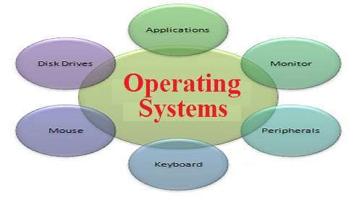

Types of OS
OS are classified into following different types depending on their capability of processing.
Single User and Single Tasking OS:
These are simple operating system designed to manage one task at a time ,for use by a single user for a standalone single computer for performing a single task .
Single User and Multitasking OS:
These OS allow execution of more than one task or process concurrently by dividing the processor time amongst different tasks.
Multi-programming OS:
These OS allow more than one programs to run at the same time .
Real Time OS:
These are designed to respond to an event within a predetermined time. These operating systems are used to control processes
Embedded OS:
Embedded in a device in the ROM. They are specific to a device and are less resource intensive.
Function Of OS
The OS performs basic tasks such as controlling and allocating memory, prioritizing system requests, controlling input and output devices, facilitating networking, and managing files
Introduction to UNIX OS
- Unix is an OS for Programmers as shell(the command interpreter)provides the programming facility.
- It provides an in-built security mechanism through the user name and password, combined with the access rights associated with files
- Developed by Ken Thompson and Ritchie originally in assembly, and later in C, thus making it portable to other machines
Supports C, Fortran, Basic, Pascal, COBOL, Lisp, Prolog, Java, Ada compilers
Features of Unix Operating System
• Multi-user and Multitasking
• Everything is a file
• Configuration data stored in text
• Small, single purpose programs
• Ability to chain programs together to perform complex task
• Facility of background processing
Architecture of the UNIX System
The UNIX operating system has a layered architecture having three main components
• Kernel
• Shell
• Utilities

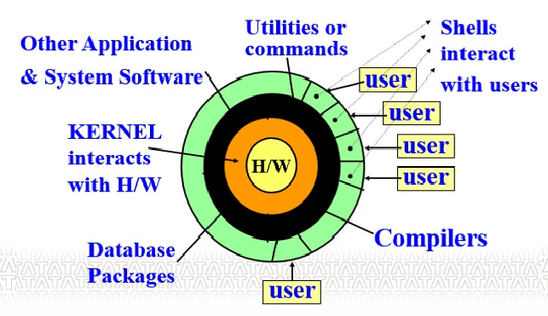

The Unix Kernel

Kernel is a collection of programs mostly written in C which allocate the system resources and coordinate all the details of the computer's internals.
Functions of Kernel:
- It allocates time and memory to programs and handles the file store and communications
- Interacts directly with the hardware through device drivers
- Provides sets of services to programs
- Manages memory, controls access, maintains file system, handles interrupts, allocates resources of the computer
System calls
The system calls are functions used in the kernel itself. UNIX system calls are used to manage the file system, control processes, and to provide interpocess communication.
System calls can be categorized as:
- File structure related calls -For example create, open,read, write,lseek,dup etc.
- Process Related calls -For example fork,exec,wait,exit etc
- Inter process related calls - For example pipe,msgget,msgsnd etc.

The Unix File System:
Unix File System is a hierarchical collection of 3 types of files:
- Ordinary Files
- Directory Files
- Special Files (device, pipe, fifo, socket).
Characteristics of Unix Files:
- UNIX file is featureless because it is simply an array of bytes.
- Dominant file type in UNIX is the text file.
- System related files are also stored in text form.
- Separate device can be added by creating a file for it.
- Root is the supremo and is represented by the ‘/’. Every sub-directory must have a parent.
- File names can be up to 14 characters long, can contain both upper and lower case alphabets, digits, a dot, hyphen (-), underscore (_) anywhere but should not have a blank or tab.
- Files are accessed using path names. Path names are a sequence of directory names separated by ‘/’.
There are two types of path names in unix.
- Absolute path name - file location is determined with respect to the root.
- Relative path name - file location is determined with respect to the current directory.
Structure of Unix File System:
The Unix File System (UFS) looks hierarchical but it is actually a directed a-cyclic graph because files can be shared.
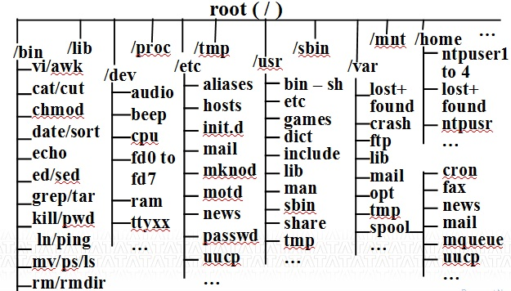
Following are some directories available under root in UFS.
/home – It holds user’s home directories. In other UNIX systems, this can be /usr directory.

/bin – It holds many of the basic Linux programs; bin stands for binaries, files that are executable.

/usr – It holds many user-oriented directories:

/sbin – It holds system files that are usually run automatically.

/etc – It and its subdirectories hold many of Linux config files.

/dev – It holds device files. All info sent to /dev/null is thrown into trash. Your terminal is one of the /dev/tty files.
Unix file System Organization:
- Unix divides physical disks into logical disks called partition which is comprising of a set of consecutive cylinders.
- The UFS resides on a single partition.
- Each file system contains four blocks :
a) boot block : This block is located in the first few sectors of a file system. It contains the initial bootstrap program used to load the operating system.Typically, the first sector contains a bootstrap program that reads in a larger bootstrap program from the next few sectors, and so forth.
b) super block : This block describes the state of the file system such as the total size of the partition, the block size, pointers to a list of free blocks, the inode number of the root directory, magic number or file signature (the first few bytes of a file which are unique to a particular file type), etc.
c) inode list : A linear array of inodes (index nodes). This is a data structure which describes the attributes of a file. There is a one to one mapping of files to inodes and vice versa. An inode is identified by it's "inode number". Users uses file names to refer to a file but Unix represent files in terms of inodes.
d) data blocks : blocks containing the actual contents of files
Internal File Maintenance:
For each file created in the system, an inode is also created. Inode is a disk file record of 64 bytes that maintains the permanent attributes of a file.
An inode is permanent and it exists until the corresponding file is removed from the system.
Sample details of an inode –
- Owner and group identifiers
- File type and file size
- Number of links for this file
- Times of file creation, last file access and modification, and last inode modification
- List of access rights – read/write/execute permissions
- Reference count showing number of times file is opened
- Physical address of file on the disk: array of 13 pointers for data storage
Whenever a file is opened, its inode is brought into main memory. The active inode is kept there until the file is closed and is used to locate the beginning of an open file on disk and to verify that every I/O request comes from a valid user as per specified access permissions.
