

L. D. College of Engineering

A Report on

SEPSIS ANALYSIS AND PREDICTION

Under subject of Project-1

B. E. IV Semester VII Computer Engineering

Submitted By:

|  |  |  |
| --- | --- | --- |
| Sr No. | Enrolment Number | Name |
| 1 | 160280107097 | Adarsh Shah |
| 2 | 160280107105 | Rushi Shah |
| 3 | 160280107033 | Jay Khatri |

Prof. Zishan Noorani Faculty Guide

Dr.S.M. Shah (Head of Department)

Academic Year 2017 - 18

## CERTIFICATE



Computer Engineering 2019-2020

##### Date:

This is to certify that the final year project entitled “**SEPSIS ANALYSIS & PREDICTION”** has been carried out by Mr. Adarsh Shah (160280107097), Mr. Rushi Shah (160280107105) and Mr. Jay Khatri (160280107033) under my guidance in fulfillment of the Degree of Bachelor of Engineering in Computer Engineering - 8th. Semester of Gujarat Technological University, Ahmedabad during the academic year 2018- 2019.

**Name of Guide Head of Department**

**Mr. Zishan Noorani** Assistant Professor Computer Engineering

**Dr. S.M. Shah** Associate Professor Computer Engineering

**CANDIDATE’S DECLARATION**

We have finished our project report entitled “**SEPSIS ANALYSIS & PREDICTION”** and submitted to our respected guides. We are in 7th semester and we have tried our best. We have done our work honestly and in a good way.

First candidate’s name : **ADARSH SHAH**

Branch : **CE**

Enrollment No. : **160280107097**

Second candidate’s name : **RUSHI SHAH**

Branch : **CE**

Enrollment No. : **160280107105**

Third candidate’s name : **Jay Khatri**

Branch : **CE**

Enrollment No. : **160280107033**

Submitted to:

### L.D. COLLEGE OF ENGINEERING, AHMEDABAD

Affiliated by:

### GUJARAT TECHNOLOGICAL UNIVERSITY

ACKNOWLEDGEMENTS

We wish to express our heartfelt appreciation to all those who have contributed to this project, both explicitly and implicitly, without the co-operation of whom, it would not have been possible to complete this project.

We would like to thank our guide Prof. Zishan Noorani for constantly guiding and showing us the correct path to reach towards our desired goal. Also we thank them for sharing their experience, knowledge and valuable time with me and showing their concern in our project to make it better.

We would like to extend our gratitude to Dr. S.M. Shah, Head of Computer Engineering Department, L.D. College of Engineering, Ahmedabad, for his continuous encouragement and motivation

We would also like to thank all the other faculties who directly or indirectly supported us in making our project successful by sharing their ideas and knowledge.

At last, we would like to thank our parents, friends and seniors who have directly or indirectly helped us in making our project work successful.

NAME:

Adarsh Shah (160280107097) Rushi Shah (160280107105)

Jay Khatri (160280107033)

**ABSTRACT**

***“DSP(Deep Sepsis Predictor)”*** is a unique sepsis prediction mechanism that uses Deep Neural Network in order to predict  whether the patient has sepsis infection or not. DSP is built using the Keras framework written in python language. Sepsis is a severe disease which occurs when chemicals released in the bloodstream to fight an infection trigger inflammation throughout the whole body. This can cause many changes that damage multiple organ systems, leading them to fail, sometimes even resulting in death. Symptoms include fever, difficulty breathing, low blood pressure, fast heart rate and mental confusion. DSP is constructed using two tier architecture, one makes up the model which does the prediction and the other layer consists of Web Portal which makes the user interface easier.  Our model uses 96 parameters for its input and all of the variables can be obtained from the patient's ICU data. Our model shows a precision score of 95.83. In order to train our model we have used Mimic-III dataset which we have obtained from MIMIC-III Clinical Database v1.4. MIMIC-III is a restricted-access database comprising of de identified health-related data associated with over forty thousand patients who stayed in critical care units of the Beth Israel Deaconess Medical Center between 2001 and 2012. Hence we have used state of the art data in order to produce such accurate results.

Index

|  |  |  |
| --- | --- | --- |
| Number | Title | Page Number |
|  |  |  |
|  | Title Page |  |
|  | GTU Completion Certificates |  |
|  | Declaration |  |
|  | Acknowledgements |  |
|  | Abstract |  |
|  | List of Figures |  |
|  | List of Tables |  |
|  |  |  |
| 1 | Project Details | 1 |
| 1.1 | Definition | 1 |
| 1.2 | Basic Objective | 1 |
| 1.3 | Working Principle | 1 |
|  |  |  |
| 2 | Introduction | 2 |
| 2.1 | Background Details | 2 |
| 2.2 | Overall Description | 2 |
| 2.3 | Tools and Technology | 2 |
| 2.4 | Environmental Characteristics | 2 |
| 2.5 | Literature Review | 3 |
|  |  |  |
| 3 | Requirement Analysis | 5 |
| 3.1 | Functional Requirements | 5 |
| 3.2 | Non-Functional Requirements | 5 |
| 3.3 | Behavioural Description | 6 |
|  |  |  |
| 4 | Scheduling | 7 |
|  |  |  |
| 5 | Data Flow Diagrams | 8 |
|  |  |  |
| 6 | ER Diagram | 10 |
|  |  |  |
| 7 | Steps to deploy the project | 11 |
|  |  |  |
| 8 | UML Diagrams | 12 |
| 8.1 | Use Case Diagram | 12 |
| 8.2 | Class Diagram | 14 |
| 8.3 | Activity Diagram | 16 |
|  |  |  |
| 9 | User Interface Design | 18 |
| 9.1 | Use Case Diagram | 18 |

|  |  |  |
| --- | --- | --- |
| 9.2 | Data Dictionary | 19 |
| 9.3 | Interface Description | 20 |
|  |  |  |
| 10 | Conclusion | 21 |
|  |  |  |
| 11 | References | 22 |
|  |  |  |
|  | Appendix | 23 |
|  | Design Engineering Canvas | 23 |
|  | Periodic Progress Reports | 27 |
|  | Patent Search and Analysis Reports | 35 |
|  |  |  |
| 12 | Plagiarism Certification | 55 |

List of Figures

|  |  |  |
| --- | --- | --- |
| Number | Title | Page Number |
|  |  |  |
| 4.1 | Iterative model | 7 |
| 5.1 | Data Flow Diagram Level 0 | 8 |
| 5.2 | Data Flow Diagram | 9 |
| 6.1 | ER Diagram | 10 |
| 8.1.1 | Use Case Diagram (BMI) | 12 |
| 8.1.2 | Use Case Diagram (Blood Connect) | 12 |
| 8.1.3 | Use case Diagram (Doctor) | 13 |
| 8.1.4 | Use case Diagram (Disease) | 13 |
| 8.2.1 | Class Diagram (BMI) | 14 |
| 8.2.2 | Class Diagram( Blood Connect) | 14 |
| 8.2.3 | Class Diagram (Doctor) | 15 |
| 8.2.4 | Class Diagram (Disease) | 15 |
| 8.3.1 | Activity Diagram (BMI) | 16 |
| 8.3.2 | Activity Diagram (Blood Connect) | 16 |
| 8.3.3 | Activity Diagram (Doctor) | 17 |
| 8.3.4 | Activity Diagram (Disease) | 17 |
| 9.1 | User Interface Diagram | 18 |
| A.1 | AEIOU Summary | 23 |
| A.2 | Empathy Map | 24 |
| A.3 | Ideation Canvas | 25 |
| A.4 | Product Development Canvas | 26 |

List of Tables

|  |  |  |
| --- | --- | --- |
| Number | Title | Page Number |
|  |  |  |
| 9.2.1 | Login/signup Table | 19 |
| 9.2.2 | BMI Table | 19 |
| 9.2.3 | Blood Donation & Receiver Table | 19 |
| 9.2.4 | Find me a Doctor Table | 19 |
| 9.2.5 | Disease Prediction Table | 20 |

# Project Details

#### Definition

The core aim of Sepsis Analysis and Prediction is to cure patients by early sepsis prediction through the use of our trained neural network model. It has been suggested by many doctors that the main reason why so many patients die due to sepsis infection is because the disease is discovered in the body when it has reached a severe stage. Hence in order to discover the disease in an early stage we have constructed a network that uses statistical reasoning and deep networks for predicting the sepsis positive patients. In order to achieve our goal we have created a dense neural network containing 45,561 trainable parameters in a total of 6 layers. Also the accuracy of the model significantly increases as the time of sepsis infection passes, but we are trying to give accurate results from the beginning.

#### Basic Objective

Sepsis is a life threatening disease and every year 1 million cases are registered only in India regarding Sepsis infection. Hence the main objective of our final year project is to try to decrease the number of cases by discovering most of the cases in early stages so that they can be cured with ease. In order to accomplish the task, we have constructed a Neural Network using data obtained from the MIMIC-III dataset available online. We have also provided an online user interface to freely interact with our model. Mimic-III database is a very powerful and diverse database which is available online. It is a trusted database  and contains data of over forty thousand patients. Also our model takes 96 different medical data variables from patients out of which all of them come from patient’s ICU information. After processing the data, our model suggests the patient using past information and Artificial Intelligence whether the patient has Sepsis Infection or not. The patient can check the result directly on the website.

#### Working Principle

We have created the model using keras framework on the structure of tensorflow library. Keras is a multipurpose framework which is very robust in creating various types of neural networks.In order to efficiently train and validate the data , we have divided the data set in two parts , one for training which constitutes the training phase and test data on which we have validated our model.

In order to obtain the required variables for the training of our model we have used the PostGres Sql queries to efficiently dig the data that is related to the Sepsis disease. We have created a complex query to obtain the 96 variables needed for the training model. We decided the required variables by suggesting doctors and doing more research on the disease.

We have trained our model at 50 epochs, 60 epochs, and 40 epochs. By Try and Error, we found the best result at 50 epochs, hence we have used the model trained at 50 epochs. Also, we have used 45561 total parameters out of which all are trained in the training phase. This has helped the model to become acquainted with the data of the patient very well and hence gives almost accurate results. The output of the model is quite simple, it gives 0 if the patient is diagnosed negative with sepsis else 1. The output is then sent to the website and displayed to the user whose data has been submitted.

# Introduction

#### Background Details

Sepsis is a life threatening situation in which the inflammation occurs in the body causes a series of changes which severely damage the bloodstreams and internal organs as a result of which the patient likely dies. The Sepsis disease has a total of three differentiated stages: 1)Sepsis 2)Severe Sepsis 3)Septic Shock. The likelihood of patient’s survivability decreases gradually in severe sepsis and the chances of death are very low in the first stage of sepsis while the condition becomes life threatening in the third stage of sepsis, septic shock. In the advent of the Big Data Age, many people have tried to automate the discovery of sepsis in the patient using different approaches  like K-Nearest Neighbour Algorithm, Logistic Regression and so on. We have tried a different approach to tackle the disease. We have tried to give results using Neural Networks. Neural Networks are computer Systems inspired by our own brain and are very efficient at learning from data without using any hardcoded rules.

We have obtained the data from the <https://physionet.org/content/mimiciii/1.4/>. Mimic-III is the third version of mimic database, the first two being mimic-1 and mimic-11. Mimic-III is the home to data of over forty thousands patients at Beth Israel Deaconess Medical Center between 2001 and 2012. The data contains more than three hundred different ICU values of a single patient. Hence the data alone gave us a wide range of spectrum to discover the dependent variables of Septic Shock. Of all the different data variables available to us, we decided on the 96 ones that were connected to sepsis in one way or another.

#### Overall Description

Our project is made up of two very important layers. The core of our project is the Deep Neural Network Model trained with 45561 parameters at 6 layers for 50 epochs taking 96 inputs. It is meticulously created by try and error on by trying various different parameters and hyper parameters like epoch size, learning rate, number of parameters, etc. One other reason for our high precision rate is the huge amount of data and large number of dependent variables available at our disposal. As stated above the data is obtained from the MIMIC-III database.

#### Tools and Technology

The technologies used to implement this project are:

* Python language  version 3.6.0 or above
* Tensorflow framework 1.1.0 or above
* Postgresql database server
* GPU if available to increase the computation speed

#### Environmental Characteristics

##### 2.4.1 Hardware and Peripherals

* Processor: > Intel Pentium 5/Dual Core
* Free Space: 200 GB minimum
* RAM : 4 GB minimum

##### 2.4.2 Users

* Patients
* Doctors
* Pathologist
* Admin

#### Literature Review

In order to start our project, it was necessary for to acquaint us with the Sepsis disease and previous work done in the field of Sepsis Prediction. Thus in the beginning we started by exploring the relevant data required for feeding the model. We were sure that we would require huge amounts of data if we were to create an accurate model. Thus our first job was to discover a trusted source of database for patients and medical data.

##### 2.5.1 Physionet

For this purpose we started exploring the <https://physionet.org/>. It was an excellent choice for discovering Medical Related data. It had various different types of data related to different aspects of Medical Study and Patients care. In a few days we were able to find the MIMIC-III database. It was an excellent choice for our model, as it had data of about forty thousands patients and their ICU data. But in order to access the MIMIC-III database, it was required to take permission from our professor and apply for  the rights to see the database. As stated in the mimic website, “MIMIC-III integrates de-identified, comprehensive clinical data of patients admitted to the Beth Israel Deaconess Medical Center in Boston, Massachusetts, and makes it widely accessible to researchers internationally under a data use agreement “. Thus we were able to obtain the whole data which sized around 64 Gb. MIMIC stands for the “Medical Information Mart for Intensive Care”.Also the data was downloaded from various different sites from hospitals like archives,Social Security Death Administration File and Hospitals Electronic Records. The main columns included in the database consisted of patient demographics, laboratory results, discharge summaries and various reports. Also before the data could be used for public purposes, it was first de-identified with Health Insurance Portability and Accordance Act.

##### 2.5.2 Sepsis-3

After successfully understanding the database, our next challenge was to discover the proper methods that could be used to automate the sepsis discovery in the patients. In order to do so, we had to first understand in depth what was sepsis and why it was such a widespread disease. In order to do so, we took the help of “The Third International Consensus for Sepsis and Sepsis Shock” [The Third International Consensus Definitions for Sepsis and Septic Shock (Sepsis-3) | Critical Care Medicine | JAMA](https://jamanetwork.com/journals/jama/fullarticle/2492881). According to this, there were three stages  of sepsis disease : Early Sepsis, Severe Sepsis and Septic Shock. The final stage of Septic Shock was defined as  a subset of Sepsis that occured when underlying circulatory abnormalities were profoundly enough to cause severe damage to the body and ultimately death. Hence we started creating a model that could discover sepsis in its first two stages so that it can be cured easily.

##### 2.5.3 Comparative Analysis

Hence we started reading papers of our predecessor who had succeeded in automating the sepsis  prediction. For this we started reading [A Comparative Analysis of Sepsis Identification Methods in an Electronic Database.](https://www.ncbi.nlm.nih.gov/pubmed/29303796) We came to know that early sepsis predictions consisted of logistical models and other tree-graph based functions. Hence we started to create a neural network in order to predict sepsis under the Studies of Sepsis-3 Criteria. Also we were successful in creating a model with precision of  around 96%.

# Requirements Analysis

#### Functional Requirements

The main functional requirements of our project are as under:

1. User interface to interact with the system.
   1. Facility to single or multiple inputs.
   2. Facility to start and stop searching process.
   3. Facility to view the output results.
2. Getting inputs in proper format.
   1. Getting inputs in proper format for BMI calculation.
   2. Getting exact inputs for proper prediction .
   3. Getting inputs in either metric or imperial format.
3. Searching on basis of Symptoms.
   1. Going through every symptoms to predict exact result.
4. Combining entered inputs to get an enhanced and filtered data set.
   1. Using height and weight to calculate BMI.
   2. Examining every symptoms for proper prediction.
   3. Combining inputs like Blood group and location for faster search.
   4. Combining inputs like city area and field to get a proper specialist .

#### Non-Functional Requirements

1. The system should respond quickly. The user interface should respond within 1s of an event by the user.
2. The Search must be performed in a reasonable time. A single search must be searched within a minute.
3. The results should be searched with sufficient accuracy. The system must have an accuracy of 80% or better.

#### Behavioural Description

* + 1. System States

The system states are as under:

1. The system is accepting inputs from the user.
2. The system is searching the results in the databases.
3. The system outputs the results.
4. The search is paused.
5. The search was stopped before it produced the output.

#### Events and Actions

The events and actions performed by the user are as under:

1. The user inputs a Blood Group.
2. The user inputs multiple inputs like city area , field and diseases.
3. The user initiates searching.
4. The user pauses searching.
5. The user resumes searching.
6. The user stops searching.
7. The user views the output generated by the system.

# Scheduling

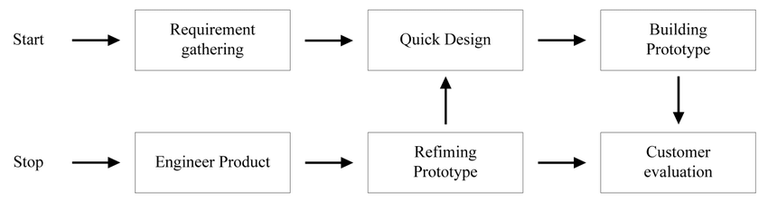

Figure 4.1 Prototype Model

**SDLC** - **Prototype Model**. : For our Sepsis Predicting model, we have used the Prototype Software approach. We have successfully created our project on the basis of two previous prototypes. We have used the prototype model because it was very efficient for us to create new neural network models on the basis of past models and using that information in order to increase various performance metrics.

In our first prototype model, we tried to preprocess the data that was available to us by the mimic-iii database. It contained a huge amount of information about myriad diseases. Thus it was necessary to prune the data and obtain only the necessary data variables required for our study. For this we had used Postgresql Server in order to create complex queries that could dig out the important information from the huge database. In the end we were able to obtain data of around ten thousands patients regarding sepsis and each one having 96 dependent variables for sepsis infection.

For the Model, in our first attempt we were able to create a model with 5 layers. Each layer had neurons in the form 2 raised to n, like 1024, 512,etc.

But the first model was not practical as it had a low precision score of 70%. In the first attempt we were training in the ratio of 95:5 and we found out that it was overfitting the data and had very few validation samples. Thus for our new model we changed the ration to 90:10. Also we tried different approaches like changing learning rate, epochs and even tried to add more layers to it. In the end we were able to find the sweet spot of our project at 6 layers,45561 trainable parameters and 50 epochs. We also tried to change the layer structure by changing 1024,512,etc to 1000,500 and so on. Hence after a few more iterations of train and test methods, we were able to achieve a precision of 96%. Now our model was finally completed.

In the final iteration of our Prototyping process, we started creating a user interface in order to show the results and take inputs from various ICU units. We started creating the website.

# Data Flow Diagram

Figure 5.1 Data Flow Diagram Level 0

Figure 5.2 Data Flow Diagram Level 1

Figure 5.3.1 Data Flow Diagram Level 2.1

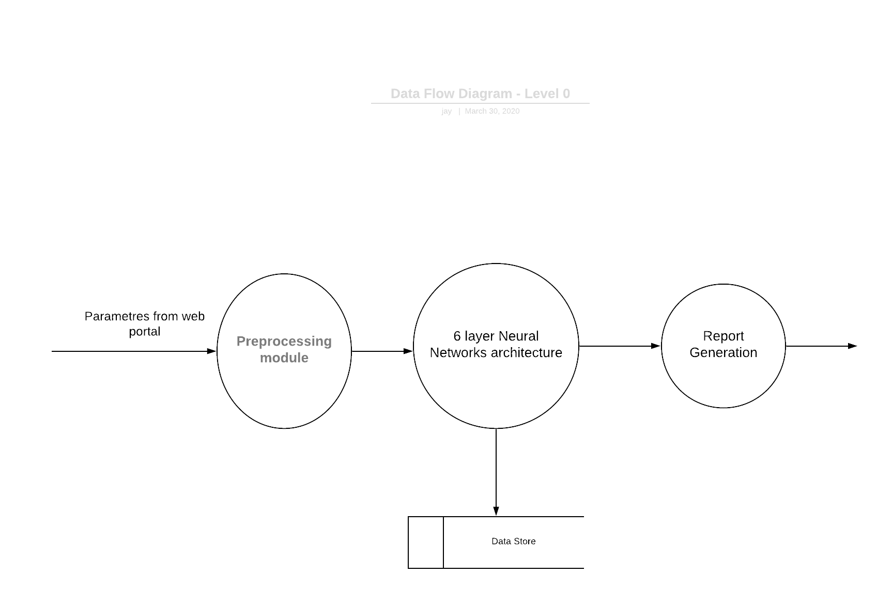

Figure 5.3.2 Data Flow Diagram Level 2.2

# ER Diagram

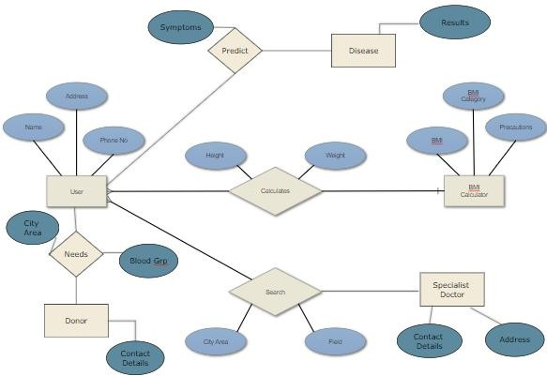

Figure 6.1 – ER Diagram

# Steps to Deploy the Project

1. The first step to deploy the Sepsis Predictor is to create an operational database to store the data. For our purpose we have used Postgresql which will store all the data from the website as input as well as output. It also stored the training as well as testing data.
2. The second step was to use the trained model file stored in the .h5 format. It has to be called explicitly by an exterior program so that it can do prediction. The Machine should have access to python language with version 3.6.0 or above and Keras and tensorflow framework. We have trained the model already hence there is no need to train it again.
3. The third step required to start the Predictor is to deploy the server program onto the Web Server. We have created the website for user convenience and ease of use. The user does not have to directly interact with the model, but can access the website for their prediction. Also the website will publish the results once they have been fetched.
4. In order to properly take the input to the website, as our model takes 96 parameters, it was necessary to create an API that can take the variables directly from the ICU patient Electronic Record and give it to the website. This was done in python language so it makes the user’s task of inputting the data quite easier.
5. The final step is to host the website onto the web server. Connect the model to the server and api to the input to the website, thus making the Sepsis Predictor complete. From the user’s point of view, it becomes very simple to interact with the website,as all he has to do is input his ICU record to the API and the website will publish the result in matter of few seconds or minutes.

# UML Diagrams

#### Use Case Diagram

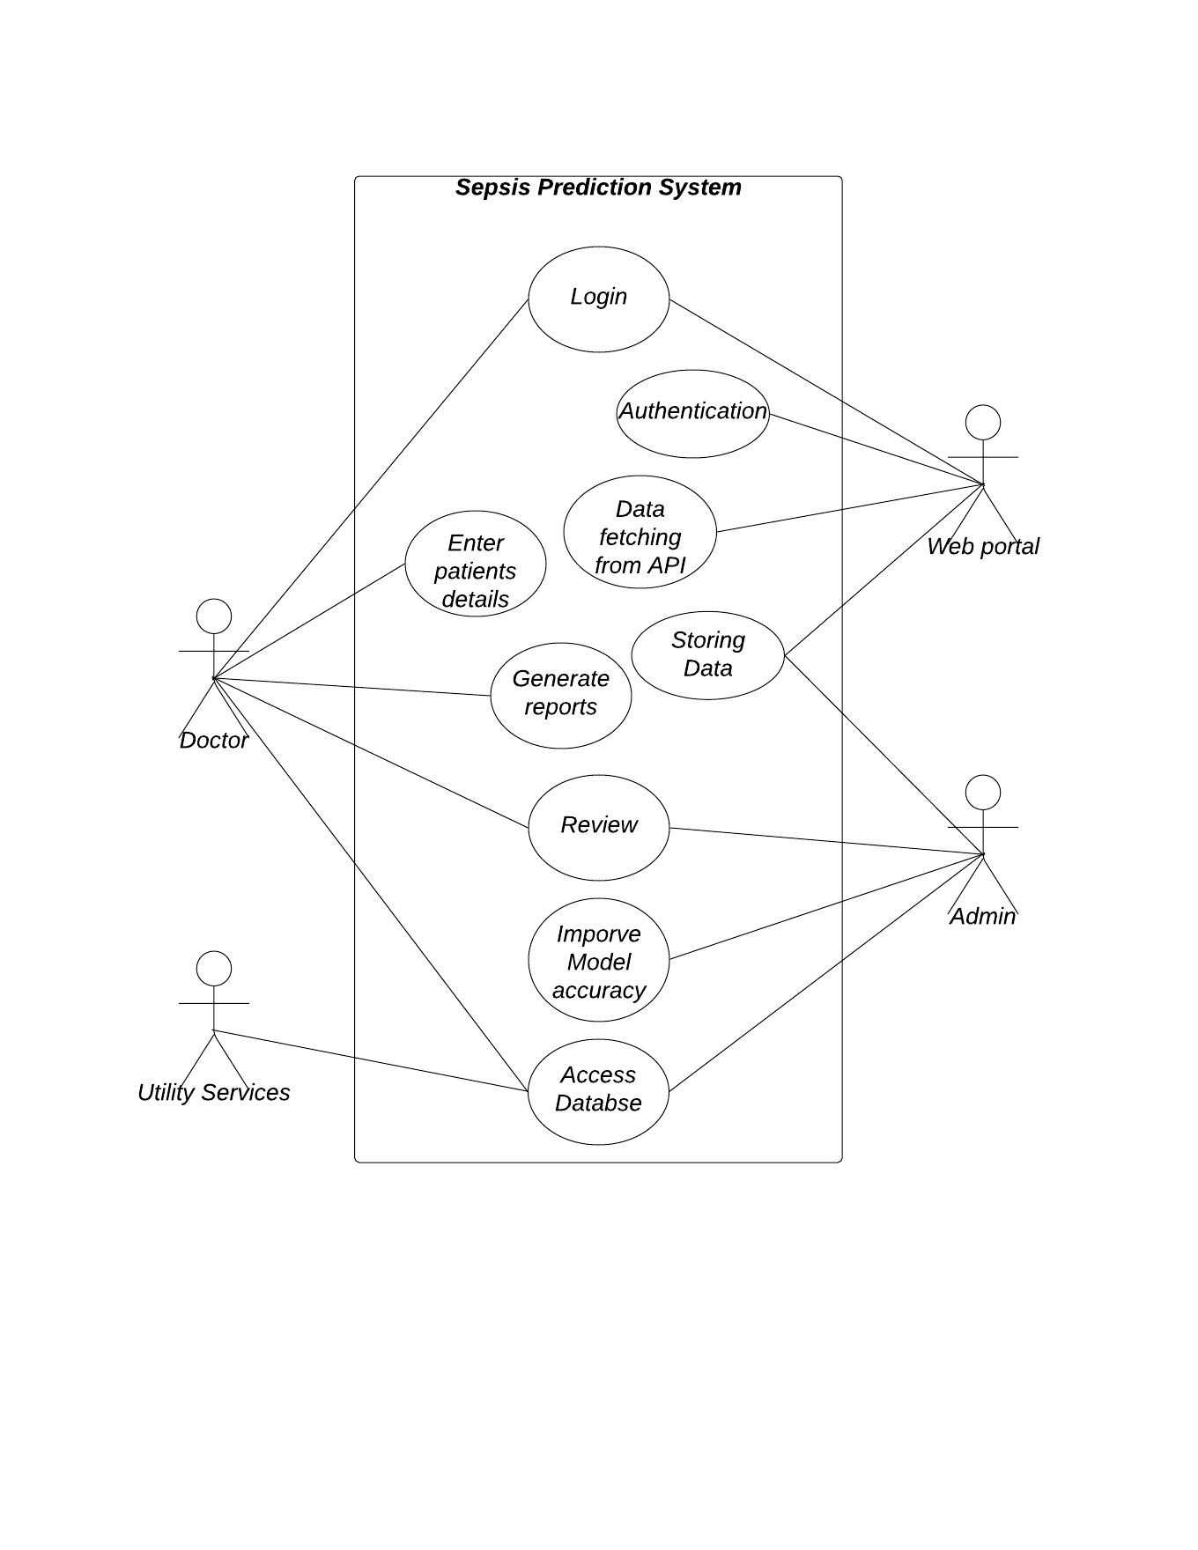

Figure 9.1 Use Case Diagram

#### Sequence Diagram

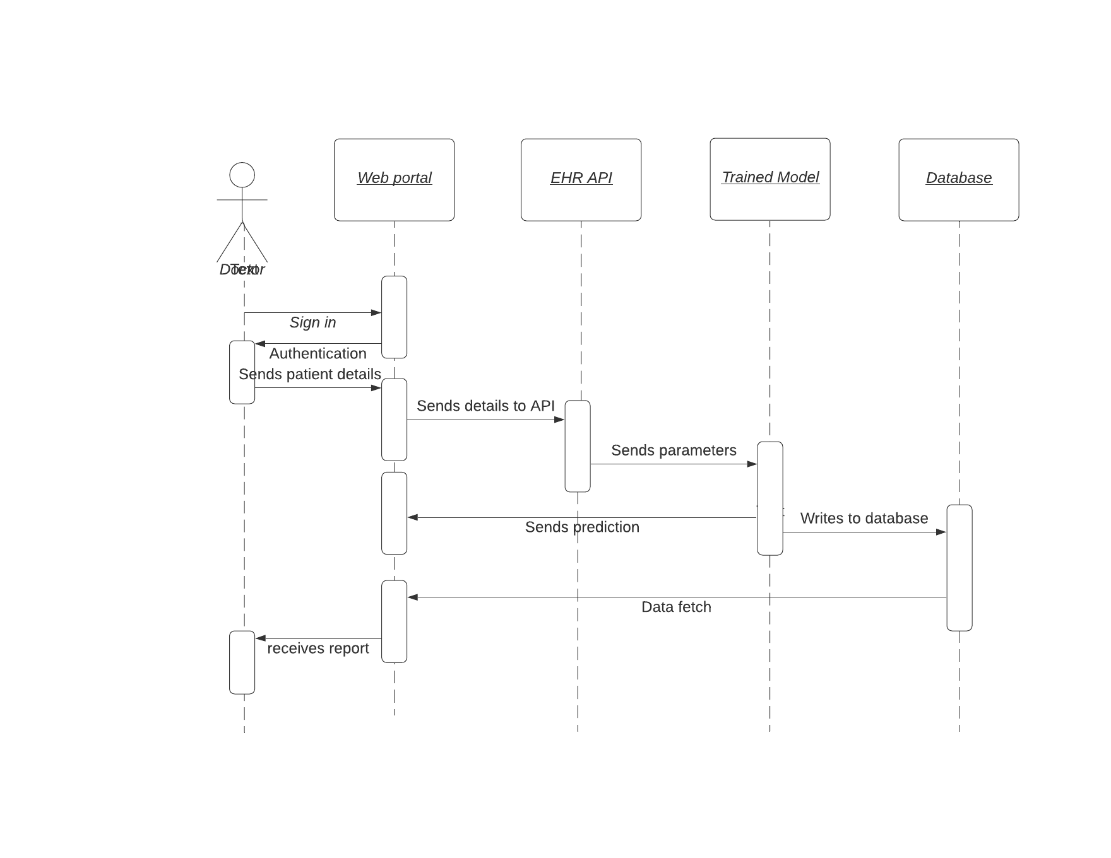

Figure 9.2 Sequence Diagram

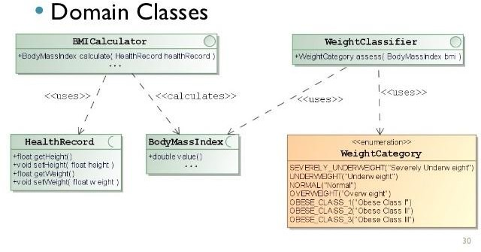

* + 1. **BMI CALCULATOR**

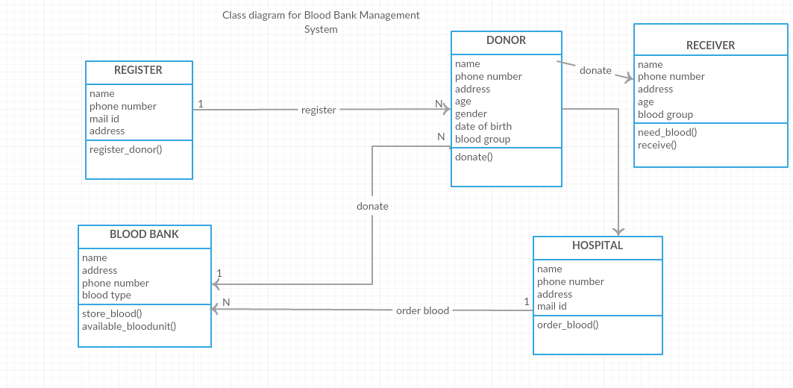

* + 1. **BLOOD DONATION & RECEIVER**

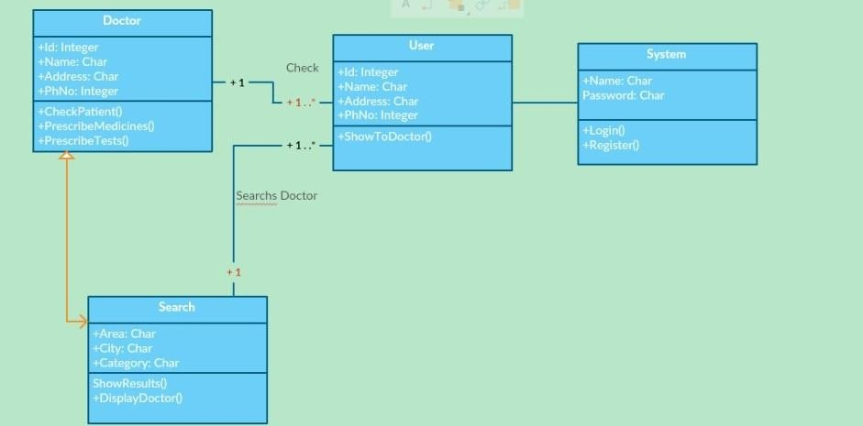

##### FIND ME A DOCTOR

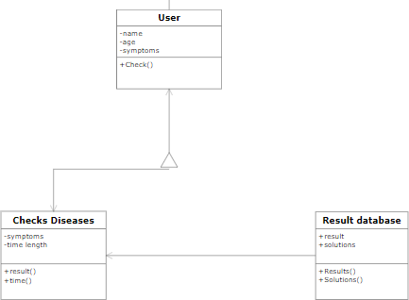

* + 1. **DISEASE PREDICTION**
  1. Activity Diagram

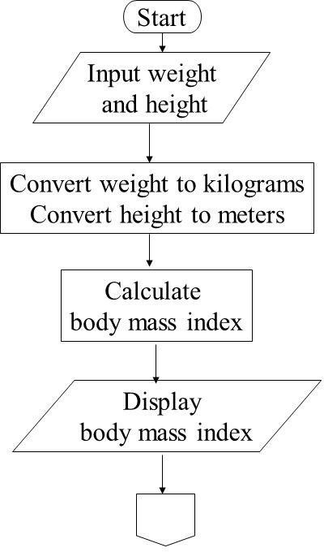

* + 1. **BMI CALCULATOR**

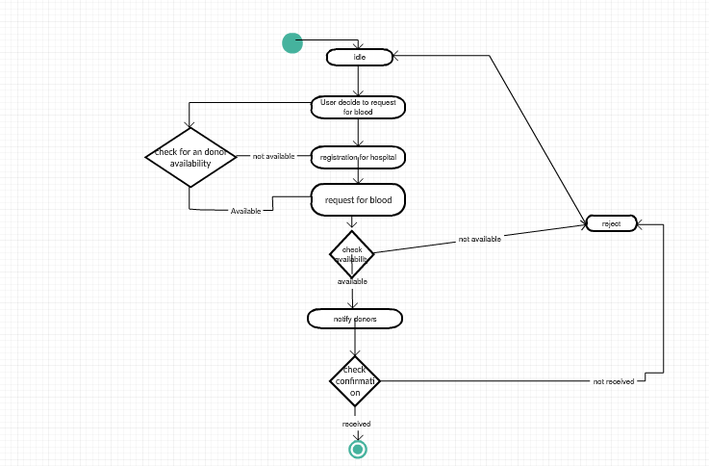

* + 1. **BLOOD DONATION & RECEIVER**

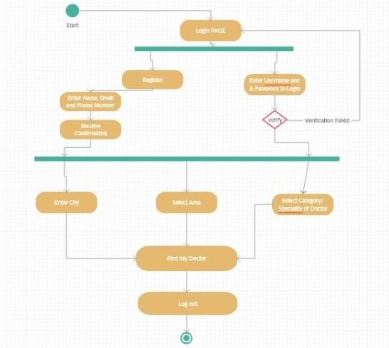

* + 1. **FIND ME A DOCTOR**

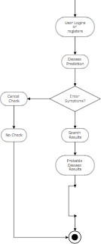

* + 1. **DISEASE PREDICTION**

# User interface design

#### Use Case Diagram

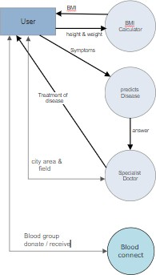

Figure 9.1.1 – Use Case Diagram

#### Data Dictionary

| **Table** | **Children** | **Parents** | **Columns** | **Rows** | **Comments** |
| --- | --- | --- | --- | --- | --- |
| admissions | 18 | 1 | 19 | 58,976 | Hospital admissions associated with an ICU stay. |
| callout |  | 2 | 24 | 34,499 | Record of when patients were ready for discharge (called out), and the actual time of their discharge (or more generally, their outcome). |
| caregivers | 7 | s | 4 | 7,567 | List of caregivers associated with an ICU stay. |
| chartevents |  | 5 | 15 | 330,712,483 | Events occuring on a patient chart. |
| chartevents_1 |  |  | 15 | 38,033,561 | Partition of chartevents. Should not be directly queried. |
| chartevents_10 |  |  | 15 | 9,584,888 | Partition of chartevents. Should not be directly queried. |
| chartevents_11 |  |  | 15 | 470,141 | Partition of chartevents. Should not be directly queried. |
| chartevents_12 |  |  | 15 | 265,413 | Partition of chartevents. Should not be directly queried. |
| chartevents_13 |  |  | 15 | 39,066,570 | Partition of chartevents. Should not be directly queried. |
| chartevents_14 |  |  | 15 | 100,075,138 | Partition of chartevents. Should not be directly queried. |
| chartevents_2 |  |  | 15 | 13,116,197 | Partition of chartevents. Should not be directly queried. |
| chartevents_3 |  |  | 15 | 38,657,533 | Partition of chartevents. Should not be directly queried. |
| chartevents_4 |  |  | 15 | 9,374,587 | Partition of chartevents. Should not be directly queried. |
| chartevents_5 |  |  | 15 | 18,201,026 | Partition of chartevents. Should not be directly queried. |
| chartevents_6 |  |  | 15 | 28,014,688 | Partition of chartevents. Should not be directly queried. |
| chartevents_7 |  |  | 15 | 255,967 | Partition of chartevents. Should not be directly queried. |
| chartevents_8 |  |  | 15 | 34,322,082 | Partition of chartevents. Should not be directly queried. |
| chartevents_9 |  |  | 15 | 1,274,692 | Partition of chartevents. Should not be directly queried. |
| cptevents |  | 2 | 12 | 573,146 | Events recorded in Current Procedural Terminology. |
| d_cpt |  |  | 9 | 134 | High-level dictionary of the Current Procedural Terminology. |
| d_icd_diagnoses | 1 |  | 4 | 14,710 | Dictionary of the International Classification of Diseases, 9th Revision (Diagnoses). |
| d_icd_procedures | 1 |  | 4 | 3,898 | Dictionary of the International Classification of Diseases, 9th Revision (Procedures). |
| d_items | 8 |  | 10 | 12,487 | Dictionary of non-laboratory-related charted items. |
| d_labitems | 1 |  | 6 | 753 | Dictionary of laboratory-related items. |
| datetimeevents |  | 5 | 14 | 4,485,937 | Events relating to a datetime. |
| diagnoses_icd |  | 3 | 5 | 651,047 | Diagnoses relating to a hospital admission coded using the ICD9 system. |
| drgcodes |  | 2 | 8 | 125,557 | Hospital stays classified using the Diagnosis-Related Group system. |
| icustays | 8 | 2 | 12 | 61,532 | List of ICU admissions. |
| inputevents_cv |  | 4 | 22 | 17,527,935 | Events relating to fluid input for patients whose data was originally stored in the CareVue database. |
| inputevents_mv |  | 5 | 31 | 3,618,991 | Events relating to fluid input for patients whose data was originally stored in the MetaVision database. |
| labevents |  | 3 | 9 | 27,854,055 | Events relating to laboratory tests. |
| microbiologyevents |  | 5 | 16 | 631,726 | Events relating to microbiology tests. |
| noteevents |  | 3 | 11 | 2,083,180 | Notes associated with hospital stays. |
| outputevents |  | 5 | 13 | 4,349,218 | Outputs recorded during the ICU stay. |
| patients | 19 |  | 8 | 46,520 | Patients associated with an admission to the ICU. |
| prescriptions |  | 3 | 19 | 4,156,450 | Medicines prescribed. |
| procedureevents_mv |  | 5 | 25 | 258,066 | Procedure start and stop times recorded for MetaVision patients. |
| procedures_icd |  | 3 | 5 | 240,095 | Procedures relating to a hospital admission coded using the ICD9 system. |
| services |  | 2 | 6 | 73,343 | Hospital services that patients were under during their hospital stay. |
| transfers |  | 3 | 13 | 261,897 | Location of patients during their hospital stay. |
|  |  |  |  |  |  |
| **40 Tables** |  |  | **534** | **728,556,685** |  |

Table 1 Data Dictionary

* 1. Interface Details

The user will be provided with a graphical user interface where they can do the following:

1. The user inputs a single input.
2. The user inputs multiple inputs that are to be the part of the same module.
3. The user initiates search or calculations.
4. The user pauses search or calculation.
5. The user resumes search or calculation.
6. The user stops search or calculation.
7. The user views the output generated by the system.

# Conclusion

Despite of multiple number of similar services available in the world, we didn’t find them enough capable of solving the multiple problems related to health in the society. Even though we cannot ensure perfect health and wellbeing of a person , we have provided them a platform to solve that problem. Nobody can fully be sure about the perfection of a certain software , but we can assure that we will be trying our level best to match with the user’s expectation and never will be depressed with a bad review instead we will be taking it as a stepping stone for improvement.

# References

## [www.1000projects.com](http://www.1000projects.com/)

* + [**www.creatly.com**](http://www.creatly.com/)
  + [**www.smartdraw.com**](http://www.smartdraw.com/)
  + [**www.w3schools.com**](http://www.w3schools.com/)
  + [**www.googlepatents.com**](http://www.googlepatents.com/)
  + [**https://www.phekb.org/sites/phenotype/files/ObesityAlgorithm_c omplete_v04.pdf**](https://www.phekb.org/sites/phenotype/files/ObesityAlgorithm_complete_v04.pdf)
  + [**https://ai.stackexchange.com/questions/1705/selecting-the-right- technique-to-predict-disease-from-symptoms**](https://ai.stackexchange.com/questions/1705/selecting-the-right-technique-to-predict-disease-from-symptoms)
  + [**http://thescipub.com/pdf/10.3844/jcssp.2010.548.552**](http://thescipub.com/pdf/10.3844/jcssp.2010.548.552)
  + [**https://www.healthitoutcomes.com/doc/algorithms-connect- patients-to-the-right-doctors-0001**](https://www.healthitoutcomes.com/doc/algorithms-connect-patients-to-the-right-doctors-0001)

Appendix

#### Design Engineering Canvas

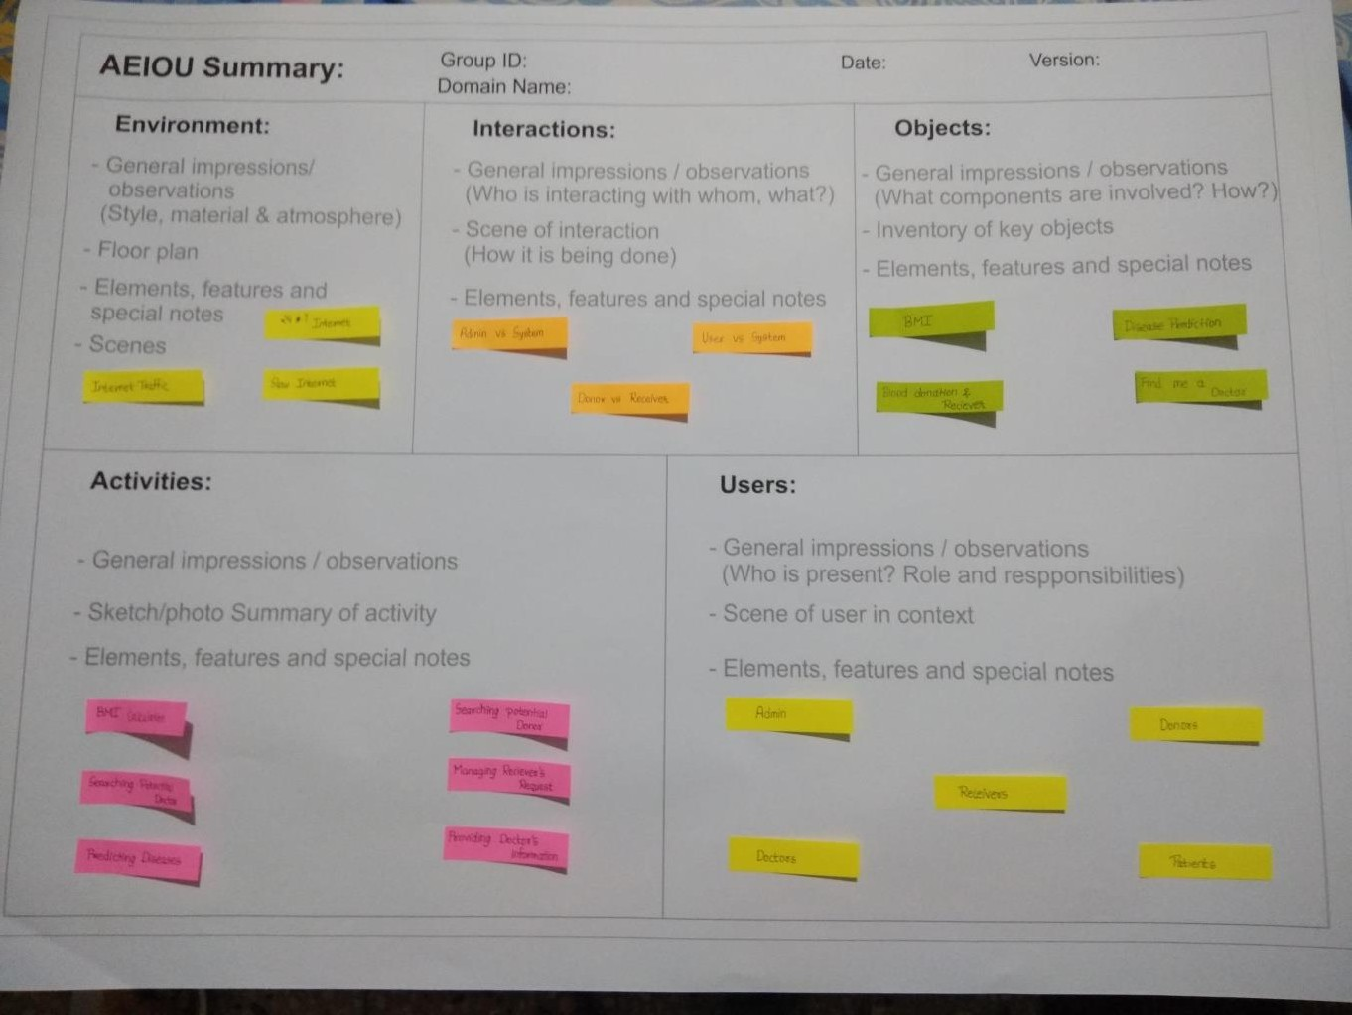

Figure A.1 – AEIOU Summary

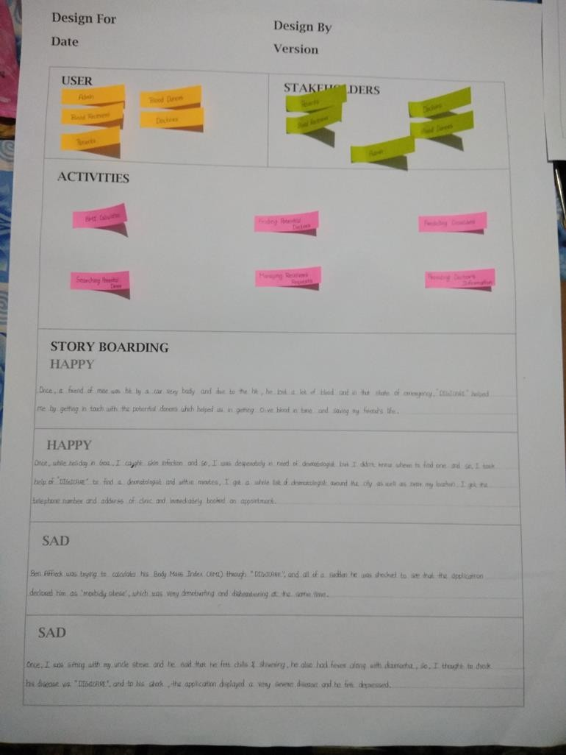

Figure A.2 – Empathy Map

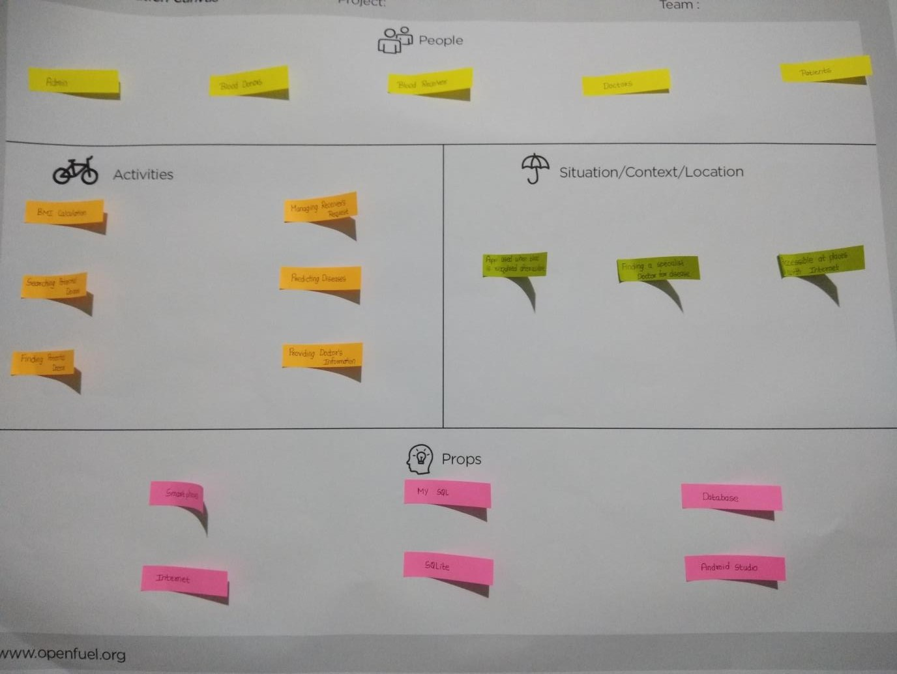

Figure A.3 – Ideation Canvas

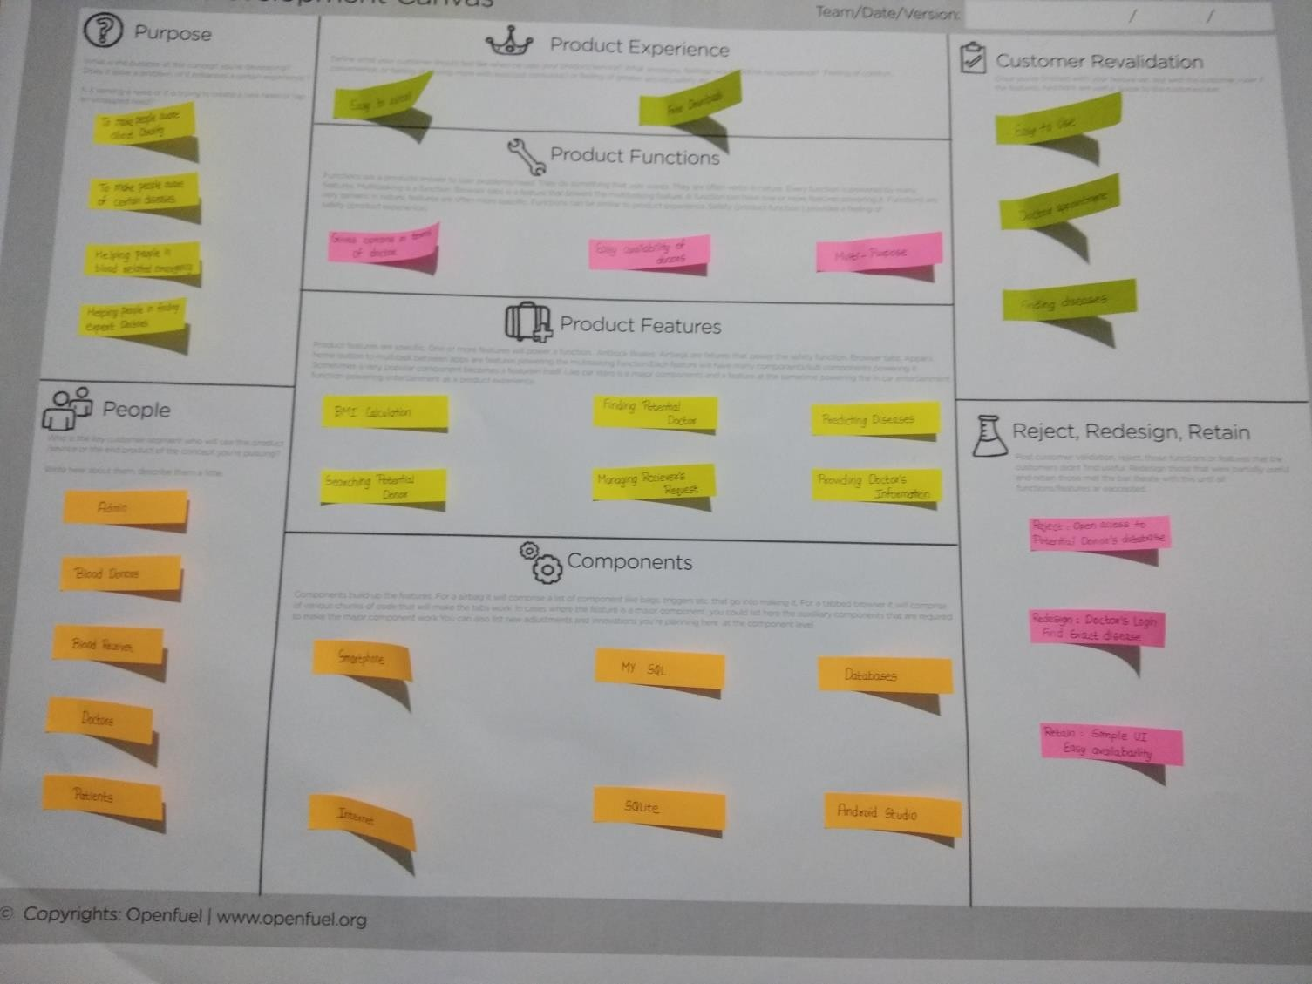

Figure A.4 – Product Development Canvas

#### Periodic Progress Reports:

Kartavya Joshi PPRs

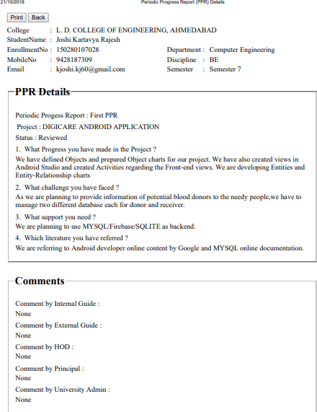

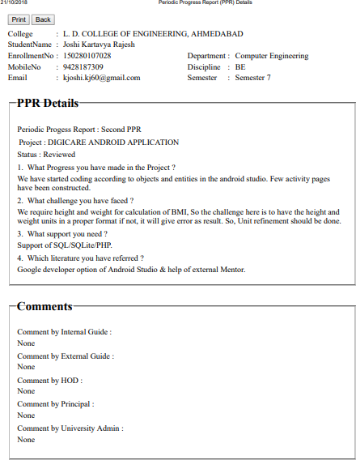

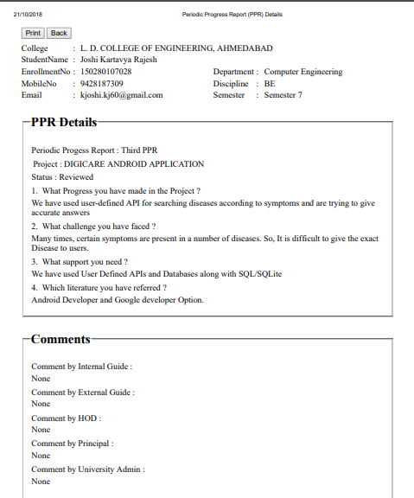

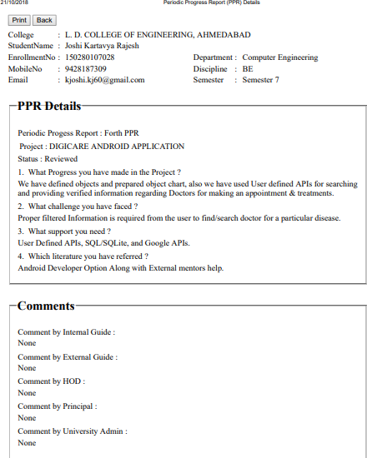

Dharmil Parmar PPRs

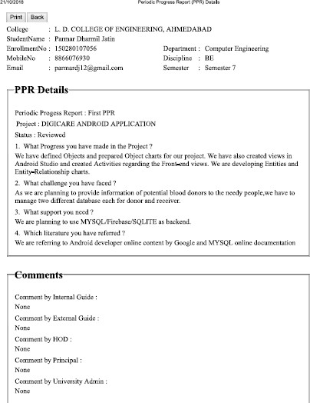

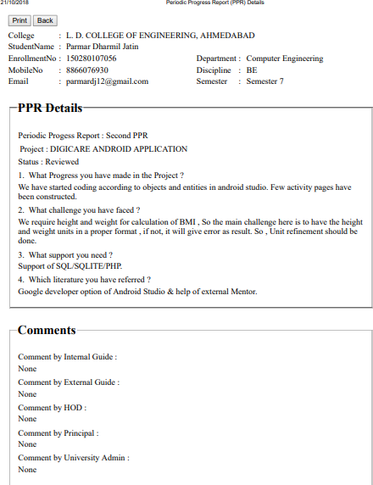

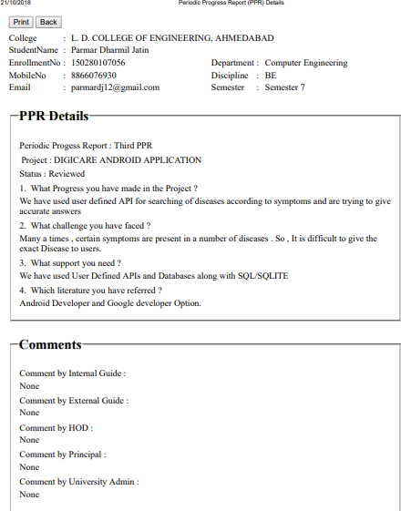

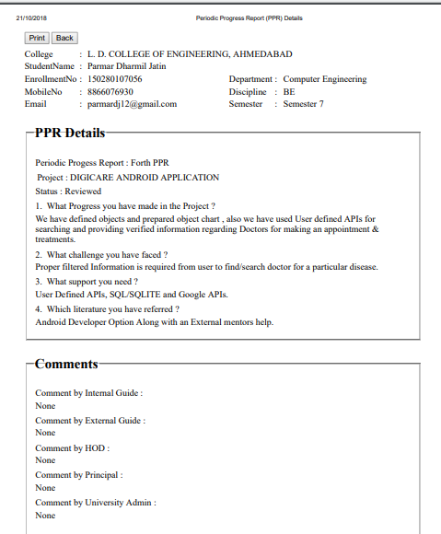

**PATENT SEARCH AND ANALYSIS REPORT**

Kartavya Joshi -PSARs

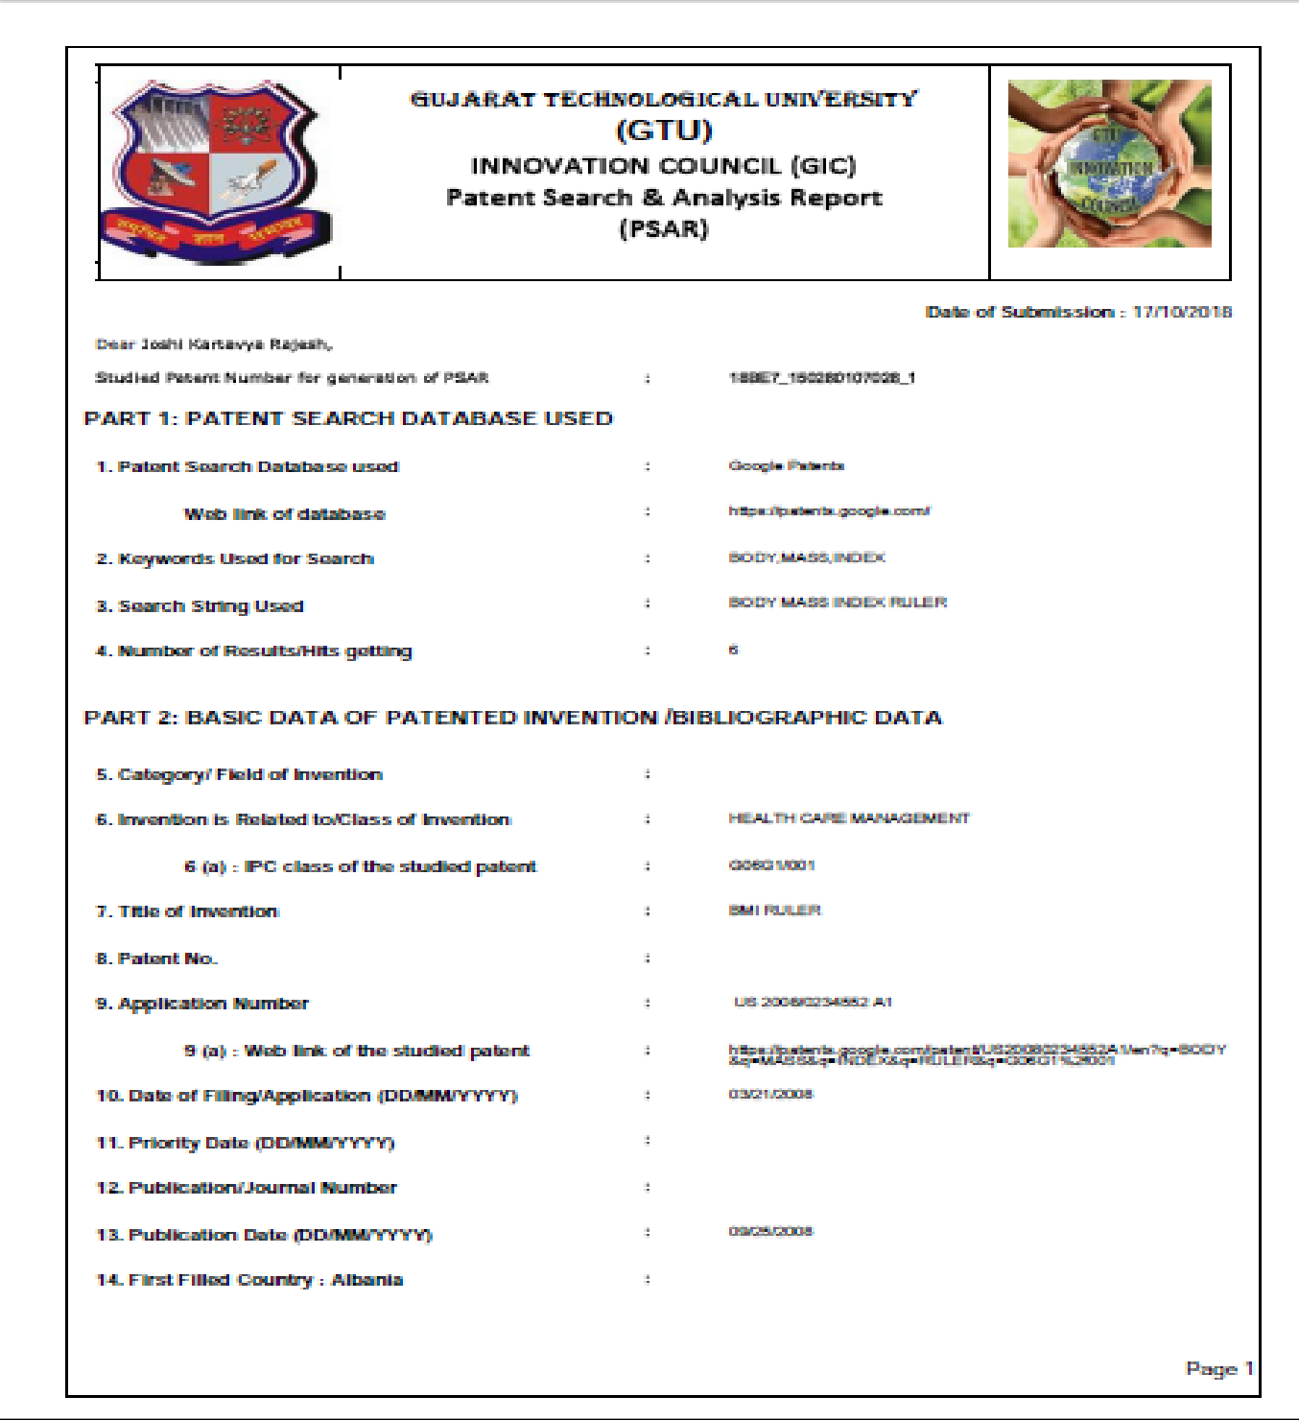

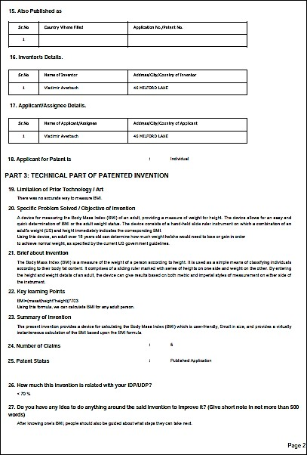

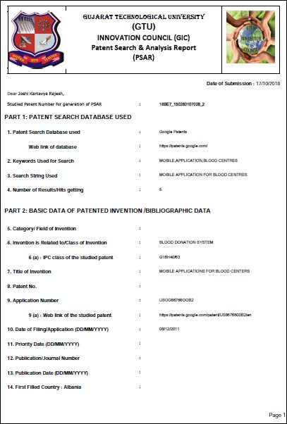

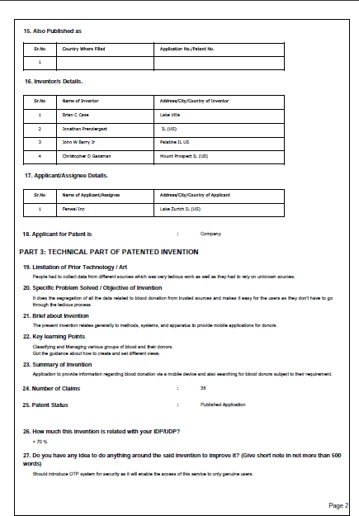

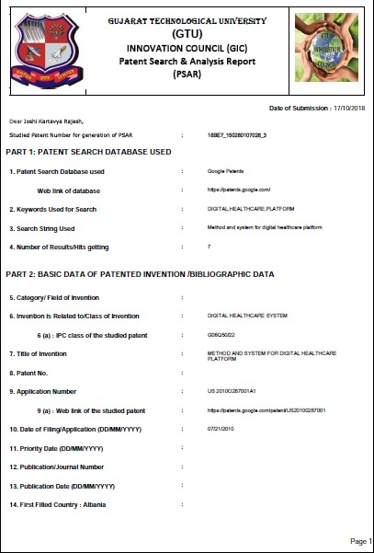

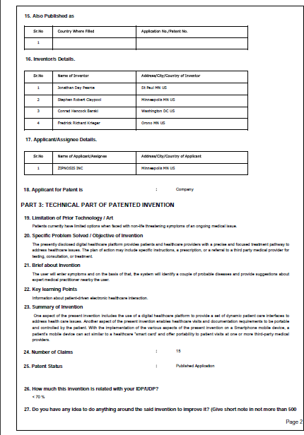

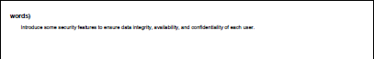

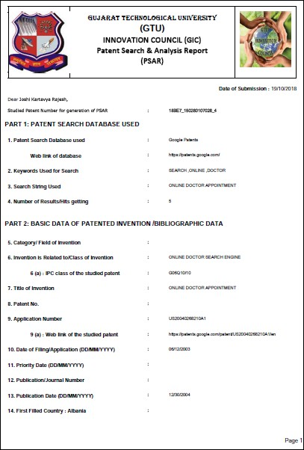

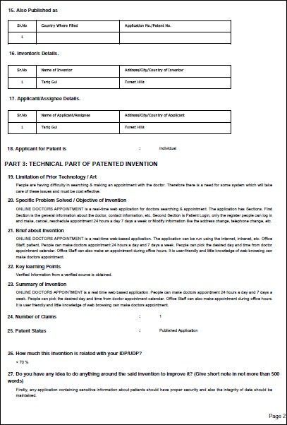

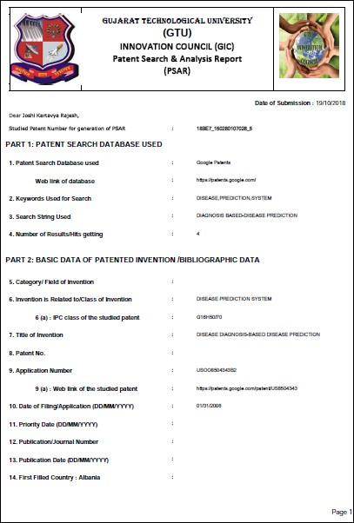

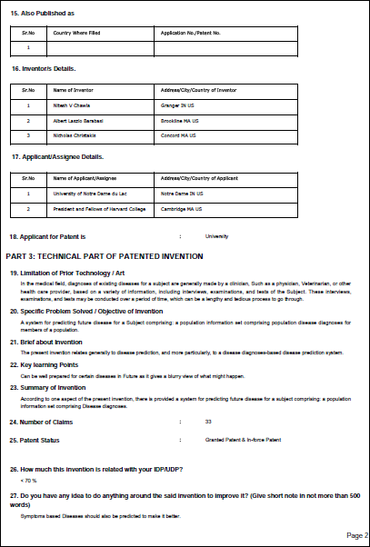

Dharmil Parmar - PSARs

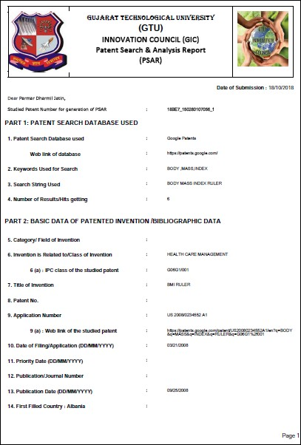

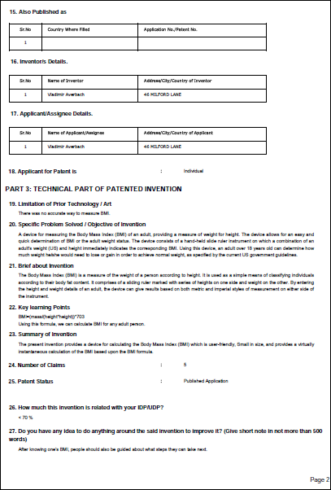

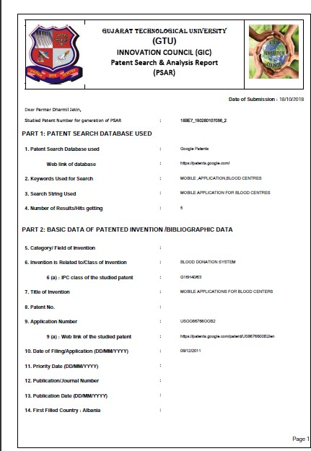

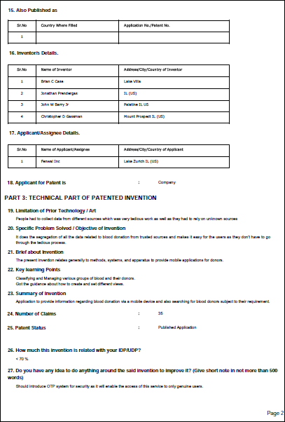

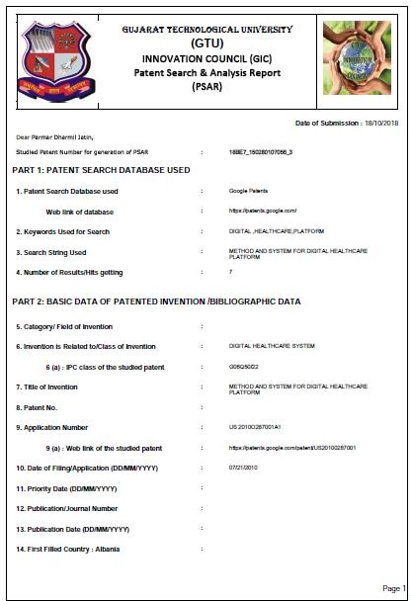

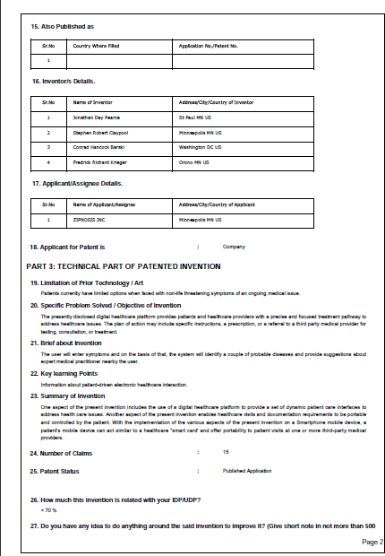

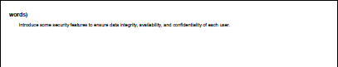

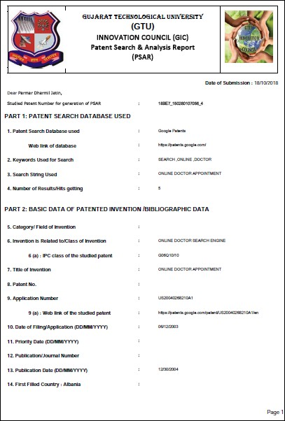



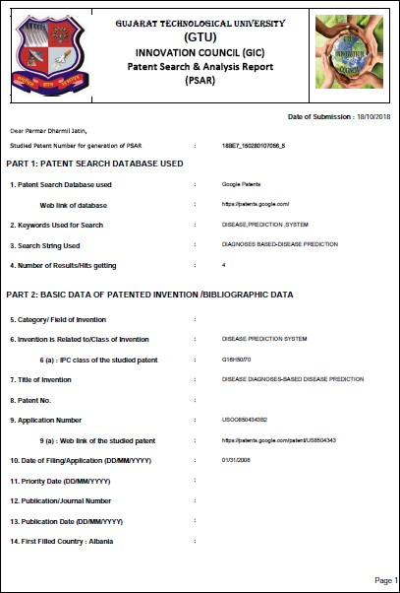



### PLAGIARISM CERTIFICATION

