STRATEGIC PLANNING AND
DATA EXPLORATION IN LOGISTICS
A Data-Driven Strategic Planning Study of Last-Mile Delivery Operations
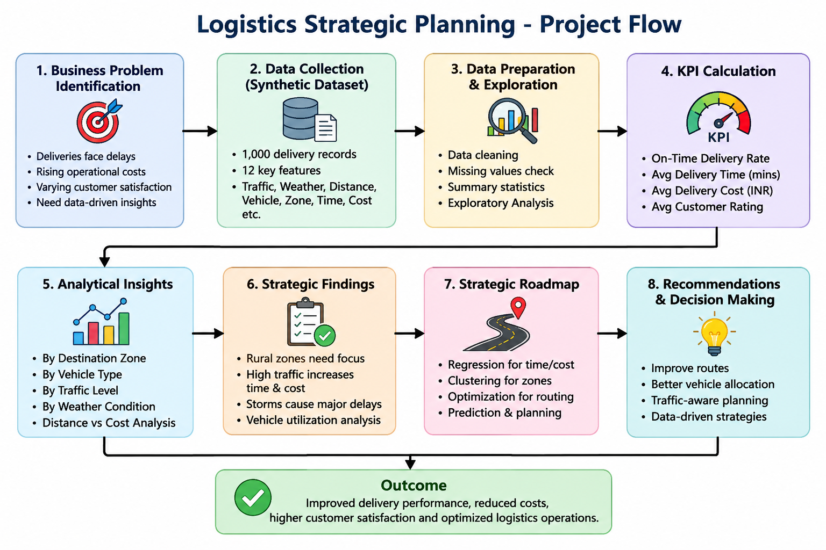
Project | Details
Dataset | Synthetic logistics delivery dataset — 1,000 records
Tools | Python, Pandas, NumPy, Matplotlib, Google Colab
Analysis focus | Delivery reliability, time, cost, vehicle utilization and operational factors
Submission | Strategic planning report and supporting GitHub project

1. Report Description
This project presents a strategic planning and data exploration framework for a last-mile logistics operation. The scenario represents a delivery network serving urban, suburban, semi-urban, and rural destinations from distribution centres in central India. The purpose is not to build a production logistics system, but to demonstrate how structured data analysis can support operational planning, performance monitoring, and resource allocation. A synthetic dataset containing 1,000 delivery records was created because a suitable public delivery-level dataset with all required operational fields was not available for the specific educational scenario.
The dataset contains delivery date, origin, destination zone, distance, traffic level, weather condition, vehicle type, load weight, vehicle capacity, delivery time, delivery cost, fuel cost, customer rating, and on-time delivery status. Four core performance indicators were selected: on-time delivery rate, average delivery time, average delivery cost, and average vehicle utilization. Exploratory analysis was then used to compare performance across vehicles, destination zones, traffic conditions, and weather conditions.
The analysis produced an overall on-time delivery rate of 82.60%, average delivery time of 99.56 minutes, average delivery cost of ₹196.43, and average vehicle utilization of 58.90%. Zone-level analysis showed that rural deliveries were the most operationally demanding, with an average distance of 32.68 km, delivery time of 135.05 minutes, and cost of ₹251.23. Traffic analysis showed a clear association between congestion and slower deliveries: high-traffic deliveries averaged 112.02 minutes compared with 91.56 minutes under low traffic. Weather analysis similarly showed longer delivery times during storms, averaging 126.46 minutes compared with 95.69 minutes in normal conditions. The distance-cost correlation was 0.442, indicating a moderate positive relationship rather than a complete explanation of cost variation. Based on these findings, the project proposes zone-specific planning, improved vehicle allocation, congestion-aware scheduling, and weather-aware contingency planning as strategic areas for further investigation.
The report also outlines how regression, clustering, and optimization could be used in a future phase to predict delivery outcomes, segment operations, and improve resource allocation. Overall, the project demonstrates how logistics data can move decision-making from general assumptions toward measurable, evidence-based planning while clearly distinguishing exploratory findings from causal claims.

2. Background Research
Logistics performance depends on the reliable movement of goods, appropriate infrastructure and services, timeliness, tracking, and the ability to arrange shipments efficiently. The World Bank Logistics Performance Index (LPI) uses six dimensions including infrastructure, logistics service quality, tracking and tracing, and timeliness. This provides an external basis for selecting delivery reliability and operational efficiency as strategic concerns.
Last-mile delivery is suitable for data exploration because performance can vary with geography, congestion, weather, vehicle choice, shipment characteristics, and route distance. Modern logistics research also emphasizes the use of data and analytical methods for prediction, routing, traffic analysis, and operational decision-making.
Research literature shows that machine learning and analytical methods are increasingly applied to freight transportation and logistics problems such as arrival-time prediction, demand forecasting, traffic analysis, vehicle routing, anomaly detection, and optimization. Therefore, this project uses descriptive analytics as the current phase and treats predictive and prescriptive analytics as logical future extensions.
Research theme | Project connection
Reliability and timeliness | On-time delivery is a core service KPI
Operational efficiency | Time and cost are monitored together
Resource utilization | Vehicle capacity is evaluated
Operational context | Traffic and weather are explored
Analytics-enabled decisions | Prediction and optimization are proposed for future work

2.1 Public Data and Synthetic Dataset
Public logistics resources were reviewed to establish the project context, particularly the World Bank Logistics Performance Index and its DataBank resources. The analytical dataset used here is explicitly synthetic and was generated for educational purposes. It must not be presented as observed company data or as a World Bank dataset. The synthetic approach provides controlled delivery-level variables needed to demonstrate the requested analysis.

3. Project Definition

3.1 Logistics Scenario
The proposed organization operates a regional last-mile delivery network with distribution centres and customers located across different geographic zones. Management wants to understand why delivery performance differs between areas and operating conditions, and how vehicles and capacity could be planned more effectively.

3.2 Problem Statement
The strategic problem is to identify measurable patterns in delivery time, cost, reliability, and vehicle utilization that can guide future resource allocation and operational planning. The analysis should identify where performance pressure is greatest and which variables deserve deeper investigation.

3.3 Objectives
- Define a realistic last-mile logistics scenario suitable for data-driven planning.
- Establish measurable KPIs for delivery reliability, time, cost, and capacity utilization.
- Explore operational differences by vehicle, destination zone, traffic, weather, and distance.
- Identify evidence-based patterns without claiming causation from exploratory analysis alone.
- Design an end-to-end roadmap for future predictive and prescriptive analytics using Python.
- Translate findings into practical strategic questions for logistics decision-makers.

3.4 KPI Framework
KPI | Definition | Result | Strategic purpose
On-Time Delivery Rate | Share of deliveries recorded as on time | 82.60% | Reliability
Average Delivery Time | Mean delivery duration | 99.56 min | Operational speed
Average Delivery Cost | Mean delivery cost | ₹196.43 | Cost efficiency
Average Vehicle Utilization | Load/capacity percentage | 58.90% | Resource utilization

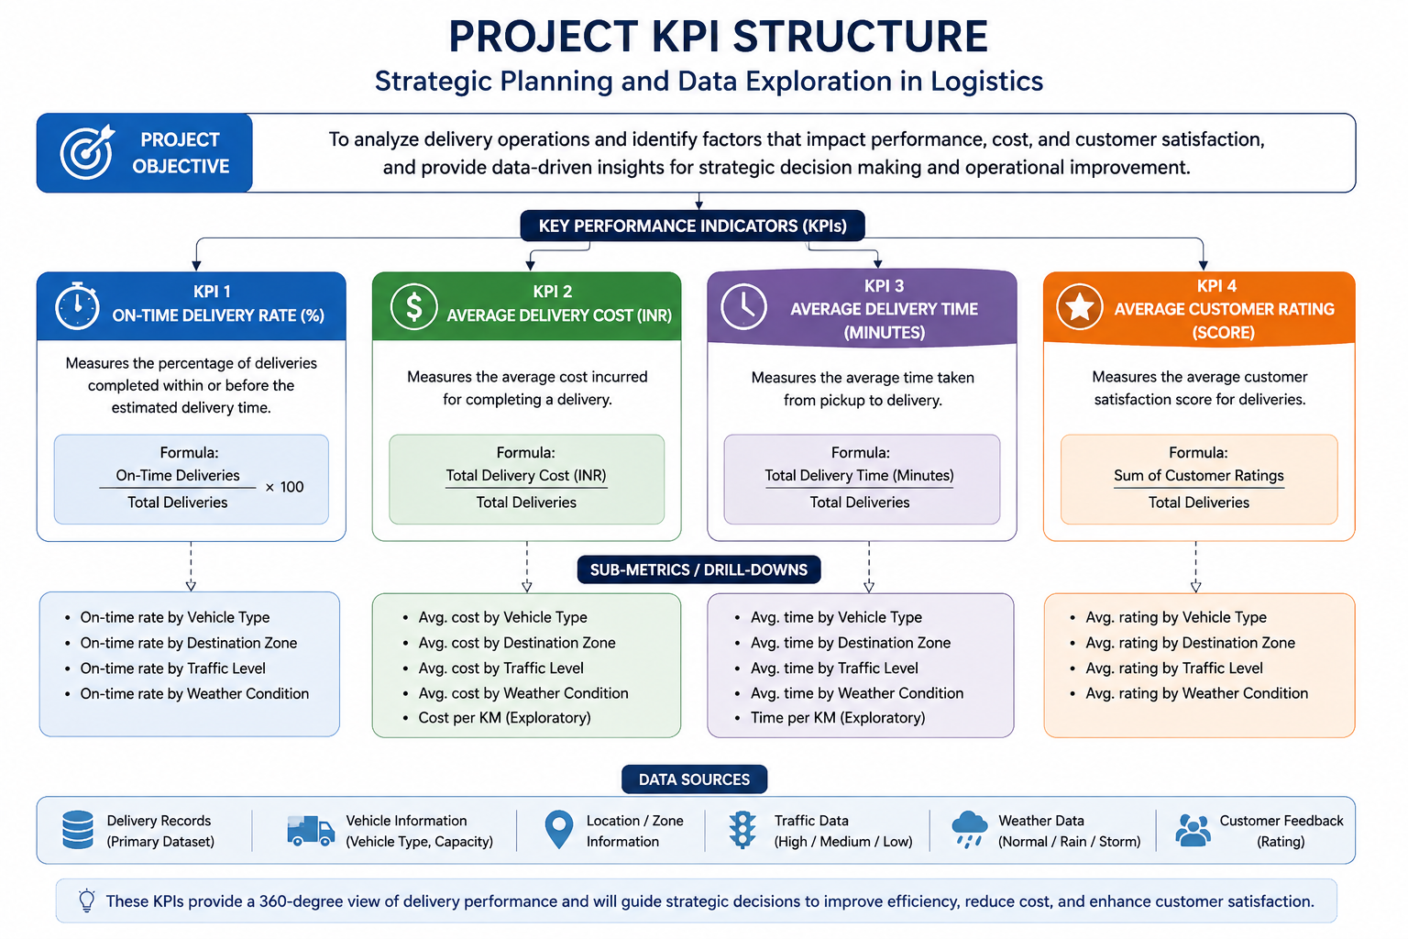

4. Dataset and Analytical Approach
The final working dataset contains 1,000 synthetic delivery observations and 15 variables. The data includes delivery date, origin, destination zone, distance, traffic, weather, vehicle type, load weight, capacity, delivery time, delivery cost, fuel cost, customer rating, and on-time status.
Variable | Type | Purpose
Delivery_ID | Identifier | Unique delivery record
Order_Date | Date | Temporal context
Origin | Categorical | Distribution centre
Destination_Zone | Categorical | Geographic segment
Distance_KM | Numeric | Route distance
Traffic_Level | Categorical | Traffic condition
Weather_Condition | Categorical | Weather context
Vehicle_Type | Categorical | Bike, Van or Truck
Load_Weight_KG | Numeric | Shipment weight
Vehicle_Capacity_KG | Numeric | Vehicle capacity
Delivery_Time_Minutes | Numeric | Delivery duration
Delivery_Cost_INR | Numeric | Delivery cost
Fuel_Cost_INR | Numeric | Estimated fuel component
Customer_Rating | Numeric | Customer experience
On_Time_Delivery | Categorical | Yes/No service result

4.1 Analytical Workflow
The workflow is intentionally focused on strategic planning and data exploration: define the business question, establish KPIs, obtain or generate appropriate data, inspect structure, perform descriptive analysis, visualize patterns, interpret results, and formulate strategic questions. Predictive modelling and optimization are proposed as future phases rather than required outputs.
5. Exploratory Data Analysis and Findings

5.1 Overall Performance
The dataset produced an on-time delivery rate of 82.60%, meaning 17.40% of the 1,000 deliveries were recorded as not on time. Average delivery time was 99.56 minutes, average delivery cost was ₹196.43, and average vehicle utilization was 58.90%.

5.2 Vehicle Analysis
Vehicle | Deliveries | Avg time | Avg cost | Utilization | Rating
Bike | 376 | 98.17 min | ₹101.31 | 59.14% | 4.42
Van | 424 | 98.44 min | ₹204.88 | 59.96% | 4.43
Truck | 200 | 104.55 min | ₹357.32 | 56.22% | 4.43
Trucks show the lowest average utilization and highest average cost. This does not mean trucks are inefficient because their greater capacity may be necessary for heavier shipments. It creates a strategic question about whether vehicle assignment is aligned with shipment weight, distance, and capacity requirements.

5.3 Destination-Zone Analysis
Zone | Deliveries | Avg distance | Avg time | Avg cost | Rating
Urban | 348 | 19.06 km | 89.47 min | ₹189.43 | 4.44
Suburban | 306 | 20.69 km | 97.01 min | ₹189.42 | 4.40
Semi-urban | 211 | 18.44 km | 97.19 min | ₹183.05 | 4.46
Rural | 135 | 32.68 km | 135.05 min | ₹251.23 | 4.41
Rural deliveries are the clearest operational outlier. Their average distance is 32.68 km, delivery time is 135.05 minutes, and cost is ₹251.23. Compared with urban deliveries, the rural segment has materially greater distance, time, and cost.

6. Environmental and Operational Factors

6.1 Traffic Analysis
Traffic | Deliveries | Avg time | Avg cost | Rating
Low | 313 | 91.56 min | ₹183.90 | 4.51
Medium | 437 | 98.16 min | ₹195.76 | 4.48
High | 250 | 112.02 min | ₹213.27 | 4.23

A clear descriptive pattern appears across traffic levels. High-traffic deliveries average 112.02 minutes compared with 91.56 minutes under low traffic, while average cost increases and customer rating decreases. This supports congestion-aware scheduling as a strategic area for further investigation.

6.2 Weather Analysis
Weather | Deliveries | Avg time | Avg cost | Rating
Normal | 727 | 95.69 min | ₹200.45 | 4.46
Rain | 202 | 104.04 min | ₹188.99 | 4.41
Storm | 71 | 126.46 min | ₹176.41 | 4.17

Storm deliveries have the longest average delivery time at 126.46 minutes and the lowest customer rating at 4.17. Because the storm group contains 71 observations and the dataset is synthetic, this is an exploratory association rather than proof of a causal weather effect.

7. Distance, Cost Relationship and Strategic Insights

7.1 Distance and Delivery Cost
The Pearson correlation between Distance_KM and Delivery_Cost_INR is 0.442. This represents a moderate positive relationship: longer deliveries tend to be associated with higher costs, but distance alone does not explain all cost variation. Vehicle type, load, traffic, and other operational conditions also contribute.

7.2 Consolidated Findings
Finding | Strategic interpretation
Reliability gap | 82.60% on-time performance leaves an improvement opportunity; about 174 of 1,000 deliveries were late.
Rural service pressure | Rural deliveries are the strongest time-and-cost outlier and may justify differentiated planning.
Congestion exposure | High traffic is associated with longer time, higher cost and lower customer rating.
Weather exposure | Storm conditions are associated with substantially longer delivery time and lower rating.
Capacity planning | 58.90% utilization indicates vehicle allocation and load planning deserve investigation.
Cost drivers | Distance is positively associated with cost, but a multi-factor approach is required.

7.3 Limitations
- The dataset is synthetic and cannot be treated as evidence of an actual company's performance.
- Grouped comparisons and correlation do not establish causation.
- The project lacks actual GPS traces, route geometry, customer time windows and real traffic feeds.
- Traffic and weather categories are simplified.
- No predictive model or route optimization model is required for the current strategic-planning scope.

8. Strategic Data Science Roadmap
Stage | Purpose
1. Business definition | Define service objectives, constraints, KPIs and decision owners.
2. Data acquisition | Combine delivery, GPS, traffic, weather, vehicle and customer data where available.
3. Data preparation | Validate types, missingness, duplicates, outliers and category consistency.
4. Exploratory analytics | Use summaries, correlations, segmentation and visualizations.
5. Predictive analytics | Predict delivery time, delay risk, demand or cost.
6. Segmentation | Cluster routes, customers, zones or delivery profiles.
7. Optimization | Allocate vehicles/routes subject to capacity and service constraints.
8. Evaluation | Compare plans using accuracy, cost, service level and utilization.
9. Decision support | Translate outputs into dashboards, alerts and management actions.
10. Monitoring | Track KPI and model performance and update planning rules.

8.1 Proposed Methods
Method | Potential use | Decision value
Regression | Predict delivery time or cost | Forecasting and planning
Classification | Predict late-delivery probability | Proactive exception management
Clustering | Group similar routes/customers/deliveries | Differentiated strategy
Optimization | Allocate vehicles/routes under constraints | Resource allocation

9. Python Code Illustrations
The project was implemented in Python using Pandas, NumPy and Matplotlib. The following shortened examples illustrate the analytical approach; the complete notebook should remain in the GitHub repository.

Loading the dataset
import pandas as pd
logistics_df = pd.read_csv("logistics_delivery_data.csv")
logistics_df.head(10)

KPI calculation
on_time_rate = (logistics_df["On_Time_Delivery"] == "Yes").mean() * 100
average_delivery_time = logistics_df["Delivery_Time_Minutes"].mean()
average_delivery_cost = logistics_df["Delivery_Cost_INR"].mean()
logistics_df["Vehicle_Utilization_%"] = (logistics_df["Load_Weight_KG"] / logistics_df["Vehicle_Capacity_KG"]) * 100

Grouped exploration
zone_kpi = logistics_df.groupby("Destination_Zone").agg(
Deliveries=("Delivery_ID", "count"),
Avg_Delivery_Time_Minutes=("Delivery_Time_Minutes", "mean"),
Avg_Delivery_Cost_INR=("Delivery_Cost_INR", "mean")
).round(2)

Correlation
correlation = logistics_df["Distance_KM"].corr(logistics_df["Delivery_Cost_INR"])

9.1 Reproducibility
The final GitHub repository should contain the notebook, CSV dataset, README, requirements information and report assets. The notebook should execute from top to bottom after the dataset is placed in the expected project folder.

10. Strategic Recommendations
Recommendation | Rationale
Adopt zone-specific planning | Rural deliveries show materially higher distance, time and cost.
Investigate congestion-aware scheduling | High traffic is associated with slower and more expensive deliveries.
Review vehicle assignment | Check whether trucks are allocated where their additional capacity is required.
Develop weather contingency rules | Severe weather is associated with longer delivery times.
Build a predictive phase | Estimate late-delivery risk and expected time before dispatch.
Test optimization scenarios | Evaluate route consolidation and vehicle allocation under constraints.

11. Conclusion
This project demonstrates a practical strategic planning approach for logistics analytics. The 1,000-record synthetic dataset was used to calculate four KPIs and explore operational variation across vehicles, zones, traffic and weather. The strongest patterns are the lower performance associated with rural deliveries, the deterioration of delivery time and customer rating under high traffic, and the longer delivery times observed during storms. The moderate distance-cost correlation indicates that logistics cost should be investigated through multiple operational factors rather than a single variable.
The current analysis is an exploratory foundation rather than a production decision system. Its value is in identifying where management attention and better data would be most useful. A future phase could incorporate real operational data, predictive models, customer time windows, GPS routes and optimization techniques to test concrete resource-allocation strategies.

12. References
- World Bank. (2023). Logistics Performance Index 2023: Connecting to Compete. World Bank Group.
- World Bank DataBank. Logistics Performance Index (LPI) data and metadata.
- Barua, L., Zou, B., & Zhou, Y. (2020). Machine learning for international freight transportation management: A comprehensive review. Research in Transportation Business & Management, 34, 100453.
- Utilizing machine learning on freight transportation and logistics applications: A review. ICT Express, 9(3), 284–295 (2023).
- A systematic review of machine learning in logistics and supply chain management: current trends and future directions. Benchmarking: An International Journal, 28(10), 2977–3005 (2021)..

