ADVANCED LOGISTICS
DATA ANALYSIS AND VISUALIZATION
Exploratory analysis, performance indicators, cost drivers, and operational recommendations

Dataset: 1,000 synthetic delivery records | 18 original columns
Currency: Indian Rupees (INR)
Prepared using Python, pandas, Matplotlib, and Seaborn

Executive Summary
This project explores a hypothetical logistics operation using 1,000 synthetic delivery records. The analysis examines delivery distances, shipment size, delivery times and costs, fuel costs, vehicle utilization, customer ratings, traffic, weather, and on-time outcomes. The dataset has 18 original columns; an additional On_Time_Flag field was derived to calculate on-time rates reliably.
- Data quality checks reported 1,000 records, 18 original columns, zero missing values, and zero duplicate rows.
- Average delivery time was 122.23 minutes (median 122.21); average delivery cost was INR 363.87 (median INR 339.06).
- High-traffic deliveries averaged 137.52 minutes versus 107.57 minutes in low traffic.
- Storm-condition deliveries averaged 138.28 minutes versus 120.36 minutes in normal weather.
- Fuel cost and delivery cost had a strong positive correlation (r = 0.97); distance and delivery time correlated at r = 0.80.
- The overall on-time rate was 12.8% (128 of 1,000 records); 959 records were marked completed and 41 cancelled.
Interpretation caution: the dataset is synthetic, so findings illustrate analytical methods and should not be treated as verified evidence about a real logistics business.

1. Project Objectives
The objectives were to:
- Conduct exploratory data analysis and summarize central tendency and variability.
- Visualize distributions and compare operational performance across vehicles, traffic levels, and weather conditions.
- Use correlation analysis to identify variables that move together and possible cost drivers.
- Assess on-time performance and customer-rating patterns.
- Translate results into practical recommendations and document the workflow with reusable Python examples.

2. Dataset and Data Quality
The dataset was generated for this assignment rather than collected from an operating company. The original columns cover delivery identifier/date, vehicle type, origin, destination zone, distance, shipment volume, package count, load weight, traffic, weather, delivery time, total delivery cost, fuel cost, vehicle utilization, customer rating, on-time status, and delivery status.
Quality check | Reported result
Rows | 1,000
Original columns | 18
Missing values | 0
Duplicate rows | 0
Completed | 959 (95.9%)
Cancelled | 41 (4.1%)
On time | 128 (12.8%)
Not on time | 872 (87.2%)
A derived numeric field, On_Time_Flag, maps 'Yes' to 1 and 'No' to 0. This is necessary because averaging text values directly is not meaningful. The original On_Time field should remain in the dataset for interpretability.

3. Descriptive Statistics
Reported descriptive statistics for selected numerical variables:
Variable | Mean | Median | Std. dev. | Minimum | Maximum
Distance (km) | 23.70 | 22.95 | 12.14 | 3.01 | 44.95
Shipment volume | 11.63 | 11.18 | 6.91 | 0.70 | 29.75
Package count | 10.56 | 11.00 | 5.76 | 1 | 20
Load weight (kg) | 94.50 | 79.03 | 67.99 | 3.00 | 287.86
Delivery time (min) | 122.23 | 122.21 | 30.78 | 36.55 | 205.92
Delivery cost (INR) | 363.87 | 339.06 | 152.75 | 107.08 | 825.12
Fuel cost (INR) | 141.61 | 112.88 | 104.12 | 20.00 | 478.47
Vehicle utilization (%) | 56.38 | 51.78 | 35.85 | 10.00 | 100.00
Customer rating | 4.26 | 4.22 | 0.24 | 3.59 | 5.00
Delivery time has nearly identical mean and median values, suggesting limited overall asymmetry in this generated sample. Delivery cost and fuel cost have means above their medians, consistent with some higher-cost deliveries pulling the averages upward. Vehicle utilization spans the full 10–100% range, so utilization should be examined by vehicle type and load before drawing operational conclusions.
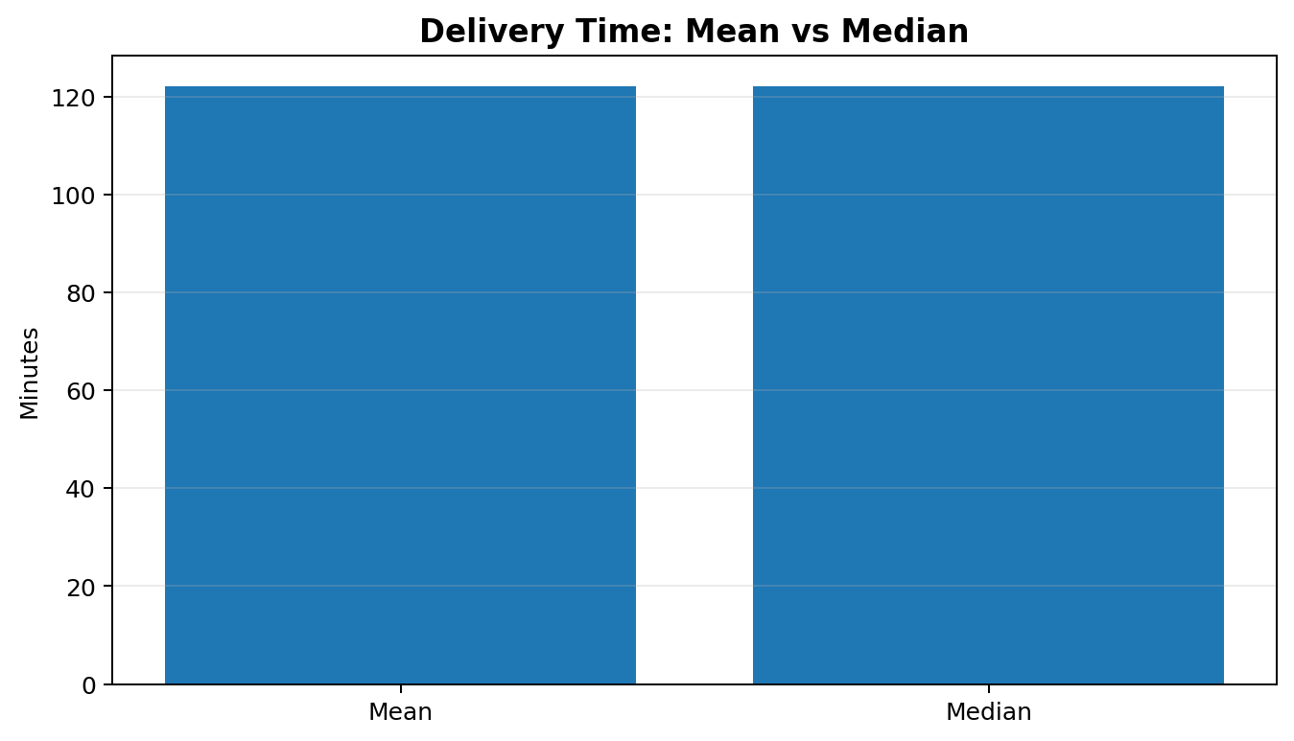
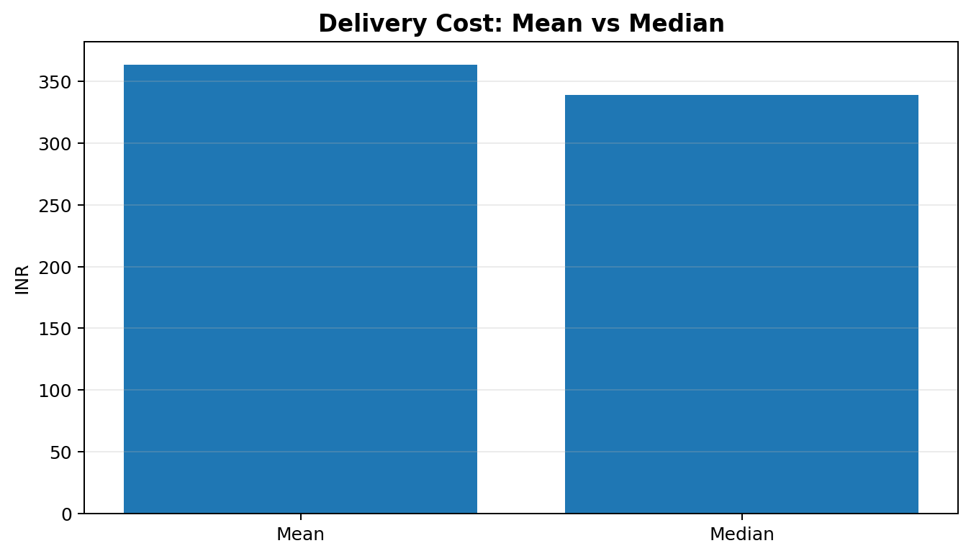

4. Delivery Performance by Traffic and Weather

4.1 Traffic level
Traffic | Deliveries | Avg. time (min) | Avg. rating
Low | 325 | 107.57 | 4.38
Medium | 428 | 124.53 | 4.27
High | 247 | 137.52 | 4.08
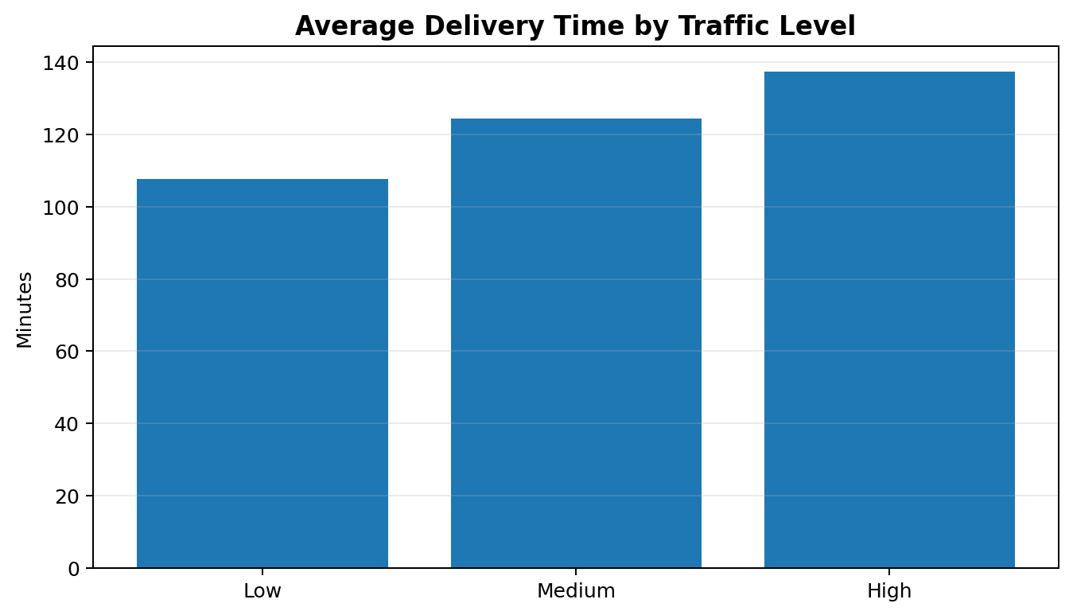
Average delivery time in high traffic was 29.95 minutes greater than in low traffic. Average ratings also declined from 4.38 in low traffic to 4.08 in high traffic. This pattern is consistent with congestion being an operational risk; it does not prove traffic alone caused delays or lower ratings.

4.2 Weather condition
Weather | Deliveries | Avg. time (min) | Avg. rating
Normal | 745 | 120.36 | 4.29
Rain | 184 | 123.61 | 4.25
Storm | 71 | 138.28 | 4.00
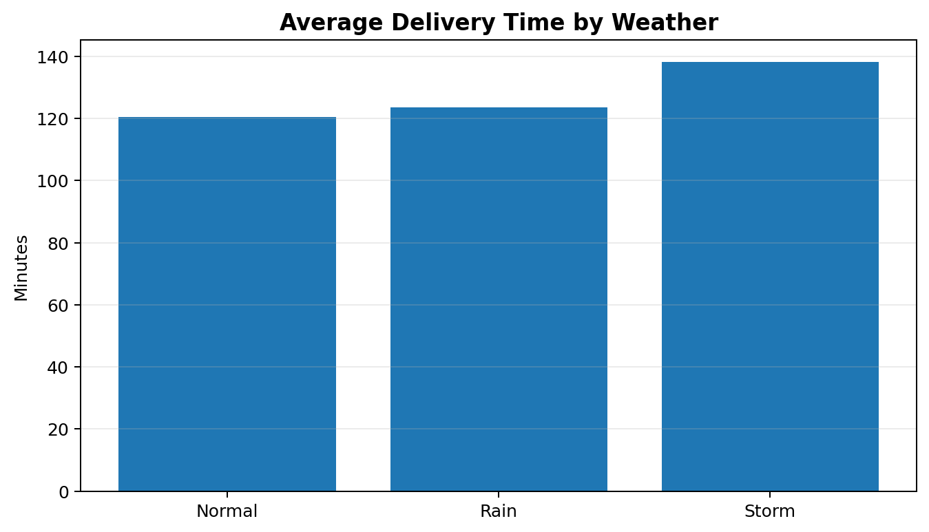
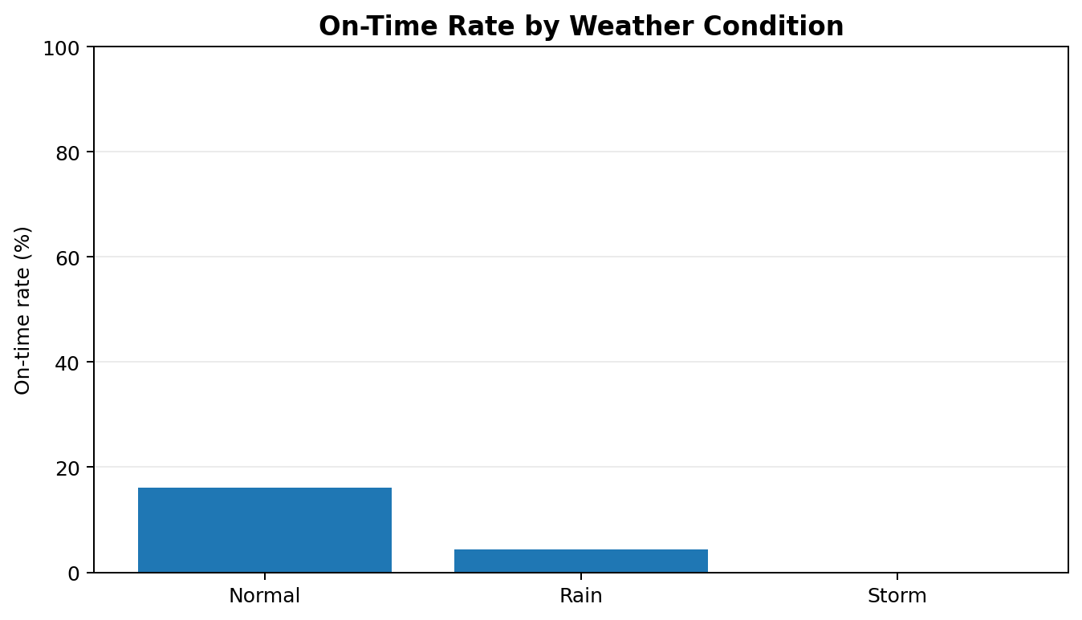
Storm deliveries averaged 17.92 minutes longer than normal-weather deliveries and had a lower average customer rating (4.00 vs. 4.29). Storm records account for 71 deliveries, so the group is smaller than the normal-weather group. Plan buffers and safe dispatch policies are reasonable recommendations to test, not conclusions that should be generalized without real data.

5. Correlation Analysis
Pearson correlation measures linear association from -1 to +1. Positive values indicate variables tend to increase together; negative values indicate one tends to decrease as the other increases. Correlation does not establish causality.
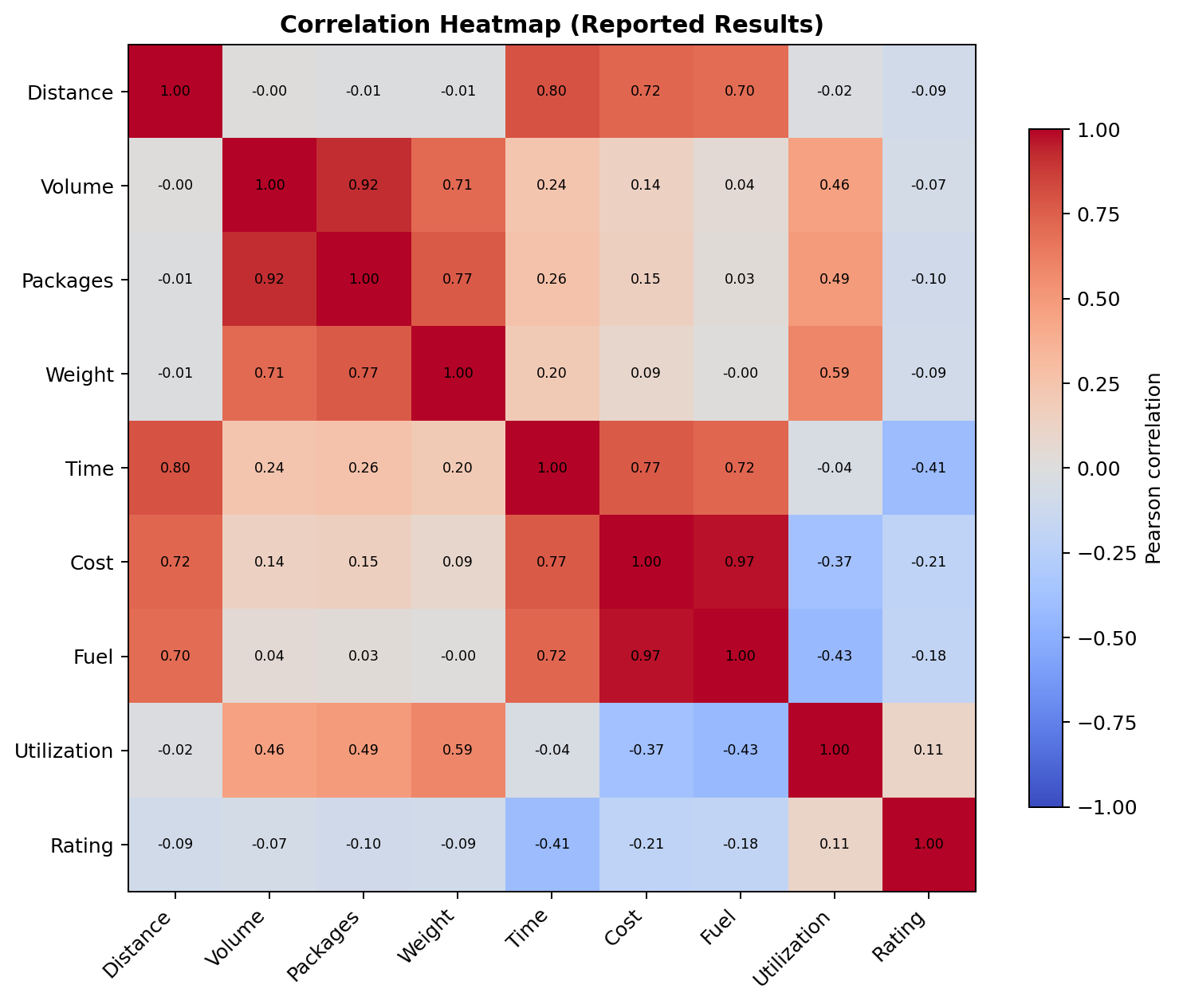
Variable pair | r | Interpretation
Fuel cost and delivery cost | +0.97 | Very strong positive association
Shipment volume and package count | +0.92 | Very strong positive association
Distance and delivery time | +0.80 | Strong positive association
Delivery time and delivery cost | +0.77 | Strong positive association
Distance and delivery cost | +0.72 | Strong positive association
Delivery time and customer rating | -0.41 | Moderate negative association
Load weight and utilization | +0.59 | Moderate positive association
Fuel cost is closely associated with total delivery cost in this synthetic dataset, partly because the data-generation rules make fuel cost a component of delivery cost. Distance is also strongly related to delivery time. Shipment volume and package count overlap substantially, so both may not be necessary in a compact predictive model. The negative relationship between delivery time and customer rating supports investigating timeliness as a customer-experience metric.

6. On-Time Delivery Performance
The dataset reports 128 on-time deliveries out of 1,000 (12.8%) and 872 not on time (87.2%). This is a low on-time rate and should be treated as a major simulated service-performance issue. Vehicle-level rates were Bike 23.44%, Truck 0.50%, and Van 8.25%. Traffic-level rates were High 0.00%, Low 31.38%, and Medium 6.07%. Weather-level rates were Normal 16.11%, Rain 4.35%, and Storm 0.00%.
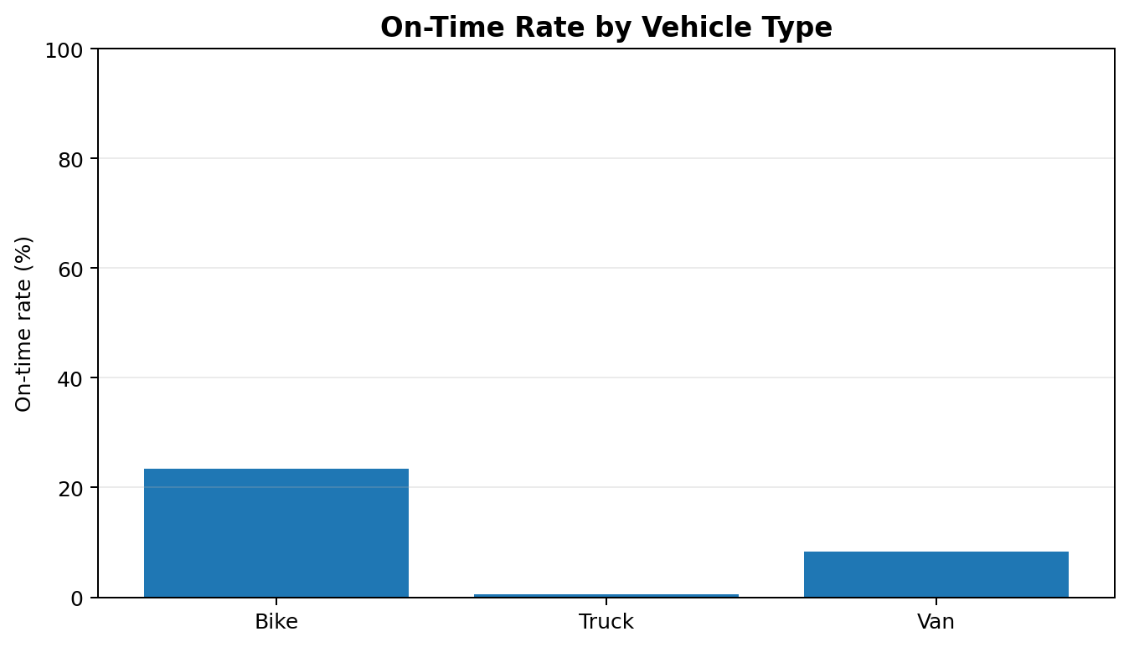
The group results align with the overall rate after converting 'Yes'/'No' to a numeric indicator. A zero rate in a category means no records in that group were labeled on time in this generated sample; it does not imply such performance is inevitable in real operations.

7. Visualization Choices
Histograms / distribution plots: Useful for understanding spread, typical values, and potential skew in continuous variables such as delivery time and cost.
Bar charts: Useful for comparing group averages or rates across discrete categories such as traffic level, weather, and vehicle type.
Correlation heatmap: Shows many pairwise relationships at once and makes strong positive or negative associations easy to spot.
Summary tables: Provide precise values and sample sizes alongside charts, reducing the risk of visual-only interpretation.

8. Recommendations
- Prioritize congestion-aware dispatch. Test route and departure-time optimization for high-traffic deliveries; compare time and on-time rate before and after.
- Build weather contingencies. Use weather forecasts to adjust ETA buffers and dispatch decisions during severe weather, while prioritizing driver safety.
- Investigate fuel-cost components. Review distance, vehicle fuel efficiency, idle time, and fuel-price assumptions; report fuel cost per kilometre in future analyses.
- Improve on-time measurement. Define promised delivery windows explicitly and validate the On_Time rule against those deadlines.
- Segment by vehicle and route. Compare vehicle performance on similar distances, loads, traffic, and zones to avoid misleading comparisons caused by different workloads.
- Track customer experience. Monitor delivery time, on-time rate, cancellation rate, and rating together, using actual operational data when available.
- Validate with real data. Before making budget or staffing decisions, repeat the analysis on verified dispatch, GPS, fuel, cost, and delivery-confirmation records.

9. Limitations
- All records are synthetic and do not represent a real logistics company.
- Some variables were generated using formulas that intentionally connect them, so high correlations may be built into the dataset.
- The On_Time field is generated from a simplified rule and should not be treated as a real service-level agreement outcome.
- Group comparisons may be affected by different route distances, shipment sizes, vehicle capacities, or sample sizes.
- Correlation is not causal evidence; further testing and real operational data are needed.

10. Selected Python Code Snippets

Load/export dataset
import pandas as pd
# Export the current analysis dataset
logistics_df.to_csv("advanced_logistics_dataset.csv", index=False)

Descriptive statistics
numerical_columns = [
"Distance_KM", "Shipment_Volume", "Package_Count",
"Load_Weight_KG", "Delivery_Time_Minutes",
"Delivery_Cost_INR", "Fuel_Cost_INR",
"Vehicle_Utilization_Percent", "Customer_Rating"
]
display(logistics_df[numerical_columns].describe().round(2))

Correlation heatmap
correlation_matrix = logistics_df[numerical_columns].corr()
plt.figure(figsize=(12, 9))
sns.heatmap(correlation_matrix, annot=True, cmap="coolwarm",
fmt=".2f", vmin=-1, vmax=1)
plt.title("Logistics Correlation Heatmap")
plt.tight_layout()
plt.show()

Correct on-time rate
logistics_df["On_Time_Flag"] = (
logistics_df["On_Time"].astype(str).str.strip().str.lower()
.eq("yes").astype(int)
)
overall_rate = logistics_df["On_Time_Flag"].mean() * 100
print(f"On-time rate: {overall_rate:.2f}%")

11. Conclusion
This analysis demonstrates how exploratory data analysis, descriptive statistics, group comparisons, and correlation analysis can be used to investigate logistics performance. The reported results highlight longer delivery times in high traffic and storm conditions, a strong association between fuel and total delivery cost, and a negative association between delivery time and customer rating. The on-time rate of 12.8% is the clearest service-level concern in the generated sample. These insights should guide questions for further investigation rather than be treated as final operational evidence. The next step is to validate the methods and findings using real, well-defined logistics data.

