**Zookeeper Running**

**Zookeeper server started successfully, listening on port 2181.**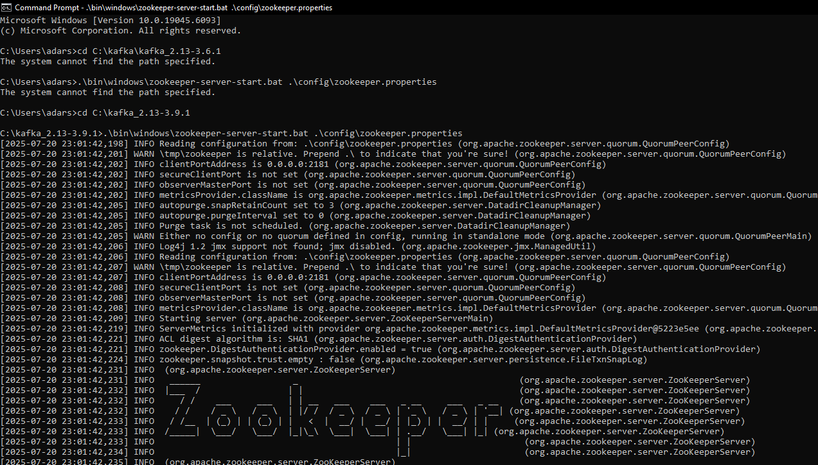

**Kafka Broker Running**

**Kafka server running on localhost:9092, accepting connections**

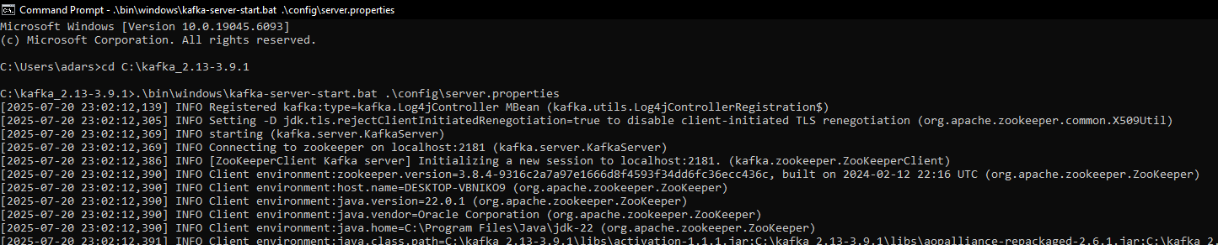

**Publisher App Console**

**User entering a message like "hellllooo” and confirmation shown: Message sent: Its Working!**

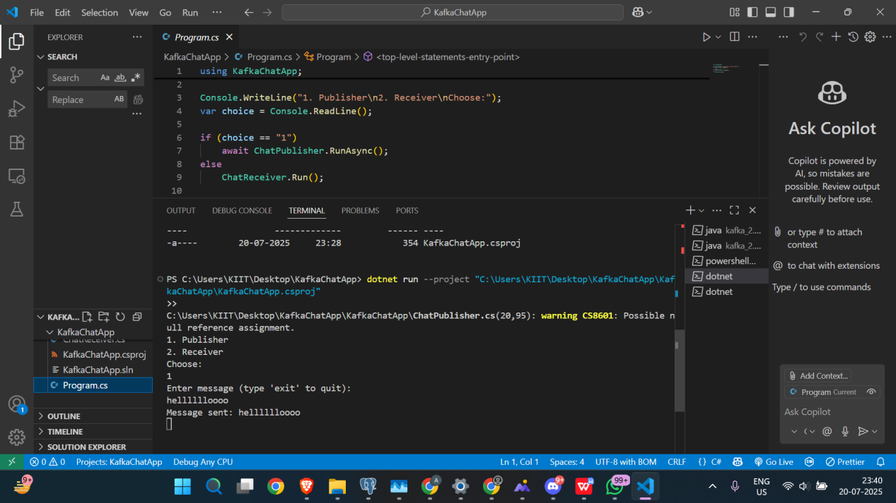

**Receiver App Console**

**Receiver printing: Received: Its Working! confirming real-time message reception**

