NDVI Vegetation Change Analysis (Shimla 2015–2025)

Input Values (from QGIS Raster Statistics)
Vegetation Gain (km²): 70.62839878676459
Vegetation Loss (km²): 182.44079686608166
Stable Vegetation (km²): 4400.2952244129265

1. Total Study Area Calculation
Formula: Total = Gain + Loss + Stable
Total = 70.62839878676459 + 182.44079686608166 + 4400.2952244129265
Total Study Area = 4653.364420 km²

2. Net Vegetation Change
Formula: Net Change = Gain − Loss
Net Change = 70.62839878676459 − 182.44079686608166
Net Vegetation Change = -111.812398 km²

3. Percentage Distribution
Gain Percentage = (Gain / Total) × 100
Gain % = (70.62839878676459 / 4653.364420065773) × 100 = 1.5178%
Loss Percentage = (Loss / Total) × 100
Loss % = (182.44079686608166 / 4653.364420065773) × 100 = 3.9206%
Stable Percentage = (Stable / Total) × 100
Stable % = (4400.2952244129265 / 4653.364420065773) × 100 = 94.5616%

4. Gross Vegetation Change
Formula: Gross Change = Gain + Loss
Gross Change = 70.62839878676459 + 182.44079686608166 = 253.069196 km²
Gross Change Percentage = (Gross Change / Total) × 100
Gross Change % = (253.06919565284625 / 4653.364420065773) × 100 = 5.4384%

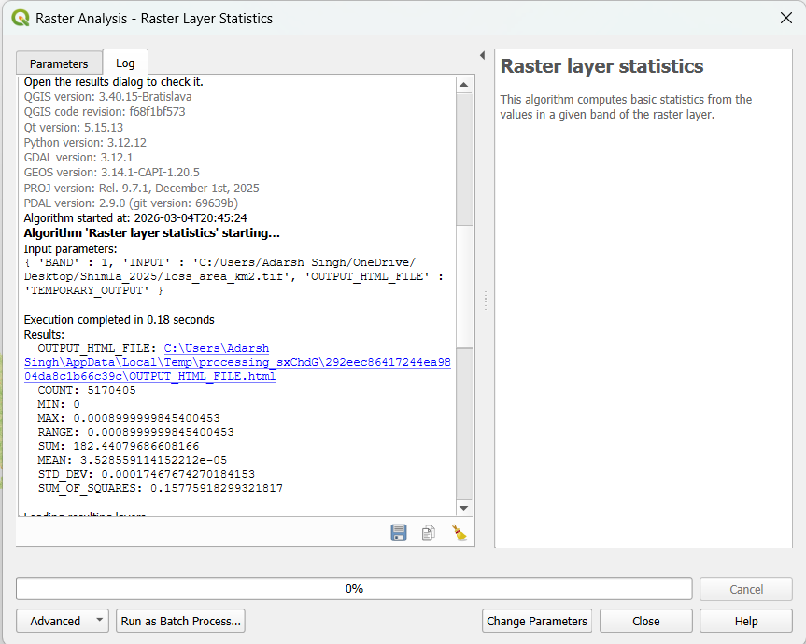

Raster Layer Statistics ( Loss Area )

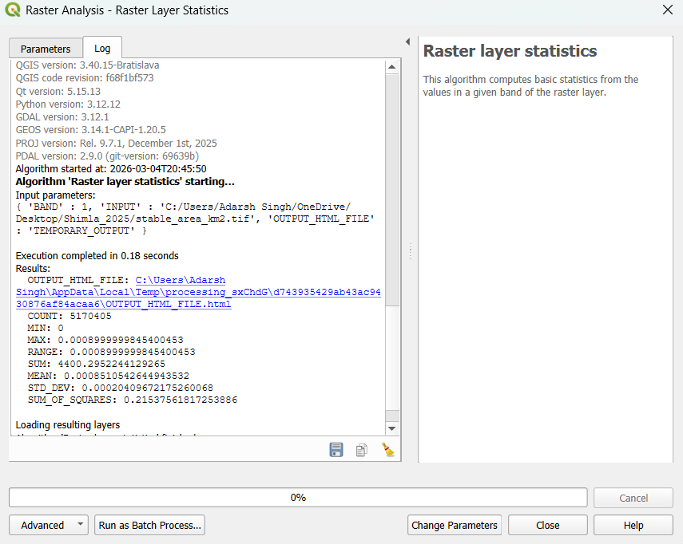

Raster Layer Statistics ( Stable Area )

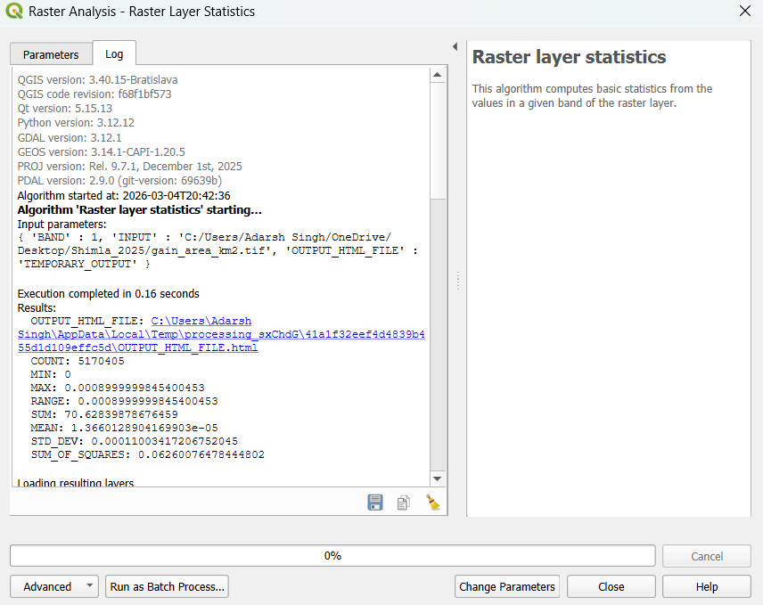

Raster Layer Statistics ( Gain Area )

