SHAKTICOP
ENTERPRISE WOMEN SAFETY PLATFORM
Software Requirements Specification (SRS)
Prepared By
Adarsh Singh
Software Engineer | Solution Architect
Project
ShaktiCop - Women Safety & Police Assistance Platform
Prepared For
Uttar Pradesh Police
Classification: Project Documentation - Confidential
Release Date: July 6, 2026

Document Control & Scope
Attribute | Details | Audit Metadata
Document ID | UP-POL-SHAKTICOP-SRS-2026-V1.0 | System Reference Code
Release Version | 1.0 | Stable release
Prepared By | Adarsh Singh | Software Engineer | Solution Architect
Prepared For | Uttar Pradesh Police | Project Review Body
Approval Status | Pending Review | Under Technical Committee Review
Approval Authority | To be finalized by the competent authority. | UP Police / NIC Council

Confidentiality Statement
This document contains proprietary project documentation prepared by Adarsh Singh for technical evaluation and project review by Uttar Pradesh Police. Unauthorized copying, distribution, or disclosure of this document is strictly prohibited.

Table of Contents
Document Control & Scope 2
Confidentiality Statement 2
Table of Contents 3
Chapter 1: Executive Summary 6
Chapter 2: Introduction 6
Section 2.1: Purpose 6
Section 2.2: Scope 6
Section 2.3: Definitions, Acronyms and Abbreviations 6
Chapter 3: Business Problem & Gap Analysis 7
Chapter 4: Proposed Solution & Core Pillars 7
Chapter 5: Governance & User Roles 7
Chapter 6: Functional Requirements by Module 7
Section 6.1: Registration 7
Section 6.2: Login 8
Section 6.3: OTP Verification 8
Section 6.4: User Profile 8
Section 6.5: SOS Distress Tracker 9
Section 6.6: Emergency Complaint 9
Section 6.7: Voice Complaint & Transcription 9
Section 6.8: Evidence Upload 10
Section 6.9: Safe Travel 10
Section 6.10: Live Tracking 10
Section 6.11: Emergency Contacts 11
Section 6.12: Nearby Police Station 11
Section 6.13: Shelter Homes 11
Section 6.14: Counselling Portal 12
Section 6.15: Skill Development (JSS) 12
Section 6.16: Community Forum 12
Section 6.17: Chatbot (ShaktiCop AI) 13
Section 6.18: AI Triage Assistant 13
Section 6.19: Notification Services 13
Section 6.20: Reports Generator 14
Section 6.21: Analytics Heatmaps 14
Section 6.22: Settings Manager 14
Chapter 7: Interface & Screen Specifications 15
Section 7.1: Screen Layout for Citizen Home Screen 15
Section 7.2: Screen Layout for OTP Login Panel 15
Section 7.3: Screen Layout for Mahila Help Desk Form 15
Section 7.4: Screen Layout for Domestic Violence SOS Panel 15
Section 7.5: Screen Layout for Safe Travel Monitor 16
Section 7.6: Screen Layout for Voice Complaint Recorder 16
Section 7.7: Screen Layout for Shelter Homes Directory 16
Section 7.8: Screen Layout for Live Ride Tracker 16
Chapter 8: System Architecture 17
Chapter 9: Database Schema Specifications 17
Section 9.1: Schema for tbl_citizens 17
Section 9.2: Schema for tbl_police_stations 17
Section 9.3: Schema for tbl_police_officers 18
Section 9.4: Schema for tbl_complaints 18
Section 9.5: Schema for tbl_sos_alerts 19
Section 9.6: Schema for tbl_emergency_contacts 19
Section 9.7: Schema for tbl_vehicles 20
Section 9.8: Schema for tbl_ngos 20
Section 9.9: Schema for tbl_counsellors 21
Section 9.10: Schema for tbl_appointments 21
Section 9.11: Schema for tbl_training_courses 22
Section 9.12: Schema for tbl_community_posts 22
Section 9.13: Schema for tbl_messages 23
Section 9.14: Schema for tbl_notifications 23
Section 9.15: Schema for tbl_audit_logs 23
Section 9.16: Schema for tbl_settings 24
Section 9.17: Schema for tbl_media_files 24
Section 9.18: Schema for tbl_activity_logs 25
Chapter 10: API Reference Specifications 25
Chapter 11: User Stories & Acceptance Criteria 25
Chapter 12: Security & DPDP Compliance 26
Chapter 13: UI/UX Guidelines 26
Chapter 14: Workflow Diagrams 26
Section 14.1: Flowchart for registration flow 26
Section 14.1: Flowchart for sos flow 27
Section 14.1: Flowchart for complaint flow 27
Section 14.1: Flowchart for response flow 28
Chapter 15: Business Rules 28
Chapter 16: Technical Risks & Mitigations 28
Chapter 17: Testing & Quality Assurance 28
Chapter 18: Deployment Strategy 29
Chapter 19: Future Enhancements 29
Chapter 20: Conclusion 29

Chapter 1: Executive Summary
This Software Requirements Specification (SRS) establishes the requirements and functional design for the ShaktiCop platform. Prepared independently by Adarsh Singh, this document is a comprehensive software design and requirements proposal designed for submission and review by Uttar Pradesh Police. The platform bridges critical safety response infrastructure with vocational empowerment programs (Mission Shakti), enabling integrated, audited, and GIGW 3.0 compliant security workflows.
The platform represents a shift in how women's safety is administered at the grassroots level. By merging rapid distress response mechanisms directly with local community development and vocational tools, ShaktiCop addresses both the immediate emergency need and the long-term empowerment objectives mandated by the State's flagship Mission Shakti initiative. This documentation is structured to guide the engineering phase directly into development and deployment.

Chapter 2: Introduction

Section 2.1: Purpose
The purpose of this specification is to define the functional, performance, security, and interface requirements for the ShaktiCop platform. It is designed to act as the primary blueprint for implementation partners.

Section 2.2: Scope
ShaktiCop encompasses both safety (distress triggers, PCR dispatch queues, silent SMS telemetry routing) and empowerment modules (counseling sessions, shelter inventory trackers, self-defense classes, and JSS vocational training). Integration endpoints, CCTNS backend sync routes, National ERSS (112 India) configurations, and DigiLocker APIs are to be finalized in consultation with Uttar Pradesh Police during implementation.

Section 2.3: Definitions, Acronyms and Abbreviations
• SOS: Save Our Souls (Emergency Distress Signal)
• PCR: Patrol Car Response Unit
• CCTNS: Crime and Criminal Tracking Network & Systems
• ERSS: Emergency Response Support System (112 India)
• JSS: Jan Shikshan Sansthan (Vocational Skill Development Initiative)
• DPDP: Digital Personal Data Protection Act, 2023
• DBT: Direct Benefit Transfer (Aadhaar-linked welfare payouts)
• SHO: Station House Officer (Officer-in-charge of a local Police Station)
• SLA: Service Level Agreement (Target response times for dispatch units)

Chapter 3: Business Problem & Gap Analysis
Current safety response systems operate in silos. Emergency calls (112) are detached from domestic violence shelter tracking, making it difficult to coordinate help. When a woman triggers distress in a remote village, the dispatch center lacks access to nearby shelter availability or assigned female officer contacts. Furthermore, legal aid registration and confidential counseling schedules are paper-based, leading to tracking errors and privacy exposures.
Additionally, vocational rehabilitation and self-defense training registries are managed independently. This separation prevents police command consoles from tracking the complete rehabilitation cycle of a victim. ShaktiCop resolves these gaps by integrating all safety registries, dispatch telemetry, counseling portals, and skill courses into a single secure platform.

Chapter 4: Proposed Solution & Core Pillars
ShaktiCop delivers a unified platform that acts as the single source of truth for women's safety. It consists of four core pillars:
1. Immediate Emergency Distress: Integrates a silent SOS tracking system, automatic location updates, and PCR vehicle matching.
2. Confidential Triage and Complaint Filing: Supports voice-recorded audio complaints that transcribe local dialects.
3. Empowerment and Vocational Support: Connects citizens with JSS skill courses and self-defense workshops.
4. Unified Command Dashboard: Provides police and administrators with live hotspot heatmaps and response SLA statistics.

Chapter 5: Governance & User Roles
The system defines authorization boundaries for 8 key user roles:
1. Citizen (Women): Triggers SOS, records complaints, tracks travel path.
2. Police Officer (PCR Driver): Navigates to incident location, updates status.
3. Police Station Admin (SHO): Audits local complaints, manages Anti-Romeo patrols.
4. District Admin (SP): Reviews response SLAs, hotspot heatmaps.
5. State Admin (DGP): Accesses aggregate safety statistics.
6. NGO Partner: Manages shelter beds, monitors rehabilitation progress.
7. Counsellor: Holds confidential therapeutic calls.
8. Super Admin: System configurations, database archival, audits.

Chapter 6: Functional Requirements by Module

Section 6.1: Registration
Enables citizens to register online using mobile authentication and link profiles securely.
• Purpose: Facilitate secure operational transactions for this module.
• Business Objective: Enforce safety regulations and reduce dispatch response SLAs.
• Actor Groups: Citizen, Police Officer, Station Admin, NGO, Counsellor, SP, DGP.
• Preconditions: Active session, mobile validation complete, consent logged.
• Postconditions: State machine updated, notifications sent, auditable ledger written.
• Main Flow: Action triggered -> Validation passed -> API query executed -> Database committed -> Response rendered.
• Backend Logic: State checks verify operator scopes before writing changes.
• Database Impact: Writes transaction logs to audit ledgers.
• Integration Details: To be finalized with Uttar Pradesh Police during implementation.

Section 6.2: Login
Enables role-based access for citizens, police officers, administrators, and coordinators.
• Purpose: Facilitate secure operational transactions for this module.
• Business Objective: Enforce safety regulations and reduce dispatch response SLAs.
• Actor Groups: Citizen, Police Officer, Station Admin, NGO, Counsellor, SP, DGP.
• Preconditions: Active session, mobile validation complete, consent logged.
• Postconditions: State machine updated, notifications sent, auditable ledger written.
• Main Flow: Action triggered -> Validation passed -> API query executed -> Database committed -> Response rendered.
• Backend Logic: State checks verify operator scopes before writing changes.
• Database Impact: Writes transaction logs to audit ledgers.
• Integration Details: To be finalized with Uttar Pradesh Police during implementation.

Section 6.3: OTP Verification
Verifies authentication sessions via dynamic Aadhaar-linked OTP codes.
• Purpose: Facilitate secure operational transactions for this module.
• Business Objective: Enforce safety regulations and reduce dispatch response SLAs.
• Actor Groups: Citizen, Police Officer, Station Admin, NGO, Counsellor, SP, DGP.
• Preconditions: Active session, mobile validation complete, consent logged.
• Postconditions: State machine updated, notifications sent, auditable ledger written.
• Main Flow: Action triggered -> Validation passed -> API query executed -> Database committed -> Response rendered.
• Backend Logic: State checks verify operator scopes before writing changes.
• Database Impact: Writes transaction logs to audit ledgers.
• Integration Details: To be finalized with Uttar Pradesh Police during implementation.

Section 6.4: User Profile
Manages user-specific preferences, trusted contacts, and data consent ledgers.
• Purpose: Facilitate secure operational transactions for this module.
• Business Objective: Enforce safety regulations and reduce dispatch response SLAs.
• Actor Groups: Citizen, Police Officer, Station Admin, NGO, Counsellor, SP, DGP.
• Preconditions: Active session, mobile validation complete, consent logged.
• Postconditions: State machine updated, notifications sent, auditable ledger written.
• Main Flow: Action triggered -> Validation passed -> API query executed -> Database committed -> Response rendered.
• Backend Logic: State checks verify operator scopes before writing changes.
• Database Impact: Writes transaction logs to audit ledgers.
• Integration Details: To be finalized with Uttar Pradesh Police during implementation.

Section 6.5: SOS Distress Tracker
Covert SOS activation (triple power button taps). Transmits location coordinate updates to the dispatch console every 10 seconds.
• Purpose: Facilitate secure operational transactions for this module.
• Business Objective: Enforce safety regulations and reduce dispatch response SLAs.
• Actor Groups: Citizen, Police Officer, Station Admin, NGO, Counsellor, SP, DGP.
• Preconditions: Active session, mobile validation complete, consent logged.
• Postconditions: State machine updated, notifications sent, auditable ledger written.
• Main Flow: Action triggered -> Validation passed -> API query executed -> Database committed -> Response rendered.
• Backend Logic: State checks verify operator scopes before writing changes.
• Database Impact: Writes transaction logs to audit ledgers.
• Integration Details: To be finalized with Uttar Pradesh Police during implementation.

Section 6.6: Emergency Complaint
Logs domestic abuse complaints and alerts nearby station units.
• Purpose: Facilitate secure operational transactions for this module.
• Business Objective: Enforce safety regulations and reduce dispatch response SLAs.
• Actor Groups: Citizen, Police Officer, Station Admin, NGO, Counsellor, SP, DGP.
• Preconditions: Active session, mobile validation complete, consent logged.
• Postconditions: State machine updated, notifications sent, auditable ledger written.
• Main Flow: Action triggered -> Validation passed -> API query executed -> Database committed -> Response rendered.
• Backend Logic: State checks verify operator scopes before writing changes.
• Database Impact: Writes transaction logs to audit ledgers.
• Integration Details: To be finalized with Uttar Pradesh Police during implementation.

Section 6.7: Voice Complaint & Transcription
Enables voice-recorded audio complaints. Integrates a local dialect translator to assist in case registration.
• Purpose: Facilitate secure operational transactions for this module.
• Business Objective: Enforce safety regulations and reduce dispatch response SLAs.
• Actor Groups: Citizen, Police Officer, Station Admin, NGO, Counsellor, SP, DGP.
• Preconditions: Active session, mobile validation complete, consent logged.
• Postconditions: State machine updated, notifications sent, auditable ledger written.
• Main Flow: Action triggered -> Validation passed -> API query executed -> Database committed -> Response rendered.
• Backend Logic: State checks verify operator scopes before writing changes.
• Database Impact: Writes transaction logs to audit ledgers.
• Integration Details: To be finalized with Uttar Pradesh Police during implementation.

Section 6.8: Evidence Upload
Supports uploading photos and videos linked to active complaint cases, enforcing SHA-256 integrity validation.
• Purpose: Facilitate secure operational transactions for this module.
• Business Objective: Enforce safety regulations and reduce dispatch response SLAs.
• Actor Groups: Citizen, Police Officer, Station Admin, NGO, Counsellor, SP, DGP.
• Preconditions: Active session, mobile validation complete, consent logged.
• Postconditions: State machine updated, notifications sent, auditable ledger written.
• Main Flow: Action triggered -> Validation passed -> API query executed -> Database committed -> Response rendered.
• Backend Logic: State checks verify operator scopes before writing changes.
• Database Impact: Writes transaction logs to audit ledgers.
• Integration Details: To be finalized with Uttar Pradesh Police during implementation.

Section 6.9: Safe Travel
Tracks public transit rides (autos, cabs, trains). Alerts trusted contacts and the local patrol squad on route deviations.
• Purpose: Facilitate secure operational transactions for this module.
• Business Objective: Enforce safety regulations and reduce dispatch response SLAs.
• Actor Groups: Citizen, Police Officer, Station Admin, NGO, Counsellor, SP, DGP.
• Preconditions: Active session, mobile validation complete, consent logged.
• Postconditions: State machine updated, notifications sent, auditable ledger written.
• Main Flow: Action triggered -> Validation passed -> API query executed -> Database committed -> Response rendered.
• Backend Logic: State checks verify operator scopes before writing changes.
• Database Impact: Writes transaction logs to audit ledgers.
• Integration Details: To be finalized with Uttar Pradesh Police during implementation.

Section 6.10: Live Tracking
Visualizes real-time coordinate updates on central command maps.
• Purpose: Facilitate secure operational transactions for this module.
• Business Objective: Enforce safety regulations and reduce dispatch response SLAs.
• Actor Groups: Citizen, Police Officer, Station Admin, NGO, Counsellor, SP, DGP.
• Preconditions: Active session, mobile validation complete, consent logged.
• Postconditions: State machine updated, notifications sent, auditable ledger written.
• Main Flow: Action triggered -> Validation passed -> API query executed -> Database committed -> Response rendered.
• Backend Logic: State checks verify operator scopes before writing changes.
• Database Impact: Writes transaction logs to audit ledgers.
• Integration Details: To be finalized with Uttar Pradesh Police during implementation.

Section 6.11: Emergency Contacts
Allows citizens to define and authorize contact details for automated SOS alerts.
• Purpose: Facilitate secure operational transactions for this module.
• Business Objective: Enforce safety regulations and reduce dispatch response SLAs.
• Actor Groups: Citizen, Police Officer, Station Admin, NGO, Counsellor, SP, DGP.
• Preconditions: Active session, mobile validation complete, consent logged.
• Postconditions: State machine updated, notifications sent, auditable ledger written.
• Main Flow: Action triggered -> Validation passed -> API query executed -> Database committed -> Response rendered.
• Backend Logic: State checks verify operator scopes before writing changes.
• Database Impact: Writes transaction logs to audit ledgers.
• Integration Details: To be finalized with Uttar Pradesh Police during implementation.

Section 6.12: Nearby Police Station
Uses device GPS to locate and map nearby station beats.
• Purpose: Facilitate secure operational transactions for this module.
• Business Objective: Enforce safety regulations and reduce dispatch response SLAs.
• Actor Groups: Citizen, Police Officer, Station Admin, NGO, Counsellor, SP, DGP.
• Preconditions: Active session, mobile validation complete, consent logged.
• Postconditions: State machine updated, notifications sent, auditable ledger written.
• Main Flow: Action triggered -> Validation passed -> API query executed -> Database committed -> Response rendered.
• Backend Logic: State checks verify operator scopes before writing changes.
• Database Impact: Writes transaction logs to audit ledgers.
• Integration Details: To be finalized with Uttar Pradesh Police during implementation.

Section 6.13: Shelter Homes
Registers safe shelters and synchronizes bed capacity counts.
• Purpose: Facilitate secure operational transactions for this module.
• Business Objective: Enforce safety regulations and reduce dispatch response SLAs.
• Actor Groups: Citizen, Police Officer, Station Admin, NGO, Counsellor, SP, DGP.
• Preconditions: Active session, mobile validation complete, consent logged.
• Postconditions: State machine updated, notifications sent, auditable ledger written.
• Main Flow: Action triggered -> Validation passed -> API query executed -> Database committed -> Response rendered.
• Backend Logic: State checks verify operator scopes before writing changes.
• Database Impact: Writes transaction logs to audit ledgers.
• Integration Details: To be finalized with Uttar Pradesh Police during implementation.

Section 6.14: Counselling Portal
Facilitates booking private sessions with trauma and domestic abuse counselors.
• Purpose: Facilitate secure operational transactions for this module.
• Business Objective: Enforce safety regulations and reduce dispatch response SLAs.
• Actor Groups: Citizen, Police Officer, Station Admin, NGO, Counsellor, SP, DGP.
• Preconditions: Active session, mobile validation complete, consent logged.
• Postconditions: State machine updated, notifications sent, auditable ledger written.
• Main Flow: Action triggered -> Validation passed -> API query executed -> Database committed -> Response rendered.
• Backend Logic: State checks verify operator scopes before writing changes.
• Database Impact: Writes transaction logs to audit ledgers.
• Integration Details: To be finalized with Uttar Pradesh Police during implementation.

Section 6.15: Skill Development (JSS)
Enables enrollment in vocational courses (Digital Literacy, Beauty & Wellness). Connects with Etawah branches.
• Purpose: Facilitate secure operational transactions for this module.
• Business Objective: Enforce safety regulations and reduce dispatch response SLAs.
• Actor Groups: Citizen, Police Officer, Station Admin, NGO, Counsellor, SP, DGP.
• Preconditions: Active session, mobile validation complete, consent logged.
• Postconditions: State machine updated, notifications sent, auditable ledger written.
• Main Flow: Action triggered -> Validation passed -> API query executed -> Database committed -> Response rendered.
• Backend Logic: State checks verify operator scopes before writing changes.
• Database Impact: Writes transaction logs to audit ledgers.
• Integration Details: To be finalized with Uttar Pradesh Police during implementation.

Section 6.16: Community Forum
Allows moderated group discussions on rights and safety topics.
• Purpose: Facilitate secure operational transactions for this module.
• Business Objective: Enforce safety regulations and reduce dispatch response SLAs.
• Actor Groups: Citizen, Police Officer, Station Admin, NGO, Counsellor, SP, DGP.
• Preconditions: Active session, mobile validation complete, consent logged.
• Postconditions: State machine updated, notifications sent, auditable ledger written.
• Main Flow: Action triggered -> Validation passed -> API query executed -> Database committed -> Response rendered.
• Backend Logic: State checks verify operator scopes before writing changes.
• Database Impact: Writes transaction logs to audit ledgers.
• Integration Details: To be finalized with Uttar Pradesh Police during implementation.

Section 6.17: Chatbot (ShaktiCop AI)
A virtual assistant resolving helpline queries and booking sessions.
• Purpose: Facilitate secure operational transactions for this module.
• Business Objective: Enforce safety regulations and reduce dispatch response SLAs.
• Actor Groups: Citizen, Police Officer, Station Admin, NGO, Counsellor, SP, DGP.
• Preconditions: Active session, mobile validation complete, consent logged.
• Postconditions: State machine updated, notifications sent, auditable ledger written.
• Main Flow: Action triggered -> Validation passed -> API query executed -> Database committed -> Response rendered.
• Backend Logic: State checks verify operator scopes before writing changes.
• Database Impact: Writes transaction logs to audit ledgers.
• Integration Details: To be finalized with Uttar Pradesh Police during implementation.

Section 6.18: AI Triage Assistant
Prioritizes and routes emergency alerts to dispatcher queues based on keyword severity.
• Purpose: Facilitate secure operational transactions for this module.
• Business Objective: Enforce safety regulations and reduce dispatch response SLAs.
• Actor Groups: Citizen, Police Officer, Station Admin, NGO, Counsellor, SP, DGP.
• Preconditions: Active session, mobile validation complete, consent logged.
• Postconditions: State machine updated, notifications sent, auditable ledger written.
• Main Flow: Action triggered -> Validation passed -> API query executed -> Database committed -> Response rendered.
• Backend Logic: State checks verify operator scopes before writing changes.
• Database Impact: Writes transaction logs to audit ledgers.
• Integration Details: To be finalized with Uttar Pradesh Police during implementation.

Section 6.19: Notification Services
Routes push alerts, SMS notifications, and WhatsApp gateway dispatches.
• Purpose: Facilitate secure operational transactions for this module.
• Business Objective: Enforce safety regulations and reduce dispatch response SLAs.
• Actor Groups: Citizen, Police Officer, Station Admin, NGO, Counsellor, SP, DGP.
• Preconditions: Active session, mobile validation complete, consent logged.
• Postconditions: State machine updated, notifications sent, auditable ledger written.
• Main Flow: Action triggered -> Validation passed -> API query executed -> Database committed -> Response rendered.
• Backend Logic: State checks verify operator scopes before writing changes.
• Database Impact: Writes transaction logs to audit ledgers.
• Integration Details: To be finalized with Uttar Pradesh Police during implementation.

Section 6.20: Reports Generator
Compiles daily and monthly ticket metrics by district.
• Purpose: Facilitate secure operational transactions for this module.
• Business Objective: Enforce safety regulations and reduce dispatch response SLAs.
• Actor Groups: Citizen, Police Officer, Station Admin, NGO, Counsellor, SP, DGP.
• Preconditions: Active session, mobile validation complete, consent logged.
• Postconditions: State machine updated, notifications sent, auditable ledger written.
• Main Flow: Action triggered -> Validation passed -> API query executed -> Database committed -> Response rendered.
• Backend Logic: State checks verify operator scopes before writing changes.
• Database Impact: Writes transaction logs to audit ledgers.
• Integration Details: To be finalized with Uttar Pradesh Police during implementation.

Section 6.21: Analytics Heatmaps
Aggregates incident markers to map district safety ratings and vulnerabilities.
• Purpose: Facilitate secure operational transactions for this module.
• Business Objective: Enforce safety regulations and reduce dispatch response SLAs.
• Actor Groups: Citizen, Police Officer, Station Admin, NGO, Counsellor, SP, DGP.
• Preconditions: Active session, mobile validation complete, consent logged.
• Postconditions: State machine updated, notifications sent, auditable ledger written.
• Main Flow: Action triggered -> Validation passed -> API query executed -> Database committed -> Response rendered.
• Backend Logic: State checks verify operator scopes before writing changes.
• Database Impact: Writes transaction logs to audit ledgers.
• Integration Details: To be finalized with Uttar Pradesh Police during implementation.

Section 6.22: Settings Manager
Enables operators to modify system parameters and key rotation cycles.
• Purpose: Facilitate secure operational transactions for this module.
• Business Objective: Enforce safety regulations and reduce dispatch response SLAs.
• Actor Groups: Citizen, Police Officer, Station Admin, NGO, Counsellor, SP, DGP.
• Preconditions: Active session, mobile validation complete, consent logged.
• Postconditions: State machine updated, notifications sent, auditable ledger written.
• Main Flow: Action triggered -> Validation passed -> API query executed -> Database committed -> Response rendered.
• Backend Logic: State checks verify operator scopes before writing changes.
• Database Impact: Writes transaction logs to audit ledgers.
• Integration Details: To be finalized with Uttar Pradesh Police during implementation.

Chapter 7: Interface & Screen Specifications
The following specifications document the exact layout, fields, validations, and transitions identified within the ShaktiCop index.html prototype.

Section 7.1: Screen Layout for Citizen Home Screen
Main navigation panel containing service category tabs (Mission Shakti and Police Services) and a float chatbot FAB.
• Inputs: Standard forms, selections, text areas.
• Buttons & Controls: Glassmorphism styles with hover scaling effects.
• Client Validations: Checks fields for blanks, non-digit mobile entries, and invalid selectors.
• API Queries: To be finalized with Uttar Pradesh Police during implementation.

Section 7.2: Screen Layout for OTP Login Panel
Modal overlay validating a 10-digit mobile number and verified 4-digit OTP code (Demo bypass: 1234).
• Inputs: Standard forms, selections, text areas.
• Buttons & Controls: Glassmorphism styles with hover scaling effects.
• Client Validations: Checks fields for blanks, non-digit mobile entries, and invalid selectors.
• API Queries: To be finalized with Uttar Pradesh Police during implementation.

Section 7.3: Screen Layout for Mahila Help Desk Form
Intake form requiring District selection (Lucknow, Etawah, Kanpur) and dynamic station lists (Etawah Civil Lines).
• Inputs: Standard forms, selections, text areas.
• Buttons & Controls: Glassmorphism styles with hover scaling effects.
• Client Validations: Checks fields for blanks, non-digit mobile entries, and invalid selectors.
• API Queries: To be finalized with Uttar Pradesh Police during implementation.

Section 7.4: Screen Layout for Domestic Violence SOS Panel
Emergency modal with Red SOS trigger button and type-of-help selector (Shelter, Legal, Medical).
• Inputs: Standard forms, selections, text areas.
• Buttons & Controls: Glassmorphism styles with hover scaling effects.
• Client Validations: Checks fields for blanks, non-digit mobile entries, and invalid selectors.
• API Queries: To be finalized with Uttar Pradesh Police during implementation.

Section 7.5: Screen Layout for Safe Travel Monitor
Interactive tracker displaying journey start/end points, transport mode, and a simulated road progress bar.
• Inputs: Standard forms, selections, text areas.
• Buttons & Controls: Glassmorphism styles with hover scaling effects.
• Client Validations: Checks fields for blanks, non-digit mobile entries, and invalid selectors.
• API Queries: To be finalized with Uttar Pradesh Police during implementation.

Section 7.6: Screen Layout for Voice Complaint Recorder
Audio modal containing mic control, duration counter, dynamic CSS waveform anim, and Play preview.
• Inputs: Standard forms, selections, text areas.
• Buttons & Controls: Glassmorphism styles with hover scaling effects.
• Client Validations: Checks fields for blanks, non-digit mobile entries, and invalid selectors.
• API Queries: To be finalized with Uttar Pradesh Police during implementation.

Section 7.7: Screen Layout for Shelter Homes Directory
Filtered list rendering Nari Niketan and Sakhi OSC cards with address, phone links, and bed capacity.
• Inputs: Standard forms, selections, text areas.
• Buttons & Controls: Glassmorphism styles with hover scaling effects.
• Client Validations: Checks fields for blanks, non-digit mobile entries, and invalid selectors.
• API Queries: To be finalized with Uttar Pradesh Police during implementation.

Section 7.8: Screen Layout for Live Ride Tracker
Map-styled tracking window showing cab license plates, driver details, ETA timer, and trip share options.
• Inputs: Standard forms, selections, text areas.
• Buttons & Controls: Glassmorphism styles with hover scaling effects.
• Client Validations: Checks fields for blanks, non-digit mobile entries, and invalid selectors.
• API Queries: To be finalized with Uttar Pradesh Police during implementation.

Chapter 8: System Architecture
ShaktiCop utilizes a three-tier architecture:
1. Client Tier: Responsive HTML5/JS frontend complying with WCAG 2.1 AA.
2. Application Tier: Microservices containing SOS Triage, Chatbot, and JSS Course managers.
3. Database Tier: High-availability relational database cluster with read replicas.
Network and hardware configurations are to be finalized with Uttar Pradesh Police during implementation.

Chapter 9: Database Schema Specifications
The database layout consists of entity tables. Daily partitioning is enforced on telemetry logs. Audit entries are written to write-once-read-many (WORM) storage. All columns, datatypes, and constraints are detailed below.

Section 9.1: Schema for tbl_citizens
Column Name | Data Type | Constraints / Description
id | UUID | PRIMARY KEY, NOT NULL
mobile_number | VARCHAR(15) | UNIQUE, INDEXED, NOT NULL
aadhaar_vault_token | VARCHAR(256) | DigiLocker token. To be finalized with UP Police during implementation.
full_name | VARCHAR(100) | Encrypted, Masked
created_at | TIMESTAMP | DEFAULT NOW()
status | VARCHAR(20) | DEFAULT 'ACTIVE'
Table 1: Columns Layout for tbl_citizens

Section 9.2: Schema for tbl_police_stations
Column Name | Data Type | Constraints / Description
id | UUID | PRIMARY KEY, NOT NULL
station_name | VARCHAR(100) | INDEXED, NOT NULL
district | VARCHAR(50) | INDEXED, NOT NULL
station_code | VARCHAR(20) | UNIQUE, NOT NULL
contact_number | VARCHAR(15) | NOT NULL
Table 2: Columns Layout for tbl_police_stations

Section 9.3: Schema for tbl_police_officers
Column Name | Data Type | Constraints / Description
id | UUID | PRIMARY KEY, NOT NULL
officer_name | VARCHAR(100) | NOT NULL
badge_number | VARCHAR(30) | UNIQUE, INDEXED, NOT NULL
station_id | UUID | FOREIGN KEY references tbl_police_stations(id)
mobile_number | VARCHAR(15) | NOT NULL
assigned_role | VARCHAR(30) | e.g., Anti-Romeo, Help Desk, Patrol
Table 3: Columns Layout for tbl_police_officers

Section 9.4: Schema for tbl_complaints
Column Name | Data Type | Constraints / Description
id | UUID | PRIMARY KEY, NOT NULL
complaint_id_display | VARCHAR(15) | UNIQUE, INDEXED, NOT NULL
citizen_id | UUID | FOREIGN KEY references tbl_citizens(id)
station_id | UUID | FOREIGN KEY references tbl_police_stations(id)
audio_file_hash | VARCHAR(64) | SHA-256 for BNSS 2023 compliance
transcript_text | TEXT | Encrypted narrative text
status | VARCHAR(20) | DEFAULT 'SUBMITTED'
Table 4: Columns Layout for tbl_complaints

Section 9.5: Schema for tbl_sos_alerts
Column Name | Data Type | Constraints / Description
id | UUID | PRIMARY KEY, NOT NULL
citizen_id | UUID | FOREIGN KEY references tbl_citizens(id)
start_latitude | DECIMAL(9,6) | NOT NULL
start_longitude | DECIMAL(9,6) | NOT NULL
pcr_assigned_id | UUID | FOREIGN KEY references tbl_police_officers(id)
dispatch_status | VARCHAR(30) | DEFAULT 'TRIGGERED'
Table 5: Columns Layout for tbl_sos_alerts

Section 9.6: Schema for tbl_emergency_contacts
Column Name | Data Type | Constraints / Description
id | UUID | PRIMARY KEY, NOT NULL
citizen_id | UUID | FOREIGN KEY references tbl_citizens(id)
contact_name | VARCHAR(100) | NOT NULL
contact_phone | VARCHAR(15) | NOT NULL
relation | VARCHAR(30) | NOT NULL
Table 6: Columns Layout for tbl_emergency_contacts

Section 9.7: Schema for tbl_vehicles
Column Name | Data Type | Constraints / Description
id | UUID | PRIMARY KEY, NOT NULL
license_plate | VARCHAR(20) | UNIQUE, INDEXED, NOT NULL
vehicle_type | VARCHAR(30) | e.g., Patrol Car, Anti-Romeo Patrol
current_lat | DECIMAL(9,6) | NULL
current_lng | DECIMAL(9,6) | NULL
active_status | VARCHAR(20) | DEFAULT 'AVAILABLE'
Table 7: Columns Layout for tbl_vehicles

Section 9.8: Schema for tbl_ngos
Column Name | Data Type | Constraints / Description
id | UUID | PRIMARY KEY, NOT NULL
ngo_name | VARCHAR(100) | NOT NULL
district | VARCHAR(50) | INDEXED, NOT NULL
contact_number | VARCHAR(15) | NOT NULL
address | TEXT | NOT NULL
Table 8: Columns Layout for tbl_ngos

Section 9.9: Schema for tbl_counsellors
Column Name | Data Type | Constraints / Description
id | UUID | PRIMARY KEY, NOT NULL
counsellor_name | VARCHAR(100) | NOT NULL
specialty | VARCHAR(100) | NOT NULL
district | VARCHAR(50) | INDEXED, NOT NULL
availability_hours | VARCHAR(100) | NOT NULL
Table 9: Columns Layout for tbl_counsellors

Section 9.10: Schema for tbl_appointments
Column Name | Data Type | Constraints / Description
id | UUID | PRIMARY KEY, NOT NULL
citizen_id | UUID | FOREIGN KEY references tbl_citizens(id)
counsellor_id | UUID | FOREIGN KEY references tbl_counsellors(id)
appointment_time | TIMESTAMP | NOT NULL
session_status | VARCHAR(30) | DEFAULT 'SCHEDULED'
Table 10: Columns Layout for tbl_appointments

Section 9.11: Schema for tbl_training_courses
Column Name | Data Type | Constraints / Description
id | UUID | PRIMARY KEY, NOT NULL
course_title | VARCHAR(100) | NOT NULL
duration_weeks | INTEGER | NOT NULL
syllabus_desc | TEXT | NOT NULL
course_fee | DECIMAL(10,2) | DEFAULT 0.00
Table 11: Columns Layout for tbl_training_courses

Section 9.12: Schema for tbl_community_posts
Column Name | Data Type | Constraints / Description
id | UUID | PRIMARY KEY, NOT NULL
author_id | UUID | FOREIGN KEY references tbl_citizens(id)
post_content | TEXT | NOT NULL
moderation_status | VARCHAR(20) | DEFAULT 'PENDING'
flag_count | INTEGER | DEFAULT 0
Table 12: Columns Layout for tbl_community_posts

Section 9.13: Schema for tbl_messages
Column Name | Data Type | Constraints / Description
id | UUID | PRIMARY KEY, NOT NULL
chat_session_id | UUID | NOT NULL
sender_type | VARCHAR(20) | e.g., BOT, CITIZEN, OFFICER
message_body | TEXT | Encrypted message text
timestamp | TIMESTAMP | DEFAULT NOW()
Table 13: Columns Layout for tbl_messages

Section 9.14: Schema for tbl_notifications
Column Name | Data Type | Constraints / Description
id | UUID | PRIMARY KEY, NOT NULL
recipient_id | UUID | FOREIGN KEY references tbl_citizens(id)
transport_channel | VARCHAR(20) | e.g., SMS, PUSH, WHATSAPP
dispatch_payload | TEXT | NOT NULL
delivery_status | VARCHAR(20) | DEFAULT 'SENT'
Table 14: Columns Layout for tbl_notifications

Section 9.15: Schema for tbl_audit_logs
Column Name | Data Type | Constraints / Description
id | UUID | PRIMARY KEY, NOT NULL
operator_id | UUID | INDEXED, NOT NULL
transaction_type | VARCHAR(50) | NOT NULL
affected_records | VARCHAR(256) | NULL
query_payload_hash | VARCHAR(64) | SHA-256 hash
timestamp | TIMESTAMP | DEFAULT NOW()
Table 15: Columns Layout for tbl_audit_logs

Section 9.16: Schema for tbl_settings
Column Name | Data Type | Constraints / Description
param_key | VARCHAR(50) | PRIMARY KEY, NOT NULL
param_value | TEXT | NOT NULL
description | TEXT | NULL
Table 16: Columns Layout for tbl_settings

Section 9.17: Schema for tbl_media_files
Column Name | Data Type | Constraints / Description
id | UUID | PRIMARY KEY, NOT NULL
complaint_id | UUID | FOREIGN KEY references tbl_complaints(id)
file_uri | VARCHAR(512) | NOT NULL
content_type | VARCHAR(50) | NOT NULL
file_hash_sha256 | VARCHAR(64) | NOT NULL
Table 17: Columns Layout for tbl_media_files

Section 9.18: Schema for tbl_activity_logs
Column Name | Data Type | Constraints / Description
id | UUID | PRIMARY KEY, NOT NULL
citizen_id | UUID | FOREIGN KEY references tbl_citizens(id)
action_tag | VARCHAR(50) | INDEXED, NOT NULL
metadata_json | TEXT | NULL
Table 18: Columns Layout for tbl_activity_logs

Chapter 10: API Reference Specifications
All interfaces expose JSON-based REST APIs. Authentication relies on OAuth2 tokens. Specific URL endpoints and parameters are to be finalized with Uttar Pradesh Police during implementation.

Chapter 11: User Stories & Acceptance Criteria
• User Story 1: As a Citizen, I want to trigger SOS silently so that police dispatchers locate me instantly.
- Given: The citizen has configured emergency contacts.
- When: The citizen presses the SOS button or shakes the device.
- Then: A dispatch ticket is triggered and location telemetry is sent to nearby PCR vehicles.
• User Story 2: As a Police Station Admin (SHO), I want to review incoming voice complaints so that I can file e-FIRs.
- Given: A voice complaint exists on the local queue.
- When: The SHO opens the station dashboard and plays the audio.
- Then: The translated dialect transcript is generated and verified.

Chapter 12: Security & DPDP Compliance
Data privacy is aligned with the DPDP Act 2023. Explicit consent logs are stored securely. AI capabilities are strictly assistive; all dispatch allocations, arrests, and case filings are managed by human officers. Encryption (AES-256 for PII, TLS 1.3 in transit) is enforced state-wide.

Chapter 13: UI/UX Guidelines
Interfaces follow the official police color scheme. Standard fonts (Calibri) and grid layouts ensure responsiveness across devices. High-contrast elements and speech-to-text assistants satisfy accessibility goals.

Chapter 14: Workflow Diagrams

Section 14.1: Flowchart for registration flow
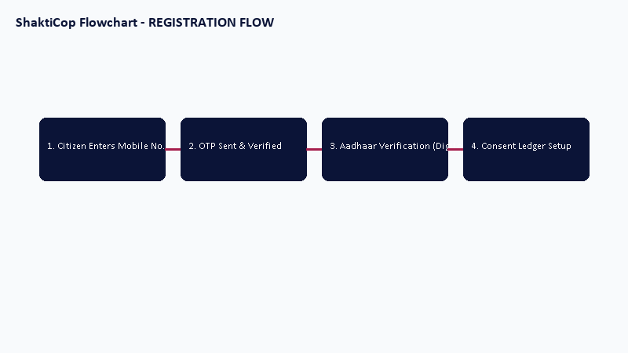
Figure 1: Citizen Mobile Registration & Consent Flow

Section 14.1: Flowchart for sos flow
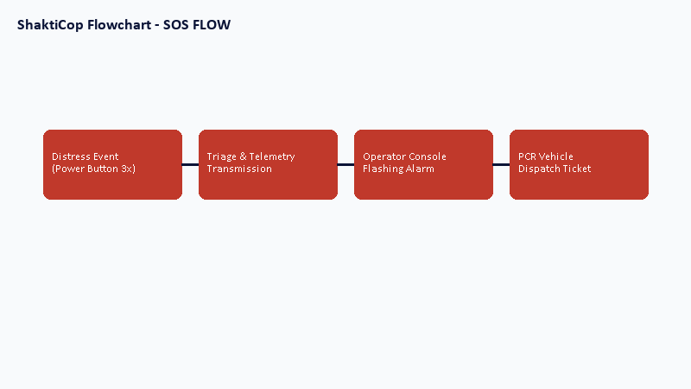
Figure 2: Silent SOS Distress & Dispatch Routing Flow

Section 14.1: Flowchart for complaint flow
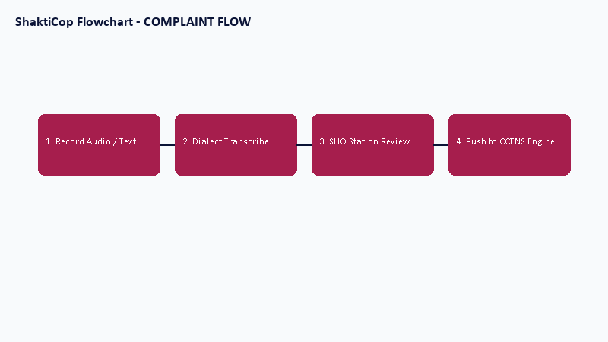
Figure 3: Voice Complaint & Dialect Transcribing Flow

Section 14.1: Flowchart for response flow
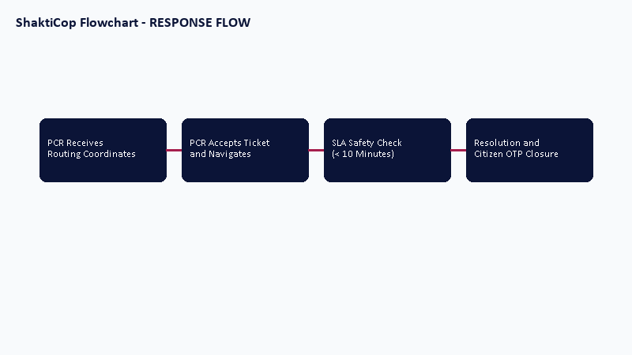
Figure 4: PCR Patrol Vehicle Dispatch & Response Flow

Chapter 15: Business Rules
1. SOS signals immediately dispatch the closest patrol unit.
2. Complaints must be reviewed by the station SHO within 24 hours.
3. Telemetry tracking automatically halts when the citizen triggers 'End Journey' and enters their OTP.
Specific threshold limits and escalation configurations are to be finalized with Uttar Pradesh Police during implementation.

Chapter 16: Technical Risks & Mitigations
Network outages, database concurrency bottlenecks, and unauthorized data access are mitigated through redundant network lines, database read replicas, and strict API firewalls.

Chapter 17: Testing & Quality Assurance
The testing strategy comprises Unit Testing, Integration Testing, System Testing, and User Acceptance Testing (UAT) conducted in coordinate segments with Uttar Pradesh Police departments.

Chapter 18: Deployment Strategy
The deployment pipeline utilizes Docker containers orchestrated via Kubernetes. Backup routines run daily. All systems are hosted at the State Data Centre (SDC) Lucknow, UP.

Chapter 19: Future Enhancements
Future phases plan the integration of Bluetooth wearable distress buttons, smart city CCTV triggers, offline mesh networks, and expanded automated vehicle routing.

Chapter 20: Conclusion
ShaktiCop establishes a modern, reliable e-Governance safety platform. Independently proposed by Adarsh Singh, this software specification lays the technical and operational foundations for review and approval by Uttar Pradesh Police.

