Introduction
NS (Version 2) is an open source network simulation tool. It is an object oriented, discrete event driven simulator written in C++ and Otcl. The primary use of NS is in network researches to simulate various types of wired/wireless local and wide area networks; to implement network protocols such as TCP and UPD, traffic source behavior such as FTP, Telnet, Web, CBR and VBR, router queue management mechanism such as Drop Tail, RED and CBQ, routing algorithms such as Dijkstra, and many more.
Ns2 is written in C++ and Otcl to separate the control and data path implementations. The simulator supports a class hierarchy in C++ (the compiled hierarchy) and a corresponding hierarchy within the Otcl interpreter (interpreted hierarchy).
The reason why ns2 uses two languages is that different tasks have different requirements: For example simulation of protocols requires efficient manipulation of bytes and packet headers making the run-time speed very important. On the other hand, in network studies where the aim is to vary some parameters and to quickly examine a number of scenarios the time to change the model and run it again is more important.
In ns2, C++ is used for detailed protocol implementation and in general for such cases where every packet of a flow has to be processed. For instance, if you want to implement a new queuing discipline, then C++ is the language of choice. Otcl, on the other hand, is suitable for configuration and setup. Otcl runs quite slowly, but it can be changed very quickly making the construction of simulations easier. In ns2, the compiled C++ objects can be made available to the Otcl interpreter. In this way, the ready-made C++ objects can be controlled from the OTcl level.

Otcl basics
This chapter introduces the syntax and some basic commands of the Otcl language that are used by ns2. It is important to understand how Otcl works before moving to the part that deals with the creation of the actual simulation scenario.

Assigning values to variables
In tcl, values can be stored to variables and these values can be further used in commands:
set a 5
set b [expr $a/5]
In the first line, the variable a is assigned the value “5”. In the second line, the result of the command [expr $a/5], which equals 1, is then used as an argument to another command, which in turn assigns a value to the variable b. The “$” sign is used to obtain a value contained in a variable and square brackets are an indication of a command substitution.

Procedures
One can define new procedures with the proc command. The first argument to proc is the name of the procedure and the second argument contains the list of the argument names to that procedure. For instance a procedure that calculates the sum of two numbers can be defined as follows:
proc sum {a b} {
expr $a + $b
}
The next procedure calculates the factorial of a number:
proc factorial a {
if {$a <= 1} {
return 1
}
#here the procedure is called again
expr $x * [factorial [expr $x-1]]
}
It is also possible to give an empty string as an argument list. However, in this case the variables that are used by the procedure have to be defined as global. For instance:
proc sum {} {
global a b
expr $a + $b
}

Files and lists
In tcl, a file can be opened for reading with the command:
set testfile [open test.dat r]
The first line of the file can be stored to a list with a command:
gets $testfile list
Now it is possible to obtain the elements of the list with commands (numbering of elements starts from 0) :
set first [lindex $list 0]
set second [lindex $list 1]
Similarly, a file can be written with a puts command:
set testfile [open test.dat w]
puts $testfile “testi”

Calling subprocesses
The command exec creates a subprocess and waits for it to complete. The use of exec is similar to giving a command line to a shell program. For instance, to remove a file:
exec rm $testfile
The exec command is particularly useful when one wants to call a tcl-script from within another tclscript. For instance, in order to run the tcl-script example.tcl multiple times with the value of the parameter “test” ranging from 1 to 10, one can type the following lines to another tcl-script:

for {set ind 1} {$ind <= 10} {incr ind} {
set test $ind
exec ns example.tcl test
}

Creating the topology
To be able to run a simulation scenario, a network topology must first be created. In ns2, the topology consists of a collection of nodes and links.
Before the topology can be set up, a new simulator object must be created at the beginning of the script with the command:
set ns [new Simulator]
The simulator object has member functions that enable creating the nodes and the links, connecting agents etc. All these basic functions can be found from the class Simulator. When using functions belonging to this class, the command begins with “$ns”, since ns was defined to be a handle to the Simulator object.

Nodes
New node objects can be created with the command:
set n0 [$ns node]
set n1 [$ns node]
set n2 [$ns node]
set n3 [$ns node]
The member function of the Simulator class, called “node” creates four nodes and assigns them to the handles n0, n1, n2 and n3. These handles can later be used when referring to the nodes. If the node is not a router but an end system, traffic agents (TCP, UDP etc.) and traffic sources (FTP,CBR etc.) must be set up, i.e, sources need to be attached to the agents and the agents to the nodes, respectively.

Agents, applications and traffic sources
The most common agents used in ns2 are UDP and TCP agents. In case of a TCP agent, several types are available. The most common agent types are:
- Agent/TCP – a Tahoe TCP sender
- Agent/TCP/Reno – a Reno TCP sender
- Agent/TCP/Sack1 – TCP with selective acknowledgement
The most common applications and traffic sources provided by ns2 are:
- Application/FTP – produces bulk data that TCP will send
- Application/Traffic/CBR – generates packets with a constant bit rate
- Application/Traffic/Exponential – during off-periods, no traffic is sent. During on-periods, packets are generated with a constant rate. The length of both on and off-periods is exponentially distributed.
- Application/Traffic/Trace – Traffic is generated from a trace file, where the sizes and interarrival times of the packets are defined.
In addition to these ready-made applications, it is possible to generate traffic by using the methods provided by the class Agent. For example, if one wants to send data over UDP, the method
send(int nbytes)
can be used at the tcl-level provided that the udp-agent is first configured and attached to some node.
Below is a complete example of how to create a CBR traffic source using UDP as transport protocol and attach it to node n0:
set udp0 [new Agent/UDP]
$ns attach-agent $n0 $udp0
set cbr0 [new Application/Traffic/CBR]
$cbr0 attach-agent $udp0
$cbr0 set packet_size_ 1000
$udp0 set packet_size_ 1000
$cbr0 set rate_ 1000000
An FTP application using TCP as a transport protocol can be created and attached to node n1 in much the same way:
set tcp1 [new Agent/TCP]
$ns attach-agent $n1 $tcp1
set ftp1 [new Application/FTP]
$ftp1 attach-agent $tcp1
$tcp1 set packet_size_ 1000
The UDP and TCP classes are both child-classes of the class Agent. With the expressions [new Agent/TCP] and [new Agent/UDP] the properties of these classes can be combined to the new objects udp0 and tcp1. These objects are then attached to nodes n0 and n1. Next, the application is defined and attached to the transport protocol. Finally, the configuration parameters of the traffic source are set. In case of CBR, the traffic can be defined by parameters rate_ (or equivalently interval_, determining the interarrival time of the packets), packetSize_ and random_ . With the random_ parameter it is possible to add some randomness in the interarrival times of the packets. The default value is 0, meaning that no randomness is added.

Traffic Sinks
If the information flows are to be terminated without processing, the udp and tcp sources have to be connected with traffic sinks. A TCP sink is defined in the class Agent/TCPSink and an UDP sink is defined in the class Agent/Null.
A UDP sink can be attached to n2 and connected with udp0 in the following way:
set null [new Agent/Null]
$ns attach-agent $n2 $null
$ns connect $udp0 $null
A standard TCP sink that creates one acknowledgement per a received packet can be attached to n3 and connected with tcp1 with the commands:
set sink [new Agent/Sink]
$ns attach-agent $n3 $sink
$ns connect $tcp1 $sink
There is also a shorter way to define connections between a source and the destination with the command:
$ns create-connection <srctype> <src> <dsttype> <dst> <pktclass>
For example, to create a standard TCP connection between n1 and n3 with a class ID of 1:
$ns create-connection TCP $n1 TCPSink $n3 1
One can very easily create several tcp-connections by using this command inside a for-loop.

Links
Links are required to complete the topology. In ns2, the output queue of a node is implemented as part of the link, so when creating links the user also has to define the queue-type.
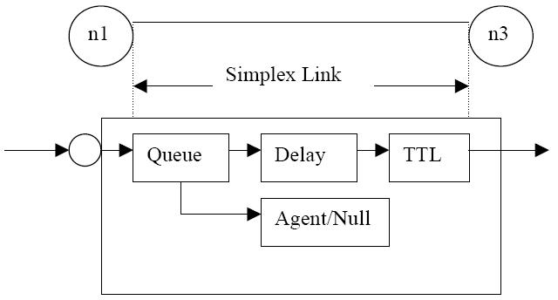
Figure 2 Link in ns2

Figure 2 shows the construction of a simplex link in ns2. If a duplex-link is created, two simplex links will be created, one for each direction. In the link, packet is first enqueued at the queue. After this, it is either dropped, passed to the Null Agent and freed there, or dequeued and passed to the Delay object which simulates the link delay. Finally, the TTL (time to live) value is calculated and updated.
Links can be created with the following command:
$ns duplex/simplex-link endpoint1 endpoint2 bandwidth delay queue-type
For example, to create a duplex-link with DropTail queue management between n0 and n2:
$ns duplex-link $n0 $n2 15Mb 10ms DropTail
Creating a simplex-link with RED queue management between n1 and n3:
$ns simplex-link $n1 $n3 10Mb 5ms RED
The values for bandwidth can be given as a pure number or by using qualifiers k (kilo), M (mega), b (bit) and B (byte). The delay can also be expressed in the same manner, by using m (milli) and u (mikro) as qualifiers. There are several queue management algorithms implemented in ns2, but in this exercise only DropTail and RED will be needed.

Tracing and monitoring
In order to be able to calculate the results from the simulations, the data has to be collected somehow. NS2 supports two primary monitoring capabilities: traces and monitors. The traces enable recording of packets whenever an event such as packet drop or arrival occurs in a queue or a link. The monitors provide a means for collecting quantities, such as number of packet drops or number of arrived packets in the queue. The monitor can be used to collect these quantities for all packets or just for a specified flow (a flow monitor).

Traces
All events from the simulation can be recorded to a file with the following commands:
set trace_all [open all.dat w]
$ns trace-all $trace_all
$ns flush-trace
close $trace_all
First, the output file is opened and a handle is attached to it. Then the events are recorded to the file specified by the handle. Finally, at the end of the simulation the trace buffer has to be flushed and the file has to be closed. This is usually done with a separate finish procedure. If links are created after these commands, additional objects for tracing (EnqT, DeqT, DrpT and RecvT) will be inserted into them.
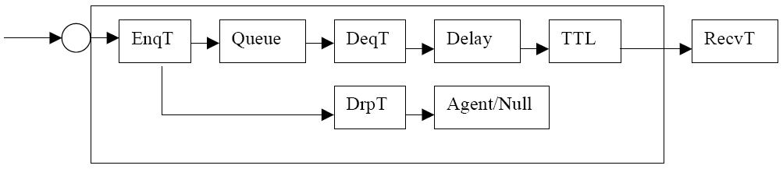
Figure 3 Link in ns2 when tracing is enabled
These new objects will then write to a trace file whenever they receive a packet. The format of the trace file is following:
+ 1.84375 0 2 cbr 210 ------- 0 0.0 3.1 225 610
- 1.84375 0 2 cbr 210 ------- 0 0.0 3.1 225 610
r 1.84471 2 1 cbr 210 ------- 1 3.0 1.0 195 600
r 1.84566 2 0 ack 40 ------- 2 3.2 0.1 82 602
+ 1.84566 0 2 tcp 1000 ------- 2 0.1 3.2 102 611
- 1.84566 0 2 tcp 1000 ------- 2 0.1 3.2 102 611

+ : enqueue
- : dequeue
d : drop
r : receive
The fields in the trace file are: type of the event, simulation time when the event occurred, source and destination nodes, packet type (protocol, action or traffic source), packet size, flags, flow id, source and destination addresses, sequence number and packet id. In addition to tracing all events of the simulation, it is also possible to create a trace object between a particular source and a destination with the command:
$ns create-trace <type> <file> <src> <dest>
where the type can be, for instance,
- Enque – a packet arrival (for instance at a queue)
- Deque – a packet departure (for instance at a queue)
- Drop – packet drop
- Recv – packet receive at the destination
Tracing all events from a simulation to a specific file and then calculating the desired quantities from this file for instance by using perl or awk and Matlab is an easy way and suitable when the topology is relatively simple and the number of sources is limited. However, with complex topologies and many sources this way of collecting data can become too slow. The trace files will also consume a significant amount of disk space.

Monitors
With a queue monitor it is possible to track the statistics of arrivals, departures and drops in either bytes or packets. Optionally the queue monitor can also keep an integral of the queue size over time.
For instance, if there is a link between nodes n0 and n1, the queue monitor can be set up as follows:
set qmon0 [$ns monitor-queue $n0 $n1]
The packet arrivals and byte drops can be tracked with the commands:
set parr [$qmon0 set parrivals_]
set bdrop [$qmon0 set bdrops_]
Besides assigning a value to a variable the set command can also be used to get the value of a variable. For example here the set command is used to get the value of the variable “parrivals” defined in the queue monitor class.
A flow monitor is similar to the queue monitor but it keeps track of the statistics for a flow rather than for aggregated traffic. A classifier first determines which flow the packet belongs to and then passes the packet to the flow monitor.
The flowmonitor can be created and attached to a particular link with the commands:
set fmon [$ns makeflowmon Fid]
$ns attach-fmon [$ns link $n1 $n3] $fmon
Notice that since these commands are related to the creation of the flow-monitor, the commands are defined in the Simulator class, not in the Flowmonitor class. The variables and commands in the Flowmonitor class can be used after the monitor is created and attached to a link. For instance, to dump the contents of the flowmonitor (all flows):
$fmon dump
If you want to track the statistics for a particular flow, a classifier must be defined so that it selects the flow based on its flow id, which could be for instance 1:
set fclassifier [$fmon classifier]
set flow [$fclassifier lookup auto 0 0 1]

Controlling the simulation
After the simulation topology is created, agents are configured etc., the start and stop of the simulation and other events have to be scheduled. The simulation can be started and stopped with the commands
$ns at $simtime “finish”
$ns run

The first command schedules the procedure finish at the end of the simulation, and the second command actually starts the simulation. The finish procedure has to be defined to flush the trace buffer, close the trace files and terminate the program with the exit routine. It can optionally start NAM (a graphical network animator), post process information and plot this information.
The finish procedure has to contain at least the following elements:
proc finish {} {
global ns trace_all
$ns flush-trace
close $trace_all
exit 0
}
Other events, such as the starting or stopping times of the clients can be scheduled in the following way:
$ns at 0.0 “cbr0 start”
$ns at 50.0 “ftp1start”
$ns at $simtime “cbr0 stop”
$ns at $simtime “ftp1 stop”
If you have defined your own procedures, you can also schedule the procedure to start for example every 5 seconds in the following way:
proc example {} {
global ns
set interval 5
….
…
$ns at [expr $now + $interval] “example”
}

Simple Simulation Example
This section presents a simple NS simulation script and explains what each line does. Example 3 is an OTcl script which creates the simple network configuration and runs the simulation scenario in Figure 4. To run this simulation, copy the code in Example 3 in a file named "ns-simple.tcl" and type "ns ns-simple.tcl" at shell prompt.
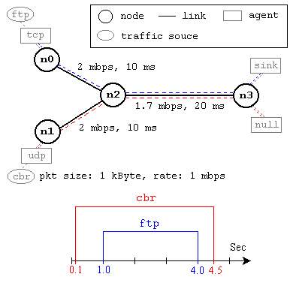
Figure 4. A Simple Network Topology and Simulation Scenario
The network consists of 4 nodes (n0, n1, n2, n3) as shown in above figure. The duplex links between n0 and n2, and n1 and n2 have 2 Mbps of bandwidth and 10 ms of delay. The duplex link between n2 and n3 has 1.7 Mbps of bandwidth and 20 ms of delay. Each node uses a DropTail queue, of which the maximum size is 10. A "tcp" agent is attached to n0, and a connection is established to a tcp "sink" agent attached to n3. As default, the maximum size of a packet that a "tcp" agent can generate is 1KByte. A tcp "sink" agent generates and sends ACK packets to the sender (tcp agent) and frees the received packets. A "udp" agent that is attached to n1 is connected to a "null" agent attached to n3. A "null" agent just frees the packets received. A "ftp" and a "cbr" traffic generator are attached to "tcp" and "udp" agents respectively, and the "cbr" is configured to generate 1 KByte packets at the rate of 1 Mbps. The "cbr" is set to start at 0.1 sec and stop at 4.5 sec, and "ftp" is set to start at 1.0 sec and stop at 4.0 sec.
#Create a simulator object
set ns [new Simulator]

#Define different colors for data flows (for NAM)
$ns color 1 Blue
$ns color 2 Red

#Open the NAM trace file
set nf [open out.nam w]
$ns namtrace-all $nf

#Define a 'finish' procedure
proc finish {} {
global ns nf
$ns flush-trace
#Close the NAM trace file
close $nf
#Execute NAM on the trace file
exec nam out.nam &
exit 0
}

#Create four nodes
set n0 [$ns node]
set n1 [$ns node]
set n2 [$ns node]
set n3 [$ns node]

#Create links between the nodes
$ns duplex-link $n0 $n2 2Mb 10ms DropTail
$ns duplex-link $n1 $n2 2Mb 10ms DropTail
$ns duplex-link $n2 $n3 1.7Mb 20ms DropTail

#Set Queue Size of link (n2-n3) to 10
$ns queue-limit $n2 $n3 10

#Give node position (for NAM)
$ns duplex-link-op $n0 $n2 orient right-down
$ns duplex-link-op $n1 $n2 orient right-up
$ns duplex-link-op $n2 $n3 orient right

#Monitor the queue for link (n2-n3). (for NAM)
$ns duplex-link-op $n2 $n3 queuePos 0.5

#Setup a TCP connection
set tcp [new Agent/TCP]
$tcp set class_ 2
$ns attach-agent $n0 $tcp
set sink [new Agent/TCPSink]
$ns attach-agent $n3 $sink
$ns connect $tcp $sink
$tcp set fid_ 1

#Setup a FTP over TCP connection
set ftp [new Application/FTP]
$ftp attach-agent $tcp
$ftp set type_ FTP

#Setup a UDP connection
set udp [new Agent/UDP]
$ns attach-agent $n1 $udp
set null [new Agent/Null]
$ns attach-agent $n3 $null
$ns connect $udp $null
$udp set fid_ 2

#Setup a CBR over UDP connection
set cbr [new Application/Traffic/CBR]
$cbr attach-agent $udp
$cbr set type_ CBR
$cbr set packet_size_ 1000
$cbr set rate_ 1mb
$cbr set random_ false

#Schedule events for the CBR and FTP agents
$ns at 0.1 "$cbr start"
$ns at 1.0 "$ftp start"
$ns at 4.0 "$ftp stop"
$ns at 4.5 "$cbr stop"

#Detach tcp and sink agents (not really necessary)
$ns at 4.5 "$ns detach-agent $n0 $tcp ; $ns detach-agent $n3 $sink"

#Call the finish procedure after 5 seconds of simulation time
$ns at 5.0 "finish"

#Print CBR packet size and interval
puts "CBR packet size = [$cbr set packet_size_]"
puts "CBR interval = [$cbr set interval_]"

#Run the simulation
$ns run
Example 3. A Simple NS Simulation Script
The following is the explanation of the script above. In general, an NS script starts with making a Simulator object instance.
- set ns [new Simulator]: generates an NS simulator object instance, and assigns it to variable ns (italics is used for variables and values in this section). What this line does is the following:
  - Create a scheduler (default is calendar scheduler)
The "Simulator" object has member functions that do the following:
  - Create compound objects such as nodes and links (described later)
  - Connect network component objects created (ex. attach-agent)
  - Set network component parameters (mostly for compound objects)
  - Create connections between agents (ex. make connection between a "tcp" and "sink")
  - Specify NAM display options
  - Etc.
Most of member functions are for simulation setup and scheduling, however some of them are for the NAM display. The "Simulator" object member function implementations are located in the "ns-2/tcl/lib/ns-lib.tcl" file.
- $ns color fid color: is to set color of the packets for a flow specified by the flow id (fid). This is for the NAM display, and has no effect on the actual simulation.
- $ns namtrace-all file-descriptor: It tells the simulator to record simulation traces in NAM input format. It also gives the file name that the trace will be written to later by the command $ns flush-trace. Similarly, the member function trace-all is for recording the simulation trace in a general format.
- proc finish {}: is called after this simulation is over by the command $ns at 5.0 "finish". In this function, post-simulation processes are specified.
- set n0 [$ns node]: The member function node creates a node.
- $ns duplex-link node1 node2 bandwidth delay queue-type: creates two simplex links of specified bandwidth and delay, and connects the two specified nodes. In NS, the output queue of a node is implemented as a part of a link, therefore users should specify the queue-type when creating links. In the above simulation script, DropTail queue is used.
- $ns queue-limit node1 node2 number: This line sets the queue limit of the two simplex links that connect node1 and node2 to the number specified.
- $ns duplex-link-op node1 node2 ...: The next couple of lines are used for the NAM display. This line of code is used to monitor the queue for the link between the nodes node1 and node2. User can see the packets in the queue, and after a while the user can even see how the packets are being dropped.
Now that the basic network setup is done, the next thing to do is to setup traffic agents such as TCP and UDP, traffic sources such as FTP and CBR, and attach them to nodes and agents respectively.
- set tcp [new Agent/TCP]: This line creates a TCP agent. To create agents or traffic sources, a user should know the class names these objects (Agent/TCP, Agnet/TCPSink, Application/FTP and so on).
- $ns attach-agent node agent: The attach-agent member function attaches an agent object created to a node object. Actually, this function calls the attach member function of specified node, which attaches the given agent to itself. Therefore, a user can do the same thing by, for example, $n0 attach $tcp.
- $ns connect agent1 agent2: After two agents that will communicate with each other are created, the next thing is to establish a logical network connection between them.
Assuming that all the network configuration is done, the next thing to do is write a simulation scenario (i.e. simulation scheduling). The Simulator object has many scheduling member functions. However, the one that is mostly used is the following:
- $ns at time "string": This member function of a Simulator object makes the scheduler (scheduler_ is the variable that points the scheduler object created by [new Scheduler] command at the beginning of the script) to schedule the execution of the specified string at given simulation time. For example, $ns at 0.1 "$cbr start" will make the scheduler call a start member function of the CBR traffic source object, which starts the CBR to transmit data.
After all network configurations, scheduling and post-simulation procedure specifications are done, the only thing left is to run the simulation. This is done by $ns run.

Extending NS: Creating a new Agent
One can extend NS by adding new protocols. This section will discuss about how a new agent can be created in NS using an example. The code in this section implements some sort of simple ‘ping’ protocol. One node will send n user defined number packets, one at a time at regular intervals, to another node which will return the packet immediately. For each packet the sender will then calculate the round trip time.

The header file
First we have to create a header file “myPing.h” in which we will define the data structure for the myPing packet header.
struct hdr_myPing {
char ret;
double send_time;

// Header access methods
static int offset_; // required by PacketHeaderManager
inline static int& offset() { return offset_; }
inline static hdr_myPing* access(const Packet* p) {
return (hdr_myPing*) p->access(offset_);
}
};

The char ‘ret’ is going to be set to '0' if the packet is on its way from the sender to the node which is being pinged, while it is going to be set to '1' on its way back. The double 'send_time' is a time stamp that is set on the packet when it is sent. This time is later used by the sender to calculate the round-trip-time. The rest of the part of program codes of the header are used to access the packet header from any packet reference.
The following piece of code declares the class ‘MyPingAgent’ as a subclass of the class ‘Agent’.
class MyPingAgent : public Agent {
public:
MyPingAgent();
int command(int argc, const char*const* argv);
void recv(Packet*, Handler*);
void send_packets();
protected:
int num_packets_;
double wait_interval_;
MyPingAgentTimer timer_;
int count;
};

The ‘num_packets_’ variable holds the total number of packets that will be sent by the sender and ‘wait_interval_’ is the time interval between two successive packets. The variable ‘count’ keeps the count of packets sent so far. We also have to define a timer handler (MyPingAgentTimer) for the sender so that it can reschedule itself each time after sending a packet. MyPingAgent will use a variable ‘timer_’ of type MyPingAgentTimer to keep track of time. The source code for the header file “myPing.h” is given below:

/* myPing.h */

#ifndef ns_myPing_h
#define ns_myPing_h

#include "agent.h"
#include "tclcl.h"
#include "packet.h"
#include "address.h"
#include "ip.h"

class MyPingAgent;

struct hdr_myPing {
char ret;
double send_time;

// Header access methods
static int offset_; // required by PacketHeaderManager
inline static int& offset() { return offset_; }
inline static hdr_myPing* access(const Packet* p) {
return (hdr_myPing*) p->access(offset_);
}
};

class MyPingAgentTimer : public TimerHandler {
public:
MyPingAgentTimer(MyPingAgent *t) : TimerHandler()
{ t_ = t; }
protected:
virtual void expire(Event *e);
MyPingAgent *t_;
};

class MyPingAgent : public Agent {
public:
MyPingAgent();
int command(int argc, const char*const* argv);
void recv(Packet*, Handler*);
void send_packets();
protected:
int num_packets_;
double wait_interval_;
MyPingAgentTimer timer_;
int count;
};

#endif
Table 1. MyPing.h

The C++ code for new Agent
First the linkage between the C++ code and Tcl code has to be defined.
static class kangAbHeaderClass : public PacketHeaderClass {
public:
kangAbHeaderClass() : PacketHeaderClass ("PacketHeader/MyPing", sizeof(hdr_myPing)) {
bind_offset(&hdr_myPing::offset_);
}
} class_kangAbhdrSnd;

static class MyPingAgentClass : public TclClass {
public:
MyPingAgentClass() : TclClass("Agent/MyPing") {}
TclObject* create(int, const char*const*) {
return (new MyPingAgent());
}
} class_myPing;
The next piece of code is the constructor for the class ‘MyPingAgent’. It binds the variables which have to be accessed both in Tcl and C++.
MyPingAgent::MyPingAgent() : Agent(PT_MYPING), timer_(this) , count(0)
{
bind("packetSize_",&size_);
bind("num_packets_",&num_packets_);
bind("wait_interval_"&wait_interval_);
}

The function ‘command()’ is called when a Tcl command for the class ‘MyPingAgent’ is executed. In our case that would be "$sender send" (assuming ‘sender’ is an instance of the Agent/MyPing class), because we want to send ping packets from the Agent to another ping agent. We have to parse the command in the ‘command()’ function. If the command matches, it will in turn the ‘send_packets()’ function which sends one packet at a time and reschedules itself again to send the next packet after the wait interval. If no match is found, it is passed to the to the ‘command()’ function of the base class (in this case 'Agent::command()') with its arguments

int MyPingAgent::command(int argc, const char*const* argv)
{
if (argc == 2) {
if (strcmp(argv[1], "send") == 0) {
send_packets();
// return TCL_OK, so the calling function knows that
// the command has been processed
return (TCL_OK);
}
}
return (Agent::command(argc, argv));
}

void MyPingAgent::send_packets()
{
if(count++ < num_packets_)
{
Packet *pkt = allocpkt();
hdr_myPing *hdr = hdr_myPing::access(pkt);
// Set the 'ret' field to 0, so the receiving node knows
// that it has to generate an echo packet
hdr->ret = 0;
// Store the current time in the 'send_time' field
hdr->send_time = Scheduler::instance().clock();
// Send the packet
send(pkt, 0);
}
if(count < num_packets_)
timer_.resched(wait_interval_);
}
The function ‘recv()’ defines the actions to be taken when a packet is received. If the ‘ret’ field is 0, a packet with the same value for the 'send_time' field, but with the ‘ret’ field set to 1 has to be returned. If ‘ret’ is 1, the roundtrip time of the packet is calculated and printed. The complete source code for “myPing.cc” is given below:

/* myPing.cc */

#include "myPing.h"

int hdr_myPing::offset_;

static class kangAbHeaderClass : public PacketHeaderClass {
public:
kangAbHeaderClass() : PacketHeaderClass("PacketHeader/MyPing",
sizeof(hdr_myPing)) {
bind_offset(&hdr_myPing::offset_);
}
} class_kangAbhdrSnd;

static class MyPingAgentClass : public TclClass {
public:
MyPingAgentClass() : TclClass("Agent/MyPing") {}
TclObject* create(int, const char*const*) {
return (new MyPingAgent());
}
} class_myPing;

/* constructor*/
MyPingAgent::MyPingAgent() : Agent(PT_MYPING), timer_(this), count(0)
{
bind("packetSize_",&size_);
bind("num_packets_",&num_packets_);
bind("wait_interval_",&wait_interval_);
}

/* if timer expires just do a timeout */
void MyPingAgentTimer::expire(Event*)
{
t_->send_packets();
}

int MyPingAgent::command(int argc, const char*const* argv)
{
if (argc == 2) {
if (strcmp(argv[1], "send") == 0) {
send_packets();
// return TCL_OK, so the calling function knows that // the command has been processed
return (TCL_OK);
}
}
return (Agent::command(argc, argv));
}

void MyPingAgent::send_packets()
{
if(count++ < num_packets_)
{
Packet *pkt = allocpkt();
hdr_myPing *hdr = hdr_myPing::access(pkt);
// Set the 'ret' field to 0, so the receiving node knows
// that it has to generate an echo packet
hdr->ret = 0;
// Store the current time in the 'send_time' field
hdr->send_time = Scheduler::instance().clock();
// Send the packet
send(pkt, 0);
}
if(count < num_packets_)
timer_.resched(wait_interval_);
}

void MyPingAgent::recv(Packet* pkt, Handler*)
{
hdr_myPing *hdr=hdr_myPing::access(pkt);
if (hdr->ret == 0) {
// Send an 'echo'. First save the old packet's send_time
double stime = hdr->send_time;
// Discard the packet
Packet::free(pkt);
// Create a new packet
Packet* pktret = allocpkt();
// Access the Ping header for the new packet:
hdr_myPing* hdrret = hdr_myPing::access(pktret);
// Set the 'ret' field to 1
hdrret->ret = 1;
// Set the send_time field to the correct value
hdrret->send_time = stime;
// Send the packet
send(pktret, 0);
}
else {
// Get the receiving time of the packet
double rcv_time = Scheduler::instance().clock();
printf("RTT = %lf\n",rcv_time-hdr->send_time);
// Discard the packet
Packet::free(pkt);
}
}
Table 2. myPing.cc
Now save these two files “myPing.h” and “myPing.cc” in the “…./ns-allinone-2.31/ns-2.31/” folder. For good practice create a separate directory for all programs for user defined protocols. In our example we have kept these two files in “…./ns-allinone-2.31/ns-2.31/bwtools/MyPing” directory.

Necessary changes in NS
Next step is to modify some of the NS system files so that the newly written protocol or agent can work with the simulator. The files that are needed to be modified are shown within red bubbles in Figure 1.
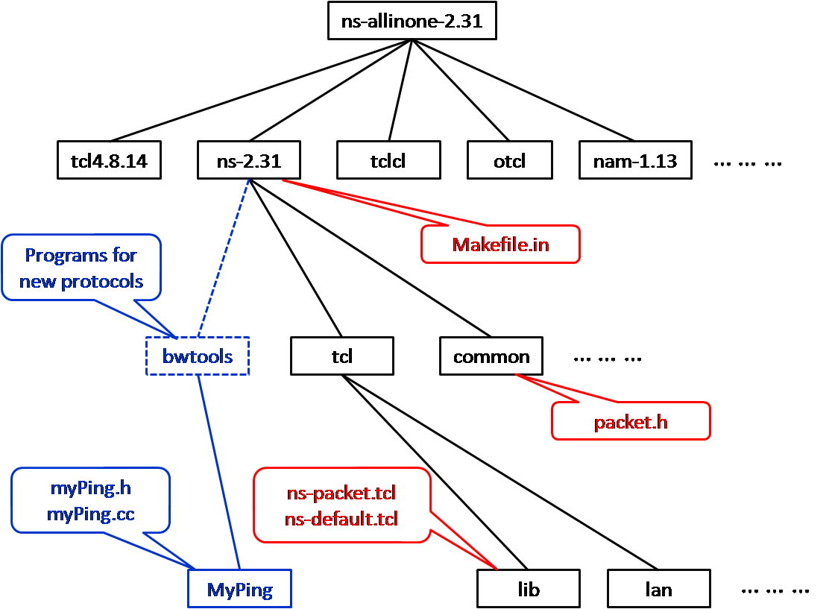
Figure 1. NS directory structure

Edit packet.h file
We need a new packet type for our MyPing agent, therefore the first step is to modify the “$NS/common/packet.h” file (assuming that the $NS environment variable points the …./ns-allinone-2.31/ns-2.31 location). There you can find the definitions for the packet protocol IDs (i.e. PT_TCP, PT_TELNET, etc.). Add a new definition for PT_PING there. In my edited version of packet.h, the last few lines of enum packet_t{} looks like the following code (it might look a bit different in different NS releases).
enum packet_t {
PT_TCP,
PT_UDP,
......
// insert new packet types here
PT_TFRC,
PT_TFRC_ACK,
PT_MYPING, // packet protocol ID for MyPing agent
PT_NTYPE // This MUST be the LAST one
};

You also have to edit the p_info() in the same file to include "MyPing".
class p_info {
public:
p_info() {
name_[PT_TCP]= "tcp";
name_[PT_UDP]= "udp";
...........
name_[PT_TFRC]= "tcpFriend";
name_[PT_TFRC_ACK]= "tcpFriendCtl";

name_[PT_MYPING]="MyPing";

name_[PT_NTYPE]= "undefined";
}
.....
}

Edit ns-packet.tcl file
Now in “$NS/tcl/lib/ns-packet.tcl” file search for the part foreach prot { .. }. Within this part add an entry for MyPing. It will look like following:

foreach prot {
# Common:
Common
Flags
IP # IP
… … …
Pushback # Pushback, router-to-router

MyPing

# Multicast:
aSRM # mcast/srm.cc
… … …
# Other:
Encap # common/encap.cc
IPinIP # IP encapsulation
HDLC # High Level Data Link Control
} {
add-packet-header $prot
}

Edit ns-default.tcl
The “$NS/tcl/lib/ns-default.tcl” file is the file where all default values for the Tcl objects are defined. Insert the following line to set the default packet size, packet number and wait interval for Agent/MyPing.
Agent/MyPing set packetSize_ 200
Agent/MyPing set num_packets_ 3
Agent/MyPing set wait_interval_ .001

Edit Makefile.in
The last change is a change that has to be applied to the “$NS/Makefile.in”. You have to add the file “myPing.o” to the list of object files for ns. In my version the last lines of the edited list look like this:
OBJ_CC = \
tools/random.o tools/rng.o tools/ranvar.o common/misc.o common/timer-handler.o \
common/scheduler.o common/object.o common/packet.o \
… … … …
bwtools/MyPing/myPing.o \
tools/trafgen.o trace/traffictrace.o tools/pareto.o \
… … … …

Recompile NS
After the changes are done in the NS files we need to recompile the NS simulator. To do so use the following command:
droy@aggarpc3:~$ cd $NS
droy@aggarpc3:ns-2.31$ pwd
/usr/share/ns-allinone-2.31/ns-2.31
droy@aggarpc3:ns-2.31$ sudo ./configure
droy@aggarpc3:ns-2.31$ sudo make

Simple example using MyPing agent
After recompiling the NS simulator we can use our MyPing agent in our simulations. Following code is simple tcl program that uses the MyPing agent.
set ns [new Simulator]
set nf [open out.tr w]
$ns trace-all $nf

#Define a 'finish' procedure
proc finish {} {
global ns nf
$ns flush-trace
#Close the trace file
close $nf
#Execute nam on the trace file
exit 0
}
set n0 [$ns node]
set n1 [$ns node]
$ns duplex-link $n0 $n1 10Mb 50ms DropTail

#####Sender Side Stuff##########
set sender [new Agent/MyPing]
$ns attach-agent $n0 $sender
$sender set packetSize_ 1500
$sender set num_packets_ 5
$sender set wait_interval_ .05

#####Receiver Side Stuff
set recv [new Agent/MyPing]
$ns attach-agent $n1 $recv

#####Connect the sender with receiver
$ns connect $sender $recv

#Schedule events for the CBR agent
$ns at 0.0 "$sender send"
$ns at 10.0 "finish"
$ns run

Figure 2. myPingExample.tcl

References:

[1] | Altman, E.; Jiménez, T. (2003). NS Simulator for beginners [Online]. Available: citeseer.ist.psu.edu/altman03ns.html
[2] | The ns Manual (formerly ns Notes and Documentation) [Online]. Available: http://www.isi.edu/nsnam/ns/doc/index.html
[3] | Chung, J.; Claypool, M. NS by Example [Online]. Available: http://nile.wpi.edu/NS/
[4] | Greis, Marc. Tutorial for the Network Simulator "ns" [Online]. Available: http://www.isi.edu/nsnam/ns/tutorial/

Prepared by: Debashis Roy
Submitted to: Akshai Aggarwal

