**Power BI | Data Analytics Project**

**Super Store Sales dashboard**

**Using Power BI Tool**

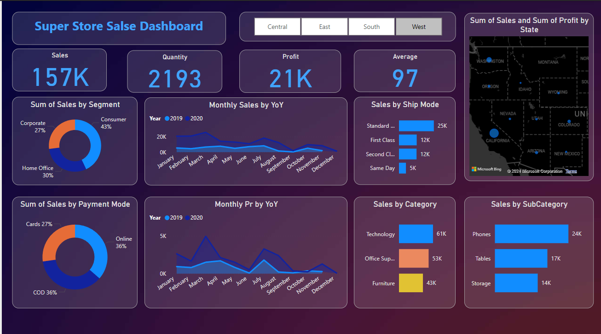

**Problem Statement**

**Analyse the dataset and review the following problem statements.**

**1.** **Sum of Sales by Segment**

**2.** **Sum of Sales by Payment Mode**

**3.** **Monthly Sales by Year**

**4.** **Sales by Ship Mode**

**5.** **Sales by Category**

**6.** **Sales by SubCategory**

**7.** **Sum of Sales and Sum of Profit by State**

**1.** **Sum of Sales by Segment**

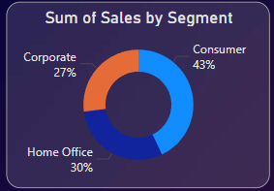

**2.** **Sum of Sales by Payment Mode**

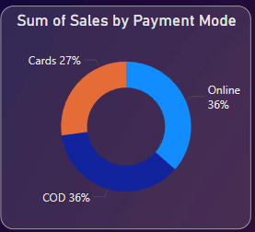

**3.** **Monthly Sales by Year**

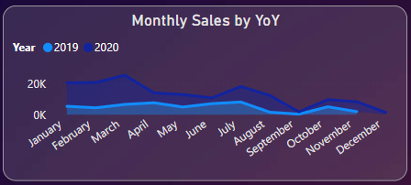

**4.** **Sales by Ship Mode**

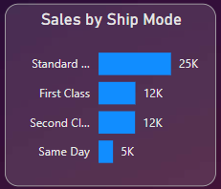

**5.** **Sales by Category**

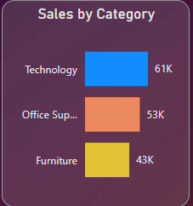

**6.** **Sales by SubCategory**

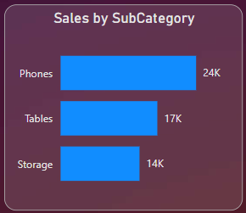

**7.** **Sum of Sales and Sum of Profit by State**

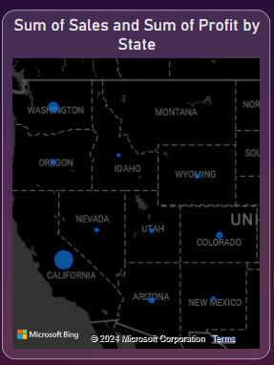

**| SALES | QUANTITY | PROFIT | AVERAGE | BY STATE**



**CENTRAL**



**EAST**

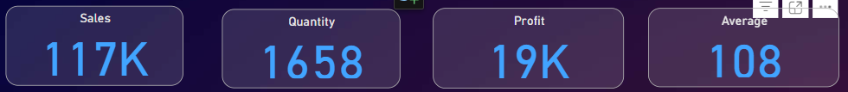

**SOUTH**

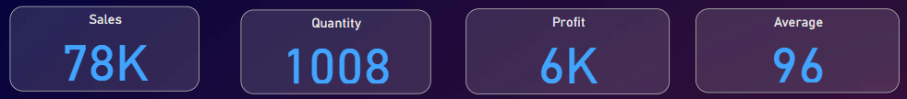

**WEST**

