

FYP Proposal – Smart Pet Feeder

Student ID: 2408599
Name: Adarsha Prasai
Section: L6CG8
Supervisor: Sangay Lama
Reader: Subash Bista

Abstract
This project proposes a low-cost, IoT-enabled smart pet feeder that combines an ESP32-based hardware unit with a secure, data-driven web application. The device performs closed-loop portion control using an HX711 load-cell interface, dispenses food via a servo-driven mechanism, monitors water level with a float sensor, and supports optional audio prompts through a DFPlayer Mini with an 8 Ω 1 W speaker. The web application, built with React and a cloud-hosted backend, provides authenticated access to manual feeding, pause/resume control, live video monitoring, event notifications, pet profile management, and long-term feeding analytics. The aim is to deliver a defensible prototype that goes beyond simple automation by introducing a robust control plane, auditable logs, remote assurance, and human-in-the-loop safety capabilities that cannot be credibly achieved by a headless device alone. (PetSafe, 2025) (WOPet, 2021) (Systems, 2021) (Shah, et al., 2023)

Table of Contents
FYP Proposal 1
Abstract 2
1. Introduction 1
2. Problem Statement 2
3. Project Objectives 2
4. Scope and Delimitations 3
5. Related Systems 4
6. Methodology 5
7. Expected Outcomes 6
8. Why the Web Application Is Essential 7
9. Work Plan and Timeline (Nine Months) 8
10. Resource Requirements 9
• Hardware 9
• Software 9
11. Risk Analysis and Mitigation 9
12. Evaluation Plan 11
13. Future Scope 11
14. Bibliography 12

Introduction
Feeding a companion animal sounds simple until you try to make it reliable, measurable, and responsive to the realities of modern life. Owners travel, work late, and deal with changing routines. Pets have evolving dietary needs across life stages and health conditions. The naive approach, dumping some kibble at fixed times can turn into underfeeding, overfeeding, or inconsistent patterns that a caregiver only notices once issues arise. Commercial feeders exist, but their design emphasizes fixed schedules and basic app triggers rather than transparent, verifiable monitoring integrated with the owner’s daily decision-making. In other words, the market has shown the appetite for convenience, but the gap lies in trust, control, and data continuity across contexts, caregivers, and devices. Systems that emphasize scheduling alone treat feeding as a one-way actuation problem; real pet care is a feedback problem that needs human oversight, measurement, and explainability.
Using the ESP32 as the control unit provides Wi-Fi connectivity, enough compute for sensor fusion and motor control.. The web application complements the device by serving as a control plane with secure identity, permissions, and analytics. Together, they transform feeding from “press start and hope” into a continuous loop of sensing, deciding, acting, and verifying. The feeder dispenses based on target mass rather than crude time-based dispensing. (Systems, 2021) (PetSafe, 2025) (WOPet, 2021)

Problem Statement
There’s a real need for a smart pet feeder that’s reliable and easy to use, combining precise portion control with a secure, cloud-connected interface. Owners should be able to check in, see logs, and stay in control even from afar. Most current products either focus only on the mechanics of dispensing or offer a basic app that doesn’t keep durable records or track events in a meaningful way. Having a web interface as the main control hub isn’t just convenient, it’s essential. It lets multiple caregivers collaborate, keeps an auditable history, provides insights over time, and ensures the system still works smoothly even when things don’t go perfectly in the real world. (WOPet, 2021) (PetSafe, 2025)

Project Objectives
- Prototype Goal:
  - Integrate an ESP32-based feeder with a modern web application
  - Highlight learning across:
    - Embedded systems
    - Networking
    - Cloud services
    - Security
    - User experience (UX)
- Device Functionality:
  - Dispense target portions reliably using:
    - Calibrated load cell
    - HX711 amplifier
  - Record each feeding event as structured data
  - Expose a robust API for secure remote control
- Web Application Features:
  - Authenticate users
  - Allow manual feed triggers
  - Expose pause and resume states
  - Display a timeline view of feeding history with:
    - Portion mass
    - Timestamps
  - Allow a pet profile including:
    - Picture
    - Breed
    - Age
    - Weight
    - Height
  - Enable adaptation of portion targets as the pet’s characteristics change
(Systems, 2021)

Scope and Delimitations
The system lets owners manually feed their pets from the web interface while keeping portion control precise using the load cell. Every feeding is logged with time and dispensed amount, and the system tracks food and water levels through weight. Owners get real-time notifications for feeding events or low levels. A pet profile stores basic details and a photo, and feeds can be paused or resumed to follow vet guidance or temporary fasting.
Features like multi-pet support and fully automated scheduling are intentionally left out, as differentiating consumption between pets is tricky. Any scheduling logic might appear as an experimental or disabled module, but the core system emphasizes control, accuracy, and oversight via the web.
(PetSafe, 2025) (WOPet, 2021)

Related Systems
Previous research shows that IoT-based feeders can automate feeding using sensors and actuators, but they often lack user-facing analytics or strong authentication. For example, Khan et al. demonstrated a system combining microcontrollers with network connectivity, proving the concept works, but left questions around robust logging, identity management, and long-term web-scale maintenance [Khan et al., 2020].
On the commercial side, products like PetSafe, Smart Feed, and offerings from WOPet show advanced hardware and strong consumer demand, but they are usually closed systems, focused on retail polish rather than research flexibility or transparent data export [PetSafe, 2019; WOPet, n.d.].
The current state of the art gives us mechanical dispensing, app-triggered actions, and basic alerts, yet it doesn’t fully integrate the web application as a core part of safety, measurement, and accountability. In particular, little has been written about balancing device autonomy with cloud control, especially when connectivity is unreliable or multiple caregivers are involved.
This project fills that gap by formalizing the interface between device and cloud, implementing “intent → actuation → verification” loops, and showing how authenticated events can serve as a trusted record of the pet’s care history.
(WOPet, 2021) (PetSafe, 2025)

Methodology
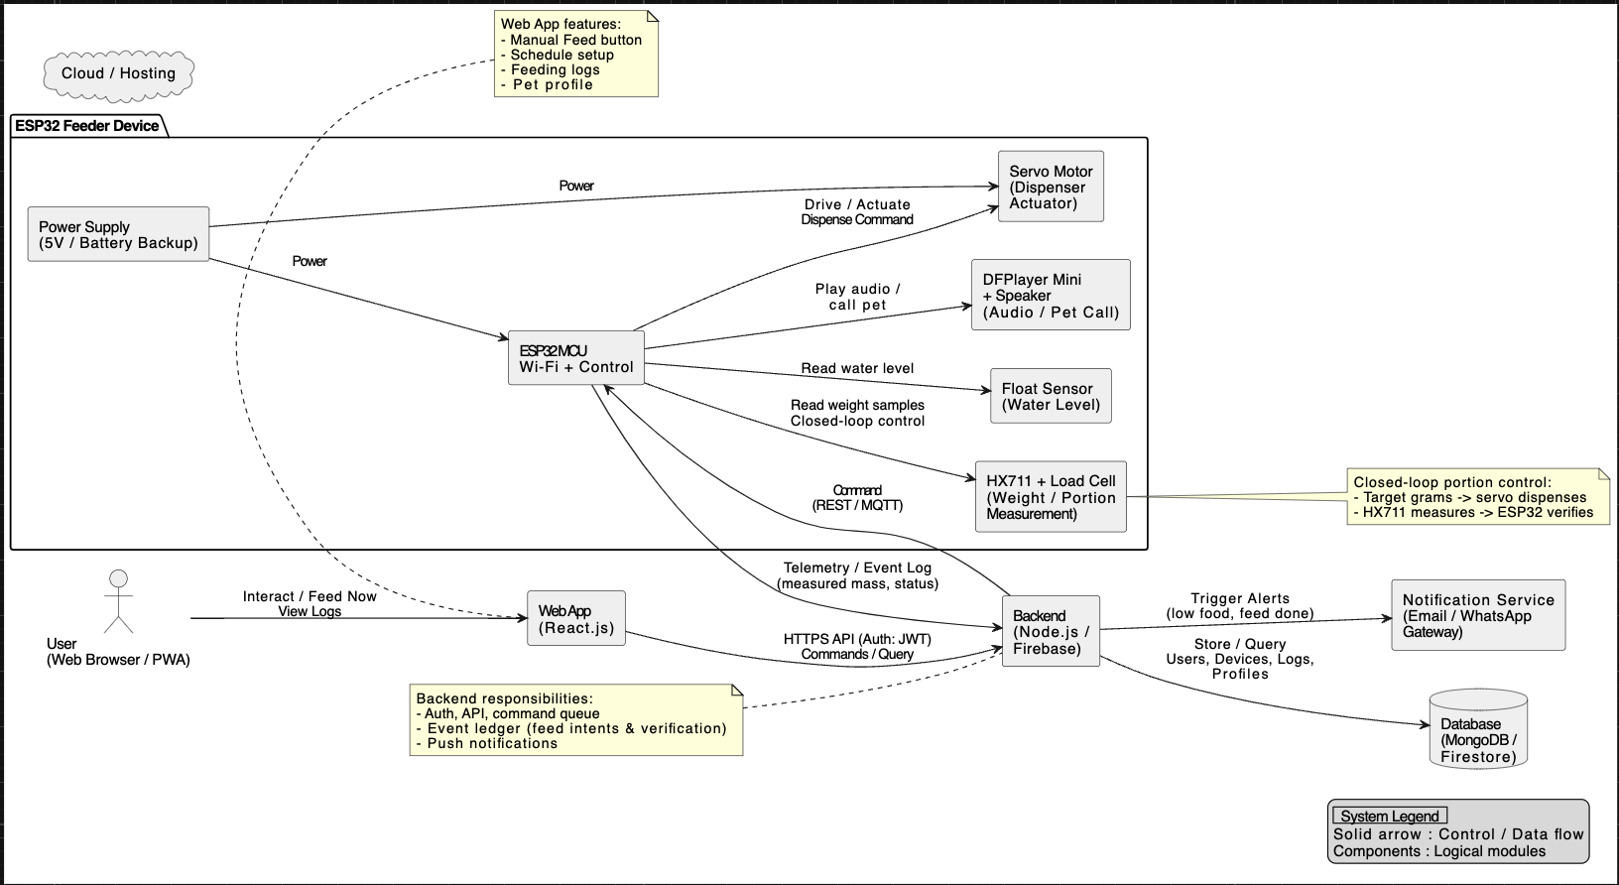
The system is built around an ESP32, chosen for its Wi-Fi, GPIO availability, and reliable tooling. It controls a servo to dispense kibble, reads mass through a load cell, and plays audio via a DFPlayer Mini. Feeding is a closed-loop process: the scale is tared, kibble is dispensed while mass is continuously monitored, and dispensing stops once the target is reached. HX711 readings are smoothed using moving average or median filters, and calibration relies on reference weights. Every feed logs the requested and actual mass, dispense time, and any anomalies, forming a detailed event log.
The networking design is resilient: the ESP32 can complete feeds offline, while the web server issues commands with idempotent tokens over REST or MQTT. Offline requests queue and execute once the device reconnects, ensuring durable, auditable actions.
The React web app manages authentication, device association, event storage, and notifications. Users can manually trigger feeds, track progress, and explore detailed event timelines. Pet profiles store name, breed, age, weight, and height. Notifications cover feed completion, low food, and low water.
Security is robust: TLS, signed tokens, replay protection, and feed logging create a trustworthy audit trail.
Calibration is guided: the web app collects raw ADC counts, calculates slope/offset, stores versioned parameters, and pushes reference data to the device. Persistent drift triggers recalibration, ensuring accurate, reliable mass measurements.
(Shah, et al., 2023)

Expected Outcomes
At project completion, the prototype will demonstrate reliable, closed-loop manual feeding with measured portions and a complete, browsable event history. The UI will show a live state card for the device; a feed control with target grams; a progress indication during dispense; and a post-event view reporting the achieved weight and any discrepancies. The notifications system will confirm success, warn on low food or water, and report device offline/online transitions. The camera feed will provide real-time reassurance that pairs with measured mass to establish trust. The pet profile will store key details and a photo, allowing the log to be contextualized by the animal’s characteristics and making it easier, later, to introduce data-driven portion recommendations. The overall result will be a demonstrable, testable system that is safe to showcase and extensible for future research. (WOPet, 2021) (PetSafe, 2025)

Why the Web Application Is Essential
The heart of the defense is this: the web application is the safety, accountability, and collaboration layer. A purely embedded schedule would dispense food, but it would not provide a durable record of who did what, when, and with what outcome. For example, if a veterinarian prescribes a temporary reduction in portions, the ability to pause remotely, see that the command was applied, and verify that subsequent feed attempts were blocked is essential. If the device jams, the log shows the partial dispense, the alert, and any remediation.
Without the web, owners cannot compare their pet’s feeding patterns over time. Say you want to check your pet’s intake over the last three months versus the same period last year, without a web interface storing and visualizing historical data, this kind of analysis would be nearly impossible. Research supports this: according to Investigation into the aetiology of hypercalcaemia in a cohort of 44 cats, veterinarians can diagnose health problems significantly faster when they have detailed feeding pattern reports. (Knowles, et al., 2020)
Without a backend, notifications cannot be reliably delivered or archived; without a UI, calibration and analytics are hidden behind serial commands that the average user will not run. The web layer transforms an opaque IoT gadget into an observable, accountable service, which is essential for adoption and quality care.
From an academic perspective, the web app also multiplies learning opportunities: implementing secure authentication, modeling device state in a database, designing APIs with idempotency, handling eventual consistency, and building data visualizations that interpret sensor readings in human terms. These are core, transferable skills in modern software engineering, which a strong FYP should surface. This project is therefore not “a feeder plus a pretty page”; it is a controlled cyber-physical system whose correctness is amplified and made defensible by the web layer. Commercial feeders demonstrate user demand for remote control, and prior academic work shows device feasibility; this project integrates these strands while framing the website as the custodian of safety, accountability, and actionable insight, not an optional accessory.
(PetSafe, 2025) (WOPet, 2021) (Shah, et al., 2023)

Work Plan and Timeline (Nine Months)
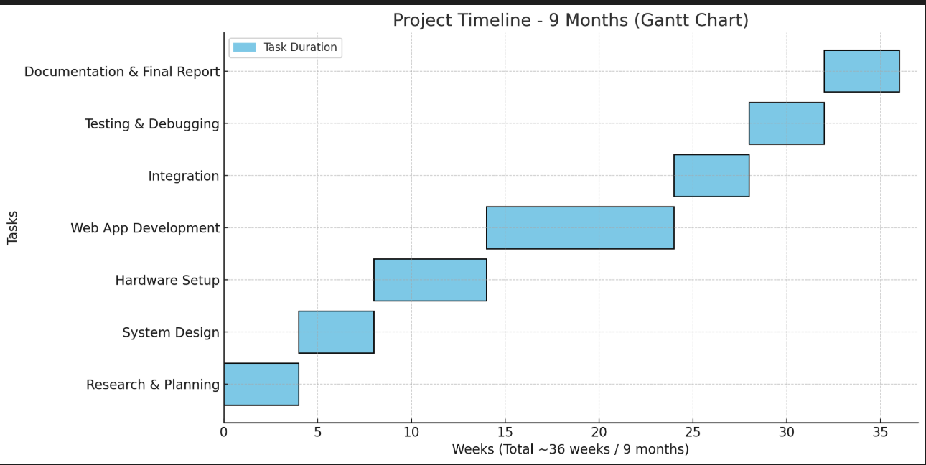

Resource Requirements

• Hardware
- ESP32 development board
- Hobby servo (suitable for dispensing gate load)
- Load cell with appropriate capacity
- HX711 amplifier
- Float switch (water level awareness)
- DFPlayer Mini + 8 Ω 1 W speaker (audio prompts)
- Camera module (ESP32-CAM or alternative)

• Software
- Arduino IDE or ESP-IDF (firmware development)
- React frontend
- Cloud-hosted backend with database for users, devices, events
- Hosting via a platform-as-a-service provider
(Systems, 2021) (Shah, et al., 2023)

Risk Analysis and Mitigation
• Hardware Risks
  - Load cell drift → include tare routines and warm-up cycles
  - Servo stalls → over-specify servo torque
  - Kibble granularity → design chute to minimize bridging; implement two-phase dispense
• Sensing Risks
  - Firmware includes calibration and warm-up routines
  - UI prompts periodic recalibration with reference weights
• Network Risks
  - Minimal offline mode for manual feed triggers
  - Device reconciles state with server when back online
• Security Risks
  - Use TLS
  - Short-lived tokens
  - Strict device association rules
• Timeline Risks
  - Prioritize core loop:
  - Manual feed
  - Closed-loop measurement
  - Event logging
  - Treat camera and advanced notifications as secondary enhancements
(Systems, 2021) (Shah, et al., 2023)

Evaluation Plan
Success is measured in four areas: functionality, accuracy, reliability, and user experience.
  - Functionality: The system must reliably perform remote manual feeds, working pause/resume commands, and persist logs on the server.
  - Accuracy: Target portions are compared to the actual dispensed mass across multiple trials, reporting mean absolute error and standard deviation for different kibble types.
  - Reliability: The device is tested under simulated network outages to ensure queued commands execute correctly when connectivity returns, without duplicates, and logs remain accurate.
  - User Experience: Properly check for bugs in the web app, handle errors. Small user tests with pet owners measure trust, ease of use, and understanding of logs.

Future Scope
In the future, the server can generate recommendations based on consumption trends observable in the logs, offering evidence-based portion suggestions rather than blind schedules. Multi-pet support becomes tractable when paired with camera-based recognition that associates consumption with individuals, which, combined with per-pet profiles, could transition the system from a generic feeder to a personalized nutrition assistant. Integrations with smart assistants are also possible. Over-the-air firmware updates could be initiated from the web interface so that security patches roll out safely. Data export and privacy controls would allow users to take their logs elsewhere or contribute anonymized data to research. All of these are aligned with the goal of making the web application a durable, ethical custodian of a pet’s feeding.

Bibliography

- Knowles, E. J., Marshall, J. . M. & Girling, S. J., 2020. Investigation into the aetiology of hypercalcaemia in a cohort of 44 cats. Veterinary Record, 187(9), pp. 354-354.
- PetSafe, 2025. PetSafe Smart Feed. [Online]
Available at: https://www.petsafe.com/smart-feed
- Shah, A., Tajuddin , S., Darzi, I. H. & Malgi, G. .., 2023. Pet Feeder using IOT. s.l., AnaPub Publications.
- Systems, E., 2021. ESP32 Technical Reference Manual, s.l.: Espressif Systems.
- WOPet, 2021. WOPet Smart Feeder. [Online]
Available at: https://wopet.com/

