

FYP Proposal – Smart Pet Feeder

Student ID: 2408599
Name: Adarsha Prasai
Section: L6CG8
Supervisor: Sangay Lama
Reader: Subash Bista

Abstract
This project proposes a low-cost, IoT-enabled smart pet feeder that combines an ESP32-based hardware unit with a secure, data-driven web application. The device performs closed-loop portion control using an HX711 load-cell interface, dispenses food via a servo-driven mechanism, monitors water level with a float sensor, and supports optional audio prompts through a DFPlayer Mini with an 8 Ω 1 W speaker. The web application, built with React and a cloud-hosted backend, provides authenticated access to manual feeding, pause/resume control, live video monitoring (if time allows), event notifications, pet profile management, and long-term feeding analytics. The aim is to deliver a defensible prototype that goes beyond simple automation by introducing a robust control plane, auditable logs, remote assurance, and human-in-the-loop safety capabilities that cannot be credibly achieved by a headless device alone.
(PetSafe, 2025) (WOPet, 2021) (Systems, 2021) (Adnan Shah, Tajuddin, Darzi, & Malgi, 2023)
Table of Contents
Abstract 2
1. Introduction 1
2. Problem Statement 2
3. Aims 2
3.1. Sub-Aims: 3
4. Objectives 4
4.1. System Development Objectives 4
4.2. Testing and Evaluation Objectives 4
5. Scope and Delimitations 5
6. Related Systems 5
7. Methodology 6
8. Expected Outcomes 8
9. Why the Web Application Is Essential 9
10. Work Plan and Timeline (Nine Months) 10
11. Resource Requirements 11
12. Risk Analysis and Mitigation 12
13. Evaluation Plan 13
14. Future Scope 14
15. References 15

Introduction
Feeding a companion animal sounds simple until you try to make it reliable, measurable, and responsive to the realities of modern life. Owners travel, work late, and deal with changing routines. Pets have evolving dietary needs across life stages and health conditions. The naive approach, dumping some kibble at fixed times can turn into underfeeding, overfeeding, or inconsistent patterns that a caregiver only notices once issues arise. Commercial feeders exist, but their design emphasizes fixed schedules and basic app triggers rather than transparent, verifiable monitoring integrated with the owner’s daily decision-making. In other words, the market has shown the appetite for convenience, but the gap lies in trust, control, and data continuity across contexts, caregivers, and devices. Systems that emphasize scheduling alone treat feeding as a one-way actuation problem; real pet care is a feedback problem that needs human oversight, measurement, and explainability.
Using the ESP32 as the control unit provides Wi-Fi connectivity, enough compute for sensor fusion and motor control.. The web application complements the device by serving as a control plane with secure identity, permissions, and analytics. Together, they transform feeding from “press start and hope” into a continuous loop of sensing, deciding, acting, and verifying. The feeder dispenses based on target mass rather than crude time-based dispensing.
(Systems, 2021) (PetSafe, 2025) (WOPet, 2021)

Problem Statement
There’s a real need for a smart pet feeder that’s reliable, easy to use, and aligned with current market trends, combining precise portion control with a secure, cloud-connected interface. Owners should be able to check in, see logs, and stay in control even from afar. Most current products either focus only on the mechanics of dispensing or offer a basic app that doesn’t keep durable records or track events in a meaningful way. Market research shows a growing demand for smart feeders that support remote control and pet-care convenience (Company, 2025). Having a web interface as the main control hub isn’t just convenient, it’s essential. It lets multiple caregivers collaborate, keeps an auditable history, provides insights over time, and ensures the system still works smoothly even when things don’t go perfectly in the real world. (WOPet, 2021) (PetSafe, 2025) (Company, 2025)

Aims
The primary aim of this project is to design and implement a low-cost, IoT-enabled smart pet feeder that ensures precise, reliable, and accountable feeding through the integration of embedded hardware control and a secure, data-driven web application. The system seeks to move beyond fixed-time automation by establishing a closed-loop feedback model where each feeding event is measurable, verifiable, and traceable, thereby improving transparency, trust, and remote accessibility in pet care.

Sub-Aims:
- To develop an ESP32-based embedded system capable of accurate food dispensing using calibrated load-cell feedback and real-time weight monitoring.
- To build a companion web application that provides authenticated control, real-time event visualization, and long-term feeding analytics.
- To implement a resilient communication architecture allowing both online and offline operation with synchronized logs and error handling.
- To ensure data integrity, safety, and accountability through secure APIs, event auditing, and human-in-the-loop confirmation mechanisms.
- To evaluate the prototype’s reliability, measurement accuracy, and usability under realistic operating conditions.

Objectives

System Development Objectives
    - Build an ESP32-based feeder that can measure and control the exact amount of food dispensed using a load cell and HX711 amplifier.
    - Use a servo motor to release food and a float sensor to monitor water levels.
    - Create a secure web application (using React and a cloud backend) that allows users to:
      - Log in safely and connect their feeder device
      - Feed their pet manually or pause feeding when needed
      - View feeding history, with time and portion size
      - Get notifications about feed completion, low food, low water, or connection issues
      - Visualize the feeding pattern of their pets
    - Make sure the feeder keeps working even if the internet goes down, and syncs data correctly once it reconnects.

Testing and Evaluation Objectives
    - Test the accuracy of the feeder by comparing the target and actual food portions.
    - Check system reliability by simulating internet or power interruptions.
    - Collect user feedback on how easy the system is to use and how much trust it builds.
    - Compare how the web interface improves safety and monitoring compared to a fully offline feeder.
(Systems, 2021)

Scope and Delimitations
The system lets owners manually feed their pets from the web interface while keeping portion control precise using the load cell. Every feeding is logged with time and dispensed amount, and the system tracks food and water levels through weight. Owners get real-time notifications for feeding events or low levels. A pet profile stores basic details and a photo, and feeds can be paused or resumed to follow vet guidance or temporary fasting.
Features like multi-pet support and fully automated scheduling are intentionally left out, as differentiating consumption between pets is tricky. Any scheduling logic might appear as an experimental or disabled module, but the core system emphasizes control, accuracy, and oversight via the web.
(PetSafe, 2025) (WOPet, 2021)

Related Systems
Previous research shows that IoT-based feeders can automate feeding using sensors and actuators, but they often lack user-facing analytics or strong authentication. For example, (Systems, 2021) demonstrated a system combining microcontrollers with network connectivity, proving the concept works, but left questions around robust logging, identity management, and long-term web-scale maintenance [Khan et al., 2020].
More recent work by (Arceo, Flores, & Mancilla, 2024)describes a smart feeder combining IoT hardware (weight sensors, camera, ultrasonic sensors) with deep learning for pet recognition and precise portion dispensing. While this system demonstrates effective portion control and automatic pet identification, it still focuses on embedded intelligence and does not integrate a web application for audit logging, multi-user management, or human-in-the-loop safety. Including this highlights the gap your project addresses by combining robust web-based monitoring and control with the hardware.
On the commercial side, products like PetSafe, Smart Feed, and offerings from WOPet show advanced hardware and strong consumer demand, but they are usually closed systems, focused on retail polish rather than research flexibility or transparent data export
The current state of the art gives us mechanical dispensing, app-triggered actions, and basic alerts, yet it doesn’t fully integrate the web application as a core part of safety, measurement, and accountability. In particular, little has been written about balancing device autonomy with cloud control, especially when connectivity is unreliable or multiple caregivers are involved.
This project fills that gap by formalizing the interface between device and cloud, implementing “intent → actuation → verification” loops, and showing how authenticated events can serve as a trusted record of the pet’s care history.
(Arceo, Flores, & Mancilla, 2024) (PetSafe, 2025) (WOPet, 2021)

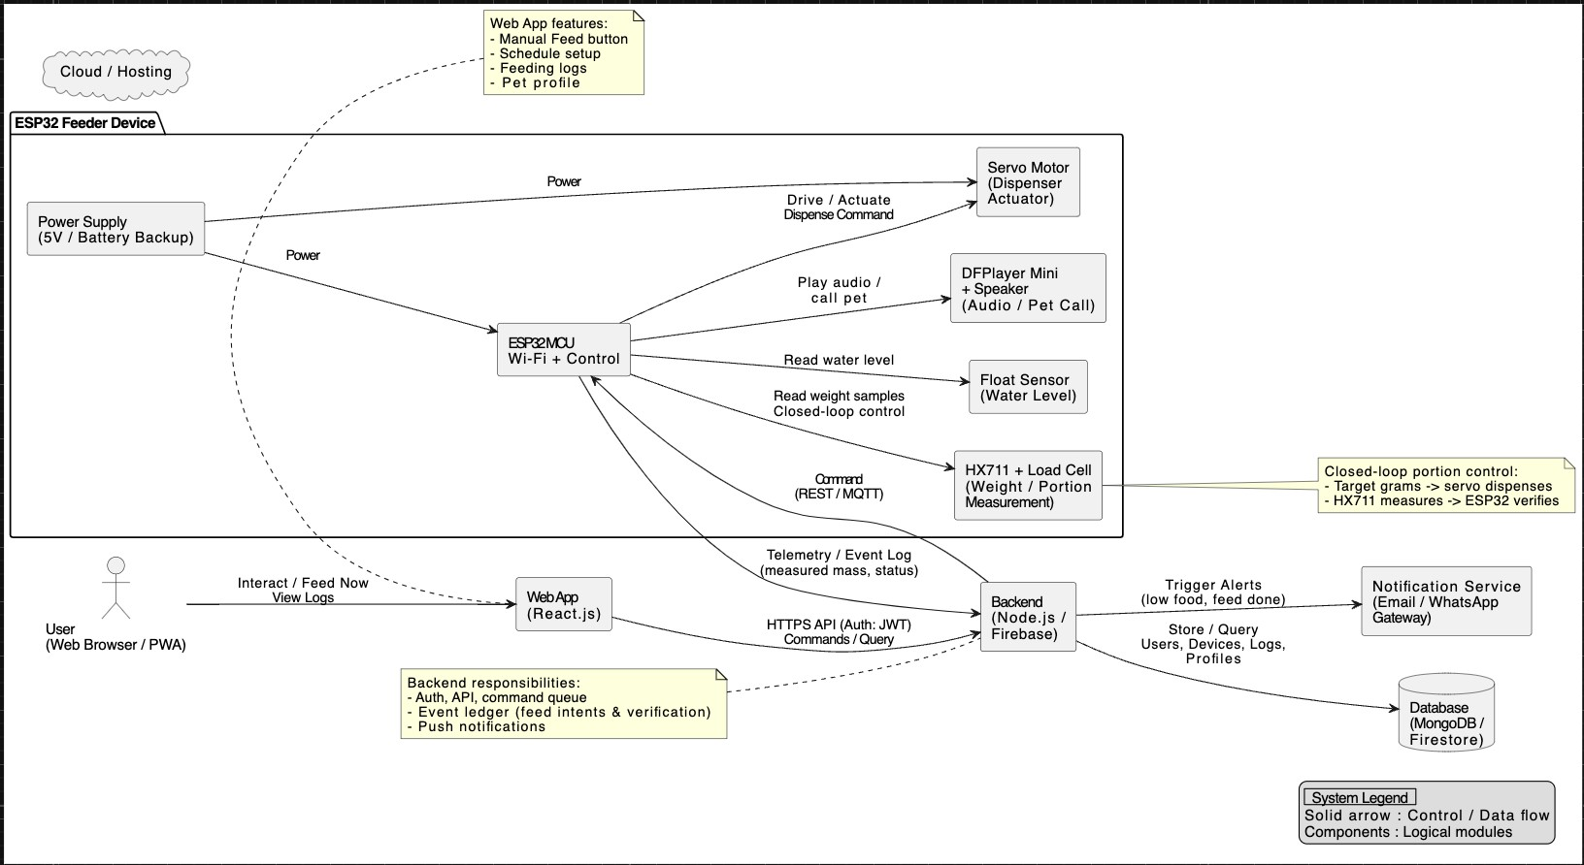
Methodology

The system is built around an ESP32, chosen for its Wi-Fi, GPIO availability, and reliable tooling. It controls a servo to dispense kibble, reads mass through a load cell, and plays audio via a DFPlayer Mini. Feeding is a closed-loop process: the scale is tared, kibble is dispensed while mass is continuously monitored, and dispensing stops once the target is reached. HX711 readings are smoothed using moving average or median filters, and calibration relies on reference weights. Every feed logs the requested and actual mass, dispense time, and any anomalies, forming a detailed event log.
The networking design is resilient: the ESP32 can complete feeds offline, while the web server issues commands with idempotent tokens over REST or MQTT. Offline requests queue and execute once the device reconnects, ensuring durable, auditable actions.
The React web app manages authentication, device association, event storage, and notifications. Users can manually trigger feeds, track progress, and explore detailed event timelines. Pet profiles store name, breed, age, weight, and height. Notifications cover feed completion, low food, and low water.
Security is robust: TLS, signed tokens, replay protection, and feed logging create a trustworthy audit trail.
Calibration is guided: the web app collects raw ADC counts, calculates slope/offset, stores versioned parameters, and pushes reference data to the device. Persistent drift triggers recalibration, ensuring accurate, reliable mass measurements.
(Adnan Shah, Tajuddin, Darzi, & Malgi, 2023)

Expected Outcomes
By the end of the project, the system should demonstrate that smart pet feeding can be done accurately, safely, and transparently through a connected web platform. The feeder and web app will work together to show that pet care can be monitored and controlled from anywhere with trust and consistency.
- Accurate Feeding:
The feeder will dispense food portions that closely match the target weight, with minimal error after calibration.
- Reliable Operation:
The system will keep functioning even if the internet goes down and will automatically update feeding data once reconnected.
- User Control and Awareness:
Users will be able to monitor, pause, or trigger feeds from the web interface, with clear logs and notifications showing exactly what happened and when.
- Improved Trust and Safety:
The combination of event logs and notifications will give users confidence that feeding is happening as expected, even when they are away.
- Data and Insight:
Feeding history will be stored in a structured form, making it possible to analyze long-term trends and support future features like portion recommendations.
- Learning and Skill Development:
The project will demonstrate practical skills in IoT integration, web development, data handling, and system security, key areas for full-stack and embedded system development.

Why the Web Application Is Essential
The heart of the defense is this: the web application is the safety, accountability, and collaboration layer. A purely embedded schedule would dispense food, but it would not provide a durable record of who did what, when, and with what outcome. For example, if a veterinarian prescribes a temporary reduction in portions, the ability to pause remotely, see that the command was applied, and verify that subsequent feed attempts were blocked is essential. If the device jams, the log shows the partial dispense, the alert, and any remediation.
Without the web, owners cannot compare their pet’s feeding patterns over time. Say you want to check your pet’s intake over the last three months versus the same period last year, without a web interface storing and visualizing historical data, this kind of analysis would be nearly impossible. Research supports this: according to Investigation into the aetiology of hypercalcaemia in a cohort of 44 cats, veterinarians can diagnose health problems significantly faster when they have detailed feeding pattern reports. (Knowles, et al., 2020)
Without a backend, notifications cannot be reliably delivered or archived; without a UI, calibration and analytics are hidden behind serial commands that the average user will not run. The web layer transforms an opaque IoT gadget into an observable, accountable service, which is essential for adoption and quality care.
From an academic perspective, the web app also multiplies learning opportunities: implementing secure authentication, modelling device state in a database, designing APIs with idempotency, handling eventual consistency, and building data visualizations that interpret sensor readings in human terms. These are core, transferable skills in modern software engineering, which a strong FYP should surface. This project is therefore not “a feeder plus a pretty page”; it is a controlled cyber-physical system whose correctness is amplified and made defensible by the web layer. Commercial feeders demonstrate user demand for remote control, and prior academic work shows device feasibility; this project integrates these strands while framing the website as the custodian of safety, accountability, and actionable insight, not an optional accessory. (WOPet, 2021) (PetSafe, 2025) (Adnan Shah, Tajuddin, Darzi, & Malgi, 2023) (E. Bray, Zheng , Tolbert, & Kaeberlein, 2022) (Knowles, Marshall, & Girling, 2020) (Kerl & Johnson, 2004)

Work Plan and Timeline (Nine Months)
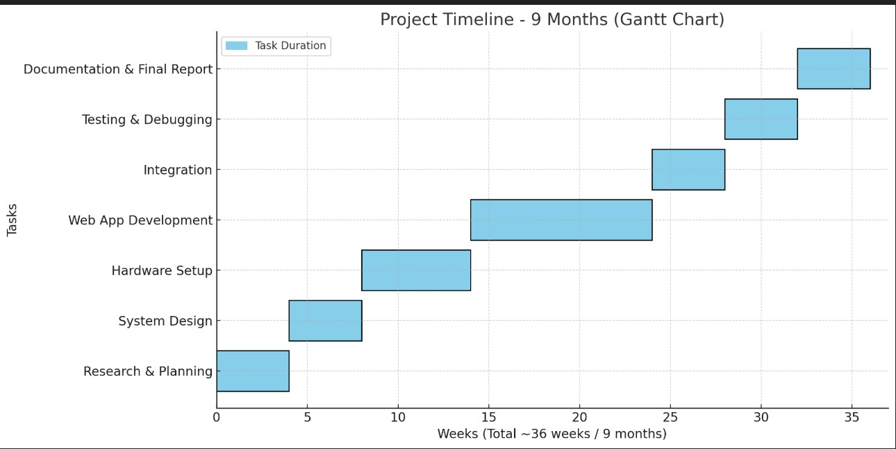

The project will be executed over nine months, starting with four weeks of research and planning to study existing systems, select suitable hardware, and define the project workflow. The next four weeks will focus on system design, including hardware schematics, sensor placement, and web application structure. Hardware setup will take six weeks, assembling and calibrating the ESP32, load cell, servo mechanism, DFPlayer, camera module, and float sensor. Web application development will span ten weeks, covering frontend, backend, database, authentication, and core features like manual feed control, event logging, notifications, and pet profiles. Integration of the hardware with the web application will occur over four weeks, ensuring real-time communication and control. Testing and debugging will take another four weeks to verify accuracy, reliability, and usability. Finally, four weeks will be dedicated to documentation and the final report, including diagrams, user manuals, and summarizing project outcomes and future scope.

Resource Requirements
- Hardware
- ESP32 development board
- Hobby servo (suitable for dispensing gate load)
- Load cell with appropriate capacity
- HX711 amplifier
- Float switch (water level awareness)
- DFPlayer Mini + 8 Ω 1 W speaker (audio prompts)
- Camera module (ESP32-CAM or alternative) (if time allows)
- Software
- Arduino IDE or ESP-IDF (firmware development)
- React frontend
- Cloud-hosted backend with database for users, devices, events
- Hosting via a platform-as-a-service provider

Risk Analysis and Mitigation
- Hardware Risks
  - Load cell drift: Implement tare routines and warm-up cycles to maintain accurate weight readings.
  - Servo stalls: Use a higher-torque servo than minimally required to prevent failures.
  - Kibble granularity: Design the chute to reduce bridging and implement a two-phase dispensing mechanism.
- Sensing Risks
  - Include calibration and warm-up routines in firmware.
  - The user interface prompts periodic recalibration using reference weights.
- Network Risks
  - Provide a minimal offline mode for manual feed commands.
  - Ensure the device reconciles its state with the server once connectivity is restored.
- Security Risks
  - Use short-lived authentication tokens.
  - Enforce strict device-to-user association rules.
- Timeline Risks
  - Prioritize the core system first: manual feeding, closed-loop portion measurement, and event logging.
  - Treat camera integration and advanced notifications as secondary enhancements.
(Systems, 2021) (Adnan Shah, Tajuddin, Darzi, & Malgi, 2023)

Evaluation Plan
The project will be evaluated through a combination of functional testing, performance measurement, and user feedback to ensure that the smart pet feeder performs reliably under real-world conditions.
- Functional Testing:
  - Verify that the feeder dispenses the correct food amount per schedule and on manual command.
  - Confirm the sensors and communication modules operate without interruption.
  - Ensure the system logs every feeding event accurately and displays it in the web interface.
- Performance Evaluation:
  - Measure accuracy of food portioning (acceptable deviation ≤ ±5 grams).
  - Test response time between user command and device action (< 5 seconds).
  - Observe system stability during network interruptions and reconnection events.
- User Evaluation:
  - Conduct usability testing with at least 3 users to assess clarity of the interface, ease of operation, and overall satisfaction.
  - Collect qualitative feedback on trust, transparency, and perceived usefulness of remote monitoring.
- Security and Reliability Assessment:
  - Test data encryption, authentication, and communication reliability between the web server and feeder.
  - Evaluate data recovery after temporary disconnection or power failure.

- Final Validation:
  - Compare real-world feeding accuracy, system reliability, and user satisfaction results against initial expected outcomes.

Future Scope
In the future, the server can generate recommendations based on consumption trends observable in the logs, offering evidence-based portion suggestions rather than blind schedules. Multi-pet support becomes tractable when paired with camera-based recognition that associates consumption with individuals, which, combined with per-pet profiles, could transition the system from a generic feeder to a personalized nutrition assistant. Integrations with smart assistants are also possible. Over-the-air firmware updates could be initiated from the web interface so that security patches roll out safely. Data export and privacy controls would allow users to take their logs elsewhere or contribute anonymized data to research. All of these are aligned with the goal of making the web application a durable, ethical custodian of a pet’s feeding.

References
- Adnan Shah, Tajuddin, S., Darzi, I. H., & Malgi, G. D. (2023). Pet Feeder using IoT. AnaPub Publications.
- Arceo, C., Flores, R., & Mancilla, S. (2024). Design and Development of a Smart Pet Feeder with IoT and Deep Learning. 11th International Electronic Conference on Sensors and Applications (pp. 1-6). Basel: MDPI AG.
- Company, T. B. (2025). Global Automatic And Smart Pet Feeder Market Report 2025. London: The Business Research Company.
- E. Bray, E., Zheng , Z., Tolbert, M. ., & Kaeberlein, M. (2022). Once-daily feeding is associated with better health in companion dogs. Frontiers in Veterinary Science, 1779-1790.
- Kerl, M. E., & Johnson, P. A. (2004). Nutritional plan: matching diet to disease. Clinical Techniques in Small Animal Practice (Clin Tech Small Anim Pract), 9-21.
- Knowles, E. J., Marshall, J. M., & Girling, S. J. (2020). Investigation into the aetiology of hypercalcaemia in a cohort of 44 cats. Veterinary Record, 354-354.
- PetSafe. (2025). PetSafe Smart Feed. Retrieved from PetSafe: https://www.petsafe.com
- Systems, E. (2021). ESP32 Technical Reference Manual. Espressif Systems.
- WOPet. (2021). WOPet Smart Feeder. Retrieved from WOPet: https://wopet.com/

