FUNCTIONS

**Q1.** Write a function that takes first & last name and then it greets the user using his full name.

**Q2.** Write a function that adds two numbers (input by user) and returns the sum of two numbers.

# Q3. Calculator:

Write a function that takes three arguments num1, num2 & operator & compute the desired operation. Return and show the desired result in your screen.

**Q4.** Write a function that squares its argument.

**Q5.** Write a function that computes factorial of a number.

**Q6.** Write a function that take start and end number as inputs & display counting in your screen.

**Q7.** Write a function that computes hypotenuse of a right angle triangle by following the steps given below.

Hypotenuse2 = Base2 + Perpendicular2

1. Take base and perpendicular as inputs.
2. Create a function calculateSquare() for calculating and returning square of a number.
3. Create a function calculateHypotenuse() for calculating hypotenuse of a right angle triangle. Make use of the calculateSquare() function.

**Q8.** Write a function that calculates the area of a rectangle.

A = width * height

Pass width and height in following manner:

1. Arguments as values
2. Arguments as variables

**Q9.** Write a function that computes power of a number. E.g. 23 is 8.

**Q10.** Write a function which accepts an argument and returns the type.

# Q11. The Age Calculator

Forgot how old you are? Calculate it!

1. Write a function named calculateAge that:
   * Takes 2 arguments: birth year, current year.
   * Calculates the 2 possible ages based on those years.
   * Outputs the result to the screen like so: "You are either NN or NN"
2. Call the function three times with different sets of values.

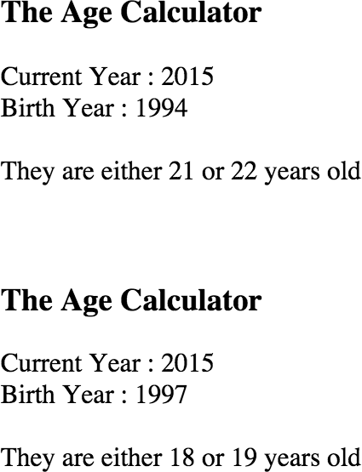

# Q12. The Temperature Converter

It's hot out! Let's make a converter based on the steps here.

1. Create a function called celsiusToFahrenheit:
   * Store a celsius temperature into a variable.
   * Convert it to fahrenheit and output "NN°C is NN°F".
2. Create a function called fahrenheitToCelsius:
   * Now store a fahrenheit temperature into a variable.
   * Convert it to celsius and output "NN°F is NN°C."

# Q13. The Lifetime Supply Calculator

Ever wonder how much a "lifetime supply" of your favorite snack is? Wonder no more!

1. Write a function named calculateSupply that:
   * Takes 2 arguments: age, amount per day.
   * Calculates the amount consumed for rest of the life (based on a constant max age).
   * Outputs the result to the screen like so: "You will need NN to last you until the ripe old age of X"
2. Call that function three times, passing in different values each time.

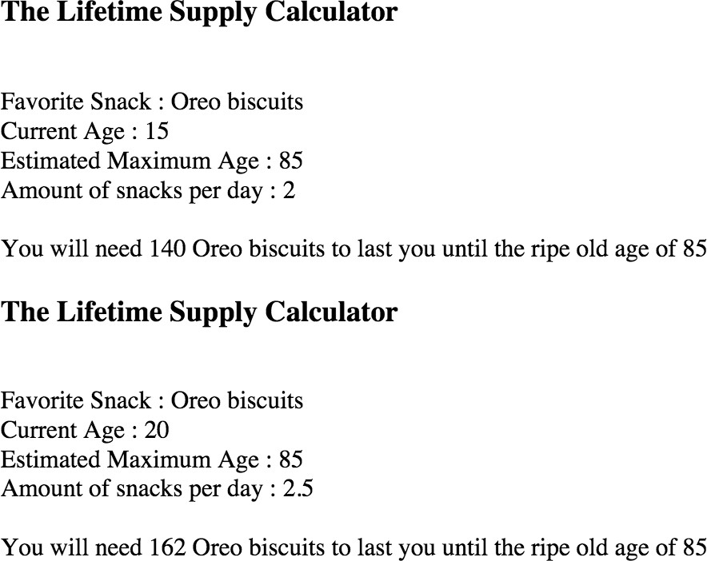

# Q14. The Geometrizer

Create 2 functions that calculate properties of a circle, using the definitions here.

1. Create a function called calcCircumference:
   * Pass the radius to the function.
   * Calculate the circumference based on the radius, and output "The circumference is NN".
2. Create a function called calcArea:
   * Pass the radius to the function.
   * Calculate the area based on the radius, and output "The area is NN".