# Arduino Based Home Automation

Arduino based Home Automation using TV Remote is a simple project, where an old TV Remote is used to control different appliances.

Home Automation is a concept where a single device is used to control many aspects of a home like switching on and off different appliances, monitoring temperature, fire alarms, garage doors etc. In this project, a remote control is used to control (simply ON and OFF) several appliances or devices, thus achieving a simple home automation system.

Remote controls are one of the commonly found devices in almost all homes. They help us operating an appliance like TV, Air Conditioning, VCR, etc. The main feature of a remote control is that it is specific to a device. For example, a TV remote control unit can only be used for that corresponding TV.

But in this project, we have designed an Arduino based Home Automation using TV Remote, where a single remote is used to control 4 different devices (possible to control more devices). The project is based on Arduino UNO and more details of the project are mentioned below.

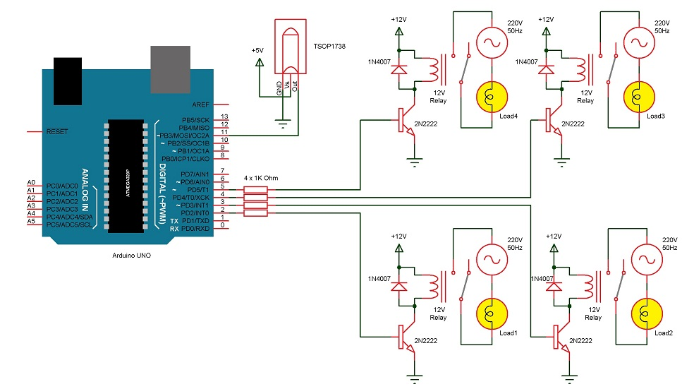

### Components Required

* Arduino UNO board
* TSOP 1738 IR Remote Control Receiver
* 1 KΩ Resistor X 4
* 2N2222 NPN Transistor X 4
* 1N4007 Diode X 4
* 12 V Relay X 4
* Remote Control
* Prototyping board (Bread board)
* Connecting wires
* 12 V Power supply