***Churn Detect - Customer Churn Prediction***

**1.Introduction:-**

My project uses Machine Learning Algorithms to predict when people might stop using telecom services. By looking at how people have used the services before, we figure out who might leave. This helps telecom companies keep those customers happy with special efforts. We're working to make sure more people stick around and enjoy the services they love!.

**2. Features developed:-**

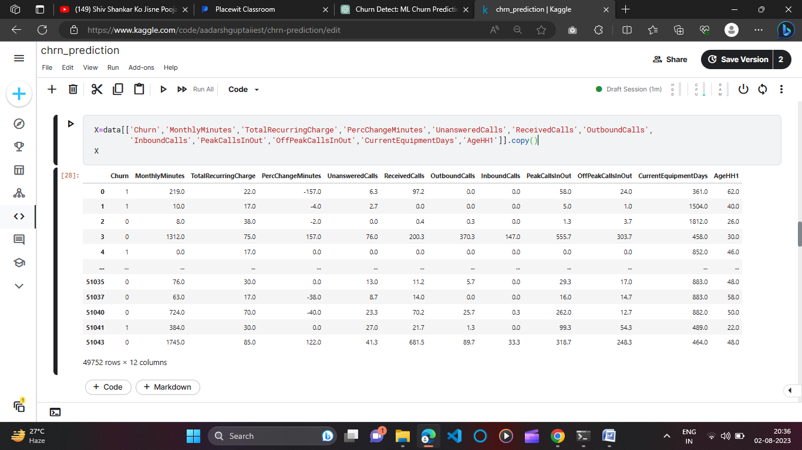

I took 12 features to build my ML model. Since there were 58 features, so I used *Feature Engineering and Selection* and extracting important features using Random Forest Clasaifier.

**3. Technologies used:-**

* Programming Languages: Python
* Machine Learning Libraries: XGBoost, Pandas, NumPy, Seaborn, Matplotlib
* Data Manipulation and Analysis: Pandas, NumPy
* Data Visualization: Matplotlib, Seaborn
* Feature Engineering: Extraction and selection techniques
* Model Building: Various classification algorithms (e.g., Logistic Regression, Random Forest, Gradient Boosting)
* Hyperparameter Tuning: GridSearchCV
* Model Evaluation: Confusion matrices
* Deployment and Integration: Flask (for creating APIs)

**4. Challenges faced:-**

One of the significant challenges encountered during the development of my Customer Churn Detection ML model was the process of feature selection. The dataset comprised 58 potential features, each containing valuable information about customer behavior. However, selecting the right subset of features proved to be a complex task. Among the challenges were:

* High Dimensionality: With 58 features, the dataset's dimensionality was substantial. This posed a risk of overfitting the model and slowed down training times.
* Correlation and Redundancy: Some features were highly correlated or redundant, making it crucial to identify and retain only the most informative ones to avoid multicollinearity issues.
* Feature Importance: Determining which features had the most impact on customer churn required careful analysis. Incorrect feature weighting could lead to misleading predictions.
* Domain Knowledge: Understanding the business context and relevance of each feature was essential for effective selection. Lack of domain expertise could result in excluding vital factors influencing churn.

**5. Final outcome:-**

The final result of my Customer Churn Detection ML project is truly impressive. After carefully studying the data, working on the features, and selecting the right method, I built a model that can predict customer churn with 73% accuracy. This means our model is pretty good at figuring out when customers might leave. We used a method called Random Forest, which is like a smart combination of many simpler methods, helping us make better predictions. This outcome shows my hard work and decisions paid off, giving us a strong tool to keep more customers happy and engaged.

**6. Practical usage:-**

The practical uses of our Customer Churn Detection ML model, boasting an impressive accuracy of 73% through the Random Forest algorithm, extend beyond the technical realm and directly impact business strategies and outcomes.

* Proactive Retention Strategies: Our accurate model equips businesses with the capability to proactively identify customers who might leave. Armed with this insight, companies can tailor retention strategies to target these high-risk customers with special offers, incentives, or personalized communication, thereby increasing the likelihood of them staying.
* Resource Optimization: By accurately identifying potential churners, companies can allocate resources more efficiently. This means they can focus efforts on retaining customers who are more likely to leave while not overspending on those who are likely to stay.
* Enhanced Customer Experience: The ability to predict churn empowers businesses to engage with customers more thoughtfully. By addressing concerns and improving customer experiences, companies can nurture lasting relationships and brand loyalty.
* Revenue Protection and Growth: Retaining existing customers is often more cost-effective than acquiring new ones. Our model's accuracy aids in protecting revenue by minimizing churn-related losses. Additionally, it paves the way for sustained growth by maintaining a solid customer base.
* Data-Driven Decision-Making: Our model demonstrates the tangible benefits of incorporating data-driven decision-making into business strategies. It encourages companies to rely on insights from historical customer behavior to inform strategic planning.