LAB MANUAL
Wireless Networks
Chapter 1 — Wireless Links, CDMA, Wi-Fi (802.11), Mobility & Personal Area Networks
Device Used for Practical Sessions
Redmi 15 5G (Android)
Name: ___________________________
Register No.: ___________________________
Class / Section: ___________________________
Academic Year: 2026 – 2027

Syllabus Coverage Map
This lab manual maps the theory topics of Chapter 1 (Wireless Networks) to hands-on experiments performable on a standard Android smartphone (Redmi 15 5G) without root access.
Theory Topic | Covered In
Wireless Links and Network Characteristics | Experiment 2
CDMA | Experiment 3
Wi-Fi: 802.11 Wireless LANs / 802.11 Architecture | Experiment 1
The 802.11 MAC Protocol (CSMA/CA) | Experiment 4
The IEEE 802.11 Frame | Experiment 5
Mobility in the Same IP Subnet | Experiment 6
Advanced Features in 802.11 (QoS/WMM, Power-save, MIMO) | Experiment 1 & 4 (Discussion)
Personal Area Networks: Bluetooth and Zigbee | Experiment 7

General Instructions
1. All experiments in this manual are designed to be performed using only an Android smartphone (Redmi 15 5G, HyperOS/MIUI-based Android) — no rooting, no external hardware is required unless stated as 'optional'.
2. Install the following free applications from the Google Play Store before the lab session:
- WiFi Analyzer (by VREM Software / Farproj) — Wi-Fi scanning, channel graph, signal strength
- Network Cell Info Lite (or Signal Strength / Netmonster) — 4G/5G RSRP, RSRQ, SINR readings
- PCAPdroid — local VPN-based packet capture (no root needed)
- nRF Connect for Mobile — BLE / Bluetooth device scanning and RSSI
- Speedtest by Ookla — throughput measurement
- Termux — for ping, traceroute and basic networking commands (optional but recommended)

3. Enable Developer Options on the Redmi 15 5G if required for some readings: Settings → About phone → tap 'MIUI/HyperOS version' 7 times → Developer options unlocked → Settings → Additional settings → Developer options.
4. Record all readings honestly in the observation tables provided, then re-plot every sample graph in this manual using your own measured data (Excel / Google Sheets / graph sheet). The graphs printed here show the expected trend only.
5. Perform experiments involving movement (Experiments 2, 6, 7) in an open corridor, hostel floor, or building with multiple Wi-Fi access points for meaningful readings.

Experiment 1: Study of 802.11 Wi-Fi LAN Architecture and Network Parameters

1. Aim
To explore the IEEE 802.11 wireless LAN architecture (BSS, ESS, Distribution System, Access Point) and to scan, identify, and tabulate the key radio parameters (SSID, BSSID, channel, frequency band, signal strength, security type) of Wi-Fi networks visible around the lab using the smartphone.

2. Apps / Tools Required (Android — Redmi 15 5G)
- WiFi Analyzer app (Play Store)
- Redmi 15 5G with Wi-Fi enabled (Location permission granted, required by Android for Wi-Fi scan results)

3. Theory / Background
A Basic Service Set (BSS) is the fundamental building block of an 802.11 network — a group of stations coordinated by a single Access Point (AP) in infrastructure mode, or communicating directly in an Independent BSS (IBSS/ad-hoc mode).
An Extended Service Set (ESS) is formed by connecting multiple BSSs through a Distribution System (DS, typically a wired backbone), all advertising the same SSID so that stations can roam transparently between APs.
Each AP/BSS is uniquely identified at Layer 2 by a BSSID (usually the AP's radio MAC address), while the SSID is the human-readable network name shared across an ESS.
Wi-Fi operates in the 2.4 GHz (channels 1–14, 20/22 MHz wide, only 3 non-overlapping in most regions: 1, 6, 11) and 5 GHz/6 GHz bands (many more non-overlapping channels, shorter range due to higher path loss).

4. Procedure
- Open the WiFi Analyzer app and grant Location permission when prompted (mandatory for Android to return scan results).
- Go to the 'AP list' or 'Signal meter' view. Let the app scan for at least 30 seconds.
- Record at least 8–10 visible access points with their SSID, BSSID, Channel, Band (2.4/5 GHz), RSSI (dBm), and Security type (Open/WPA2/WPA3) in the observation table below.
- Switch to the 'Channel graph' view and take a screenshot showing channel overlap of nearby APs.
- Identify which BSSIDs share the same SSID (this indicates an ESS with multiple APs/roaming range extenders).
- Note the least congested channel in your lab's 2.4 GHz band from the channel graph.

5. Observation Table (fill in with your own live readings)
SSID | BSSID (MAC) | Channel | Band | RSSI (dBm) | Security
12345 | De:69:c1:8b:22:a3 | 6 | 5 GHz | -61 | WPA2
Galaxy | 9a:b6:b2:1a:53:28 | 1 | 5 GHz | -50 | WPA2
Sohan 2G | 40:ae:30:56:44:78 | 1 | 2.4 GHz | -61 | WPA2
KLE_Tech | 58:61:63:01:e6:e3 | 11 | 2.4 GHz | -49 | WPA2

6. Result Graph

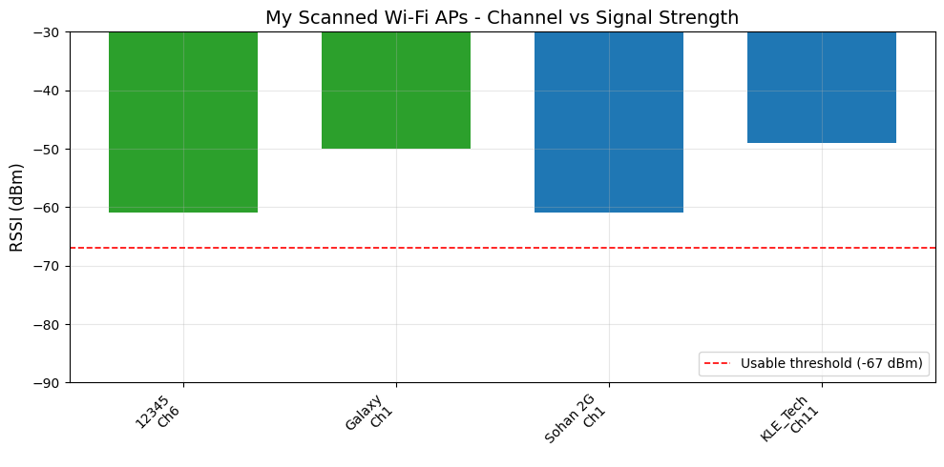
Fig 1.1 — Sample plot: RSSI of scanned APs vs their operating channel (2.4 GHz vs 5 GHz shown in different colours).
Note:
The graph above shows a sample / expected trend. Replot this graph using YOUR OWN measured values from the observation table (use Excel, Google Sheets, or graph sheet).

7. Result & Analysis
- APs sharing the same SSID but different BSSIDs (e.g., extenders/mesh nodes) confirm the ESS concept — they form one logical Wi-Fi network for the user while being distinct BSSs at Layer 2.
- Channels 1, 6, and 11 are the only non-overlapping 2.4 GHz channels; if multiple nearby APs are seen on channel 6 with strong RSSI, expect co-channel interference and reduced throughput.
- 5 GHz APs generally show lower RSSI than 2.4 GHz APs at the same distance, confirming higher path loss at higher frequency.
- State, from your own data, which channel your lab's router should ideally use to minimise congestion.

8. Viva-Voce Questions
- Differentiate between BSS, ESS, and IBSS.
- What is the difference between SSID and BSSID?
- Why are only channels 1, 6, and 11 recommended for 2.4 GHz deployments?
- What role does the Distribution System (DS) play in 802.11 architecture?
- Why does Android require Location permission to perform a Wi-Fi scan?

Experiment 2: Wireless Link Characteristics — RSSI vs Distance and Path-Loss Modelling

1. Aim
To study how wireless link quality (RSSI) degrades with distance from an access point, and to empirically estimate the path-loss exponent (n) of the indoor environment using the log-distance path loss model.

2. Apps / Tools Required (Android — Redmi 15 5G)
- WiFi Analyzer app (for live RSSI readout)
- Measuring tape / marked corridor at 1 m intervals
- A single fixed Wi-Fi AP as the reference transmitter

3. Theory / Background
Wireless links suffer attenuation (path loss), shadowing, and multipath fading — unlike wired links, the received signal strength is a random, distance- and environment-dependent quantity.
The log-distance path loss model: PL(d) = PL(d0) + 10·n·log10(d/d0) + Xσ, where d0 is a close-in reference distance, n is the path-loss exponent (≈2 for free space, 2.7–4.3 for indoor obstructed environments), and Xσ is a shadowing random variable.
Since RSSI (dBm) = TxPower − PL(d), a plot of RSSI vs log(distance) is expected to be linear, whose slope gives −10n.

4. Procedure
- Stand at d0 = 1 m from the AP with the phone. Open WiFi Analyzer's Signal Meter and note the RSSI for that AP.
- Move away in a straight line and record RSSI at d = 2, 3, 4, 5, 6, 8, 10, 12, 15 metres (use a corridor if possible for line-of-sight and through 1–2 walls for obstructed readings).
- Take 3 readings at each distance and use the average to reduce fluctuation/fading effects.
- Tabulate distance vs average RSSI.
- Compute the path-loss exponent n by linear regression of RSSI against 10·log10(d/d0) (a spreadsheet 'SLOPE' function works, or use the formula in the theory section).

5. Observation Table (fill in with your own live readings)
Distance d (m) | RSSI Trial 1 | RSSI Trial 2 | RSSI Trial 3 | Average RSSI (dBm)
1 | -37 | -38 | -36 | -37.0
3 | -56 | -58 | -55 | -56.3
6 | -69 | -70 | -68 | -69.0
10 | -73 | -75 | -72 | -73.3
15 | -78 | -79 | -77 | -78.0

6. Result Graph
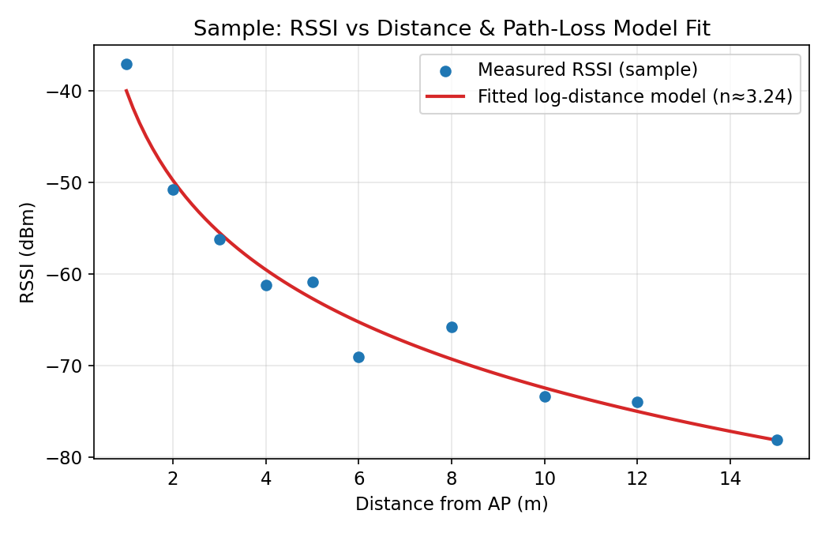
Fig 2.1 — Sample plot: RSSI vs distance with fitted log-distance path-loss curve (fitted n ≈ 3.24 for the sample data).
Note:
The graph above shows a sample / expected trend. Replot this graph using YOUR OWN measured values from the observation table (use Excel, Google Sheets, or graph sheet).

7. Result & Analysis
- RSSI decreases approximately logarithmically with distance, confirming the log-distance path loss model.
- A path-loss exponent n close to 2 indicates near free-space/line-of-sight propagation; n > 3 indicates significant obstruction (walls, furniture) typical of indoor environments.
- Fluctuations between trials at the same distance illustrate small-scale fading due to multipath — this is why real Wi-Fi links use retransmission and rate adaptation.
- Report your own computed value of n and classify your lab environment (open corridor vs obstructed office) based on it.

8. Viva-Voce Questions
- Define path loss and shadowing; how do they differ from multipath fading?
- What does a higher path-loss exponent (n) physically indicate?
- Why do we average multiple RSSI readings at the same distance?
- How does the presence of walls/obstacles affect n?
- How is RSSI-based path loss estimation used in practical applications like indoor positioning?

Experiment 3: Cellular Spread-Spectrum Link Characteristics (CDMA-derived 4G/5G) — Signal Quality vs Obstruction

1. Aim
To study the wireless link characteristics of a modern cellular network (which uses code-division / OFDMA multiple access derived from CDMA principles) by measuring RSRP, RSRQ and SINR at different locations with varying line-of-sight/obstruction, and to relate these to the concepts of near–far problem and power control used in CDMA systems.

2. Apps / Tools Required (Android — Redmi 15 5G)
- Network Cell Info Lite app (or similar signal-monitor app)
- Redmi 15 5G with an active SIM (4G/5G)

3. Theory / Background
CDMA (Code Division Multiple Access) allows multiple users to share the same frequency band simultaneously by assigning each a unique orthogonal/pseudo-random spreading code; the receiver despreads using the matching code, and interference from other users appears as noise-like background.
A key CDMA problem is the near–far problem: a nearby transmitter can drown out a distant one unless tight, fast power control is used so that all signals arrive at the base station with roughly equal power. Modern 4G/5G networks (which evolved from and coexist with CDMA-family standards) retain fast closed-loop power control and use similar link-quality metrics.
RSRP (Reference Signal Received Power) indicates the raw received power of the reference signal (like RSSI in Wi-Fi); RSRQ (Reference Signal Received Quality) additionally factors in interference/load; SINR (Signal to Interference + Noise Ratio) reflects how usable the link is for high data rates.

4. Procedure
- Install and open Network Cell Info Lite; grant Phone/Location permissions.
- Note the current Cell ID, band, RSRP, RSRQ, and SINR while standing near a window (best expected signal).
- Move to progressively more obstructed locations: middle of the room, a corner, an adjacent room, behind a concrete wall, a stairwell, and (if accessible) a basement/lift lobby.
- At each location wait 10 seconds for the reading to stabilise, then record RSRP, RSRQ, SINR and note whether the network shows 4G/LTE or 5G-NR.
- Repeat with mobile data ON and check if the network sometimes falls back from 5G to 4G in the most obstructed spot — note this as a form of adaptive link management.

5. Observation Table (fill in with your own live readings)
Location | RSRP (dBm) | RSRQ (dB) | SINR (dB) | Network Type (4G/5G)
Near window | -90 | -12 | 0 | 5G-NR
Mid room | -102 | -17 | 12 | 5G-NR
Corner | -96 | -14 | 2 | 5G
Next room | -103 | -16 | 7 | 4G/LTE
Behind wall | -108 | -18 | 10 | 4G/LTE

6. Result Graph

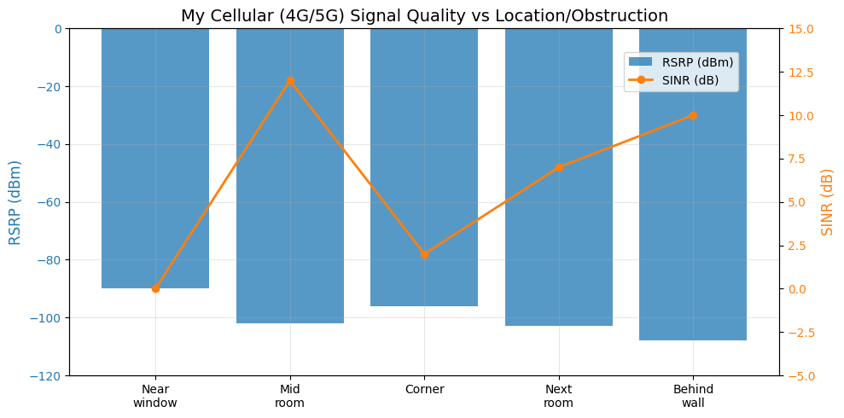
Fig 3.1 — Sample plot: RSRP (bars) and SINR (line) across locations of increasing obstruction.
Note:
The graph above shows a sample / expected trend. Replot this graph using YOUR OWN measured values from the observation table (use Excel, Google Sheets, or graph sheet).

7. Result & Analysis
- RSRP and SINR both degrade as line-of-sight is lost and obstruction increases, mirroring the RSSI-vs-distance trend seen in Wi-Fi (Experiment 2) but with additional building-penetration loss.
- A sharp SINR drop even when RSRP is only moderately low indicates rising interference/noise floor — analogous to the CDMA near–far scenario where usable capacity depends on interference, not just raw power.
- Automatic fallback from 5G-NR to 4G/LTE in poor-coverage spots demonstrates network-side adaptive link/rate management, conceptually similar to CDMA power control and soft handoff.
- Summarise, from your own readings, at what SINR threshold the connection became noticeably unusable (slow browsing/call drop).

8. Viva-Voce Questions
- Explain the near–far problem in CDMA and how power control solves it.
- Differentiate RSRP, RSRQ, and SINR.
- Why can two users in CDMA share the same frequency and time slot simultaneously?
- What is soft handoff in CDMA, and how does it differ from hard handoff in GSM/802.11?
- Why might your phone fall back from 5G to 4G in a basement?

Experiment 4: 802.11 MAC Protocol — CSMA/CA Behaviour Under Contention

1. Aim
To empirically observe the effect of the 802.11 Distributed Coordination Function (DCF)/CSMA-CA MAC protocol by measuring how per-station throughput changes as the number of devices contending for the same Wi-Fi channel increases.

2. Apps / Tools Required (Android — Redmi 15 5G)
- Speedtest by Ookla app (or an iperf3 Android client + a laptop running iperf3 -s)
- 3–5 additional Wi-Fi-capable devices (classmates' phones/laptops) on the same AP
- (Optional) Termux with iperf3 installed for more accurate throughput logging

3. Theory / Background
802.11 uses CSMA/CA (Carrier Sense Multiple Access with Collision Avoidance) at the MAC layer: a station senses the channel, waits if busy, and after it becomes idle waits a DIFS plus a random backoff (drawn from a contention window) before transmitting, to avoid collisions since collision detection is not feasible on a shared radio medium.
Because only one station can transmit successfully at a time on a channel, the total available airtime/throughput is shared among all contending stations; per-station throughput roughly falls as more stations contend, and backoff/collision overhead grows with the number of stations.
Optional RTS/CTS handshaking and ACK frames add further overhead per successful transmission, especially visible as contention increases.

4. Procedure
- Ensure all test devices connect to the SAME Wi-Fi AP/SSID and, ideally, the same band (e.g., all on 2.4 GHz) to guarantee they share one collision domain.
- With only your phone connected to the network, run a Speedtest (or iperf3 download test) and record the throughput. This is the n = 1 baseline.
- Add a second device performing a simultaneous large download/Speedtest, and re-run the test on your phone. Record throughput. Repeat for n = 3, 4, 5, 6 simultaneously active devices.
- For best accuracy, run all simultaneous tests for at least 20–30 seconds and take the sustained average throughput, not the peak.
- Tabulate throughput per device against the number of contending devices n.

5. Observation Table (fill in with your own live readings)
No. of Contending Devices (n) | Trial 1 (Mbps) | Trial 2 (Mbps) | Avg. Throughput/Device (Mbps)
1 | 58.4 | 60.1 | 59.3
2 | 27.9 | 29.4 | 28.7
3 | 18.2 | 17.5 | 17.9
4 | 12.6 | 13.9 | 13.3
5 | 9.8 | 10.5 | 10.2

6. Result Graph
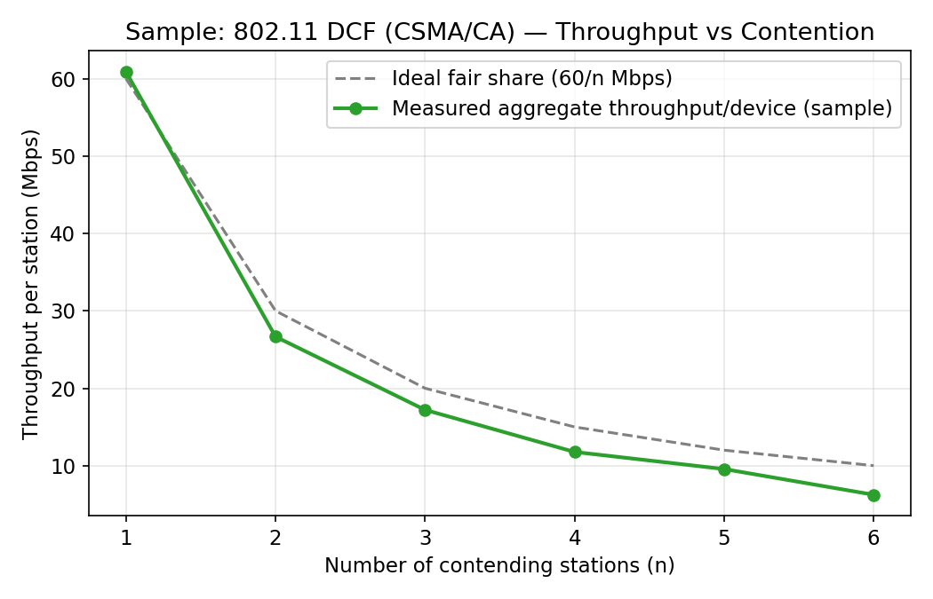
Fig 4.1 — Sample plot: measured per-device throughput vs number of contending stations, compared against the ideal 1/n fair-share line.
Note:
The graph above shows a sample / expected trend. Replot this graph using YOUR OWN measured values from the observation table (use Excel, Google Sheets, or graph sheet).

7. Result & Analysis
- Per-device throughput drops as n increases, but not exactly as 1/n — the gap below the ideal fair-share line represents the MAC overhead (backoff time, collisions, ACK/inter-frame spacing) introduced by CSMA/CA.
- The relative overhead (measured/ideal ratio) typically worsens as n grows, since collision probability and average backoff both increase with more contending stations.
- This experiment demonstrates why real Wi-Fi networks slow down noticeably in crowded environments (classrooms, conferences) even though the nominal link rate hasn't changed.
- Discuss, using your own data, how much of the throughput loss going from n=1 to n=5 is attributable to fair sharing vs MAC overhead.

8. Viva-Voce Questions
- Explain the CSMA/CA algorithm and why collision detection (CSMA/CD) is not used in wireless LANs.
- What are DIFS, SIFS, and the contention window, and how do they interact?
- How does the RTS/CTS mechanism help with the hidden-terminal problem?
- Why is measured throughput lower than the ideal 1/n fair-share value?
- How does 802.11e/WMM (QoS) prioritise certain traffic classes over others in this contention process?

Experiment 5: Study of IEEE 802.11 Frame Structure via Captured Traffic

1. Aim
To study the general IEEE 802.11 frame structure (Frame Control, Duration, Address fields, Sequence Control, Data, FCS) conceptually, and to practically capture and analyse encapsulated network traffic on the phone using PCAPdroid to relate higher-layer packets to underlying 802.11 frame overhead.

2. Apps / Tools Required (Android — Redmi 15 5G)
- PCAPdroid app (local VPN-based capture, no root required)
- A Wi-Fi connection generating mixed traffic (browsing, streaming, a speed test)

3. Theory / Background
A generic 802.11 MAC frame consists of: Frame Control (2 bytes: protocol version, type/subtype — management/control/data, ToDS/FromDS flags, retry, power-management bits), Duration/ID (2 bytes, used for NAV/virtual carrier sensing), up to four Address fields (6 bytes each — source, destination, transmitter/receiver BSSID depending on ToDS/FromDS), Sequence Control (fragment/sequence numbers for duplicate detection), a variable-length Frame Body (payload, 0–2312 bytes), and a Frame Check Sequence (FCS, 4-byte CRC for error detection).
Frame TYPES include Management (beacon, association request/response, probe, authentication), Control (RTS, CTS, ACK), and Data frames (the actual payload, e.g., an IP packet). Beacons are broadcast periodically by an AP to announce the SSID, supported rates and capabilities.
IMPORTANT LIMITATION: capturing full raw 802.11 frames with all MAC-layer fields requires the Wi-Fi radio to be placed in monitor mode, which stock (non-rooted) Android devices — including the Redmi 15 5G — do NOT expose. PCAPdroid instead captures IP-layer packets via a local VPN service, which lets us study protocol overhead and encapsulation conceptually, i.e., every IP packet you see here is itself carried inside an 802.11 data frame's Frame Body over the air.

4. Procedure
- Install PCAPdroid, grant the VPN permission when prompted (this is a local, on-device capture, not sent to any external VPN server).
- Start a capture, then generate varied traffic for 2–3 minutes: open a browser and load 2–3 sites, run a short video, run one Speedtest.
- Stop the capture and open the app's connection log / stats view.
- Record the count of packets/connections by protocol (TCP, UDP, TLS/QUIC, DNS, ICMP, etc.) and export a .pcap file if you want to inspect it further later (e.g., with Wireshark on a PC).
- (Discussion) For every packet counted here, sketch/label the equivalent 802.11 Data frame that would carry it over the air, identifying which Address field would hold your phone's MAC, the AP's BSSID, and the final destination.

5. Observation Table (fill in with your own live readings)
Protocol | Packets/Connections Captured | % of Total | Typical 802.11 Frame Type Carrying It
TCP | 412 | 42.3% | Data (QoS Data, ToDS=1)
UDP | 156 | 16.0% | Data (QoS Data, ToDS=1)
TLS/QUIC | 289 | 29.7% | Data (encrypted payload)
DNS | 47 | 4.8% | Data (small payload)
ICMP | 12 | 1.2% | Data

6. Result Graph
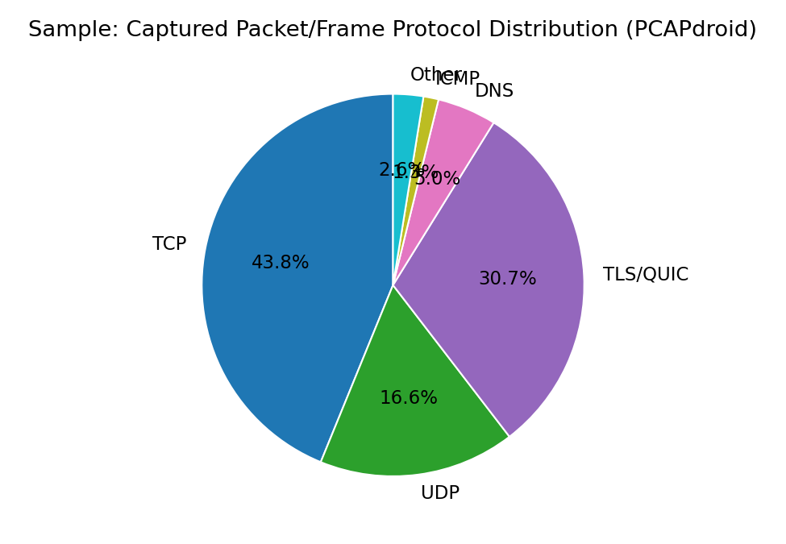
Fig 5.1 — Sample plot: distribution of captured packet protocols during the browsing/streaming/speed-test session.
Note:
The graph above shows a sample / expected trend. Replot this graph using YOUR OWN measured values from the observation table (use Excel, Google Sheets, or graph sheet).

7. Result & Analysis
- Every captured IP packet/connection, regardless of protocol, is ultimately fragmented into one or more 802.11 Data frames for over-the-air transmission — each incurring its own Frame Control, Address, and FCS overhead plus a MAC-layer ACK.
- A high proportion of small DNS/ACK-like packets increases relative MAC overhead (per-frame fixed cost) compared to large streaming payloads, which amortise overhead better.
- TLS/QUIC dominating the capture reflects modern encrypted-by-default traffic; note that 802.11 frame HEADERS (addresses, sequence numbers) are never encrypted, only the frame body/payload is (via WPA2/WPA3), which is why Wi-Fi analyzer tools can still see AP/station addresses even on secured networks.
- State, from your own capture, which protocol dominated and why, given the applications you used.

8. Viva-Voce Questions
- List and explain the fields of a generic 802.11 MAC frame.
- What do the ToDS and FromDS bits in Frame Control indicate, and how many Address fields are used in each combination?
- Differentiate Management, Control, and Data frame types with one example each.
- Why can PCAPdroid not show you the actual over-the-air 802.11 header fields on a non-rooted phone?
- What is the purpose of the Duration/NAV field in virtual carrier sensing?

Experiment 6: Mobility Management Within the Same IP Subnet — Wi-Fi Roaming/Handoff Analysis

1. Aim
To study how a mobile station roams between two access points of the same Extended Service Set (same SSID, same IP subnet) while walking through the building, and to measure the effect of the resulting Layer-2 handoff (BSSID change) on ping latency and packet loss, without any change of IP address.

2. Apps / Tools Required (Android — Redmi 15 5G)
- WiFi Analyzer app (to monitor connected BSSID in real time)
- Termux with ping installed, OR the Ping & Network Tools app
- A building/floor with at least 2 APs broadcasting the same SSID (or a mesh/extender setup)

3. Theory / Background
Within a single IP subnet, a mobile station can move between multiple APs of the same ESS (same SSID) without changing its IP address, because Layer-3 addressing is independent of which AP/BSS the station is currently associated with — this is sometimes called micro-mobility or link-layer roaming.
The handoff process at Layer 2 involves the station scanning for a stronger AP, performing (re)authentication and re-association with the new AP, after which the Distribution System updates its forwarding tables to deliver frames for that station's MAC to the new AP. During this brief interval, buffered/in-flight frames may be delayed or lost, causing a momentary latency spike or packet loss.
This is fundamentally different from mobility ACROSS subnets (macro-mobility), which requires Mobile IP or similar Layer-3 mechanisms to preserve the original IP address — not required here since we stay in one subnet.

4. Procedure
- Identify a route in your building where you will pass from being closer to AP1 to being closer to AP2, both broadcasting the same SSID.
- Connect the phone to the SSID and open a continuous ping to the gateway/router IP (e.g., using Termux: ping <gateway-IP>, or the Ping & Network Tools app in continuous mode). Also keep WiFi Analyzer open in split-screen/quickly switchable to note the connected BSSID.
- Start walking slowly and steadily from near AP1 toward AP2, keeping the ping running continuously; note the timestamp/sequence number at which the connected BSSID changes (this is the handoff instant).
- Record RTT values before, during, and after the handoff instant, and note any 'Request timeout'/lost packets around that point.
- Repeat 2–3 times and average the handoff-related latency spike and number of lost packets.

5. Observation Table (fill in with your own live readings)
Time (s) | Connected BSSID | Ping RTT (ms) | Packet Lost? (Y/N)
0–30 | AP1 (…0F:22) | ~15 | N
31 | AP1 → AP2 (switch) | 95 | N
32 | AP2 (…0F:9A) | 130 | N
33 | AP2 (…0F:9A) | — | Y (timeout)
34–60 | AP2 (…0F:9A) | ~16 | N

6. Result Graph
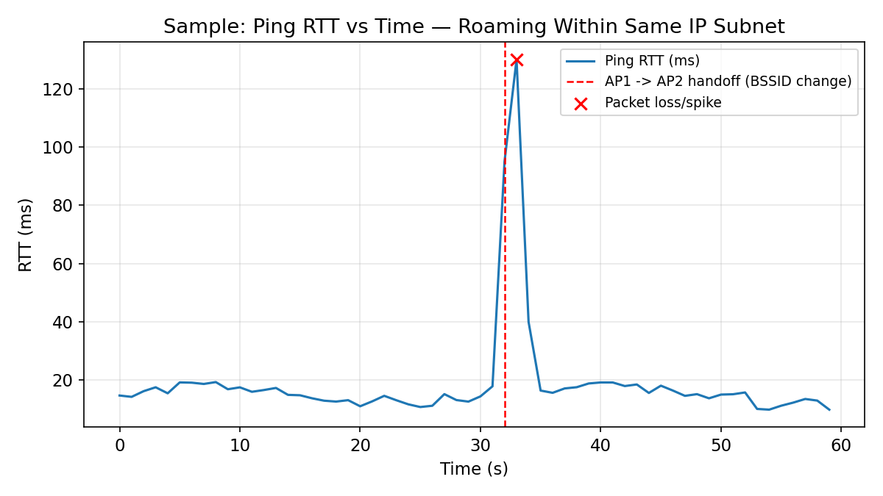
Fig 6.1 — Sample plot: ping RTT vs time showing a latency spike/packet loss at the moment of AP-to-AP handoff (BSSID change), with normal RTT restored afterwards.
Note:
The graph above shows a sample / expected trend. Replot this graph using YOUR OWN measured values from the observation table (use Excel, Google Sheets, or graph sheet).

7. Result & Analysis
- The IP address of the phone (verifiable via ifconfig/Settings → Wi-Fi details) remains unchanged throughout, even as the BSSID changes — confirming that this is Layer-2 roaming within one IP subnet, not a Layer-3 mobility event.
- A short-lived RTT spike and/or a single lost ping around the handoff instant reflects the re-association delay with the new AP; well-designed enterprise Wi-Fi (fast roaming / 802.11r) minimises this to near-zero.
- Once re-associated, RTT returns to baseline, showing the handoff is transparent to upper-layer applications (though a real-time application like a VoIP call may perceive a brief glitch).
- From your own data, estimate the total handoff duration (time between last packet via AP1 and first stable packet via AP2) and comment on how it would affect a live video call.

8. Viva-Voce Questions
- Why doesn't the phone's IP address change when it roams between two APs of the same SSID?
- What is the difference between micro-mobility (same subnet) and macro-mobility (different subnet, e.g., Mobile IP)?
- What are re-authentication and re-association in the context of Wi-Fi roaming?
- What is 802.11r (Fast BSS Transition) and how does it reduce handoff latency?
- Why might a packet be lost exactly at the moment of AP handoff?

Experiment 7: Personal Area Networks — Bluetooth (BLE) Device Discovery, RSSI-Distance Study, and Comparison with Zigbee

1. Aim
To discover nearby Bluetooth Low Energy (BLE) devices, measure their RSSI as a function of distance, and compare the practical and theoretical characteristics of Bluetooth versus Zigbee as competing low-power Personal Area Network (PAN) technologies.

2. Apps / Tools Required (Android — Redmi 15 5G)
- nRF Connect for Mobile app (BLE scanner)
- A BLE peripheral to scan (a BLE fitness band, earbuds case, or any classmate's phone advertising BLE)
- Measuring tape

3. Theory / Background
Bluetooth (IEEE 802.15.1-derived) and Zigbee (IEEE 802.15.4-based) are both short-range, low-power Personal Area Network (PAN) technologies, but target different trade-offs: Bluetooth Classic/BLE favours moderate data rates (up to ~2 Mbps for BLE) with simple point-to-point/star topology and wide smartphone support; Zigbee favours very low power, low data rate (~250 kbps), and native mesh networking for large sensor/home-automation deployments.
BLE devices periodically transmit advertising packets containing a device address, advertised name/services, and TX power; a scanner (like our phone) can passively receive these and read the RSSI without pairing.
As with Wi-Fi (Experiment 2), BLE RSSI also follows a log-distance path-loss trend, and can be used for coarse proximity/distance estimation (as used in COVID-exposure-notification-style apps and beacon-based indoor navigation).

4. Procedure
- Open nRF Connect, go to the Scanner tab, and start scanning for BLE devices.
- Identify a specific target BLE device (e.g., a smartband) and place it at d = 0.5 m from the phone.
- Record its RSSI. Move the phone away to d = 1, 2, 3, 5, 7, 10, 15 m (line of sight, minimal obstruction) and record RSSI at each distance.
- Tabulate distance vs RSSI for the BLE device.
- Separately, research (no hardware needed) and fill in a comparison table of Bluetooth vs Zigbee vs Wi-Fi across range, data rate, power consumption, topology, and typical use cases.

5. Observation Table (fill in with your own live readings)
Distance (m) | BLE RSSI (dBm)
0.5 | -54
1 | -59
3 | -72
7 | -84
15 | -96

6. Result Graph
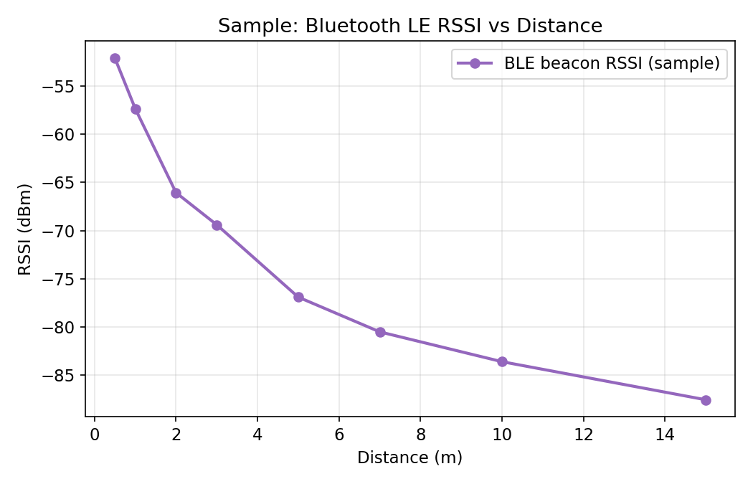
Fig 7.1 — Sample plot: BLE beacon RSSI vs distance.
Note:
The graph above shows a sample / expected trend. Replot this graph using YOUR OWN measured values from the observation table (use Excel, Google Sheets, or graph sheet).

7. Result & Analysis
- BLE RSSI decreases with distance following the same log-distance behaviour observed for Wi-Fi, but starting from a much lower transmit power, resulting in a shorter usable range (typically 10–30 m indoors vs 30–50 m+ for Wi-Fi).
- Bluetooth/BLE is optimised for short bursts of data to/from a small number of paired peripherals (star topology, one hop), whereas Zigbee's mesh capability lets a message hop through multiple low-power nodes to cover a much larger area (e.g., a whole smart building) at the cost of higher latency per hop.
- For a fixed application (e.g., a wireless door sensor network across a large campus), justify from your comparison table whether Bluetooth or Zigbee would be the better technical choice.

8. Viva-Voce Questions
- Compare Bluetooth, BLE, Zigbee, and Wi-Fi in terms of range, data rate, and power consumption.
- What is a BLE advertising packet, and why doesn't scanning for it require pairing?
- Why is Zigbee preferred over Bluetooth for large-scale home/building automation sensor networks?
- How can RSSI be used for proximity/indoor-positioning applications, and what are its limitations?
- What frequency band do both classic Bluetooth/BLE and Zigbee (in most regions) operate in, and why does this cause potential mutual interference with Wi-Fi?

Appendix A: PAN Technology Comparison Reference Table
Use this reference table to complete the comparison discussion in Experiment 7.
Parameter | Bluetooth Classic / BLE | Zigbee (802.15.4) | Wi-Fi (802.11)
Standard | IEEE 802.15.1 (BLE: Bluetooth SIG) | IEEE 802.15.4 + Zigbee Alliance stack | IEEE 802.11 a/b/g/n/ac/ax
Frequency band | 2.4 GHz ISM | 2.4 GHz (also 868/915 MHz) | 2.4 GHz / 5 GHz / 6 GHz
Typical data rate | 1–3 Mbps (BLE: up to 2 Mbps) | ~250 kbps | Tens to thousands of Mbps
Typical range | 10–30 m | 10–100 m per hop (mesh extends further) | 30–100 m
Power consumption | Low (BLE: very low) | Very low | Higher
Topology | Point-to-point / small star (piconet) | Mesh, star, or tree | Star (infrastructure BSS/ESS)
Typical use case | Audio, wearables, phone accessories | Home automation, sensor networks | General-purpose internet access, LANs

Appendix B: Consolidated Result Summary Sheet
Fill this summary after completing all experiments — to be signed off by the lab instructor.
Exp. No. | Title | Key Result Obtained | Date | Faculty Signature
1 | 802.11 Architecture & Parameters
2 | RSSI vs Distance / Path Loss
3 | Cellular Signal Quality (CDMA-derived)
4 | 802.11 MAC / CSMA-CA Contention
5 | 802.11 Frame Structure
6 | Mobility / Roaming in Same Subnet
7 | Bluetooth BLE vs Zigbee

