**Succour Android Application**

**Software Requirements: -**

* Windows /Ubuntu
* Android Studio
* Java jdk version 8 and above
* Android Emulator/Mobile

**Hardware Requirements: -**

* 32/64-bit os windows 8 or above
* 8 Gb Ram

**Steps for installing the App**

* Open Android Studio
* Open given source file
* Select where you want to install the app i.e Mobile or Android Emulator
* If you want to install on mobile, connect your mobile with usb and turn on developer option and usb debugging in mobile (Go to mobile settings)
* Click on install on android studio
* Now you’re ready to go.

**How to Use Succour App: -**

* After Installing the app, Registration page will open.
* If you already a user you can directly go to login page otherwise fill your details and register yourself
* A map page open to get your current location, you can click on Go to Main Page button to go to home page.

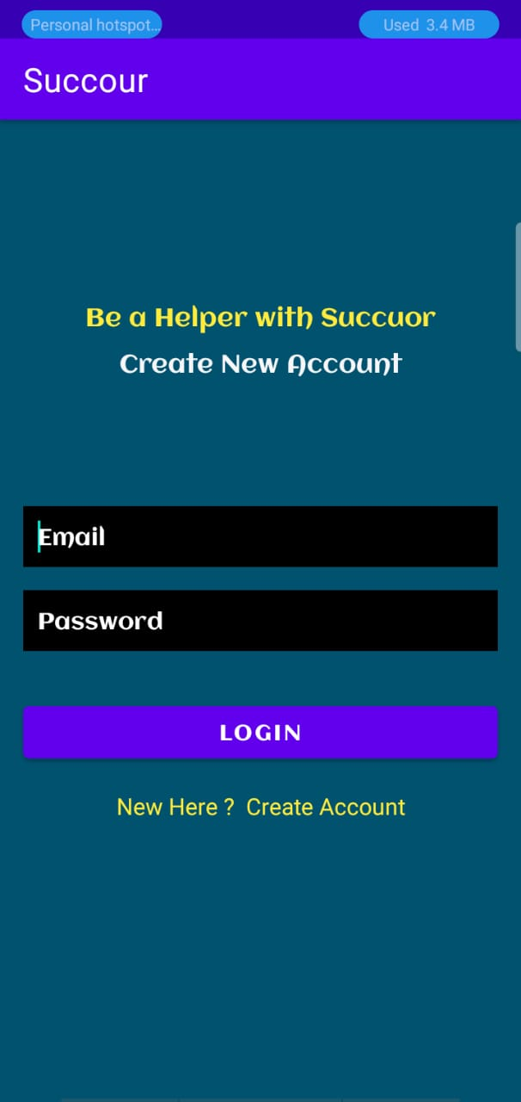 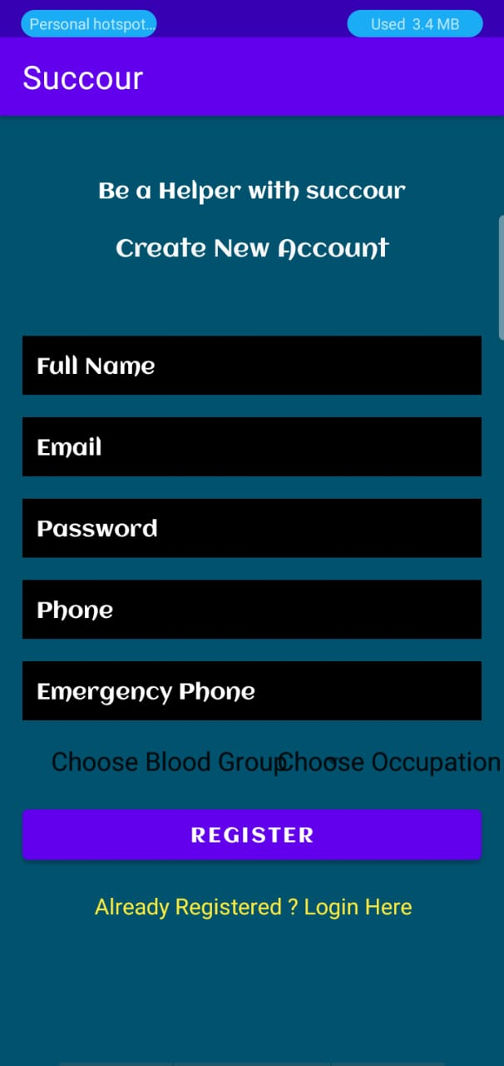

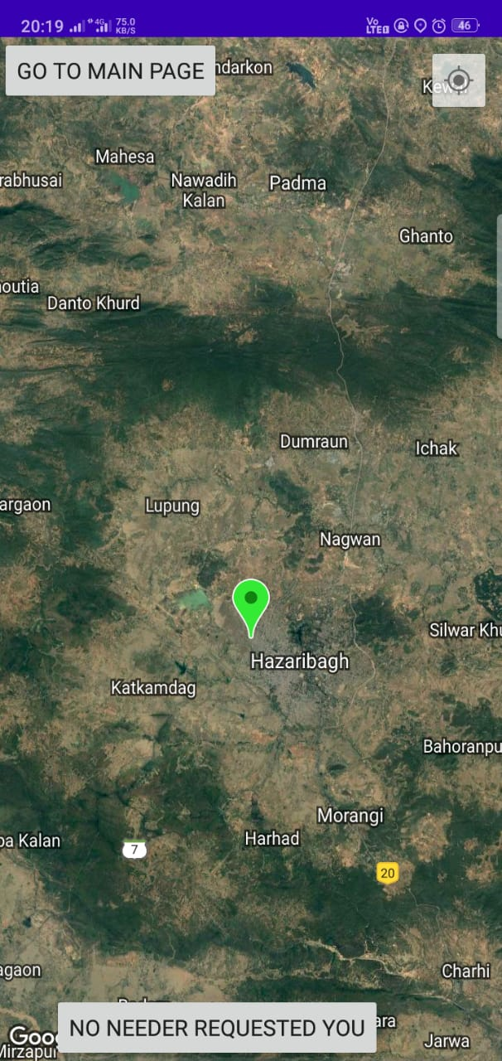 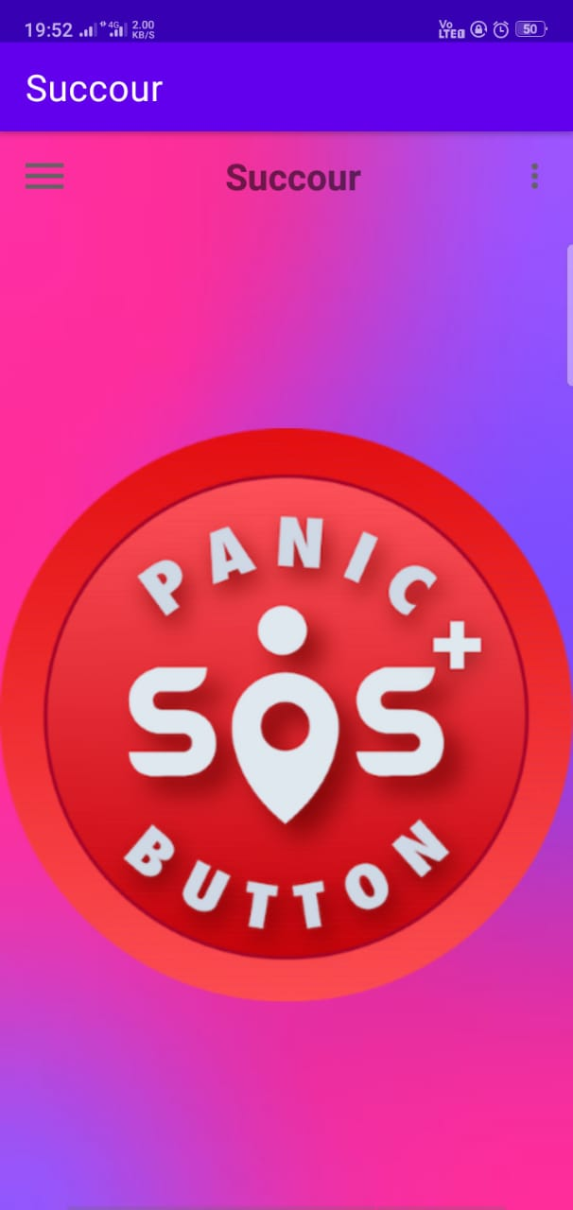

**For Emergency Situation: -**

* If you want help or in emergency situation, just click on panic button
* It asks that do you want to send message to your emergency contact, you can select according to your choice
* Click on search nearby user, now it will do all job, if no user found, then it simply say no user found.
* You can click on call button to contact your helper
* If user found, then you can cancel the help or if they reached to you, you must click Reached button to get complete your task.

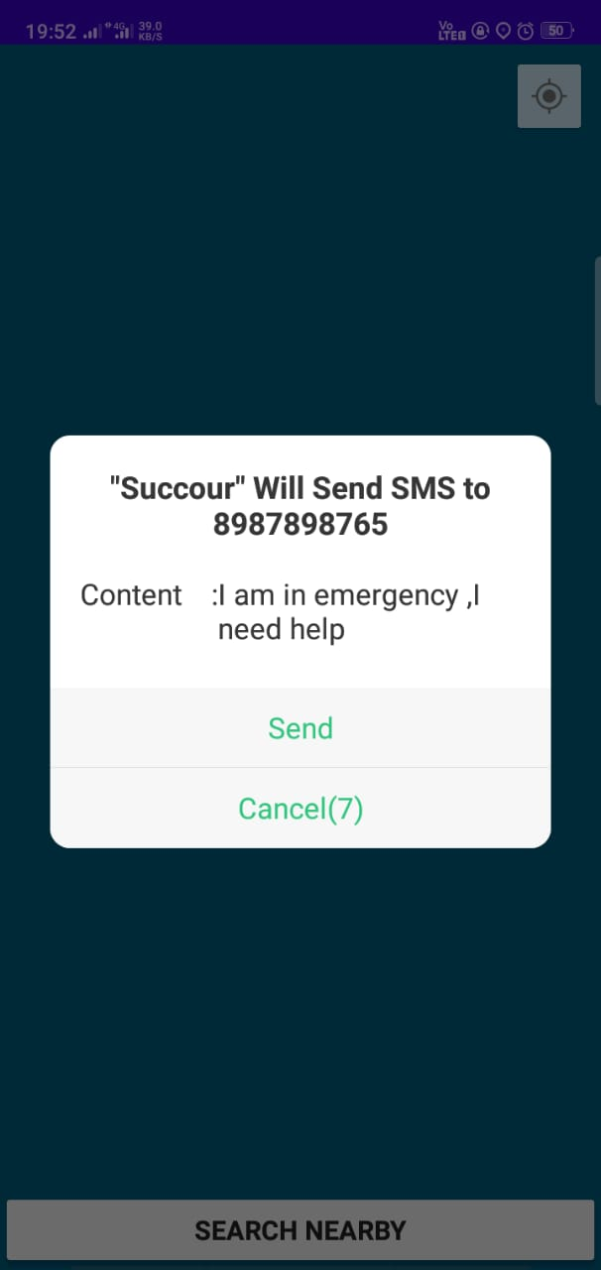 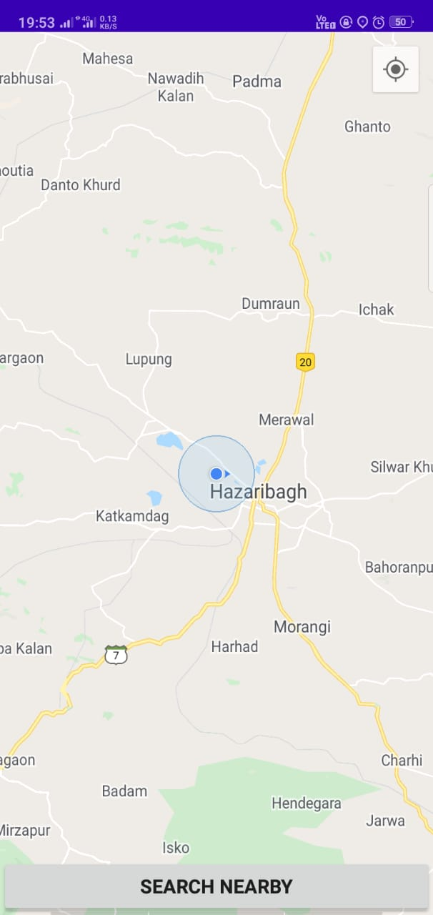

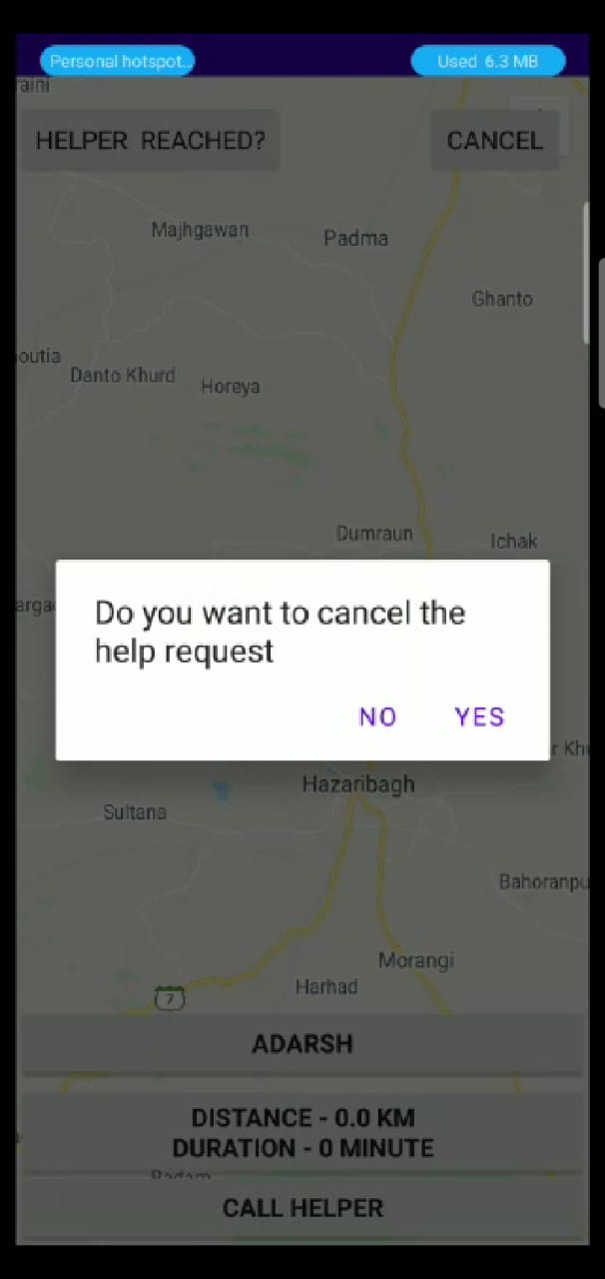

**For finding Additional Feature: -**

* On click the navigation drawer, you get a additional feature button.
* Click on it
* After entering in additional feature, you got three options: -
  + Nearby Doctor
  + Nearby Motor Mechanic
  + Nearby Blood Donor

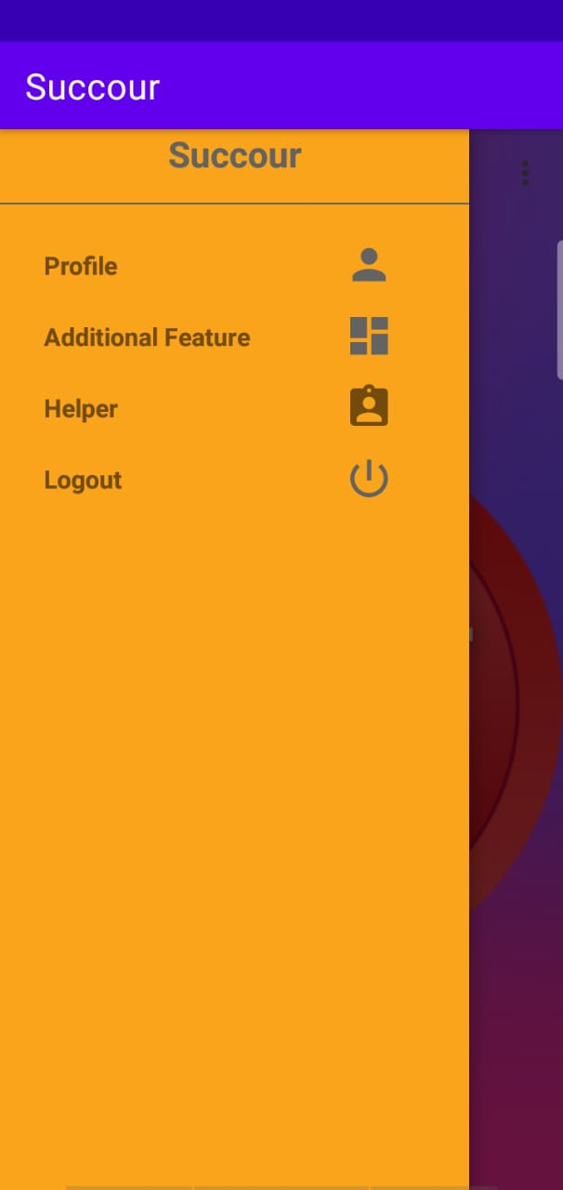 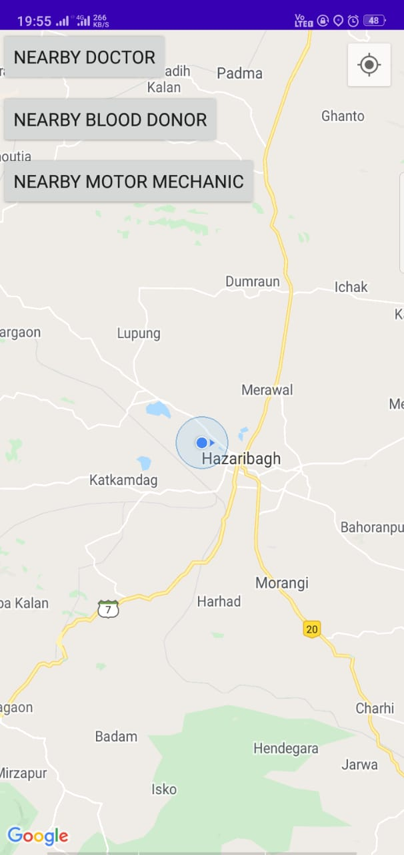

**Nearby Doctor: -**

* + - It will search nearby doctor in your radius of 5km.
    - if no user found, then it simply says no user found.
    - You can click on call button to contact your helper
    - If user found, then you can cancel the help or if they reached to you, you must click Reached button to get complete your task.

**Nearby Motor Mechanic: -**

* + - It will search nearby mechanic in your radius of 5km.
    - if no user found, then it simply says no user found.
    - You can click on call button to contact your helper
    - If user found, then you can cancel the help or if they reached to you, you must click Reached button to get complete your task.

**Nearby Blood Donor: -**

* + - * Firstly, it asks for the required blood group
      * After selecting blood group, it will display the lists of blood donor present nearby.

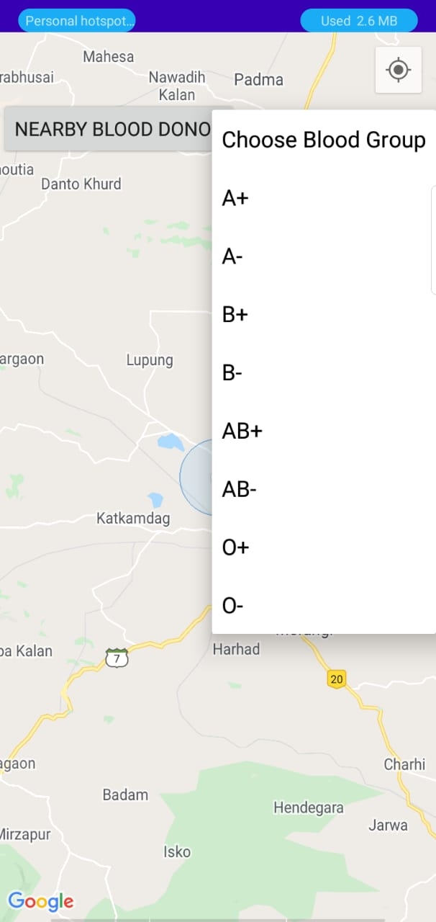 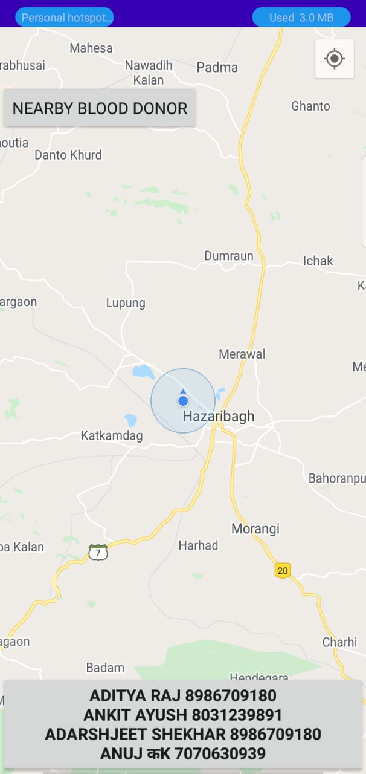

**For Helper Side: -**

* After getting notification from helper side, you have 20s to decide help or not.
* If within 20s you haven’t done anything then it automatically cancels for your help.
* Otherwise, you have to options to choose whether you want to help or not.
* If you don’t want then simply click no.
* Else click yes, it will show you the map with needer location and details,
* You can contact with needer by clicking call button
* After reaching, you can click on Have you reached Button.

