  
  **Week 12 In class Assignment**

**Student Name: Adarsh Kumar**

**Student ID: 500224470**

**Course Code: CSDD1007**

**Instructor Name: Abdul Khan**

**Code**

**Index file Code (HTML)**

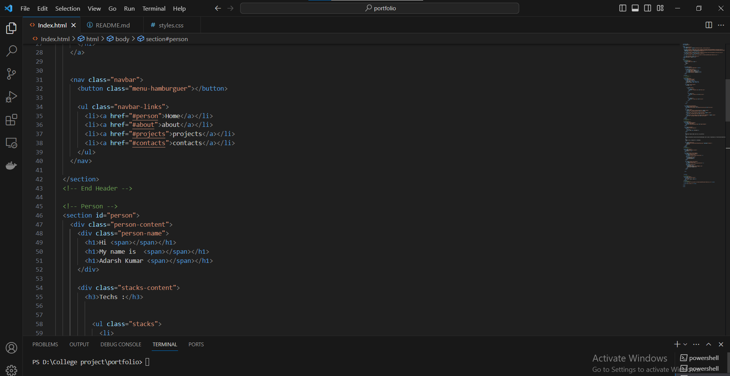

**CSS code**

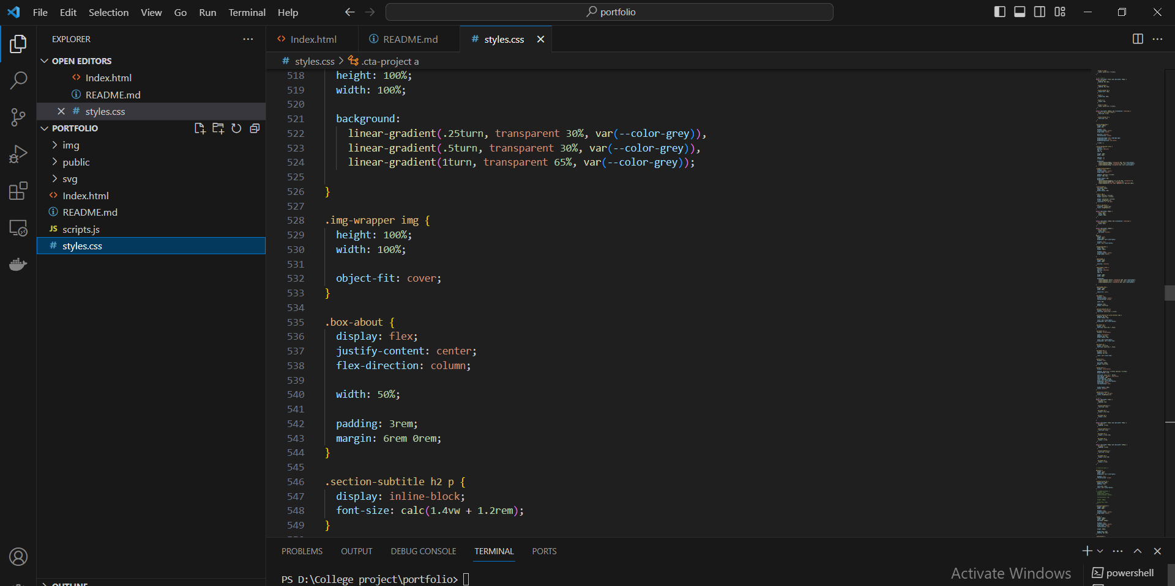

**JS Code**

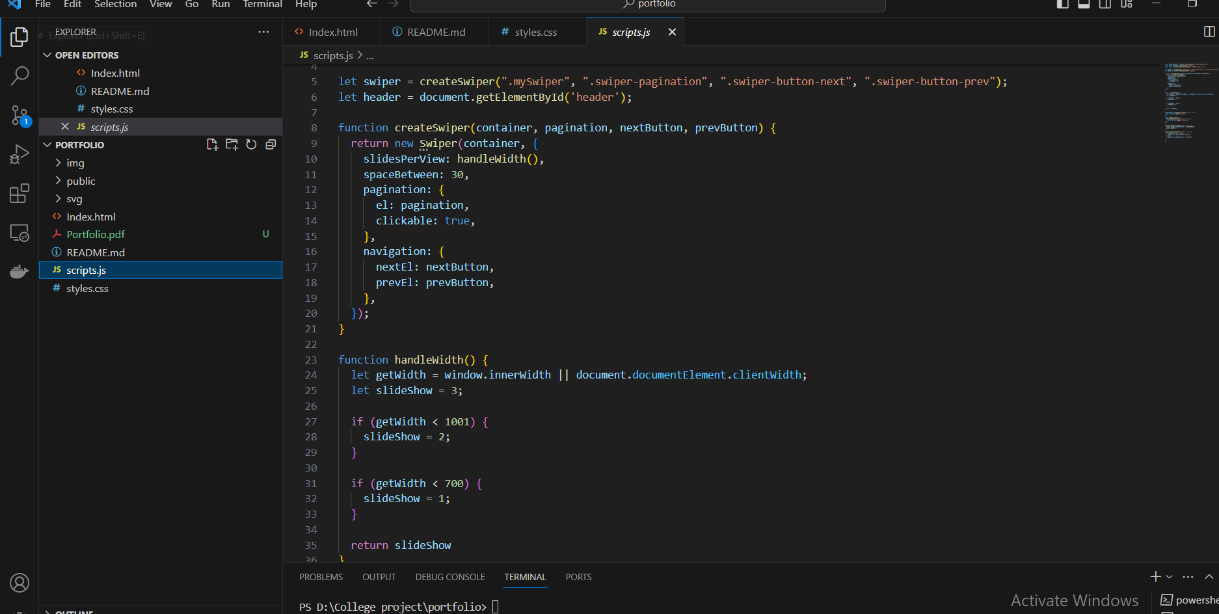

**Output**

**Home page**

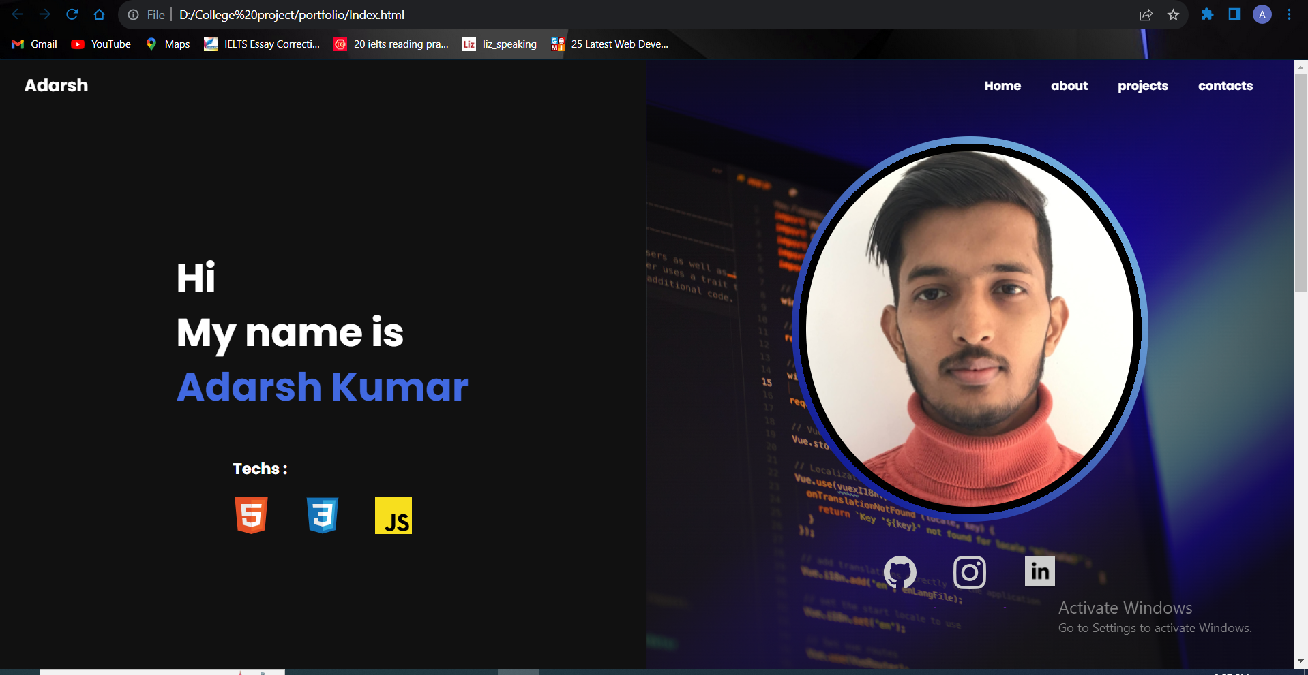

**About**

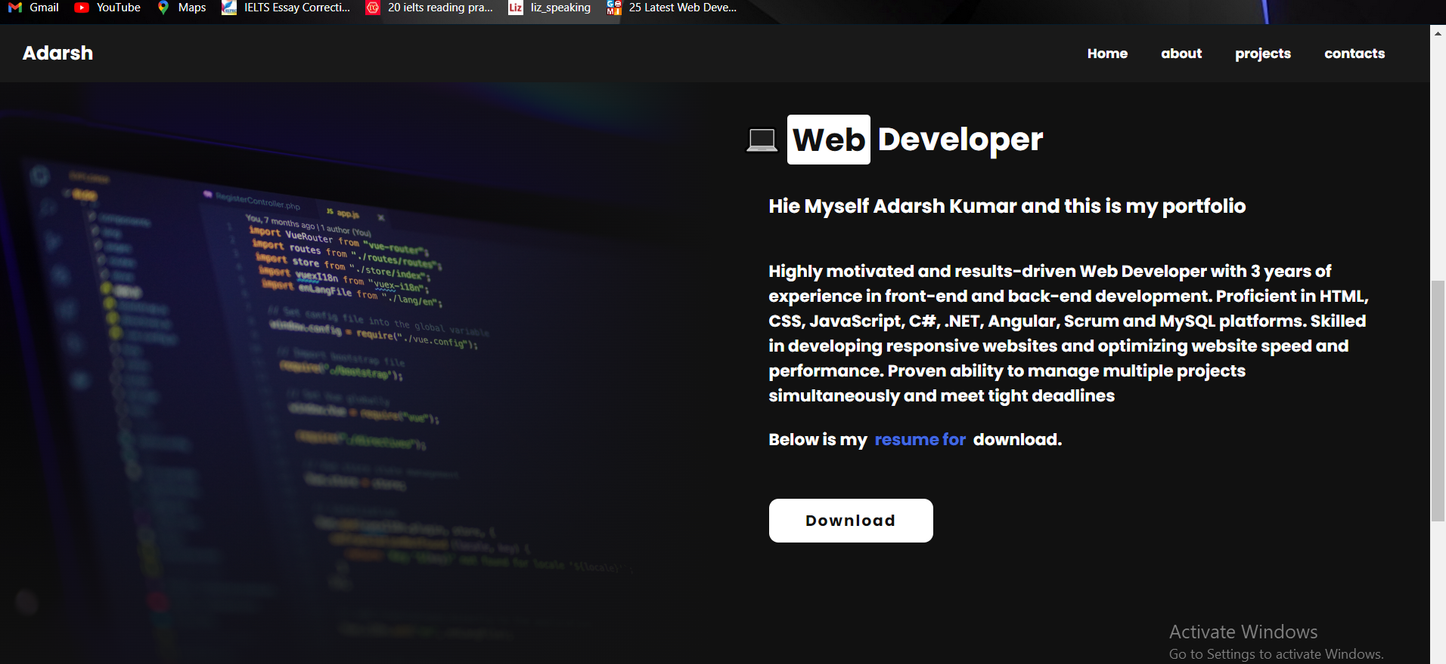

**Contact**

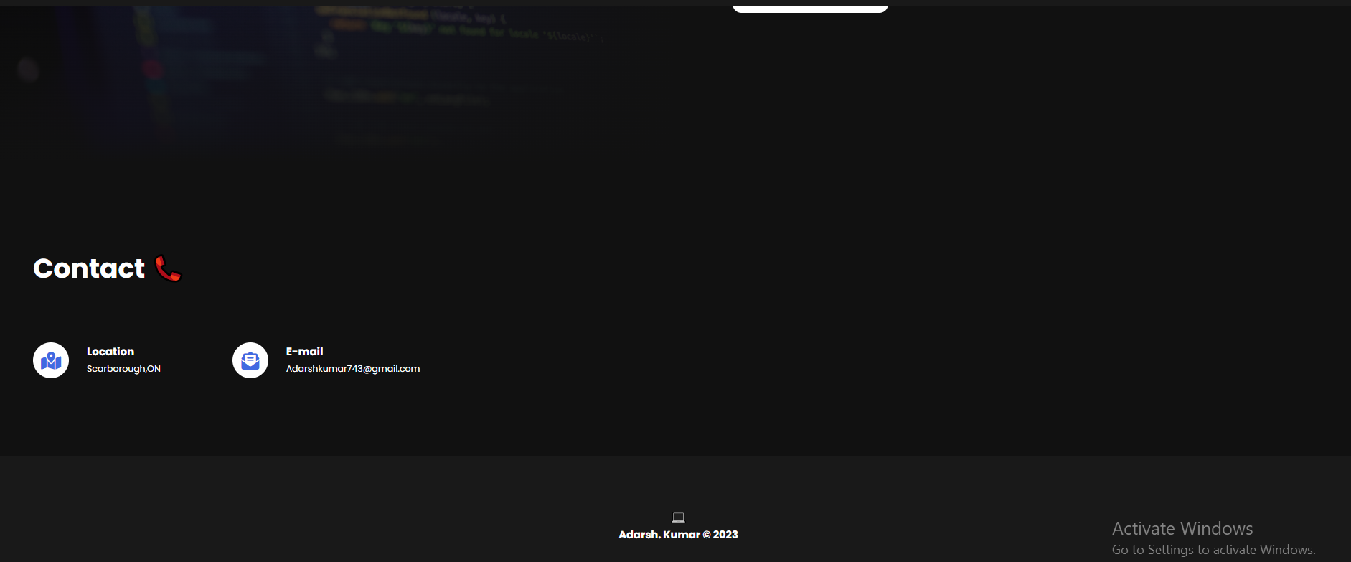

**GitHub and LinkedIn Link**

