



Essay / Assignment Title: Tableau Dashboard and Data Story

Programme title: MSc Information Technology Management

Name: Adarsh Kumar
Student Id: Q1124546
Year: 2025-2026

CONTENTS

INTRODUCTION 4
LITERATURE REVIEW 5
METHODOLOGY 7
RESULTS AND DISCUSSIONS 9
CONCLUSION 15
BIBLIOGRAPHY 16

GitHub Link: - https://github.com/Adarshkumar99/ML-Super_Store

Statement of compliance with academic ethics and the avoidance of plagiarism

I honestly declare that this dissertation is entirely my own work and none of its part has been copied from printed or electronic sources, translated from foreign sources and reproduced from essays of other researchers or students. Wherever I have been based on ideas or other people texts I clearly declare it through the good use of references following academic ethics.
(In the case that is proved that part of the essay does not constitute an original work, but a copy of an already published essay or from another source, the student will be expelled permanently from the postgraduate program).

Name and Surname (Capital letters):

...................... Adarsh Kumar............................................

Date: .........15........./.....06...../...2026......

INTRODUCTION

Today, a business's environment is becoming more and more data-driven and high-volume, and the capacity to convert raw, high-volume data into strategic data is becoming a key part of Information Technology managers' jobs. The increasing volume of transactional data generated by an organisation, especially as they move towards a digital-first approach, can easily outpace the ability for manual analysis (Jauhari and Vobugari, 2025). This results in the condition of "Information Overload". This occurs when there are thousands of rows of data, and important business situations are lost in the "noise. This is a complete data visualization and storytelling project based on the Global Superstore data set. The project is designed to leverage Tableau, a leading Business Intelligence (BI) tool, in order to uncover potential areas of inefficiency, areas of profit leakage by geographical locations, and product-specific risks that are not always apparent in traditional approaches of reporting in spreadsheet formats (Bansal, 2025).
The overall goal of the analysis will be twofold. They are to build an interactive, multidimensional dashboard to give the real-time health check of the organization's sales and profitability, and to build a story around the data to spur executive stakeholders towards action (Ajax, Joseph, and Own, 2025). The report highlights how best practices for data visualization and key machine learning principles, including linear regression-style trend lines, can help IT management close the technical data science and executive decision-making gap.

LITERATURE REVIEW

Research in data visualization deems that beyond the role of conveying information and representing it, data visualization serves as an environment to help cognitively process the data in more complex ways. According to Goh (2023), data dashboarding is a vital skill in today's professional world, especially in finance and accounting. The key strength of a dashboard is the capability to make complicated data easier to view through the dashboard and provide swift analysis of summary statistics and probability outcomes. Dashboards provide managers with a view that condenses several metrics into one so that they can get a handle on "likelihood of key outcomes" without having to go through separate reports. This project follows Goh's steps and uses a summary statistics and frequency distributions to give a summary of the health of the Superstore right off the bat. This also highlights that Tableau has not only evolved into a key industry standard, but it's assisting with making information more accessible to non-technical users by enabling it to be communicated visually, as opposed to traditionally through rows and columns (Goh, 2023).
Frempong et al (2022) focus further on the application of real-time analytics in the public sector and public intelligence. Tableau is an important link between "Big Data" repositories and decision-making (Frempong et al., 2022). Their research points out that anything that is interactive comes down to the fact that it enables one to "drill down" into specific data segments by employing filters and actions, which makes it a high value asset for a BI tool. This project is oriented to doing this, by providing dynamic dashboards, actions, and slicers that can be used throughout the visualization to make every number a clickable link leading to the "why" puzzle. Frempong et al. (2022) also state that real-time visualization shortens the "time-to-insight" and equips managers with the ability to respond to market trends in real time, and not just after the end of the month.
Finally, visualization for business optimization is discussed by Radivojević, Mravik, and Šarac (2025). Their research is dedicated to using large data and visualization in order to optimize the sales performance. According to Radivojević et al. (2025), the incorporation of business analytics is essential in order to gain valuable information about market trends and operational outliers, etc. Having access to advanced types of visualizations, such as scatter plots for detecting outliers or trend lines for a temporal analysis, enables organizations to shift from descriptive reporting to predictive and prescriptive models. This project uses these more advanced visual tools to find customer outliers and predict future sales trends, derived using linear regression models. Together, these literatures justify the methodology adopted in this report: A good dashboard should be both accurate and actionable and be designed to enhance optimization objectives. According to Radivojević, Mravik, and Šarac (2025), the "Visual Analytics" approach is better than the traditional methods, in that it is taking advantage of human spatial reasoning to extract patterns that algorithms might find hard to detect.

METHODOLOGY

1. Data Source and Selection
The dataset for this project is chosen as the 'Superstore' dataset from Kaggle (Chowdhury, 2022). It was decided to choose this data set because it met the technical requirements of this assignment and comprises 9994 individual items and 21 different variables. The data includes a variety of different data types such as categorical (Category, Region, Segment), numerical (Sales, Profit, Discount), and geographical (i.e., State, Country) data, which would make it perfect for variety of more advanced business analysis. The dataset covers several years (4 years in this case) for retail transactions, with sufficient time depth to enable meaningful time-series forecasting and trend analysis.

2. Data Preparation and Modeling
The data must be cleaned in Excel beforehand to maintain the integrity of the data before it is finally imported into Tableau (Su, 2025). The following data cleaning was performed: Removal of null values; Keep the date formatting consistent. When this text file has been imported into Tableau, each of the fields 'State' and 'City' was added to create geographic roles, allowing for geographic mapping.

3. Technical Implementation and Calculated Fields
Three custom calculated fields were created to go beyond description sales data, to offer deeper KPI (Key Performance Indicator) data:
Profit Margin: Calculated as the sum of Profit divided by the sum of Sales. This was expressed as a percentage to give a uniform measure of the efficiency of different regions, irrespective of the amount of their sales.
Profitability Status: A logical calculation of Profit > 0 = "Profitable", otherwise = "Loss". This was identifying an attribute with red for losses and green for gains, for this field for use across various visuals.
Shipping Delay: Use of DATEDIFF between Order Date and Ship Date for the delay. This was then consolidated and used as a key benchmark/Indicator (KPI) as part of the Executive Scorecard for the purpose of highlighting the identified supply chain bottlenecks.

RESULTS AND DISCUSSIONS

1. Visual Analysis and Interpretations
The dashboard design is based on the concept of “Data-Ink Ratio” which emphasizes clarity over decoration (S. Kristiansen, Garrison, and Bruckner, 2022; Sterratt, Rohani, and Gal, 2026). Each of the five visuals offers a specific perspective on the organisation's performance:
Geographic Sales Map: It is filled with revenue distribution across the United States. The use of a Red-Black diverging palette suggests that the interpretation is that although market penetration is nationwide, a high percentage of revenue is concentrated in California, New York, and Texas. It is the fundamental basis for determining the geographic market share.
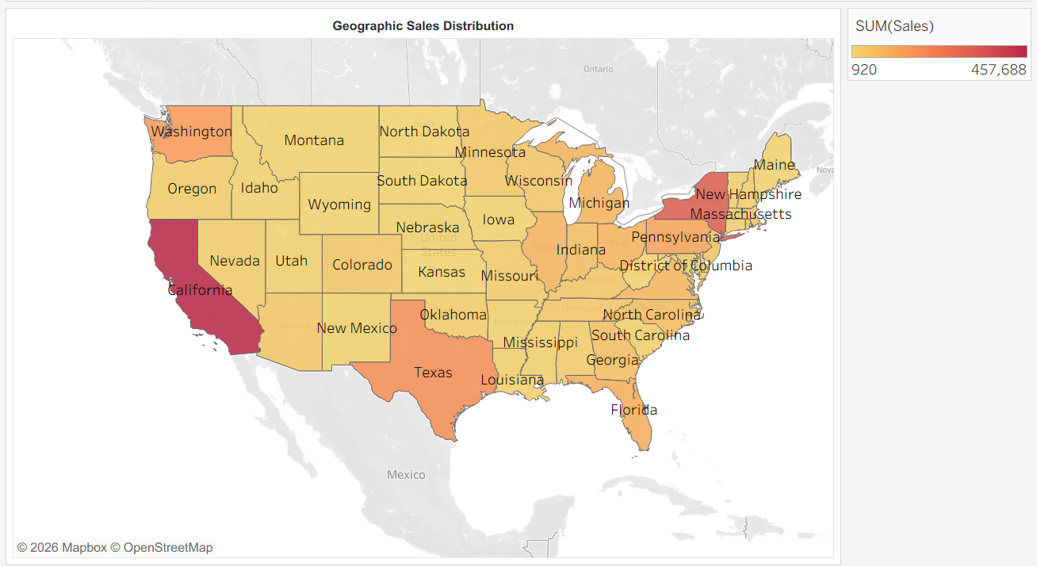
Figure 1: Geographic Sales Map
(Source: Self-created in Tableau)
Monthly Sales Trends: This continuous line graph shows trends in sales from 2014 to 2017. A Linear Regression trend line is a basic Machine Learning use case that highlights a solid positive growth pattern. The chart indicates that a good amount of seasonality is included, as there are identifiable peaks in the fourth-quarter holiday time.
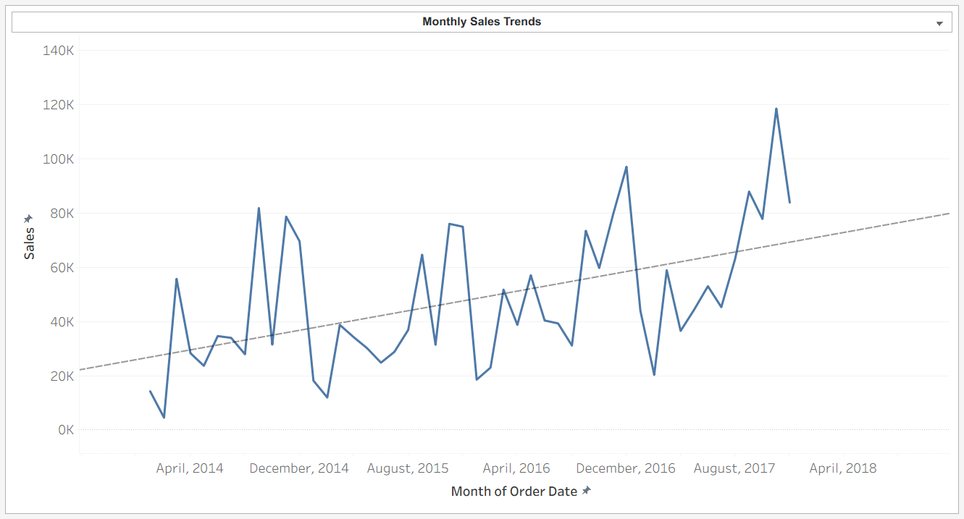
Figure 2: Monthly Sales Trends
(Source: Self-created in Tableau)
Profitability by Product Line: It is a diverging chart type that is divided into sub-categories profitable and unprofitable using the "Profitability Status" calculated field. Because it isolates and highlights every "Value Leak," in this instance "Tables" and "Bookcases," the interpretation instantly makes it clear that there is an inverse relationship between their sales volume and profitability. The higher their sales volume, the less profitable they were for the retailer.
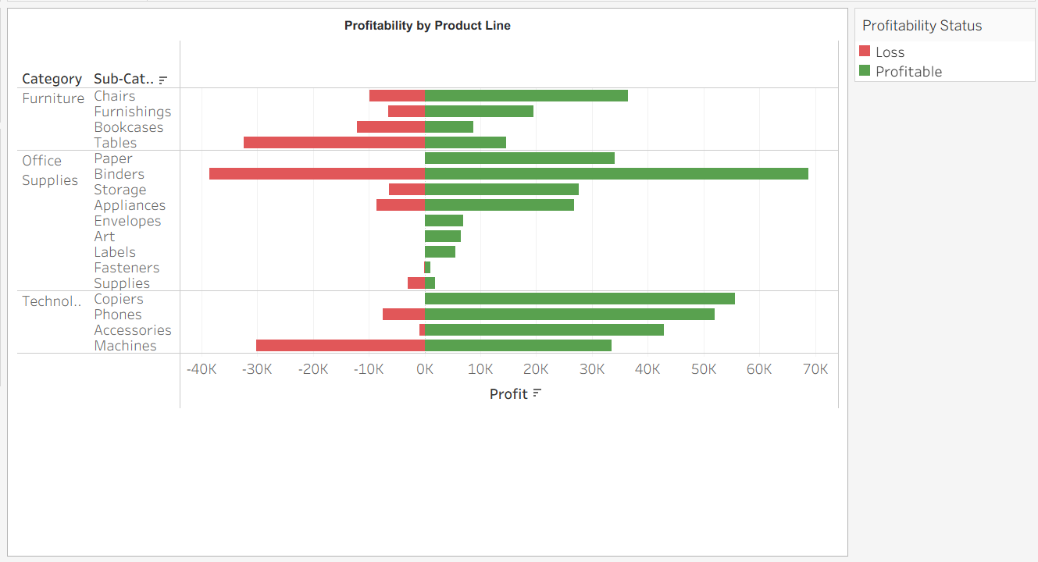
Figure 3: Profitability by Product Line
(Source: Self-created in Tableau)
Customer Profitability Analysis: A scatter plot with average reference lines provides a quadrant analysis of customers. The focus for the interpretation is on the bottom right quadrant, which has the designation "High-Risk" outlier customers who contribute to negative net margins with significant revenue.
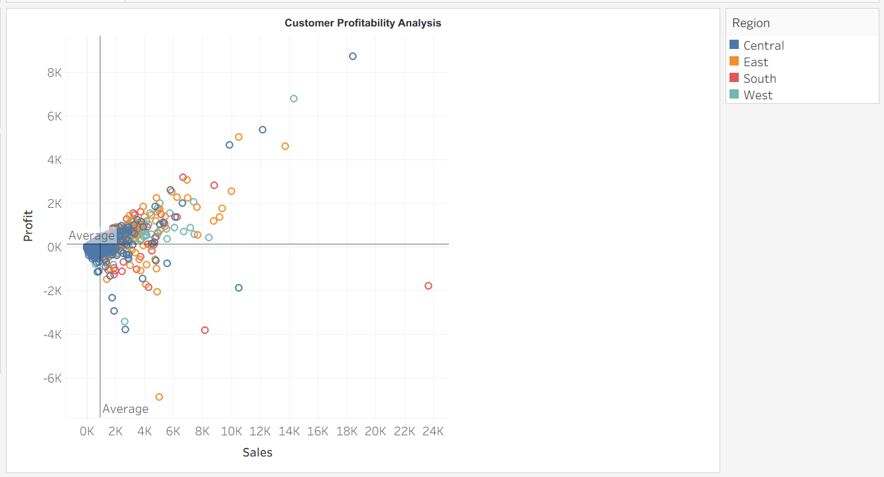
Figure 4: Profitability by Product Line
(Source: Self-created in Tableau)
Regional Profit Tree Map: This is a proportional visual representation in box sizes that relates to the level of profit and colour to indicate the regional identity. According to the interpretation, the West region is the most efficient region, enjoying a profit margin of 14.94%, almost twice as high as the Central region.
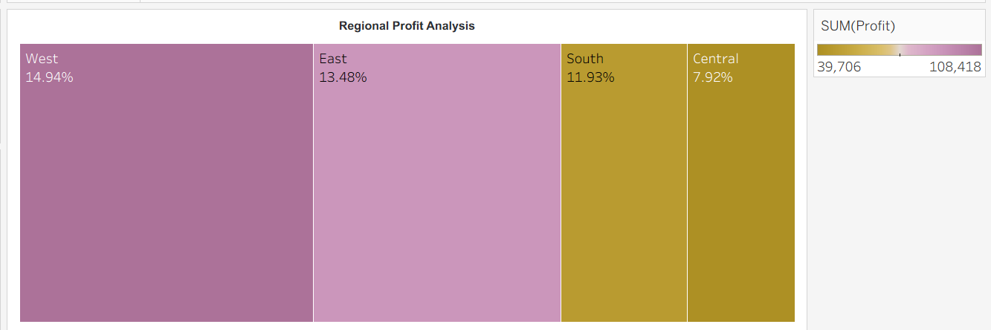
Figure 5: Regional Profit Tree Map
(Source: Self-created in Tableau)
Executive KPIs: The executive KPI values indicates strong overall performance. In the case of this dataset, it generated a profit of 286,397 from total sales of 2,297,201, with an average shipping delay time of 4 days and a healthy profit margin of 12.47%.
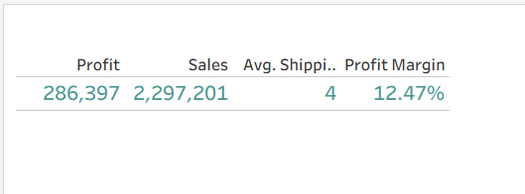
Figure 6: Executive KPIs
(Source: Self-created in Tableau)
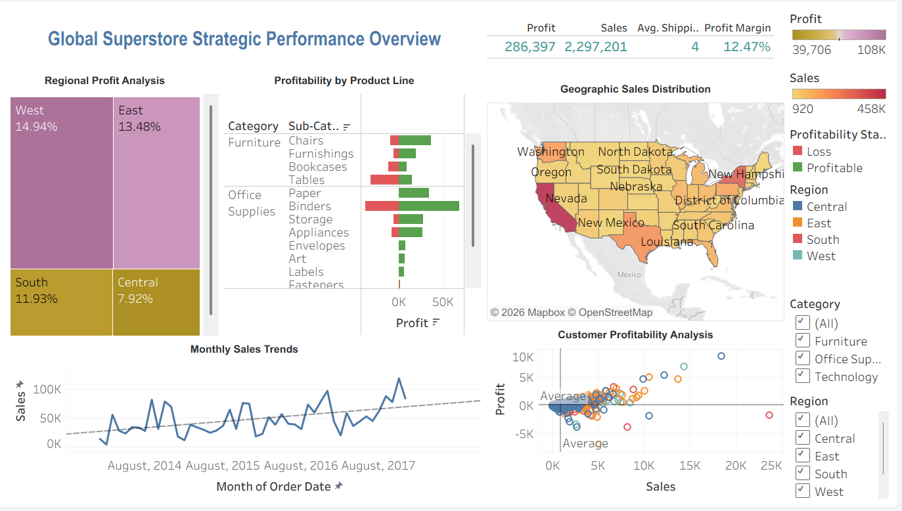
Figure 7: Interactive Dashboard
(Source: Self-created in Tableau)
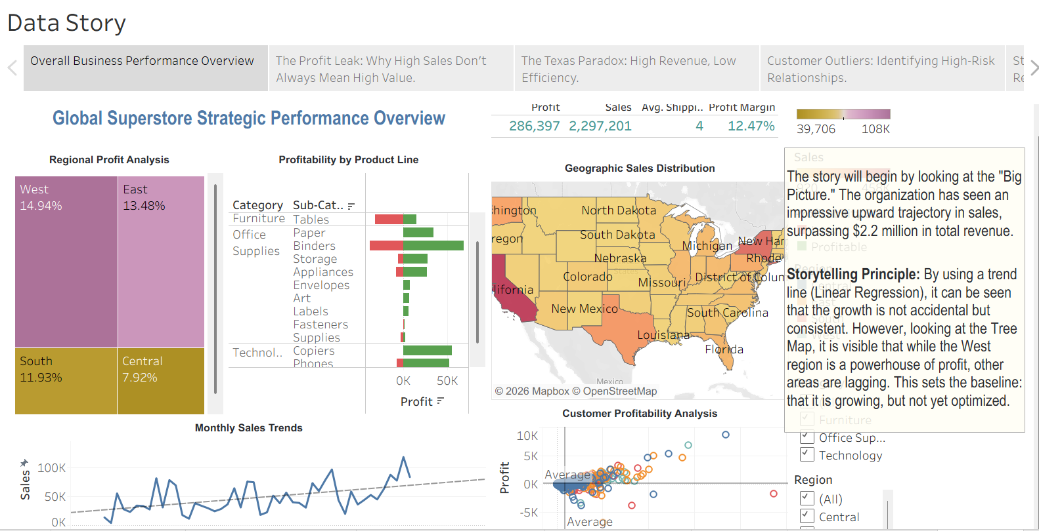
Figure 8: Tableau Story
(Source: Self-created in Tableau)

2. Discussion of Results and Business Insights
The combination of all five depicts a perilous “Vanity Metric Trap”, health is good with the Sales Trend (Visual 2), but data on profits shows dangerous operational inefficiencies. The first biggest discovery is "Product Profitability Gap" in the Furniture category. The “Tables” sub-category has seen a turnover rate of more than 23% and has lost more than $17,000 since it was started. This means that the existing logistical or pricing system for heavy furniture is not working correctly, because gross revenues are less than the cost of sale.
The second big surprise from the dashboard is geographically: the "Texas Paradox". Even though the Map (Visual 1) indicates that Texas is an excellent revenue producer, the Central region is clearly underperforming due to Texas when it is filtered out. Scatter Plot (Visual 4) gives further indication that, not only is this a regional problem, but also a relationship problem as specific high-volume revenue generation is getting unsustainable discounts to these accounts in Texas and Illinois. This indicates a push by this sales group to hit volume targets rather than profitable growth.
In the prescriptive sense, these findings call for the transition to Prescriptive Analytics. Customers need to get moved out of the negative profit quadrant, and the organization must do more than just savor its sales growth, it needs to adopt a "Data-Driven Discount Ceiling". Furthermore, all operational Best Practices need to be harmonised throughout the company in the West region. If those “Profit Leaks” can be uncovered as they pertain to a product, a place and a single customer account, then the IT manager can advise the executive team to implement surgical interventions to safeguard the bottom line and continue the sales trend that's mapped by the machine learning trend analysis.

3. Actionable Recommendations
The following prescriptive actions are recommended for maximizing performance, based on the narrative insights:
- Product Portfolio Rationalization: Go straight to the "Tables" sub-category. A line in which the shipping agreements cannot be renegotiated and/or the price cannot be raised by 15% should be eliminated to reduce the profit leakage by $17,000 per year.
- Discount Governance: Central (Texas and Illinois) to implement a “Discount Ceiling” of 15%. This policy should help to keep high-volume transactions from entering the negative-profit zone.
- Operational Benchmarking: Make the "West" region's logistics and selling methods standardized throughout the company. By adopting the margin of the western world (14.9%) as a corporate KPI benchmark, they will improve efficiency and contribute to move the organisation towards sustainable and data-driven profitability.

CONCLUSION

The project illustrates how Tableau has the power to transform the field of IT Management and Data Visualization. Stateless descriptive reports have been transformed, creating a dynamic Business Intelligence tool that points out the critical product and geographical profit leaks. The dashboard meets all the technical demands, from data joins for complex data to calculating custom KPI's and interactive storytelling. For Tables, the results indicate that there's a clear path for executive action when it comes to losses. For the Texas market, the results clarify the inefficiencies, offering an obvious roadmap for executive action regarding losses. In the end, this project is about the power of humanizing ‘big data' – making the nearly 10,000 lines of transactions into a story that calls out for strategic action. As organizations become more complex, these types of visual management technologies will continue to be the foundation of profitable and data-informed leadership.

BIBLIOGRAPHY

- Ajax, R., Joseph, O. and Own, J. (2025) ‘How Real-Time Dashboards Improve Business Performance’. At: https://www.researchgate.net/profile/Raymond-Ajax/publication/388780068_How_Real-Time_Dashboards_Improve_Business_Performance/links/67a5d43d645ef274a4734236/How-Real-Time-Dashboards-Improve-Business-Performance.pdf (Accessed: 20 May 2026).
- Bansal, D.K. (2025) ‘The Power of Retail Data Analytics: Transforming Customer Insights into Business Success’ Technology (IJRCAIT), 8(2). At: https://papers.ssrn.com/sol3/Delivery.cfm?abstractid=5264345 (Accessed: 20 May 2026).
- Chowdhury, V. (2022) Superstore dataset, Kaggle. At: https://www.kaggle.com/datasets/vivek468/superstore-dataset-final/data (Accessed: 20 May 2026).
- Frempong, D., Akinboboye, O., Okoli, I., Afrihyia, E., Umar, M.O., Umana, A.U., Appoh, M. and Omolayo, O. (2022) ‘Real-time analytics dashboards for decision-making using Tableau in public sector and business intelligence applications’ Journal of Frontiers in Multidisciplinary Research, 3(2), pp.65-80. At: https://www.researchgate.net/profile/Olasehinde-Omolayo/publication/393907578_Real-Time_Analytics_Dashboards_for_Decision-Making_Using_Tableau_in_Public_Sector_and_Business_Intelligence_Applications/links/68b6e19d7984e374aced0467/Real-Time-Analytics-Dashboards-for-Decision-Making-Using-Tableau-in-Public-Sector-and-Business-Intelligence-Applications.pdf (Accessed: 20 May 2026).
- Goh, C. (2023) ‘Data dashboarding in accounting using Tableau’ Economics and Business Quarterly Reviews, 6(1). At: https://papers.ssrn.com/sol3/Delivery.cfm?abstractid=4402840 (Accessed: 20 May 2026).
- Jauhari, S. and Vobugari, S. (2025) ‘Delineating the Big Data Era and the Information Overload Problem’. Available at SSRN 5209835. At: https://papers.ssrn.com/sol3/Delivery.cfm?abstractid=5209835 (Accessed: 20 May 2026).
- Radivojević, A., Mravik, M. and Šarac, M. (2025) ‘Utilizing Business Analytics, Big Data, and Visualization for Sales Performance Optimization’ In Sinteza 2025-International Scientific Conference on Information Technology, Computer Science, and Data Science (pp. 503-510). Singidunum University. At: https://portal.sinteza.singidunum.ac.rs/Media/files/2025/503-510.pdf (Accessed: 20 May 2026).
- S. Kristiansen, Y., Garrison, L. and Bruckner, S. (2022, August) ‘Content-driven layout for visualization design’ In Proceedings of the 15th International Symposium on Visual Information Communication and Interaction (pp. 1-8). At: https://dl.acm.org/doi/pdf/10.1145/3554944.3554950 (Accessed: 20 May 2026).
- Sterratt, D.C., Rohani, N. and Gal, K. (2026) ‘Actionable visualization principles and guidance for a foundational university data science course’ Teaching Statistics. At: https://onlinelibrary.wiley.com/doi/pdf/10.1002/test.70037 (Accessed: 20 May 2026).
- Su, W. (2025) ‘Understanding the Effects of Increased Transparency on Data Preprocessing Through In-Process Visualizations (Doctoral dissertation, The University of North Carolina at Chapel Hill)’. At: https://cdr.lib.unc.edu/downloads/7w62fq749 (Accessed: 20 May 2026).

