
REPORT
OF
CUSTOMER SEGMENTATION USING K-MEANS CLUSTERING
Internship Evaluation Report
Submitted
To
School of Computer Science and Engineering
IILM University, Greater Noida, U.P.
In partial fulfilment of the requirement of degree of
B.Tech CSE
By
ROLL NUMBER: 25SCS1003001632
NAME: ADARSH PRATAP SINGH
SESSION: 2025–29
INTERNSHIP ORGANIZATION: QUALITYKIOSK TECHNOLOGIES PVT. LTD.
ROLE: PYTHON DEVELOPER
INTERNSHIP PERIOD: 25 JUNE 2026 – 25 AUGUST 2026
CANDIDATE’S DECLARATION
I, ADARSH PRATAP SINGH, hereby declare that the internship evaluation report titled “Customer Segmentation Using K-Means Clustering” has been prepared by me as part of the academic requirements for the award of the degree of Bachelor of Technology in Computer Science and Engineering.
The report presents the work and technical learning associated with my internship as a Python Developer at QualityKiosk Technologies Pvt. Ltd. from 25 June 2026 to 25 August 2026. The technical material has been compiled from the project report, presentation, and research material used during the project.
I further declare that the references used in preparing this report have been acknowledged appropriately and that, to the best of my knowledge, this report has not been submitted to any other institute for the fulfilment of any degree or diploma requirement.

Signature:ADARSH
Name: ADARSH PRATAP SINGH
Roll No.: 25SCS1003001632

ACKNOWLEDGMENT
I take this opportunity to express my gratitude to QualityKiosk Technologies Pvt. Ltd. for providing me with the opportunity to undertake an internship as a Python Developer and gain practical exposure to software and data-oriented development.
I am thankful to the organization and the professionals involved in the internship for their guidance, technical exposure, and support during the project work. The internship helped me understand how Python-based data processing, machine-learning implementation, visualization, evaluation, and documentation can be applied to a practical customer analytics problem.
I also express my gratitude to the faculty members of the School of Computer Science and Engineering, IILM University, for their academic guidance. I am thankful to my parents and everyone who supported me throughout the internship and the preparation of this report.

Signature: ADARSH
Student Name: ADARSH PRATAP SINGH
Roll No.: 25SCS1003001632

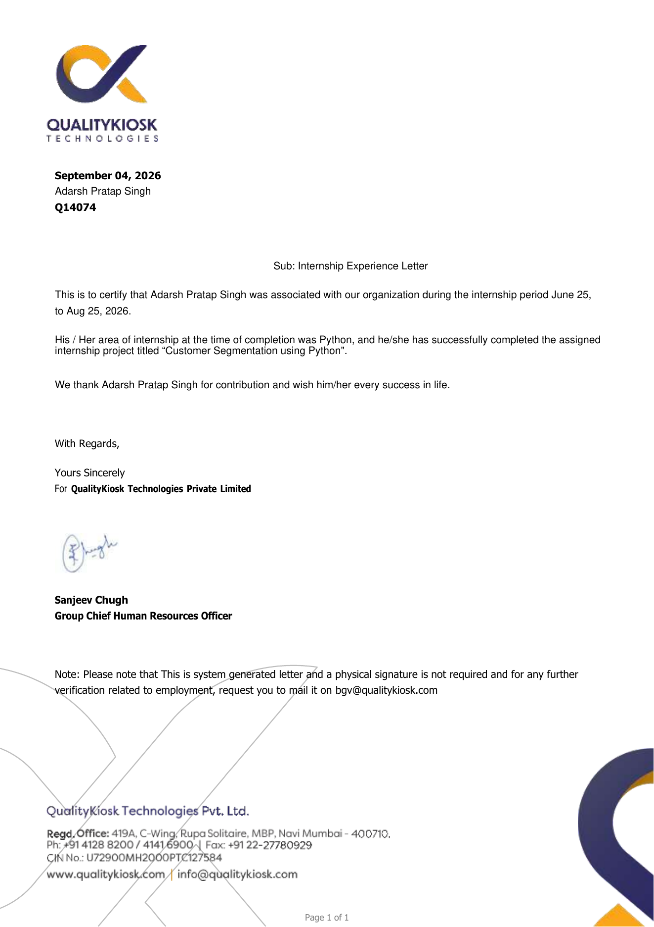

TABLE OF CONTENTS
Chapter No. | Chapter Name | Page Nos.
 | Cover Page | ----
3. | Internship Completion Certificate | ----
1. | Candidate’s Declaration | i
2. | Acknowledgment | ii
4. | Project Description | 1
 | 4.1 Introduction | 1
 | 4.2 Organization Profile | 2
 | 4.3 Problem Statement | 3
 | 4.4 Project Objectives | 3
 | 4.5 Scope of the Project | 4
 | 4.6 Technologies and Tools Used | 4
 | 4.7 System Architecture | 4
 | 4.8 Methodology | 4
 | 4.9 Expected Outcomes | 7
 | 4.10 Certificates of completion and other communication mail proof must be attached | 10
5. | Bibliography/References | 10

LIST OF FIGURES AND TABLES
List of Figures
Figure 4.1 System Architecture / Project Pipeline
Figure 4.2 Silhouette-Guided Cluster Selection
Figure 4.3 K-Means Algorithm Workflow
List of Tables
Table 4.1 Dataset Attributes
Table 4.2 Technologies and Tools
Table 4.3 Customer Cluster Profiles
Table 4.4 Project Limitations
4. PROJECT DESCRIPTION
4.1 INTRODUCTION
Customer segmentation is the process of dividing a broad customer base into groups that share similar characteristics or behaviours. In a data-rich business environment, segmentation helps organizations understand differences among customers and design more focused marketing and engagement strategies.
The project uses K-Means clustering on a mall customer dataset containing 200 customer records. The available attributes are CustomerID, Gender, Age, Annual Income (k$), and Spending Score (1–100). The objective is to discover meaningful customer groups without requiring pre-existing class labels.
A major emphasis of the project is selecting the number of clusters. The Elbow Method is useful for observing diminishing reductions in within-cluster sum of squares (WCSS), but it can be ambiguous. The Silhouette method complements it by measuring cluster cohesion and separation. In the supplied project work, silhouette-guided evaluation resulted in K = 5.
The project therefore combines Python-based data preparation, exploratory analysis, K-Means implementation, internal evaluation, visualization, and interpretation into a reproducible customer-segmentation workflow.
4.2 ORGANIZATION PROFILE
QualityKiosk Technologies Pvt. Ltd. is a technology and digital engineering organization that provides reliability, cloud, AI, product engineering, quality engineering, and automation solutions. The company was established in 2000 and works with enterprises across multiple industries and geographies. Its current services include AI engineering, digital reliability, intelligent automation, data and observability, cloud-related engineering, and quality engineering. The organization describes its approach as combining domain expertise, engineering, automation, and AI to improve reliability and digital experiences.
During the internship period from 25 June 2026 to 25 August 2026, I worked remotely as a Python Developer. The internship provided practical exposure to Python-based data processing and machine-learning development through the Customer Segmentation using K-Means Clustering project.
As a Python Developer on the project, the relevant responsibilities included preparing and validating structured data, implementing data-processing workflows in Python, supporting exploratory data analysis, implementing and evaluating the K-Means model, generating analytical visualizations, checking model outputs, organizing reusable code, and documenting the technical workflow and results. These responsibilities are aligned with the technical requirements demonstrated by the project materials.
Internship mentor/supervisor: To be updated from the official internship certificate.
Mode of internship: Online / Remote.
Internship duration: 25 June 2026 to 25 August 2026.
4.3 PROBLEM STATEMENT
Businesses often treat their customer base as a single group even though customers differ in income, age, spending behaviour, preferences, and engagement. This can lead to inefficient marketing-resource allocation and weak personalization.
- Identify meaningful customer segments from mall/customer data.
- Select a robust and justifiable number of clusters when natural boundaries are unclear.
- Build a reproducible pipeline from raw data to interpretable customer profiles.
- Translate clustering results into actionable marketing strategies.
4.4 PROJECT OBJECTIVES
- Apply K-Means clustering to the mall/customer dataset to obtain distinct customer groups.
- Evaluate and select the optimal number of clusters using both the Elbow and Silhouette methods.
- Prepare descriptive cluster profiles that can support marketing strategy and customer targeting.
- Document the complete data-preparation, modelling, evaluation, and interpretation pipeline.
- Understand the practical use of unsupervised machine learning for customer analytics.
4.5 SCOPE OF THE PROJECT
The scope covers customer segmentation using the attributes available in the supplied mall customer dataset. The workflow includes data validation, cleaning, exploratory analysis, feature preparation, selection of K, K-Means clustering, internal evaluation, visualization, and interpretation of customer segments.
The project is intentionally limited by the supplied feature set. It does not claim to build a production customer-management system, real-time recommender system, or revenue-forecasting model. Its primary purpose is to demonstrate an end-to-end analytical and machine-learning workflow that can be extended with richer business data.
The internship scope also includes the Python development activities required to implement, test, visualize, and document the analytical pipeline.
4.6 TECHNOLOGIES AND TOOLS USED
Technology / Tool | Purpose
Python | Primary programming language for data processing and machine-learning implementation.
Pandas | Data loading, cleaning, transformation, and tabular analysis.
NumPy | Numerical computation and array-based operations.
Scikit-learn | K-Means clustering, StandardScaler, and silhouette-score evaluation.
Matplotlib | Data and model-result visualization.
Seaborn | Exploratory data analysis and statistical visualization.
Jupyter Notebook | Development, experimentation, execution, and demonstration environment.

The supplied research paper specifically identifies Scikit-learn, Seaborn, NumPy, Pandas, Matplotlib, and Jupyter Notebook as the principal tools/platform used for the experimental setup.
4.7 SYSTEM ARCHITECTURE
The system architecture represents the complete analytical pipeline used in the project. The customer dataset first passes through validation and cleaning. The prepared data is then explored through descriptive analysis and visualizations. Relevant numerical features are prepared for clustering, candidate values of K are evaluated using WCSS and Silhouette Score, and the selected K is used to train the K-Means model. Finally, the resulting clusters are profiled and translated into business-oriented interpretations.
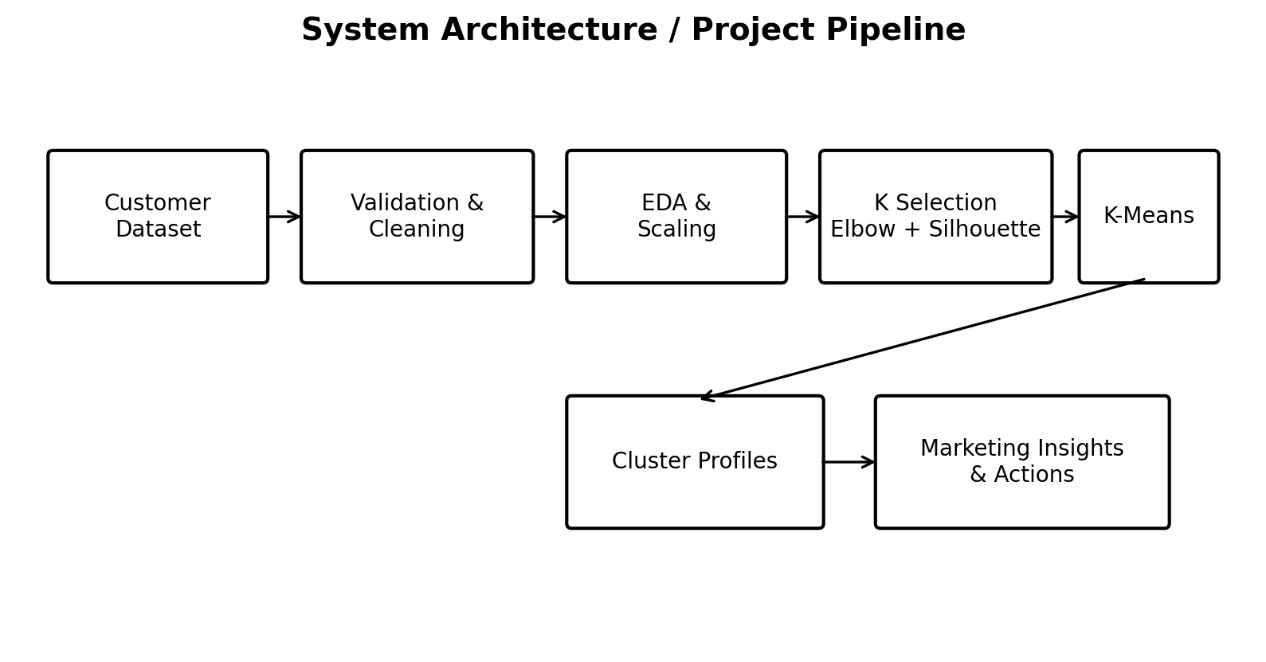
Figure 4.1 System Architecture / Project Pipeline
4.8 METHODOLOGY
4.8.1 Dataset Preparation
The dataset contains 200 customer records with five attributes: CustomerID, Gender, Age, Annual Income (k$), and Spending Score (1–100). CustomerID acts as a unique identifier rather than a behavioural feature. The dataset structure is checked before modelling.
Attribute | Description | Use in Analysis
CustomerID | Unique customer identifier. | Identification only; not used as a behavioural clustering feature.
Gender | Male/Female category. | Descriptive analysis; categorical encoding may be used if included in modelling.
Age | Customer age in years. | Demographic analysis and optional modelling feature.
Annual Income (k$) | Annual income measured in thousands of dollars. | Primary behavioural/economic clustering feature.
Spending Score (1–100) | Relative spending score assigned to a customer. | Primary spending-behaviour clustering feature.

Table 4.1 Dataset Attributes
4.8.2 Data Preprocessing and Cleaning
Before clustering, the dataset is checked for missing values, duplicate records, and type consistency. The supplied project report states that the provided files contain no missing values. CustomerID uniqueness is checked to identify duplicate records. Where categorical variables are used as clustering inputs, they can be encoded numerically.
Feature scaling is important because K-Means relies on Euclidean distance. StandardScaler or MinMaxScaler can be used to place numerical variables on comparable scales before clustering. The preprocessing stage therefore aims to produce clean and numerically suitable data for the clustering algorithm.
4.8.3 Exploratory Data Analysis
Exploratory Data Analysis (EDA) is used to understand the distributions and relationships in the dataset before model fitting. The documented approach includes univariate analysis of Age, Annual Income, and Spending Score; bivariate analysis using Annual Income versus Spending Score; and grouped statistics to identify behavioural patterns.
The Annual Income versus Spending Score relationship is particularly useful because it provides a visual basis for identifying customer groups that differ in purchasing behaviour and economic profile.
4.8.4 Selection of Optimal K
Two complementary approaches are used. First, the Elbow Method evaluates WCSS across candidate values of K and looks for the point at which additional clusters produce diminishing reductions in within-cluster variation. Second, the Silhouette Score evaluates how well each observation fits its assigned cluster relative to the nearest alternative cluster.
The silhouette coefficient ranges from −1 to +1. Values closer to +1 indicate better separation, values around 0 indicate overlap near cluster boundaries, and negative values may indicate possible misassignment. The supplied project work uses silhouette-guided evaluation and selects K = 5 for the final segmentation.
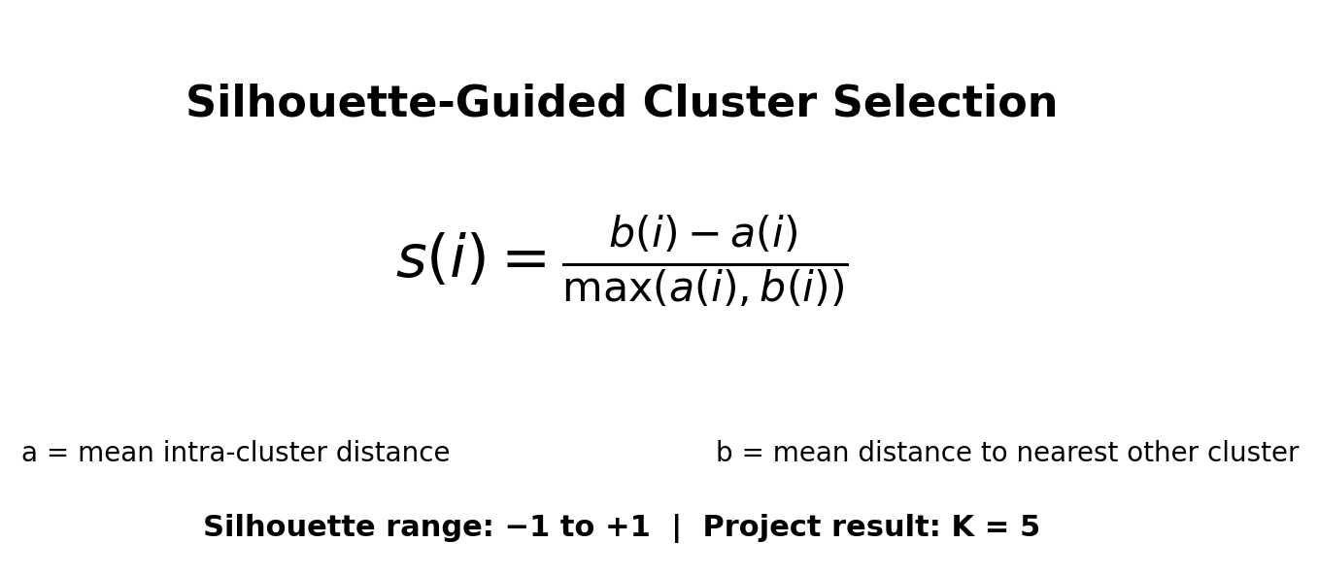
Figure 4.2 Silhouette-Guided Cluster Selection
4.8.5 K-Means Algorithm
K-Means is a centroid-based partitioning algorithm. It begins with K initial centroids, assigns each observation to the nearest centroid using a distance measure, recomputes each centroid as the mean of the observations assigned to it, and repeats the assignment-update process until convergence or the maximum number of iterations is reached.
- Select the required number K of clusters.
- Initialize K centroids, preferably using a suitable initialization strategy such as k-means++.
- Assign every data point to its nearest centroid.
- Recalculate each centroid from the points assigned to it.
- Repeat assignment and centroid update until convergence.
- Generate final cluster labels, centroids, and cluster statistics.
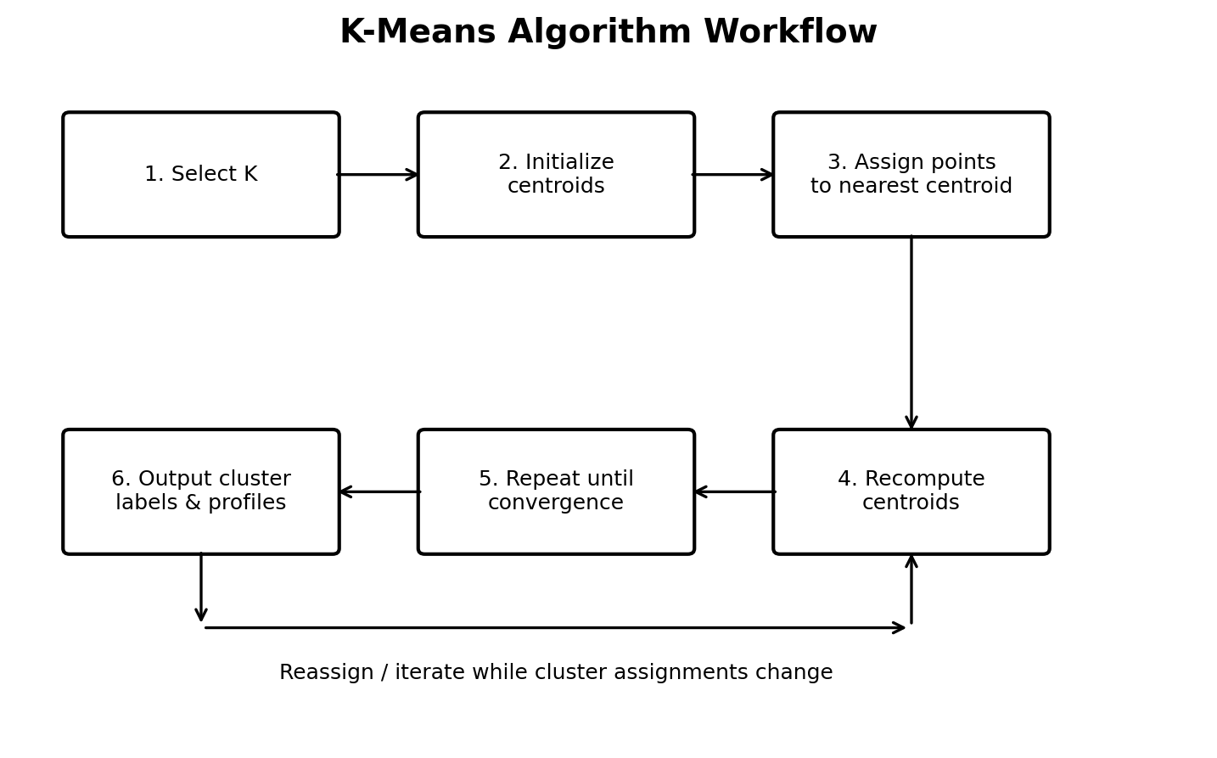
Figure 4.3 K-Means Algorithm Workflow
4.8.6 Model Evaluation
WCSS and the Silhouette Score are the primary internal evaluation measures documented in the project. WCSS measures cluster compactness; lower WCSS indicates tighter clusters. The Silhouette Score measures both intra-cluster cohesion and separation from the nearest competing cluster.
The evaluation procedure considers candidate values of K, records WCSS and average silhouette scores, visualizes the metric trends, and selects a value that provides strong separation together with interpretable customer groups. In the project, K = 5 was selected.
4.9 EXPECTED OUTCOMES
The expected outcome is a clear and reproducible customer-segmentation workflow that converts raw customer attributes into actionable customer groups. The documented project achieves this by producing five interpretable segments and linking each segment to a potential business strategy.
Cluster | Profile | Business Interpretation
1 | High Income – High Spending | High-value customers; suitable for premium loyalty programmes and personalized high-end promotions.
2 | High Income – Low Spending | Potentially under-engaged customers; investigate product/experience gaps and use targeted re-engagement.
3 | Low Income – High Spending | Valuable but price-sensitive customers; maintain service quality and use affordable loyalty offers.
4 | Average Income – Average Spending | Moderate segment; suitable for cross-selling, upselling, and controlled experiments.
5 | Low Income – Low Spending | Budget-sensitive customers; use selective promotions and discount bundles.

Table 4.3 Customer Cluster Profiles
4.9.1 Project Results
The final segmentation divides the mall customer dataset into five actionable groups. The High Income–High Spending group is identified as the most commercially valuable segment and can receive priority in targeted marketing. High Income–Low Spending customers represent an opportunity for re-engagement after understanding why their spending is low. Low Income–High Spending customers demonstrate relatively strong spending despite lower income and can be retained through value-sensitive offers.
The Average Income–Average Spending group represents a moderate segment where cross-selling and upselling can be tested. The Low Income–Low Spending group is more price-sensitive and is better suited to carefully selected promotional strategies. These interpretations are consistent with the supplied project report and research paper.
4.9.2 Practical Implications
- Allocate more immediate marketing attention to the High Income–High Spending segment.
- Investigate product or experience gaps for High Income–Low Spending customers before attempting aggressive conversion.
- Use affordable retention and loyalty offers for Low Income–High Spending customers.
- Apply cross-sell, upsell, and controlled A/B experiments to Average Income–Average Spending customers.
- Use budget-oriented promotions and discount bundles selectively for Low Income–Low Spending customers.
- Track changes in cluster membership over time if the model is later operationalized.
4.9.3 Limitations
Limitation | Effect
Dataset size: 200 records | The sample is relatively small and may not generalize to larger customer populations.
Limited feature set | Transaction history, purchase frequency, recency, product categories, and monetary value are not included.
K-Means assumptions | K-Means relies on distance and tends to work best for roughly compact/spherical clusters.
Static segmentation | The project does not continuously update customer membership over time.

Table 4.4 Project Limitations
4.9.4 Future Scope
- Expand the dataset with more customers and richer transaction-level features.
- Add RFM-style features such as recency, frequency, and monetary value where appropriate.
- Compare K-Means with DBSCAN, hierarchical clustering, and Gaussian Mixture Models.
- Develop a periodic re-segmentation pipeline and monitor customer movement between clusters.
- Connect segment assignments to marketing experiments and measure conversion lift or retention impact.
- Develop a lightweight application or dashboard so non-technical users can explore customer segments.
4.9.5 Learning Outcomes
The internship project provided practical exposure to the complete unsupervised-learning workflow: understanding a business problem, preparing structured data, performing exploratory analysis, implementing a machine-learning algorithm in Python, evaluating model quality, creating visualizations, interpreting results, and documenting technical work.
From the Python Developer perspective, the project strengthened skills in Pandas-based data manipulation, NumPy-based numerical operations, Scikit-learn model implementation, visualization with Matplotlib and Seaborn, debugging and validation, and organizing an analytical workflow from raw data to final results.
The project also demonstrated that machine-learning output must be interpreted in a business context. A technically valid cluster is useful only when its characteristics can be understood and connected to an actionable decision.
4.10 INTERNSHIP SUPPORTING DOCUMENTS
The official Internship Experience Letter issued by QualityKiosk Technologies Pvt. Ltd. is attached as Chapter 3 of this report. Relevant internship communication/mail proof is included in the supporting documentation/GitHub repository.
5. BIBLIOGRAPHY / REFERENCES
[1] “Customer segmentation based on survival character,” IEEE, July 2003.
[2] “Customer Segmentation Using K Means Clustering,” Towards Data Science,
April 2019.
[3] Expert Systems with Applications, “Retail Business Analytics: Customer Visit
Segmentation Using Market Basket Data,” 2018.
[4] Pascal Ezenkwu, “Application of the K-Means Algorithm for Efficient Customer
Segmentation,” International Journal of Advanced Research in Artificial Intelligence,
2015.
[5] Ashutosh Bhardwaj, “Silhouette Coefficient Validating clustering techniques,”
Towards Data Science, May 26, 2020.
[6] V. Vijilesh, “Customer Segmentation Using Machine Learning,” International
Research Journal of Engineering and Technology, vol. 08, no. 05, May 2021.
[7] Aman Banduni and Ilavendhan A., “Customer Segmentation Using Machine
Learning,” IJCRT, vol. 05, 2018.
[8] Tushar Kansal, Suraj Bahuguna, Vishal Singh, and Tanupriya Choudhury,
“Customer Segmentation using K-means Clustering,” IEEE, July 2019.
[9] K. Maheswari, “Finding Best Possible Number of Clusters using K-Means
Algorithm,” International Journal of Engineering and Advanced Technology, vol. 9,
no. 1S4, December 2019.
[10] Dhiraj Kumar, “Implementing Customer Segmentation Using Machine
Learning,” July 10, 2021.
[11] Hemashree Kilari, Sailesh Edara, Guna Ratna Sai Yarra, and Dileep Varma
Gadhiraju, “Customer Segmentation using K-Means Clustering,” InternationalJournal of Engineering Research & Technology (IJERT), Vol. 11, Issue 03, March
2022.
[12] Customer Segmentation project report and presentation materials supplied for the
internship evaluation.
[13] QualityKiosk Technologies Pvt. Ltd., “About Us,” official company website,
accessed August 2026.

