- To create virtual environment
sudo apt-get install python3-venv
python3 -m venv <my-virtual-env>

- To activate virtual environment
source ./my-virtual-env/bin/activate

- Install django
pip install django

- Startproject
django-admin startproject <name of the project>

- To run server
python manage.py runserver

- To create app inside the django project
python manage.py startapp <app name>

and add that app into settings.py
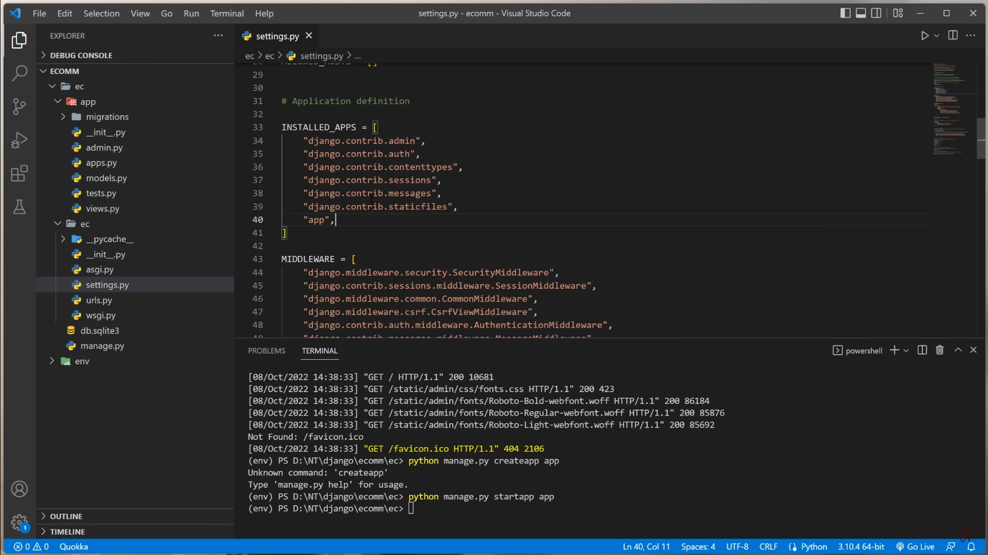
Intial Steps:
- First add the created app inside the main project/settings.py
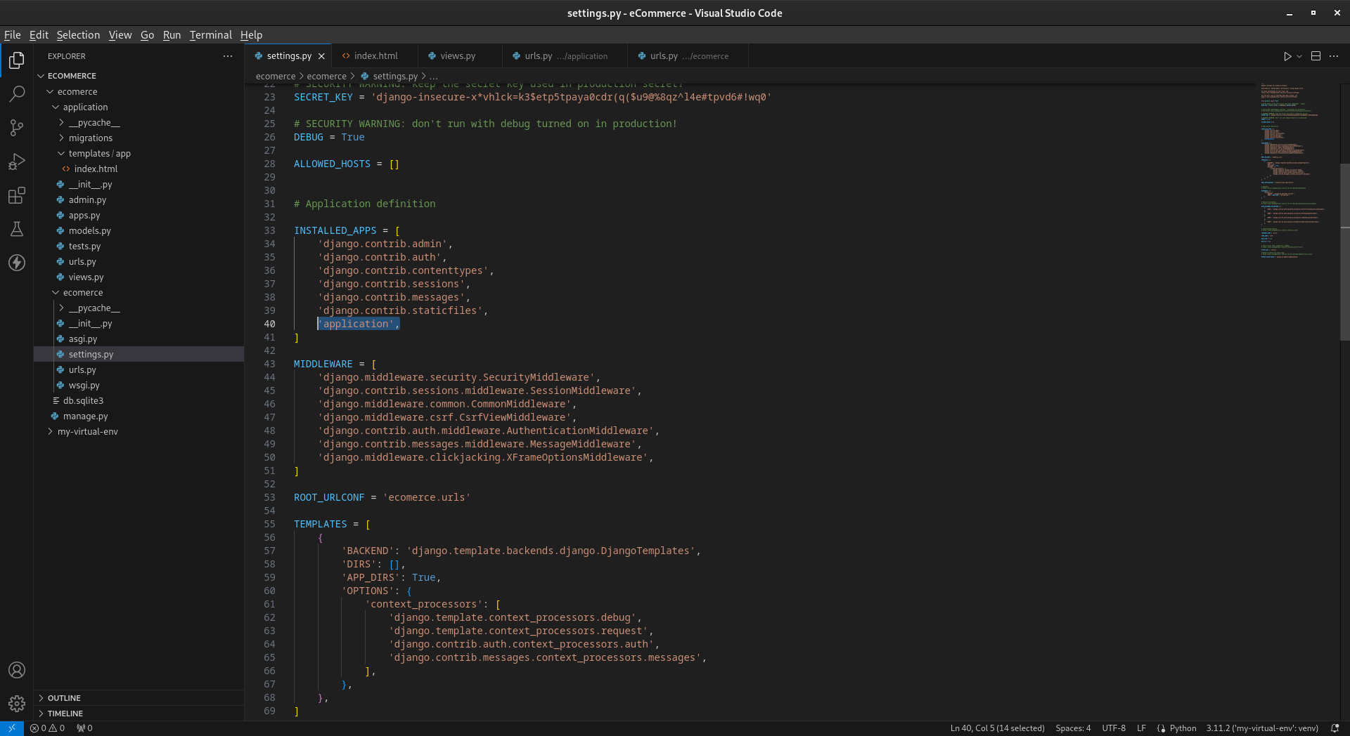
- Create template > app > <filename>.html under the app level.
- Write bussiness logic under the app level in views.py file and show that into htm [combination of python+html]
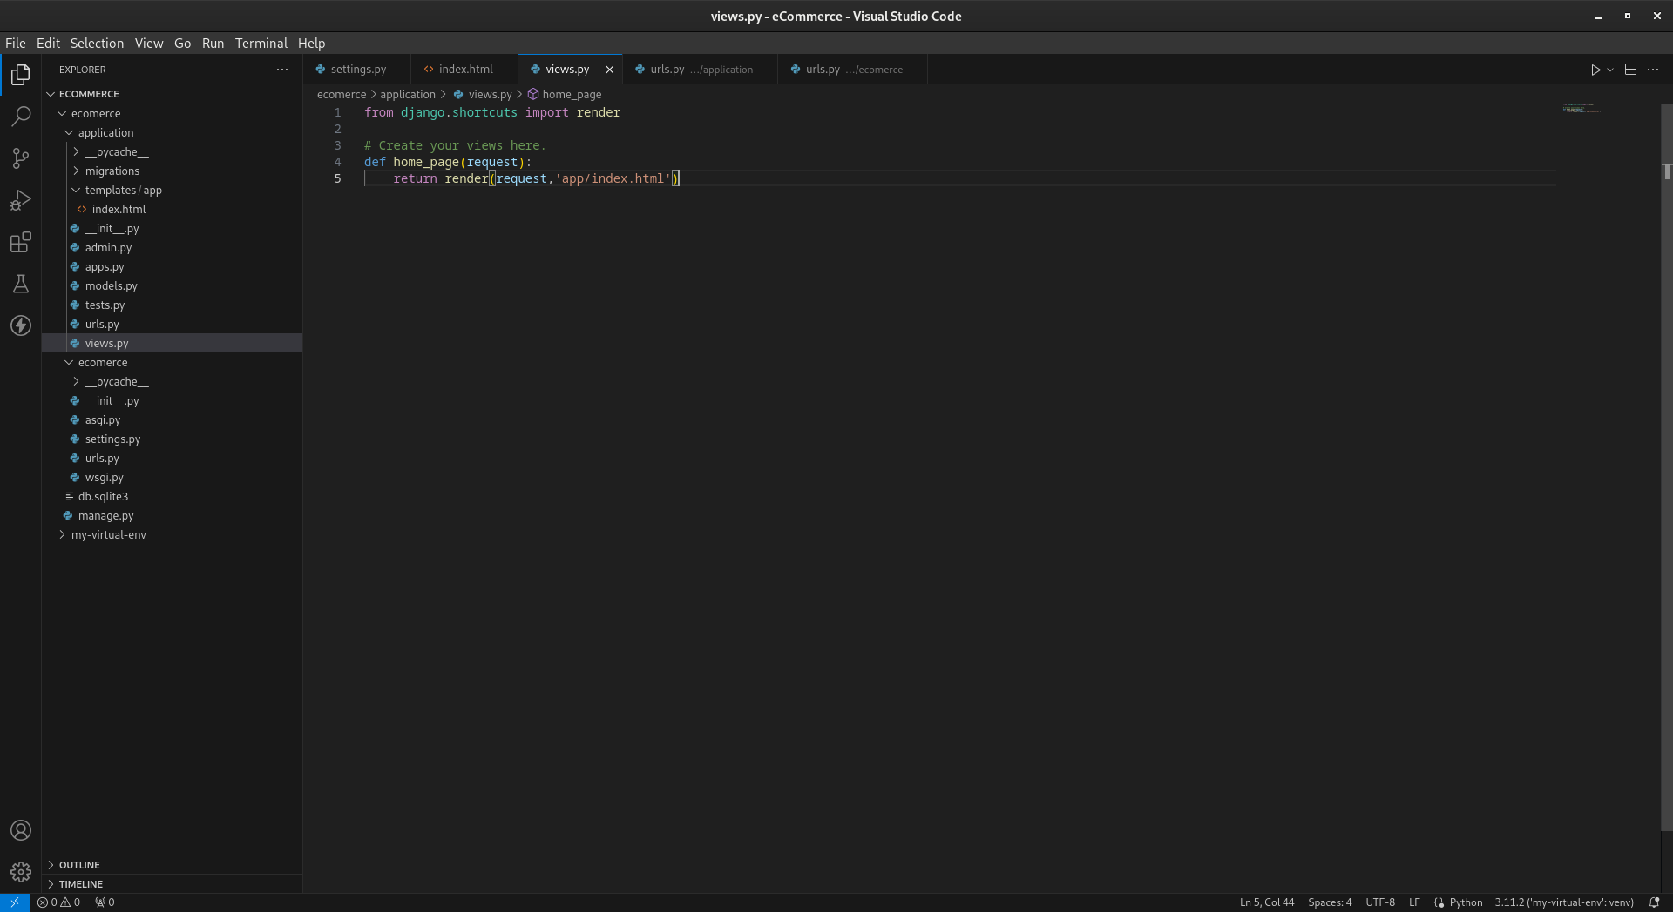
- Create urls.py file under the app level and add views.py functions or methods in side the urls.py

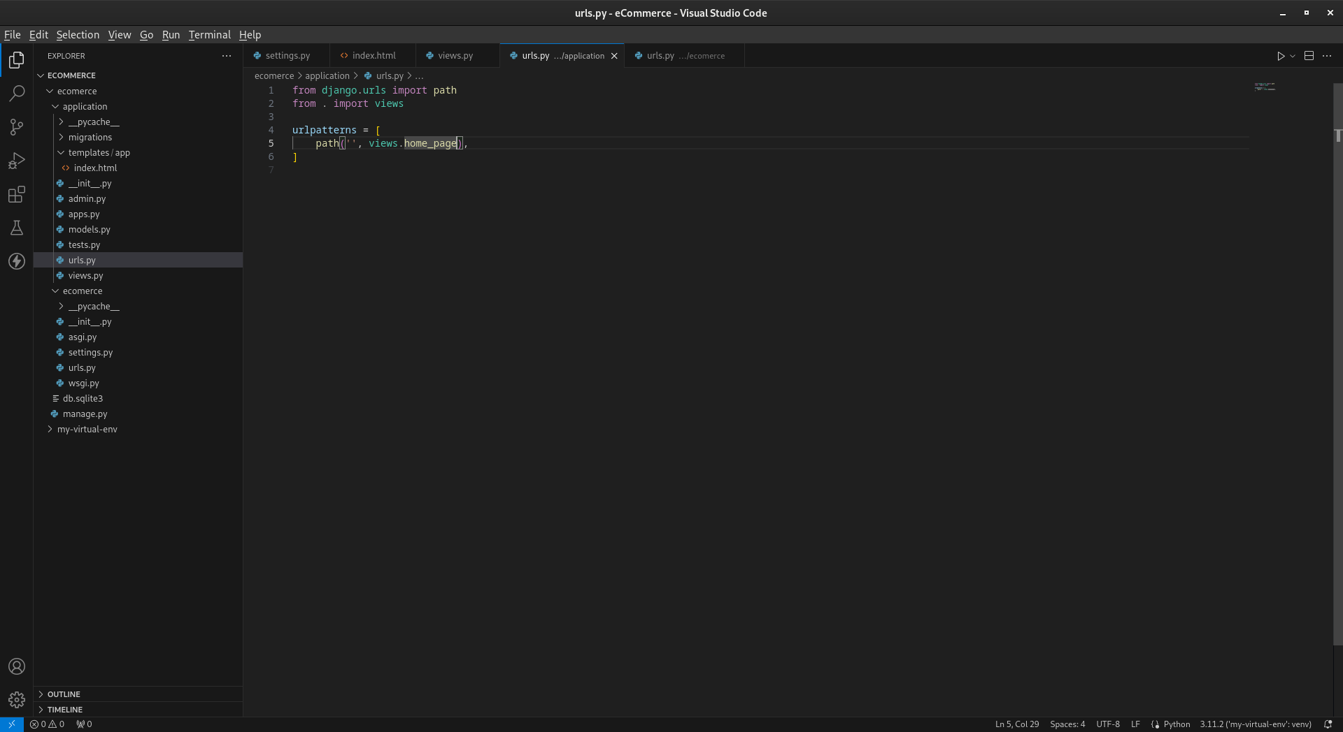
- Finally add app level urls.py file into project level urls.py
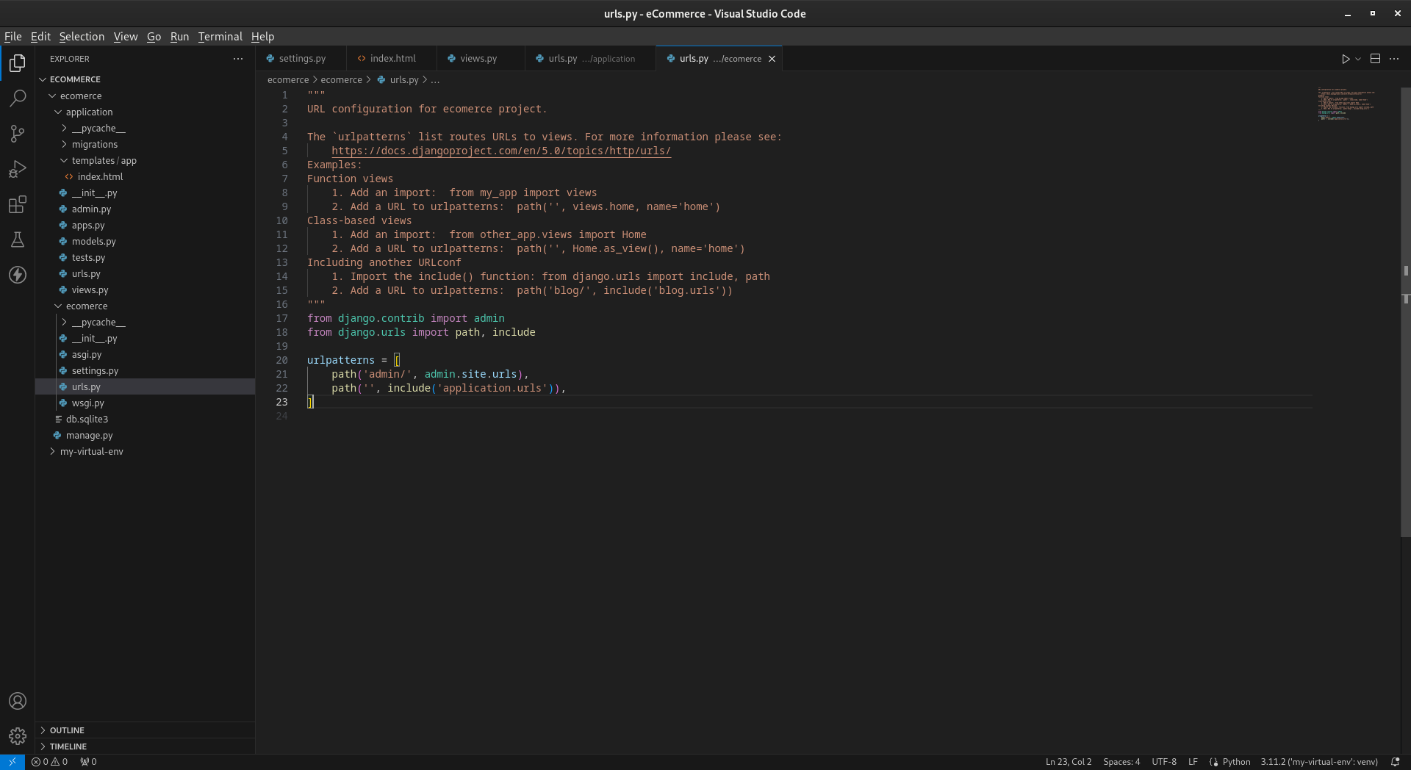
- To create database field
  - Add the fields under the models.py file what ever you want in app level.
  - Then follw this below commands to magrate
python manage.py makemigration
python manage.py migrate
python manage.py createsuperuser

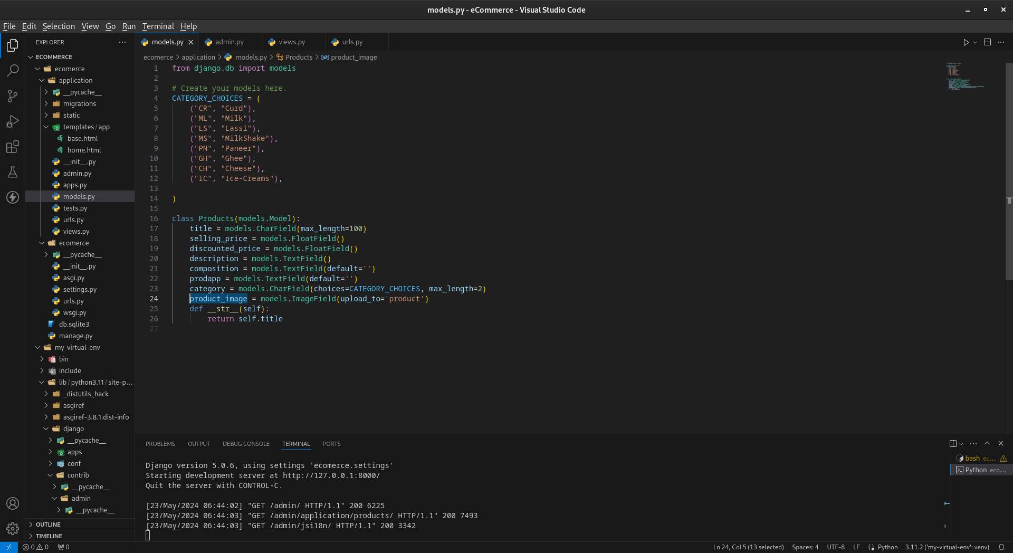
  - Then register models.py file under admin.py in app level
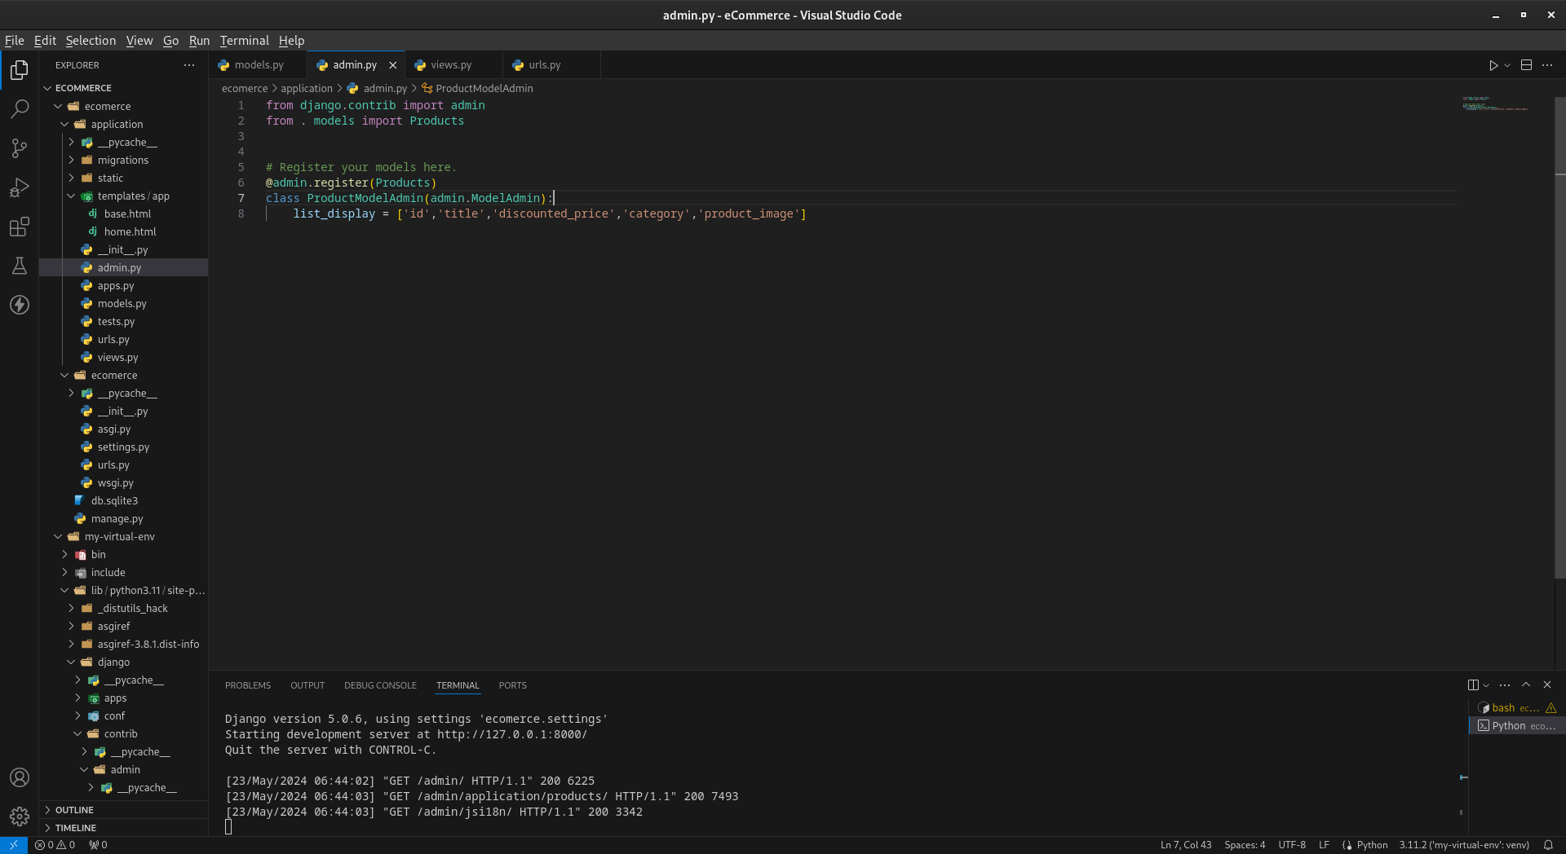
------------------------------------------------------------------
- For adding the css,js and images in the app level:
css
create static --> app images
js
After creating this folders and add the respective files in this the folders.

Then after add the MEDIA_URL and MEDIA_ROOT in the settings.py

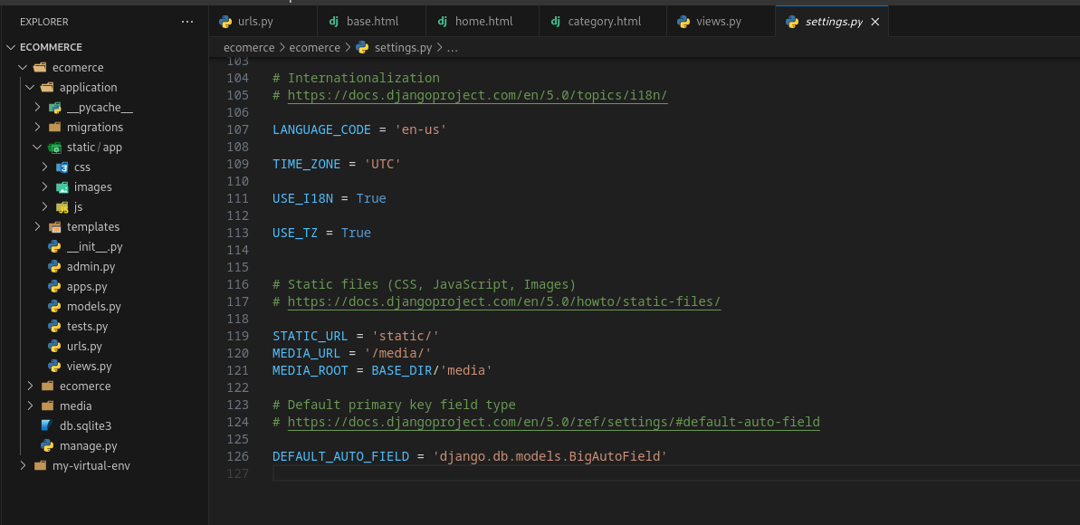
Syntax for css: <link rel="stylesheet" href="{% static 'app/css/all.min.css' %}" />

Syntax for JS: <script src="{% static 'app/js/all.min.js' %}"></script>

Syntax for Images: <img src="{% static "app/images/banner/b2.jpg" %}

------------------------------------------------------------------
How to link one page to another page:

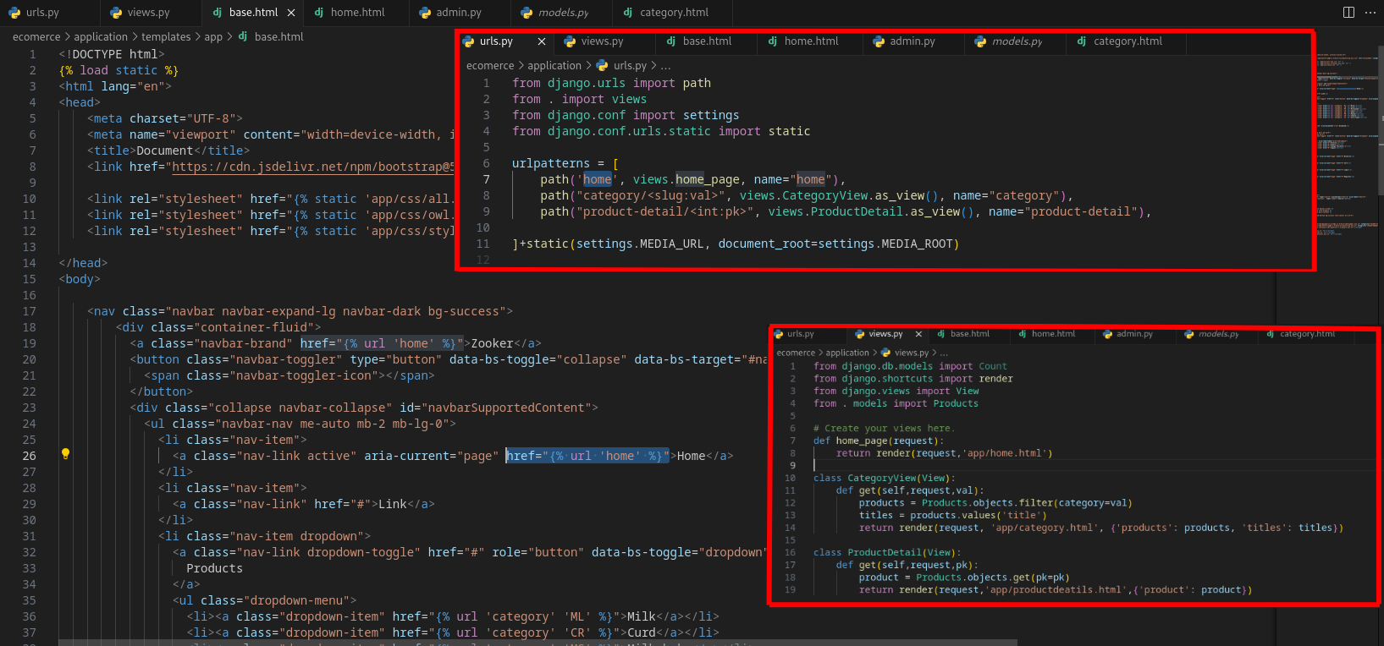
HTML tags are used to define the structure and content of web pages. They are enclosed in angle brackets and typically come in pairs, with an opening tag and a closing tag. Here's a breakdown of various types of HTML tags based on their functionality:

1. **Structural Tags**
These tags define the overall structure of an HTML document.

- `<html>`: The root element of an HTML document.
- `<head>`: Contains metadata, scripts, and links to CSS files.
- `<body>`: Contains the content of the HTML document.

2. **Metadata Tags**
These tags provide metadata about the HTML document.

- `<title>`: Sets the title of the web page (displayed in the browser's title bar or tab).
- `<meta>`: Provides metadata such as character set, description, keywords, and author.
- `<link>`: Links external resources like CSS files.
- `<style>`: Embeds internal CSS.
- `<base>`: Specifies the base URL for all relative URLs in the document.

3. **Content Sectioning Tags**
These tags define the organization and structure of content.

- `<header>`: Represents introductory content or a set of navigational links.
- `<nav>`: Defines navigation links.
- `<section>`: Represents a section of a document, typically with a heading.
- `<article>`: Represents independent, self-contained content.
- `<aside>`: Defines content aside from the content it is placed in (like a sidebar).
- `<footer>`: Represents the footer of a document or section.
- `<main>`: Specifies the main content of a document.

4. **Text Content Tags**
These tags define text content and its structure.

- `<h1>` to `<h6>`: Define headings, with `<h1>` being the highest and `<h6>` the lowest level.
- `<p>`: Defines a paragraph.
- `<ul>`: Defines an unordered list.
- `<ol>`: Defines an ordered list.
- `<li>`: Defines a list item.
- `<dl>`: Defines a description list.
- `<dt>`: Defines a term in a description list.
- `<dd>`: Describes a term in a description list.
- `<pre>`: Defines preformatted text.
- `<blockquote>`: Defines a block of quoted text.
- `<div>`: Defines a division or section in a document.
- `<span>`: Defines a span of text (inline container).

5. **Inline Text Formatting Tags**
These tags apply styles to text within other elements.

- `<a>`: Defines a hyperlink.
- `<strong>`: Defines important text (bold by default).
- `<em>`: Defines emphasized text (italic by default).
- `<b>`: Defines bold text.
- `<i>`: Defines italic text.
- `<u>`: Defines underlined text.
- `<small>`: Defines smaller text.
- `<mark>`: Defines marked/highlighted text.
- `<br>`: Inserts a line break.
- `<hr>`: Defines a thematic change or a horizontal rule.

6. **Multimedia Tags**
These tags handle multimedia content.

- `<img>`: Embeds an image.
- `<audio>`: Embeds sound content.
- `<video>`: Embeds video content.
- `<source>`: Specifies multiple media resources for `<video>` and `<audio>`.
- `<track>`: Defines text tracks for `<video>` and `<audio>` (like subtitles).

7. **Form and Input Tags**
These tags create interactive forms and inputs.

- `<form>`: Defines an HTML form for user input.
- `<input>`: Defines an input control.
- `<textarea>`: Defines a multi-line text input control.
- `<button>`: Defines a clickable button.
- `<select>`: Defines a drop-down list.
- `<option>`: Defines an option in a drop-down list.
- `<label>`: Defines a label for an `<input>` element.
- `<fieldset>`: Groups related elements in a form.
- `<legend>`: Defines a caption for a `<fieldset>`.

8. **Table Tags**
These tags create tables.

- `<table>`: Defines a table.
- `<tr>`: Defines a table row.
- `<th>`: Defines a header cell in a table.
- `<td>`: Defines a standard cell in a table.
- `<caption>`: Defines a table caption.
- `<thead>`: Groups header content in a table.
- `<tbody>`: Groups body content in a table.
- `<tfoot>`: Groups footer content in a table.

9. **Scripting Tags**
These tags are used for embedding scripts.

- `<script>`: Embeds a client-side script (like JavaScript).
- `<noscript>`: Defines an alternate content for users with scripts disabled or browsers that don't support scripts.

10. **Interactive Elements**
These tags are used for embedding interactive content.

- `<details>`: Defines additional details that the user can view or hide.
- `<summary>`: Defines a visible heading for a `<details>` element.
- `<dialog>`: Defines a dialog box or window.

Each of these tags plays a crucial role in building the structure and functionality of web pages, and understanding them is key to mastering HTML.

auto_now_add

ORM Vs Django Admin Panel:

ORM (Object-Relational Mapper:

Function: Acts as a bridge between your Python code and the database.
Focuses on: Data representation and manipulation.
Tasks:
Defines data structure using models (classes representing database tables).
Enables creating, retrieving, updating, and deleting data using Python objects.
Handles translations between Python objects and database queries (SQL).
Benefits:
Abstraction: Protects you from dealing with raw SQL specifics.
Simplicity: Offers a Pythonic way to interact with data.
Reduced Errors: Less prone to SQL syntax errors.
Automatic Migrations: Manages database schema changes.

Django Admin Panel:

Function: Provides a user interface for managing data in your Django application.
Focuses on: User interaction and data management.
Tasks:
Offers a web interface to view, edit, create, and delete data based on your models.
Requires configuration to specify which models are editable through the admin panel.
Provides basic functionalities for managing data efficiently within your Django project.
Benefits:
Convenience: Enables easy data manipulation through a user-friendly interface.
Efficiency: Streamlines CRUD operations (Create, Read, Update, Delete) for authorized users.
Development Speed: Saves time building basic data management functionalities.

In simpler terms:

ORM is the engine under the hood: It defines how your data is structured and allows your code to interact with it.
It provides a visual interface for users to manage data based on the structure defined by your ORM (models).
Analogy:

Imagine a library. The ORM is like a cataloging system that defines how books are organized and described. The Admin Panel is the librarian's interface for adding, removing, and managing the books in the library.

Fields:

Django offers a variety of fields to define the structure and data types of your models, which correspond to database tables. These fields determine how data is stored, validated, and displayed. Here's a glimpse into some common Django fields:

Basic Fields:

CharField: Stores text data with a maximum length (useful for names, descriptions).
TextField: Stores large amounts of text data (ideal for articles, content).
IntegerField: Stores whole numbers (e.g., for quantities, IDs).
BooleanField: Represents True/False values (often used for flags, switches).
DateField: Stores dates (e.g., for birthdays, creation dates).
DateTimeField: Stores dates and times (e.g., for event scheduling).

Advanced Fields:

EmailField: Stores email addresses with basic validation.
URLField: Stores URLs with validation to ensure proper format.
IPAddressField: Stores IP addresses.
FilePathField: Stores file paths relative to a specific location.
ImageField: Stores references to uploaded images.
FileField: Stores references to uploaded files of any type.

Relational Fields:

ForeignKey: Represents a many-to-one relationship between models (e.g., a blog post having a foreign key to an Author model).
ManyToManyField: Represents a many-to-many relationship between models (e.g., a student enrolled in multiple courses).
OneToOneField: Represents a one-to-one relationship between models (e.g., a profile picture for a user).

Other Fields:

DecimalField: Stores fixed-point decimal numbers for precise calculations (e.g., for currency).
NullBooleanField: Similar to BooleanField but allows storing null values (useful for optional flags).
PositiveIntegerField/NegativeIntegerField: Restricts IntegerField to positive or negative values only.
SlugField: Generates short, unique strings (often used for URLs).
Remember, this is not an exhaustive list, and Django provides additional field types for specific use cases. You can also create custom fields if needed.

For a comprehensive reference on Django model fields, refer to the official documentation: [Django model field reference ON Django Project docs.djangoproject.com]

------------------------------------------------------------------

ForeignKey:

In Django, a foreign key is a type of field used to create a many-to-one or one-to-many relationship between models. It is defined using the ForeignKey field in your model class. This field is used to link one model to another, indicating that each instance of the model with the foreign key can be associated with one instance of another model.

Difference between render() and redirect():
The main difference between the render() and redirect() functions is that the render() function renders a template, while the redirect() function redirects the user to a different URL.

When to use render()

You should use the render() function when you want to render a template to an HTTP response. This is typically done when you want to display a page to the user.

When to use redirect()

You should use the redirect() function when you want to redirect the user to a different URL. This is typically done when you want to send the user to a different page after they have completed an action, such as submitting a form.

Queryset:

In Django, a QuerySet is a collection of database queries to retrieve objects from your database. It represents a set of objects from your model and allows you to read, filter, and manipulate those objects. QuerySets are lazy, meaning that the actual database query is not executed until the data is needed, which can improve performance and efficiency.

Path converters:

Path converters are a powerful mechanism introduced in Django 2.0 to streamline URL definition and enhance code readability. They serve two key purposes:

Matching URL Segments: They validate that specific parts of a URL conform to a defined pattern. This ensures that only valid URLs reach the corresponding views.
Data Type Conversion: Path converters can automatically convert captured URL segments to appropriate data types before passing them to your views. This eliminates the need for manual type conversion within your views, making your code more concise.

The following path converters are available by default:

str - Matches any non-empty string, excluding the path separator, '/'. This is the default if a converter isn’t included in the expression.

int - Matches zero or any positive integer. Returns an int.

slug - Matches any slug string consisting of ASCII letters or numbers, plus the hyphen and underscore characters. For example, building-your-1st-django-site.

uuid - Matches a formatted UUID. To prevent multiple URLs from mapping to the same page, dashes must be included and letters must be lowercase. For example, 075194d3-6885-417e-a8a8-6c931e272f00. Returns a UUID instance.

path - Matches any non-empty string, including the path separator, '/'. This allows you to match against a complete URL path rather than a segment of a URL path as with str.

auto_now vs auto_now_add:

Feature | auto_now | auto_now_add
Sets the value | On every save | Only on first creation
Commonly used for | Last modified/updated timestamps | Creation timestamps

Retrieving Objects:

Retrieve a single object by primary key:
rticle = Article.objects.get(pk=1)

Retrieve a single object using field lookup:
article = Article.objects.get(title='My First Article')

Retrieve multiple objects using filter:
articles = Article.objects.filter(title__contains='Article')

Retrieve all objects:
articles = Article.objects.all()

Retrieve the first object in a query set:
first_article = Article.objects.first()

Retrieve the last object in a query set:
last_article = Article.objects.last()

Retrieve a single object or return None if it doesn't exist:
article = Article.objects.filter(title='Nonexistent Article').first()

QuerySet Methods:

all()
Returns all objects in the QuerySet.

filter()
Returns a new QuerySet containing objects that match the given lookup parameters.

exclude()
Returns a new QuerySet containing objects that do not match the given lookup parameters.

get()
Returns a single object that matches the given lookup parameters. Raises ‘DoesNotExist’ or ‘MultipleObjects’ Returned if no objects or multiple objects are found, respectively.

order_by()
Returns a new QuerySet ordered by the given field(s). Prefix with a minus sign to indicate descending order.

values()
Returns a QuerySet that returns dictionaries, rather than model instances, when iterated over.

values_list()
Similar to values(), but returns tuples when iterated over.

distinct()
Returns a new QuerySet that eliminates duplicate rows.

count()
Returns the number of objects in the QuerySet.

first()
Returns the first object matched by the QuerySet, or None if there are no matches.

last()
Returns the last object matched by the QuerySet, or None if there are no matches.

exists()
Returns True if the QuerySet contains any results, and False if it does not.

aggregate()
Performs an aggregate calculation on the QuerySet.

annotate()
Annotates each object in the QuerySet with the provided aggregate values.

select_related()
Performs a SQL join and includes the fields of the related object in the QuerySet.

prefetch_related()
Performs a separate lookup for each relationship and does the joining in Python.

raw()
Executes raw SQL queries.

