

**KLE TECHNOLOGICAL UNIVERSITY**

**DUGC 2.0**

**USER INSTRUCTION MANUAL**

**School of Computer Science and Engineering**

**TABLE OF CONTENTS:**

1. Introduction
2. About Us
3. Access to the Website
4. Modules
5. DUGC Members
   1. DUGC Chairman
   2. DUGC Coordinator
   3. Faculty Coordinator
   4. Course Faculty
6. Guidelines
7. Contact
8. **INTRODUCTION**

Welcome to the DUGC User Manual!

DUGC is an innovative and user-friendly system designed to streamline and enhance the processes related to the Department Undergraduate Committee (DUGC). Whether you are a faculty coordinator, DUGC coordinator, or the DUGC chairman, this comprehensive guide will help you navigate through the features and functionalities that the DUGC website offers.

The DUGC website is specifically crafted to simplify the management and coordination of undergraduate activities within the department. It aims to provide a centralized platform for efficient communication, collaboration, and decision-making among faculty members and committee administrators.

1. **ABOUT US**

The DUGC website is designed and developed by the students of SoCSE in the 5th semester for the ease of data management and analysis of undergraduate activities within the Department of Computer Science and Engineering.

The DUGC website comes with an intuitive and easy-to-navigate interface, ensuring that users can quickly adapt to the system. It seamlessly manages and organizes documents related to departmental activities, meetings, and decisions. It facilitates smooth communication between committee members, coordinators, and faculties through integrated messaging features. It easily schedules and manages DUGC meetings, ensuring timely and effective decision-making processes. Importantly, it keeps track of student records, academic progress, and committee-related interactions.

The DUGC website gains insights into the performance of students in minor(ISA) exams, allowing for comprehensive analysis and decision-making. It tracks and assesses lab evaluations, ensuring a holistic view of students' practical skills and progress.

Lastly, it also provides a comprehensive analysis of end-semester exams, aiding in evaluating overall academic performance.

This User Manual serves as a comprehensive guide to help you understand and make the most out of DUGC website. Each section is designed to provide step-by-step instructions, explanations of features, and troubleshooting tips to ensure a seamless experience.

1. **ACCESS TO THE WEBSITE**

Step 1: Clone the GitHub repository.

GitHub link:

Step 2: Open the terminal or Node.js command prompt.

Step 3: Navigate to the directory where the repository is cloned.

Step 4: Run the command ng serve.

Step 5: This will provide a localhost link along with the port number.

Step 6: Open another terminal or Node.js command prompt.

Step 7: Navigate to the directory backend/backend/server.

Step 8: Run the command npm run start.

Step 9: This action establishes a connection to the database.

Now, open the localhost link obtained in Step 5, and you will be able to access the DUGC website.

1. **MODULES**
2. **ISA Analysis :**

ISA Analysis is a module designed for easy result analysis representation of the In-Semester Assessment (Minor).

1. **LAB CIE Analysis :**

LAB CIE Analysis is a module designed for easy result analysis representation of the Laboratory Continuous Internal Evaluation (CIE) results.

1. **End Sem Result Analysis :**

End Sem Result Analysis is a module designed for easy result analysis representation of the End-Semester Assessment (Minor) results.

1. **Course Withdrawal :**

Course Withdrawal is a module designed for the approval of a course withdrawal application by students.

1. **Circular :**

The Circular module is designed for sharing notices, meeting links, and meeting minutes with all faculties and DUGC members.

1. **Eligibility :**

Eligibility is a module designed for approving students for the end-semester examination based on attendance and marks.

1. **Makeup Minor :**

Makeup Minor is a module designed for approving students for makeup examinations by validating reasons for their absence from minor exams.

1. **Add User :**

Add User is a module designed for adding new faculty coordinators, and DUGC members to access the website.

1. **DUGC MEMBERS**

* **DUGC Chairman :**

The DUGC Chairman is the head of the DUGC committee, with exclusive rights to add new users and access all website functionalities(mainly to view analysis and approve applications).

* **DUGC Coordinator :**

The DUGC Coordinator possesses the ability to utilize all website features, with the exception of the privilege to add new users.

* **Faculty Coordinator :**

The Faculty Coordinator manages courses, uploads mark sheets, and views the analysis of their respective courses.

1. **GUIDELINES**

* **DUGC Chairman :**

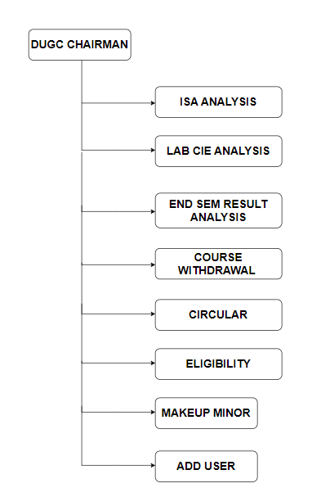

* Usage of ISA analysis module:

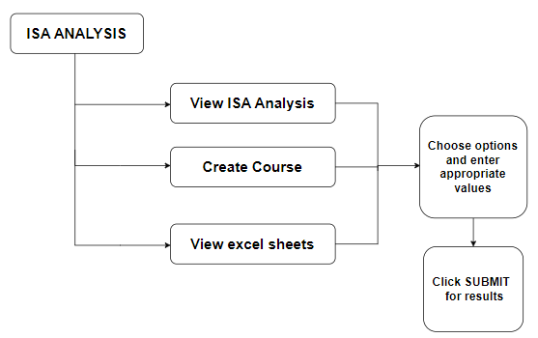

* Usage of LAB CIE analysis module:

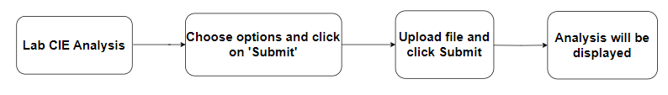

* Usage of End Sem Result analysis module:

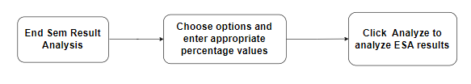

* Usage of Course Withdrawal module:

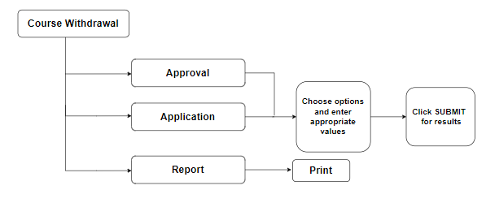

* Usage of Circular module:

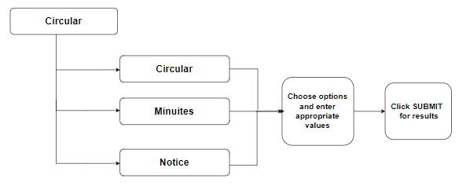

* Usage of Eligibility module:

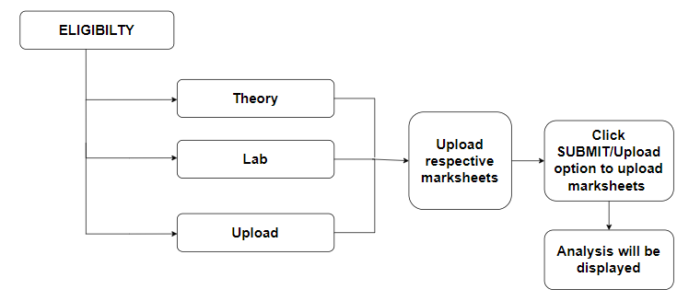

* Usage of Makeup Minor module:

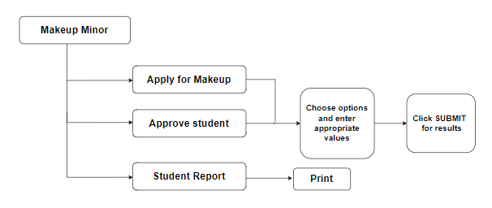

* Usage of Add User module:

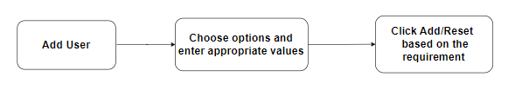

* **DUGC Coordinator :**

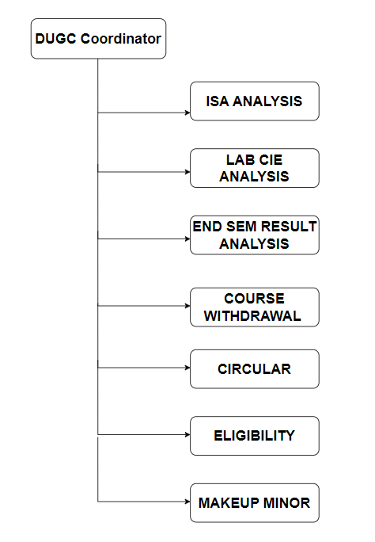

* Usage of ISA analysis module:

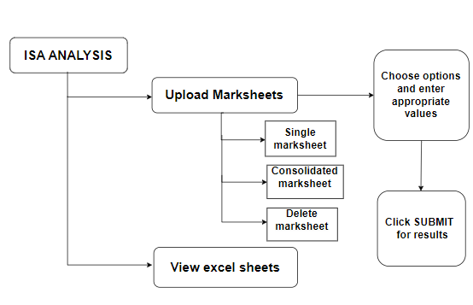

* Usage of LAB CIE analysis module:



* Usage of End Sem Result analysis module:



* Usage of Course Withdrawal module:



* Usage of Circular module:



* Usage of Eligibility module:



* Usage of Makeup Minor module:



* **Faculty Coordinator**

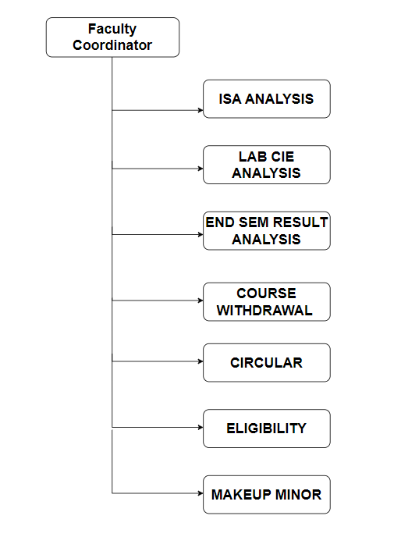

* Usage of ISA analysis module:

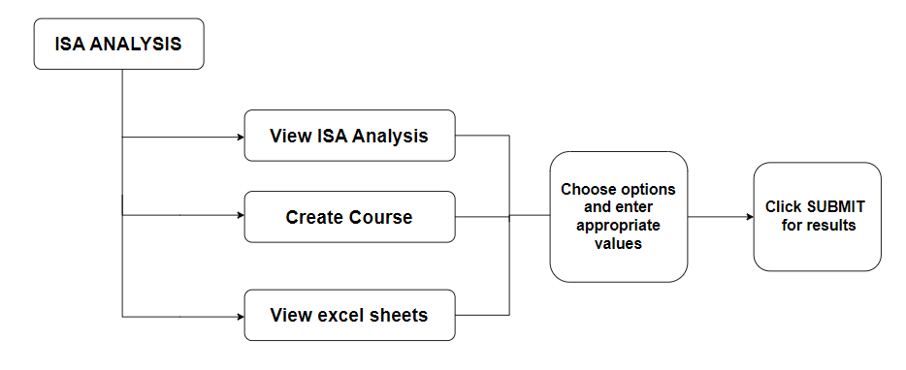

* Usage of LAB CIE analysis module:



* Usage of End Sem Result analysis module:



* Usage of Course Withdrawal module:



* Usage of Circular module:



* Usage of Eligibility module:



* Usage of Makeup Minor module:



* **Course Faculty**

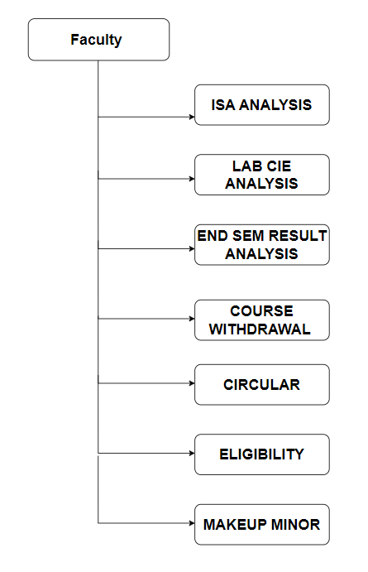

* Usage of ISA analysis module:



* Usage of LAB CIE analysis module:



* Usage of End Sem Result analysis module:



* Usage of Course Withdrawal module:



* Usage of Circular module:



* Usage of Eligibility module:



* Usage of Makeup Minor module:



1. **CONTACT**

If you encounter any issues, have questions, or need assistance with the product, our support team is here to help. Please do not hesitate to reach out to us through messages or emails by visiting the ‘Contact Us’ option on the Home page.

For more information, Contact the department office, SoCSE, KLE Technological University, Hubballi.

Our dedicated team is committed to providing prompt and effective support to ensure your experience with our product is seamless. Thank you for choosing DUGC 2.0.