Explorative analysis of factors influencing relapse in alcohol patients and sobriety period prediction using machine learning techniques

Dr P.G Sunitha Hiremath
Department of computer science and Engineering
Kle Technological University
Hubli Karnataka
pgshiremath@kletech.ac.in

Anushree Motagi
Department of computer science and Engineering
Kle Technological University
Hubli Karnataka
anushreemotagi@gmail.com
Adarsh Sidnal
Department of computer science and Engineering
Kle Technological University
Hubli Karnataka
kksidnal@gmail.com

Rohan Jadhav
Department of computer science and Engineering
Kle Technological University
Hubli Karnataka
rohanjadav39@gmail.com
Sayam Jain
Department of computer science and Engineering
Kle Technological University
Hubli Karnataka
sayamjain301003@gmail.com

Vivek V.Pais
SDM De-addiction and Research Centre,Ujire,India
vivekvpais@gmail.com

Abstract— Purpose: To analyze the factors contributing to the relapse of persons with alcohol dependencies and to predict their sobriety period by considering male patient’s data from a De addiction center.
Design: To carry out this work,329 relapsed male patient’s data was collected through the case sheets and descriptive statistics; Bivariate and multivariate logistic regression was applied to determine the prominent factors associated with relapse and their correlation by the Pearson and Spearman correlation coefficients. The sobriety period of the patients taken as the class variable, but the number of patients in each class was varying. This class imbalance was overcome by using Synthetic Minority Oversampling Technique.
Findings: More than 92% (303) of patients were found to be relapsed once. Among the 303 patient records, the sobriety period of 33 patients was less than a 1 month, 28 in 1-3 months, 22 in 3-6 months, 36 in 6-9 months, 70 in 9-12 months and 114 in more than a year. Around 82.8% of patients were at very high risk, 8.91% at high risk,3.96% at medium risk and 4.29% at low risk of alcohol consumption. The risk factors for relapse were Craving (r=0.13, p=0.02) and peer pressure (r=0.137, p=0.016). The Factors for sobriety were found to be motivation factor (r=0.106, p=0.007), the influence of camp and willingness for treatment (r=0.05, p<0.05). Sobriety period predictive models were built using Gaussian NB, Random Forest and KNN. Gaussian NB outperformed with a sobriety period prediction accuracy of 98.68%
Practical implication: Finding the probable sobriety period of patients is very important for planning treatment strategies to prevent their relapse after discharge.
Keywords— relapse, sobriety, alcohol risk level
- Introduction
Alcoholism is an illness marked by the consumption of alcoholic beverages and it is called as a dual disease since it includes both psychological and physical components. In Karnataka, a southern state in India, among 67 million population, 9.45 million consume alcohol and the per household consumption is 1.29 litres/month. The proportion of males consuming alcohol increased from 28.3% in 2005 to 29.2% in 2015. Around 19% of alcohol consumers reported drinking every day in 2005 has increased to 22% in 2015[12] For this rise in the alcohol consumption, people have reported various reasons like peer pressure or to cope with the stress or feel happy or avoid the problems in life.
Alcohol dependent persons take treatment in private or government de-addiction camps or hospitals to overcome their alcohol addiction. After few days of their treatment many persons start drinking again with the same pattern as before and this is called as relapse. It is one of the greatest problems patients face and Relapse prevention has become one of the major challenges in the treatment of alcoholism. About 50% of alcohol users relapse within 3 months. There is evidence that approximately 90 per cent of alcohol dependents are likely to experience at least one relapse over the 4 years following treatment [ 8].
2. Literature Survey
In [1], the authors analysed 607 patients who took in patient treatment for substance use disorder in Norway. Their study found that 37% of patients who relapsed within 3 months of follow up were of young age and had psychiatric illness. However, they also found that patients with short inpatient stay period (2-4 months) are at higher risk of relapse when compared to patients with longer stay period (>6months). To investigate what psychological factors, lead to relapse, authors [2] conducted a correlation study on 110 patients in Vietnam and found that positive outcome expectancies, craving, negative emotional states and maladaptive coping as the factors of relapse. The authors [5] showed that addiction severity significantly impacted the risk of relapse in patients. A qualitative study was carried out by authors [6] to identify the factors of relapse after a twelve-step program and found that unemployment, commitment to therapy, shame and guilt in seeking support, and loneliness are the factors for relapse. Education, self-efficacy, social support and craving were the factors associated with the relapse in the rural population of Karnataka state in India as found by authors [7] in a study carried out on 112 patients. Similarly, a study carried out by authors [8], found that craving, pleasurable events, family conflicts, financial problems, and loss of a significant one as risk factors of relapse. In a study carried out on 94 patients suffering with alcohol dependence syndrome, authors [9] found positive family history of alcoholism, disturbed sleep pattern and high score on AUDIT (Alcohol Use Disorder Identification Test) scale as the risk factors of relapse. In [10] authors discussed about Alcohol Relapse Situation Appraisal Questionnaire (A-RSAQ) which they developed to assess alcohol relapse situations. Similarly authors of [11] analysed social media data of patients attending Alcohol Anonymous meetings to find the reasons for relapse.
Authors in [4] illustrated that self-efficacy of patients at the time of discharge and motivation during their follow up period increase the sobriety period. Similarly, in [3], the authors analysed the effect of specific nursing intervention programmes on motivation and relapse prevention of patients. They found that risk-reward analysis, coping, skill training, assertiveness training, family interaction programme and psychoeducation will have a positive effect on the motivation of clients.
In all the above discussed research works, authors explored the factors influencing the relapse, sobriety and association between them and relapse prevention mechanisms but they did not work on predicting the sobriety period of patients after their treatment. We are the first one to build sobriety period predictive model with a good accuracy. Our model can be used as an assistance tool for the personnel at the de-addiction Centre to develop appropriate treatment strategies to increase patient’s sobriety period.

2. Methodology:
To carry out this study we collected 329 male patient’s data who took treatment in Shri Dharmasthala Manjunatheshwara (SDM) De-addiction and research Centre, Ujire a place in Karnataka state in India. In this center Trained counselors, Nurses, Physicians and psychiatrists test, interview and record patient related details in case sheets. A predefined set of questionnaire are used in the case sheet to collect patients details which include patient’s drinking pattern, age of alcohol initiation, duration, type and quantity of consumption, reasons to start and continue the consumption of alcohol, socio demographic details, family history of alcoholism and psychiatry illness, patient’s past and present physiological and psychological health conditions, stressors, withdrawal symptoms, adverse childhood experiences and adolescent behavioral problems, problems related job, financial conditions, personal life, details of previous treatments taken duration of alcohol abstinence and reasons for relapse and sobriety.

The steps carried out to find the relevant predictor variables of relapse and to build and evaluate sobriety period predictive model are :
- Data Cleaning: Handled the missing values, converted the categorical data into numerical and corrected spelling errors and noisy data,
- New Feature Extraction: Generated 5 new features namely Number of relapses, Withdrawal stage, Father and brother Alcoholism history and Risk level,
- Relevant Features Selection: Selected 22 relevant features by using SelectKbest,
- Class Imbalance: Data was balanced using SMOTE (Synthetic Minority Oversampling Technique)
- Correlation Analysis: Using Spearmen correlation coefficient and Pearson correlation coefficient for Boolean columns point biserial correlation coefficient to analyze the relationship between the variables,
- Model Building and Evaluation:Built Random Forest, Gaussian NB and KNN classifiers for sobriety period prediction and evaluated using Accuracy, Precision, Recall and F1 score metrics. The next section discusses details of the experiments carried out and results obtained.
3. Experiments and Results
3.1 Pre-processing
This data was preprocessed to get the quality data. The first step in the preprocessing was to identify variables with missing values, assess their distribution and fill with appropriate values. Missing values can cause problems with certain analyses and models, so it is important to address them before proceeding with further analysis. we identified those attributes which had NULL values in them. Some of the attributes are Age (1.52%), Smoking /Smokeless (0.31%), Medical problems(present) (0.31%), Chronic Health problem (0.31%), Period of sober (0.31%), Past treatment history (0.62%). We filled these attributes containing NULL values using appropriate statistical measures like mean, median and mode depending upon the type and skewness of data. Further, we removed some attributes which had more than 90% of redundant values and handled some other attributes which had spelling errors and converted some of the attribute values into 0 and 1.
Since the data consisted of objects, string extraction techniques were utilized to extract numerical content from attributes and corrected grammatical mistakes in categorical columns. For example, we used the replace function to correct grammatical mistakes in the "Marital history details" column. We also used regex to extract numerical content from the "Education in year" column. Using these techniques can help ensure that the data is in a suitable format for subsequent analysis. The next step was to convert multivalued categorical attributes to One hot encoded attributes. The dummies’ function was used to one-hot encode the attributes. This function converted each unique value in the multivalued attribute into a separate column and assigned a binary value (0 or 1) based on the presence or absence of that value in the dataset. For instance, if an attribute had four unique values, then four separate columns were created, and if a particular row had one of those values, then the corresponding column was assigned a value of 1, and the remaining columns were assigned a value of 0. This step was repeated for all the multivalued attributes in the dataset: Reasons for starting alcohol, Stressors, Withdrawal Symptoms, Chronic Health Problems, Psychiatric problems Past and Present, Behavior Problems Identified in childhood and Describe your childhood experiences. Finally, all attributes were converted into their proper data types, mainly numerical, to enable feature extraction and model prediction techniques to be applied to the data. SelectKbest feature extraction algorithm was used to select the relevant feature, in which we used mutual_info_ regression, f_ classif and chi2 to score the attributes and selected the best 25 attributes based on their scores as shown in the figure 1 after this we confirmed their correlation with the target variable by checking their correlation coefficients. The selected attributes are as mentioned in Table 2.

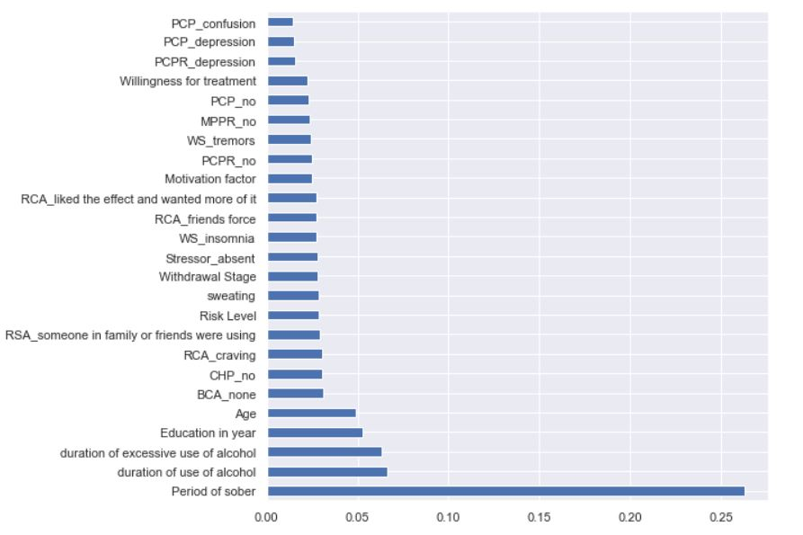
Fig. 1. Regression Scores

After applying the model for these 25 selected attributes we got a less accuracy therefore among these selected 25 attributes we applied SelectKbest to select only 22 relevant attributes based on f_classif and got these attributes, which are listed below in Table 2.

Table-2: Relevant Attributes
Relevant Attributes
Age | Friends forced
Education | PCP_confusion
Duration of use of alcohol | PCP_depression
Period of sober group | PCPR_depression
Duration of excessive use of alcohol | BCA_none
Risk level | WS_insomnia
RSA_Someone in family or friends was using | Motivation factors
RCA_liked the effect and wanted more of it | Willingness for treatment
Sweating | WS_tremors
RCA_craving | Withdrawal stages
Stressors_Absent | CHP_no

The data we collected was not balanced so SMOTE (Synthetic Minority Oversampling Technique) was used for handling class imbalance. Here synthetic samples are generated for the minority class to equal the number of records in all four classes. Thus, after applying SMOTE 329 patient’s records were converted into 2243 records. The next Section discusses the exploration of the relationship between various predictor variables and relapse period
3.2 Statistical analysis
The data consists of 329 males patients data, in which 303 were once relapsed, 22 twice, 4 thrice. The objective of our study is to analyse once relapsed patient’s data, hence only 303 patient’s details were considered. To analyse the drinking pattern w.r.t age, Patients are grouped under age groups as shown in Table 2. The data was analyzed w.r.t number of patients in each age group, their mean age, duration of alcohol consumption, duration of excessive use of alcohol consumption and average quantity of alcohol consumption in last 30 days.
Table-2:Alcohol Consumption Pattern of Patients
Age group | Age | Number of patients | Duration of use of alcohol(days) | Duration of excessive use of alcohol(days) | The avg quantity consumed in ml
20-30 | 27.27+/-2.33 | 36 | 926.52+/-863.67 | 76.75+/-35.17 | 508.33+/-212.73
31-40 | 35.77+/-2.88 | 137 | 1262.87+/-2089.35 | 149.81+/-76.95 | 590.84+/-364.59
40-50 | 45.11+/-2.82 | 93 | 2042.75+/-3359.99 | 223.96+/-92.29 | 538.22+/-385.8
50-60 | 53.78+/-2.49 | 30 | 1767.83+/-2731.81 | 286.63+/-134.31 | 454.5+/-208.99
>60 | 63.5+/-2.73 | 6 | 1947.83+/-3527.98 | 378.4+/-145.14 | 330.0+/-73.48

It is observed that, a maximum of 75.90% of once relapsed patients are in the age range of 31-50 years with mean age of 35 and 45 years. and less in other age groups, but the average quantity of alcohol consumption is decreased with age. Average quantity of alcohol consumption is found to be more in the 31-40 years age group. It was found to that in this age group of 31-40 years ,the highest education attained by the patients was 10th (37.63%)(High school education), most of the patients were married(79.86%) and the most of them(48.5%) were farmers and daily wage workers. Among these patients, 20.46% of patients had chronic health problems such as blood pressure, diabetes, liver disorder and asthma and 32.34% of the patients had psychiatric complications at present.

3.3 Exploratory Data Analysis:
This section discusses the factors that influenced patients for their relapse and/or sobriety period. Correlation analysis was carried out to identify the influencing factors of relapse and sobriety period. A weak negative correlation of 0.1084 was observed between age and period of sober which matches with most of the works[1][2]. So age can be considered as one of the prominent predictors of relapse. The most common reason for the decrease in relapse rate at a later age found to be their motivation and living arrangement and influence of the camp. Many works reported an association between craving as the reason for the relapse[1][2][3]. But, we found out that peer pressure (r=0.137, p=0.016), depression and craving (r=-0.13, p=0.02) are the major reason for the relapse.

Study also found that patient’s medical health problems and past psychiatric complication (confusion) is related to their relapse. Whereas motivation factors, the influence of the camp and willingness were the factors influenced them for remaining abstinent after de-addiction. Therefore, the counsellors in de addiction camp are suggested to develop and apply strategies which help to improve the self-efficacy of patients so as to increase their period of soberness. The categories of problematic behaviours seen in the patient’s childhood/adolescent ages were investigated. It’s observed that 7.92% of patients reported running away from home, 26.4% with Scholastic backwardness, and 7.92% with alcohol use, but a very less percentage of patients reported other factors like stealing, gambling, sexual issues, frequent physical fights and violence, destruction of others property, experimenting with drugs. 33.99% of patients had a family history of alcoholism either their father was alcoholic or bother, but these attributes did not show any valid correlation with the relapse.

In the camp, they were given treatment for 8 days. During these days every piece of information about the patients was noted such as behavioural changes etc. Based on these we extracted a withdrawal symptoms column and found that many patients were found in the final withdrawal stage (57.09%) and the withdrawal symptoms of sweating(r=0.02 ,p=0.065) and tremors(r=-0.104,p=0.06) have a good correlation coefficient with the relapse.

4. Sobriety period prediction Model Building and Evaluation

Once relapsed patients data set consists of 303 patient records with 33 patients relapsed within 1 month, 28 in 1-3 months, 22 in 3-6 months and 36 in 6-9 months , 70 in 9-12 months and 114 more than a year. Thus the sobriety period of once relapsed patients was varying which lead class imbalance problem. The SMOTE technique was applied to balance this data, and as a result, 2243 patient records were generated with an equal number of records in each class. The data were divided into training and test data in the ratio 70:30. The number of features considered was 22 which were extracted using SelectKbest. The model was built with different machine learning techniques like Random Forest, GuassianNB and K-Nearest Neighbours to observe which could provide the highest predictive accuracy. The performance of the classifier models is measured using accuracy. The number of tuples belonging to each class is almost the same. The macro average and weighted average for each of the metrics precision, recall and f1 score are the same, with an overall accuracy of the Gaussian NB model in predicting the sobriety period was 98.68%. The performance of all three algorithms is shown in Table 3. It can be observed from Table 3 that,the Gaussian NB has outperformed followed by Random Forest and K Nearest Neighbour. The experiment was performed maintaining the N_estimators to 800 and cross-validation set to 10. The F1-score is 88.98% and Recall is 92.1 % which signifies the model can classify the relapse to a satisfactory extent support by the confusion matrix shown in figure 2. Precision-Recall being high concludes that the model is accurately classifying the class although there is an imbalance in class observed. We are the first one to carry out this kind of sobriety period prediction, hence we could not compare the performance of our model with others’ work.

Table 4: Model Accuracy Measurement

Model | Accuracy | Precision | F1-score | Recall
GuassianNB | 98.68% | 99.05% | 99.3% | 98.68%
Random Forest | 92.10% | 86.36% | 88.98% | 92.1%
KNN | 47.36% | 60.59% | 52.99% | 47.36%

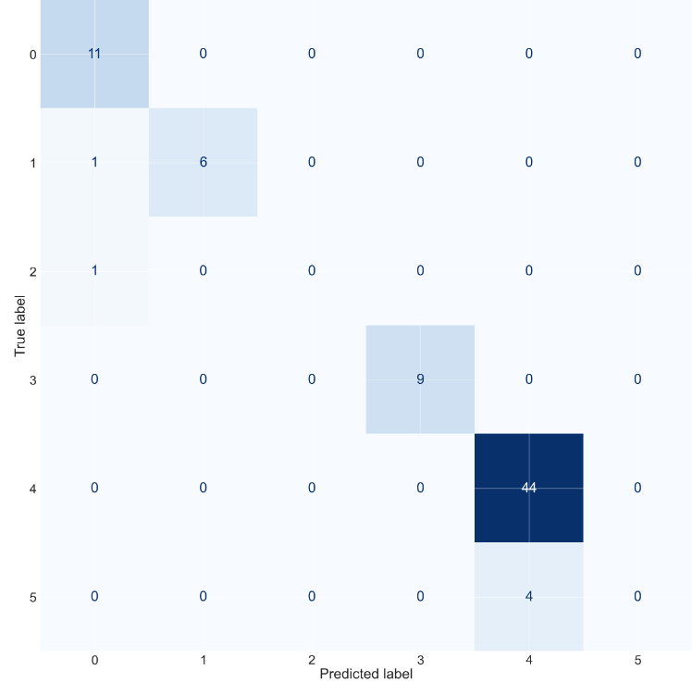
Figure 2: Confusion matrix
In the above confusion matrix we can observe that there 6 class labels representing the period of soberiety. On the y axis there are True labels and on the x-axis there are predicted labels. In first class all the values are predicted true similarly in the fourth and fifth class all the values are predicted true. In second and third class one value in each class is predicted false and in sixth class 4 values are predicted false.

5. Conclusion

We analysed once relapsed patient’s data to identify the factors that influenced their relapse and/or sobriety period. Maximum number of patients (75.9%) was found to be in the age group of 31-50 years, their highest education was 10th (37.62%) (High school education). Most of the patients were married (79.86%), and they were (48.5%) farmers and daily wage workers. The relapse rate was significantly higher among people who had no formal education or studied only up to primary school. Around 73%of the patients had attained the maximum secondary school level and remaining lower than this.

Increased craving and peer pressure were the major factors associated with relapse and motivation factor, willingness for treatment and Influence of the camp are proven to be the factors contributing to the abstinence in patients. Therefore, peer support and family counselling are very important for improving these factors and increasing periods of sober. These would probably contribute to the overall success rate of de-addiction programs.

Acknowledgement
We thank Dr D. Veerendra Hegde, President “Of Shri Dharmasthala Manjunatheshwara De-addiction and Research Centre”, Ujire, Karnataka State, India, for having permitted us to carry out research and insightful discussion about alcoholism, its effects and prevention.

References

1] Helle Wessel Andersson, Merethe Wenaasb, Trond Nordfjærna, Relapse after inpatient substance use treatment: A prospective cohort study among users of illicit substances

2] Nhat Van Trieu, Penpaktr Uthis and Sunisa Suktrakul Faculty of Nursing, Chulalongkorn University, Bangkok, Thailand: Alcohol dependence and the psychological factors leading to a relapse: a hospital-based study in Vietnam

3] Suma Jose1, Indra Selvam Venkatakrishnan2, Vijayaraghavan R3 and Susila C4. Effectiveness of specific nursing intervention program on motivation and relapse among clients with alcohol dependence syndrome-a pilot study

4] Anja Müllera Hansjörg Znojb Franz Moggia: How Are Self-Efficacy and Motivation Related to Drinking Five Years after Residential Treatment? A Longitudinal Multicentre Study

5] Factors Relating ors Relating to Substance Abuse Relapse: Sur o Substance Abuse Relapse: A Survival Analysis al Analysis of Adults Living in Oxford House Recovery Homes Ronald D. Harvey

6] Identification of relation of relapse factors of alcoholics after their first twelve step program Mirna V. Hernandez California State University - San Bernardino

7] Factors Contributing to Alcohol Relapse in a Rural Population: Lessons from a Camp Based De Addiction Model from Rural Karnataka Rahul Rampure, Leeberk Raja Inbaraj1, Carolin George Elizabeth1, Gift Norman1 Department of Family Medicine, Rural Development Trust Hospital, Anantapur, Andhra Pradesh, 1 Department of Family Medicine and Community Health, Bangalore Baptist Hospital, Bangalore, Karnataka, India

8] Assessment of the risk factors for relapse/ lapse among currently abstinent patients with alcohol dependence Markose A*, Varghese A*, Jose C*, Varghese ES*, Jacob E*, Baby B*, Mathew B*, Paul B*, Sandhya Gupta **, Renju S Baby S

9] Risk of Relapse in Clients with Alcohol Dependence Syndrome in a Tertiary Care Hospital Pavithra Subash1, Padmavathi Nagarajan2, Shivanand Kattimani3

10] The Alcohol Relapse Situation Appraisal Questionnaire: Development and Validation Rosemarie A. Martina, ∗, Selene M. MacKinnon, Jennifer E. Johnson, Mark G. Myers d, Travis A.R. Cook b, a, Damaris J. Rohsenow

11] A Structured Approach to Understanding Recovery and Relapse in AA Yue Zhang1, Arti Ramesh1, Jennifer Golbeck2, Dhanya Sridhar3, and Lise Getoor3 SUNY Binghamton1 University of Maryland, College Park2 University of California, Santa Cruz3 {yzhan202, artir}@binghamton.edu, golbeck@cs.umd.edu, {dsridhar, getoor}@ucsc.edu

12] Samarth Gupta, Soumi Roy Chowdhury, DB Gupta, Sanjib Pohi, A Study to Assess Alcohol Taxation, Affordability, and Price Elasticity Patterns in India

