**Flight booking**

**Overview:** Form to store person details and flight details with validatio

**Features:**

* front-end validation (Jquery validation).
* Backend validation ( using request class).
* Inserting data in DB.
* Showing Confirmation message.

**MySQL DB:**

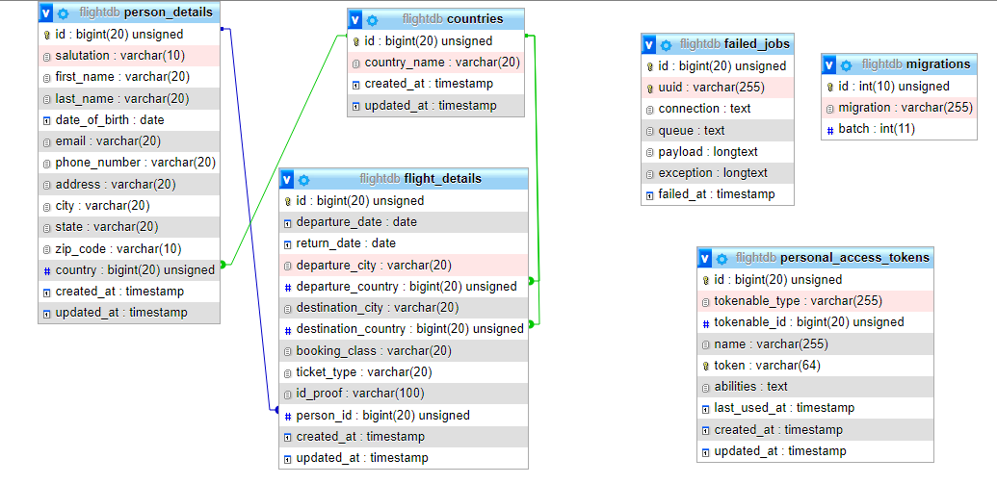

Modules:

* Person Details.
* Flight Details.

Time taken:

|  |  |  |  |
| --- | --- | --- | --- |
| Person Details | 4 hr database | 4 hr development | 2hr buffer |
| Flight Details | 4 hr database | 4 hr development | 2hr buffer |

**Rest API:**

**Enter Flight Booking data (URL):** <http://127.0.0.1:8000/api/flight_data>

* POST method
* Insert both personal details n flight details.

**Get individual data (URL):** <http://127.0.0.1:8000/api/flight_data/1>

* GET method

**Update data (URL):** <http://127.0.0.1:8000/api/flight_data>

* PUT method
* Only for departure_date and return_date, date fromat(YYYY-mm-dd).

**Delete data (URL):** <http://127.0.0.1:8000/api/flight_data/1>

* Delete method