**Creating Microservices for account and loan In this hands on exercises, we will create two microservices for a bank. One microservice for handing accounts and one for handling loans. Each microservice will be a specific independent Spring RESTful Webservice maven project having it's own pom.xml. The only difference is that, instead of having both account and loan as a single application, it is split into two different applications. These webservices will be a simple service without any backend connectivity.**

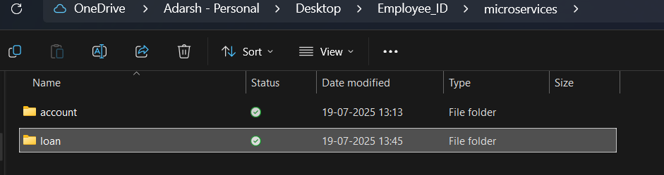

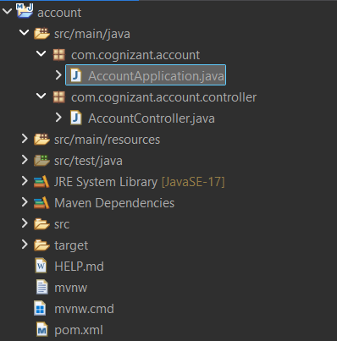

AccountController.java

package com.cognizant.account.controller;

import org.springframework.web.bind.annotation.GetMapping;

import org.springframework.web.bind.annotation.PathVariable;

import org.springframework.web.bind.annotation.RestController;

import java.util.Map;

*@RestController*

public class AccountController {

*@GetMapping*("/accounts/{number}")

public Map<String, Object> getAccountDetails(*@PathVariable* String number) {

return Map.*of*(

"number", number,

"type", "savings",

"balance", 234343

);}}

Pom.xml

<?xml version="1.0" encoding="UTF-8"?>

<project xmlns="http://maven.apache.org/POM/4.0.0" xmlns:xsi="http://www.w3.org/2001/XMLSchema-instance"

xsi:schemaLocation="http://maven.apache.org/POM/4.0.0 https://maven.apache.org/xsd/maven-4.0.0.xsd">

<modelVersion>4.0.0</modelVersion>

<parent>

<groupId>org.springframework.boot</groupId>

<artifactId>spring-boot-starter-parent</artifactId>

<version>3.5.3</version>

<relativePath/> <!-- lookup parent from repository -->

</parent>

<groupId>com.cognizant</groupId>

<artifactId>account</artifactId>

<version>0.0.1-SNAPSHOT</version>

<name>account</name>

<description>Demo project for Spring Boot</description>

<url/>

<licenses>

<license/>

</licenses>

<developers>

<developer/>

</developers>

<scm>

<connection/>

<developerConnection/>

<tag/>

<url/>

</scm>

<properties>

<java.version>17</java.version>

</properties>

<dependencies>

<dependency>

<groupId>org.springframework.boot</groupId>

<artifactId>spring-boot-starter-web</artifactId>

</dependency>

<dependency>

<groupId>org.springframework.boot</groupId>

<artifactId>spring-boot-devtools</artifactId>

<scope>runtime</scope>

<optional>true</optional>

</dependency>

<dependency>

<groupId>org.springframework.boot</groupId>

<artifactId>spring-boot-starter-test</artifactId>

<scope>test</scope>

</dependency>

</dependencies>

<build>

<plugins>

<plugin>

<groupId>org.springframework.boot</groupId>

<artifactId>spring-boot-maven-plugin</artifactId>

</plugin>

</plugins>

</build>

</project>

OUTPUT:

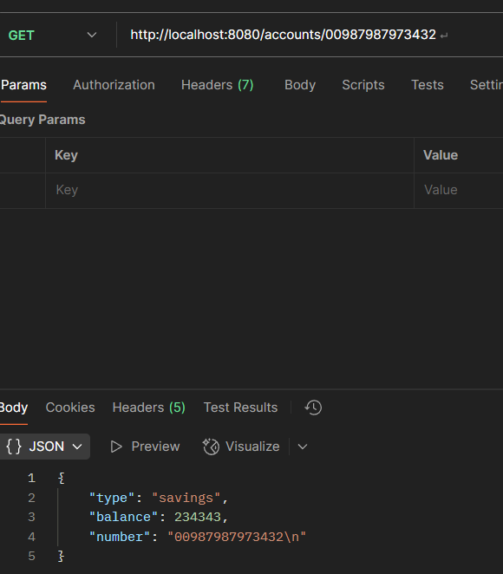

**Loan Microservice :**

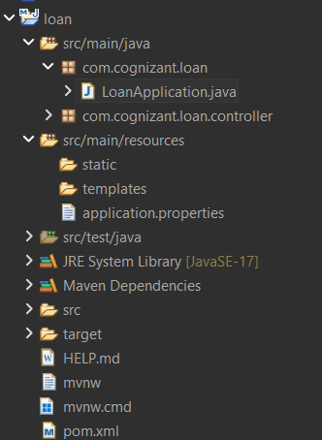

**LoanController.java**

**package com.cognizant.loan.controller;**

**import org.springframework.web.bind.annotation.GetMapping;**

**import org.springframework.web.bind.annotation.PathVariable;**

**import org.springframework.web.bind.annotation.RestController;**

**import java.util.Map;**

***@RestController***

**public class LoanController {**

***@GetMapping*("/loans/{number}")**

**public Map<String, Object> getLoanDetails(*@PathVariable* String number) {**

**return Map.*of*(**

**"number", number,**

**"type", "car",**

**"loan", 400000,**

**"emi", 3258,**

**"tenure", 18**

**);**

**}**

**}**

**OUTPUT:**

