Create a React Application named “cricketapp” with the following components:

1. ListofPlayers

* Declare an array with 11 players and store details of their names and scores using the map feature of ES6

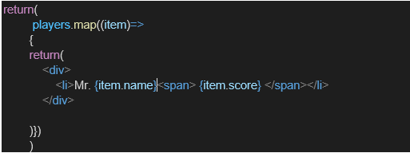

* Filter the players with scores below 70 using arrow functions of ES6.

1. IndianPlayers
   1. Display the Odd Team Player and Even Team players using the Destructuring features of ES6
   2. Declare two arrays T20players and RanjiTrophy players and merge the two arrays and display them using the Merge feature of ES6

Display these two components in the same home page using a simple if else in the flag variable.

**// src/components/IndianPlayers.js**

import React from "react";

const IndianPlayers = () => {

  const team = ["Rohit", "Virat", "Dhoni", "Hardik", "Jadeja", "Bumrah"];

  const oddPlayers = team.filter((_, index) => index % 2 !== 0);

  const evenPlayers = team.filter((_, index) => index % 2 === 0);

  const [T20players, RanjiTrophyPlayers] = [

    ["Surya", "Gill", "Pant"],

    ["Rahane", "Pujara", "Iyer"]

  ];

  const mergedPlayers = [...T20players, ...RanjiTrophyPlayers];

  return (

    <div>

      <h2>Team Split</h2>

      <p><strong>Odd Team:</strong> {oddPlayers.join(", ")}</p>

      <p><strong>Even Team:</strong> {evenPlayers.join(", ")}</p>

      <h3>Merged Players (T20 + Ranji Trophy)</h3>

      <ul>

        {mergedPlayers.map((player, index) => (

          <li key={index}>{player}</li>

        ))}

      </ul>

    </div>

  );

};

export default IndianPlayers;

**// src/components/ListofPlayers.js**

import React from "react";

const ListofPlayers = () => {

  const players = [

    { name: "Rohit", score: 85 },

    { name: "Virat", score: 95 },

    { name: "Dhoni", score: 70 },

    { name: "Hardik", score: 60 },

    { name: "Rahul", score: 68 },

    { name: "Jadeja", score: 72 },

    { name: "Bumrah", score: 50 },

    { name: "Shami", score: 45 },

    { name: "Surya", score: 77 },

    { name: "Gill", score: 66 },

    { name: "Pant", score: 91 },

  ];

  const filteredPlayers = players.filter(player => player.score < 70);

  return (

    <div>

      <h2>All Players</h2>

      <ul>

        {players.map((player, index) => (

          <li key={index}>{player.name} - {player.score}</li>

        ))}

      </ul>

      <h3>Filtered Players (Score &lt; 70)</h3>

      <ul>

        {filteredPlayers.map((player, index) => (

          <li key={index}>{player.name} - {player.score}</li>

        ))}

      </ul>

    </div>

  );

};

export default ListofPlayers;

**// src/App.js**

import React from "react";

import ListofPlayers from "./components/ListofPlayers";

import IndianPlayers from "./components/IndianPlayers";

function App() {

  const flag = false;

  return (

    <div className="App">

      <h1>Welcome to Cricket App</h1>

      {flag ? <ListofPlayers /> : <IndianPlayers />}

    </div>

  );

}

export default App;

**Output:**

**When Flag=true**

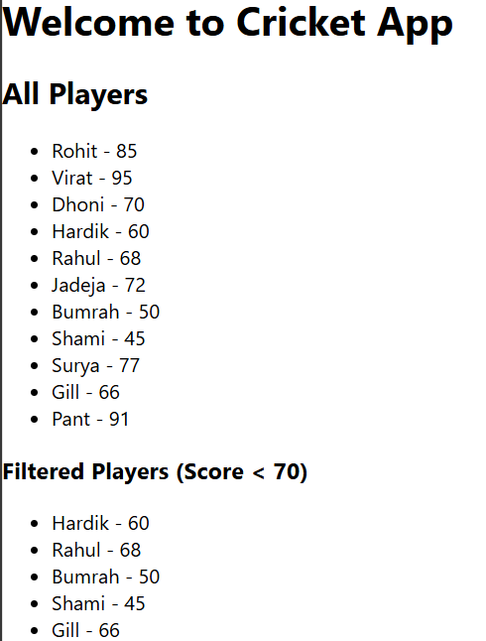

**When flag = false**

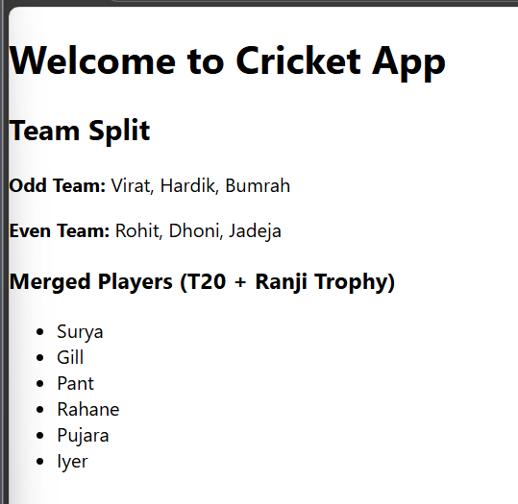

**Exercise 2**

**Create a React Application named “officespacerentalapp” which uses React JSX to create elements, attributes and renders DOM to display the page.**

**Create an element to display the heading of the page.**

**Attribute to display the image of the office space**

**Create an object of office to display the details like Name, Rent and Address.**

**Create a list of Object and loop through the office space item to display more data.**

**To apply Css, Display the color of the Rent in Red if it’s below 60000 and in Green if it’s above 60000.**

**CODE;**

import React from "react";

import "./App.css";

function App() {

  const officeSpaces = [

    {

      id: 1,

      name: "DBS",

      rent: 50000,

      address: "Chennai",

      image: process.env.PUBLIC_URL + "/office3.jpg"

    },

    {

      id: 2,

      name: "WeWork",

      rent: 75000,

      address: "Bangalore",

      image: process.env.PUBLIC_URL + "/office2.jpg"

    },

    {

      id: 3,

      name: "SmartWorks",

      rent: 58000,

      address: "Hyderabad",

      image: process.env.PUBLIC_URL + "/office1.jpg"

    }

  ];

  return (

    <div className="App">

      <h1>Office Space , at Affordable Range</h1>

      {officeSpaces.map((office) => (

        <div key={office.id} className="office-card">

          <img src={office.image} alt={office.name} className="office-img" />

          <h2>Name: {office.name}</h2>

          <p

            style={{

              color: office.rent < 60000 ? "red" : "green",

              fontWeight: "bold"

            }}

          >

            Rent: Rs. {office.rent}

          </p>

          <p><strong>Address:</strong> {office.address}</p>

        </div>

      ))}

    </div>

  );

}

export default App;

**APP.css**

.App {

  text-align: center;

  padding: 20px;

  font-family: Arial, sans-serif;

}

.office-card {

  margin-bottom: 40px;

}

.office-img {

  width: 300px;

  height: 200px;

  object-fit: cover;

  margin: 20px 0;

}

**OUTPUT:**



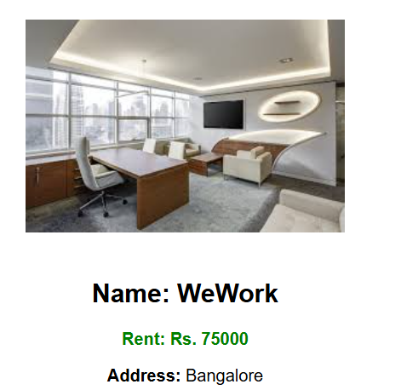

**EXERCISE 3:**

**Create a React Application “eventexamplesapp” to handle various events of the form elements in HTML.**

1. **Create “Increment” button to increase the value of the counter and “Decrement” button to decrease the value of the counter. The “Increase” button should invoke multiple methods.** 
   1. **To increment the value**
   2. **Say Hello followed by a static message.**
2. **Create a button “Say Welcome” which invokes the function which takes “welcome” as an argument.**
3. **Create a button which invokes synthetic event “OnPress” which display “I was clicked”**

**Create a “CurrencyConvertor” component which will convert the Indian Rupees to Euro when the Convert button is clicked.**

**Handle the Click event of the button to invoke the handleSubmit event and handle the conversion of the euro to rupees.**

**CODE:  
APP.js**

import React, { useState } from 'react';

import CurrencyConvertor from './CurrencyConvertor';

function App() {

  const [count, setCount] = useState(5);

  const handleIncrement = () => {

    incrementValue();

    sayHello();

  };

  const incrementValue = () => {

    setCount(prev => prev + 1);

  };

  const sayHello = () => {

    alert("Hello! Member1");

  };

  const handleDecrement = () => {

    setCount(prev => prev - 1);

  };

  const sayWelcome = (msg) => {

    alert(msg);

  };

  const onPressHandler = () => {

    alert("I was clicked");

  };

  return (

    <div style={{ padding: '20px', fontFamily: 'Arial' }}>

      <h1>{count}</h1>

      <button onClick={handleIncrement}>Increment</button>

      <button onClick={handleDecrement} style={{ marginLeft: '10px' }}>Decrement</button>

      <br /><br />

      <button onClick={() => sayWelcome("Welcome")}>Say welcome</button>

      <br /><br />

      <button onClick={onPressHandler}>Click on me</button>

      <hr />

      <CurrencyConvertor />

    </div>

  );

}

export default App;

**CurrencyConvertor.js**

import React, { useState } from 'react';

function CurrencyConvertor() {

  const [amount, setAmount] = useState('');

  const [currency, setCurrency] = useState('Euro');

  const handleSubmit = (e) => {

    e.preventDefault();

    if (currency === 'Euro') {

      const result = parseFloat(amount) * 80; // 1 Euro = ₹80

      alert(`Converting to Euro Amount is ${result}`);

    }

  };

  return (

    <div style={{ marginTop: '40px' }}>

      <h1 style={{ color: 'green' }}>Currency Convertor!!!</h1>

      <form onSubmit={handleSubmit}>

        <label>Amount: </label>

        <input

          type="number"

          value={amount}

          onChange={(e) => setAmount(e.target.value)}

        /><br /><br />

        <label>Currency: </label>

        <select

          value={currency}

          onChange={(e) => setCurrency(e.target.value)}

        >

          <option value="Euro">Euro</option>

        </select>

        <br /><br />

        <button type="submit">Submit</button>

      </form>

    </div>

  );

}

export default CurrencyConvertor;

OUTPUT:

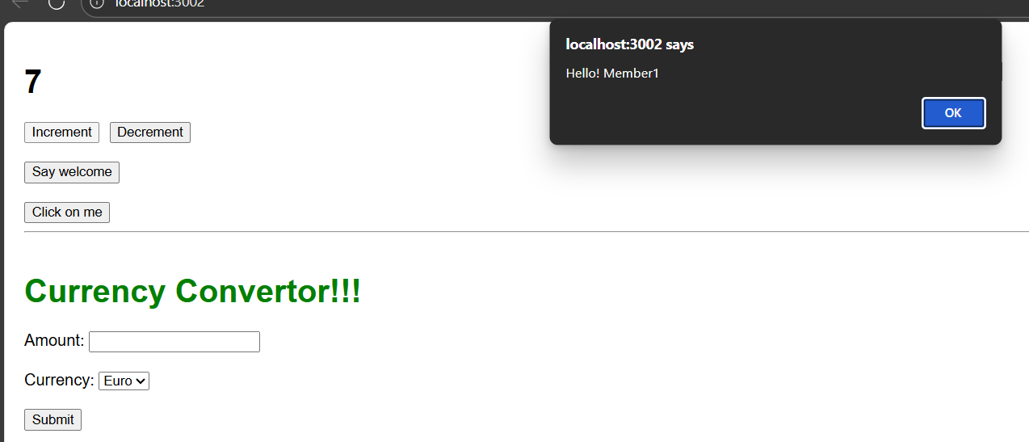

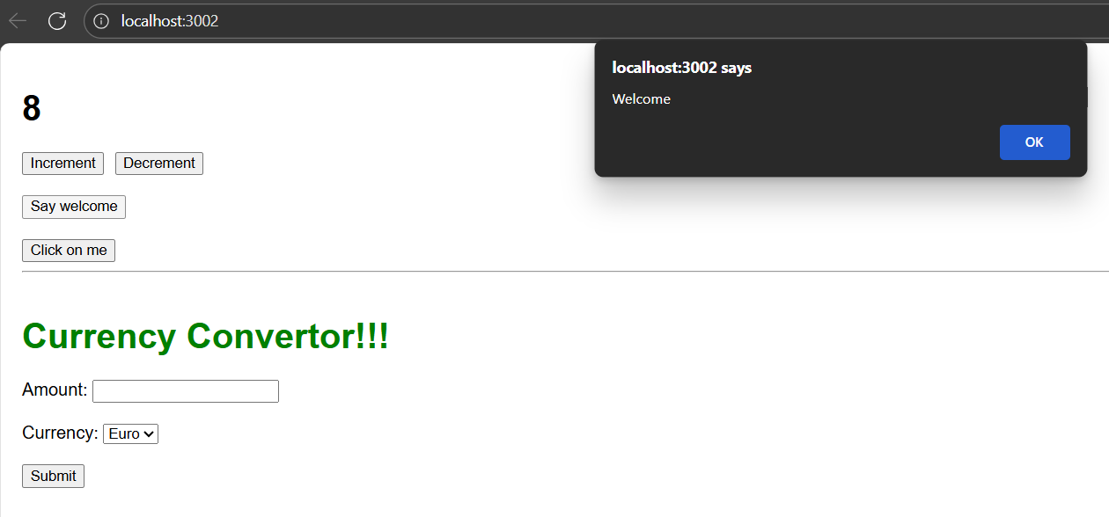

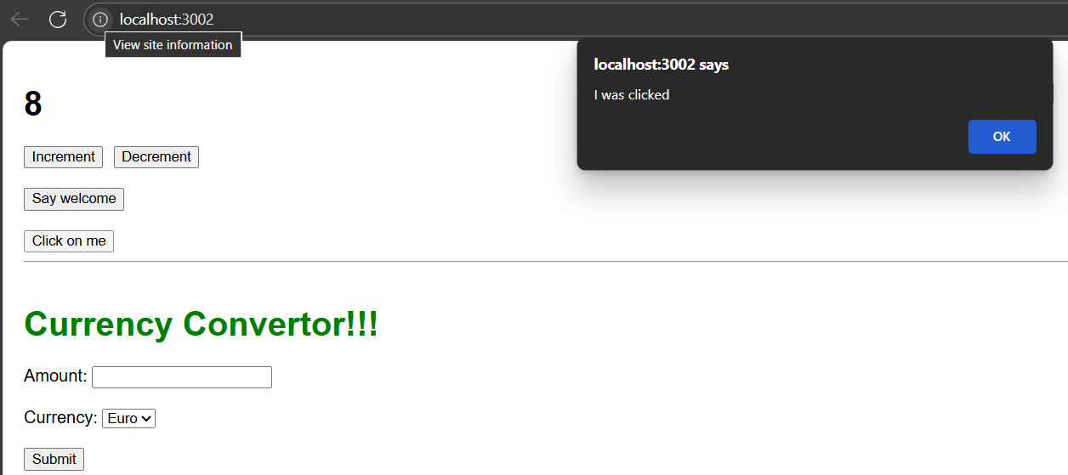

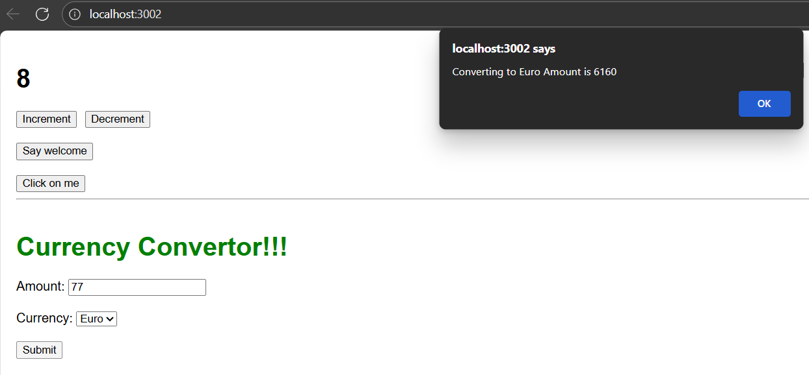

**EXERCISE 3**

**Create a React Application named “ticketbookingapp” where the guest user can browse the page where the flight details are displayed whereas the logged in user only can book tickets.**

**The Login and Logout buttons should accordingly display different pages. Once the user is logged in the User page should be displayed. When the user clicks on Logout, the Guest page should be displayed.**

**CODE:  
APP.js**

import React, { useState } from 'react';

import GuestPage from './components/GuestPage';

import UserPage from './components/UserPage';

function App() {

  const [isLoggedIn, setIsLoggedIn] = useState(false);

  const handleLogin = () => setIsLoggedIn(true);

  const handleLogout = () => setIsLoggedIn(false);

  return (

    <div style={{ padding: '20px', fontFamily: 'Arial' }}>

      <h1>✈️ Ticket Booking App</h1>

      {!isLoggedIn ? (

        <>

          <button onClick={handleLogin}>Login</button>

          <GuestPage />

        </>

      ) : (

        <>

          <button onClick={handleLogout}>Logout</button>

          <UserPage />

        </>

      )}

    </div>

  );

}

export default App;

**GUESTpage.js**

import React from 'react';

import FlightList from './FlightList';

function GuestPage() {

  return (

    <div>

      <h2>Welcome Guest 👋</h2>

      <p>You can browse flights but need to log in to book.</p>

      <FlightList showBooking={false} />

    </div>

  );

}

export default GuestPage;

**FlightList.js:**

import React from 'react';

const flights = [

  { id: 1, from: 'Delhi', to: 'Mumbai', time: '10:00 AM' },

  { id: 2, from: 'Bangalore', to: 'Chennai', time: '2:00 PM' },

  { id: 3, from: 'Kolkata', to: 'Delhi', time: '6:00 PM' },

];

function FlightList({ showBooking }) {

  const handleBook = (id) => alert(`Flight ${id} booked successfully!`);

  return (

    <div>

      <h3>Available Flights</h3>

      <ul>

        {flights.map((flight) => (

          <li key={flight.id} style={{ marginBottom: '10px' }}>

            ✈️ {flight.from} → {flight.to} at {flight.time}

            {showBooking && (

              <button style={{ marginLeft: '10px' }} onClick={() => handleBook(flight.id)}>

                Book

              </button>

            )}

          </li>

        ))}

      </ul>

    </div>

  );

}

export default FlightList;

**UserPage.js:**

import React from 'react';

import FlightList from './FlightList';

function UserPage() {

  return (

    <div>

      <h2>Welcome User ✅</h2>

      <p>You can now book flights.</p>

      <FlightList showBooking={true} />

    </div>

  );

}

export default UserPage;

**OUTPUT:**

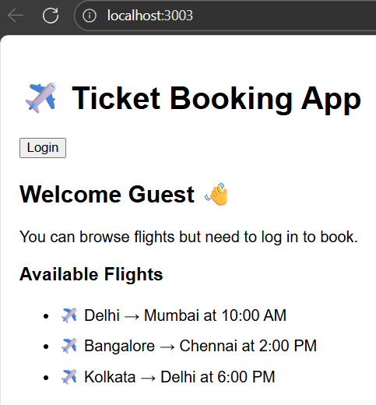

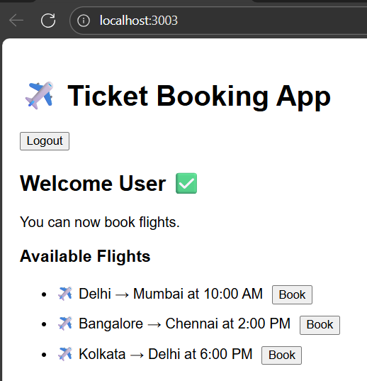

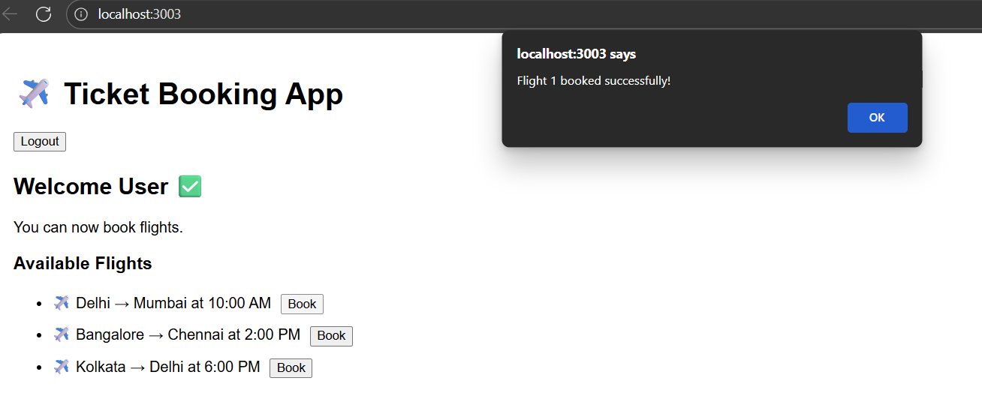

**EXERCISE 5**

**Create a React App named “bloggerapp” in with 3 components.**

1. **Book Details**
2. **Blog Details**
3. **Course Details**

**Implement this with as many ways possible of Conditional Rendering.**

**CODE:**

**APP.js**

import React, { useState } from 'react';

import CourseDetails from './components/CourseDetails';

import BookDetails from './components/BookDetails';

import BlogDetails from './components/BlogDetails';

import './App.css';

function App() {

  const [showAll, setShowAll] = useState(true);

  let content;

  if (showAll) {

    content = (

      <>

        <CourseDetails />

        <BookDetails />

        <BlogDetails />

      </>

    );

  } else {

    content = <p>Click the button to show details.</p>;

  }

  return (

    <div className="app">

      <button onClick={() => setShowAll(!showAll)}>

        {showAll ? 'Hide Details' : 'Show Details'}

      </button>

      <div className="container">{content}</div>

    </div>

  );

}

export default App;

**App.css**

.app {

  padding: 20px;

  font-family: Arial;

  text-align: center;

}

.container {

  display: flex;

  justify-content: space-around;

  margin-top: 20px;

}

.section {

  border-left: 3px solid green;

  padding-left: 15px;

}

**BookDetails.js:**

import React from 'react';

function BookDetails() {

  const books = [

    { title: 'Master React', price: 670 },

    { title: 'Deep Dive into Angular 11', price: 800 },

    { title: 'Mongo Essentials', price: 450 }

  ];

  return (

    <div className="section">

      <h2>Book Details</h2>

      {books.length === 0 || books.map((b, index) => (

        <div key={index}>

          <h3>{b.title}</h3>

          <p>{b.price}</p>

        </div>

      ))}

    </div>

  );

}

export default BookDetails;

**BlogDetails.js**

import React from 'react';

function BlogDetails() {

  const blogs = [

    {

      title: 'React Learning',

      author: 'Stephen Biz',

      content: 'Welcome to learning React!'

    },

    {

      title: 'Installation',

      author: 'Schwezdenier',

      content: 'You can install React from npm.'

    }

  ];

  return (

    <div className="section">

      <h2>Blog Details</h2>

      {blogs.length && blogs.map((b, index) => (

        <div key={index}>

          <h3>{b.title}</h3>

          <strong>{b.author}</strong>

          <p>{b.content}</p>

        </div>

      ))}

    </div>

  );

}

export default BlogDetails;

**CourseDetails.js:**

import React from 'react';

function CourseDetails() {

  const courses = [

    { name: 'Angular', date: '4/5/2021' },

    { name: 'React', date: '6/3/2021' }

  ];

  return (

    <div className="section">

      <h2>Course Details</h2>

      {courses.length > 0 ? (

        courses.map((c, index) => (

          <div key={index}>

            <h3>{c.name}</h3>

            <p>{c.date}</p>

          </div>

        ))

      ) : (

        <p>No courses available</p>

      )}

    </div>

  );

}

export default CourseDetails;

**OUTPUT:**

