APNADUKAN

|  |
| --- |
| Author |
| ADARSA SWAIN |

**Name of Degree**:Bachelor of Technology

**Name of Dept**.: Computer Science & Engineering

**Name of Faculty**: Mr. Sagar Pande

**Month & Year of Submission**:November, 2020

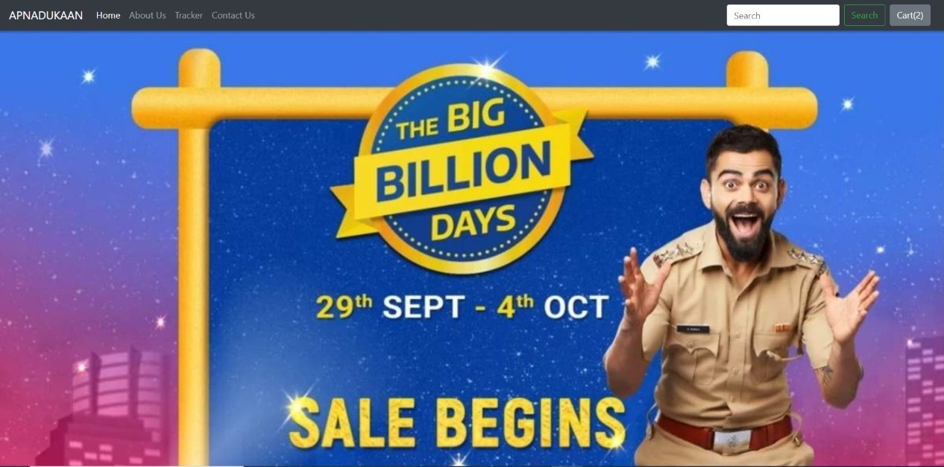

**ABSTRACT**

This project was developed with at most care and concern by Myself for python programming using Django along with Html, CSS, Javascript.

The Apnadukkan is a world famous ecommerce website which can be used to place order by anyone of any age [no age restrictions], but I try to modified this website into a brand new level by merging using tracker which track the order from your cart javascript, css, and json which help to be more userfreindly to buy the usability of the products .

Now all you have to go to the website order your products track your order and get your product in your home.

**ACKNOWLEDGEMENT**

We would like to express my special thanks of gratitude to my teacher Mr. Sagar Pande Sir who gave us the golden opportunity to do this wonderful project on the topic ‘Apnadukan’, which also helped us in doing a lot of research and we came to know about so many new things, we are really thankful to you sir.

Secondly, we would also like to thank each one of our parents and friends who helped us a lot in finalizing our project within the limited time frame.



**INTRODUCTION**

The aim of this project is on the online shopping application it is developed

using HTML5, JAVA script, CSS, Django. The application is very

useful where the buyer can directly buy the products from home via internet

on mobile or system. The application reduces lot of work load for customer as

well as owner. The transaction of money is completed in real time system.

It similar to each and every eccomerce website named as Apnadukan same as Amazon. By this online shopping the product is directly delivered to customer home.

Online shopping is the process consumers go through to purchase products or

Services over the Internet. An online shop, e-shopping, e-store, internet shop, web shop , web store , online store,or virtual store evokes the physical analogy of buying  products or services at a bricks-and-mortar  retailer or in a mall. The

metaphor of an online catalog is also used, by analogy with mail order catalogs.

They get their desired product of their own choice by sitting in their home With proper discount and getting the product of their own.



**ANALYSIS**

**Study of the Problem**

The Current shopping System is critical toset up online shops, customers to browse through the shops, and a system administrator to approve and reject requests for new shops and maintain lists of shop categories**.** This is a small scale project for Online shopping System. The basic idea is that the candidates can buy product from anywhere during any time by using their card number and password provided to them and through the Paytm account. The database will maintain the product details information. Customer can view their product details using the cart no and Gmail id details . This Online shopping system involves with two types of users.

* **customer**
* **ADMINISTRATOR**

**customer role:**

The customer’s can go to the homepage. He/She can view his/her product details and buy their product. The customer can just view the information whereas he/she could not make changes in the database.

**ADMINISTRATOR ROLE:**

The administrator plays a vital role in the Online shopping system. The administrator controls the entire database. The report of the product is generated by the administrator itself. The main role of the administrator is to safeguard the database and can add/delete the products from the database.

**Project Scope**

The supplementary specification applies to online shopping system. This specification defines the non-functional requirement of the system such as:

**Functionality:**

Since it stand alone application, one or more user may use it at a time.

**Usability:**

Desktop interface

**Technology:**

Front End : HTML, Java Script ,Django

Database : SQlite

**Reliability:**

The system is available during online time only .

**Performance:**

The performance depends on hardware specification

|  |  |  |
| --- | --- | --- |
| CHAPTER NO. | TOPIC | PAGE NO. |
| 1 | INTRODUCTION | 5 |
| 2 | ANALYSIS |  |
| *2.1* | *STUDY OF THE PROBLEM* | *6* |
| *2.2* | *PROJECT SCOPE* | *7* |
| *2.3* | *OBJECTIVES* | *8* |
| 3 | DESIGN | 9 |
| 4 | IMPLEMENTATION | 10 |

**OBJECTIVE**

The purpose of this document is to define the requirements of Online shopping system. This supplementary specification lists the requirements that are not readily captured in the use case model. Supplementary specification and the use case model capture a complete set of requirement of the system.

**IMPLEMENTATION**

CODE FOR HOMEPAGE

<!doctype html>

<html lang="en">

<head>

<!-- Required meta tags -->

<meta charset="utf-8">

<meta name="viewport" content="width=device-width, initial-scale=1, shrink-to-fit=no">

<!-- Bootstrap CSS -->

<link rel="stylesheet" href="https://stackpath.bootstrapcdn.com/bootstrap/4.2.1/css/bootstrap.min.css" integrity="sha384-GJzZqFGwb1QTTN6wy59ffF1BuGJpLSa9DkKMp0DgiMDm4iYMj70gZWKYbI706tWS" crossorigin="anonymous">

<title>{% block title%} {% endblock %}</title>

<style>

{% block css %} {% endblock %}

</style>

</head>

<body>

<nav class="navbar navbar-expand-lg navbar-dark bg-dark">

<a class="navbar-brand" href="#">APNADUKAAN</a>

<button class="navbar-toggler" type="button" data-toggle="collapse" data-target="#navbarSupportedContent" aria-controls="navbarSupportedContent" aria-expanded="false" aria-label="Toggle navigation">

<span class="navbar-toggler-icon"></span>

</button>

<div class="collapse navbar-collapse" id="navbarSupportedContent">

<ul class="navbar-nav mr-auto">

<li class="nav-item active">

<a class="nav-link" href="#">Home <span class="sr-only">(current)</span></a>

</li>

<li class="nav-item">

<a class="nav-link" href="about">About Us</a>

</li>

<li class="nav-item">

<a class="nav-link" href="tracker">Tracker</a>

</li>

<li class="nav-item">

<a class="nav-link" href="contact">Contact Us</a>

</li>

</ul>

<form method='get' action='search' class="form-inline my-2 my-lg-0">

<input class="form-control mr-sm-2" type="search" placeholder="Search" aria-label="Search" name="search" id="search">

<button class="btn btn-outline-success my-2 my-sm-0" type="submit">Search</button>

</form>

<button type="button" class="btn btn-secondary mx-2" id="popcart" data-container="body" data-toggle="popover" data-placement="bottom" data-html="true" data-content="Vivamus

sagittis lacus vel augue laoreet rutrum faucibus.">

Cart(<span id="cart">0</span>)

</button>

</div>

</nav>

{% block body %}

{% endblock %}

<!-- Optional JavaScript -->

<!-- jQuery first, then Popper.js, then Bootstrap JS -->

<script src="https://code.jquery.com/jquery-3.3.1.js"

integrity="sha256-2Kok7MbOyxpgUVvAk/HJ2jigOSYS2auK4Pfzbm7uH60="

crossorigin="anonymous"></script>

<script src="https://cdnjs.cloudflare.com/ajax/libs/popper.js/1.14.6/umd/popper.min.js" integrity="sha384-wHAiFfRlMFy6i5SRaxvfOCifBUQy1xHdJ/yoi7FRNXMRBu5WHdZYu1hA6ZOblgut" crossorigin="anonymous"></script>

<script src="https://stackpath.bootstrapcdn.com/bootstrap/4.2.1/js/bootstrap.min.js" integrity="sha384-B0UglyR+jN6CkvvICOB2joaf5I4l3gm9GU6Hc1og6Ls7i6U/mkkaduKaBhlAXv9k" crossorigin="anonymous"></script>

{% block js %}

<script>

console.log('working');

if(localStorage.getItem('cart') == null){

var cart = {};

}

else

{

cart = JSON.parse(localStorage.getItem('cart'));

document.getElementById('cart').innerHTML = Object.keys(cart).length;

}

$('.cart').click(function(){

console.log('clicked');

var idstr = this.id.toString();

console.log(idstr);

if (cart[idstr] !=undefined){

cart[idstr] = cart[idstr] + 1;

}

else

{

cart[idstr] = 1;

}

console.log(cart);

localStorage.setItem('cart', JSON.stringify(cart));

document.getElementById('cart').innerHTML = Object.keys(cart).length;

});

$('#popcart').popover();

document.getElementById("popcart").setAttribute('data-content', '<h5>Cart for your items in my shopping cart</h5>');

</script>

{% endblock %}

CODE FOR CHCKOUT:

{% extends 'basic.html' %}

{% block title%} Checkout - My Awesome Cart{% endblock %}

{% block body %}

<div class="container">

<div class="col my-4">

<h2>Step 1 - My Awesome Cart Express Checkout - Review Your Cart Items</h2>

<div class="my-4">

<ul class="list-group" id="items">

</ul>

<nav aria-label="breadcrumb">

<ol class="breadcrumb mt-3">

<li class="breadcrumb-item active" aria-current="page">Your Cart Total Is <b>Rs.<span id="totalprice"></b> </span>Enter your details below & place your order. Thanks for using My Awesome Cart!</li>

</ol>

</nav>

</div>

</div>

<div class="col my-4">

<h2>Step 2 - Enter Address & Other Details:</h2>

<form method="post" action="checkout">{% csrf_token %}

<input type="hidden" name="itemsJson" id="itemsJson">

<input type="hidden" name="amount" id="amount">

<div class="form-row">

<div class="form-group col-md-6">

<label for="inputname">Name</label>

<input type="text" class="form-control" id="name" name="name" placeholder="Name">

</div>

<div class="form-group col-md-6">

<label for="inputEmail4">Email</label>

<input type="email" class="form-control" id="email" name="email" placeholder="Email">

</div>

</div>

<div class="form-group">

<label for="inputAddress">Address</label>

<input type="text" class="form-control" id="address1" name="address1" placeholder="1234 Main St">

</div>

<div class="form-group">

<label for="inputAddress2">Address line 2</label>

<input type="text" class="form-control" id="address2" name="address2" placeholder="Apartment, studio, or floor">

</div>

<div class="form-row">

<div class="form-group col-md-6">

<label for="inputCity">City</label>

<input type="text" class="form-control" id="city" name="city">

</div>

<div class="form-group col-md-4">

<label for="inputState">State</label>

<input type="text" class="form-control" id="state" name="state" placeholder="Enter State">

</div>

<div class="form-group col-md-2">

<label for="inputZip">Zip</label>

<input type="text" class="form-control" id="zip_code" name="zip_code">

</div>

</div>

<div class="form-group">

<label for="inputZip">Phone Number</label>

<input type="tel" class="form-control" id="phone" name="phone">

</div>

<button type="submit" class="btn btn-primary">Place Order</button>

</form>

</div>

</div>

{% endblock %}

{% block js %}

<script>

if (localStorage.getItem('cart') == null) {

var cart = {};

} else {

cart = JSON.parse(localStorage.getItem('cart'));

}

console.log(cart);

var sum = 0;

var totalprice = 0;

if ($.isEmptyObject(cart)) {

//if object is empty

mystr = `<p>Your cart is empty, please add some items to your cart before checking out!</p>`

$('#items').append(mystr);

} else {

for (item in cart) {

let name = cart[item][1];

let qty = cart[item][0];

let itemPrice = cart[item][2];

sum = sum + qty;

totalprice = totalprice+qty*itemPrice;

mystr = `<li class="list-group-item d-flex justify-content-between align-items-center">

${name}

<span class="badge badge-primary badge-pill">${qty}</span>

</li>`

$('#items').append(mystr);

}

}

document.getElementById('cart').innerHTML = sum;

document.getElementById('totalprice').innerHTML = totalprice;

$('#itemsJson').val(JSON.stringify(cart));

{% if thank %}

alert('Thanks for ordering with us. Your order is is {{id}}. Use it to track your order using our order tracker');

localStorage.clear();

document.location = "home";

{% endif %}

$('#amount').val($('#totalprice').html())

</script>

{% endblock %}

CODE FOR SEARCH:

{% extends 'basic.html' %}

{% block title%} Search Results - My Awesome Cart{% endblock %}

{% block css %}

.col-md-3

{

display: inline-block;

margin-left:-4px;

}

.carousel-indicators .active {

background-color: blue;

}

.col-md-3 img{

width: 170px;

height: 200px;

}

body .carousel-indicator li{

background-color: blue;

}

body .carousel-indicators{

bottom: -40px;

}

.carousel-indicators li {

background-color: #7270fc;

}

body .carousel-control-prev-icon,

body .carousel-control-next-icon{

background-color: blue;

}

.carousel-control-prev,

.carousel-control-next{

top: auto;

bottom: auto;

padding-top: 222px;

}

body .no-padding{

padding-left: 0,

padding-right: 0;

}

{% endblock %}

{% block body %}

{% load static %}

<div class="container">

<!--Slideshow starts here -->

{% for product, range, nSlides in allProds %}

<h5 class="my-4">Flash Sale On {{product.0.category}} - Recommended Items</h5>

<div class="row">

<div id="demo{{forloop.counter}}" class="col carousel slide my-3" data-ride="carousel">

<ul class="carousel-indicators">

<li data-target="#demo{{forloop.counter}}" data-slide-to="0" class="active"></li>

{% for i in range %}

<li data-target="#demo{{forloop.parentloop.counter}}" data-slide-to="{{i}}"></li>

{% endfor %}

</ul>

<div class="container carousel-inner no-padding">

<div class="carousel-item active">

{% for i in product %}

<div class="col-xs-3 col-sm-3 col-md-3">

<div class="card align-items-center" style="width: 18rem;">

<img src='/media/{{i.image}}' class="card-img-top" alt="...">

<div class="card-body">

<h5 class="card-title" id="namepr{{i.id}}">{{i.product_name}}</h5>

<p class="card-text">{{i.desc|slice:"0:53"}}...</p>

<h6 class="card-title" >Price: <span id="pricepr{{i.id}}">{{i.price}}</span></h6>

<span id="divpr{{i.id}}" class="divpr">

<button id="pr{{i.id}}" class="btn btn-primary cart">Add To Cart</button>

</span>

<a href="/shop/products/{{i.id}}"><button id="qv{{i.id}}" class="btn btn-primary cart">QuickView</button></a>

</div>

</div>

</div>

{% if forloop.counter|divisibleby:4 and forloop.counter > 0 and not forloop.last %}

</div>

<div class="carousel-item">

{% endif %}

{% endfor %}

</div>

</div>

</div>

<!-- left and right controls for the slide -->

<a class="carousel-control-prev" href="#demo{{forloop.counter}}" data-slide="prev">

<span class="carousel-control-prev-icon"></span>

</a>

<a class="carousel-control-next" href="#demo{{forloop.counter}}" data-slide="next">

<span class="carousel-control-next-icon"></span>

</a>

</div>

{% endfor %}

</div>

{% endblock %}

{% block js %}

<script>

{% if msg|length != 0 %}

alert('{{msg}}');

window.location.href = "/"

{% endif %}

// Find out the cart items from localStorage

if (localStorage.getItem('cart') == null) {

var cart = {};

} else {

cart = JSON.parse(localStorage.getItem('cart'));

updateCart(cart);

}

// If the add to cart button is clicked, add/increment the item

//$('.cart').click(function() {

$('.divpr').on('click', 'button.cart', function(){

var idstr = this.id.toString();

if (cart[idstr] != undefined) {

qty = cart[idstr][0] + 1;

} else {

qty = 1;

name = document.getElementById('name'+idstr).innerHTML;

price = document.getElementById('price'+idstr).innerHTML;

cart[idstr] = [qty, name, parseInt(price)];

}

updateCart(cart);

});

//Add Popover to cart

$('#popcart').popover();

updatePopover(cart);

function updatePopover(cart) {

console.log('We are inside updatePopover');

var popStr = "";

popStr = popStr + "<h5> Cart for your items in my shopping cart </h5><div class='mx-2 my-2'>";

var i = 1;

for (var item in cart) {

popStr = popStr + "<b>" + i + "</b>. ";

popStr = popStr + document.getElementById('name' + item).innerHTML.slice(0, 19) + "... Qty: " + cart[item][0] + '<br>';

i = i + 1;

}

popStr = popStr + "</div> <a href='/shop/checkout'><button class='btn btn-primary' id ='checkout'>Checkout</button></a> <button class='btn btn-primary' onclick='clearCart()' id ='clearCart'>Clear Cart</button> "

console.log(popStr);

document.getElementById('popcart').setAttribute('data-content', popStr);

$('#popcart').popover('show');

}

function clearCart() {

cart = JSON.parse(localStorage.getItem('cart'));

for (var item in cart) {

document.getElementById('div' + item).innerHTML = '<button id="' + item + '" class="btn btn-primary cart">Add To Cart</button>'

}

localStorage.clear();

cart = {};

updateCart(cart);

}

function updateCart(cart) {

var sum = 0;

for (var item in cart) {

sum = sum + cart[item][0];

document.getElementById('div' + item).innerHTML = "<button id='minus" + item + "' class='btn btn-primary minus'>-</button> <span id='val" + item + "''>" + cart[item][0] + "</span> <button id='plus" + item + "' class='btn btn-primary plus'> + </button>";

}

localStorage.setItem('cart', JSON.stringify(cart));

document.getElementById('cart').innerHTML = sum;

console.log(cart);

updatePopover(cart);

}

// If plus or minus button is clicked, change the cart as well as the display value

$('.divpr').on("click", "button.minus", function() {

a = this.id.slice(7, );

cart['pr' + a][0] = cart['pr' + a][0] - 1;

cart['pr' + a][0] = Math.max(0, cart['pr' + a][0]);

if (cart['pr' + a][0] == 0){

document.getElementById('divpr' + a).innerHTML = '<button id="pr'+a+'" class="btn btn-primary cart">Add to Cart</button>';

delete cart['pr'+a];

}

else{

document.getElementById('valpr' + a).innerHTML = cart['pr' + a][0];

}

updateCart(cart);

});

$('.divpr').on("click", "button.plus", function() {

a = this.id.slice(6, );

cart['pr' + a][0] = cart['pr' + a][0] + 1;

document.getElementById('valpr' + a).innerHTML = cart['pr' + a][0];

updateCart(cart);

});

</script>

CODE FOR CONTACT:

{% extends 'basic.html' %}

{% block title%} Contact Us - My Awesome Cart{% endblock %}

{% block body %}

<div class="container my-3">

<h3>Contact Us</h3>

<form action="contact" method="post">{% csrf_token %}

<div class="form-group">

<label for="name">Name</label>

<input type="text" class="form-control" id="name" name='name' placeholder="Enter Your Name">

</div>

<div class="form-group">

<label for="name">Email</label>

<input type="email" class="form-control" id="email" name='email' placeholder="Enter Your Email">

</div>

<div class="form-group">

<label for="name">Phone</label>

<input type="tel" class="form-control" id="phone" name='phone' placeholder="Enter Your Phone Number">

</div>

<div class="form-group">

<label for="desc">How May We Help You?</label>

<textarea class="form-control" id="desc" name='desc' rows="3"></textarea>

</div>

<button type="submit" class="btn btn-success">Submit</button>

</form>

</div>

{% endblock %}

CODE OVERVIEW:

{% extends 'basic.html' %}

{% block css %}

.col-md-3

{

display: inline-block;

margin-left:-4px;

}

.carousel-indicators .active {

background-color: blue;

}

.col-md-3 img{

width: 170px;

height: 200px;

}

body .carousel-indicator li{

background-color: blue;

}

body .carousel-indicators{

bottom: 0;

}

body .carousel-control-prev-icon,

body .carousel-control-next-icon{

background-color: blue;

}

.carousel-control-prev,

.carousel-control-next{

top: auto;

bottom: auto;

padding-top: 222px;

}

body .no-padding{

padding-left: 0,

padding-right: 0;

}

{% endblock %}

{% block body %}

{% load static %}

<div id="carouselExampleSlidesOnly" class="carousel slide" data-ride="carousel">

<div class="carousel-inner">

<div class="carousel-item active">

<img src="/static/img/Flipkart-BigBillionDays2019-banner (1).jpg" class="d-block w-100" alt="...">

</div>

<div class="carousel-item">

<img src="/static/img/thumb.jfif" class="d-block w-100" alt="...">

</div>

<div class="carousel-item">

<img src="/static/img/images.jfif" class="d-block w-100" alt="...">

</div>

</div>

</div>

<div class="container">

<!--Slideshow starts here -->

{% for product, range, nSlides in allProds %}

<h5 class="my-4">Flash Sale On {{product.0.category}} - Recommended Items</h5>

<div class="row">

<div id="demo{{forloop.counter}}" class="col carousel slide my-3" data-ride="carousel">

<ul class="carousel-indicators">

<li data-target="#demo{{forloop.counter}}" data-slide-to="0" class="active"></li>

{% for i in range %}

<li data-target="#demo{{forloop.parentloop.counter}}" data-slide-to="{{i}}" ></li>

{% endfor %}

</ul>

<div class="container carousel-inner no-padding">

<div class="carousel-item active">

{% for i in product %}

<div class="col-xs-3 col-sm-3 col-md-3">

<div class="card" style="width: 18rem;">

<img src='/media/{{i.image}}' class="card-img-top" alt="...">

<div class="card-body">

<h5 class="card-title" id="namepr{{i.id}}">{{i.product_name}}</h5>

<p class="card-text">{{i.desc|slice:"0:53"}}...</p>

<h6 class="card-title" >Price : <span id="pricepr{{i.id}}">{{i.price}}</span></h6>

<span id="divpr{{i.id}}" class="divpr">

<button id="pr{{i.id}}" class="btn btn-primary cart">Add To Cart</button>

</span>

<a href="products{{i.id}}"><button id="qv{{i.id}}" class="btn btn-primary cart">QuickView</button></a>

</div>

</div>

</div>

{% if forloop.counter|divisibleby:4 and forloop.counter > 0 and not forloop.last %}

</div><div class="carousel-item">

{% endif %}

{% endfor %}

</div>

</div>

</div>

<!-- left and right controls for the slide -->

<a class="carousel-control-prev" href="#demo{{forloop.counter}}" data-slide="prev">

<span class="carousel-control-prev-icon"></span>

</a>

<a class="carousel-control-next" href="#demo{{forloop.counter}}" data-slide="next">

<span class="carousel-control-next-icon"></span>

</a>

</div>

{% endfor %}

</div>

{% endblock %}

{% block js %}

<script>

if(localStorage.getItem('cart') == null){

var cart = {};

}

else

{

cart = JSON.parse(localStorage.getItem('cart'));

updateCart(cart);

}

//$('.cart').click(function(){

$('.divpr').on('click', 'button.cart', function(){

var idstr = this.id.toString();

if (cart[idstr] != undefined) {

qty = cart[idstr][0] + 1;

} else {

qty = 1;

name = document.getElementById('name'+idstr).innerHTML

price = document.getElementById('price'+idstr).innerHTML

cart[idstr] = [qty, name, parseInt(price)];

}

updateCart(cart);

});

$('#popcart').popover();

updatePopover(cart);

function updatePopover(cart)

{

console.log('We are inside updatePopover');

var popStr = "";

popStr = popStr + "<h5> Cart for your items in my shopping cart </h5><div class='mx-2 my-2'>";

var i = 1;

for (var item in cart){

popStr = popStr + "<b>" + i + "</b>. ";

popStr = popStr + document.getElementById('name' + item).innerHTML.slice(0, 19) + "... Qty: " + cart[item][0] + '<br>';

i = i+1;

}

popStr = popStr + "</div> <a href='checkout'><button class='btn btn-primary' id ='checkout'>Checkout</button></a> <button class='btn btn-primary' onclick='clearCart()' id ='clearCart'>Clear Cart</button>"

console.log(popStr);

document.getElementById('popcart').setAttribute('data-content', popStr);

$('#popcart').popover('show');

}

function clearCart() {

cart = JSON.parse(localStorage.getItem('cart'));

for (var item in cart) {

document.getElementById('div' + item).innerHTML = '<button id="' + item + '" class="btn btn-primary cart">Add To Cart</button>'

}

localStorage.clear();

cart = {};

updateCart(cart);

}

function updateCart(cart) {

var sum=0;

for (var item in cart) {

sum=sum+cart[item][0];

document.getElementById('div' + item).innerHTML = "<button id='minus" + item + "' class='btn btn-primary minus'>-</button> <span id='val" + item + "''>" + cart[item][0] + "</span> <button id='plus" + item + "' class='btn btn-primary plus'> + </button>";

}

localStorage.setItem('cart', JSON.stringify(cart));

document.getElementById('cart').innerHTML = Object.keys(cart).length;

console.log(cart);

updatePopover(cart);

}

$('.divpr').on("click", "button.minus", function() {

a = this.id.slice(7, );

cart['pr' + a][0] = cart['pr' + a][0] - 1;

cart['pr' + a][0] = Math.max(0, cart['pr' + a][0]);

document.getElementById('valpr' + a).innerHTML = cart['pr' + a][0];

updateCart(cart);

});

$('.divpr').on("click", "button.plus", function() {

a = this.id.slice(6, );

cart['pr' + a][0] = cart['pr' + a][0] + 1;

document.getElementById('valpr' + a).innerHTML = cart['pr' + a][0];

updateCart(cart);

});

</script>

{% endblock %}

**SCREENSHOT**

**HOME PAGE:**

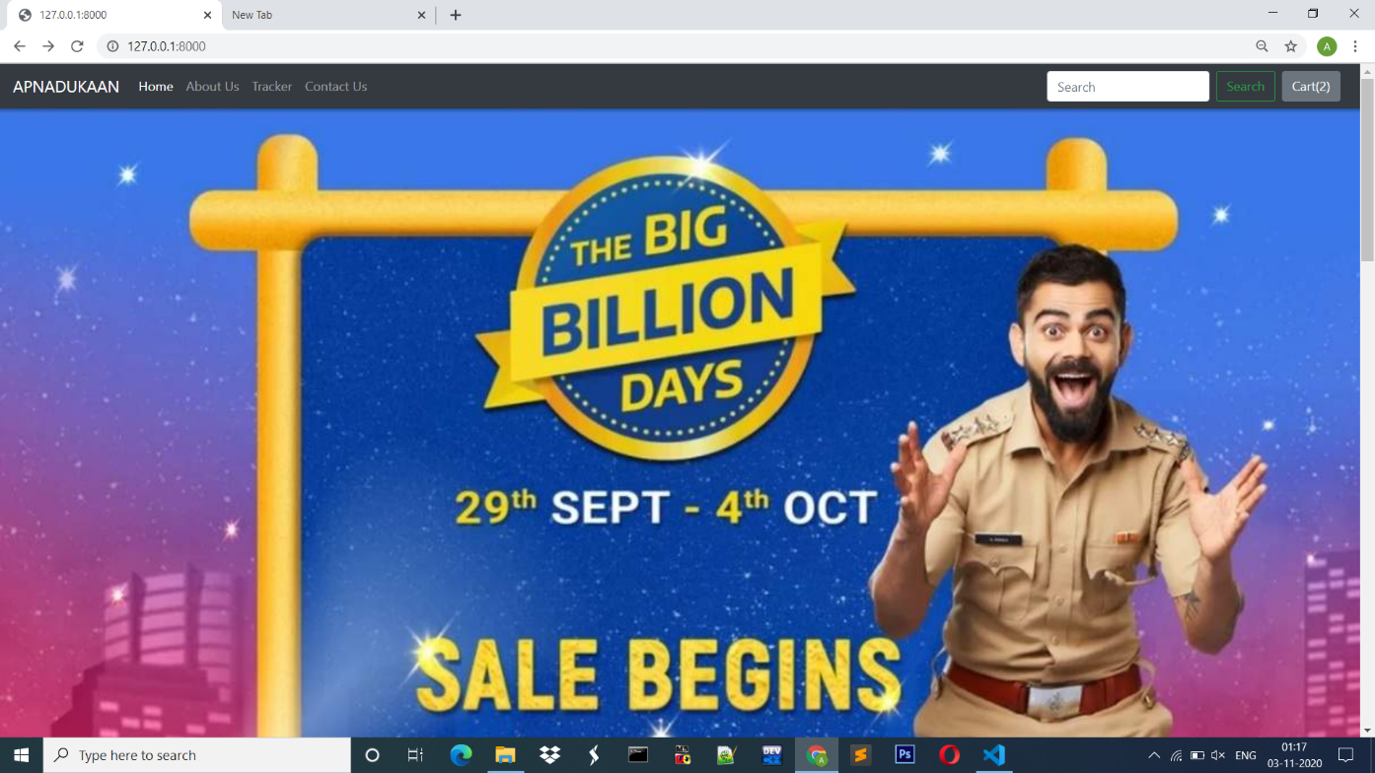

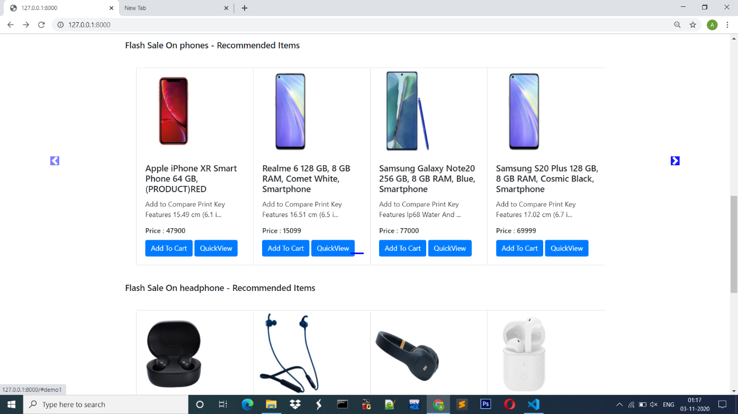

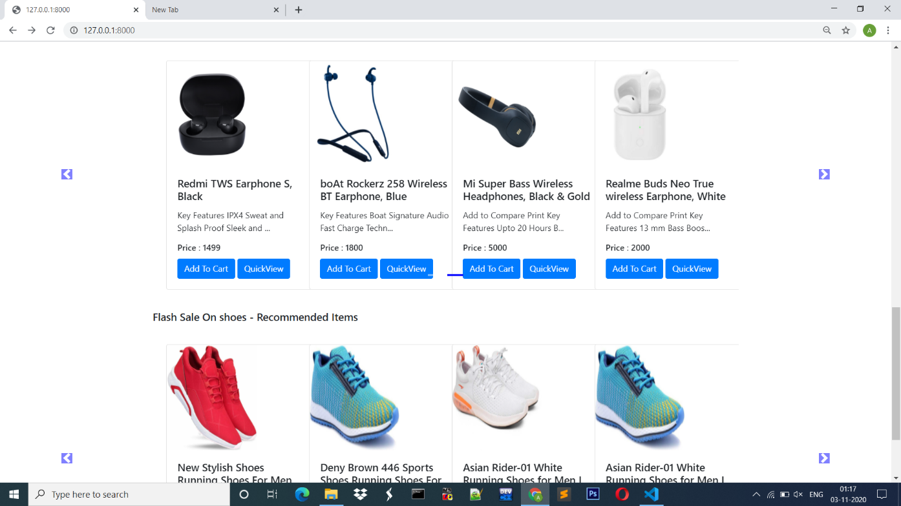

**ABOUT PAGE:**

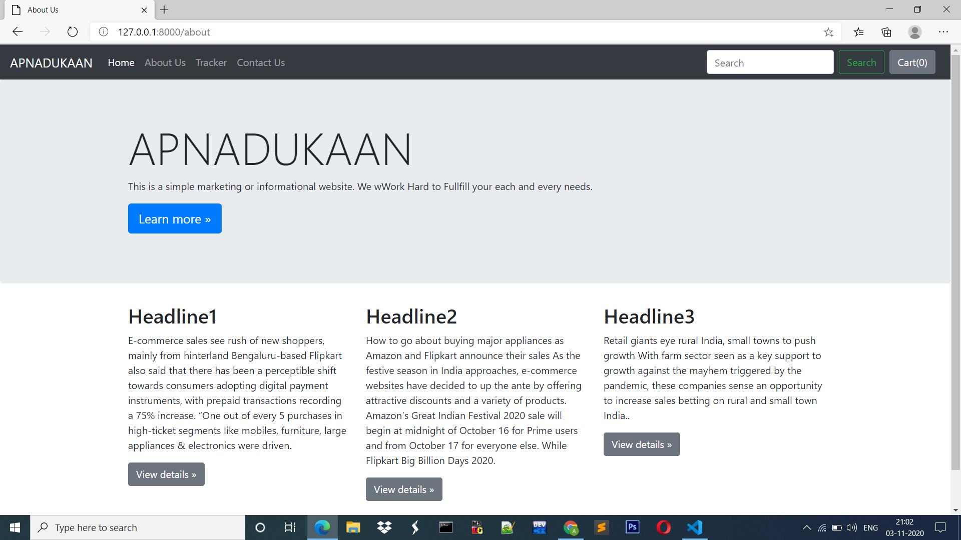

**TRACKER PAGE:**

