|  |  |  |  |  |  |  |  |  |  |  |
| --- | --- | --- | --- | --- | --- | --- | --- | --- | --- | --- |
| Exp  . no |  | Experiment Name | Date of performance | R1 (3) | R2 (3) | R3 (3) | R4 (3) | R5 (3) | Total Marks (15) | Signature |
|  |  |  |  |  |  |  |  |  |  |  |
|  |  |  |  |  |  |  |  |  |  |  |
|  |  |  |  |  |  |  |  |  |  |  |
|  |  |  |  |  |  |  |  |  |  |  |
|  |  |  |  |  |  |  |  |  |  |  |
|  |  |  |  |  |  |  |  |  |  |  |

# Experiment - 8

**Aim:** Write a program to implement Hangman game.

## **Program:**

import random

def choose_word():

words = ["doctor", "banana", "brain", "grape", "pear","monday","earth"]

return random.choice(words)

def display_word(word, guessed_letters):

display = ""

for letter in word:

if letter in guessed_letters:

display += letter

else:

display += "_"

return display

def hangman():

word = choose_word()

guessed_letters = []

attempts = 6

print("Welcome to Hangman!")

print(display_word(word, guessed_letters))

while attempts > 0:

guess = input("Guess a letter: ").lower()

if guess in guessed_letters:

print("You've already guessed that letter.")

elif guess in word:

print("Correct guess!")

guessed_letters.append(guess)

print(display_word(word, guessed_letters))

if "_" not in display_word(word, guessed_letters):

print("Congratulations! You've guessed the word:", word)

break

else:

print("Incorrect guess!")

attempts -= 1

print("Attempts remaining:", attempts)

print(display_word(word, guessed_letters))

if attempts == 0:

print("Sorry, you've run out of attempts. The word was:", word)

hangman()

**OUTPUT:**

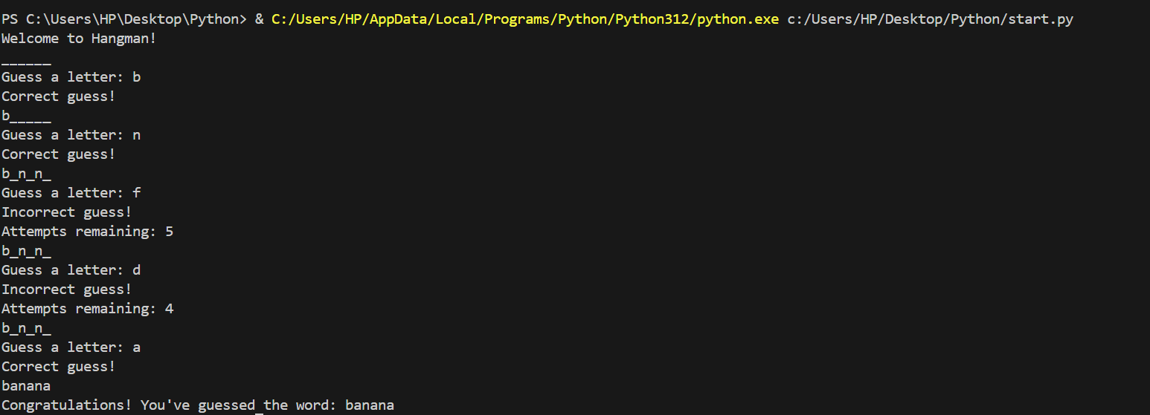

**Experiment – 9**

**Aim:**  Write a program to implement Hangman game.

**Source Code:**

1. Create text file.

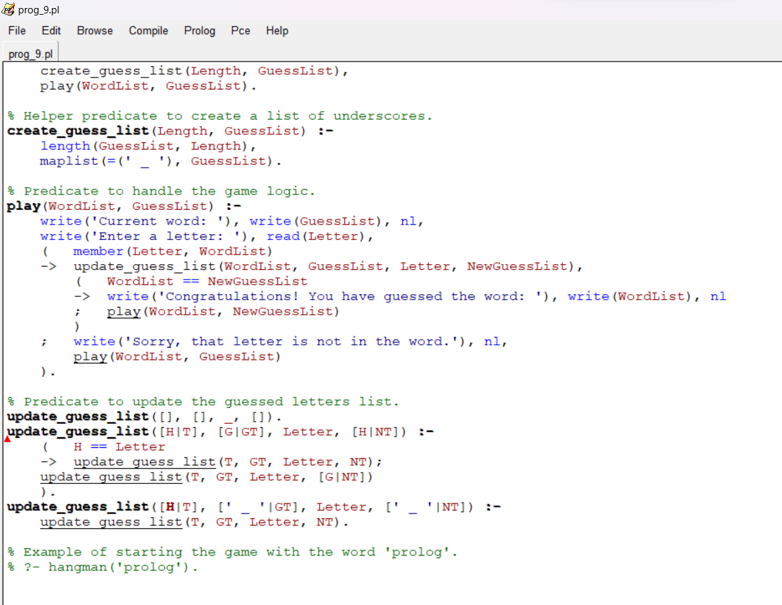

1. Open the prolog console and use the ‘consult’ command to compile the file and use it as a knowledge base.

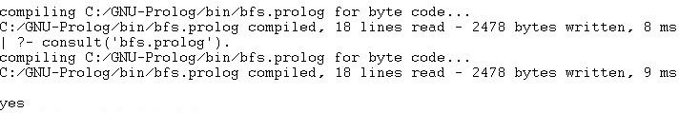

**OUTPUT**

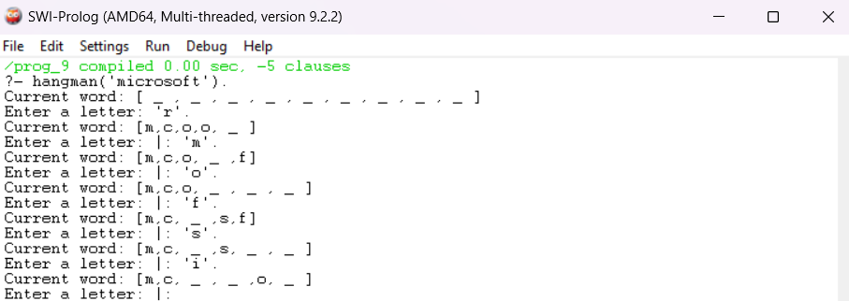

# Experiment - 10

**Aim:** Write a program to implement the Tic-Tac-Toe game.

## **Program:**

# Set up the game board as a list

board = ["-", "-", "-",

"-", "-", "-",

"-", "-", "-"]

# Define a function to print the game board

def print_board():

print(board[0] + " | " + board[1] + " | " + board[2])

print(board[3] + " | " + board[4] + " | " + board[5])

print(board[6] + " | " + board[7] + " | " + board[8])

# Define a function to handle a player's turn

def take_turn(player):

print(player + "'s turn.")

position = input("Choose a position from 1-9: ")

while position not in ["1", "2", "3", "4", "5", "6", "7", "8", "9"]:

position = input("Invalid input. Choose a position from 1-9: ")

position = int(position) - 1

while board[position] != "-":

position = int(input("Position already taken. Choose a different position: ")) - 1

board[position] = player

print_board()

# Define a function to check if the game is over

def check_game_over():

# Check for a win

if (board[0] == board[1] == board[2] != "-") or \

(board[3] == board[4] == board[5] != "-") or \

(board[6] == board[7] == board[8] != "-") or \

(board[0] == board[3] == board[6] != "-") or \

(board[1] == board[4] == board[7] != "-") or \

(board[2] == board[5] == board[8] != "-") or \

(board[0] == board[4] == board[8] != "-") or \

(board[2] == board[4] == board[6] != "-"):

return "win"

# Check for a tie

elif "-" not in board:

return "tie"

# Game is not over

else:

return "play"

# Define the main game loop

def play_game():

print_board()

current_player = "X"

game_over = False

while not game_over:

take_turn(current_player)

game_result = check_game_over()

if game_result == "win":

print(current_player + " wins!")

game_over = True

elif game_result == "tie":

print("It's a tie!")

game_over = True

else:

# Switch to the other player

current_player = "O" if current_player == "X" else "X"

# Start the game

play_game()

**OUTPUT:**

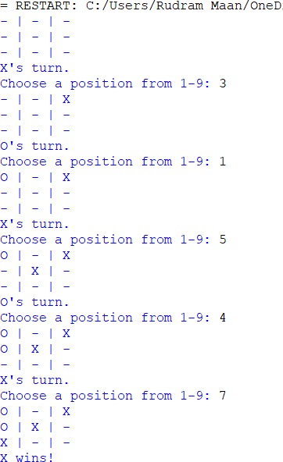

# Experiment - 11

**Aim:** Write a program to remove stop words for a given passage from a text file using NLTK.

## **Program:**

import nltk

from nltk.corpus import stopwords

from nltk.tokenize import word_tokenize

nltk.download('stopwords')

example_sent = """This is a sample sentence, showing off the stop words filtration."""

stop_words = set(stopwords.words('english'))

word_tokens = word_tokenize(example_sent)

# Method 1: List comprehension

filtered_sentence = [w for w in word_tokens if not w.lower() in stop_words]

# Method 2: Using a loop

filtered_sentence_loop = []

for w in word_tokens:

if w.lower() not in stop_words:

filtered_sentence_loop.append(w)

print("Original Tokens:", word_tokens)

print("Filtered Sentence (List Comprehension):", filtered_sentence)

print("Filtered Sentence (Using Loop):", filtered_sentence_loop)

**OUTPUT:**

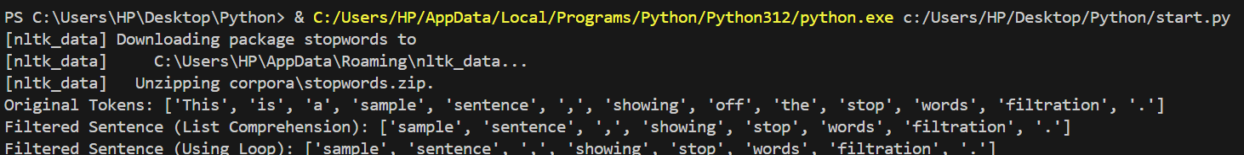

# Experiment - 12

**Aim:** Write a program to implement stemming for a given sentence using NLTK.

## **Theory:**

**Stemming** is the process of producing morphological variants of a root/base word. Stemming programs are commonly referred to as stemming algorithms or stemmers. A stemming algorithm reduces the words “chocolates”, “chocolatey”, and “choco” to the root word, “chocolate” and “retrieval”, “retrieved”, “retrieves” reduce to the stem “retrieve”.

## **Program:**

import nltk

from nltk.stem import PorterStemmer

from nltk.tokenize import word_tokenize

nltk.download('punkt')

stemmer = PorterStemmer()

def stem_sentence(sentence):

words = word_tokenize(sentence)

stemmed_words = [stemmer.stem(word) for word in words]

stemmed_sentence = ' '.join(stemmed_words)

return stemmed_sentence

sentence = input("Enter a sentence: ")

stemmed_sentence = stem_sentence(sentence)

print("Original Sentence:", sentence)

print("Stemmed Sentence:", stemmed_sentence)

**Output:**

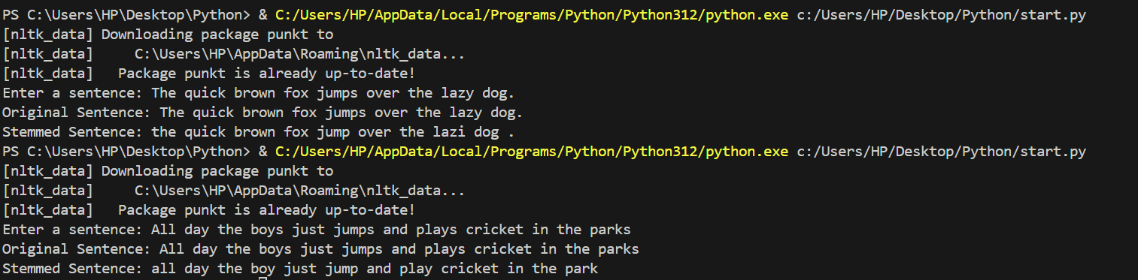

# Experiment - 13

**Aim:** Write a program to POS (part of speech) tagging for the give sentence using NLTK.

## **Program:**

import nltk

from nltk.tokenize import word_tokenize from nltk import pos_tag

def pos_tagging(sentence):

words = word_tokenize(sentence) tagged_words = pos_tag(words) return tagged_words

sentence = "The quick brown fox jumps over the lazy dog." tagged_words = pos_tagging(sentence)

print("Tagged Words:", tagged_words)

**OUTPUT:**

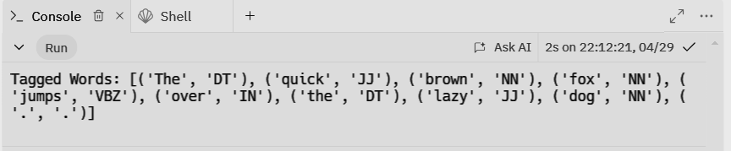

# Experiment - 14

**Aim:** Write a program to implement Lemmatization using NLTK

## **Theory:**

Lemmatization is the process of reducing words to their base or root form, known as the lemma. Unlike stemming, which simply chops off the ends of words to create their base form, lemmatization takes into account the meaning of the word and its context in the sentence. This means that lemmatization produces valid words that are present in the dictionary.

Ex - "running" -> "run"

## **Program:**

import nltk

from nltk.stem import WordNetLemmatizer

from nltk.tokenize import word_tokenize

nltk.download('wordnet')

lemmatizer = WordNetLemmatizer()

def lemmatize_sentence(sentence):

words = word_tokenize(sentence)

lemmatized_words = [lemmatizer.lemmatize(word) for word in words]

lemmatized_sentence = ' '.join(lemmatized_words)

return lemmatized_sentence

sentence = "The quick brown foxes are running over the lazy dogs"

lemmatized_sentence = lemmatize_sentence(sentence)

print("Original Sentence:", sentence)

print("Lemmatized Sentence:", lemmatized_sentence)

**OUTPUT:**

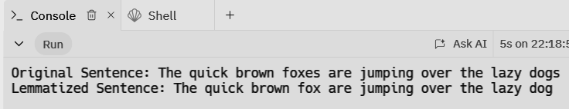

**Experiment – 15**

**Aim:**  Write a program for Text Classification for the given sentence using NLTK.

**Source Code:**

import nltk

from nltk.tokenize import word_tokenize

from nltk.corpus import stopwords

from nltk.stem import WordNetLemmatizer

from nltk.classify import NaiveBayesClassifier

import random

# Download necessary NLTK data

nltk.download('punkt')

nltk.download('stopwords')

nltk.download('wordnet')

def preprocess(sentence):

# Tokenize the sentence

tokens = word_tokenize(sentence.lower())

# Remove stopwords

stop_words = set(stopwords.words('english'))

filtered_tokens = [word for word in tokens if word not in stop_words]

# Lemmatize tokens

lemmatizer = WordNetLemmatizer()

lemmatized_tokens = [lemmatizer.lemmatize(word) for word in filtered_tokens]

return lemmatized_tokens

def extract_features(words):

return dict([(word, True) for word in words])

def train_classifier():

# Sample training data

training_data = [

(preprocess("Natural language processing is a field of artificial intelligence."), "technology"),

(preprocess("Forests are home to diverse ecosystems."), "nature"),

(preprocess("Computers can understand and generate human language."), "technology"),

(preprocess("Mountains offer breathtaking views and fresh air."), "nature"),

(preprocess("Machine learning algorithms improve with more data."), "technology"),

(preprocess("Rivers provide water for plants and animals."), "nature")

]

# Extract features from training data

training_features = [(extract_features(tokens), category) for tokens, category in training_data]

# Train Naive Bayes classifier

classifier = NaiveBayesClassifier.train(training_features)

return classifier

def classify_sentence(classifier, sentence):

tokens = preprocess(sentence)

features = extract_features(tokens)

category = classifier.classify(features)

return category

def main():

classifier = train_classifier()

test_sentences = [

"The internet has revolutionized communication.",

"Birds migrate to warmer climates during winter.",

"Artificial intelligence is shaping the future of technology.",

"Forests play a crucial role in maintaining ecological balance.",

"Deep learning models require large datasets for training.",

"Oceans cover more than 70% of the Earth's surface.",

"Blockchain technology is transforming various industries.",

"Wildlife conservation is essential for biodiversity."

]

# Classify test sentences

for sentence in test_sentences:

category = classify_sentence(classifier, sentence)

print(f"Sentence: {sentence}")

print(f"Category: {category}")

print("-" * 50)

if __name__ == "__main__":

main()

**Output:**

## 